1. Material in this doc on 10.1 through 10.5 has all been installed into wedge doc on 4/10.16 and was then deleted from this doc.

2. There remains material that may be relevant source material for 10.7 developed in a doc of that name.

DO NOT EDIT THIS DOC, it is frozen.

10.6. The pullback of a differential form : Method 1

(a) Definition of a pullback acting dual basis vectors λi

Here is the basic scenario where we have in mind that m ≥ n (adapted from Sjamaar page 39) :

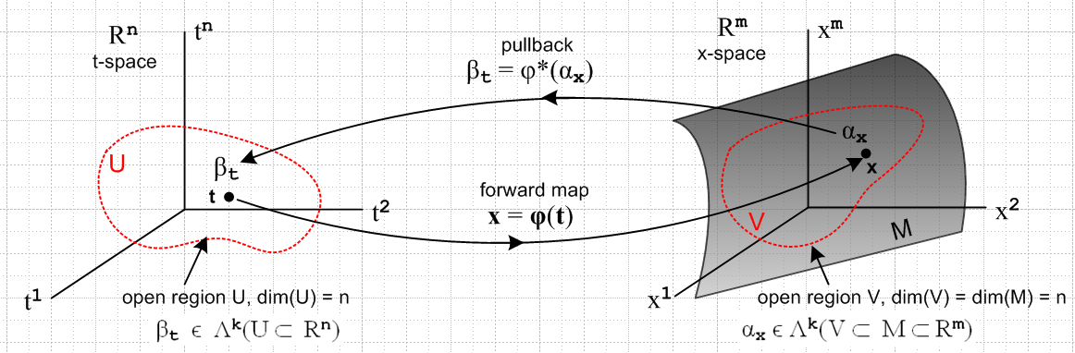
(10.6.1)

On the left is t-space = Rn which contains some open set U on which a k-form βt is defined at point t where t ϵ U ⊂ Rn.

On the right is x-space = Rm which contains some open set V on which a k-form αx is defined at point x where x ϵ V ⊂ M ⊂ Rm where M is some manifold.

The lower arrow going to the right shows how point t on the left maps "forward" to point x on the right.

The upper arrow shows how a k-form called αx defined on V in x-space on the right is "pulled back" to become a k-form called βt defined on U in t-space on the left. Our task is to show how to compute βt from αx. Later we shall use the pullback to define the notion of integration of a form on a manifold. Right now we just want to define the pullback.

The mapping φ is continuous in both directions so it maps open sets to open sets.

The phrase "open set" has some ambiguity. Suppose U is an open n-dimensional chunk of Rn. Then that U would be open relative to Rn. Under the mapping φ, U gets mapped into V which is an n-dimensional "surface" embedded in Rm . If m > n, the set V is not open relative to Rm because an open m-ball at point x on V is not included in V. However, an open n-ball relative to the surface V around any point in V is contained in V, so we loosely say V is open relative to itself, though not relative to Rm. Relative to itself, V does not include any boundary points (hence the dotted boundary on the edges of V).
We shall think of region V as a dotted-boundary curved "patch" on a manifold M of dimension n embedded in Rm , and then V is open relative to that manifold M.
In principle the open set U in Rn could also be of dimension less than n and then the same situation arises in Rn on the left where U is open relative to itself but not relative to Rn.
In any event, one can think about k-forms βt ϵ Λk(U ⊂ Rn) with k ranging from 0 to n on the left, and k-forms αx ϵ Λk(V ⊂ M ⊂ Rm) with k ranging from 0 to m on the right. Since the pullback is going to map a k-form on the right to a k-form on the left, and since n ≤ m, our interest will only be in k-forms having k in the range 0 to n.
In the discussion below, U will always have the full dimension n of Rn so V will always be a "surface patch" of dimension n on M within Rm. Furthermore, we shall be interested in k-forms where k = n.

How then does one compute the pulled back form βt from the original form αx ? We start by studying how basis vectors are pulled back and then in (b) we show how forms which are linear combinations of these basis vectors are pulled back.

Recall from (2.1) how xλi = <xei| refers to a dual basis vector λi at some point x in x-space. In our current context, x would be a point in V on manifold M within Rm as shown in (10.6.1). Similarly we can refer to the dual basis in t-space as tλj where t lies in U in Rn. There are m dual vectors xλi in x-space, while there are n dual vectors tλj in t-space.

Below we treat k = 1, then k = 2, then the general k = k, and finally k = 0.

k = 1

We start by defining the action of pullback φ* on a the simplest 1-form which is a basis vector xλi in x-space,

φ*(xλi) ≡ Σj=1n (Dφ)ij tλj = Σj=1n Rij tλj i = 1,2...m . (10.6.2)

If t-space is Rn, there are then n basis vectors xei in the tangent space at x, and there are then n dual basis vectors xλi in the corresponding cotangent space.

Some comments on notations (Dφ) and R are certainly due at this point. First,

(Dφ)ij ≡ (∂φi(t)/∂tj) = $\frac{∂φi(t)}{∂tj}$ ≡ Rij i = 1,2...m j = 1,2..,n (10.6.3)

The object (Dφ) is thus a matrix of derivatives having m rows (first i index) and n columns (second j index). In Chapter 2 where we considered the general transformation x' = F(x) we referred to the differential of the transformation as the R-matrix where Rab = (∂x'a/∂xb) as in (2.1.2). Here we have x = φ(t) as our general transformation and the R-matrix is Rab = (∂xa/∂tb). In the discussion of Chapter 2, taken from our document Tensor, we had in mind that the transformation x' = F(x) was a mapping between x-space and x'-space where both spaces were of dimension n, so R was an nxn matrix. But now for x = φ(t) the transformation maps from t-space of dimension n to x-space of dimension m, so the differential R matrix is only square nxn if both t-space and x-space have dimension n, which means that the manifold M is some full chunk of Rn . For a general n-dimensional "surface" or manifold in Rm, the differential matrix R = (Dφ) is an m x n matrix. The notation (Dφ) is favored by Spivak and other authors, but we like R in dense equations because it is 1 symbol instead of 4 symbols.

We now continue to study (10.6.2) above,

φ*(xλi) ≡ Σj=1n (Dφ)ij tλj = Σj=1n Rij tλj ≡ βt i = 1,2...m . (10.6.2)

The object xλi (argument of φ*) is a 1-form in x-space, xλi ϵ Λ1(V ⊂ M ⊂ Rm).
The object on the right of (10.6.2) is a linear combination of the dual basis vectors tλj ϵ Λ1(U ⊂ Rn) and so is a 1-form in t-space. We call this 1-form βt just to give it a name.

We can now compare the transformations φ and φ* :

φ : U ⊂ Rn → V ⊂ M ⊂ Rm x = φ(t)
t-space x-space x = (x1,x2.....xm) t = (t1,t2...tn)

φ* : Λ1(V ⊂ M ⊂ Rm) → Λ1(U ⊂ Rn) βt = φ*(xλi) pullback (10.6.4)
1-form in x-space 1-form in t-space

where the notation Λ1(V) means the space of rank-1 linear functionals defined on vectors in V. The first mapping pushes forward from t-space to x-space, the second mapping pulls back from x-space to t-space.

The following drawing illustrates the discussion above for the special case n = 1 and k = n, where the red curve is in general non-planar :

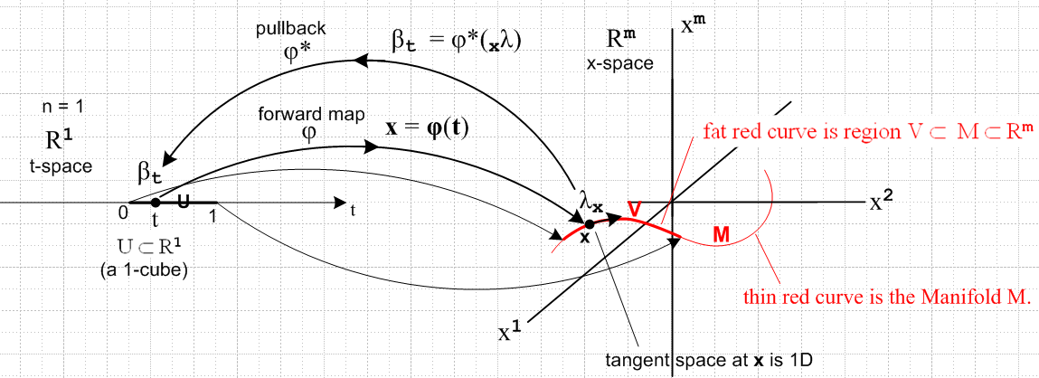
(10.6.5)

The mapping φ takes the unit interval [0,1] in t-space to the thick part of the red curve in x-space. This kind of mapping is called a 1-cube. The thick red curve on the right is the image of this 1-cube mapping, though one can think of it as being the 1-cube (multiple mappings can yield the same image, however). We can also think of the domain as being a 1-cube, since it is a unit one-dimensional cube. Thus we in fact have three distinct meanings for the term 1-cube. The same is true for 2-cubes and k-cubes.

k = 2

The pullback of a basis vector in Λ2(V ⊂ M ⊂ Rm) is defined as

φ*(xλi$_{1}$ ^ xλi$_{2}$) ≡ Σj$_{1}$j$_{2}$=1n (Dφ)i$_{1}$j$_{1}$ (Dφ)i$_{2}$j$_{2}$ (tλj$_{1}$ ^ tλj$_{2}$) i1 = 1, i2 = 2, n = 2

= Σj$_{1}$j$_{2}$=1n Ri$_{1}$j$_{1}$Ri$_{2}$j$_{2}$ (tλj$_{1}$ ^ tλj$_{2}$) ≡ βt . (10.6.6)

The tangent space at x has two tangent vectors xe1 and xe2 and correspondingly there are two dual basis functionals xλ1 and xλ2. The only ordered basis 2-form is xλ1 ^ xλ2, though we write this as xλi$_{1}$ ^ xλi$_{2}$ in (10.6.6) to make the notation more regular, and similarly allow the sum to go to n = 2.

This mapping takes a basic 2-form at a point x in V on M in x-space and maps it to (pulls it back to) some 2-form at point t in U in t-space. We call this 2-form βt just to give it a name (it is of course a different βt from that appearing earlier). Notice the symmetric sums on j1 and j2.

Here is a drawing illustrating the k=2 case. As in the previous drawing, we think of x-space as being Rm but we draw it as if it were R3 just to be able to draw something. For k = 1 the manifold M on the right was the thin red curve embedded in R3, while V was the fat piece of this curve. For k = 2 the manifold of interest is a torus and V is a patch on that torus which is "mapped into" from a 2-cube in t-space by the mapping x = φ(t). The 2-cube (as the mapping domain) is often written [0,1]2.

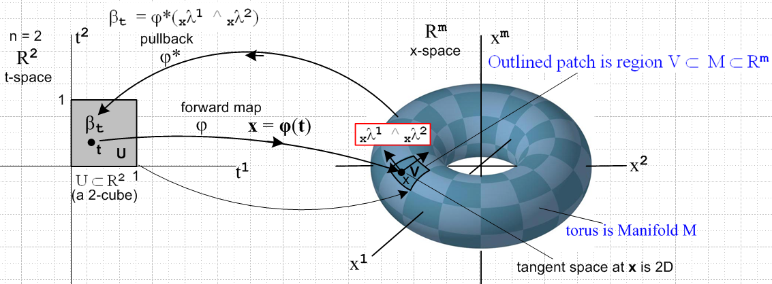

(10.6.7)

How can equation (10.6.6) concerning rank-2 dual tensors be stated in terms of rank-2 tensor functions?

φ*(xλi$_{1}$ ^ xλi$_{2}$) = Σj$_{1}$j$_{2}$=1n Ri$_{1}$j$_{1}$Ri$_{2}$j$_{2}$ (tλj$_{1}$ ^ tλj$_{2}$) . (10.6.6)

To find out, we close both sides of bra (10.6.6) onto the ket |v1> ⊗ |v2> = |v1,v2> where vi are both in Rn = t-space so these vectors each have n components (n=2 here), see (2.11.e.7). Doing this gives

[φ*(xλi$_{1}$ ^ xλi$_{2}$)] (v1,v2) = Σj$_{1}$j$_{2}$=1n Ri$_{1}$j$_{1}$Ri$_{2}$j$_{2}$ (tλj$_{1}$ ^ tλj$_{2}$)(v1,v2) (10.6.8)

where both sides of this equation are rank-2 tensor functions in Λ2f(V) [defined above (4.4.34)]. We shall now process the right hand side of (10.6.8). First use (4.4.20b) to write

(tλj$_{1}$ ^ tλj$_{2}$)(v1,v2) = [ (v1)j$_{1}$(v2)j$_{2}$ - (v1)j$_{2}$(v2)j$_{1}$] (10.6.9)

so then

RHS(10.6.8) = (1/2) Σj$_{1}$j$_{2}$=1n Ri$_{1}$j$_{1}$Ri$_{2}$j$_{2}$ [ (v1)j$_{1}$(v2)j$_{2}$ - (v2)j$_{1}$(v1)j$_{2}$] // (4.4.20b)

= (1/2) { Σj$_{1}$j$_{2}$=1n Ri$_{1}$j$_{1}$Ri$_{2}$j$_{2}$(v1)j$_{1}$(v2)j$_{2}$ - (v1↔ v2) } // do ↔ to make 2nd term

= (1/2) { [Σj$_{1}$=1nRi$_{1}$j$_{1}$(v1)j$_{1}$] [Σj$_{2}$=1nRi$_{2}$j$_{2}$(v2)j$_{2}$] - (v1↔ v2) } // reorder

= (1/2) { (Rv1)i$_{1}$(Rv2)i$_{2}$ - (v1↔ v2) } // matrix multiplication

= (1/2) [ xλi$_{1}$(Rv1)xλi$_{2}$(Rv2) - xλi$_{2}$(Rv1)xλi$_{1}$(Rv2)] // (2.11.c.5) λi(v) = vi

= (xλi$_{1}$ ^ xλi$_{2}$)(Rv1, Rv2) . // (4.4.20b) (10.6.10)

We have thus shown that the tensor function representation of the pullback definition is this:

[φ*(xλi$_{1}$ ^ xλi$_{2}$)](v1,v2) = (xλi$_{1}$ ^ xλi$_{2}$)(Rv1, Rv2) . (10.6.11)
ok to here 6:30 PM Tues 3.1
k = k

Finally we define the pullback on a basis vector in Λk :

φ*(xλi$_{1}$ ^ xλi$_{2}$....^ xλi$_{k}$) = Σj$_{1}$j$_{2}$...j$_{k}$=1n Ri$_{1}$j$_{1}$Ri$_{2}$j$_{2}$ ....Ri$_{k}$j$_{k}$ (tλj$_{1}$ ^ tλj$_{2}$ ....^ tλj$_{k}$)
or
φ*(xλI) = ΣJ RIJ tλJ . (10.6.12)

The pullback mapping is then,

φ* : Λk(V ⊂ M ⊂ Rm) → Λk(U ⊂ Rn) . (10.6.13)
k-form in x-space k-form in t-space

As we did with k=2, we again wish to evaluate the tensor function statement of (10.6.11) (λt→ λ for now). As before we close with an appropriate ket to get,

[φ*(λxI)](vn$_{1}$,vn$_{2}$...vn$_{k}$) = ΣJ RIJ (λj$_{1}$ ^ λj$_{2}$ ....^ λj$_{k}$)(vn$_{1}$,vn$_{2}$...vn$_{k}$) . (10.6.14)

We now process the right hand side of (10.6.11). There are quite a few steps, each explained:

RHS (6.9) = ΣJ RIJ (λj$_{1}$ ^ λj$_{2}$ ....^ λj$_{k}$)(vn$_{1}$,vn$_{2}$...vn$_{k}$)

= ΣJ RIJ AltJ[(λj$_{1}$ ⊗ λj$_{2}$ ....⊗ λj$_{k}$)(vn$_{1}$,vn$_{2}$...vn$_{k}$)] // (8.3.8)

= ΣJ RIJ AltJ[(λj$_{1}$(vn$_{1}$)λj$_{2}$(vn$_{2}$) ...λj$_{k}$(vn$_{k}$)] // (6.1.3)

= ΣJ RIJ AltN[(λj$_{1}$(vn$_{1}$)λj$_{2}$(vn$_{2}$) ...λj$_{k}$(vn$_{k}$)] // (A.8.29)

= AltN [ ΣJ RIJ (λj$_{1}$(vn$_{1}$)λj$_{2}$(vn$_{2}$) ...λj$_{k}$(vn$_{k}$) ] // (A.8.10)

= AltN [ ΣJ RIJ (vn$_{1}$)j$_{1}$(vn$_{2}$)j$_{2}$ ... λ(vn$_{k}$)j$_{k}$ ] // (2.11.c.5)

= AltN [ Σj$_{1}$j$_{2}$...j$_{k}$=1n Ri$_{1}$j$_{1}$Ri$_{2}$j$_{2}$ ....Ri$_{k}$j$_{k}$ (vn$_{1}$)j$_{1}$(vn$_{2}$)j$_{2}$ ... λ(vn$_{k}$)j$_{k}$ ]

= AltN { [Σj$_{1}$Ri$_{1}$j$_{1}$(vn$_{1}$)j$_{1}$] [Σj$_{2}$Ri$_{2}$j$_{2}$(vn$_{2}$)j$_{2}$] ... [Σj$_{k}$Ri$_{k}$j$_{k}$(vn$_{k}$)j$_{k}$] }

= AltN { (Rvn$_{1}$)i$_{1}$(Rvn$_{2}$)i$_{2}$... (Rvn$_{k}$)i$_{k}$ } // (Rv)i = ΣjRijvj

= AltN {λi$_{1}$(Rvn$_{1}$)λi$_{2}$(Rvn$_{2}$)... λi$_{k}$(Rvn$_{k}$) } // (2.11.c.5)

= AltI {λi$_{1}$(Rvn$_{1}$) λi$_{2}$(Rvn$_{2}$)... λi$_{k}$(Rvn$_{k}$) } // (A.8.29)

= AltI {(λi$_{1}$ ⊗ λi$_{2}$ ....⊗ λj$_{k}$) (Rvn$_{1}$, Rvn$_{2}$ ...Rvn$_{k}$)} // (6.1.3)

= ( λi$_{1}$ ^ λi$_{2}$... ^ λi$_{k}$ )(Rvn$_{1}$,Rvn$_{2}$...Rvn$_{k}$) . // (8.3.8) (10.6.15)

We have thus shown that the tensor function representation of the pullback definition is this:

[φ*(xλi$_{1}$ ^ xλi$_{2}$....^ xλi$_{k}$)](vn$_{1}$,vn$_{2}$...vn$_{k}$) = ( tλi$_{1}$ ^ tλi$_{2}$... ^ tλi$_{k}$ )(Rvn$_{1}$,Rvn$_{2}$...Rvn$_{k}$)
or
[φ*(xλI)] (vn$_{1}$,vn$_{2}$...vn$_{k}$) = tλI(Rvn$_{1}$,Rvn$_{2}$...Rvn$_{k}$) . (10.6.16)

Finally, having held off a long time, we can rewrite equations above using the cosmetic notations introduced in (10.1.7).

dxi ≡ xλi
dtj ≡ tλj (10.6.17)

to get these Cosmetic equations for pulling back basis vectors and their tensor functions, // R = (Dφ).

φ*(dxi ) ≡ Σj=1n Rij dtj R ≡ (Dφ) i = 1,2...m . (10.6.2)C

φ*(dxi$_{1}$ ^ dxi$_{2}$) ≡ Σj$_{1}$j$_{2}$=1n Ri$_{1}$j$_{1}$Ri$_{2}$j$_{2}$ dtj$_{1}$ ^ dtj$_{2}$ i1, i2 ϵ {1,2...m} (10.6.6)C

[φ*(dxi$_{1}$ ^ dxi$_{2}$)](v1,v2) = (dxi$_{1}$ ^ dxi$_{2}$)(Rv1, Rv2) // tensor function (10.6.11)C

φ*(dxi$_{1}$ ^ dxi$_{2}$....^ dxi$_{k}$.) ≡ Σj$_{1}$j$_{2}$...j$_{k}$=1n Ri$_{1}$j$_{1}$Ri$_{2}$j$_{2}$ .... Ri$_{k}$j$_{k}$ (dtj$_{1}$ ^ dtj$_{2}$ ....^ dti$_{k}$)
or (10.6.12)C
φ*(dxI) = ΣJ RIJ dtJ .

[φ*(dxi$_{1}$ ^ dxi$_{2}$....^ dxi$_{k}$)](vn$_{1}$,vn$_{2}$...vn$_{k}$) = ( dxi$_{1}$ ^ dxi$_{2}$.... ^ dxi$_{k}$ )(Rvn$_{1}$,Rvn$_{2}$...Rvn$_{k}$)
or (10.6.16)C
[φ*(dxI)](vn$_{1}$,vn$_{2}$...vn$_{k}$) = (dxI)(Rvn$_{1}$,Rvn$_{2}$...Rvn$_{k}$) vi ϵ Rn , Rvi ϵ Rm

k = 0

A 0-form in x-space is just a function f(x) ϵ Λ0(V ⊂ M ⊂ Rm). The pullback of this 0-form in x-space to a 0-form in t-space is defined by

φ*(f(x)) ≡ (f o φ)(t) = f(φ(t)) ≡ F(t) ≡ βt ϵ Λ0(U ⊂ Rm) x ϵ V, t ϵ U (10.6.18)

That is to say, we just replace the x in f(x) by x = φ(t) to get the pullback βt .

ok to here 3 PM 2.29.16 can I do the properties at this point? No!

(b) Action of a pullback on a differential form α

The hard part is done! The pullback of a differential k-form α in x-space,

αx = Σ'I fI(x) xλI (10.2.1) (10.6.19)

is defined to be the following k-form in t-space,

φ*(αx) ≡ Σ'I φ*(fI(x)) φ*(xλI)

= Σ'I fI(φ(t)) ΣJ RIJ tλJ // (10.6.18) and (10.6.12)

= ΣJ [ Σ'I fI(φ(t)) RIJ ] (tλJ) // reorder

= ΣJ GJ(t) (tλJ) GJ(t) ≡ Σ'I fI(φ(t)) RIJ

= Σ'J gJ(t) (tλJ) gJ(t) ≡ k! AltJ[GJ(t)] , (10.6.20)

where the last line comes from (10.1.1) through (10.1.3). We have stated the result both in terms of symmetric ΣJ and ordered Σ'J summations. The coefficient functions gJ(t) can be re-expressed as,

gJ(t) ≡ k!AltJ[GJ(t)] = k!AltJ[ Σ'I fI(φ(t)) RIJ]

= k! Σ'I fI(φ(t)) AltJ[RIJ] // Alt is linear

= k! Σ'I fI(φ(t)) [ (1/k!) det(RIJ) ] // (A.8.30)

= Σ'I fI(φ(t)) det(RIJ) . (10.6.21)

The pullback of αx along φ is then

φ*(αx) = Σ'I fI(φ(t)) det(RIJ(t)) (tλJ)

= Σ'I fI(φ(t)) det[(Dφ)IJ(t)] (tλJ) ≡ βt (10.6.22)

We can redraw our figure one more time, showing how a general m-form αx in x-space is pulled back along φ into the m-form βt = φ*(αx) in t-space :

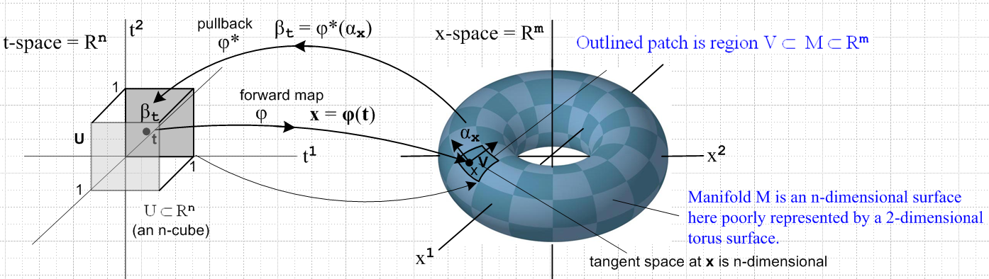
(10.6.23)
Recall that (Dφ)ij is a function of t, so

[Dφ(t)]ij ≡ (∂φi(t)/∂tj) = $\frac{∂φi(t)}{∂tj}$ ≡ R(t)ij i = 1,2...m j = 1,2..,n . (10.6.3)

We pause again to write equations in Cosmetic notation :

αx = Σ'I fI(x) dxI // k-form in x-space (10.6.19)C

φ*(xα) = ΣJ GJ(t) dtJ GJ(t) ≡ Σ'I fI(φ(t)) RIJ R = (Dφ) (10.6.20)C

φ*(xα) = Σ'J gJ(t) dtJ gJ(t) ≡ Σ'I fI(φ(t)) det(RIJ) . (10.6.22)C

Next, we want to obtain a tensor function definition of the pullback of a k-form. Start with

[φ*(xα)](vn$_{1}$,vn$_{2}$...vn$_{k}$) ≡ Σ'I φ*(fI(x)) { [φ*(xλI)](vn$_{1}$,vn$_{2}$...vn$_{k}$) }

= Σ'I fI(φ(t)) tλI(Rvn$_{1}$,Rvn$_{2}$...Rvn$_{k}$) // (10.6.16)

= xα (Rvn$_{1}$,Rvn$_{2}$...Rvn$_{k}$) . (10.6.23a)

In more conventional form

[φ*(αx)](v1,v2...vk) = αφ(t) (Rv1,Rv2...Rvk) . (10.6.23b)

= αφ(t)((Dφ)v1,(Dφ)v2...(Dφ)vk) . (10.6.23d)

Everything on the right depends on t, not x. For example, one should write [R(t)]vi and [(Dφ)(t)]v1

Since the k-form on the right is to be expressed entirely in t-space terms, we have replaced x = φ(t) on the αx label to make it αφ(t). Showing all t dependence, we get

[φ*(αx)](v1,v2...vk) = αφ(t)(R(t)v1,R(t)v2...R(t)vk)

= αφ(t)([(Dφ)(t)]v1,[(Dφ)(t)]v2...[(Dφ)(t)]vk) . (10.6.23c)

Suppressing this t dependence gives a less cluttered result,

[φ*(αx)](v1,v2...vk) = αφ(t)(Rv1,Rv2...Rvk)

= αφ(t)((Dφ)v1,(Dφ)v2...(Dφ)vk) . (10.6.23d)

The tensor function αx(w1,w2...wk) ϵ Λkf(Rm) is of course k-multilinear and alternating in its vector arguments wi, each of which has m components. In (6.21) we have for example w1 = (Dφ)v1 where vi is a vector having n components. Since we know from above that R = (Dφ) is a matrix with m rows and n columns, things conform properly.
The right side of (10.6.23d) is seen to be linear in the vi due to the matrix form Rvi for each argument. It alternates if we swap Rvi ↔ Rvj so it then alternates under vi ↔ vj. Therefore, since the right side is a k-multilinear alternating function of the vectors v1,v2...vk, it is in fact an rank-k tensor function in Λkf(Rn). The name of this rank-k tensor function is [φ*(αx)](v1,v2...vk) .

Equation (10.6.23d) says: αx is a k-form in x-space, and φ*(αx) is the pulled back k-form in t-space. We make this pulled back form be a rank-k tensor function associated with t-space by adding the k vector arguments (v1,v2...vk) where the vi are vectors in t-space. This is the same as closing the bra t<φ*(αx)| with the ket |v1,v2...vk>t in the tensor product space, where the scalar product t< | >t is for V*k on the left and Vk on the right, where V = Rn = t-space. Note that t<φ*(αx)| ϵ Λk(Rn) ⊂ V*k = (Rn)*k .

In a normal treatment of pullbacks, the tensor function equation (10.6.23d) is taken to be the definition of the pullback of a k-form from x-space to t-space. This definition is equivalent to our definition in terms of the action on dual basis vectors and on functions f(x). Our definition work took place directly in the space of dual tensor functionals, not in the space of tensor functions. Notice that (10.6.23d) does not involve any dual basis vectors like dxi ≡ xλi .

One fringe benefit of (10.6.23d) is that it also gives the φ* rule for rank-0 forms. If there are no arguments it just says

φ*(αx) = αφ(t)

so if αx = f(x), then φ*(f(x)) = φ*(αx) = αφ(t) = f(φ(t)) = (f o φ)(t) as in (10.6.18) above.

Equation (10.6.23d) appears in Spivak but not quite as we have written it. Spivak says on the bottom of page 89 and the top of page 90, more or less,

f*ω(p)(v1,v2...vk) = ω(f(p))(f*(v1), f*(v2), ... f*(vk) ) where f*(v) = (Df)v .

His actual notation includes some subtleties about where the tails of vectors are located. To translate to our notation, the first step to replace ω(s) by ωs in two places,

[f*ωp](v1,v2...vk) = ωf(p)((Df)v1, (Df)v2, ... (Df)vk ) .

We then replace f→ φ, p→ x and ω → α to get

[φ*αx](v1,v2...vk) = αφ(x)((Dφ)v1, (Dφ)v2, ... (Dφ)vk )

and we arrive at (10.6.23d).

(c) Properties of the pullback operator φ*

ok to here

