Section 10.12 Integration of Differential Forms PhL 4.13.16

Junk maintained at the end of this file.

10.12 Integration of 1-forms

General Review of k-form integration

This section is presented in the x = φ(t) notation introduced in Section 10.9 and illustrated in hybrid Fig (10.9.3) which we replicate here,

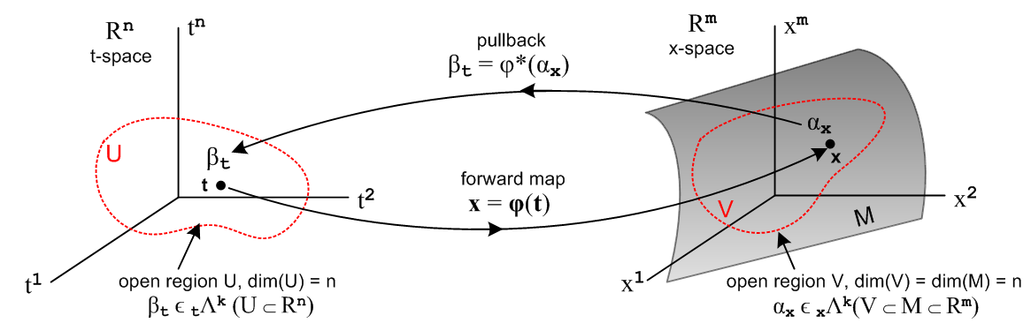

(10.9.3)
The main result of Section 10.11 is this description of the integration of a k-form over a surface,

∫S' αx' = ∫S'[Σ'I fI(x') dx'i$_{1}$ ^ dx'i$_{2}$ ^ ... ^ dx'i$_{k}$ ] // αx' = Σ'I fI(x') dx'^I
≡ ∫S [ Σ'J gJ(x) dxj$_{1}$ ^ dxj$_{2}$ ^ ... ^ dxj$_{k}$ ] // first definition (pull back)
≡ ∫S [ Σ'J gJ(x) dxj$_{1}$dxj$_{2}$ ... dxj$_{k}$] // second definition
where
gJ(x) = Σ'I fI(F(x)) det(RIJ) and x' = F(x) , R = (DF) . (10.11.7)

Using the x = φ(t) notation we rewrite the above (with some specialization) as,

∫φ αx = ∫φ Σ'I fI(x) dxi$_{1}$ ^ dxi$_{2}$ ^ ... ^ dxi$_{k}$ // αx = Σ'I fI(x) dx^I
≡ ∫[0,1]k Σ'J gJ(t) dtj$_{1}$ ^ dtj$_{2}$ ^ ... ^ dtj$_{k}$ // first definition (pull back)
≡ ($^{\int_{0}^{1}{}}$$^{\int_{0}^{1}{}}$ ... $^{\int_{0}^{1}{}}$) Σ'J gJ(t) dtj$_{1}$dtj$_{2}$ ... dtj$_{k}$ // second definition
where
gJ(t) = Σ'I fI(φ(t)) det(RIJ) and x = φ(t) , R = (Dφ) . (10.12.1)

Here the pulled-back integration region formerly called S is taken to be the unit cube in k dimensions, written above as [0,1]k and referred to as a k-cube. The pre-pullback integration region formerly called S' is here called φ, with the idea that this region is φ([0,1]k).

Note: A k-chain is a linear combination of k-cubes and is used by both Sjamaar (p 65) and Spivak (p 97) in their derivations of Stokes' Theorem. In fact, Spivak's entire Chapter 4 which includes his discussion of tensor products, wedge products and tensor functions is entitled Integration on Chains.

Integration of 1-forms

We wish now to look in more detail at the integration of 1-forms. There is much repetition of statements below because the meaning of objects tends to quietly diffuse away as one proceeds.

Consider this general 1-form in x-space Rm ,

αx = Σi fi(x) xλi = Σi fi(x) dxi . (10.12.2)

We wish to define a meaning for the integration of this 1-form αx over a piece of the curve x = φ(t),

∫φ αx = ∫φ Σi fi(x) dxi = integral of a 1-form over a piece of the curve φ in Rm . (10.12.3)

The transformation x = φ(t) is a mapping φ: t → Rm. Variable t is often called "the parameter".

Comment: Officially it is the mapping φ which is "the curve", but one loosely refers to the image (trace) of this mapping in Rm as "the curve". The distinction is necessary because many mappings can have the same image curve, such as φ(t) and φ(t2), where the parameter is "re-speeded" (reparametrized). This picture shows the general respeeding idea :
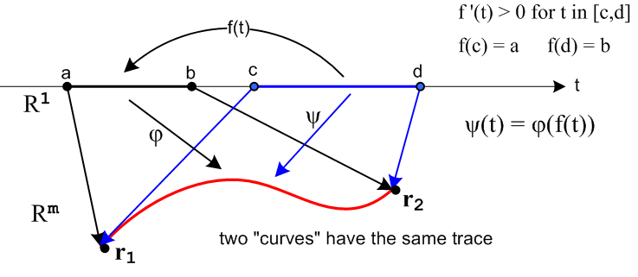 (10.12.4)

Here the same red curve is the image of two different transformations x = φ(t) and x = ψ(t) with different domain intervals, and ψ(t) = φ(f(t)) where f(t) is a monotonic respeeding function. A special case would be [a,b] = [c,d] = [0,1] to which our example φ(t) and ψ(t) = φ(t2) would apply. Mappings φ and ψ are called smoothly equivalent curves and ∫φ αx is the same for any two such curves (Buck p 386 Theorem 2 (i)). A similar but generalized reparametrization comment applies to integration of 2-forms and k-forms.

So imagine that we have a curved line hanging in Rm space and as t varies perhaps from 0 to 1 in t-space, we move along the image curve in Rm. The problem is how to integrate a 1-form along this curve.

We can define the calculational meaning of the above integral in two steps, each being a definition, as outlined in Section 10.11.

First definition:

∫φ αx ≡ ∫[0,1] φ*(αx)

= the integral in t-space of the pullback of αx over the 1-cube [0,1] (10.12.5)

On the left is an integral of the 1-form αx over a curve φ in Rm.
On the right is an integral of a different 1-form φ*(αx) (the pullback of αx) over a 1-cube [0,1] in R1.
Note that αx lies in xΛ1(Rm) while φ*(αx) lies in tΛ1(R).
Since our usual 1-form pullback mapping is φ* : xΛ1(Rm) → tΛ1(Rn), we have n = 1 (see (10.7.18)).

The "tall" m x n R-matrix for this problem is then an m x 1 matrix which is just a column vector of m elements ∂tφi ,

Ri1 = (D(t)φ)i1 = ∂φi(t)/∂t . // t1 ≡ t, the only coordinate in t-space (10.12.6)

We then compute the pullback of φ*(αx) of αx:

αx = Σi fi(x) xλi = Σi fi(x) dxi = f(x) • dx , dx ≡ (dx1, dx2, .... dxm)

φ*(αx) = Σi φ*(fi(x)) φ*(dxi) // (10.9.5) item 3

= Σi fi(φ(t)) Σj=1n Rij dtj // (10.9.5) items 1 and 5

= Σi fi(φ(t)) Ri1 dt1 // n = 1

= Σi fi(φ(t)) [∂φi(t)/∂t] dt // (10.12.6) and t1 = t

= g(t) dt (10.12.7)

where

g(t) ≡ Σi fi(φ(t)) [∂φi(t)/∂t] = Σi fi(φ(t)) ∂tφi(t) = f(φ(t)) • (∂tφ) . (10.12.8)

The object φ*(αx) = g(t) dt is a 1-form in dual t-space tΛ1(R).

Using the definition given above, one then has,

∫φ αx = ∫φ αx = ∫[0,1] φ*(αx) = ∫[0,1] g(t) dt . (10.12.9)

Thus the integral of the 1-form αx over the curve φ in x-space is defined to be equal to the integral of the 1-form g(t) dt over a 1-cube in t-space. So far no regular calculus integrals have appeared.

Second definition:

∫[0,1] g(t) tλ = ∫[0,1] g(t) dt ≡ $^{\int_{0}^{1}{}}$g(t) dt . (10.12.10)

On the left is the integral of a 1-form on a 1-cube, on the right is an ordinary calculus integral of a function over the interval [0,1] of the real axis. It is this second definition that motivates giving the dual space basis vector tλ the cosmetic name dt.
If one flips the "orientation" of the integration domain, so that [0,1] becomes [1,0], the result changes sign, and of course this fact agrees with the usual notion that $^{\int_{1}^{0}{}}$g(t) dt = - $^{\int_{0}^{1}{}}$g(t) dt .
We have then shown that the integral of a 1-form is described by,

∫φ αx = ∫φ f(x) • dx = ∫[0,1] g(t) dt

= $^{\int_{0}^{1}{}}$ f(φ(t)) • (∂tφ(t)) dt = $^{\int_{0}^{1}{}}$fi(φ(t)) [∂φi(t)/∂t] dt . (10.12.11)

This result appears in Sjamaar Ch 4 Eq (4.1) with φ = c and m = n.

Notice that the only locations where f(x) is "sensed" in this integral are points on the curve x = φ(t).

Since dx = (∂tφ(t)) dt, the above can be written concisely as

∫φ αx = ∫φ f(x) • dx =$^{\int_{0}^{1}{}}$ f(φ(t)) • dx where dx = (∂tφ(t)) dt . (10.12.12)

We redisplay the earlier Fig (10.9.3b) to illustrate the above discussion, where βt = g(t) dt :

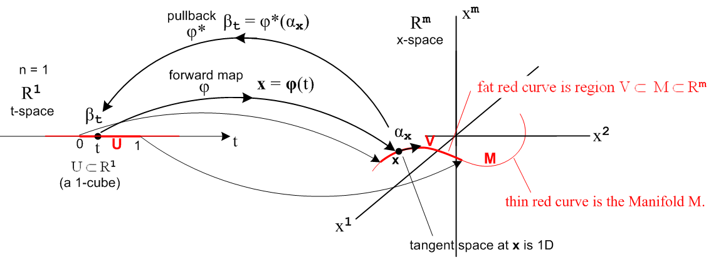
(10.12.13)
Recall now our "no differential forms" integration done in (10.10.42),

L' <Bt> = $^{\int_{0}^{a}{}}$dx Σj=13 Bi(F(x)) Ri1(x) . // Bt means Btangent (10.12.14)

In the x = φ(t) notation this reads, setting a = 1 and replacing 3 by m,

L <Bt> =$^{\int_{0}^{1}{}}$dt Σj=1m Bi(φ(t)) (Dφ)i1(t)

= $^{\int_{0}^{1}{}}$dt Σj=1m Bi(φ(t)) ∂iφ(t)

= $^{\int_{0}^{1}{}}$ B(φ(t)) • ∂φ(t) dt (10.12.15)

which is the same integral appearing in (10.12.11) with f = B. Therefore, we can interpret (10.12.15) as being the integral of the 1-form,

αx = Σi Bi(x) xλi = Σi Bi(x) dxi = B(x) • dx (10.12.16)

and one then has

∫φ αx = ∫φ B(x) • dx = $^{\int_{0}^{1}{}}$ B(φ(t)) • ∂φ(t) dt = $^{\int_{0}^{1}{}}$ B(φ(t)) • dx (10.12.17)

where dx = (∂tφ(t)) dt. This integral is normally written ∫φ B(x) • dx showing again the motivation for the cosmetic functional notation dx. This is the "line integral of a vector field B over a curve φ ".

Now return to (10.2.11),

∫φ αx = $^{\int_{0}^{1}{}}$ f(φ(t)) • (∂tφ(t)) dt . (10.12.11)

Suppose the vector field f(φ(t)) happens to be tangent to the curve φ for all values of t. In this case

f(φ(t)) • (∂tφ(t)) = | f(φ(t)) | | (∂tφ(t)) | (10.12.18)

since ∂tφ(t) is tangent to the curve at t. Note that

| (∂tφ(t)) |2 = Σi=1m (∂tφi(t))2 = Σi=1m Ri1 2 . (10.12.19)

which we recognize as the K2 object of (10.10.41). Setting | f(φ(t)) | = T(φ(t)), we find that

∫φ αx = $^{\int_{0}^{1}{}}$ T(φ(t)) K(t) dt (10.12.20)

and this shows how the temperature integral of (10.10.42) can be fitted into the 1-form framework.

Example for Rm = R2: The "angle form" problem mentioned in (10.5.10). (10.12.21)

In this problem we have specific functions f1 and f2, a specific range [0,2π] for the t-space domain, and a specific curve (a circle) x = φ(t) = (x1,x2).

αx = Σi=12 fi(x) xλi = f1(x) dx1 + f2(x) dx2

= - (x2/r2) dx1 + (x1/r2) dx2 where r2 ≡ (x1)2 + (x2)2

x1 = φ1(t) = cos t ∂tφ1(t) = -sin t t = [0,2π]
x2 = φ2(t) = sin t ∂tφ2(t) = cos t t is the polar angle of the vector x = (x1,x2)

r2 = (x1)2 + (x2)2 = cos2 t + sin2 t = 1 vector x lies on the unit circle in x-space

f1(φ(t)) = - (x2/r2) = - sin t
f2(φ(t)) = + (x1/r2) = cos t

αx = - sin t dx1 + cos t dx2

φ*(αx) = g(t) dt pullback of αx

g(t) = fi(φ(t)) [∂φi(t)/∂t] = [ f1(φ(t))∂tφ1(t) + f2(φ(t))∂tφ2(t)] = [ (-sin t)(-sin t) + (cos t)(cos t) ]

= 1
so
φ*(αx) = 1 dt

∫φ αx = ∫[0,2π] φ*(α) = ∫[0,2π] g(t) dt = ∫[0,2π] dt = $^{\int_{0}^{2π}{}}$dt

= 2π .

So the integral of this particular 1-form α around the unit circle gives the number 2π. In this example we are trying to "cover" a full circle with a single mapping x = φ(t) and the circle has a "seam" which maps back to both t = 0 and t = 2π resulting in the 2π above. See comments below (10.5.9) concerning how this 1-form example provides a counterexample to the Poincare Lemma and shows that αx is not exact.

Integration of 1-forms over more general regions of t-space

In the general mapping picture where φ : Rn → Rm one is allowed to have k-forms with k ≤ n but we are usually interested in the case that k = n since this makes the most "efficient" use of t-space on the left. But there is no reason not to consider k < n.

Consider then this 1-form situation in the context φ: R2 → R3 :

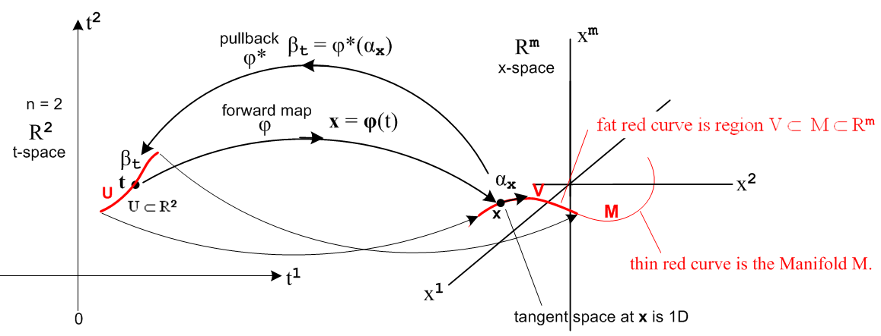
(10.12.22)

Now the simple 1-cube in R1 t-space is replaced by a general curve U in R2, but we are still mapping a curve U to a curve V. We go through the steps above:

αx = Σi fi(x) xλi = Σi fi(x) dxi . (10.12.2)

∫φ αx = ∫V Σi fi(x) dxi = integral of a 1-form over a piece of the curve V in Rm . (10.12.3)

First definition:

∫V αx ≡ ∫U φ*(αx)

= the integral in t-space of the pullback of αx over the curve U in R2 (10.12.23)

We then compute the pullback of φ*(αx) of αx :

αx = Σi fi(x) xλi = Σi fi(x) dxi = f(x) • dx , dx ≡ (dx1, dx2, .... dxm)

φ*(αx) = Σi=1m φ*(fi(x)) φ*(dxi) // (10.9.5) item 3

= Σi=1m fi(φ(t)) Σj=12 Rij dtj // (10.9.5) items 1 and 5

= Σi Σj fi(φ(t)) [∂φi(t)/∂tj] dtj

= Σj gj(t) dtj

= g(t) • dt (10.12.24)
where

gj(t) ≡ Σi fi(φ(t)) [∂φi(t)/∂tj] = Σi fi(φ(t)) ∂jφi(t) = f(φ(t)) • (∂jφ) . (10.12.25)

Second definition:

∫U gj(t) tλj = ∫U g(t) • dt = ∫U g(t) • dt . (10.12.26)

Assembling the pieces,

∫V αx = ∫V f(x) • dx = ∫U φ*(αx) = ∫U g(t) • dt = ∫U g(t) • dt . (10.12.27)

When one curve is mapped into another by x = φ(t), this result shows how to reduce the integral of the 1-form αx to a calculus line integral in t-space. In effect, the line integral ∫V f(x) • dx in x-space is replaced by the line integral ∫U g(t) • dt in t-space.

*********************** END ********************************

OLD STUFF

(b) Integration of a 2-form

For the moment we set m = 3 and consider this 2-form in x-space R3 ,

α = Σ'I fI(x) xλ^I = Σ'I fI(x) dx^I = Σ1≤i$_{1}$<i$_{2}$≤3 fi$_{1}$i$_{2}$(x) dxi$_{1}$ ^ dxi$_{2}$

= f12(x) dx1 ^ dx2 + f13(x) dx1 ^ dx3 + f23(x) dx2 ^ dx3 .

We wish to define a meaning for the integration of this 2-form α over a piece of the surface x = φ(t),

∫φ α = ∫φ Σ'I fI(x) dxi$_{1}$ ^ dxi$_{2}$ = integral of a 2-form over the surface φ in R3 .

The transformation x = φ(t) is a mapping φ: (t1,t2) → R3. Officially it is the mapping φ which is the "surface", but we loosely refer to the image (trace) of this mapping in R3 as "the surface". The distinction is necessary because many mappings can have the same image surface, such as φ(t1,t2) and φ(t12,t22) where the parameters are respeeded (see Comment above). So imagine that we have a 2D surface hanging in R3 and as t1 and t2 vary (each perhaps from 0 to 1 in t-space), we move around on the image surface in R3. The problem is how to integrate a 2-form over this surface.

We can define the calculational meaning of the above integral in two steps, each being a definition:

First definition:

∫φ α ≡ ∫[0,1]2 φ*(α) = the integral in t-space of the pullback of α over the 2-cube [0,1]2

On the left we have an integral of the 2-form α over a surface φ in R3.
On the right we have an integral of a different 2-form φ*(α) (the pullback of α) over a 2-cube [0,1]2.
Note that α lies in xΛ2(R3) while φ*(α) lies in tΛ2(R2).
Since our usual mapping is φ* : xΛ1(Rm) → tΛ1(Rn) we have m = 3 and n = 2.

The "tall" m x n R-matrix for this problem is then a 3 x 2 matrix,
Rij = (Dφ)ij = ∂φi/∂tj = ∂jφi i = 1,2,3 j = 1,2 R = $\left(\begin{matrix}∂1φ1 & ∂2φ1 \\ ∂1φ2 & ∂2φ2 \\ ∂1φ3 & ∂2φ3\end{matrix}\right)$.
We then compute the pullback of α,

α = Σ1≤i$_{1}$<i$_{2}$≤3 fi$_{1}$i$_{2}$(x) xλ^I = Σ1≤i$_{1}$<i$_{2}$≤3 fi$_{1}$i$_{2}$(x) dxi$_{1}$ ^ dxi$_{2}$

φ*(α) = Σ1≤i$_{1}$<i$_{2}$≤3 φ*(fi$_{1}$i$_{2}$(x)) φ*(dxi$_{1}$ ^ dxi$_{2}$) // (10.9.6) item 3
= Σ1≤i$_{1}$<i$_{2}$≤3 fi$_{1}$i$_{2}$(φ(t)) Σ1≤j$_{1}$<j$_{2}$≤2 det $_{1}$$_{1}$$_{1}$$_{2}$$_{2}$$_{1}$$_{2}$$_{2}$ dtj$_{1}$ ^ dtj$_{2}$ // (10.9.16)
= Σ1≤i$_{1}$<i$_{2}$≤3 fi$_{1}$i$_{2}$(φ(t)) det $_{1}$$_{1}$$_{2}$$_{2}$ dt1 ^ dt2 // only one term in Σ1≤j$_{1}$<j$_{2}$≤2

= Σ1≤i$_{1}$<i$_{2}$≤3 fi$_{1}$i$_{2}$(φ(t)) det $_{1}$$_{1}$$_{2}$$_{2}$ dt1 ^ dt2 // more compact notation
// these determinants are the 2x2 minors of the matrix R shown above

= Σ1≤i$_{1}$<i$_{2}$≤3 fi$_{1}$i$_{2}$(φ(t)) $_{1}$$_{2}$ dt1 ^ dt2 // Jacobian notation for determinants

= Σ1≤i$_{1}$<i$_{2}$≤3 [ fi$_{1}$i$_{2}$(φ(t)) $_{1}$$_{2}$] dt1 ^ dt2

= Σ1≤i$_{1}$<i$_{2}$≤3 gi$_{1}$i$_{2}$(t) dt1 ^ dt2

where

gi$_{1}$i$_{2}$(t) = fi$_{1}$i$_{2}$(φ(t)) $_{1}$$_{2}$.

Since in this example there are so few terms (namely three) in the sum Σ1≤i$_{1}$<i$_{2}$≤3 , we just write them out

φ*(α) = [ f12(φ(t)) $\frac{∂(φ1,φ2)}{∂(t1,t2)}$ + f13(φ(t)) $\frac{∂(φ1,φ3)}{∂(t1,t2)}$ + f23(φ(t)) $\frac{∂(φ2,φ3)}{∂(t1,t2)}$] dt1 ^ dt2

= G(t) dt1 ^ dt2
where

G(t) ≡ [ f12(φ(t)) $\frac{∂(φ1,φ2)}{∂(t1,t2)}$ + f13(φ(t)) $\frac{∂(φ1,φ3)}{∂(t1,t2)}$ + f23(φ(t)) $\frac{∂(φ2,φ3)}{∂(t1,t2)}$] .

The pullback φ*(α) = G(t) dt1 ^ dt2 is a 2-form in dual t-space tΛ2(R2).

Using the definition given above, we then have

∫φ α ≡ ∫[0,1]2 φ*(α) = ∫[0,1]2 G(t) dt1 ^ dt2 .

Thus the integral of the 2-form α over the surface φ in x-space is defined to be equal to the integral of the 2-form g(t) dt1 ^ dt2 over a 2-cube in t-space. So far no regular calculus integrals have appeared.

Second definition:

∫[0,1]2 g(t) tλ1 ^tλ2 = ∫[0,1]2 G(t) dt1 ^ dt2 ≡ $^{\int_{0}^{1}{}}$$^{\int_{0}^{1}{}}$ G(t1,t2) dt1dt2 .

and now we have an ordinary calculus double integral which evaluates to a real number.

Comment on orientation

Orientation of the domain surface is a tricky business in a k-form integral but can at worst cause confusion about the sign of the result. To make things more "visible", suppose [a,b] = [c,d] = [1,0]. In t-space R2, if [a,b] = (b-a)1 = 1 and [c,d] = (d-c)2= 2, then the 2-cube (unit square) integration domain [0,1]2 can be regarded as being 1 ^ 2 . Recall from the discussion near (4.3.14) that one can regard A ^ B as connected with the signed area of a parallelogram (2-piped), so A ^ B is associated with the area of the front side and B ^ A with the area of the back side, akin to the cross product situation A x B, and these two area have the same magnitude but opposite sign. So we can regard,

∫1 x 2 1 = 1 area of the front side of a unit square is 1 area unit
∫2 x 1 1 = -1 area of the back side of a unit square is -1 are unit

The integral appearing above is this

∫[0,1]2 G(t) dt1 ^ dt2 = ∫1 x 2 G(t) dt1 ^ dt2 = $^{\int_{0}^{1}{}}$$^{\int_{0}^{1}{}}$ G(t1,t2) dt1dt2 .

Now consider

∫1 x 2 G(t) dt1 ^ dt2 = ∫1 x 2 [- G(t) dt2 ^ dt1] = – ∫1 x 2 G(t) dt2 ^ dt1

∫2 x 1 G(t) dt1 ^ dt2 = [- ∫1 x 2] G(t) dt2 ^ dt1 = – ∫1 x 2 G(t) dt2 ^ dt1

In both these equations a minus sign is generated. In the first the minus sign arises because the 2-form called G(t) dt2 ^ dt1 is the negative of the different 2-form called G(t) dt2 ^ dt1. In the second equation the integration domain 1 ^ 2 refers to the front side of the unit square, while 2 x 1 refers to the back side of the unit square, and these domains differ by a minus sign. If both changes are made at once one gets

∫1 x 2 G(t) dt1 ^ dt2 = + ∫2 x 1 G(t) dt2 ^ dt1

If the integration domain is written simply as [0,1]2, one ends up with

∫[0,1]2 G(t) dt1 ^ dt2 = + ∫[0,1]2 G(t) dt2 ^ dt1

and this seems to be a contradiction since everyone knows that dt2 ^ dt1 = - dt1 ^ dt2 . The issue here is that the two [0,1]2 domains are not the same, they just look the same. See Sjamaar's page 64 Remark 5 where he treats the domain 2 ^ 1 as a "respeeding" (reparametrization) of the domain 1 ^ 2 which reverses the orientation of that domain.

Further processing:

Using the Hodge correspondence suggested in (4.3.17) we define three new function names Fi

f12 ≡ F3
f23 ≡ F1
f13 ≡ - F2

with a minus in the last line since f13 is in anticyclic order compared to (4.3.17). Then ** becomes

∫φ α = $^{\int_{0}^{1}{}}$$^{\int_{0}^{1}{}}$[ F3(φ(t)) $\frac{∂(φ1,φ2)}{∂(t1,t2)}$ – F2(φ(t)) $\frac{∂(φ1,φ3)}{∂(t1,t2)}$ + F1(φ(t)) $\frac{∂(φ2,φ3)}{∂(t1,t2)}$] dt1dt2

= $^{\int_{0}^{1}{}}$$^{\int_{0}^{1}{}}$[ F1(φ(t)) $\frac{∂(φ2,φ3)}{∂(t1,t2)}$ – F2(φ(t)) $\frac{∂(φ1,φ3)}{∂(t1,t2)}$ + F3(φ(t)) $\frac{∂(φ1,φ2)}{∂(t1,t2)}$] dt1dt2

= $^{\int_{0}^{1}{}}$$^{\int_{0}^{1}{}}$[ F1(φ(t)) $\frac{∂(φ2,φ3)}{∂(t1,t2)}$ + F2(φ(t)) $\frac{∂(φ3,φ1)}{∂(t1,t2)}$ + F3(φ(t)) $\frac{∂(φ1,φ2)}{∂(t1,t2)}$] dt1dt2

= $^{\int_{0}^{1}{}}$$^{\int_{0}^{1}{}}$ F(φ(t)) • n(t) dt1dt2 = $^{\int_{0}^{1}{}}$$^{\int_{0}^{1}{}}$ F(φ(t)) • [ n(t) dt1dt2]

= $^{\int_{0}^{1}{}}$$^{\int_{0}^{1}{}}$ F(φ(t)) • dA

where n below is a vector normal to the surface in R3 at point x = φ(t),

n(t) ≡ ( $\frac{∂(φ2,φ3)}{∂(t1,t2)}$, $\frac{∂(φ3,φ1)}{∂(t1,t2)}$, $\frac{∂(φ1,φ2)}{∂(t1,t2)}$) dA ≡ n(t) dt1dt2 // Buck p 335, 403

That n really is a normal vector can be verified by showing that n • xuj = 0 for any tangent base vector xuj in the tangent space TxM, where from (E.2) (xuj)i = Rij = ∂jφi , see Buck p 336.

If we forward map a tiny rectangle of area dt1dt2 at t in t-space to the surface in x-space, it maps into a tiny oriented area dA at x on the surface which has normal n and area |dA| = |n| dt1dt2 .

Going back to the original 2-form α we can write

α = Σ1≤i$_{1}$<i$_{2}$≤3 fi$_{1}$i$_{2}$(x) dxi$_{1}$ ^ dxi$_{2}$

= f12(x) dx1 ^ dx2 + f13(x) dx1 ^ dx3 + f23(x) dx2 ^ dx3

= F1(x) dx2 ^ dx3 + F2(x) dx3 ^ dx1 + F3(x) dx1 ^ dx2

= F1(x) dS1 + F2(x) dS2 + F3(x) dS3

= F(x) • dS // dS1 = *dx1 etc, so can say dS = *dx

where in cyclic order we define the following differential area 2-forms

dS1 ≡ dx2 ^ dx3 dS2 ≡ dx3 ^ dx1 dS3 ≡ dx1 ^ dx2

Then our conclusion from the above can be concisely written,

∫φ α = ∫φ F(x) • dS = $^{\int_{0}^{1}{}}$$^{\int_{0}^{1}{}}$ F(φ(t)) • dA where dA ≡ n(t) dt1dt2 .

Normally this is written

"∫φ F(x) • dS " = $^{\int_{0}^{1}{}}$$^{\int_{0}^{1}{}}$ F(φ(t)) • n(t) dt1dt2

where the operational meaning of the object on the left is given by the calculus integral on the right. The object on the left is called "the surface integral of a vector field F(x) over a surface φ".

Generalization to Rm

If the 2D surface lies in Rm instead of R3, the above results are easily generalized. The 2-form α is then,

α = Σ1≤i$_{1}$<i$_{2}$≤m fi$_{1}$i$_{2}$(x) xλ^I = Σ1≤i$_{1}$<i$_{2}$≤m fi$_{1}$i$_{2}$(x) dxi$_{1}$ ^ dxi$_{2}$ = Σ'I fI(x) dx^I

where there are $\left(\begin{matrix}m \\ 2\end{matrix}\right)$ terms in the ordered sum Σ'I. The pullback also has $\left(\begin{matrix}m \\ 2\end{matrix}\right)$ terms, being

φ*(α) = Σ1≤i$_{1}$<i$_{2}$≤m fi$_{1}$i$_{2}$(φ(t)) $_{1}$$_{2}$ dt1 ^ dt2

= Σ1≤i$_{1}$<i$_{2}$≤m gi$_{1}$i$_{2}$(t) dt1 ^ dt2 gi$_{1}$i$_{2}$(t) = fi$_{1}$i$_{2}$(φ(t)) $_{1}$$_{2}$

= G(t) dt1 ^ dt2 G(t) = Σ1≤i$_{1}$<i$_{2}$≤m fi$_{1}$i$_{2}$(φ(t)) $_{1}$$_{2}$.

The pullback φ*(α) = G(t) dt1 ^ dt2 is still a 2-form in dual t-space tΛ2(R2). Then

∫φ α ≡ ∫[0,1]2 φ*(α) = ∫[0,1]2 G(t) dt1 ^ dt2 ≡ $^{\int_{0}^{1}{}}$$^{\int_{0}^{1}{}}$ G(t1,t2) dt1dt2

Here G(t) is a sum of $\left(\begin{matrix}m \\ 2\end{matrix}\right)$ terms each of which is a 2x2 Jacobian weighted by a function fi$_{1}$i$_{2}$.

(c) Integration of a k-form

The k-form of interest is

α = Σ'I fI(x) xλ^I = Σ'I fI(x) dx^I = Σ'I fi$_{1}$i$_{2}$...i$_{k}$(x) dxi$_{1}$ ^ dxi$_{2}$ ^ ...^ dxi$_{k}$

We wish to define a meaning for the integration of this k-form α over a piece of the surface x = φ(t),

∫φ α = ∫φ Σ'I fI(x) dx^I = integral of a k-form over the surface of dimension n in Rm .

Since the surface is embedded in Rm we have n ≤ m. The k-form has k ≤ n, although in our previous examples we had k = n. For example, in Example (b) one could map a line segment in R2 to a curve in Rm which would lie on the surface in Rm of that example. This is illustrated here in red,

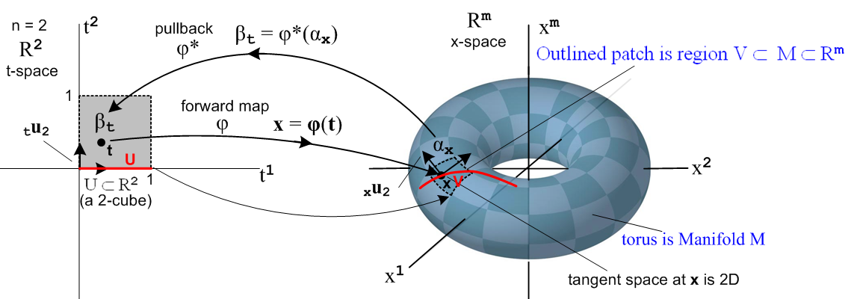

where now αx = Σi fi(x) dxi is a 1-form. If we agree to place the red line segment in t-space on the t1 axis as shown, then this situation is really no different from Example (a) where t2 can be ignored. For this reason, we limit our interest to k = n ≤ m.

The transformation x = φ(t) is a mapping φ: (t1,t2,..tk) → R3. Officially it is the mapping φ which is the "surface", but we loosely refer to the image (trace) of this mapping in Rm as "the surface". The distinction is necessary because many mappings can have the same image, such as φ(t1,t2, ...) and φ(t12,t22, ...) where the parameters are respeeded (see Comment above). So imagine that we have an n-dimensional surface hanging in Rm and as t1 ... tn vary (each perhaps from 0 to 1 in t-space), we move around on the image surface in Rm. The problem is how to integrate a k-form over this surface.

We can define the calculational meaning of the above integral in two steps, each being a definition:

First definition: k = n

∫φ α ≡ ∫[0,1]k φ*(α) = the integral in t-space of the pullback of α over the k-cube [0,1]k

On the left of this equation we have an integral of the k-form α over a surface φ in Rm.
On the right we have an integral of a different 2-form φ*(α) (the pullback of α) over a k-cube [0,1]k in Rn.
Note that α lies in xΛk(Rm) while φ*(α) lies in tΛk(Rn) [ n = k ]
Our usual mapping is φ* : xΛk(Rm) → tΛk(Rn) with m ≥ n.

The "tall" m x n R-matrix for this problem is then a general m x n matrix,

Rij = (Dφ)ij = ∂φi/∂tj = ∂jφi i = 1,2,3..m j = 1,2..n

We then compute the pullback of α,

α = Σ1≤i$_{1}$<i$_{2}$≤..<i$_{k}$≤m fi$_{1}$i$_{2}$...i$_{k}$(x) dxi$_{1}$ ^ dxi$_{2}$ ^ ...^ dxi$_{k}$

= Σ'I fI(x) dx^I

φ*(α) = Σ'I φ*(fI(x)) φ*(dx^I) // (10.9.6) item 3

= Σ'I fI(φ(t)) ΣJ RIJ dt^J // (10.9.6) items 1 and 4

= Σ'I fI(φ(t)) Σ'J det(RIJ(t)) dt^J // (10.9.12) R = (Dφ(t))

= Σ'J [Σ'I fI(φ(t)) det(RIJ(t)) ] dt^J

= Σ'J gJ(t) dt^J = Σ'J gJ(t) dtj$_{1}$ ^ dtj$_{2}$ ^ ...^ dtj$_{k}$
where

gJ(t) ≡ Σ'I fI(φ(t)) det(RIJ(t)) .

The pullback φ*(α) = Σ'J gJ(t) dt^J is a k-form in dual t-space tΛk(Rn).

Using the definition given above, we then have

∫φ α ≡ ∫[0,1]k φ*(α) = ∫[0,1]k Σ'J gJ(t) dt^J .

Thus the integral of the k-form α over the surface φ in x-space is defined to be equal to the integral of the k-form Σ'J gJ(t) dt^J over a k-cube in t-space. So far no regular calculus integrals have appeared.

Second definition:

∫[0,1]k Σ'J gJ(t) tλ^J = ∫[0,1]k Σ'J gJ(t) dtj$_{1}$ ^ dtj$_{2}$ ^ ...^ dtj$_{k}$

≡ ($^{\int_{0}^{1}{}}$$^{\int_{0}^{1}{}}$ ..... $^{\int_{0}^{1}{}}$) Σ'J gJ(t) dtj$_{1}$dtj$_{2}$....dtj$_{k}$ .

On the left is the integral of a k-form over a k-cube, on the right is an ordinary calculus k-fold integral of a function over the unit cube in k dimensions. It is this second definition that motivates giving the dual space basis vectors tλi the cosmetic names dti. We have then shown that

∫φ α = ∫[0,1]k Σ'J gJ(t) dtj$_{1}$ ^ dtj$_{2}$ ^ ...^ dtj$_{k}$

= ($^{\int_{0}^{1}{}}$$^{\int_{0}^{1}{}}$ ..... $^{\int_{0}^{1}{}}$) Σ'J Σ'I fI(φ(t)) det(RIJ(t))dtj$_{1}$dtj$_{2}$....dtj$_{k}$

= Σ'I Σ'J ($^{\int_{0}^{1}{}}$$^{\int_{0}^{1}{}}$ ..... $^{\int_{0}^{1}{}}$) fI(φ(t)) det(RIJ(t)) dtj$_{1}$dtj$_{2}$....dtj$_{k}$ R= (Dφ)

ok to here. I am not happy with the integral of a form suddenly being a real number, but it may be related to how the dα operation turns a real thing into a form, bumping up the rank 1.

Note that dt1 ^ dt2 is in standard increasing order. For the integral against dt2 ^ dt1 = - dt1 ^ dt2 one gets the area of the "back side" of the surface, regarded as the negative of the area of the "front side". See Sjamaar Ch 8 and Buck Ch 6 for discussions of orientation of surfaces in various dimensions.

