Section 10.6 PhL 3.6.16

1. Material on 10.6 from this doc was installed into wedge doc on 4/10/16 and then deleted from here.

2. Valid material still exists in this doc for use in Section 10.7 or later, but 10.7 is developed now in a new doc of that name so that material was also deleted from below.

DO NOT EDIT THIS DOC, it is frozen.

older:
I will edit here to make a clean version that works for non-square R matrix.
This is version 8, derived from version 6.

10.8 Change of variable and function names 2
10.9 Properties of the pullback function φ* 9
10.9 More relationships 14
10.9 The pullback of a general differential k-form 14
(a) The dual-space pullback equation for a k-form 16
(b) The tensor-function pullback equation for a k-form 20

**************************************************
In this new notation we write,

F*(λ'i) ≡ <e'i| F* = <e'i| R = Rij<uj| = Rijλj
F*(dx'i) ≡ <e'i| F* = <e'i| R = Rij<uj| = Rijdxj (10.7.17)
so
F*(λ'i) = Rij λj = (DF)ijλj
F*(dx'i) = Rij dxj = (DF)ij dxj (10.7.18)
This then is a very simple example of pulling back a differential 1-form from dual x'-space to dual x-space.

We can "close" the functional above with some arbitrary vector |v> (evaluate the functional at v) in x-space to get

[F*(λ'i)](v) ≡ <e'i| F* | v> = <e'i| R | v> = <e'i| R*1 | v> = <e'i| R |uj><uj | v>
= Rij λj(v) = Rij vj = [Rv]i = <ui |Rv> = λi(Rv)
so
[F*(λ'i)](v) = λi(Rv)
[F*(dx'i)](v) = dxi(Rv) (10.7.19)

and in this way we have pulled back a rank-1 basis-vector tensor function from Λ1f(Rm) to Λ1f(Rn) .

For a general rank-1 functional αx' in dual x'-space we would write, as in (2.11.c.7),

αx' = Σi=1m αi λ'i αx' ϵ Λ1(Rm)
αx' = Σi=1m αi dx'i αx' ϵ Λ1(Rm) (10.7.20)

βx ≡ F*(αx') = ΣiαiF*(λ'i) = Σiαi Rijλj = Σiαi (DF)ijλj βx ϵ Λ1(Rn)
βx ≡ F*(αx') = ΣiαiF*(dx'i) = Σiαi Rijdxi = Σiαi (DF)ijdxi βx ϵ Λ1(Rn) (10.7.21)

Comment: It might be logical to use symbol αx in place of βx, but we retain βx just to emphasize that the differential forms αx' and βx = F*(αx') are totally different forms living in totally different spaces. The symbols αx' and αx are so similar, it seems one could just replace x' by x to get from one to the other.

In terms of tensor functions, we evaluate (10.7.21) at location v to get

[F*(αx')](v) = Σiαi Rijλj(v) = Σiαi Rij vj = Σiαi [Rv]j = αx'(Rv) . (10.7.22)

In Dirac notation we write the above line as

[F*(αx')](v) = <αx'| F* | v > = <αx'| R | v > = <αx'| Rv > = αx'(Rv) . (10.7.23)

Sometimes one sees the pullback function F* defined by the above tensor function equation,

[F*(αx')](v) ≡ αx'(Rv) (10.7.24)

but we feel that our definition of F* as shown above is more fundamental, directly making the connection F* = R where R is the Dirac Hilbert Space operator whose matrix elements Rij = <e'i | R | uj> form the "tall" differential R matrix of the underlying transformation x' = F(x).

10.8 Change of variable and function names

We are now going to make a painful change of variable and function names to get our results into a more standard form found in the differential forms literature. It is a bit painful and requires some new notations for basis vectors, but it must be done at some point. We change then from Picture A' to Picture F' where, unfortunately, there is both an old x-space and a new x-space and they are not the same.

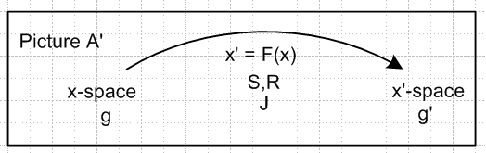

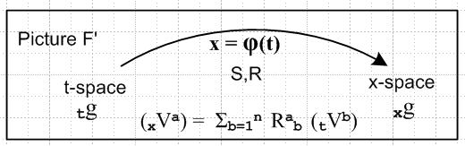 (10.8.1)

The underlying function name F is changed to φ but the transformation differentials are still called R and S. Here is the translation dictionary:

x-space → t-space
x'-space → x-space

F → φ
x' = F(x) → x = φ(t) general transformation
R,S → R,S differential matrices (no change in name)
F* → φ* pullback operator
F* → φ* pullback function

V → tV vector in t-space
V' → xV vector in x-space

e → te tangent base vectors in t-space
u → tu axis-aligned basis vectors in t-space
g → tg metric tensor in t-space

u' → xu tangent base vectors in x-space
e' → xe axis-aligned basis vectors in x-space
g' → xg metric tensor in x-space (10.8.2)

We try to stay somewhat consistent with the previous notation and this requires that the axis-aligned basis vectors be called tu in t-space, but xe in x-space. Please refer to the above table if there is confusion.

Here is the translated kinematics package (10.6.a.1) with item (i) adjusted for the "tall R matrix" situation m > n:

(a) x = φ(t) xform Rij ≡ (∂xi/∂tj) = ∂j(t)xi R = (Dφ)
xV = R tV vector Sij ≡ (∂ti/∂xj) = ∂j(x)ti

(b) xei with (xei)j = δij axis-aligned basis vectors in x-space (i = 1..m)
tei tei = S xei tangent base vectors in x-space (i = 1..n)

(c) tui with (tui)j = δij axis-aligned basis vectors in t-space (i = 1..n)
xui xui= R tui tangent base vectors in t-space (i = 1..n)
(xui)j = Rjk (tui)k

(d) x1 = | xei> <xei| = | xei> <xei| = | xui> <xui| = | xui> <xui| completeness in x-space
t1 = | tei> <tei| = | tei> <tei| = | tui> <tui| = | tui> <tui| completeness in t-space

(e) (tuj)i = tui • tuj = <tui | tuj > = tgij = xui • xuj = <xui | xuj >
(tej)i = tui • tej = <tui | tej > = Sij = Rji
(xej)i = xei • xej = <xei | xej > = xgij = tei • tej = <tei | tej >
(xuj)i = xei • xuj = <xei | xuj > = Rij = Sji

(f) tei = xgij tej xei = xgij xej tui = tgij tuj xui = tgij xuj
tei = xgij tej xei = xgij xej tui = tgij tuj xui = tgij xuj

(g) <tej | S | xei> = <xei | R | tej> = xgij
<tej | S | xui> = <xui | R | tej> = Sij = Rji
<tuj | S | xei> = <xei | R | tuj> = Rij = Sji
<tuj | S | xui> = <xui | R | tuj> = tgij .

(h) S = RT Sij = (RT)ij = Rji
R = ST Rij = (ST)ij = Sji

(i) SR = 1 SST = RTR = 1 (10.6.a.1), (10.6.d.1) (10.8.3)

Next is the uniqueness table translated from (10.6.d.2):

Metric tensors
tgij, tgij unique
xgij unique, since xgij = RiaRjb tgab
xgij not unique, since xgij = RiaRjb tgab = SaiSbj tgab and Sij not unique

Transformation matrices
Rij = Sji unique (tall R matrix from x' = F(x))
Rij = Sji unique since Rij = tgjaRia and both tgja and Ria are unique
Rji = Sij not unique, see (10.6.c.3)
Rij = Sji not unique, since Rij = xgia Raj and xgia not unique

Axis-aligned basis vectors
(tuj)i unique since (tuj)i = tgji (xej)i unique since (xej)i = xgij (= δij)
(tuj)i unique since (tuj)i = tgji (xej)i not unique since (xej)i = xgij
(tuj)i unique since (tuj)i = tgji (xej)i unique since (xej)i = xgij
(tuj)i unique since (tuj)i = tgji (xej)i unique since (xej)i = xgij

Tangent base vectors
(tej)i not unique since (tej)i = Rji (xuj)i unique since (xuj)i = Rij
(tej)i not unique since (tej)i = Rji (xuj)i not unique since (xuj)i = Rij
(tej)i unique since (tej)i = Rji (xuj)i unique since (xuj)i = Rij
(tej)i unique since (tej)i = Rji (xuj)i not unique since (xuj)i = Rij

(10.6.d.2) (10.8.4)
We now translate most earlier results into the new notation:

{tui} i = 1,2...n basis for t-space , axis-aligned
(tui)j = δij components of these basis vectors in t-space . (10.6.e.1) (10.8.5)

xui = (10.6.e.4) (10.8.6)

R** = [xu1, xu2 ....xun] R has full rank n ⇒ basis for TxM complete (10.6.e.5) (10.8.7)

Non-Dual

xui = R tui |xui> = R |tui> i = 1,2..n push forward (10.7.1) (10.8.8)
tui = S xui |tui> = S |xui> i = 1,2..n pull back (10.7.2) (10.8.9)

xui = R tui |xui> = R |tui> i = 1,2..n push forward
tui = RT xui |tui> = RT |xui> i = 1,2..n pull back (10.7.4) (10.8.10)

xei = R tei |xei> = R |tei> i = 1,2..n push forward
tei = RT xei |tei> = RT |xei> i = 1,2..n pull back (10.7.5) (10.8.11)

Dual

(xui)T= (tui)T RT <xui| = <tui|RT i = 1,2..n push forward
(tu)T = (xu)T R <tui| = <xu|R i = 1,2..n pull back (10.7.6) (10.8.12)

(xei)T= (tei)T RT <xei| = <tei|RT i = 1,2..n push forward
(tei)T = (xei)T R <tei| = <xei|R i = 1,2..n pull back (10.7.7) (10.8.13)

<xei| φ* = <xei| R = Rij<tuj| pullback operator φ* = R

<xui| φ* = <xui| R = <tui| (10.7.9) (10.8.14)

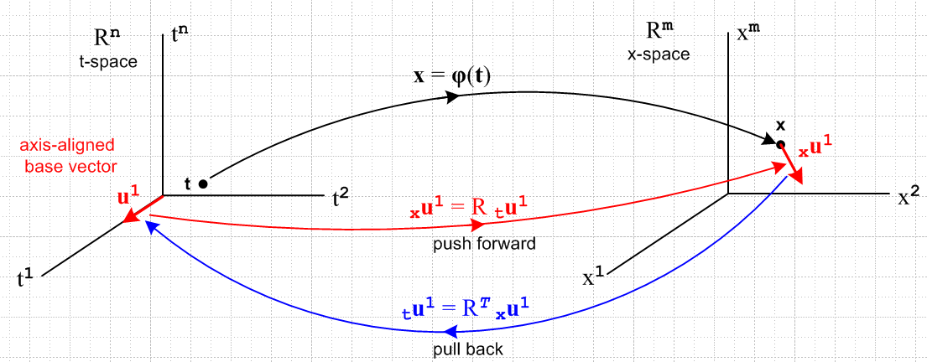
(10.7.11) (10.8.15)

We now translate equations (10.7.12) through (10.7.20) to the new notation:

tλi ≡ <tui| = basis functional in dual t-space ϵ Λ1(Rn) i = 1..n
xλi ≡ <xei| = basis functional in dual x-space ϵ Λ1(Rm) i = 1..m (10.7.12) (10.8.16)

<xei| φ* = xλiφ* = <xei| R = xλiR = Rij<tuj| . (10.7.13) (10.8.17)

φ*(<xa| ) ≡ <xa| φ* = <xa| R . pull back a dual vector φ* ≡ R (10.7.14) (10.8.18)

φ*(<xei| ) = φ*(xλi ) = <xei| φ* = Rij<tuj| = Rij tλi (10.7.15) (10.8.19)

φ* : Λ1(Rm) → Λ1(Rn) . R = (Dφ) (10.7.16) (10.8.20)

φ*(xλi) ≡ <xei| φ* = <xei| R = Rij<tuj| = Rij tλj
φ*(dxi) ≡ <xei| φ* = <xei| R = Rij<tuj| = Rij dtj (10.7.17) (10.8.21)
so
φ*(xλi) = Rij tλj = (Dφ)ij tλj pullback of a simple 1-form
φ*(dxi) = Rij dtj = (Dφ)ij dtj cosmetic form (10.7.18) (10.8.22)

[φ*(xλi)](v) = tλi(Rv) tensor function forms of previous line
[φ*(dxi)](v) = dti(Rv) (10.7.19) (10.8.23)

αx = Σi=1m αi(x) xλi αx ϵ Λ1(Rm) general 1-form
αx = Σi=1m αi(x) dxi αx ϵ Λ1(Rm) general 1-form (10.7.20) (10.8.24)

βt ≡ φ*(αx) = Σiαi φ*(xλi) = Σiαi Rij tλj = Σiαi (Dφ)ij tλj
βt ≡ φ*(αx) = Σiαiφ*(dxi) = Σiαi Rij dti = Σiαi (Dφ)ij dti (10.7.21) (10.7.25) ok to here

[φ*(αx)](v) = αx(Rv) tensor function form of 1-form pullback (10.7.24) (10.8.26)

10.9 Pullback of k-forms

We wish now to study the "push forward" of basis functions in Vk (Chapter 5)

xeJ ≡ xej$_{1}$⊗ xej$_{2}$⊗ .....⊗ xej$_{k}$ |xeJ> ≡ |xej$_{1}$>⊗ |xej$_{2}$>⊗ .....⊗ |xej$_{k}$>
teJ ≡ tej$_{1}$⊗ tej$_{2}$⊗ .....⊗ tej$_{k}$ |teJ> ≡ |tej$_{1}$>⊗ |tej$_{2}$>⊗ .....⊗ |tej$_{k}$>

R |teJ> = R |tej$_{1}$> ⊗ R |tej$_{2}$> ⊗ .....⊗ R |tej$_{k}$> // (5.6.17)
= |xej$_{1}$> ⊗ |xej$_{2}$> ⊗ ..... ⊗ |xej$_{k}$> // (10.8.11)
= |xeJ> .

Repeating this for the non-dual wedge space Lk (Chapter 7)

xe^J ≡ xej$_{1}$^ xej$_{2}$^ .....^ xej$_{k}$ |xe^J> ≡ |xej$_{1}$> ^ |xej$_{2}$> ^ .....^ |xej$_{k}$>
te^J ≡ tej$_{1}$^ tej$_{2}$^ .....^ tej$_{k}$ |te^J> ≡ |tej$_{1}$> ^ |tej$_{2}$> ^ .....^ |tej$_{k}$>

R |te^J> = R |tej$_{1}$> ^ R |tej$_{2}$> ^ .....^ R |tej$_{k}$> // (7.9.d.15)
= |xej$_{1}$> ^ |xej$_{2}$> ^ ..... ^ |xej$_{k}$> // (10.8.11)
= |xe^J> .

Next we do the push forwards for the tensor product dual space V*k (Chapter 6)

xλJ ≡ xλj$_{1}$⊗ xλj$_{2}$⊗ .....⊗ xλj$_{k}$ <xeJ| ≡ <xej$_{1}$| ⊗ <xej$_{2}$| ⊗ .....⊗ <xej$_{k}$|
tλJ ≡ tλj$_{1}$⊗ tλj$_{2}$⊗ .....⊗ tλj$_{k}$ <teJ| ≡ <tej$_{1}$| ⊗ <tej$_{2}$| ⊗ .....⊗ <tej$_{k}$|

<teJ| RT ≡ <tej$_{1}$|RT ⊗ <tej$_{2}$|RT ⊗ .....⊗ <tej$_{k}$|RT // (6.6.18)
= <xej$_{1}$| ⊗ <xej$_{2}$| ⊗ ..... ⊗ <xej$_{k}$| // (10.8.13)
= <xeJ| .

and finally for the wedge product dual space Λk (Chapter 8)

xλ^J ≡ xλj$_{1}$ ^ xλj$_{2}$ ^ .....^ xλj$_{k}$ <xe^J| ≡ <xej$_{1}$| ^ <xej$_{2}$| ^ .....^ <xej$_{k}$|
tλ^J ≡ tλj$_{1}$ ^ tλj$_{2}$ ^ .....^ tλj$_{k}$ <te^J| ≡ <tej$_{1}$| ^ <tej$_{2}$| ^ .....^ <tej$_{k}$|

<te^J| RT ≡ <tej$_{1}$|RT ^ <tej$_{2}$|RT ^ .....^ <tej$_{k}$|RT // (6.6.18)
= <xej$_{1}$| ^ <xej$_{2}$| ^ ..... ^ <xej$_{k}$| // (8.9.d.15)
= <xe^J| .

The above is WRONG because tλi ≡ <tui| . So repair here:

xλ^J ≡ xλj$_{1}$ ^ xλj$_{2}$ ^ .....^ xλj$_{k}$ <xe^J| ≡ <xej$_{1}$| ^ <xej$_{2}$| ^ .....^ <xej$_{k}$|
tλ^J ≡ tλj$_{1}$ ^ tλj$_{2}$ ^ .....^ tλj$_{k}$ <tu^J| ≡ <tuj$_{1}$| ^ <tuj$_{2}$| ^ .....^ <tuj$_{k}$|

<tu^J| RT ≡ <tuj$_{1}$|RT ^ <tuj$_{2}$|RT ^ .....^ <tuj$_{k}$|RT // (8.9.d.15)
= <xuj$_{1}$| ^ <xuj$_{2}$| ^ ..... ^ <xej$_{k}$| // (10.8.12)
= <xu^J| .

But we want the result in terms of <xe^J| and I did not write that transformation out. I would need

<tuj|RT = <tuj|RT |xei ><xei| = <tuj|S |xei ><xei| = Rij <xei|

OK, I will replace all of the above with pull backs instead of push forwards. The last is then

xλ^J ≡ xλj$_{1}$ ^ xλj$_{2}$ ^ .....^ xλj$_{k}$ <xe^J| ≡ <xej$_{1}$| ^ <xej$_{2}$| ^ .....^ <xej$_{k}$|
tλ^J ≡ tλj$_{1}$ ^ tλj$_{2}$ ^ .....^ tλj$_{k}$ <tu^J| ≡ <tuj$_{1}$| ^ <tuj$_{2}$| ^ .....^ <tuj$_{k}$|

<xe^J| φ* =

<xe^J| R ≡ <xej$_{1}$|R ^ <xej$_{2}$|R ^ .....^ <xej$_{k}$|R // (8.9.d.15)

= <xej$_{1}$|φ* ^ <xej$_{2}$|φ* ^ .....^ <xej$_{k}$|φ* // φ* ≡ R

= φ*( xλj$_{1}$) ^ φ*( xλj$_{2}$) ^ .....^ φ*( xλj$_{k}$) // (10.8.19)

= [ Rj$_{1}$i$_{1}$ tλi$_{1}$ ] ^ [ Rj$_{2}$i$_{2}$ tλi$_{2}$ ] ^ .... ^ [ Rj$_{k}$i$_{k}$ tλi$_{k}$] // (10.8.19)

= ΣI RJI ( tλi$_{1}$ ^ tλi$_{2}$ ^ .....^ tλi$_{k}$ ) // multiindex

= ΣI RJI tλ^J

= <xuj$_{1}$| ^ <xuj$_{2}$| ^ ..... ^ <xej$_{k}$| // (10.8.12)
= <xu^J| .

*******************************************************
Here then is a summary. To get the pull backs column we use the fact that RTR = t1 . Recall from (10.6.d.1) that RTR = 1 for matrices for a "tall" R matrix and this then passes to the Dirac operators.

Push forwards Pull backs Space

R |teJ> = |xeJ> |teJ> = RT|xeJ> Vk tensor product

R |te^J> = |xe^J> |te^J> = RT|xe^J> Lk wedge product

<teJ| RT = <xeJ| <teJ| = <xeJ|R V*k dual tensor product

<tu^J| RT = <xe^J| <tu^J| = <xe^J|R Λk . dual wedge product

The pullback of interest is the lower right entry in the above table, which we can write out as

<tu^J| = <tuj$_{1}$| ^ <tuj$_{2}$| ^ .....^ <tuj$_{k}$| // φ* ≡ R

= <xe^J|R = <xej$_{1}$|R ^ <xej$_{2}$|R ^ .....^ <xej$_{k}$|R

= <xe^J|φ* = <xej$_{1}$|φ* ^ <xej$_{2}$|φ* ^ .....^ <xej$_{k}$|φ*

In function notation this says that a pullback for Λk appears as

tλ^J = φ*(xλ^J) = φ*(xλj$_{1}$) ^ φ*(xλj$_{2}$) ^ .... ^ φ*(xλj$_{k}$)

or in cosmetic notation

dt^J = φ*(dx^J)

= φ*(dxj$_{1}$) ^ φ*(dxj$_{2}$) ^ .... ^ φ*(dxj$_{k}$)

= dtj$_{1}$ ^ dtj$_{2}$ ^ .... ^ dtj$_{k}$

Question: Where are the dφj$_{1}$ objects of Sjamaar? x = φ(t)

10.9 Properties of the pullback function φ*
______________________________________________________________________________

Fact: φ* is linear, so φ*(s1α + s2β) = s1(φ*α) + s2(φ*β) where α, β are both k-forms. (10.9.1)

Proof: φ*(<α| ) ≡ <α| φ* = <α| R and R is a linear operator acting on either the bra or ket space. To prove that R is a linear operator consider

<α| R = <α | xei><xei| R | tuj><tuj| = αi Rij <tuj|
so
<s1α + s2β| R = <s1α + s2β | xei><xei| R | tuj><tuj| = (s1αi+s2βi) Rij <tuj|

= s1αiRij <tuj| + s2βiRij <tuj| = s1<α| R + s2<β| R

Then φ*(<s1α + s2β| ) = <s1α + s2β| R = s1<α| R + s2<β| R = s1φ*(α) + s2(φ*β)

Proof: φ*( s1α + s2β) = [ s1<α| + s2<β| ] φ* // Dirac notation

[ s1<α| + s2<β| ] R // φ* = R

= s1<α| R + s2<β| R // R is a linear operator

= s1<α| φ* + s2<β| φ* // name change

= s1(φ*α) + s2(φ*β) // functional form of φ* QED

Basically φ* is linear because R is linear going way back to V' = Rij Vj and dx' = R dx. R is the linearization at a point x of the generally non-linear underlying transformation x' = F(x). More specifically, <xei| R = Rij<tuj| from (10.8.17).
___________________________________________________________________________

Fact: φ*(α1 ^ α2 ^...^ αN) = φ*(α1) ^ φ*(α2) ^...^ φ*(αN) where αi is an arbitrary ki-form. (10.9.2)

Proof: φ*(α1 ^ α2 ^....^ αN) = [ <α1| ^ <α2| ^ ... ^ <αN| ] | φ* // Dirac notation

= [ <α1| φ* ^ <α2| φ* ^ ... ^ <αN| φ* ] // (8.9.d.15)

= φ*(α1) ^ φ*(α2) ^...^ φ*(αN) // functional form for φ* QED

Add something here regarding 0-forms and how they can be added to this theorem.
___________________________________________________________________________

Fact: φ*(dα) = d(φ*α) (10.9.3)

Proof: A. α = Σ'IfI(x) xλ^I // (10.2.1)

dα = Σ'I dfI(x) xλ^I = Σ'I ( Σj=1n [∂jfI(x)] xλj) ^ xλ^I // (10.3.6)

φ*(dα) = Σ'I Σj=1n [∂jfI(x)]x=φ(t) φ*(xλj ^ xλ^I) // (10.9.28) linear

= Σ'I Σj=1n [∂jfI(x)]x=φ(t) φ*(xλj) ^ φ*(xλ^I) // (10.9.29)

B. φ*α = Σ'IfI(x(t)))φ*(xλ^I) // (10.9.28) linear

d(φ*α ) = Σ'I dfI(x(t))) φ*(λ^I) // (10.3.6)

= Σ'I Σj=1n[∂jfI(x) (∂xj/∂tr)] tλr ^ φ*(λ^I) // (10.3.6)

= Σ'I Σj=1n[∂jfI(x) Rir] tλr ^ φ*(λ^I) // (10.8.3) item (a)

= Σ'I Σj=1n[∂jfI(x)] (Rir tλr) ^ φ*(λ^I) // regroup

= Σ'I Σj=1n[∂jfI(x)] φ*(xλi) ^ φ*(λ^I) // (10.8.17)

The two results are the same, so φ*(dα) = d(φ*α) . QED

Corollary: d(φ*(dα)) = 0 since this is d2(φ*α), see (10.3.12) (10.9.4)
______________________________________________________________________________

Fact: φ*(ψ*α) = (ψ o φ)* α where α is a k-form (10.9.5)

Proof: This theorem involves two mappings φ and ψ which are composed to form a third Φ :

y = ψ(x) x = φ(t) t → x → y t → y
φ ψ Φ
y = ψ(φ(t)) = [ψ o φ ](t) = Φ(t) .

In Dirac notation we denote spaces by subscripts on the bras (dual space vectors)

t<α| // start with t-space k-form
t<α| φ* = x<β| // apply φ* to get an x-space k-form
x<β| ψ* = y<κ| // then apply ψ* to get a y-space k-form

Combining these two steps to get

(t<α| φ*)ψ* = y<κ| . // normally written t<α| φ*ψ*

Instead of taking two steps, do it in one step using Φ

t<α| Φ* = y<κ| . // apply Φ* to get a y-space form directly from t<α|

Since both methods give the same y<κ| conclude that

(t<α| φ*)ψ* = t<α| Φ* = t<α| (ψ o φ)*

or in function notation,

ψ*(φ*(α)) = (ψ o φ)*(α) QED

A Chapter 1 style category diagram for this scenario would be

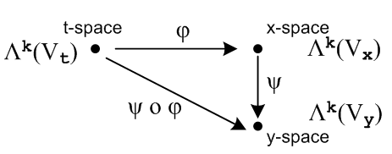
______________________________________________________________________________

Extra Stuff

I want to see φ*(xλ^I) = <xe^I | φ* = <xe^I | R appear somewhere in my writeup. With my new theorems, I know this would be

φ*xλ^I = <xe^I | R = <xe^i$_{1}$|R ^ <xe^i$_{2}$|R ^ .....

= φ*xλ^i$_{1}$ ^ φ*xλ^i$_{2}$ ^ ......

= (Ri1j1 tλj1) ^ (Ri2j2 tλj2) ^ ...

= RIJ (tλj1 ^ tλj$_{2}$ ^ ..... )

= RIJ tλ^J

So there you are: really want those parens now to contain my ugly many-symbol argument

φ*(xλ^I) = ΣJ RIJ tλ^J

Now maybe he makes up this name

(Ri1j1 tλj1) = dφi1

Then you could write

φ*(xλ^I) =

I see this is just my theorem to be proven below, but I have the main idea in a Ch 7 theorem. Then

φ*(dx^I ) = φ*(dxi$_{1}$) ^ φ*(dxi$_{2}$) ^ ......

= dφi$_{1}$ ^ dφi$_{2}$ ^ ...

Why would you use this name dφi$_{1}$ for these little forms? Well we do have this

dφi$_{1}$ = φ*(dxi$_{1}$) = Ri1j1 dtj1

So the equation dφi$_{1}$ = Ri1j1 dtj1 DOES look like the calculus equation

φi(t)

dφi(t) = Rij dtj

BUT notice now that dφi(t) ≠ dxi although that would be true in calculus.

Recall the similarity mentioned in (10.3.3) and (10.3.4),

df = (∂jf(x)) dxj 1-form (10.3.3)

df = (∂jf(x)) dxj calculus (10.3.4)

Thinking of x = φ(t) we can similarly write,

dxi = dφi = (∂φi/∂tj) dtj 1-form

At the 2-form level one has

dxi$_{1}$ ^ dxi$_{2}$ = Σj$_{1}$j$_{2}$ [ (∂φi$_{1}$/∂tj$_{1}$) dtj$_{1}$] ^ [(∂φi$_{2}$/∂tj$_{2}$) dtj$_{2}$ ]

= Σj$_{1}$j$_{2}$ (∂φi$_{1}$/∂tj$_{1}$)(∂φi$_{2}$/∂tj$_{2}$) dtj$_{1}$ ^ dtj$_{2}$

= Σj$_{1}$j$_{2}$ Ri$_{1}$j$_{1}$Ri$_{2}$j$_{2}$ dtj$_{1}$ ^ dtj$_{2}$ 2-form

At the k-form level one then has

dxi$_{1}$ ^ dxi$_{2}$ ....^ dxi$_{2}$ = Σj$_{1}$Ri$_{1}$j$_{1}$Ri$_{2}$j$_{2}$ .... dtj$_{1}$ ^ dtj$_{2}$ ....^ dti$_{k}$
or
dx^I = ΣJ RIJ dt^J k-form

From Appendix A we know from the second line of (A.8.36) with I ↔ J that

Fact : ΣJ TIJ x^J = Σ'J det(TIJ) x^J if TIJ has factored form (A.8.36)

As written, the generic vector x^J is a vector in the wedge space Lk(V), but the Fact can be transposed to the dual space Λk(V) where it has the same form since the functions are real. Just replace xi = |xi> by <xi|. Then set <xi| = <xei| = xλi = dxi . The object RIJ has exactly the factored form required, so we conclude that (10.8.25) can be rewritten using the ordered sum Σ'J as

dx^I = Σ'J det(RIJ) dt^J (10.8.26)

For example,
dxi$_{1}$ ^ dxi$_{2}$ = Σ1≤j$_{1}$<j$_{2}$≤n det $_{1}$$_{1}$$_{1}$$_{2}$$_{2}$$_{1}$$_{2}$$_{2}$ dtj$_{1}$ ^ dtj$_{2}$

I think the above stuff is wrong because an x-space form cannot be a linear combination of t-space forms! The pullback action is missing here.

10.9 More relationships

10.9 The pullback of a general differential k-form

Recall from (10.8.14) the action of operator φ* = R on the bra <xei |,

<xei | φ* = <xei | R = Σj=1n Rij <tuj | i = 1,2..m . (10.8.14) (10.9.1)

Any operator P which acts on a vector space V, has a natural extension to being an operator on the tensor product space Vn , while its transpose PT has an extension acting on the dual tensor product space V*n

P | v1,v2....vk> ≡ P [ | v1> ⊗ |v2>....⊗|vk> ] = P| v1> ⊗ P|v2>....⊗ P|vk> .

< v1,v2....vk| PT = [ < v1| ⊗ <v2|....⊗<vk| ] PT = < v1|PT ⊗ <v2|PT....⊗<vk|PT . (10.9.2)

Taking the operator PT to be φ* = R, one has

< xei, xei$_{2}$....xei$_{k}$| φ* = < xei$_{1}$, xei$_{2}$....xei$_{k}$| R // φ* ≡ R

= < xei$_{1}$|R ⊗ <xei$_{2}$|R....⊗ <xei$_{k}$|R // (10.9.2) with PT = R, and next line is (10.9.1)

= [Σj$_{1}$=1n Ri$_{1}$j$_{1}$ <tuj$_{1}$ | ] ⊗ [Σj$_{2}$=1n Ri$_{2}$j$_{2}$ <tuj$_{2}$ | ] ... ⊗ [Σj$_{k}$=1n Ri$_{k}$j$_{k}$ <tuj$_{k}$ | ]

= Σj$_{1}$j$_{2}$...j$_{k}$=1n Ri$_{1}$j$_{1}$ Ri$_{2}$j$_{2}$ ... Ri$_{k}$j$_{k}$ ( <tuj$_{1}$ | ⊗ <tuj$_{2}$ | ... ⊗ <tuj$_{k}$| )

= Σj$_{1}$j$_{2}$...j$_{k}$=1n Ri$_{1}$j$_{1}$ Ri$_{2}$j$_{2}$ ... Ri$_{k}$j$_{k}$ <tui$_{1}$, tui$_{2}$....tui$_{k}$ | . (10.9.3)

In multiindex notation this says (note that ΣJ is a full symmetric sum),

< xeI | φ* = ΣJ RIJ <tuJ | ϵ (Rn)*k = dual tensor-product t-space . (10.9.4)

A nearly identical result applies for wedge space Λk(Rn). Apply AltI to both sides of (10.9.4) to get

AltI [ < xeI | φ* ] = AltI [ ΣJ RIJ <tuJ | ] . (10.9.5)

According to (8.1.2) the left side is just

AltI [ < xeI | φ* ] = [ AltI < xeI | ] φ*

= < xe^I | φ* where <xe^I| ≡ <xej$_{1}$ | ^ <xej$_{2}$ | ... ^ <xej$_{k}$| . (10.9.6)

The right side of (10.9.5) takes more work :

AltI [ ΣJ RIJ <tuJ | ] = ΣJ [AltI(RIJ)] <tuJ | // = ΣJ (1/k!) det(RIJ ) <tuJ | by (A.8.30)

= ΣJ [(1/k!) ΣP(-1)P RP(I)J ] <tuJ | // (A.2.1) def of AltI

= (1/k!) ΣP(-1)P ( ΣJ RP(I)J <tuJ | ) // reorder

= [(1/k!) ΣP(-1)P ( ΣJ RP(I)P(J) ] <tuP(J) | ) // (A.1.20) that ΣJ fJ = ΣJ fP(J)

= [(1/k!) ΣP(-1)P ΣJ RIJ ] <tuP(J) | // (A.8.31) that RP(I)P(J) = RIJ

= ΣJ RIJ [(1/k!) ΣP(-1)P <tuP(J) | ] // reorder

= ΣJ RIJ AltJ <tuJ | // (A.2.1) def of AltJ

= ΣJ RIJ <tu^J | where <tu^I| ≡ <tuj$_{1}$ | ^ <tuj$_{2}$ | ... ^ <tuj$_{k}$| . (10.9.7)

Thus we have from (10.9.5) the following result, which we compare on the next line to (10.9.4),

< xe^I | φ* = ΣJ RIJ <tu^J | ϵ Λk(Rn) = dual wedge-product t-space (10.9.8)

< xeI | φ* = ΣJ RIJ <tuJ | ϵ (Rn)*k = dual tensor-product t-space . (10.9.4)

A general element of Λk(Rm) at a point x on our surface M (a general "differential k-form") can be written from (10.2.1),

αx = Σ'I fI(x) xλ^I or <αx | = Σ'I fI(x) < xe^I | . (10.9.9)

Applying φ* = R to the Dirac form then gives, using (10.9.8),

<αx | φ* = Σ'I fI(x) [ < xe^I | φ* ] = Σ'I fI(x) [ΣJ RIJ <tu^J | ] . (10.9.10)

Again using φ*(αx) ≡ <αx | φ* and <tu^J | = λ^J and x =φ(t), the above line can be restated,

φ*(αx) = Σ'I fI(φ(t)) ΣJ RIJ tλ^J (10.9.11)
which is then the pullback of an arbitrary differential k-form. If αx is just a function (0-form), the pullback is defined to be φ*(f) ≡ f(φ(t)).

We see from our operations above that:

Fact: The pullback of a k-form in x-space is a k-form in t-space, where k ≤ n ≤ m. (10.9.12)

After all, xλ^I is the wedge product of k dual basis vectors, and so is tλ^J .

There are now two paths leading off from this waypoint.

(a) The dual-space pullback equation for a k-form

Write (10.9.11) reordered as

φ*(αx) = ΣJ [ Σ'I fI(φ(t)) RIJ ] tλ^J

= ΣJ GJ(t) tλ^J GJ(t) ≡ Σ'I fI(φ(t)) RIJ

= Σ'J gJ(t) tλ^J gJ(t) ≡ k! AltJ[GJ(t)] , (10.9.13)

where the last line comes from (10.1.1) through (10.1.3). We have stated the result both in terms of symmetric ΣJ and ordered Σ'J summations. The coefficient functions gJ(t) can be re-expressed as,

gJ(t) ≡ k!AltJ[GJ(t)] = k!AltJ[ Σ'I fI(φ(t)) RIJ]

= k! Σ'I fI(φ(t)) AltJ[RIJ] // Alt is linear

= k! Σ'I fI(φ(t)) [ (1/k!) det(RIJ) ] // (A.8.30)

= Σ'I fI(φ(t)) det(RIJ) . (10.9.14)

The pullback of αx "along φ" is then

φ*(αx) = Σ'J Σ'I fI(φ(t)) det(RIJ(t)) tλ^J

= Σ'J Σ'I fI(φ(t)) det[(Dφ)IJ(t)] tλ^J ≡ βt // = (φ*αx) (10.9.15)

Being a linear combination of tλ^J, φ*(αx) is seen to be an element of Λk(Rn) which is associated with t-space. That is to say, φ*(αx) is a differential form at a point t in t-space, so we give it an arbitrary name βt.

We pause once again to rewrite our last several results in cosmetic Section 10.1 (subscript C) notation:

αx = Σ'I fI(x) xλ^I = Σ'I fI(x) dx^I (10.9.9)C

φ*(αx) = Σ'I fI(φ(t)) ΣJ RIJ dt^J R = (Dφ) (10.9.11)C

φ*(αx) = ΣJ [ Σ'I fI(φ(t)) RIJ ] dt^J

= ΣJ GJ(t) dt^J GJ(t) ≡ Σ'I fI(φ(t)) RIJ

= Σ'J gJ(t) dt^J gJ(t) ≡ k! AltJ[GJ(t)] , (10.9.13)C

φ*(αx) = Σ'J Σ'I fI(φ(t)) det(RIJ(t)) dt^J

= Σ'J Σ'I fI(φ(t)) det[(Dφ)IJ(t)] dt^J ≡ βt . (10.9.15)C

Using y = φ(x) in place of x = φ(t) and α = Σ'I fI(y) dy^I, writing function fI(φ(t)) as φ*(fI), and sliding
Σ'J to the right, the above becomes

φ*(α) = Σ'I φ*(fI) Σ'J det[(Dφ)IJ(x)] dx^J

and this is how Sjamaar [2015] presents his pullback result,

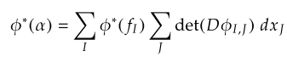
where his sums are both ordered sums which we call Σ'J and Σ'I .

It is useful to write out (10.9.15)C in full notation :

φ*(αx) = Σ1≤j$_{1}$<j$_{2}$<....<j$_{k}$≤n Σ1≤i$_{1}$<i$_{2}$<....<i$_{k}$≤m fi$_{1}$i$_{2}$...i$_{k}$(φ(t))

* det [RIJ] * ( dti$_{1}$ ^ dti$_{2}$ .....^ dti$_{k}$ ) (10.9.16)

where RIJ is this kxk matrix,

Ri$_{1}$j$_{1}$ Ri$_{1}$j$_{2}$ ... Ri$_{1}$j$_{k}$
RIJ = Ri$_{2}$j$_{1}$ Ri$_{2}$j$_{2}$ ... Ri$_{2}$j$_{k}$
.....
Ri$_{k}$j$_{1}$ Ri$_{k}$j$_{2}$ ... Ri$_{k}$j$_{k}$ (10.9.17)
with
Rij = (Dφ)ij = (∂φi/∂tj) = ∂jφi(t) . // (10.8.3)

The object det(RIJ) is a k x k minor of the full m x n matrix R, so k ≤ n ≤ m in our application. Remember that, due to the ordered sums, all the ir are different, and all the jr are different, so no row or column appears twice in RIJ.

Here is a hybrid picture where we add more detail to Fig. (10.8.15),

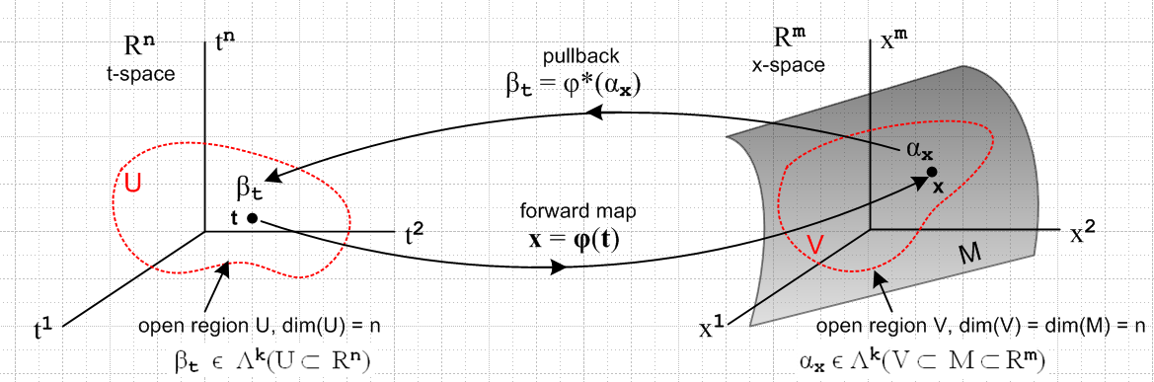
(10.9.18)

We have added an n-dimensional open domain region U in t-space which maps via x = φ(t) into an open region V which lies on the manifold M (a "surface"), which is of dimension n. Our point of interest t lies in U, and x lies in V. The picture is a bit symbolic since it shows t-space = Rn and x-space = Rm, but the differential forms αx and βt are really objects within the dual spaces (Rm)* and (Rn)*.

Here is a more practical picture for the special case n = 2 and k = 2:

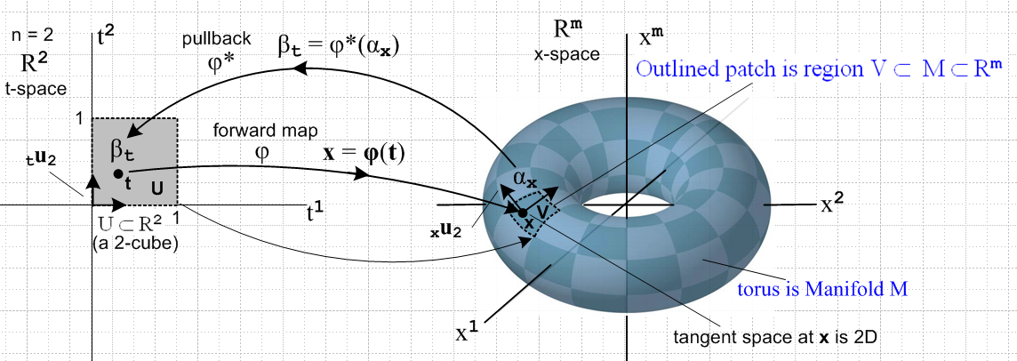
(10.9.19)

Here the open region U is a unit square [0,1]2 which maps into a patch on a torus. That is, if m = 3 the object on the right is a torus in R3, but we can imagine it to be a torus embedded in Rm for any m ≥ 3.
The space of vectors defined on U ⊂ R2 is a 2-dimensional dual space (R*2)(U). On this space we can define either 1-forms or 2-forms. The above picture suggests a 2-form since the region U is an area, and since we will later associate dt1 ^ dt2 with the calculus differential dt1dt2 which represents an area (we are not there yet).
The picture shows the "forward map" x = φ(t), suggesting that forward means left to right in the picture. Then αx is "pulled back" right to left from dual x-space to dual t-space where it becomes βt.
One could imagine a set of 16x6 = 96 mappings like the one shown above which would "cover the torus", using one little patch for each mapping (with some small overlap between patches). One would then have an atlas of 96 square maps like that on the left which would serve to cover the surface of Planet Toroid. This is the basic idea of a manifold. In the torus example, one could do the job with only 2 maps. Doing it with a single map does not fly since then some seam curve on the torus would map back to two boundaries of the square and the mapping is then not one-to-one and smooth. Manifold mappings have to be continuous in both mapping directions at every point, and a seam is a place without continuity.
The aspect ratio of the 2-cube on the left is not significant. One could change it to be an arbitrary rectangle in t-space and select a φ to make it map to the same small image patch in x-space. Or one could construct a mapping φ which maps the unit 2-cube [0,1]2 to the entire left half of the torus. See Sjamaar.
The black arrows on the left are the t-space basis vectors tui (only tu2 is labeled). As shown in (10.8.6), these map according to xui = R tui into basis vectors which are tangent to M, and these vectors then span the tangent space TxM at point x on M. It is clear that the two xui vary as the point x on M is varied.

As another example consider this situation with n = 1 and k = 1,

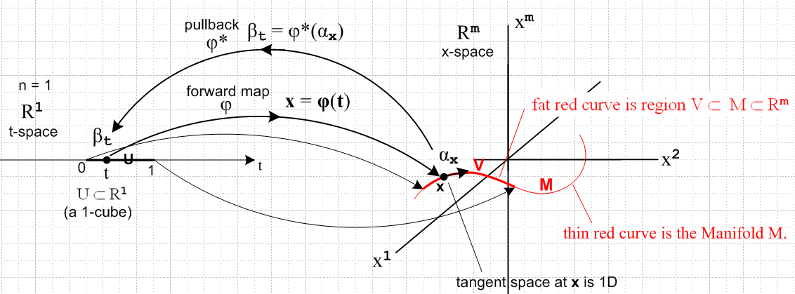
(10.9.20)

Now the domain in t-space is a U = 1-cube [0,1] which maps to a (generally non-planar) red curve which is embedded in Rm . Here αx and βt are 1-forms. The red curve segment V lies on the manifold curve M as shown, just as the patch of the previous example lay on the torus. There is only one basis vector tu in t-space (not shown) and it maps to the unlabeled black arrow on the right which is xu and is of course tangent to the curve at x.

(b) The tensor-function pullback equation for a k-form

Recall (5.6.17)

P [ |T1> ⊗ |T2>...⊗ |TN>] = P |T1> ⊗ P|T2>...⊗ P |TN> (5.6.17)

which describes the effect of an operator P on a tensor product of N arbitrary tensors. If the tensors are just vectors and if the operator is R, then

R| v1,v2...vk> = R [ | v1> ⊗ | v2> ..... ⊗ | vk> ]

= R | v1> ⊗ R | v2> ..... ⊗ R | vk> = | Rv1> ⊗ | Rv2> ..... ⊗ | Rvk>

= | Rv1,Rv2...Rvk> . (10.9.21)

Therefore

<αx | φ*| v1,v2...vk> = <αx | R |v1,v2...vk> = <αx | Rv1,Rv2...Rvk> . (10.9.22)

In function notation this is written

[φ*αx] (v1,v2...vk) = αx(Rv1,Rv2...Rvk) for αx = Σ'I fI(x) dx^I (10.9.23)

and this is the pullback equation written in terms of tensor functions. Each side of this equation is a totally antisymmetric k-multilinear tensor function in the dual space Λkf(V) of (8.3.1a).

Traditionally one defines the original differential form to be α and not αx so (10.9.27) becomes,

[φ*α] (v1,v2...vk) = α(Rv1,Rv1...Rvk) for α = Σ'I fI(x) dx^I . (10.9.24)

Since [φ*α] is a t-space k form, we might indicate that by adding a subscript t to get [φ*α]t. Recall that earlier this was called βt. And since α is an x-space k-form, we add a label there as well to get αx, ]

[φ*α]t (v1,v2...vk) = αx(Rv1,Rv1...Rvk) for α = Σ'I fI(x) dx^I . (10.9.25)

Since x = φ(t), replace αx → αφ(t) to get

[φ*α]t (v1,v2...vk) = αφ(t)(Rv1,Rv1...Rvk) for α = Σ'I fI(x) dx^I . (10.9.26)

Finally, since Rij = (D(t)φ)ij = (∂φi(t)/∂tj) as in (10.9.17), we replace R = (D(t)φ) to get

[φ*α]t (v1,v2...vk) = αφ(t)( (D(t)φ)v1, (D(t)φ)v1... (D(t)φ)vk) α = Σ'I fI(x) dx^I . (10.9.27)

The entire right side depends only on the variable t, appropriate since it is a t-space k-form. Had we started with variables y = φ(x) instead of x = φ(t) the above would have t→x and x→ y to become

[φ*α]x (v1,v2...vk) = αφ(x)( (D(x)φ)v1, (D(x)φ)v1... (D(x)φ)vk) α = Σ'I fI(y) dy^I . (10.9.28)

This expression appears in Sjamaar [2015] page 96 from which we quote,

He writes (D(x)φ) as Dφ(x) and [φ*α]x as φ*(α)x .

The tensor function pullback equation also appears in Spivak but not quite as we have written it. Spivak says on the top of page 90 and the bottom of page 89,

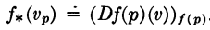

which we interpret to mean

[f*(ω)](p)(v1,v2...vk) = ω(f(p)) ( (D(p)f)v1, (D(p)f)v2, ... (D(p)f)vk ) .

Replacing ω→α, f→φ and p → x gives

[φ*(α)](x)(v1,v2...vk) = α(φ(x))( (D(x)φ)v1, (D(x)φ)v2, ... (D(x)φ)vk ) .

We then interpret (x) on the left and φ(x) on the right as tags indicating the space of the differential form, so the above becomes

[φ*(α)]x(v1,v2...vk) = αφ(x)( (D(x)φ)v1, (D(x)φ)v2, ... (D(x)φ)vk )

in agreement with (10.9.28) and with Sjamaar's form. Sjamaar 2015 refers to φ*α as the pullback of α, but Spivak writing in 1965 does not use the term pullback in his book. Having a name for something is always helpful.

