Section 10.6 PhL 3.6.16

10.6 The pullback of a simple differential form

Picture A

In Chapter 2 we discussed the transformation x' = F(x) from x-space to x'-space using this picture,

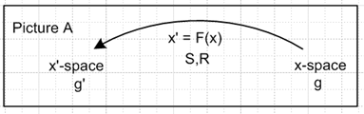 (2.1.1)

The differential (the R-matrix) of the transformation was given by

V'a = RabVb Rab ≡ (∂x'a/∂xb) = ∂bx'a ≡ (∇F)ab ≡ (DF)ab ≡ (DF)ab (2.1.2)

dx'a = Rabdxb dx' = Rdx . (2.1.12)

Here V'a = RabVb shows the transformation of a contravariant vector under x' = F(x). In matrix notation one would write V' = RV.

Above we have defined the objects ∇F and DF as being alternate names for matrix R because authors like Spivak use this notation. In (E.4.4) of Tensor we show that this is in fact a "reverse dyadic notation". Often (DF)ab is written unbolded as just (DF)ab so then R = (DF) with the idea that a matrix like R is normally not bolded.

Tangent Base Vectors and TxM

In Tensor it is shown in Section 3.2 that e'n are axis-aligned basis vectors [ (e'n)i = δni] in x'-space which map into the "tangent base vectors" en in x-space according to en= Se'n and e'n = Ren . One writes en = ∂x/∂x'n so en is tangent to the "coordinate line" of a constant value x'n drawn in x-space, see Tensor (3.2.8), (1.13) and (3.4.3).
Then in Tensor Section 3.5 the inverse transformation is discussed, x = F-1(x'), and for that transformation the un are axis-aligned basis vectors [ (un)i = δni] in x-space which map into the "inverse tangent base vectors" u'n in x'-space according to u'n= Run and un= Su'n as in Tensor (3.5.3) In this case the inverse tangent base vector u'n is tangent to the inverse coordinate line in x'-space which correspond to a constant value of xn in x-space.

Forward transformation from x-space to x'-space:

x' = F(x) Rik ≡ (∂x'i/∂xk) = ∂kx'i
Sik ≡ (∂xi/∂x'k) = ∂'kxi RS = SR = 1

e'n with (e'n)i = δni axis-aligned basis vectors in x'-space
en en= Se'n tangent base vector in x-space

Inverse transformation from x'-space to x-space: ( R and S the same as above )

x = F-1(x') Rik ≡ (∂x'i/∂xk) = ∂kx'i
Sik ≡ (∂xi/∂x'k) = ∂'kxi RS = SR = 1
but same R and S as above

un with (un)i = δni axis-aligned basis vectors in x-space
u'n u'n= Run tangent base vector in x'-space

If we were to rename spaces x' → t and x → x' the above would say

STOP. Tensor doc is simply unclear on this topic (on what topic?)and needs a rewrite. Do that (but not inline) right now.

Then in Tensor Section 3.5 the inverse transformation is discussed, x = F-1(x'), and for that transformation the un are axis-aligned basis vectors [ (un)i = δni] in x-space which map into the "inverse tangent base vectors" u'n in x'-space according to u'n= Run and un= Su'n as in Tensor (3.5.3) In this case the inverse tangent base vector u'n is tangent to the inverse coordinate line in x'-space which correspond to a constant value of xn in x-space.
As we show below, it is this last mapping that will be of great interest. As just stated, it has

(un)i = δni axis aligned basis vectors in x-space

u'n tangent base vectors in x'-space

It will map axis-aligned basis vectors tui in t-space into tangent base vectors we shall call xei in x-space. These vectors xei for i = 1,2..n will be seen below to span that tangent space TxM at a point x on a manifold M. Thus we have a clear connection between the notion of tangent base vectors and the tangent space TxM.

About t-space and x-space

We now change x' → t and x → x' to get instead the following Picture F,

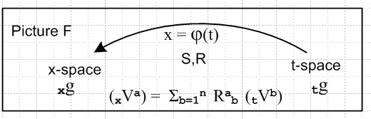

BUT we then physically switch the two sides of Picture F to get this rendering new of Picture F which is the more traditional picture used in our current context,

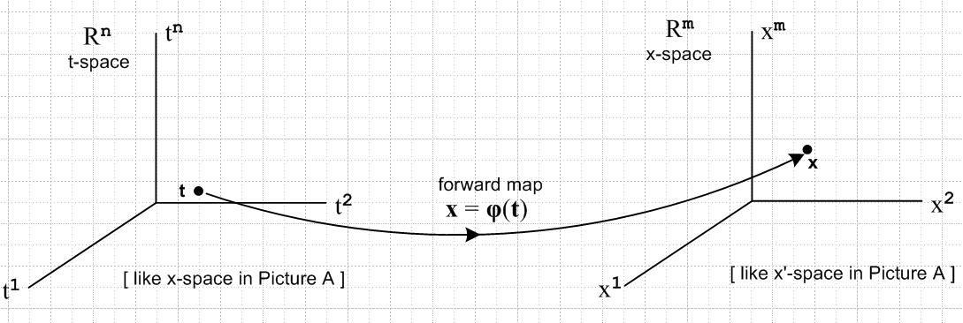
(10.6.1)

Instead of being x' = F(x), the new transformation is x = φ(t). The new (2.1.2) R matrix is this

(xVa) = Σb=1n Rab (tVb) Rab ≡ (∂xa/∂tb) = ∂bxa ≡ (∇φ)ab ≡ (Dφ)ab
or
(xV) = R (tVb) dx = R dt . (10.6.2)

We adopt the notation that xA is something in x-space while tA is something in t-space.

In Chapter 2 (and in the underlying Tensor document) the two spaces had the same dimension, but now
t-space = Rn and x-space = Rm and we have in mind that m ≥ n. The R matrix is then in general no longer square, but is in fact an m x n matrix with m rows (first index a) and n columns (second index b). R is a "tall" matrix when m > n. We have chosen the dimension names m and n to be consistent with Spivak and Sjamaar.

Basis vectors in the two spaces

We start with a set of n axis-aligned basis vectors in t-space, as was done in (2.4.1),

{tui } i = 1,2...n basis for t-space

(tui )j = δij components of these basis vectors in t-space (10.6.3)

Since these are basis vectors in t-space, we map them into x-space using (xV) = R (tVb) of (10.6.2),

(xei) = R(tui)
or
(xei)j = Σa=1n Rja (tui)a = Σa=1n Rja δia = Rji i = 1,2...n j = 1,2..m . (10.6.4)

STOP RIGHT HERE!!! The above says

(xei)j = Rji

whereas wedge doc says

(en)i = Rni (en)i = Rni (en)i = Rni (en)i = Rni . (2.3.4)
or
(ei)j = Rij

So there is a transpose issue lurking here somewhere.

_______________________________________________________________________________
Since there are m basis vectors in x-space, we define the rest of the xei arbitrarily such that the m basis vectors {xei} in Rm are linearly independent, so

xei = as needed i = n+1, n+2 .....m . (10.6.5)

Note that equation (xei) = R(tui) or (xui)j = Σa=1n Rja(tui)a is a "component transformation".

Applying (gx)i'i to both sides of the second line of (10.6.4) gives (according to ***)

(xei)j = Rji

___________________________________________________________________________________

"Raising/lower components and maintaining tilts" as below (2.9.2) we can write a version of (10.6.4) for the dual basis vectors xei and tui,

(xei) = R(tui)
or
(xei)j = Σa=1n Rja (tui)a = Σa=1n Rja δia = Rji i = 1,2...n j = 1,2..m . (10.6.6)

Since (xei)j = Rji and (xei)j = Rji, we conclude from (10.6.4) and (10.6.6) that

Fact: The first n x-space basis vectors xei for i = 1 to n are the columns of R** .
The first n x-space basis vectors xei for i = 1 to n are the columns of R** . (10.6.7)

That is to say, in (xei)j = Rji if we fix i and examine j = 1,2...m, we describe the column i of R**.

If the columns of R** [or R**] are denoted ci [ or ci ] then one can write,

R** = [ c1, c2.....cn ] = [xe1, xe2 ....xen ] ci = xei

R** = [ c1, c2.....cn ] = [xe1, xe2 ....xen ] ci = xei . (10.6.8)

Recall that R is a tall matrix with m rows and n columns, so each ci [ or ci ] has m components.

Metric Tensor Comment: We have been quiet about the metric tensors tg and xg in the two spaces. Since we have used covariant notation, this entire section should be valid for any choice of metric tensors. For example

(tg)ij = (tui) • (tuj) i,j = 1,2..n // (2.4.2) translated from Picture A to Picture F

(xg)ij = Σrs=1nRirRjs(tg)rs i,j = 1,2..m // (2.2.3) translated from Picture A to Picture F

One normally selects tg in t-space (often Cartesian meaning (tg)ij = δi,j) and then the last line above gives xg in x-space. The last line just states that the metric tensor transforms as a rank-2 tensor. The object (tg)ij is n x n whereas (xg)ij is m x m since the R matrix has m rows and n columns.
ok to here
The pullback operator

Now we are going to "pull back" all m of the xei basis vectors in x-space to vectors in t-space which vectors will turn out to be the rows of the R matrix. Here we are not inverse-mapping the first n xei back to their corresponding tui in t-space, we are doing something different. We first define,

φ*T(xei) ≡ Σj=1n Rij (tuj) i = 1..m (10.6.9)

where φ*T is a pullback operator which maps from x-space to t-space, φ*T : Rm→ Rn. The reason for writing this as the transpose of operator φ* will become clear below.
The sum on the right of (10.6.9) is a linear combination of t-space basis vectors, it is not a sum of vector components as in (10.6.4), so φ*T(xei) is a vector in t-space, not in x-space.
Now take the contravariant s component of both sides of (10.6.9),

[φ*T(xei)]s = Σj=1n Rij (tuj)s i = 1,2...m s = 1,2...n

= Σj=1n Rij δjs // (10.6.3)

= Ris . (10.6.10)

Reversing the tilts as done earlier, we can rewrite (10.6.9) and (10.6.10) as

φ*T(xei) ≡ Σj=1n Rij (tuj) i = 1..m

[φ*T(xei)]s = Ris . (10.6.11)

Therefore we conclude from (10.6.10) and (10.6.11) that

Fact: The m t-space vectors φ*T(xei) for i =1 to m are the rows of the R** matrix.
The m t-space vectors φ*T(xei) for i =1 to m are the rows of the R** matrix. (10.6.12)

If the rows of R** [ or R**] are denoted ri [ or ri ] then we can write

R** = $\left[\begin{matrix}r1 \\ r2 \\ ... \\ rm\end{matrix}\right]$ = $\left[\begin{matrix}φ*T(xe1) \\ φ*T(xe2) \\ ... \\ φ*T(xem)\end{matrix}\right]$ and ri = φ*T(xei) .

R** = $\left[\begin{matrix}r1 \\ r2 \\ ... \\ rm\end{matrix}\right]$ = $\left[\begin{matrix}φ*T(xe1) \\ φ*T(xe2) \\ ... \\ φ*T(xem)\end{matrix}\right]$ and ri = φ*T(xei) . (10.6.13)

Recall that R is a tall matrix with m rows and n columns, so each ri [ or ri ] has n components.

Thus, the pullback of an x-space basis vector xei is nothing more than the corresponding row of the R matrix for the transformation x = φ(t) . Every basis vector xei for i = 1 to m has such a pullback.

This drawing represents the three mappings so far described, fix this up

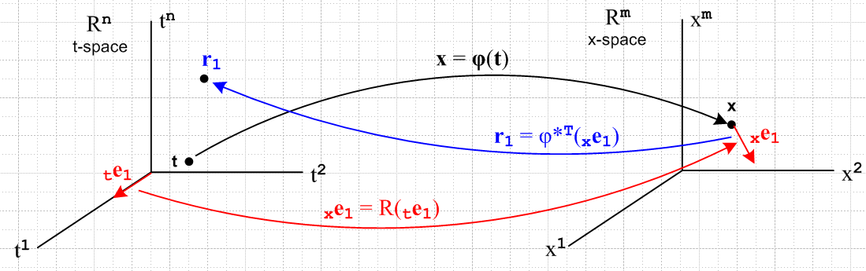
(10.6.14)

Here we show the mappings for the basis vector tu1.

In Dirac notation one can write (10.6.9) and (10.6.11) as ket equations,

φ*T | xei> = Σj=1n Rij | tuj> i = 1,2..m

φ*T | xei> = Σj=1n Rij | tuj> . (10.6.15)

Since the transpose of A|b> is <b|AT as in (2.11.d.7), and since the R matrix is real, the corresponding bra equations are

<xei | φ* = Σj=1n Rij <tuj | i = 1,2..m

<xei | φ* = Σj=1n Rij <tuj | . (10.6.16)

The bras in these equations are dual space vectors (rank-1 linear functionals) as discussed in Section 2.11.
The ket <xei | is an element of dual space (Rm)* while <tuj | inhabits (Rn)*. Note that Fig (10.6.14) displays only the spaces Rn and Rm and not the corresponding dual spaces.

In terms of the (2.11.c.2) basis functionals xλi = <xei| of the dual space (Rm)*, this second line of (10.6.16) may be written,

φ*(xλi) = Σj=1n Rij (tλj) = Σj=1n (Dφ)ij (tλj) i = 1,2..m (10.6.17a)

or in cosmetic notation of Section 10.1 above,

φ*(dxi) = Σj=1n Rij (dtj) = Σj=1n (Dφ)ij (dtj) i = 1,2..m . (10.6.17b)

Since xλi = dxi is a very simple example of a differential form, we see in (10.6.17) our first example of "the pull back of a differential form". What is being "pulled back" is the dual vector <xei| = xλi ϵ (Rm)* . The pulled back vector is φ*(xλi) ϵ (Rn)*. The mapping is φ*: (Rm)*→ (Rn)*.

The Tangent Space Basis Vectors

Assume that as t ranges over some portion of t-space, the mapping x = φ(t) describes a "smooth surface" M embedded in x-space, hopefully a manifold. If we start at some t and move to t + dt in t-space, we move from some point x on M to some nearby point x + dx on M. This dx is tangent to the surface M and thus lies in the tangent space TxM of M at point x, as discussed above in Section 10.2. Applying R to each of the n axis-aligned differentials dti = dti(tui) in t-space (no i sum), we thereby generate a set of n differential vectors dxi = Rdti which are in effect a set of short basis vectors which span the tangent space TxM. Since dxi = dxi (xui), we may take the basis vectors {xei, i=1,2..n} as spanning TxM, in agreement with our arrangement of things in Section 6.2. The vectors {xei, i=n+1,n+2..m} are then all orthogonal to the "surface" M.
We know from the fact xei • xej = δij that the set {xei, i=1,2..n} also form a basis for the tangent space TxM. This conclusion can be reached as well by raising all i indices in the previous paragraph. In this case, the set {xei, i=n+1,n+2..m} are then all orthogonal to the "surface" M.
According to (10.6.7) we may conclude that

Fact: The first n basis vectors xei, which are the columns of R** , span the tangent space TxM.
The first n basis vectors xei, which are the columns of R** , span the tangent space TxM.
(10.6.18)

The dual vectors (functionals) in the sense of xλi = <xei| then span the cotangent space of TxM.
ok to here except need to update the picture

10.7 The pullback of a general differential form

Recall from (10.6.16) the action of operator φ* on the bra <xei |,

<xei | φ* = Σj=1n Rij <tuj | i = 1,2..m . (10.6.16) (10.7.1)

An operator P which acts on a vector space V, has a natural extension to being an operator on the tensor product space Vn ,

P | v1,v2....vk> = P [ | v1> ⊗ |v2>....⊗|vk> ] = P| v1> ⊗ P|v2>....⊗ P|vk> . (10.7.2)

Similarly, an operator Q which acts on a dual vector space V*, has a natural extension to being an operator on V*n ,

< v1,v2....vk| Q = [ < v1| ⊗ <v2|....⊗<vk| ] Q = < v1|Q ⊗ <v2|Q....⊗<vk|Q . (10.7.3)

Setting Q = φ* we then define,

< xei$_{1}$, xei$_{2}$....xei$_{k}$| φ*

= < xei$_{1}$|φ* ⊗ <xei$_{2}$|φ*....⊗ <xei$_{k}$|φ*

= [Σj$_{1}$=1n Ri$_{1}$j$_{1}$ <tuj$_{1}$ | ] ⊗ [Σj$_{2}$=1m Ri$_{2}$j$_{2}$ <tuj$_{2}$ | ] ... ⊗ [Σj$_{k}$=1m Ri$_{k}$j$_{k}$ <tuj$_{k}$ | ]

= Σj$_{1}$j$_{2}$...j$_{k}$=1n Ri$_{1}$j$_{1}$ Ri$_{2}$j$_{2}$ ... Ri$_{k}$j$_{k}$ ( <tuj$_{1}$ | ⊗ <tuj$_{2}$ | ... ⊗ <tuj$_{k}$| )

= Σj$_{1}$j$_{2}$...j$_{k}$=1n Ri$_{1}$j$_{1}$ Ri$_{2}$j$_{2}$ ... Ri$_{k}$j$_{k}$ | tui$_{1}$, tui$_{2}$....tui$_{k}$ > . (10.7.4)

In multiindex notation this says (note that ΣJ is a full symmetric sum),

< xeI | φ* = ΣJ RIJ <tuJ | . (10.7.5)

A nearly identical result can be obtained for wedge space Λk. Apply AltI to both sides of (10.7.5) to get

AltI [ < xeI | φ* ] = AltI [ ΣJ RIJ <tuJ | ] . (10.7.6)

According to (8.1.2) the left side is just

AltI [ < xeI | φ* ] = AltI [ < xeI | ] φ*

= < xe^I | φ* where <xe^I| = <xej$_{1}$ | ^ <xej$_{2}$ | ... ^ <xej$_{k}$| . (10.7.7)

The right side is a little tricky:

AltI [ ΣJ RIJ <tuJ | ] = ΣJ [AltI(RIJ)] <tuJ |

= ΣJ [(1/k!) ΣP(-1)P RP(I)J ] <tuJ | // (A.2.1) def of AltI

= (1/k!) ΣP(-1)P ( ΣJ RP(I)J ] <tuJ | ) // reorder

= [(1/k!) ΣP(-1)P ( ΣJ RP(I)P(J) ] <tuP(J) | ) // (A.1.20) that ΣJ fJ = ΣJ fP(J)

= [(1/k!) ΣP(-1)P ΣJ RIJ ] <tuP(J) | // (A.8.31) that RP(I)P(J) = RIJ

= ΣJ RIJ [(1/k!) ΣP(-1)P <tuP(J) | ] // reorder

= ΣJ RIJ AltJ <tuJ | // (A.2.1) def of AltJ

= ΣJ RIJ <tu^J | where <tu^I| = <tuj$_{1}$ | ^ <tuj$_{2}$ | ... ^ <tuj$_{k}$| . (10.7.8)

Thus we have shown how φ* acts on dual basis vectors of the space Λk(Rm),

< xe^I | φ* = ΣJ RIJ <tu^J | . (10.7.9)

This is identical in form to (10.7.5) but the basis vectors are wedge products instead of tensor products.

A general element of Λk(Rm) at a point x on our surface M can be written from (10.2.1),

αx = Σ'I fI(x) xλ^I
or
<αx | = Σ'I fI(x) < xe^I | (10.7.10)

Then

<αx | φ* = Σ'I fI(x) [ < xe^I | φ* ] = Σ'I fI(x) [ΣJ RIJ <tu^J | ]
or
φ*(αx) = Σ'I fI(x) ΣJ RIJ tλ^J = Σ'I fI(φ(t)) ΣJ RIJ tλ^J (10.7.11)

which is then the pullback of an arbitrary differential k-form. We see from our operations above that:

Fact: The pullback of a k-form in x-space is a k-form in t-space, where k ≤ n ≤ m. (10.7.12)

After all, xλ^I is the wedge product of k dual basis vectors, and so is tλ^J .

There are now two paths leading off from this waypoint.

First path

Write (10.7.11) as

φ*(αx) = ΣJ [ Σ'I fI(φ(t)) RIJ ] tλ^J

= ΣJ GJ(t) tλ^J GJ(t) ≡ Σ'I fI(φ(t)) RIJ

= Σ'J gJ(t) tλ^J gJ(t) ≡ k! AltJ[GJ(t)] , (10.7.13)

where the last line comes from (10.1.1) through (10.1.3). We have stated the result both in terms of symmetric ΣJ and ordered Σ'J summations. The coefficient functions gJ(t) can be re-expressed as,

gJ(t) ≡ k!AltJ[GJ(t)] = k!AltJ[ Σ'I fI(φ(t)) RIJ]

= k! Σ'I fI(φ(t)) AltJ[RIJ] // Alt is linear

= k! Σ'I fI(φ(t)) [ (1/k!) det(RIJ) ] // (A.8.30)

= Σ'I fI(φ(t)) det(RIJ) . (10.7.14)

The pullback of αx along φ is then

φ*(αx) = Σ'J Σ'I fI(φ(t)) det(RIJ(t)) tλ^J

= Σ'J Σ'I fI(φ(t)) det[(Dφ)IJ(t)] tλ^J ≡ βt (10.7.15)

Being a linear combination of tλ^J , φ*(αx) is seen to be an element of Λk(Rn) which is associated with t-space. That is to say, φ*(αx) is a differential form at a point t in t-space, so we give it an arbitrary name βt.
We pause once more to rewrite our last several results in cosmetic notation:

αx = Σ'I fI(x) xλ^I = Σ'I fI(x) dx^I (10.7.10)C

φ*(αx) = Σ'I fI(φ(t)) ΣJ RIJ dt^J R = (Dφ) (10.7.11)C

φ*(αx) = ΣJ [ Σ'I fI(φ(t)) RIJ ] dt^J

= ΣJ GJ(t) dt^J GJ(t) ≡ Σ'I fI(φ(t)) RIJ

= Σ'J gJ(t) dt^J gJ(t) ≡ k! AltJ[GJ(t)] , (10.7.13)C

φ*(αx) = Σ'J Σ'I fI(φ(t)) det(RIJ(t)) dt^J

= Σ'J Σ'I fI(φ(t)) det[(Dφ)IJ(t)] dt^J ≡ βt (10.7.15)C

It is probably useful to write out this last equation in full notation :

φ*(αx) = Σ1≤j$_{1}$<j$_{2}$<....<j$_{k}$≤n Σ1≤i$_{1}$<i$_{2}$<....<i$_{k}$≤m fi$_{1}$i$_{2}$...i$_{k}$(φ(t))

* det [RIJ] ( dti$_{1}$ ^ dti$_{2}$ .....^ dti$_{k}$ ) (10.7.16)

where RIJ is this kxk matrix,

Ri$_{1}$j$_{1}$ Ri$_{1}$j$_{2}$ ... Ri$_{1}$j$_{k}$
RIJ = Ri$_{2}$j$_{1}$ Ri$_{2}$j$_{2}$ ... Ri$_{2}$j$_{k}$
.....
Ri$_{k}$j$_{1}$ Ri$_{k}$j$_{2}$ ... Ri$_{k}$j$_{k}$ (10.7.17)

The object det(RIJ) is a k x k minor of the full m x n matrix R, so k ≤ n ≤ m in our application.

And it is probably time for some kind of picture where we add detail to Fig (10.6.1). Consider:

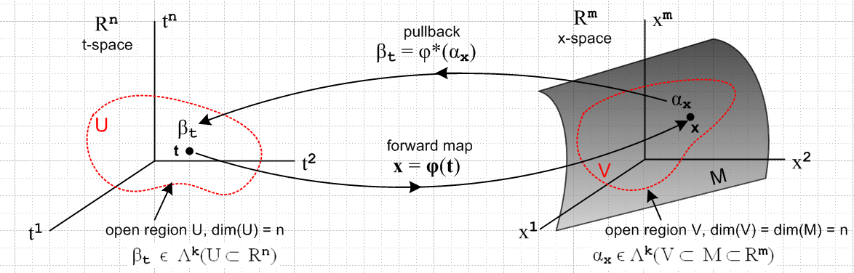
(10.7.18)

We have added an n-dimensional open domain region U in t-space which maps via x = φ(t) into an open region V which lies on the manifold M (a "surface"), which is of dimension-n. Our point of interest t lies in U, and x lies in V. The picture is a bit symbolic since it shows t-space = Rn and x-space = Rm , but the differential forms αx and βt are really elements of the dual spaces (Rm)* and (Rn)* .
A more practical picture for n = 2 and k = 2:

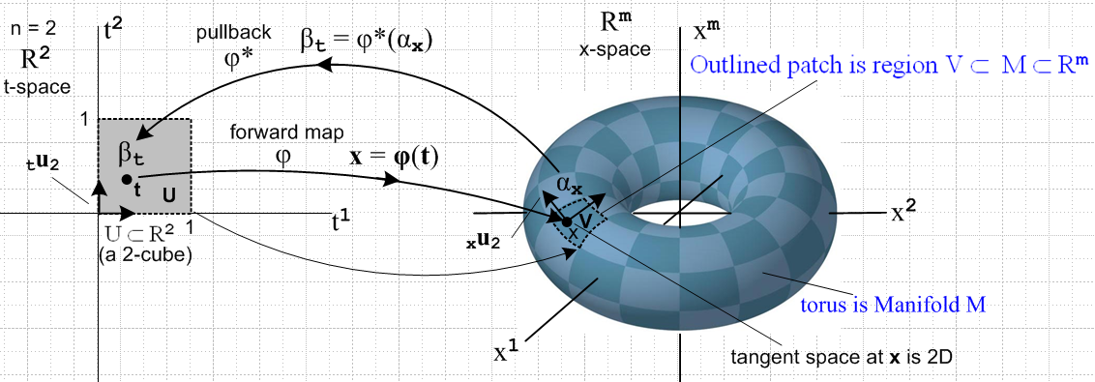
(10.7.19)

Here the open region U is a unit square [0,1]2 which maps into a patch on a torus. That is, if m = 3 the object on the right is a torus in R3, but we can imagine it to be a torus embedded in Rm for any m ≥ 3.
The space of vectors defined on U ⊂ R2 is a 2-dimensional dual space (R*)2(U). On this space we can define either 1-forms or 2-forms. The above picture suggests a 2-form since the region U is an area, and since we will later associate dt1 ^ dt2 with the calculus differential dt1dt2 which represents an area (we are not there yet).
The picture shows the "forward map" x = φ(t), suggesting that forward means left to right in the picture. Then αx is "pulled back" right to left from dual x-space to dual t-space where it becomes βt.
One could imagine a set of 16x6 = 96 mappings like the one shown above which would "cover the torus", using one little patch for each mapping. One would then have an atlas of 96 square maps like that on the left which would serve to cover the surface of Planet Toroid. This is the basic idea of a manifold. In the torus example, one could do the job with only 2 maps.
The aspect ratio of the 2-cube on the left is not significant. One could change it to be an arbitrary rectangle in t-space and select a φ to make it map to the same small image patch. Or one could construct a mapping φ which maps the unit 2-cube [0,1]2 to the entire left half of the torus. See Sjamaar.
The black arrows on the left are the t-space basis vectors tui (only tu2 is labeled). As shown in (10.6.6), these map according to (xei) = R(tui) into basis vectors which are tangent to M, and these vectors then span the tangent space TxM at point x on M. It is clear that the two xei will vary if the point x on M is varied.

As another example consider this situation with n = 1 and k = 1,

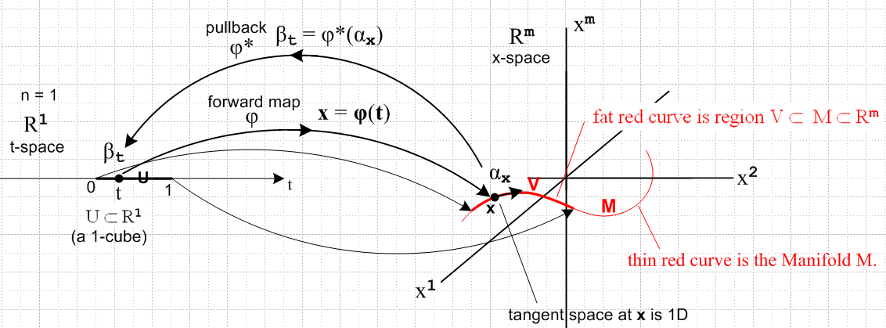
(10.7.20)

Now the domain in t-space is a U = 1-cube [0,1] which maps to a (generally non-planar) red curve which is embedded in Rm . Here αx and βt are 1-forms. The red curve V lies on the manifold M as shown, just as the patch of the previous example lay on the torus. There is only one basis vector tu in t-space (not shown) and it maps the black arrow on the right which is xe and is of course tangent to the curve at x.

Second path

We return to our waypoint (10.7.11) showing the pullback of a general k-form,

φ*(αx) = Σ'I fI(x) ΣJ RIJ tλ^J x = φ(t) (10.7.11)
or
<αx | φ* = Σ'I fI(x) ΣJ RIJ <tu^J |

We make this bra into a tensor function by closing it with a ket | vn$_{1}$,vn$_{2}$...vn$_{k}$> of t-space vectors,

| vn$_{1}$,vn$_{2}$...vn$_{k}$> = | vn$_{1}$> ⊗ | vn$_{2}$> ..... ⊗ | vn$_{k}$> ϵ Vk V = Rn (10.7.21)

to get

<αx | φ*| vn$_{1}$,vn$_{2}$...vn$_{k}$> = Σ'I fI(x) ΣJ RIJ <tu^J | vn$_{1}$,vn$_{2}$...vn$_{k}$>. (10.7.22)

In more conventional notation this reads

[φ*(αx)] (vn$_{1}$,vn$_{2}$...vn$_{k}$) = Σ'I fI(x) ΣJ RIJ tλ^J(vn$_{1}$,vn$_{2}$...vn$_{k}$) . (10.7.23)

For the time being, we shall ignore the Σ'I fI(x) part and just consider ΣJ RIJ tλ^J(vn$_{1}$,vn$_{2}$...vn$_{k}$). To save symbols, write tλ = λ. We now process our expression through a battery of steps to get the desired result:

ΣJ RIJ tλ^J(vn$_{1}$,vn$_{2}$...vn$_{k}$) = ΣJ RIJ (λj$_{1}$ ^ λj$_{2}$ ....^ λj$_{k}$)(vn$_{1}$,vn$_{2}$...vn$_{k}$)

= ΣJ RIJ AltJ[(λj$_{1}$ ⊗ λj$_{2}$ ....⊗ λj$_{k}$)(vn$_{1}$,vn$_{2}$...vn$_{k}$)] // (8.3.8)

= ΣJ RIJ AltJ[(λj$_{1}$(vn$_{1}$)λj$_{2}$(vn$_{2}$) ...λj$_{k}$(vn$_{k}$)] // (6.1.3)

= ΣJ RIJ AltN[(λj$_{1}$(vn$_{1}$)λj$_{2}$(vn$_{2}$) ...λj$_{k}$(vn$_{k}$)] // (A.8.29)

= AltN [ ΣJ RIJ (λj$_{1}$(vn$_{1}$)λj$_{2}$(vn$_{2}$) ...λj$_{k}$(vn$_{k}$) ] // (A.8.10)

= AltN [ ΣJ RIJ (vn$_{1}$)j$_{1}$(vn$_{2}$)j$_{2}$ ... λ(vn$_{k}$)j$_{k}$ ] // (2.11.c.5)

= AltN [ Σj$_{1}$j$_{2}$...j$_{k}$=1m Ri$_{1}$j$_{1}$Ri$_{2}$j$_{2}$ ....Ri$_{k}$j$_{k}$ (vn$_{1}$)j$_{1}$(vn$_{2}$)j$_{2}$ ... λ(vn$_{k}$)j$_{k}$ ]

= AltN { [Σj$_{1}$Ri$_{1}$j$_{1}$(vn$_{1}$)j$_{1}$] [Σj$_{2}$Ri$_{2}$j$_{2}$(vn$_{2}$)j$_{2}$] ... [Σj$_{k}$Ri$_{k}$j$_{k}$(vn$_{k}$)j$_{k}$] }

= AltN { (Rvn$_{1}$)i$_{1}$(Rvn$_{2}$)i$_{2}$... (Rvn$_{k}$)i$_{k}$ } // (Rv)i = ΣjRijvj

= AltN {λi$_{1}$(Rvn$_{1}$)λi$_{2}$(Rvn$_{2}$)... λi$_{k}$(Rvn$_{k}$) } // (2.11.c.5)

= AltI {λi$_{1}$(Rvn$_{1}$) λi$_{2}$(Rvn$_{2}$)... λi$_{k}$(Rvn$_{k}$) } // (A.8.29)

= AltI {(λi$_{1}$ ⊗ λi$_{2}$ ....⊗ λj$_{k}$) (Rvn$_{1}$, Rvn$_{2}$ ...Rvn$_{k}$)} // (6.1.3)

= ( λi$_{1}$ ^ λi$_{2}$... ^ λi$_{k}$ )(Rvn$_{1}$,Rvn$_{2}$...Rvn$_{k}$) . // (8.3.8)

= ( λ^I )(Rvn$_{1}$,Rvn$_{2}$...Rvn$_{k}$) .

To summarize:

ΣJ RIJ tλ^J(vn$_{1}$,vn$_{2}$...vn$_{k}$) = ( λ^I )(Rvn$_{1}$,Rvn$_{2}$...Rvn$_{k}$)

We then insert this into ** to get

[φ*(αx)] (vn$_{1}$,vn$_{2}$...vn$_{k}$) = Σ'I fI(x) [ΣJ RIJ tλ^J(vn$_{1}$,vn$_{2}$...vn$_{k}$)]

= Σ'I fI(x) [ ( λ^I )(Rvn$_{1}$,Rvn$_{2}$...Rvn$_{k}$)]

= [Σ'I fI(x) λ^I ](Rvn$_{1}$,Rvn$_{2}$...Rvn$_{k}$)

= αx(Rvn$_{1}$,Rvn$_{2}$...Rvn$_{k}$)

We end up then with the "tensor function definition" of the pullback of a differential form αx :

[φ*(αx)] (vn$_{1}$,vn$_{2}$...vn$_{k}$) = αx(Rvn$_{1}$,Rvn$_{2}$...Rvn$_{k}$)

which in Dirac notation is

<αx | φ*| vn$_{1}$,vn$_{2}$...vn$_{k}$> = <αx | Rvn$_{1}$,Rvn$_{2}$...Rvn$_{k}$> .

This certainly suggests that

φ*| vn$_{1}$,vn$_{2}$...vn$_{k}$> = | Rvn$_{1}$,Rvn$_{2}$...Rvn$_{k}$>

I will continue here tomorrow! if this is somehow obvious, the proof becomes a LOT simpler!!!

