Section 10.6 PhL 3.6.16
I will edit here to make a clean version that works for non-square R matrix.

10.6 The pullback of a simple differential form

Preliminaries

Much mathematical hardware goes with a mapping. In mechanics, the selection of an appropriate set of coordinates and corresponding basis vectors is sometimes referred to as stating the kinematics of a problem (as opposed to the dynamics which involves equations of motion). Here we apply this term loosely to the cloud of equations associated with a mapping. Not all these equations will be used in our analysis, but we like being able to see them all in one place just in case something is needed.

In this section we shall move in and out of the Dirac notation in a somewhat repetitive fashion intended to make the reader more comfortable with that notation. As stated earlier, we feel that the Dirac notation is the safest notation in terms of avoiding wrong interpretations of rank-1 and rank-2 tensor indices.

The notion of a pullback φ* is often presented as "something new", but the main point of this section and the next is to show that φ* is just the R matrix/operator of the underlying transformation x = φ(t). We present it this way since our present document is already heavily invested (Chapter 2) in the tensor aspects of a general transformation.

In Chapter 2 we discussed the transformation x' = F(x) from x-space to x'-space using this picture,

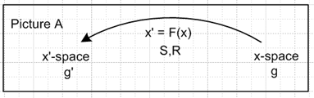 (2.1.1)

The vector transformation and "the differential" (the R-matrix) of the transformation were given by

V'a = RabVb Rab ≡ (∂x'a/∂xb) = ∂bx'a ≡ (∇F)ab ≡ (DF)ab ≡ (DF)ab (2.1.2)

dx'a = Rabdxb dx' = Rdx . (2.1.12) (10.6.1)

Here V'a = RabVb shows the transformation of a contravariant vector under x' = F(x). In matrix notation one would write V' = RV. Repeated indices are always summed unless otherwise stated.

Above we have defined ∇F and DF as alternate names for matrix R because many authors (like Spivak) use this notation. In Tensor (E.4.4) we show that this is in fact a "reverse dyadic notation". Often (DF)ab is written unbolded (DF)ab so then R = (DF) with the idea that a matrix like R is normally not bolded.
Axis-Aligned Vectors and Tangent Base Vectors : The Kinematics Package

It is shown in Tensor Section 3.2 that e'n are axis-aligned basis vectors [ (e'n)i = δni] in x'-space which inverse map to the "tangent base vectors" en in x-space according to en= Se'n and e'n = Ren. From (2.3.1) en = ∂x/∂x'n so en is tangent to an x'n "coordinate line" in x-space as discussed below (2.3.1).
Then in Tensor Section 3.5 the inverse transformation is discussed, x = F-1(x'), and for that transformation the un are axis-aligned basis vectors [ (un)i = δni] in x-space which map into the "inverse tangent base vectors" u'n in x'-space according to u'n= Run and un= Su'n as in Tensor (3.5.3) In this case the inverse tangent base vector u'n is tangent to an inverse coordinate line for coordinate xn.
Many "facts" about the basis vectors en, e'n, un and u'n are developed in Tensor and here is a summary with primed equation numbers referring to that document :

(a) x' = F(x) xform Rij ≡ (∂x'i/∂xj) = ∂jx'i R = (DF)
V' = R V vector contra only Sij ≡ (∂xi/∂x'j) = ∂'jxi

(b) e'i with (e'i)j = δij axis-aligned basis vectors in x'-space
ei ei= Se'i tangent base vector in x-space (7.18.1)'

(c) ui with (ui)j = δij axis-aligned basis vectors in x-space
u'i u'i= Rui tangent base vector in x'-space (7.18.3)'
(u'i)j = Rjk (ui)k

(d) 1= | e'i> <e'i| = | e'i> <e'i| = | u'i> <u'i| = | u'i> <u'i| completeness in x'-space
1= | ei> <ei| = | ei> <ei| = | ui> <ui| = | ui> <ui| completeness in x-space

(e) (uj)i = ui • uj = <ui | uj > = gij = u'i • u'j = <u'i | u'j >
(ej)i = ui • ej = <ui | ej > = Sij = Rji
(e'j)i = e'i • e'j = <e'i | e'j > = gij = ei • ej = <ei | ej >
(u'j)i = e'i • u'j = <e'i | u'j > = Rij = Sji (7.19.12)'

(f) ei = g'ij ej e'i = g'ij e'j ui = gij uj u'i = gij u'j
ei = g'ij ej e'i = g'ij e'j ui = gij uj u'i = gij u'j (7.19.14)'

(g) <ei | S | e'j> = <e'j | R | ei> = g'ji
<ei | S | u'j> = <u'j | R | ei> = Sji = Rij
<ui | S | e'j> = <e'j | R | ui> = Rji = Sij
<ui | S | u'j> = <u'j | R | ui> = gji . (7.19.19)' (10.6.2)

In any equation, any index or label can be raised or lowered on both sides. The object gin is the tensor-correct form of gin = δin = δi,n , allowing for indices to be raised and lowered, see (2.2.2). Here are two sample Dirac notation manipulations using the above information (implied sum in completeness),

|ei> = [1] |ei> = | uj> <uj|ei> = | uj>Rij = Rij |uj> or ei = Rijuj

|e'i> = [1] |e' i> = | u'j> <u'j| e'i> = | u'j> Rij = Rij |u'j> or e'i = Riju'j (10.6.3)

The first result ei = Rijuj appears in (2.5.5) showing that Rij is the basis change matrix between these two sets of basis vectors. Notice that an equation like ei = Rijuj is a "vector sum equation" since
ei = ΣjRijuj has a sum of vectors on the right side. No component indices appear on the vectors in this equation (i and j are labels).

What happens for a non-square tall R matrix?

In Chapter 2 and in Tensor it was assumed that x' = F(x) was an invertible mapping F: RN→RN . Now however we wish to consider the non-invertible mapping x' = F(x) where

F: Rn → Rm m > n
F: x-space → x'-space x ϵ Rn, x' ϵ Rm F(x) = x' . (10.6.4)

In Rab = (∂x'a/∂xb) the row index a ranges 1 to m, while column index b ranges 1 to n. Thus the down-tilt R matrix is a "tall" non-square matrix having m rows and n columns with m > n.
If we let the variable x exhaust some domain U within x-space, the mapping x' = F(x) generates a "surface" embedded within x'-space = Rm which has dimension n. We assume that the mapping F has sufficient smoothness properties so that this surface can be called a Manifold.
In this new context, one can write x = F-1(x') only for points x' on the manifold. For general points x' in x'-space the equation x = F-1(x') does not exist. This has rather severe implications for the kinematics package summarized above. For example, the S matrix does not exist, since Sij ≡ (∂xi/∂x'j) cannot be computed. In general anything depending on Sij no longer exists. For example, although the axis-aligned basis vectors e'i exist in x'-space, the tangent base vectors ei ≡ Se'i no longer exist in x-space. Although the metric tensors gij and gij continue to exist in x-space, only the metric tensor g'ij survives in x'-space. One reason that g'ij no longer exists is that g'ij = Sai Sbj gab and Sai does not exist. In the developmental notation of Tensor, if x-space is Cartesian, one finds that the contravariant metric tensor is given by g' = RRT, see (5.7.9)'. When R is a "tall" non-square matrix, a standard rank theorem of linear algebra shows that det(RRT) = 0 for any R. This means that g' = RRT is non-invertible, so its inverse (the covariant metric tensor ') does not exist, supporting the claim just made that g'ij no longer exists in standard notation. One implication is that, although contravariant and covariant vectors Vi and Vi exist in x-space, covariant vector components V'i do not exist in x'-space because there is no g'ij to lower the index of V'i to make it be V'i. But we can at least write V'i = RijVj = RijVj.
Despite these crater-like impacts on the theory presented in Chapter 2 and in Tensor, much of the kinematics package does manage to survive. Before continuing, we remark on which R matrices exist and which do not exist:

Rij ≡ (∂x'i/∂xj) is unique Rji = Sij is not unique

Rij = g'ikRik is unique Rij = g'ik Rkj is not unique

(RT)ij = Rji is unique since Rij is unique

Note that the en are not unique and g'ij is not unique

We record below the equations of (10.6.2) that are still valid in a slimmed-down kinematics package appropriate for F: Rn → Rm (m > n) and its corresponding "tall" R matrix Rij ≡ (∂x'i/∂xj) :

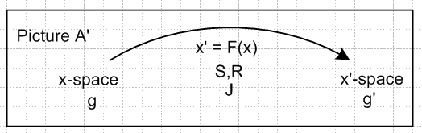

(a) x' = F(x) xform Rij ≡ (∂x'i/∂xj) = ∂jx'i R = (DF)
V' = R V contravariant only

(b) e'i with (e'i)j = δij axis-aligned basis vectors in x'-space

(c) ui with (ui)j = δij axis-aligned basis vectors in x-space
u'i u'i= Rui tangent base vector in x'-space
(u'i)j = Rjk (ui)k

(d) 1= | e'i> <e'i| = | e'i> <e'i| = | u'i> <u'i| = | u'i> <u'i| completeness in x'-space
1 = | ui> <ui| = | ui> <ui| completeness in x-space

(e) (uj)i = ui • uj = <ui | uj > = gij = u'i • u'j = <u'i | u'j >
(e'j)i = e'i • e'j = <e'i | e'j > = gij
(u'j)i = e'i • u'j = <e'i | u'j > = Rij

(f) e'i = g'ij e'j ui = gij uj u'i = gij u'j
ui = gij uj u'i = gij u'j

(g) <e'i | R | uj> = Rij ≡ [R(e',u)]ij
<u'i | R | uj> = δij ≡ [R(u',u)]ij (10.6.5)

At the top we have done a cosmetic left/right mirror reflection on Picture A to produce Picture A' which aligns better with drawings below. On the last line we show the R matrix in Dirac notation. The notion that Rij is not a true tensor since it has one foot in x'-space and one foot in x-space is made more concrete

Basis vectors in the two spaces

From (10.6.5c) we select as a basis for x-space the set of n axis-aligned basis vectors ui,

{ui} i = 1,2...n basis for x-space

(ui)j = δij components of these basis vectors in x-space . (10.6.6)

These map into a set of n tangent base vectors u'i in x'-space as shown in (10.6.5c),

u'i = R ui |u'i> = R |ui>
or
(u'i)j = Rja (ui)a = Rja δia = Rji i = 1,2...n j = 1,2..m . (10.6.7)

Since there are m basis vectors in x'-space, we define the rest of the u'i arbitrarily such that the m basis vectors {u'i} in Rm are linearly independent, so

u'i = as needed i = n+1, n+2 .....m . (10.6.8)

Note in (10.6.7) that (u'i)j = Rja(ui)a = Σa=1n Rja(ui)a is a "component sum equation", in contrast with the "vector sum equation" e'i = Σj=1nRiju'j appearing in (10.6.3).

Based on (10.6.7) that Rji = (u'i)j, one concludes that the columns of R** are the contravariant basis vectors u'i

R** = [u'1, u'2 ....u'n ] (10.6.9)

Like any x'-space vectors, the u'i vectors have m components, so R** has m rows, and it obviously has n columns, consistent with comments above about R being an m x n matrix

We can apply gij to both sides of (10.6.7) and then use (10.6.5f) to get

u'i = R ui |u'i> = R |ui>
or (10.6.10)
(u'i)j = Rja (ui)a = Rja gib(ub)a = Rja gibδba = Rja gia = Rji .

Comment: this says that the push-forward of the contravariant up-label basis vectors is unique, because the down-tilt R matrix is involved. In contrast,

(u'i)j = Rja (ui)a = Rja (ui)a = Rja δia = Rji = Sij

This says that the push-forward of the covariant up-label basis vectors is not unique since Sdt is not unique! One way to confirm this fact is to note that the covariant metric tensor g'ij is not unique as noted elsewhere, so lowering the index on (u'i)j introduces non-uniqueness.

ok to here, resume making use of RT which in fact does exist in an appropriate sense. Work first in ket space, and later change to bra space.

Consider now, using a completeness relations from (10.6.5d) and a matrix element from (10.6.5g),

<e'i | R = <e'i | R*1 = <e'i | R | uj> <uj| = Rij <uj| (10.6.11)

The right side of this "vector sum equation" is a linear combinations of vectors in x-space, so the left side must also be a vector in x-space. We now create a duplicate name F* for operator R and we write the above as

<e'i | F* ≡ <e'i | R = Rij <uj|

(e'i)T R = Rij (uj)T

Take the covariant vector component k of this equation

[(e'i)T R]k = Rij (uj)Tk = Rij (uj)k = Rik = unique

[(e'i)T R]k = Rij (uj)Tk = Rij (uj)k = Rik = unique

So things are unique for the up-label basis vectors, which is helpful since those are the ones I care about when things switch to λi .

This F* is called the pullback operator. We know that |e'i> = e'i is an axis-aligned basis vector in x'-space Rm, and <e'i | is the corresponding dual vector in the dual space (Rm)*. We see then that the action of F* is to "pull back" this dual basis vector <e'i | of dual x'-space into a certain linear combination of dual vectors in dual x-space.

Of more interest to us is the action of F* on the dual vector <u'i | in dual x'-space.

<u'i | F* ≡ <u'i | R = <u'i | R | uj> <uj| = δij <uj| = <ui |

How does this look in transpose world?

RT |u'i> = |ui>
or
S |u'i> = |ui>
or
S u'i = ui not unique
or
Sab(u'i)b = (ui)a not unique
or
Sab(u'i)b = (ui)a unique
or
Rba(u'i)b = (ui)a unique

So the pullback of the up-label ket basis vector is unique for covariant components, but not unique for the contravariant components.

*****************************

I want to say this:

<e'i | R = Rij <uj|
or
RT |e'i > = Rij |uj>
or
RT e'i = Rijuj

but I am worried that RT does not exist. But maybe that depends on which RT you are talking about. How do you write out the left side of this last equation?

[RT e'i]a = Rij (uj)a pick u basis // covariant vector component in x-space

(RT)ab (e'i)b = Rij(uj)a

Rba (e'i)b = Rij(uj)a = Ria

[R(e',u)]ij (e'i(u))b

so it involves the downtilt R matrix

Σj=1n Rij <uj |

First of all, both sides of this equation

Now I need to set a Target. Here it is

<e'i | φ* = <e'i | R = Σj=1n Rij <uj |

How do I get to this Target? I need to show that

<e'i | R = Σj=1n Rij <uj | this is a "vector sum equation".

Let's try closing both sides with | uk> in an attempt to verify the Target,

<e'i | R | uk> = Σj=1n Rij <uj | uk> ?

<e'i | R | uk> = Σj=1n Rij δjk ?

<e'i | R | uk> = Rik ? YES!!!!

I do know that

|e'i> = [1] |e' i> = | u'j> <u'j| e'i> = | u'j> Rij = Rij |u'j> or e'i = Riju'j (10.6.3)

which says

|e'i> = Rij |u'j>

and this in turn says

<e'i| = Rij <u'j|

OUCH!! But what I wanted was this

<e'i | R = Rij <uj |

<xei | φ* = Σj=1n Rij <tuj | i = 1,2..m . (10.6.15) (10.7.1)

<e'i | φ* = <e'i | R = Σj=1n Rij <uj | i = 1,2..m . (10.6.15) (10.7.1)

The pullback operator

We wish to define the action of a certain "pullback operator" called φ*T on an axis-aligned basis vector in x-space. Using completeness 1 = | tuj> <tuj|, then using <a|XT|b> = <b|X|a>, and then looking up the resulting R matrix element in (10.6.4), we find,

φ*T |xei> ≡ RT |xei> = |tuj> <tuj| RT |xei> = | tuj><xei| R |tuj> = Rij| tuj>.
or
φ*T |xei> = Rij| tuj> and similarly φ*T |xei> = Rij| tuj> . (10.6.11)

Although we give the operator φ*T a life of its own, it is really just φ*T = RT = R-1 = S. So the first point is that the so-called pullback operator is nothing new, it is something we know all about. The above equation shows that φ*T "pulls back" an axis-aligned basis vector |xei> in x-space into a certain linear combination of axis-aligned basis vectors in t-space, namely, Rij| tuj> .

Of more interest to us is the action of φ*T on a tangent base vector |xui> in x-space. Using the same tricks, we evaluate,

φ*T |xui> ≡ RT |xui> = |tuj> <tuj| RT |xui> = | tuj><xui| R |tuj> = | tuj> tgij = | tui>
or
φ*T |xui> = | tui> and similarly φ*T |xui> = | tui> . (10.6.12)

This fact is obvious from (10.6.7) since |xui> = R |tui> ⇒ |tui> = R-1 |xui> = RT |xui> .

Thus, the pullback operator grabs all the tangent base vectors which span the tangent space TxM and pulls them back into the axis-aligned basis vectors in t-space. Eventually this is how we are going to be able to integrate over a manifold in x-space. Notice that there is a 1-to-1 mapping between all of t-space and the space TxM, each space having dimension n, so that R-1 exists for this restricted mapping with i = 1,2..n.
In regular vector notation we can write (10.6.11) and (10.6.12) as

φ*T xei = RT xei = Rij tuj or φ*T xei = RT xei = Rij tuj

φ*T xui = RT xui = tui or φ*T xui = RT xui = tui (10.6.13)

where RT reverse to the covariant transpose as discussed in ***.

We now enhance Fig (10.6.5) showing the pullback of the first tangent base vector,

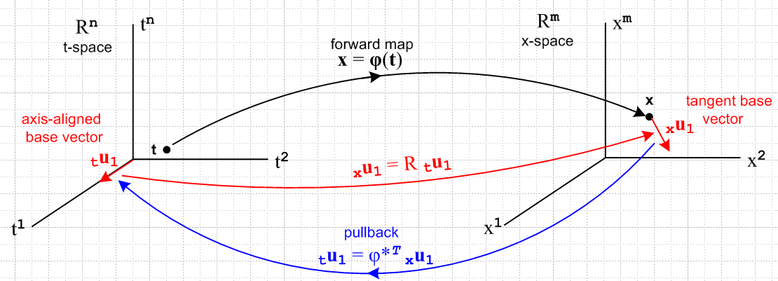
(10.6.14)

Since the transpose of A|b> is <b|AT as in (2.11.d.7), and since the R matrix is real, the dual space equations corresponding to the right sides of (10.6.11) and (10.6.12) are

<xei| φ* ≡ <xei| R = Rij< tuj|.

<xui | φ* = < tui| (10.6.15)

The bras in these equations are dual space vectors (rank-1 linear functionals) as discussed in Section 2.11.
The bra <xui | is an element of dual space (Rm)* while <tuj | inhabits (Rn)*. Note that Fig (10.6.14) displays only the spaces Rn and Rm and not the corresponding dual spaces, but one could imagine a similar drawing showing only the dual spaces.

Using the λi notation of Section 2.11 we can rewrite the first equation of (10.6.15) as

φ* xλi = Rij (tλj) = (Dφ)ij (tλj) (10.6.16)

where we define φ*α ≡ <α | φ*. This is the pullback of the ith dual-space basis vector functional xλi. Using (2.11.c.5) we can close with a generic vector v in t-space to get

[φ* xλi](v) = Rij (tλi)(v) = Rij vj = [Rv]i . (10.6.17)

Doing this directly in Dirac notation of course gives the same result,

<xei| φ*| v> = Rij< tuj| v> = Rij vj = [Rv]i = <xei | Rv> . (10.6.18)

Since this is valid for all basis vectors <xei| we recover our original statement that φ* = R,

φ*| v> = | Rv> = R |v> . (10.6.19)

In cosmetic notation we can write (10.6.16) as

φ* dxi = Rij dtj = (Dφ)ij dtj (10.6.20)

Since xλi = dxi is a very simple example of a differential form, we see in (10.6.20) our first example of "the pullback of a differential form". What is being "pulled back" is the dual vector <xei| = xλi ϵ (Rm)* . The pulled back vector is φ*(xλi) ϵ (Rn)*. The mapping is φ*: (Rm)*→ (Rn)*.

The Tangent Space Basis Vectors

Here we formalize some of the notions hinted at above. Assume that as t ranges over some portion of t-space in (10.6.14), the mapping x = φ(t) describes a "smooth surface" M embedded in x-space, hopefully a manifold or a piece thereof. If we start at some t and move to t + dt in t-space, we move from some point x on M to some nearby point x + dx on M. This dx is, by the definition of M, tangent to the surface M and thus lies in the tangent space TxM of M at point x, as discussed above in Section 10.2. Applying R to each of the n axis-aligned differentials dti = dti(tui) in t-space (no i sum), we thereby generate a set of n differential vectors dxi = Rdti which are in effect a set of short basis vectors which span the tangent space TxM. Since dxi = dxi (xui), we may take the basis vectors {xui, i=1,2..n} as spanning TxM, in agreement with our arrangement of things in Section 6.2. The vectors {xui, i=n+1,n+2..m} are then all orthogonal to the "surface" M. This set of m-n basis vectors spans the "perp space" (TxM) ⊥ and this space is said to have codimension m-n within Rm.
We know from the fact xui • xuj = δij that the set {xui, i=1,2..n} also form a basis for the tangent space TxM. This conclusion can be reached as well by raising all i indices in the previous paragraph. In this case, the set {xui, i=n+1,n+2..m} are then all orthogonal to the "surface" M.
According to (10.6.7) we may conclude that

Fact: The first n basis vectors xui, which are the columns of R** , span the tangent space TxM.
The first n basis vectors xui, which are the columns of R** , also span the tangent space TxM.
(10.6.21)

The cotangent space of TxM is the space of linear functionals xα defined on TxM, and this is precisely the space of differential forms defined on TxM.

10.7 The pullback of a general differential form

Recall from (10.6.15) the action of operator φ* = R on the bra <xei |,

<xei | φ* = Σj=1n Rij <tuj | i = 1,2..m . (10.6.15) (10.7.1)

Any operator P which acts on a vector space V, has a natural extension to being an operator on the tensor product space Vn , while its transpose PT has an extension acting on the dual tensor product space V*n

P | v1,v2....vk> ≡ P [ | v1> ⊗ |v2>....⊗|vk> ] = P| v1> ⊗ P|v2>....⊗ P|vk> .

< v1,v2....vk| PT = [ < v1| ⊗ <v2|....⊗<vk| ] PT = < v1|PT ⊗ <v2|PT....⊗<vk|PT . (10.7.2)

Taking the operator PT to be φ* which is the differential matrix R, one has

< xei$_{1}$, xei$_{2}$....xei$_{k}$| φ* = < xei$_{1}$, xei$_{2}$....xei$_{k}$| R // φ* ≡ R

= < xei$_{1}$|R ⊗ <xei$_{2}$|R....⊗ <xei$_{k}$|R // (10.7.3) with PT = R, and next line is (10.7.1)

= [Σj$_{1}$=1n Ri$_{1}$j$_{1}$ <tuj$_{1}$ | ] ⊗ [Σj$_{2}$=1m Ri$_{2}$j$_{2}$ <tuj$_{2}$ | ] ... ⊗ [Σj$_{k}$=1m Ri$_{k}$j$_{k}$ <tuj$_{k}$ | ]

= Σj$_{1}$j$_{2}$...j$_{k}$=1n Ri$_{1}$j$_{1}$ Ri$_{2}$j$_{2}$ ... Ri$_{k}$j$_{k}$ ( <tuj$_{1}$ | ⊗ <tuj$_{2}$ | ... ⊗ <tuj$_{k}$| )

= Σj$_{1}$j$_{2}$...j$_{k}$=1n Ri$_{1}$j$_{1}$ Ri$_{2}$j$_{2}$ ... Ri$_{k}$j$_{k}$ <tui$_{1}$, tui$_{2}$....tui$_{k}$ | . (10.7.3)

In multiindex notation this says (note that ΣJ is a full symmetric sum),

< xeI | φ* = ΣJ RIJ <tuJ | ϵ (Rn)* = dual tensor-product t-space (10.7.4)

A nearly identical result applies for wedge space Λk(Rn). Apply AltI to both sides of (10.7.4) to get

AltI [ < xeI | φ* ] = AltI [ ΣJ RIJ <tuJ | ] . (10.7.5)

According to (8.1.2) the left side is just

AltI [ < xeI | φ* ] = AltI [ < xeI | ] φ*

= < xe^I | φ* where <xe^I| = <xej$_{1}$ | ^ <xej$_{2}$ | ... ^ <xej$_{k}$| . (10.7.6)

The right side of (10.7.5) is a little tricky:

AltI [ ΣJ RIJ <tuJ | ] = ΣJ [AltI(RIJ)] <tuJ |

= ΣJ [(1/k!) ΣP(-1)P RP(I)J ] <tuJ | // (A.2.1) def of AltI

= (1/k!) ΣP(-1)P ( ΣJ RP(I)J ] <tuJ | ) // reorder

= [(1/k!) ΣP(-1)P ( ΣJ RP(I)P(J) ] <tuP(J) | ) // (A.1.20) that ΣJ fJ = ΣJ fP(J)

= [(1/k!) ΣP(-1)P ΣJ RIJ ] <tuP(J) | // (A.8.31) that RP(I)P(J) = RIJ

= ΣJ RIJ [(1/k!) ΣP(-1)P <tuP(J) | ] // reorder

= ΣJ RIJ AltJ <tuJ | // (A.2.1) def of AltJ

= ΣJ RIJ <tu^J | where <tu^I| = <tuj$_{1}$ | ^ <tuj$_{2}$ | ... ^ <tuj$_{k}$| . (10.7.7)

Thus we have shown how φ* ≡ R acts on dual basis vectors < xe^I | of the space Λk(Rm),

< xe^I | φ* = ΣJ RIJ <tu^J | ϵ Λk(Rn) = dual wedge-product t-space (10.7.8)

This is identical in form to (10.7.4) but the basis vectors are wedge products instead of tensor products.
ok to here 1:15 AM 3.20.16

A general element of Λk(Rm) at a point x on our surface M (a general "differential k-form") can be written from (10.2.1),

αx = Σ'I fI(x) xλ^I or <αx | = Σ'I fI(x) < xe^I | . (10.7.9)

Applying φ* = R then gives, using (10.7.8),

<αx | φ* = Σ'I fI(x) [ < xe^I | φ* ] = Σ'I fI(x) [ΣJ RIJ <tu^J | ] . (10.7.10)

Again using φ*(αx) ≡ <αx | φ* and <tu^J | = λ^J and x =φ(t) the above line can be restated,

φ*(αx) = Σ'I fI(φ(t)) ΣJ RIJ tλ^J (10.7.11)

which is then the pullback of an arbitrary differential k-form. We see from our operations above that:

Fact: The pullback of a k-form in x-space is a k-form in t-space, where k ≤ n ≤ m. (10.7.12)

After all, xλ^I is the wedge product of k dual basis vectors, and so is tλ^J .

There are now two paths leading off from this waypoint.

First path

Write (10.7.11) reordered as

φ*(αx) = ΣJ [ Σ'I fI(φ(t)) RIJ ] tλ^J

= ΣJ GJ(t) tλ^J GJ(t) ≡ Σ'I fI(φ(t)) RIJ

= Σ'J gJ(t) tλ^J gJ(t) ≡ k! AltJ[GJ(t)] , (10.7.13)

where the last line comes from (10.1.1) through (10.1.3). We have stated the result both in terms of symmetric ΣJ and ordered Σ'J summations. The coefficient functions gJ(t) can be re-expressed as,

gJ(t) ≡ k!AltJ[GJ(t)] = k!AltJ[ Σ'I fI(φ(t)) RIJ]

= k! Σ'I fI(φ(t)) AltJ[RIJ] // Alt is linear

= k! Σ'I fI(φ(t)) [ (1/k!) det(RIJ) ] // (A.8.30)

= Σ'I fI(φ(t)) det(RIJ) . (10.7.14)

The pullback of αx "along φ" is then

φ*(αx) = Σ'J Σ'I fI(φ(t)) det(RIJ(t)) tλ^J

= Σ'J Σ'I fI(φ(t)) det[(Dφ)IJ(t)] tλ^J ≡ βt (10.7.15)

Being a linear combination of tλ^J , φ*(αx) is seen to be an element of Λk(Rn) which is associated with t-space. That is to say, φ*(αx) is a differential form at a point t in t-space, so we give it an arbitrary name βt.

We pause once again to rewrite our last several results in cosmetic (subscript C) notation:

αx = Σ'I fI(x) xλ^I = Σ'I fI(x) dx^I (10.7.9)C

φ*(αx) = Σ'I fI(φ(t)) ΣJ RIJ dt^J R = (Dφ) (10.7.11)C

φ*(αx) = ΣJ [ Σ'I fI(φ(t)) RIJ ] dt^J

= ΣJ GJ(t) dt^J GJ(t) ≡ Σ'I fI(φ(t)) RIJ

= Σ'J gJ(t) dt^J gJ(t) ≡ k! AltJ[GJ(t)] , (10.7.13)C

φ*(αx) = Σ'J Σ'I fI(φ(t)) det(RIJ(t)) dt^J

= Σ'J Σ'I fI(φ(t)) det[(Dφ)IJ(t)] dt^J ≡ βt (10.7.15)C

It is useful to write out this last equation in full notation :

φ*(αx) = Σ1≤j$_{1}$<j$_{2}$<....<j$_{k}$≤n Σ1≤i$_{1}$<i$_{2}$<....<i$_{k}$≤m fi$_{1}$i$_{2}$...i$_{k}$(φ(t))

* det [RIJ] ( dti$_{1}$ ^ dti$_{2}$ .....^ dti$_{k}$ ) (10.7.16)

where RIJ is this kxk matrix,

Ri$_{1}$j$_{1}$ Ri$_{1}$j$_{2}$ ... Ri$_{1}$j$_{k}$
RIJ = Ri$_{2}$j$_{1}$ Ri$_{2}$j$_{2}$ ... Ri$_{2}$j$_{k}$
.....
Ri$_{k}$j$_{1}$ Ri$_{k}$j$_{2}$ ... Ri$_{k}$j$_{k}$ (10.7.17)

The object det(RIJ) is a k x k minor of the full m x n matrix R, so k ≤ n ≤ m in our application.

And it is time for some kind of picture where we add more detail to Fig (10.6.14),

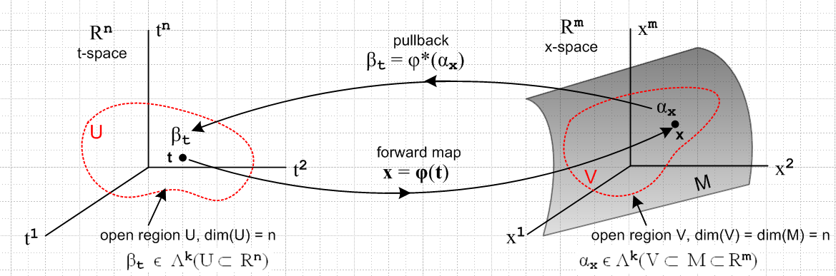
(10.7.18)

We have added an n-dimensional open domain region U in t-space which maps via x = φ(t) into an open region V which lies on the manifold M (a "surface"), which is of dimension n. Our point of interest t lies in U, and x lies in V. The picture is a bit symbolic since it shows t-space = Rn and x-space = Rm, but the differential forms αx and βt are really objects within the dual spaces (Rm)* and (Rn)*.

Here is a more practical picture for the special case n = 2 and k = 2:

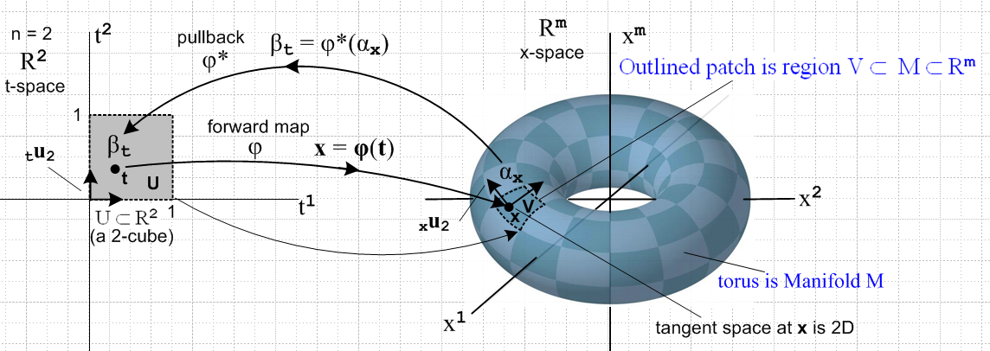
(10.7.19)

Here the open region U is a unit square [0,1]2 which maps into a patch on a torus. That is, if m = 3 the object on the right is a torus in R3, but we can imagine it to be a torus embedded in Rm for any m ≥ 3.
The space of vectors defined on U ⊂ R2 is a 2-dimensional dual space (R*)2(U). On this space we can define either 1-forms or 2-forms. The above picture suggests a 2-form since the region U is an area, and since we will later associate dt1 ^ dt2 with the calculus differential dt1dt2 which represents an area (we are not there yet).
The picture shows the "forward map" x = φ(t), suggesting that forward means left to right in the picture. Then αx is "pulled back" right to left from dual x-space to dual t-space where it becomes βt.
One could imagine a set of 16x6 = 96 mappings like the one shown above which would "cover the torus", using one little patch for each mapping. One would then have an atlas of 96 square maps like that on the left which would serve to cover the surface of Planet Toroid. This is the basic idea of a manifold. In the torus example, one could do the job with only 2 maps.
The aspect ratio of the 2-cube on the left is not significant. One could change it to be an arbitrary rectangle in t-space and select a φ to make it map to the same small image patch in x-space. Or one could construct a mapping φ which maps the unit 2-cube [0,1]2 to the entire left half of the torus. See Sjamaar.
The black arrows on the left are the t-space basis vectors tui (only tu2 is labeled). As shown in (10.6.7), these map according to xui = R tui into basis vectors which are tangent to M, and these vectors then span the tangent space TxM at point x on M. It is clear that the two xei will vary if the point x on M is varied.

As another example consider this situation with n = 1 and k = 1,

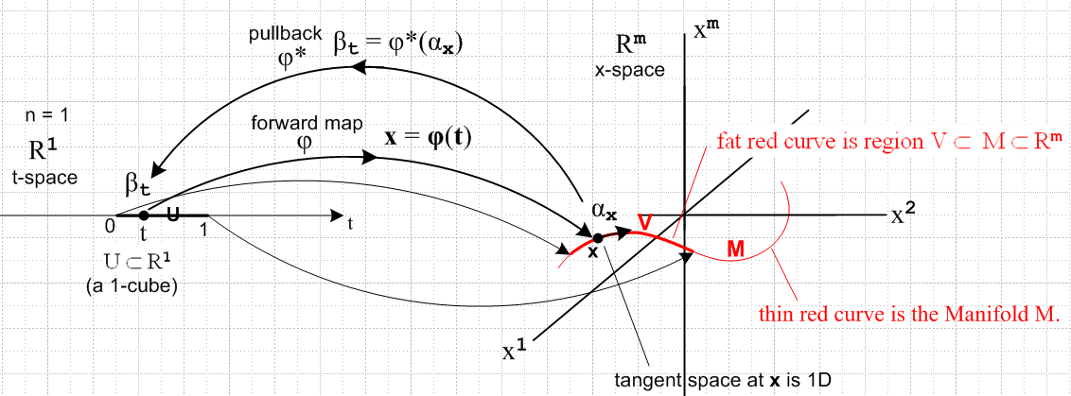
(10.7.20)

Now the domain in t-space is a U = 1-cube [0,1] which maps to a (generally non-planar) red curve which is embedded in Rm . Here αx and βt are 1-forms. The red curve V lies on the manifold M as shown, just as the patch of the previous example lay on the torus. There is only one basis vector tu in t-space (not shown) and it maps to the black arrow on the right which is xe and is of course tangent to the curve at x.

Second path

We return to our waypoint (10.7.11) showing the pullback of a general k-form,

φ*(αx) = Σ'I fI(x) ΣJ RIJ tλ^J x = φ(t) (10.7.11)
or
<αx | φ* = Σ'I fI(x) ΣJ RIJ <tu^J | // φ* = R

We make this bra into a tensor function by closing it with a ket | vn$_{1}$,vn$_{2}$...vn$_{k}$> of t-space vectors,

| vn$_{1}$,vn$_{2}$...vn$_{k}$> = | vn$_{1}$> ⊗ | vn$_{2}$> ..... ⊗ | vn$_{k}$> ϵ Vk V = Rn (10.7.21)

to get

<αx | φ*| vn$_{1}$,vn$_{2}$...vn$_{k}$> = Σ'I fI(x) ΣJ RIJ <tu^J | vn$_{1}$,vn$_{2}$...vn$_{k}$>. (10.7.22)

In more conventional notation this reads

[φ* αx] (vn$_{1}$,vn$_{2}$...vn$_{k}$) = Σ'I fI(x) ΣJ RIJ tλ^J(vn$_{1}$,vn$_{2}$...vn$_{k}$) . (10.7.23)

For the time being, we shall ignore the Σ'I fI(x) part and just consider ΣJ RIJ tλ^J(vn$_{1}$,vn$_{2}$...vn$_{k}$). We now process this expression through a long battery of steps to get the desired result:

ΣJ RIJ tλ^J(vn$_{1}$,vn$_{2}$...vn$_{k}$) = ΣJ RIJ (tλj$_{1}$ ^ tλj$_{2}$ ....^ tλj$_{k}$)(vn$_{1}$,vn$_{2}$...vn$_{k}$)

= ΣJ RIJ AltJ[(tλj$_{1}$ ⊗ tλj$_{2}$ ....⊗ tλj$_{k}$)(vn$_{1}$,vn$_{2}$...vn$_{k}$)] // (8.3.8)

= ΣJ RIJ AltJ[(tλj$_{1}$(vn$_{1}$)tλj$_{2}$(vn$_{2}$) ...tλj$_{k}$(vn$_{k}$)] // (6.1.3)

= ΣJ RIJ AltN[(tλj$_{1}$(vn$_{1}$)tλj$_{2}$(vn$_{2}$) ...tλj$_{k}$(vn$_{k}$)] // (A.8.29)

= AltN [ ΣJ RIJ (tλj$_{1}$(vn$_{1}$)tλj$_{2}$(vn$_{2}$) ...tλj$_{k}$(vn$_{k}$) ] // (A.8.10)

= AltN [ ΣJ RIJ (vn$_{1}$)j$_{1}$(vn$_{2}$)j$_{2}$ ... (vn$_{k}$)j$_{k}$ ] // (2.11.c.5)

= AltN [ Σj$_{1}$j$_{2}$...j$_{k}$=1m Ri$_{1}$j$_{1}$Ri$_{2}$j$_{2}$ ....Ri$_{k}$j$_{k}$ (vn$_{1}$)j$_{1}$(vn$_{2}$)j$_{2}$ ... (vn$_{k}$)j$_{k}$ ]

= AltN { [Σj$_{1}$Ri$_{1}$j$_{1}$(vn$_{1}$)j$_{1}$] [Σj$_{2}$Ri$_{2}$j$_{2}$(vn$_{2}$)j$_{2}$] ... [Σj$_{k}$Ri$_{k}$j$_{k}$(vn$_{k}$)j$_{k}$] }

= AltN { (Rvn$_{1}$)i$_{1}$(Rvn$_{2}$)i$_{2}$... (Rvn$_{k}$)i$_{k}$ } // (Rv)i = ΣjRijvj

= AltN {xλi$_{1}$(Rvn$_{1}$)xλi$_{2}$(Rvn$_{2}$)... xλi$_{k}$(Rvn$_{k}$) } // (2.11.c.5)

= AltI {xλi$_{1}$(Rvn$_{1}$) xλi$_{2}$(Rvn$_{2}$)... xλi$_{k}$(Rvn$_{k}$) } // (A.8.29)

= AltI {(xλi$_{1}$ ⊗ xλi$_{2}$ ....⊗ xλj$_{k}$) (Rvn$_{1}$, Rvn$_{2}$ ...Rvn$_{k}$)} // (6.1.3)

= ( xλi$_{1}$ ^ xλi$_{2}$... ^ xλi$_{k}$ )(Rvn$_{1}$,Rvn$_{2}$...Rvn$_{k}$) . // (8.3.8)

= ( xλ^I )(Rvn$_{1}$,Rvn$_{2}$...Rvn$_{k}$) . (10.7.24)

To summarize:

ΣJ RIJ tλ^J(vn$_{1}$,vn$_{2}$...vn$_{k}$) = ( xλ^I )(Rvn$_{1}$,Rvn$_{2}$...Rvn$_{k}$) . (10.7.25)

We then insert this into (10.7.23) to get

[φ* αx] (vn$_{1}$,vn$_{2}$...vn$_{k}$) = Σ'I fI(x) [ΣJ RIJ tλ^J(vn$_{1}$,vn$_{2}$...vn$_{k}$)]

= Σ'I fI(x) [ ( tλ^I )(Rvn$_{1}$,Rvn$_{2}$...Rvn$_{k}$)]

= [Σ'I fI(x) xλ^I ](Rvn$_{1}$,Rvn$_{2}$...Rvn$_{k}$)

= αx(Rvn$_{1}$,Rvn$_{2}$...Rvn$_{k}$) . (10.7.26)

We end up then with the "tensor function definition" of the pullback of a differential form αx :

[φ* αx] (vn$_{1}$,vn$_{2}$...vn$_{k}$) = αx(Rvn$_{1}$,Rvn$_{2}$...Rvn$_{k}$) (10.7.27)

which in Dirac notation is

<αx | φ*| vn$_{1}$,vn$_{2}$...vn$_{k}$> = <αx | Rvn$_{1}$,Rvn$_{2}$...Rvn$_{k}$> . (10.7.28)

Writing the right side as <αx | R | vn$_{1}$,vn$_{2}$...vn$_{k}$> we get

<αx | φ*| vn$_{1}$,vn$_{2}$...vn$_{k}$> = <αx | R | vn$_{1}$,vn$_{2}$...vn$_{k}$> (10.7.29)

which serves as a check on the fact that φ* = R. Alternatively, one can regard the last three equations in reverse order as a quick derivation of the pullback definition (10.7.27) .

Ref to Spivak and Sjamaar??

