Section 10.6 PhL 3.6.16
I will edit here to make a clean version that works for non-square R matrix.

10.6 Kinematics Packages for various mappings

Much mathematical hardware goes with a mapping. In mechanics, the selection of an appropriate set of coordinates and corresponding basis vectors is sometimes referred to as stating the kinematics of a problem (as opposed to the dynamics which involves equations of motion). Here we apply this term loosely to the cloud of equations associated with a mapping. Not all these equations will be used in our analysis, but we like being able to see them all in one place just in case something is needed.

In Chapter 2 we discussed the transformation x' = F(x) from x-space to x'-space using this picture,

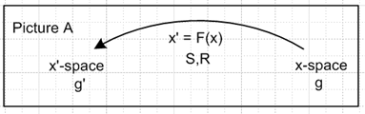 (2.1.1)

The vector transformation and "the differential" (the R-matrix) of the transformation were given by

V'a = RabVb Rab ≡ (∂x'a/∂xb) (2.1.2)

dx'a = Rabdxb dx' = Rdx . (2.1.12) (10.6.1)

Here V'a = RabVb shows the transformation of a contravariant vector under x' = F(x). In matrix notation one would write V' = RV. Repeated indices are always summed unless otherwise stated.

Axis-Aligned Vectors and Tangent Base Vectors : The Kinematics Package

It is shown in Tensor Section 3.2 that e'j are axis-aligned basis vectors [ (e'j)i = δji] in x'-space which inverse map to the "tangent base vectors" ej in x-space according to ej= Se'j and e'j = Rej. From (2.3.1) ej = ∂x/∂x'j so ej is tangent to an x'j "coordinate line" in x-space as discussed below (2.3.1).
Then in Tensor Section 3.5 the inverse transformation is discussed, x = F-1(x'), and for that transformation the uj are axis-aligned basis vectors [ (uj)i = δji] in x-space which map into the "inverse tangent base vectors" u'j in x'-space according to u'j= Ruj and uj= Su'j as in Tensor (3.5.3) In this case the inverse tangent base vector u'j is tangent to an inverse coordinate line for coordinate xj.
Many "facts" about the basis vectors ej, e'j, uj and u'j are developed in Tensor and below is our kinematics package summary with primed equation numbers referring to that document. We have in mind here the F: RN → RN so the matrices R and S are then N x N square matrices.

(a) x' = F(x) xform Rij ≡ (∂x'i/∂xj) = ∂jx'i R = (DF)
V' = R V vector contra only Sij ≡ (∂xi/∂x'j) = ∂'jxi

(b) e'i with (e'i)j = δij axis-aligned basis vectors in x'-space
ei ei= Se'i tangent base vector in x-space (7.18.1)'

(c) ui with (ui)j = δij axis-aligned basis vectors in x-space
u'i u'i= Rui tangent base vector in x'-space (7.18.3)'
(u'i)j = Rjk (ui)k

(d) 1= | e'i> <e'i| = | e'i> <e'i| = | u'i> <u'i| = | u'i> <u'i| completeness in x'-space
1= | ei> <ei| = | ei> <ei| = | ui> <ui| = | ui> <ui| completeness in x-space

(e) (uj)i = ui • uj = <ui | uj > = gij = u'i • u'j = <u'i | u'j >
(ej)i = ui • ej = <ui | ej > = Sij = Rji
(e'j)i = e'i • e'j = <e'i | e'j > = gij = ei • ej = <ei | ej >
(u'j)i = e'i • u'j = <e'i | u'j > = Rij = Sji (7.19.12)'

(f) ei = g'ij ej e'i = g'ij e'j ui = gij uj u'i = gij u'j
ei = g'ij ej e'i = g'ij e'j ui = gij uj u'i = gij u'j (7.19.14)'

(g) <ei | S | e'j> = <e'j | R | ei> = g'ji
<ei | S | u'j> = <u'j | R | ei> = Sji = Rij
<ui | S | e'j> = <e'j | R | ui> = Rji = Sij
<ui | S | u'j> = <u'j | R | ui> = gji . (7.19.19)'

(h) RRT = RTR = 1 SST = STS = 1 RS = SR = 1
RT = R-1 = S ST = S-1 = R . (7.9.8)' (10.6.2)

In any equation, any index or label can be raised or lowered on both sides. The object gin is the tensor-correct form of gin = δin = δi,n , allowing for indices to be raised and lowered, see (2.2.2). Here are two sample Dirac notation manipulations using the above information (implied sum in completeness),

|ei> = [1] |ei> = | uj> <uj|ei> = | uj>Rij = Rij |uj> or ei = Rijuj

|e'i> = [1] |e' i> = | u'j> <u'j| e'i> = | u'j> Rij = Rij |u'j> or e'i = Riju'j (10.6.3)

The first result ei = Rijuj appears in (2.5.5) showing that Rij is the basis change matrix between these two sets of basis vectors. Notice that an equation like ei = Rijuj is a "vector sum equation" since
ei = ΣjRijuj has a sum of vectors on the right side. No component indices appear on the vectors in this equation (i and j are labels).

What happens for a non-square tall R matrix?

In Chapter 2 and in Tensor it was assumed that x' = F(x) was an invertible mapping F: RN→RN . Now however we wish to consider the non-invertible mapping x' = F(x) where

F: Rn → Rm m > n
F: x-space → x'-space x ϵ Rn, x' ϵ Rm F(x) = x' . (10.6.4)

In Rab = (∂x'a/∂xb) the row index a ranges 1 to m, while column index b ranges 1 to n. Thus the down-tilt R matrix is a "tall" non-square matrix having m rows and n columns with m > n.
If we let the variable x exhaust some domain U within x-space, the mapping x' = F(x) generates a "surface" embedded within x'-space = Rm which has dimension n. We assume that the mapping F has sufficient smoothness properties so that this surface can be called a Manifold.
In this new context, one can write x = F-1(x') only for points x' on the manifold. For general points x' in x'-space the equation x = F-1(x') does not exist. This has rather severe implications for the kinematics package summarized above. For example, the S matrix does not exist, since Sij ≡ (∂xi/∂x'j) cannot be computed. In general anything depending on Sij no longer exists. For example, although the axis-aligned basis vectors e'i exist in x'-space, the tangent base vectors ei ≡ Se'i no longer exist in x-space. Although the metric tensors gij and gij continue to exist in x-space, only the metric tensor g'ij survives in x'-space. One reason that g'ij no longer exists is that g'ij = Sai Sbj gab and Sai does not exist. In the developmental notation of Tensor, if x-space is Cartesian, one finds that the contravariant metric tensor is given by g' = RRT, see (5.7.9)'. When R is a "tall" non-square matrix, a standard rank theorem of linear algebra shows that det(RRT) = 0 for any R. This means that g' = RRT is non-invertible, so its inverse (the covariant metric tensor ') does not exist, supporting the claim just made that g'ij no longer exists in standard notation. One implication is that, although contravariant and covariant vectors Vi and Vi exist in x-space, covariant vector components V'i do not exist in x'-space because there is no g'ij to lower the index of V'i to make it be V'i. But we can at least write V'i = RijVj = RijVj.
Despite these severe impacts on the theory presented in Chapter 2 and in Tensor, much of the kinematics package does manage to survive. Before continuing, we remark on which R matrices exist and which do not exist:

Rij ≡ (∂x'i/∂xj) exists Rji = Sij does not exist

Rij = g'ikRik exists Rij = g'ik Rkj does not exist because g'ik does not exist

(RT)ij = Rji exists since Rij exists.

We record below the equations of (10.6.2) that are still valid in a slimmed-down kinematics package appropriate for F: Rn → Rm (m > n) and its corresponding "tall" R matrix Rij ≡ (∂x'i/∂xj) :

(a) x' = F(x) xform Rij ≡ (∂x'i/∂xj) = ∂jx'i R = (DF)
V' = R V contravariant only

(b) e'i with (e'i)j = δij axis-aligned basis vectors in x'-space

(c) ui with (ui)j = δij axis-aligned basis vectors in x-space
u'i u'i= Rui tangent base vector in x'-space
(u'i)j = Rjk (ui)k

(d) 1= | e'i> <e'i| = | e'i> <e'i| = | u'i> <u'i| = | u'i> <u'i| completeness in x'-space
1 = | ui> <ui| = | ui> <ui| completeness in x-space

(e) (uj)i = ui • uj = <ui | uj > = gij = u'i • u'j = <u'i | u'j >
(e'j)i = e'i • e'j = <e'i | e'j > = gij
(u'j)i = e'i • u'j = <e'i | u'j > = Rij

(f) e'i = g'ij e'j ui = gij uj u'i = gij u'j
ui = gij uj u'i = gij u'j

(g) <e'i | R | uj> = Rij ≡ [R(e',u)]ij
<u'i | R | uj> = δij ≡ [R(u',u)]ij (10.6.5)

On the last line we show the R matrix in Dirac notation. The notion that Rij is not a true tensor since it has one foot in x'-space and one foot in x-space is made more concrete.

The Notion of Elbow Room

We can to some extent limp along with the above reduced kinematics package. For example, we still have the important idea that u'i= Rui maps the n axis-aligned basis vectors ui of x-space into a set of n tangent base vectors in x'-space. It is easy to show (we will do this later) that the u'i span the tangent space Tx'M at point x' on the manifold M.
We would like to invert u'i= Rui to get ui= Su'i and then we could say that u'i= Rui pushes forward the ui from x-space into the u'i in x'-space, and then ui= Su'i pulls back these tangent base vectors from x'-space to x-space. Since S does not exist, we cannot accomplish this goal. When we try to compute Sij ≡ (∂xi/∂x'j) at some point x' on M, we are forced to differentiate in some directions that don't lie on M (perhaps none of the directions is along the manifold), and since x = F-1(x') is only defined for x' on M, we are stuck.
At this point we present two nice drawings taken from Spivak's 1965 book ,

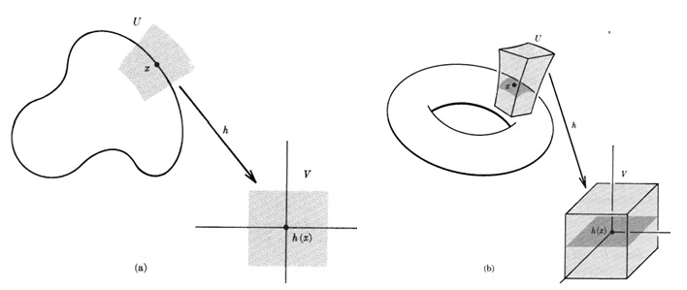

In the left drawing a line segment on the horizontal axis is being mapped (by h-1 = F) to a portion of a curve. This is a mapping F: R1 → R2. The gray area suggests the idea of creating "elbow room". The line segment is assumed to lie within a gray square which square maps to a region which encloses the curve segment. The mapping then becomes F: R2 → R2 and one can now differentiate in a direction normal to the curved line segment (which here is the manifold M). The idea here is then to enlarge the domain from 1D to 2D.

The right drawing shows a similar situation. One starts with the dark gray square and it maps to a dark gray patch on a toroid. At a point on this patch, we can differentiate in two directions if we are careful, but we cannot differentiate normal do the patch. But if the domain is enlarged from the dark square to the light gray cube, the mapping of that cube becomes the light gray cuboid shown encasing the dark patch, and then at a point on the patch one can differentiate in any direction. So here F: R2→R3 is extended to become F: R3 → R3.

We shall carry out this play for our general case F: Rn→ Rm and enhance this to become F: Rm→ Rm . To do this, consider the following set of equations comprising the original x' = F(x),

x'1 = F1(x1, x2, x3... xn) x' = F(x) , F: Rn→ Rm
x'2 = F2(x1, x2, x3... xn) n < m
... differential matrices are R and S
x'n = Fn(x1, x2, x3... xn) R is tall m x n, S is wide n x m
x'n+1 = Fn+1(x1, x2, x3... xn)
...
x'm = Fm(x1, x2, x3... xn) . m equations, n variables

We try now this extended version of x' = F(x) with changes shown in red:

x'1 = F1(x1, x2, x3... xn, xn+1....xm) x' = F(x) , F: Rm→ Rm
x'2 = F2(x1, x2, x3... xn,xn+1....xm)
... differential matrices are R and S
x'n = Fn(x1, x2, x3... xn,xn+1....xm) both R and S are square m x m matrices
x'n+1 = Fn+1(x1, x2, x3... xn,xn+1....xm) + xn+1
x'n+2 = Fn+2(x1, x2, x3... xn,xn+1....xm) + xn+2
...
x'm = Fm(x1, x2, x3... xn,xn+1....xm) + xm m equations, m variables

We draw in the extra variables in red, but the intention is that the Fi don't depend on any of these extra variables, we are just getting the thing into the formal m x m form. The last m-n variables x'n+1 through x'm had adders equal to the corresponding x-space variables xn+1 through xm.
We have thus enlarged x-space from Rn to Rm by adding m-n new axes, but our domain of interest does not extend into any of these new directions, it is still entirely contained in Rn. But now we have some elbow room around the domain in x-space. If we imagine extending the domain slightly into these new directions, the manifold M in x-space extends a little perpendicular to itself (into is perp space), and this provides elbow room for doing differentiation in x'-space, as in the Spivak pictures. Elbow room is provided in Rm around each point x' on the manifold M, and we can then compute the m x m differential matrix which we shall call S .
The m x m R-matrix Rij ≡ (∂x'i/∂xj) for the above transformation has this structure:

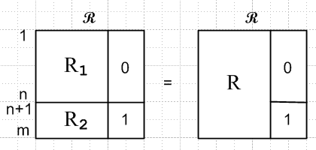

The original tall R matrix is called R, and we can think of it as an nxn square R1 over a rectangular R2. This original R matrix is now embedded in an m x m R matrix where there are all 0's to the right of R1 , and which has an (m-n)x(m-n) identity matrix in the lower right corner. The identity matrix is caused by the red adder terms in ****, while the region of 0's is because the Fi don't depend on the higher variables.
Notice that det(R) = det(R1). As long as R1 has full rank n, we have det(R1) ≠ 0 and so det(R) ≠ 0, which means R is invertible and we call this inverse S = R-1, so that RS = 1m . The matrix structure of RS = 1m is as follows,

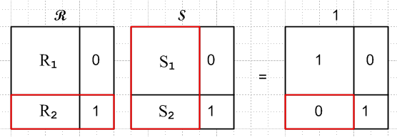

with which we associate these two matrix equations,

R1S1 = 1

R2 S1 + 1 S2 = 0

The second equation is highlighted in red outlines. Assuming R1 has full rank n, the solutions to these equations are

S1 = R1-1
S2 = - R2 S1 = - R2R1-1.

Defining R and S as tall matrices, we rewrite the above RS = 1m as

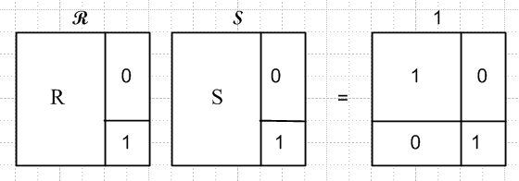

Where R is R1 over R2 and S is S1 over S2.

Summary: We have enlarged the original mapping x' = F(x) from F: Rn → Rm to F: Rm → Rm. The new mapping embeds the old mapping and provides m x m differential matrices R and S which both "exist". If we make the replacements R,S → R,S we can regard *** as providing a full kinematics package for the new enhanced transformation which has provided elbow room for the original transformation. To avoid confusion, we write that kinematics package here, and we cosmetically flip Picture A left to right to get Picture A' since this will better suit our needs below.

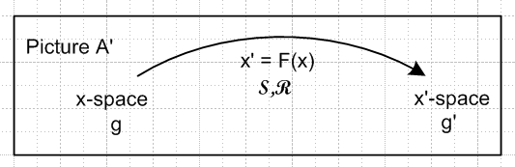

(a) x' = F(x) xform Rij ≡ (∂x'i/∂xj) = ∂jx'i R = (DF)
V' = R V vector contra only Sij ≡ (∂xi/∂x'j) = ∂'jxi

(b) e'i with (e'i)j = δij axis-aligned basis vectors in x'-space
ei ei= Se'i tangent base vector in x-space (7.18.1)'

(c) ui with (ui)j = δij axis-aligned basis vectors in x-space
u'i u'i= Rui tangent base vector in x'-space (7.18.3)'
(u'i)j = Rjk (ui)k

(d) 1= | e'i> <e'i| = | e'i> <e'i| = | u'i> <u'i| = | u'i> <u'i| completeness in x'-space
1= | ei> <ei| = | ei> <ei| = | ui> <ui| = | ui> <ui| completeness in x-space

(e) (uj)i = ui • uj = <ui | uj > = gij = u'i • u'j = <u'i | u'j >
(ej)i = ui • ej = <ui | ej > = Sij = Rji
(e'j)i = e'i • e'j = <e'i | e'j > = gij = ei • ej = <ei | ej >
(u'j)i = e'i • u'j = <e'i | u'j > = Rij = Sji (7.19.12)'

(f) ei = g'ij ej e'i = g'ij e'j ui = gij uj u'i = gij u'j
ei = g'ij ej e'i = g'ij e'j ui = gij uj u'i = gij u'j (7.19.14)'

(g) <ei | S | e'j> = <e'j | R | ei> = g'ji
<ei | S | u'j> = <u'j | R | ei> = Sji = Rij
<ui | S | e'j> = <e'j | R | ui> = Rji = Sij
<ui | S | u'j> = <u'j | R | ui> = gji . (7.19.19)'

(h) RRT = RTR = 1 SST = STS = 1 RS = SR = 1
RT = R-1 = S ST = S-1 = R . (7.9.8)' (10.6.2)

10.7 The Pullback Operator

Basis vectors in for x-space and x'-space

From (10.6.5c) we select as a basis for x-space Rm the set of m axis-aligned basis vectors ui,

{ui} i = 1,2...m basis for x-space Rm

(ui)j = δij j = 1,2...m components of these basis vectors in x-space . (10.6.6)

The first n of these map into a set of n tangent base vectors u'i in x'-space as shown in (10.6.5c),

u'i = R ui |u'i> = R |ui> i = 1,2..n
or
(u'i)j = Σa=1m Rja (ui)a = Σa=1n Rja (ui)a j = 1,2..m // rightmost columns of R are 0

= Σa=1n Rja (ui)a // left part of R is R.

= Σa=1n Rja δia = Rji = Rji

Inverting the above and using R-1 = S we obtain

ui = S u'i |ui> = S |u'i> i = 1,2..n
or
(ui)j = Σa=1m Sja (u'i)a = Σa=1m Sja Rai j = 1,2..m // using *****

= (SR)ji = δji

The result that (u'i)j = Rji is consistent with ***, while (ui)j = δji agrees with **.

Working

What about the remaining u'i for i = n+1 to m? I think you really cannot go set these arbitrarily, if you stick with the enlarged kinematics you really must use

u'i = R ui i = n+1, n+2 .....m

(u'i)j = Rji j = 1..m

This part of the R matrix ( rightmost columns i , all rows) has a very simple form. We find

(u'i)j = 0 for j = 1..n

(u'i)j = δij for j = n+1..m

So, these last m-n basis vectors in x'-space have all zeros for their first n components, and then one of the final components is 1. So for example

(u'n+1) = (0.0....0; 1,0,0..)
(u'n+2) = (0.0....0; 0,1,0..)
....
(u'm) = (0.0....0; 0,0,0..1)

These basis vectors are mappings of the unphysical added ones in x-space.

I think this is a problem with my very simple enlargement method. These basis vectors do not span the perp space as a general rule, so the full set of u'i is not a basis for x'-space Rm . Is that a problem or not? I can just use the first n of the official u'i and then roll my own for the perp space.

PAUSE. Today I have "simulated" in v7 how Section 10.6 would flow if I implement the elbow room idea. I certainly adds a lot of complexity. I somehow suspect it is not necessary, and the way I did it is probably too artificial to be useful. Will ponder tomorrow.

= Σa=1n Sja (u'i)a j = 1,2..m // rightmost columns of S are 0

= Σa=1n Sja (u'i)a

= Σa=1n Sja (u'i)a // left part of S is S

= Σa=1n Sja δia = Sja // = Sja

Mystery: If I look back at (10.6.2) it says

(uj)i = ui • uj = <ui | uj > = gij = u'i • u'j = <u'i | u'j >

but this does not seem to agree with what we have above.

= Rja δia = Rji i = 1,2...n j = 1,2..m . (10.6.7)

Since there are m basis vectors in x'-space, we define the rest of the u'i arbitrarily such that the m basis vectors {u'i} in Rm are linearly independent, so

u'i = as needed i = n+1, n+2 .....m . (10.6.8)

Note in (10.6.7) that (u'i)j = Rja(ui)a = Σa=1n Rja(ui)a is a "component sum equation", in contrast with the "vector sum equation" e'i = Σj=1nRiju'j appearing in (10.6.3).

Based on (10.6.7) that Rji = (u'i)j, one concludes that the columns of R** are the contravariant basis vectors u'i

R** = [u'1, u'2 ....u'n ] (10.6.9)

Like any x'-space vectors, the u'i vectors have m components, so R** has m rows, and it obviously has n columns, consistent with comments above about R being an m x n matrix.

We can apply gij to both sides of (10.6.7) and then use (10.6.5f) to get

u'i = R ui |u'i> = R |ui>
or (10.6.10)
(u'i)j = Rja (ui)a = Rja gib(ub)a = Rja gibδba = Rja gia = Rji .

ok to here, resume making use of RT which in fact does exist in an appropriate sense. Work first in ket space, and later change to bra space.

Consider now, using a completeness relations from (10.6.5d) and a matrix element from (10.6.5g),

<e'i | R = <e'i | R*1 = <e'i | R | uj> <uj| = Rij <uj| (10.6.11)

The right side of this "vector sum equation" is a linear combinations of vectors in x-space, so the left side must also be a vector in x-space. We now create a duplicate name F* for operator R and we write the above as

<e'i | F* ≡ <e'i | R = Rij <uj|

This F* is called the pullback operator. We know that |e'i> = e'i is an axis-aligned basis vector in x'-space Rm, and <e'i | is the corresponding dual vector in the dual space (Rm)*. We see then that the action of F* is to "pull back" this dual basis vector <e'i | of dual x'-space into a certain linear combination of dual vectors in dual x-space.

Of more interest to us is the action of F* on the dual vector <u'i | in dual x'-space.

<u'i | F* ≡ <u'i | R = <u'i | R | uj> <uj| = δij <uj| = <ui |

*****************************

I want to say this:

<e'i | R = Rij <uj|
or
RT |e'i > = Rij |uj>
or
RT e'i = Rijuj

but I am worried that RT does not exist. But maybe that depends on which RT you are talking about. How do you write out the left side of this last equation?

[RT e'i]a = Rij (uj)a pick u basis // covariant vector component in x-space

(RT)ab (e'i)b = Rij(uj)a

Rba (e'i)b = Rij(uj)a = Ria

[R(e',u)]ij (e'i(u))b

so it involves the downtilt R matrix

Σj=1n Rij <uj |

First of all, both sides of this equation

Now I need to set a Target. Here it is

<e'i | φ* = <e'i | R = Σj=1n Rij <uj |

How do I get to this Target? I need to show that

<e'i | R = Σj=1n Rij <uj | this is a "vector sum equation".

Let's try closing both sides with | uk> in an attempt to verify the Target,

<e'i | R | uk> = Σj=1n Rij <uj | uk> ?

<e'i | R | uk> = Σj=1n Rij δjk ?

<e'i | R | uk> = Rik ? YES!!!!

I do know that

|e'i> = [1] |e' i> = | u'j> <u'j| e'i> = | u'j> Rij = Rij |u'j> or e'i = Riju'j (10.6.3)

which says

|e'i> = Rij |u'j>

and this in turn says

<e'i| = Rij <u'j|

OUCH!! But what I wanted was this

<e'i | R = Rij <uj |

<xei | φ* = Σj=1n Rij <tuj | i = 1,2..m . (10.6.15) (10.7.1)

<e'i | φ* = <e'i | R = Σj=1n Rij <uj | i = 1,2..m . (10.6.15) (10.7.1)

The pullback operator

We wish to define the action of a certain "pullback operator" called φ*T on an axis-aligned basis vector in x-space. Using completeness 1 = | tuj> <tuj|, then using <a|XT|b> = <b|X|a>, and then looking up the resulting R matrix element in (10.6.4), we find,

φ*T |xei> ≡ RT |xei> = |tuj> <tuj| RT |xei> = | tuj><xei| R |tuj> = Rij| tuj>.
or
φ*T |xei> = Rij| tuj> and similarly φ*T |xei> = Rij| tuj> . (10.6.11)

Although we give the operator φ*T a life of its own, it is really just φ*T = RT = R-1 = S. So the first point is that the so-called pullback operator is nothing new, it is something we know all about. The above equation shows that φ*T "pulls back" an axis-aligned basis vector |xei> in x-space into a certain linear combination of axis-aligned basis vectors in t-space, namely, Rij| tuj> .

Of more interest to us is the action of φ*T on a tangent base vector |xui> in x-space. Using the same tricks, we evaluate,

φ*T |xui> ≡ RT |xui> = |tuj> <tuj| RT |xui> = | tuj><xui| R |tuj> = | tuj> tgij = | tui>
or
φ*T |xui> = | tui> and similarly φ*T |xui> = | tui> . (10.6.12)

This fact is obvious from (10.6.7) since |xui> = R |tui> ⇒ |tui> = R-1 |xui> = RT |xui> .

Thus, the pullback operator grabs all the tangent base vectors which span the tangent space TxM and pulls them back into the axis-aligned basis vectors in t-space. Eventually this is how we are going to be able to integrate over a manifold in x-space. Notice that there is a 1-to-1 mapping between all of t-space and the space TxM, each space having dimension n, so that R-1 exists for this restricted mapping with i = 1,2..n.
In regular vector notation we can write (10.6.11) and (10.6.12) as

φ*T xei = RT xei = Rij tuj or φ*T xei = RT xei = Rij tuj

φ*T xui = RT xui = tui or φ*T xui = RT xui = tui (10.6.13)

where RT reverse to the covariant transpose as discussed in ***.

We now enhance Fig (10.6.5) showing the pullback of the first tangent base vector,

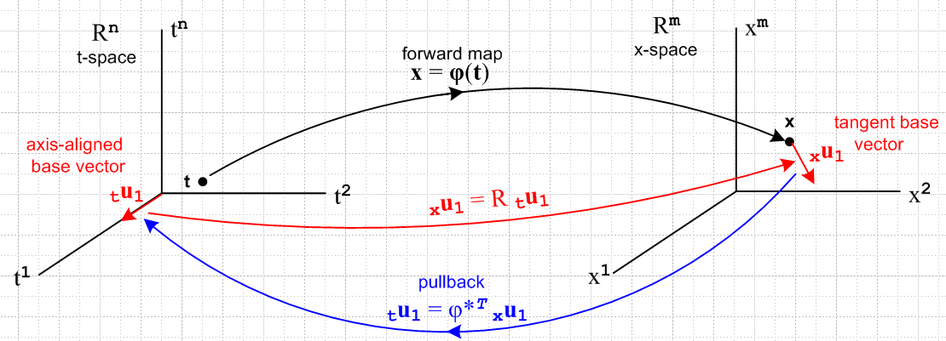
(10.6.14)

Since the transpose of A|b> is <b|AT as in (2.11.d.7), and since the R matrix is real, the dual space equations corresponding to the right sides of (10.6.11) and (10.6.12) are

<xei| φ* ≡ <xei| R = Rij< tuj|.

<xui | φ* = < tui| (10.6.15)

The bras in these equations are dual space vectors (rank-1 linear functionals) as discussed in Section 2.11.
The bra <xui | is an element of dual space (Rm)* while <tuj | inhabits (Rn)*. Note that Fig (10.6.14) displays only the spaces Rn and Rm and not the corresponding dual spaces, but one could imagine a similar drawing showing only the dual spaces.

Using the λi notation of Section 2.11 we can rewrite the first equation of (10.6.15) as

φ* xλi = Rij (tλj) = (Dφ)ij (tλj) (10.6.16)

where we define φ*α ≡ <α | φ*. This is the pullback of the ith dual-space basis vector functional xλi. Using (2.11.c.5) we can close with a generic vector v in t-space to get

[φ* xλi](v) = Rij (tλi)(v) = Rij vj = [Rv]i . (10.6.17)

Doing this directly in Dirac notation of course gives the same result,

<xei| φ*| v> = Rij< tuj| v> = Rij vj = [Rv]i = <xei | Rv> . (10.6.18)

Since this is valid for all basis vectors <xei| we recover our original statement that φ* = R,

φ*| v> = | Rv> = R |v> . (10.6.19)

In cosmetic notation we can write (10.6.16) as

φ* dxi = Rij dtj = (Dφ)ij dtj (10.6.20)

Since xλi = dxi is a very simple example of a differential form, we see in (10.6.20) our first example of "the pullback of a differential form". What is being "pulled back" is the dual vector <xei| = xλi ϵ (Rm)* . The pulled back vector is φ*(xλi) ϵ (Rn)*. The mapping is φ*: (Rm)*→ (Rn)*.

The Tangent Space Basis Vectors

Here we formalize some of the notions hinted at above. Assume that as t ranges over some portion of t-space in (10.6.14), the mapping x = φ(t) describes a "smooth surface" M embedded in x-space, hopefully a manifold or a piece thereof. If we start at some t and move to t + dt in t-space, we move from some point x on M to some nearby point x + dx on M. This dx is, by the definition of M, tangent to the surface M and thus lies in the tangent space TxM of M at point x, as discussed above in Section 10.2. Applying R to each of the n axis-aligned differentials dti = dti(tui) in t-space (no i sum), we thereby generate a set of n differential vectors dxi = Rdti which are in effect a set of short basis vectors which span the tangent space TxM. Since dxi = dxi (xui), we may take the basis vectors {xui, i=1,2..n} as spanning TxM, in agreement with our arrangement of things in Section 6.2. The vectors {xui, i=n+1,n+2..m} are then all orthogonal to the "surface" M. This set of m-n basis vectors spans the "perp space" (TxM) ⊥ and this space is said to have codimension m-n within Rm.
We know from the fact xui • xuj = δij that the set {xui, i=1,2..n} also form a basis for the tangent space TxM. This conclusion can be reached as well by raising all i indices in the previous paragraph. In this case, the set {xui, i=n+1,n+2..m} are then all orthogonal to the "surface" M.
According to (10.6.7) we may conclude that

Fact: The first n basis vectors xui, which are the columns of R** , span the tangent space TxM.
The first n basis vectors xui, which are the columns of R** , also span the tangent space TxM.
(10.6.21)

The cotangent space of TxM is the space of linear functionals xα defined on TxM, and this is precisely the space of differential forms defined on TxM.

10.7 The pullback of a general differential form

Recall from (10.6.15) the action of operator φ* = R on the bra <xei |,

<xei | φ* = Σj=1n Rij <tuj | i = 1,2..m . (10.6.15) (10.7.1)

Any operator P which acts on a vector space V, has a natural extension to being an operator on the tensor product space Vn , while its transpose PT has an extension acting on the dual tensor product space V*n

P | v1,v2....vk> ≡ P [ | v1> ⊗ |v2>....⊗|vk> ] = P| v1> ⊗ P|v2>....⊗ P|vk> .

< v1,v2....vk| PT = [ < v1| ⊗ <v2|....⊗<vk| ] PT = < v1|PT ⊗ <v2|PT....⊗<vk|PT . (10.7.2)

Taking the operator PT to be φ* which is the differential matrix R, one has

< xei$_{1}$, xei$_{2}$....xei$_{k}$| φ* = < xei$_{1}$, xei$_{2}$....xei$_{k}$| R // φ* ≡ R

= < xei$_{1}$|R ⊗ <xei$_{2}$|R....⊗ <xei$_{k}$|R // (10.7.3) with PT = R, and next line is (10.7.1)

= [Σj$_{1}$=1n Ri$_{1}$j$_{1}$ <tuj$_{1}$ | ] ⊗ [Σj$_{2}$=1m Ri$_{2}$j$_{2}$ <tuj$_{2}$ | ] ... ⊗ [Σj$_{k}$=1m Ri$_{k}$j$_{k}$ <tuj$_{k}$ | ]

= Σj$_{1}$j$_{2}$...j$_{k}$=1n Ri$_{1}$j$_{1}$ Ri$_{2}$j$_{2}$ ... Ri$_{k}$j$_{k}$ ( <tuj$_{1}$ | ⊗ <tuj$_{2}$ | ... ⊗ <tuj$_{k}$| )

= Σj$_{1}$j$_{2}$...j$_{k}$=1n Ri$_{1}$j$_{1}$ Ri$_{2}$j$_{2}$ ... Ri$_{k}$j$_{k}$ <tui$_{1}$, tui$_{2}$....tui$_{k}$ | . (10.7.3)

In multiindex notation this says (note that ΣJ is a full symmetric sum),

< xeI | φ* = ΣJ RIJ <tuJ | ϵ (Rn)* = dual tensor-product t-space (10.7.4)

A nearly identical result applies for wedge space Λk(Rn). Apply AltI to both sides of (10.7.4) to get

AltI [ < xeI | φ* ] = AltI [ ΣJ RIJ <tuJ | ] . (10.7.5)

According to (8.1.2) the left side is just

AltI [ < xeI | φ* ] = AltI [ < xeI | ] φ*

= < xe^I | φ* where <xe^I| = <xej$_{1}$ | ^ <xej$_{2}$ | ... ^ <xej$_{k}$| . (10.7.6)

The right side of (10.7.5) is a little tricky:

AltI [ ΣJ RIJ <tuJ | ] = ΣJ [AltI(RIJ)] <tuJ |

= ΣJ [(1/k!) ΣP(-1)P RP(I)J ] <tuJ | // (A.2.1) def of AltI

= (1/k!) ΣP(-1)P ( ΣJ RP(I)J ] <tuJ | ) // reorder

= [(1/k!) ΣP(-1)P ( ΣJ RP(I)P(J) ] <tuP(J) | ) // (A.1.20) that ΣJ fJ = ΣJ fP(J)

= [(1/k!) ΣP(-1)P ΣJ RIJ ] <tuP(J) | // (A.8.31) that RP(I)P(J) = RIJ

= ΣJ RIJ [(1/k!) ΣP(-1)P <tuP(J) | ] // reorder

= ΣJ RIJ AltJ <tuJ | // (A.2.1) def of AltJ

= ΣJ RIJ <tu^J | where <tu^I| = <tuj$_{1}$ | ^ <tuj$_{2}$ | ... ^ <tuj$_{k}$| . (10.7.7)

Thus we have shown how φ* ≡ R acts on dual basis vectors < xe^I | of the space Λk(Rm),

< xe^I | φ* = ΣJ RIJ <tu^J | ϵ Λk(Rn) = dual wedge-product t-space (10.7.8)

This is identical in form to (10.7.4) but the basis vectors are wedge products instead of tensor products.
ok to here 1:15 AM 3.20.16

A general element of Λk(Rm) at a point x on our surface M (a general "differential k-form") can be written from (10.2.1),

αx = Σ'I fI(x) xλ^I or <αx | = Σ'I fI(x) < xe^I | . (10.7.9)

Applying φ* = R then gives, using (10.7.8),

<αx | φ* = Σ'I fI(x) [ < xe^I | φ* ] = Σ'I fI(x) [ΣJ RIJ <tu^J | ] . (10.7.10)

Again using φ*(αx) ≡ <αx | φ* and <tu^J | = λ^J and x =φ(t) the above line can be restated,

φ*(αx) = Σ'I fI(φ(t)) ΣJ RIJ tλ^J (10.7.11)

which is then the pullback of an arbitrary differential k-form. We see from our operations above that:

Fact: The pullback of a k-form in x-space is a k-form in t-space, where k ≤ n ≤ m. (10.7.12)

After all, xλ^I is the wedge product of k dual basis vectors, and so is tλ^J .

There are now two paths leading off from this waypoint.

First path

Write (10.7.11) reordered as

φ*(αx) = ΣJ [ Σ'I fI(φ(t)) RIJ ] tλ^J

= ΣJ GJ(t) tλ^J GJ(t) ≡ Σ'I fI(φ(t)) RIJ

= Σ'J gJ(t) tλ^J gJ(t) ≡ k! AltJ[GJ(t)] , (10.7.13)

where the last line comes from (10.1.1) through (10.1.3). We have stated the result both in terms of symmetric ΣJ and ordered Σ'J summations. The coefficient functions gJ(t) can be re-expressed as,

gJ(t) ≡ k!AltJ[GJ(t)] = k!AltJ[ Σ'I fI(φ(t)) RIJ]

= k! Σ'I fI(φ(t)) AltJ[RIJ] // Alt is linear

= k! Σ'I fI(φ(t)) [ (1/k!) det(RIJ) ] // (A.8.30)

= Σ'I fI(φ(t)) det(RIJ) . (10.7.14)

The pullback of αx "along φ" is then

φ*(αx) = Σ'J Σ'I fI(φ(t)) det(RIJ(t)) tλ^J

= Σ'J Σ'I fI(φ(t)) det[(Dφ)IJ(t)] tλ^J ≡ βt (10.7.15)

Being a linear combination of tλ^J , φ*(αx) is seen to be an element of Λk(Rn) which is associated with t-space. That is to say, φ*(αx) is a differential form at a point t in t-space, so we give it an arbitrary name βt.

We pause once again to rewrite our last several results in cosmetic (subscript C) notation:

αx = Σ'I fI(x) xλ^I = Σ'I fI(x) dx^I (10.7.9)C

φ*(αx) = Σ'I fI(φ(t)) ΣJ RIJ dt^J R = (Dφ) (10.7.11)C

φ*(αx) = ΣJ [ Σ'I fI(φ(t)) RIJ ] dt^J

= ΣJ GJ(t) dt^J GJ(t) ≡ Σ'I fI(φ(t)) RIJ

= Σ'J gJ(t) dt^J gJ(t) ≡ k! AltJ[GJ(t)] , (10.7.13)C

φ*(αx) = Σ'J Σ'I fI(φ(t)) det(RIJ(t)) dt^J

= Σ'J Σ'I fI(φ(t)) det[(Dφ)IJ(t)] dt^J ≡ βt (10.7.15)C

It is useful to write out this last equation in full notation :

φ*(αx) = Σ1≤j$_{1}$<j$_{2}$<....<j$_{k}$≤n Σ1≤i$_{1}$<i$_{2}$<....<i$_{k}$≤m fi$_{1}$i$_{2}$...i$_{k}$(φ(t))

* det [RIJ] ( dti$_{1}$ ^ dti$_{2}$ .....^ dti$_{k}$ ) (10.7.16)

where RIJ is this kxk matrix,

Ri$_{1}$j$_{1}$ Ri$_{1}$j$_{2}$ ... Ri$_{1}$j$_{k}$
RIJ = Ri$_{2}$j$_{1}$ Ri$_{2}$j$_{2}$ ... Ri$_{2}$j$_{k}$
.....
Ri$_{k}$j$_{1}$ Ri$_{k}$j$_{2}$ ... Ri$_{k}$j$_{k}$ (10.7.17)

The object det(RIJ) is a k x k minor of the full m x n matrix R, so k ≤ n ≤ m in our application.

And it is time for some kind of picture where we add more detail to Fig (10.6.14),

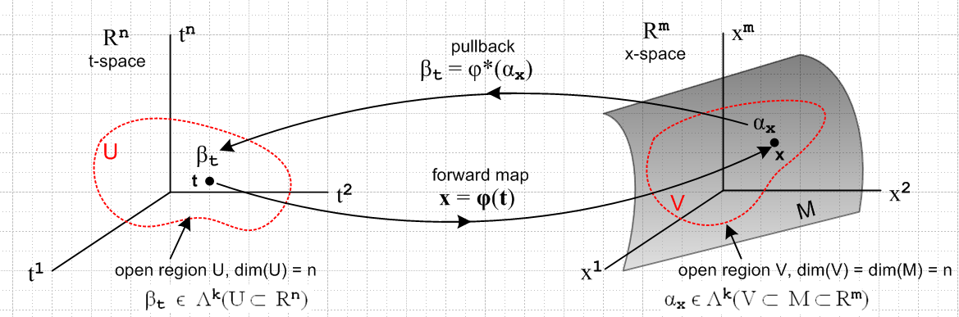
(10.7.18)

We have added an n-dimensional open domain region U in t-space which maps via x = φ(t) into an open region V which lies on the manifold M (a "surface"), which is of dimension n. Our point of interest t lies in U, and x lies in V. The picture is a bit symbolic since it shows t-space = Rn and x-space = Rm, but the differential forms αx and βt are really objects within the dual spaces (Rm)* and (Rn)*.

Here is a more practical picture for the special case n = 2 and k = 2:

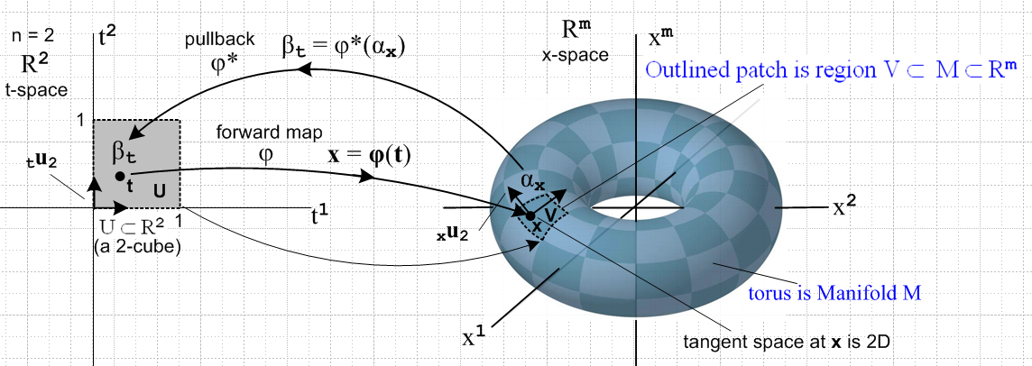
(10.7.19)

Here the open region U is a unit square [0,1]2 which maps into a patch on a torus. That is, if m = 3 the object on the right is a torus in R3, but we can imagine it to be a torus embedded in Rm for any m ≥ 3.
The space of vectors defined on U ⊂ R2 is a 2-dimensional dual space (R*)2(U). On this space we can define either 1-forms or 2-forms. The above picture suggests a 2-form since the region U is an area, and since we will later associate dt1 ^ dt2 with the calculus differential dt1dt2 which represents an area (we are not there yet).
The picture shows the "forward map" x = φ(t), suggesting that forward means left to right in the picture. Then αx is "pulled back" right to left from dual x-space to dual t-space where it becomes βt.
One could imagine a set of 16x6 = 96 mappings like the one shown above which would "cover the torus", using one little patch for each mapping. One would then have an atlas of 96 square maps like that on the left which would serve to cover the surface of Planet Toroid. This is the basic idea of a manifold. In the torus example, one could do the job with only 2 maps.
The aspect ratio of the 2-cube on the left is not significant. One could change it to be an arbitrary rectangle in t-space and select a φ to make it map to the same small image patch in x-space. Or one could construct a mapping φ which maps the unit 2-cube [0,1]2 to the entire left half of the torus. See Sjamaar.
The black arrows on the left are the t-space basis vectors tui (only tu2 is labeled). As shown in (10.6.7), these map according to xui = R tui into basis vectors which are tangent to M, and these vectors then span the tangent space TxM at point x on M. It is clear that the two xei will vary if the point x on M is varied.

As another example consider this situation with n = 1 and k = 1,

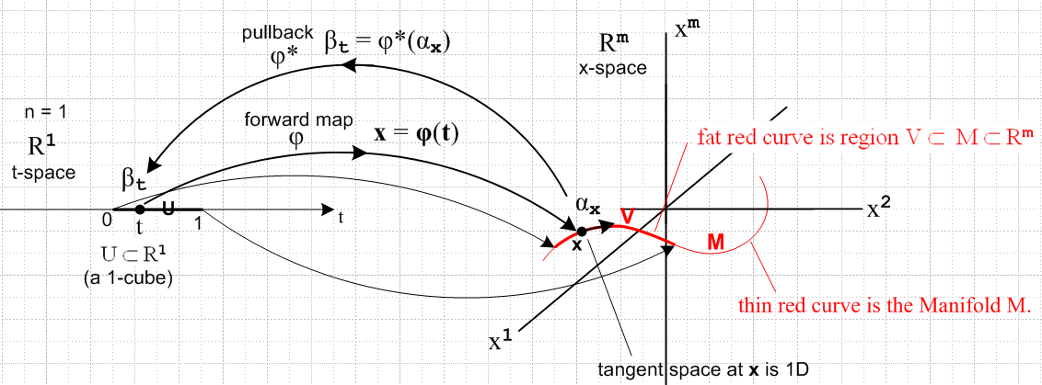
(10.7.20)

Now the domain in t-space is a U = 1-cube [0,1] which maps to a (generally non-planar) red curve which is embedded in Rm . Here αx and βt are 1-forms. The red curve V lies on the manifold M as shown, just as the patch of the previous example lay on the torus. There is only one basis vector tu in t-space (not shown) and it maps to the black arrow on the right which is xe and is of course tangent to the curve at x.

Second path

We return to our waypoint (10.7.11) showing the pullback of a general k-form,

φ*(αx) = Σ'I fI(x) ΣJ RIJ tλ^J x = φ(t) (10.7.11)
or
<αx | φ* = Σ'I fI(x) ΣJ RIJ <tu^J | // φ* = R

We make this bra into a tensor function by closing it with a ket | vn$_{1}$,vn$_{2}$...vn$_{k}$> of t-space vectors,

| vn$_{1}$,vn$_{2}$...vn$_{k}$> = | vn$_{1}$> ⊗ | vn$_{2}$> ..... ⊗ | vn$_{k}$> ϵ Vk V = Rn (10.7.21)

to get

<αx | φ*| vn$_{1}$,vn$_{2}$...vn$_{k}$> = Σ'I fI(x) ΣJ RIJ <tu^J | vn$_{1}$,vn$_{2}$...vn$_{k}$>. (10.7.22)

In more conventional notation this reads

[φ* αx] (vn$_{1}$,vn$_{2}$...vn$_{k}$) = Σ'I fI(x) ΣJ RIJ tλ^J(vn$_{1}$,vn$_{2}$...vn$_{k}$) . (10.7.23)

For the time being, we shall ignore the Σ'I fI(x) part and just consider ΣJ RIJ tλ^J(vn$_{1}$,vn$_{2}$...vn$_{k}$). We now process this expression through a long battery of steps to get the desired result:

ΣJ RIJ tλ^J(vn$_{1}$,vn$_{2}$...vn$_{k}$) = ΣJ RIJ (tλj$_{1}$ ^ tλj$_{2}$ ....^ tλj$_{k}$)(vn$_{1}$,vn$_{2}$...vn$_{k}$)

= ΣJ RIJ AltJ[(tλj$_{1}$ ⊗ tλj$_{2}$ ....⊗ tλj$_{k}$)(vn$_{1}$,vn$_{2}$...vn$_{k}$)] // (8.3.8)

= ΣJ RIJ AltJ[(tλj$_{1}$(vn$_{1}$)tλj$_{2}$(vn$_{2}$) ...tλj$_{k}$(vn$_{k}$)] // (6.1.3)

= ΣJ RIJ AltN[(tλj$_{1}$(vn$_{1}$)tλj$_{2}$(vn$_{2}$) ...tλj$_{k}$(vn$_{k}$)] // (A.8.29)

= AltN [ ΣJ RIJ (tλj$_{1}$(vn$_{1}$)tλj$_{2}$(vn$_{2}$) ...tλj$_{k}$(vn$_{k}$) ] // (A.8.10)

= AltN [ ΣJ RIJ (vn$_{1}$)j$_{1}$(vn$_{2}$)j$_{2}$ ... (vn$_{k}$)j$_{k}$ ] // (2.11.c.5)

= AltN [ Σj$_{1}$j$_{2}$...j$_{k}$=1m Ri$_{1}$j$_{1}$Ri$_{2}$j$_{2}$ ....Ri$_{k}$j$_{k}$ (vn$_{1}$)j$_{1}$(vn$_{2}$)j$_{2}$ ... (vn$_{k}$)j$_{k}$ ]

= AltN { [Σj$_{1}$Ri$_{1}$j$_{1}$(vn$_{1}$)j$_{1}$] [Σj$_{2}$Ri$_{2}$j$_{2}$(vn$_{2}$)j$_{2}$] ... [Σj$_{k}$Ri$_{k}$j$_{k}$(vn$_{k}$)j$_{k}$] }

= AltN { (Rvn$_{1}$)i$_{1}$(Rvn$_{2}$)i$_{2}$... (Rvn$_{k}$)i$_{k}$ } // (Rv)i = ΣjRijvj

= AltN {xλi$_{1}$(Rvn$_{1}$)xλi$_{2}$(Rvn$_{2}$)... xλi$_{k}$(Rvn$_{k}$) } // (2.11.c.5)

= AltI {xλi$_{1}$(Rvn$_{1}$) xλi$_{2}$(Rvn$_{2}$)... xλi$_{k}$(Rvn$_{k}$) } // (A.8.29)

= AltI {(xλi$_{1}$ ⊗ xλi$_{2}$ ....⊗ xλj$_{k}$) (Rvn$_{1}$, Rvn$_{2}$ ...Rvn$_{k}$)} // (6.1.3)

= ( xλi$_{1}$ ^ xλi$_{2}$... ^ xλi$_{k}$ )(Rvn$_{1}$,Rvn$_{2}$...Rvn$_{k}$) . // (8.3.8)

= ( xλ^I )(Rvn$_{1}$,Rvn$_{2}$...Rvn$_{k}$) . (10.7.24)

To summarize:

ΣJ RIJ tλ^J(vn$_{1}$,vn$_{2}$...vn$_{k}$) = ( xλ^I )(Rvn$_{1}$,Rvn$_{2}$...Rvn$_{k}$) . (10.7.25)

We then insert this into (10.7.23) to get

[φ* αx] (vn$_{1}$,vn$_{2}$...vn$_{k}$) = Σ'I fI(x) [ΣJ RIJ tλ^J(vn$_{1}$,vn$_{2}$...vn$_{k}$)]

= Σ'I fI(x) [ ( tλ^I )(Rvn$_{1}$,Rvn$_{2}$...Rvn$_{k}$)]

= [Σ'I fI(x) xλ^I ](Rvn$_{1}$,Rvn$_{2}$...Rvn$_{k}$)

= αx(Rvn$_{1}$,Rvn$_{2}$...Rvn$_{k}$) . (10.7.26)

We end up then with the "tensor function definition" of the pullback of a differential form αx :

[φ* αx] (vn$_{1}$,vn$_{2}$...vn$_{k}$) = αx(Rvn$_{1}$,Rvn$_{2}$...Rvn$_{k}$) (10.7.27)

which in Dirac notation is

<αx | φ*| vn$_{1}$,vn$_{2}$...vn$_{k}$> = <αx | Rvn$_{1}$,Rvn$_{2}$...Rvn$_{k}$> . (10.7.28)

Writing the right side as <αx | R | vn$_{1}$,vn$_{2}$...vn$_{k}$> we get

<αx | φ*| vn$_{1}$,vn$_{2}$...vn$_{k}$> = <αx | R | vn$_{1}$,vn$_{2}$...vn$_{k}$> (10.7.29)

which serves as a check on the fact that φ* = R. Alternatively, one can regard the last three equations in reverse order as a quick derivation of the pullback definition (10.7.27) .

Ref to Spivak and Sjamaar??

In this section we shall move in and out of the Dirac notation in a somewhat repetitive fashion intended to make the reader more comfortable with that notation. As stated earlier, we feel that the Dirac notation is the safest notation in terms of avoiding wrong interpretations of rank-1 and rank-2 tensor indices.

The notion of a pullback F* is often presented as "something new", but the main point of this section and the next is to show that F* is just the R matrix/operator of the underlying transformation x = F(t). We present it this way since our present document is already heavily invested (Chapter 2) in the tensor aspects of a general transformation.

