Section 10.6 PhL 3.6.16
I will edit here to make a clean version that works for non-square R matrix.
This is version 8, derived from version 6.

10.6 Transformation Kinematics 1
(a) Axis-Aligned Vectors and Tangent Base Vectors : The Kinematics Package 2
(b) What happens for a non-square tall R matrix? 3
(c) Some Linear Algebra for non-square matrices 7
(d) Implications for the Kinematics Package 9
(e) Basis vectors for the Tangent Space at point x' on M 10
10.7 The Pullback Operator 11
10.8 Change of variable and function names 15
10.9 The pullback of a general differential k-form 19
(a) The dual-space pullback equation for a k-form 21
(b) The tensor-function pullback equation for a k-form 24
(c) Properties of the pullback operator φ* 26

10.6 Transformation Kinematics

Much mathematical hardware goes with a mapping. In mechanics, the selection of an appropriate set of coordinates and corresponding basis vectors is sometimes referred to as stating the kinematics of a problem (as opposed to the dynamics which involves equations of motion). Here we apply this term loosely to the cloud of equations associated with a mapping. Not all these equations will be used in our analysis, but we like being able to see them all in one place just in case something is needed.

In the following Sections we shall move in and out of the Dirac notation of Section 2.11 in a somewhat repetitive fashion intended to make the reader more comfortable with that notation. As stated earlier, we feel that the Dirac notation is the safest notation in terms of avoiding wrong interpretations of rank-1 and rank-2 tensor indices.

The notion of a pullback is often presented as "something new", but the main point of the following sections is to show that the pullback operator is just the R matrix/operator of the underlying transformation.

In Chapter 2 we discussed the transformation x' = F(x) from x-space to x'-space using this picture,

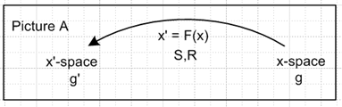 (2.1.1)

The vector transformation and "the differential" (the R-matrix) of the transformation were given by

V'a = RabVb Rab ≡ (∂x'a/∂xb) = ∂bx'a ≡ (∇F)ab ≡ (DF)ab ≡ (DF)ab (2.1.2)

dx'a = Rabdxb dx' = Rdx . (2.1.12) (10.6.1)

Here V'a = RabVb shows the transformation of a contravariant vector under x' = F(x). In matrix notation one would write V' = RV. Repeated indices are always summed unless otherwise stated.

Above we have defined ∇F and DF as alternate names for matrix R because many authors (like Spivak) use this notation. In Tensor (E.4.4) we show that this is in fact a "reverse dyadic notation". Often (DF)ab is written unbolded (DF)ab so then R = (DF) with the idea that a matrix like R is normally not bolded.

(a) Axis-Aligned Vectors and Tangent Base Vectors : The Kinematics Package

It is shown in Tensor Section 3.2 that e'n are axis-aligned basis vectors [ (e'n)i = δni] in x'-space which inverse map to the "tangent base vectors" en in x-space according to en= Se'n and e'n = Ren. From (2.3.1) en = ∂x/∂x'n so en is tangent to an x'n "coordinate line" in x-space as discussed below (2.3.1).
Then in Tensor Section 3.5 the inverse transformation is discussed, x = F-1(x'), and for that transformation the un are axis-aligned basis vectors [ (un)i = δni] in x-space which map into the "inverse tangent base vectors" u'n in x'-space according to u'n= Run and un= Su'n as in Tensor (3.5.3) In this case the inverse tangent base vector u'n is tangent to an inverse coordinate line for coordinate xn.
Many "facts" about the basis vectors en, e'n, un and u'n are developed in Tensor and here is a summary (our kinematics package) with primed equation numbers referring to that document :

(a) x' = F(x) xform Rij ≡ (∂x'i/∂xj) = ∂jx'i R = (DF)
V' = R V vector Sij ≡ (∂xi/∂x'j) = ∂'jxi

(b) e'i with (e'i)j = δij axis-aligned basis vectors in x'-space (i = 1..m)
ei ei= Se'i tangent base vectors in x-space (i = 1..n) (7.18.1)'

(c) ui with (ui)j = δij axis-aligned basis vectors in x-space (i = 1..n)
u'i u'i= Rui tangent base vectors in x'-space (i = 1..n) (7.18.3)'
(u'i)j = Rjk (ui)k

(d) 1= | e'i> <e'i| = | e'i> <e'i| = | u'i> <u'i| = | u'i> <u'i| completeness in x'-space
1= | ei> <ei| = | ei> <ei| = | ui> <ui| = | ui> <ui| completeness in x-space

(e) (uj)i = ui • uj = <ui | uj > = gij = u'i • u'j = <u'i | u'j >
(ej)i = ui • ej = <ui | ej > = Sij = Rji
(e'j)i = e'i • e'j = <e'i | e'j > = g'ij = ei • ej = <ei | ej >
(u'j)i = e'i • u'j = <e'i | u'j > = Rij = Sji (7.19.12)'

(f) ei = g'ij ej e'i = g'ij e'j ui = gij uj u'i = gij u'j
ei = g'ij ej e'i = g'ij e'j ui = gij uj u'i = gij u'j (7.19.14)'

(g) <ej | S | e'i> = <e'i | R | ej> = g'ij
<ej | S | u'i> = <u'i | R | ej> = Sij = Rji
<uj | S | e'i> = <e'i | R | uj> = Rij = Sji
<uj | S | u'i> = <u'i | R | uj> = gij . (7.19.19)'

(h) S = RT Sij = (RT)ij = Rji
R = ST Rij = (ST)ij = Sji

(i) S = R-1 R = S-1 RS = SR = 1 (7.9.8)'
RRT = RTR = SST = STS = 1 (7.9.9)' (10.6.a.1)

In any equation, any index or label can be raised or lowered on both sides. The object gin is the tensor-correct form of gin = δin = δi,n , allowing for indices to be raised and lowered, see (2.2.2). Here is a sample Dirac notation manipulation using the above information (implied sum in completeness),

|ei> = [1] |ei> = | uj> <uj|ei> = | uj>Rij = Rij |uj> or ei = Rijuj . (10.6.a.2)

The result ei = Rijuj appears in (2.5.5) showing that Rij is the basis change matrix between these two sets of basis vectors. Notice that an equation like ei = Rijuj is a "vector sum equation" since
ei = Σj=1nRijuj has a sum of vectors on the right side. No component indices appear on the vectors in this equation (i and j are labels).

(b) What happens for a non-square tall R matrix?

In Chapter 2 and in Tensor it was assumed that x' = F(x) was an invertible mapping F: RN→RN . Now however we wish to consider the non-invertible mapping x' = F(x) where

F: Rn → Rm m > n
F: x-space → x'-space x ϵ Rn, x' ϵ Rm F(x) = x' . (10.6.b.1)

In Rab = (∂x'a/∂xb) the row index a ranges 1 to m, while column index b ranges 1 to n. Thus the down-tilt R matrix is a "tall" non-square matrix having m rows and n columns with m > n.
If we let the variable x exhaust some domain U within x-space, the mapping x' = F(x) generates a "surface" embedded within x'-space = Rm which has dimension n. We assume that the mapping F has sufficient smoothness properties so that this surface can be called a Manifold M.
Thus, the mapping x' = F(x) is defined in effect for all x in Rn (or perhaps for a region U in Rn), and produces (as its image) the manifold M within Rm . The inverse mapping x = F-1(x') is then only defined for points x' on the manifold M. For such points, the mapping and its inverse are assumed one-to-one. This inverse mapping is a set of n equations which one can presumably write down. The equations represent x = F-1(x') only when x' lies on M. For other values of x', the set of equations still exists but no longer represents the inverse function x = F-1(x'). This point is hopefully clarified by some Examples.

Example 1: Let U be a square in R2 x-space with corners (-1,-1) to (1,1). We map this square into R3 using the following map x' = F(x):

x'1 = x1
x'2 = x2
x'3 = $\sqrt{22- (x1)2-(x2)2}$ x' = F(x) (10.6.b.2)

The image in R3 x'-space is an upper hemispherical surface of radius 2.
What is the inverse mapping x = F-1(x') ? One can take it to be the first two lines above

x1 = x'1
x2 = x'2 x = F-1(x') (10.6.b.3)

but the inverse mapping only applies to points x' on the hemisphere. The above two equations of course exist for points x' not on the hemisphere, but they only act as the inverse mapping for points on the hemisphere.
Here is Maple code for Example 1. The transformation is first entered and plotted, xp = x' :

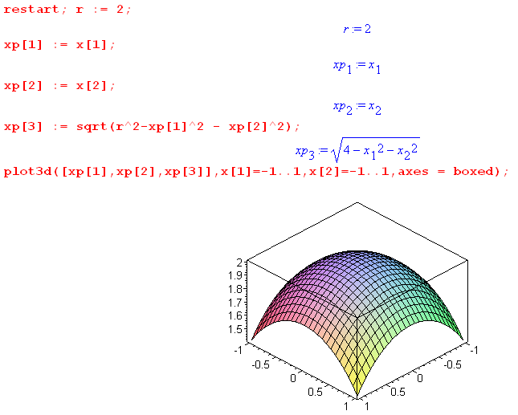
Maple then computes the "tall" R matrix,

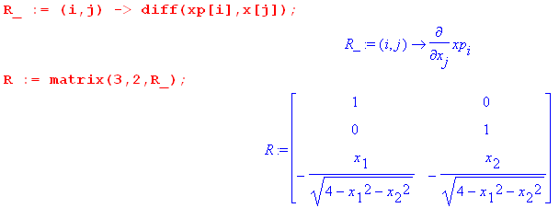

The S matrix is computed by hand from (10.6.b.3) and is then entered into Maple. Maple then computes the matrices RS and SR,

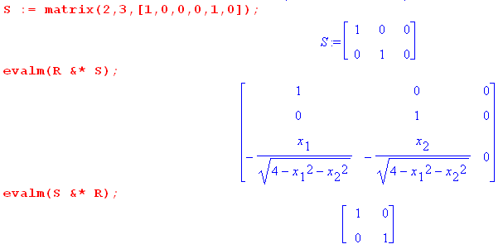

Notice that RS ≠ 1 while SR = 1.

Example 2: Let U be the same square as in Example 1, but the new mapping is this

x'1 = x1 + 2x2 1
x'2 = 2x1 + x2 2
x'3 = x1 + 3x2 3 x' = F(x) (10.6.b.4)

The image in R3 x'-space is a tilted plane passing through the origin. We reuse the above Maple code for this example, but don't display the Maple output.

What is the inverse mapping x = F-1(x') ?

If one solves the first two equations for x1 and x2 the result is

x1 = -1/3 x'1 + 2/3 x'2
x2 = 2/3 x'1 - 1/3 x'2 x = F-1(x') (10.6.b.5)

and this then can be taken to be the inverse mapping x = F-1(x'). Inserting these expressions into the third equation gives

5/3 x'1 - 1/3 x'2 - x'3 = 0 (10.6.b.6)

which is the equation of the tilted image plane passing through the origin whose normal is (5/3,-1/3,-1).

On the other hand, if one instead solves the second two equations in (10.6.b.4) one finds

x1 = 3/5 x'2 - 1/5 x'3
x2 = - 1/5 x'2 +2/5 x'3 x = F-1(x') . (10.6.b.7)

Notice that this inverse mapping is different from (10.6.b.5). When these two expressions are inserted into the first equation of (10.6.b.4), one gets

x'1 - 1/5 x'2 - 3/5 x'3 = 0 (10.6.b.8)

Multiplication by 5/3 gives (10.6.b.6) so this is, of course, the equation for the same tilted plane.

In this Example we find that the inverse equation set x = F-1(x') is not unique. If we work with the first and third equations in (10.6.b.4) we get a third set of inverse equations which we leave to the reader.

By visual inspection, the R matrix computed from x' = F(x) (10.6.b.4) is this:

R = Rab = (∂x'a/∂xb) = $\left(\begin{matrix}1 & 2 \\ 2 & 1 \\ 1 & 3\end{matrix}\right)$ (10.6.b.9)

and is a "tall" R matrix for this problem. For the two inverse transformations stated in (10.6.b.5) and (10.6.b.7) we compute an S matrix, again by inspection (Maple did the products on the right)

S = Sab = (∂xa/∂x'b) = $\left(\begin{matrix}-1/3 & 2/3 & 0 \\ 2/3 & -1/3 & 0\end{matrix}\right)$ SR = $\left(\begin{matrix}-1/3 & 2/3 & 0 \\ 2/3 & -1/3 & 0\end{matrix}\right)$$\left(\begin{matrix}1 & 2 \\ 2 & 1 \\ 1 & 3\end{matrix}\right)$ = $\left(\begin{matrix}1 & 0 \\ 0 & 1\end{matrix}\right)$

S = Sab = (∂xa/∂x'b) = $\left(\begin{matrix}0 & 3/5 & -1/5 \\ 0 & -1/5 & 2/5\end{matrix}\right)$ SR = $\left(\begin{matrix}0 & 3/5 & -1/5 \\ 0 & -1/5 & 2/5\end{matrix}\right)$$\left(\begin{matrix}1 & 2 \\ 2 & 1 \\ 1 & 3\end{matrix}\right)$ = $\left(\begin{matrix}1 & 0 \\ 0 & 1\end{matrix}\right)$
(10.6.b.10)

Thus we have found two different "left inverses" S of the tall matrix R. If we try out these S matrices on the right of R, we find

RS = $\left(\begin{matrix}1 & 2 \\ 2 & 1 \\ 1 & 3\end{matrix}\right)$$\left(\begin{matrix}-1/3 & 2/3 & 0 \\ 2/3 & -1/3 & 0\end{matrix}\right)$ = $\left(\begin{matrix}1 & 0 & 0 \\ 0 & 1 & 0 \\ 5/3 & -1/3 & 0\end{matrix}\right)$ ≠ $\left(\begin{matrix}1 & 0 & 0 \\ 0 & 1 & 0 \\ 0 & 0 & 1\end{matrix}\right)$

RS = $\left(\begin{matrix}1 & 2 \\ 2 & 1 \\ 1 & 3\end{matrix}\right)$$\left(\begin{matrix}0 & 3/5 & -1/5 \\ 0 & -1/5 & 2/5\end{matrix}\right)$ = $\left(\begin{matrix}0 & 1/5 & 3/5 \\ 0 & 1 & 0 \\ 0 & 0 & 1\end{matrix}\right)$ ≠ $\left(\begin{matrix}1 & 0 & 0 \\ 0 & 1 & 0 \\ 0 & 0 & 1\end{matrix}\right)$ (10.6.b.11)

Example 2 serves then to illustrate that a tall R matrix might have multiple left inverses, but those left inverses are not also right inverses. It turns out that there are in fact no right inverses for a tall R, as shown below.

Before leaving this example, we comment on the "coordinate lines" in x-space using our first inverse solution (10.6.b.5).

x1 = -1/3 x'1 + 2/3 x'2
x2 = 2/3 x'1 - 1/3 x'2 x = F-1(x') (10.6.b.5)

If we vary only x'1 (keeping the other two coordinates in x'-space fixed) both x1 and x2 vary, and not surprisingly they define a certain line in x-space, and this is the coordinate line in x-space for x'1 . If we instead vary only x'2, again both x1 and x2 vary and they define some other line in x-space, the x'2 coordinate line. If we vary only x'3 , then x1 and x2 do not vary and this coordinate line is just a point!

Recall that the tangent base vectors en are tangent to the coordinate lines in x-space. As shown in (10.6.a.1) (c) one has (ej)i = Sij so the tangent base vectors are the columns of S, S = [e1, e2, e3]. Looking at S = $\left(\begin{matrix}-1/3 & 2/3 & 0 \\ 2/3 & -1/3 & 0\end{matrix}\right)$for our first inverse solution, we see that the first two tangent base vectors are indeed reasonable tangents to coordinate lines in x-space. Since the third coordinate line is just a point, if can have no tangent base vector, and in fact e3 = (0,0) which "resolves" this problem.

(c) Some Linear Algebra for non-square matrices

The linear algebra for non-square matrices is a topic often omitted in linear algebra presentations. Here we consider only the special case of two matrices where each has the shape of the transpose of the other, and we cherry-pick a few relevant theorems. As we show below, non-square matrices never have two-sided inverses, so one talks only about the possibility of such a matrix having a "right inverse" or a "left inverse".

Consider then the following matrix products where we assume m > n :

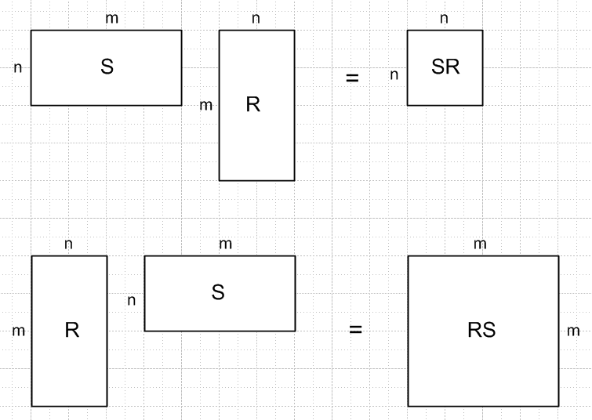 (10.6.c.1)

A nameless matrix rank theorem is the following :

Fact: rank(AB) ≤ min{rank(A),rank(B) } . (10.6.c.2)

Consider first the upper part of the figure. Both S and R each have some rank ≤ n, since this is the smaller matrix dimension. The Fact then says rank(SR) ≤ n. Since SR is an n x n matrix, it could therefore have full rank n, and then it is possible that one could have SR = 1. This says that it is possible for R to have a left inverse S, and for S to have a right inverse R.

Another nameless theorem states that if R has full rank n, then in fact it has at least one left inverse S, and if S is full rank, it has at least one right inverse R. The theorem does not say how to compute these inverses, nor does it suggest how many inverses there might be (a non-trivial problem). So,

Fact: tall R has full rank ⇒ R has at least one left inverse S
wide S has full rank ⇒ S has at least one right inverse R (10.6.c.3)

In our Example 2 above, matrix R in (10.6.b.9) has full rank 2, so we know it has at least one left inverse S. We explicitly found two such left inverses S as shown in (10.6.b.10). Since each of these left inverses has R as a right inverse, we know (and confirm) that each S must have full rank 2. Thus, we know (and confirm) that two of the tangent base vectors en are linearly independent (these being columns of S).

Now consider the lower part of Fig. (10.6.c.1). Fact (10.6.c.2) says rank(RS) ≤ n, but the matrix RS is m x m. Thus it cannot possibly have full rank m, so it can never be the m x m identity matrix. We may then conclude that R has no right inverses and S has no left inverses:

Fact: tall R has no right inverses
wide S has no left inverses (10.6.c.4)

Corollary: A non-square matrix cannot have a two-sided inverse. (10.6.c.5)

If we take S = RT, then the two matrices on the right in the drawing are RTR and RRT. Yet another matrix rank theorem says,

Fact: rank(RRT) = rank(RTR) = rank(R). (10.6.c.6)

If R has full rank n, then the small matrix RTR has rank n and so is full rank, det(RTR) ≠ 0, and RTR is invertible. But the m x m larger matrix RRT having rank n must have det(RRT) = 0 and is not invertible.

Fact: If tall R has full rank n, then (RTR)-1 exists.
For any tall R, (RRT)-1 does not exist. (10.6.c.7)

With this in mind, another theorem says that if tall R is full rank, then we know one of its left inverses:

Fact: If tall R has full rank n, then one left inverse is given by S = (RTR)-1RT . (10.6.c.8)

Proof: By the previous fact we know (RTR)-1 exists, so SR = [(RTR)-1RT]R = (RTR)-1 (RTR) = 1 .

We mention in passing two other matrix theorems for arbitrary conforming matrices A,B,C:

Fact: (Sylvester's Inequality)
rank(A) + rank(B) ≤ rank(AB) + n where n is the conforming dimension (10.6.c.9)

Fact: (Frobenius Inequality)
rank(AB) + rank(BC) ≤ rank(ABC) + rank(B) (10.6.c.10)

(d) Implications for the Kinematics Package

The set of relations shown in (10.6.a.1) still stands for F: Rn→ Rm with its tall R matrix, with the exception of the last item (i),

(i) S = R-1 R = S-1 RS = SR = 1 RRT = RTR = SST = STS = 1 . (10.6.a.1)

This must be replaced by

(i) SR = 1 SST = RTR = 1 (10.6.d.1)

since RS ≠ 1 and two-sided inverses R-1 and S-1 do not exist for F: Rn→ Rm with m>n.

A second implication is that certain items in the kinematics package are no longer unique. We have already seen that Sij is not unique, so anything depending on Sij is also not unique. Here is a list showing which objects are unique, and which are not:

Metric tensors
gij, gij unique
g'ij unique, since g'ij = RiaRjbgab
g'ij not unique, since g'ij = RiaRjbgab = SaiSbjgab and Sij not unique

Transformation matrices
Rij = Sji unique (tall R matrix from x' = F(x))
Rij = Sji unique since Rij = gjaRia and both gja and Ria are unique
Rji = Sij not unique, see (10.6.c.3)
Rij = Sji not unique, since Rij = g'ia Raj and g'ia not unique

Axis-aligned basis vectors
(uj)i unique since (uj)i = gji (e'j)i unique since (e'j)i = g'ij (= δij)
(uj)i unique since (uj)i = gji (e'j)i not unique since (e'j)i = g'ij
(uj)i unique since (uj)i = gji (e'j)i unique since (e'j)i = g'ij
(uj)i unique since (uj)i = gji (e'j)i unique since (e'j)i = g'ij (= δij)

Tangent base vectors
(ej)i not unique since (ej)i = Rji (u'j)i unique since (u'j)i = Rij
(ej)i not unique since (ej)i = Rji (u'j)i not unique since (u'j)i = Rij
(ej)i unique since (ej)i = Rji (u'j)i unique since (u'j)i = Rij
(ej)i unique since (ej)i = Rji (u'j)i not unique since (u'j)i = Rij (10.6.d.2)

(e) Basis vectors for the Tangent Space at point x' on M

Warning: For certain notational reasons, we have this unfortunate fact:
• In Section 10.2 the tangent vectors at point x on M are called xei .
• In Section 10.6 the tangent vectors at point x' on M are called u'i (this section).
• In Section 10.8 the tangent vectors at point x on M are called xui .

From (10.6.5c) we select as a basis for x-space the set of n axis-aligned basis vectors ui,

{ui} i = 1,2...n basis for x-space

(ui)j = δij components of these basis vectors in x-space . (10.6.e.1)

These map into a set of n tangent base vectors u'i in x'-space,

u'i = R ui |u'i> = R |ui>
or
(u'i)j = Rja (ui)a = Rja δia = Rji i = 1,2...n j = 1,2..m . (10.6.e.2)

We know that u'i = R ui because this is the way any vector transforms: v' = R v.

Since there are m basis vectors in x'-space, we define the rest of the u'i arbitrarily such that the m basis vectors {u'i} in Rm are linearly independent, so

u'i = as needed i = n+1, n+2 .....m . (10.6.e.3)

Note in (10.6.e.2) that (u'i)j = Rja(ui)a = Σa=1n Rja(ui)a is a "component sum equation", in contrast with the "vector sum equation" ei = Σj=1nRijuj appearing in (10.6.a.2). To summarize for u'i :

u'i = (10.6.e.4)

We show just below that the first n u'i span the tangent space Tx'M. Since the remaining u'i must be selected so that the full set of m u'i is a basis for x'-space, we know that the higher m-n u'i must span the perp space (Tx'M) ⊥ of the tangent space, and this space is said to have codimension m-n within Rm.

Based on (10.6.e.2) that Rji = (u'i)j, one concludes that the columns of R** are the contravariant basis vectors u'i which span Tx'M. Each of these u'i has m components and R** has m rows.

R** = [u'1, u'2 ....u'n] (10.6.e.5)

As long as R** has full rank n, the columns are linearly independent so the u'i form a (complete) basis.

We now show that the first n tangent base vectors u'i do in fact span the tangent space Tx'M.

Assume that, as x ranges over some portion of x-space, the mapping x' = F(x) describes a "smooth surface" M embedded in x'-space, hopefully a manifold or a piece thereof. If we start at some x and move to x + dx in x-space, we move from some point x' on M to some nearby point x' + dx' on M. By the definition of M, this dx' lies on the surface M and so is tangent to the surface M at x' and thus lies in the tangent space Tx'M of M at point x'. Applying R to each of the n axis-aligned differentials dxi = dxi(ui) in x-space (no i sum), we thereby generate a set of n differential vectors dx'i = Rdxi in x'-space which are in effect a set of short basis vectors which span the tangent space Tx'M. Since dx'i = dx'i (u'i), we may take the basis vectors {u'i, i=1,2..n} as spanning Tx'M. The upper u'i are orthogonal to M and span the perp space (Tx'M) ⊥ as noted.
We know from the fact u'i • u'j = δij that the up-label vectors {u'i, i=1,2..n} also form a basis for the tangent space Tx'M. This conclusion can be reached as well by raising all i indices in the previous paragraph. In this case, the set {u'i, i=n+1,n+2..m} are then all orthogonal to the "surface" M.
These last paragraphs and (10.6.e.5) have shown that:

Fact: The first n x'-space tangent base vectors u'i, which are the columns of full-rank R** , span the tangent space Tx'M at point x' on M, and this is true as well for the u'i . (10.6.e.6)

10.7 The Pullback Operator

From (10.6.e.2), or just from the fact that vectors transform as v' = Rv, we know that

u'i= Rui |u'i> = R |ui> i = 1,2..n . (10.7.1)

One can say that the n axis-aligned basis vectors ui in x-space are "pushed forward" by R to become the tangent-space-spanning vectors u'i in x'-space. Applying S to both sides and using (10.6.d.1) that SR = 1, one finds that

ui= S u'i |ui> = S |u'i> i = 1,2..n . (10.7.2)

Since S = RT this can be written

ui= RT u'i |ui> = RT |u'i> i = 1,2..n . (10.7.3)
Thus, while operator R "pushes forward" the |ui> to the |u'i>, the operator RT "pulls back" the |u'i> from x'-space into the |ui> in x-space, just reversing the first process.
For the label-up basis functions we this have have

u'i = Rui |u'i> = R |ui> i = 1,2..n push forward
ui = RT u'i |ui> = RT |u'i> i = 1,2..n pull back . (10.7.4)

Similarly,

e'i = Rei |e'i> = R |ei> i = 1,2..n push forward
ei = RT e'i |ei> = RT |e'i> i = 1,2..n pull back . (10.7.5)

In the dual space of bras (linear functionals) this becomes, according to (2.11.g.4),

(u'i)T= (ui)T RT <u'i| = <ui|RT i = 1,2..n push forward
(ui)T = (u'i)TR <ui| = <u'i|R i = 1,2..n pull back (10.7.6)

(e'i)T= (ei)T RT <e'i| = <ei|RT i = 1,2..n push forward
(ei)T = (e'i)TR <ei| = <e'i|R i = 1,2..n pull back , (10.7.7)

Notice that

<e'i| R = <e'i| R [1] = <e'i| R |uj><uj| = Rij<uj| (10.7.8)

so that operator R pulls back the axis-aligned dual basis vector <e'i| in dual x'-space to a certain linear combination of the basis vectors in dual x-space.

In the context of differential forms, the operator R is sometimes given the new name F*, where F* ≡ R. It is called "the pullback operator". The F in F* refers to the F in the transformation x' = F(x), so F* is just the differential R of this transformation. So,

<e'i| F* = <e'i| R = Rij<uj|

<u'i| F* = <u'i| R = <ui| (10.7.9)

We now cosmetically reflect our usual transformation Picture A shown above (10.6.1) left to right to get

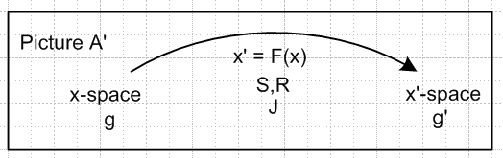 (10.7.10)

and here then is a more detailed picture, showing the basis vector u1 being pushed forward in red and pulled back in blue,

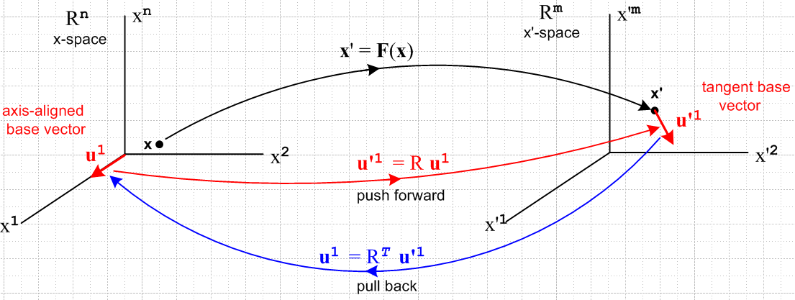
(10.7.11)

A picture similar to the above, which has dual x-space space (Rn)* on the left and dual x'-space (Rm)* on the right, would show the push forward <u'1| = <u1|RT in red and the pullback <u1| = <u'1|R in blue. Below we shall have hybrid pictures showing the non-dual spaces but also showing the mapping of linear functionals between the dual-spaces.

Recall from Section 2.11 our special notation for basis functionals in a dual space,

λi = <ei| basis functional // λi = (ei)T
λi(v) = <ei|v> = vi basis function // λi(v) = (ei)Tv (2.11.c.2)

where there the ei were axis-aligned basis vectors. Here we write,

λi ≡ <ui| = basis functional in dual x-space i = 1..n // ui axis-aligned
λ'i ≡ <e'i| = basis functional in dual x'-space i = 1..m // e'i axis-aligned . (10.7.12)

In this notation we overload the F* notation slightly to write

F*(λ'i) ≡ <e'i| F* = <e'i| R = Rij<uj| = Rijλj
F*(dx'i) ≡ <e'i| F* = <e'i| R = Rij<uj| = Rijdxj (10.7.13)

and then F* : Λ1(Rm) → Λ1(Rn). Again, the main idea is F*λ'i means <e'i| F*, and since <e'i| F* is Rij<uj| , F*λ'i is a functional in dual x-space. In the cosmetic notation of (10.1.7) one then writes,

F*(λ'i) = Rij λj = (DF)ijλj
F*(dx'i) = Rij dxj = (DF)ij dxj (10.7.14)
This then is a very simple example of pulling back a differential 1-form from dual x'-space to dual x-space. Many authors write F*λ'i as F*(λ'i) but we are trying to conserve parentheses and there seems to be no ambiguity omitting this pair.

We can "close" the functional above with some arbitrary vector |v> (evaluate the functional at v) in x-space to get

[F*(λ'i)](v) ≡ <e'i| F*| v> = <e'i| R| v> = <e'i| R*1 | v> = <e'i| R |uj><uj | v>
= Rij λj(v) = Rij vj = [Rv]i = <ui |Rv> = λi(Rv)

[F*(dx'i)](v) = dxi(Rv) (10.7.15)

and in this way we have pulled back a basis-vector tensor function.

For a general rank-1 functional αx' in dual x'-space we would write, as in (2.11.c.7),

αx' = Σi=1m αi λ'i αx' ϵ Λ1(Rm)
αx' = Σi=1m αi dx'i αx' ϵ Λ1(Rm) (10.7.16)

βx ≡ F*(αx') = ΣiαiF*(λ'i) = Σiαi Rijλj = Σiαi (DF)ijλj βx ϵ Λ1(Rn)
βx ≡ F*(αx') = ΣiαiF*(dx'i) = Σiαi Rijdxi = Σiαi (DF)ijdxi βx ϵ Λ1(Rn) (10.7.17)

Comment: It would be logical to use symbol αx in place of βx, but we retain βx just to emphasize that the differential forms αx' and βx = F*(αx') are totally different forms living in totally different spaces. The symbols αx' and αx are so similar, it seems one could replace x' by x to get from one to the other.

In terms of tensor functions, we evaluate (10.7.17) at location v to get

[F*(αx')](v) = Σiαi (R)ijλj(v) = Σiαi (R)ijvj = Σiαi [Rv]j = αx'(Rv) (10.7.18)

In Dirac notation we write the above line as

[F*(αx')](v) = <αx'| F* | v > = <αx'| R | v > = <αx'| Rv > = αx'(Rv) . (10.7.19)

Sometimes one sees the pullback operator F* defined by the above tensor function equation,

[F*(αx')](v) ≡ αx'(Rv) (10.7.20)

but we feel that our definition of F* as shown above is more fundamental, directly making the connection F* = R where R is the Dirac Hilbert Space operator whose matrix elements Rij = <e'i | R | uj> form the "tall" differential R matrix of the underlying transformation x' = F(x).

10.8 Change of variable and function names

We are now going to make a change of variable and function names to get our results into a more standard form found in the differential forms literature. It is a bit painful and requires some new notations for basis vectors, but it must be done at some point. We change then from Picture A' to Picture F' where, unfortunately, there is both an old x-space and a new x-space and they are not the same.

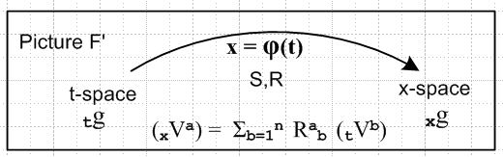 (10.8.1)

The underlying function name F is changed to φ but the differentials are still called R and S. Here is the translation dictionary:

x-space → t-space
x'-space → x-space

F → φ
x' = F(x) → x = φ(t) general transformation
R,S → R,S differential matrices (no change in name)
F* → φ* pullback operator

V → tV vector in t-space
V' → xV vector in x-space

e → te tangent base vectors in t-space
u → tu axis-aligned basis vectors in t-space
g → tg metric tensor in t-space

u' → xu tangent base vectors in x-space
e' → xe axis-aligned basis vectors in x-space
g' → xg metric tensor in x-space (10.8.2)

We try to stay somewhat consistent with the previous notation and this requires that the axis-aligned basis vectors be called tu in t-space, but xe in x-space. Please refer to the above table if there is confusion.

Here is the translated kinematics package (10.6.a.1) with item (i) adjusted for the "tall R matrix" situation m > n:

(a) x = φ(t) xform Rij ≡ (∂xi/∂tj) = ∂j(t)xi R = (Dφ)
xV = R tV vector Sij ≡ (∂ti/∂xj) = ∂j(x)ti

(b) xei with (xei)j = δij axis-aligned basis vectors in x-space (i = 1..m)
tei tei = S xei tangent base vectors in x-space (i = 1..n)

(c) tui with (tui)j = δij axis-aligned basis vectors in t-space (i = 1..n)
xui xui= R tui tangent base vectors in t-space (i = 1..n)
(xui)j = Rjk (tui)k

(d) 1 = | xei> <xei| = | xei> <xei| = | xui> <xui| = | xui> <xui| completeness in x-space
1 = | tei> <tei| = | tei> <tei| = | tui> <tui| = | tui> <tui| completeness in t-space

(e) (tuj)i = tui • tuj = <tui | tuj > = tgij = xui • xuj = <xui | xuj >
(tej)i = tui • tej = <tui | tej > = Sij = Rji
(xej)i = xei • xej = <xei | xej > = xgij = tei • tej = <tei | tej >
(xuj)i = xei • xuj = <xei | xuj > = Rij = Sji

(f) tei = xgij tej xei = xgij xej tui = tgij tuj xui = tgij xuj
tei = xgij tej xei = xgij xej tui = tgij tuj xui = tgij xuj

(g) <tej | S | xei> = <xei | R | tej> = xgij
<tej | S | xui> = <xui | R | tej> = Sij = Rji
<tuj | S | xei> = <xei | R | tuj> = Rij = Sji
<tuj | S | xui> = <xui | R | tuj> = tgij .

(h) S = RT Sij = (RT)ij = Rji
R = ST Rij = (ST)ij = Sji

(i) SR = 1 SST = RTR = 1 (10.6.a.1), (10.6.d.1) (10.8.3)

Next is the uniqueness table translated from (10.6.d.2):

Metric tensors
tgij, tgij unique
xgij unique, since xgij = RiaRjb tgab
xgij not unique, since xgij = RiaRjb tgab = SaiSbj tgab and Sij not unique

Transformation matrices
Rij = Sji unique (tall R matrix from x' = F(x))
Rij = Sji unique since Rij = tgjaRia and both tgja and Ria are unique
Rji = Sij not unique, see (10.6.c.3)
Rij = Sji not unique, since Rij = xgia Raj and xgia not unique

Axis-aligned basis vectors
(tuj)i unique since (tuj)i = tgji (xej)i unique since (xej)i = xgij (= δij)
(tuj)i unique since (tuj)i = tgji (xej)i not unique since (xej)i = xgij
(tuj)i unique since (tuj)i = tgji (xej)i unique since (xej)i = xgij
(tuj)i unique since (tuj)i = tgji (xej)i unique since (xej)i = xgij

Tangent base vectors
(tej)i not unique since (tej)i = Rji (xuj)i unique since (xuj)i = Rij
(tej)i not unique since (tej)i = Rji (xuj)i not unique since (xuj)i = Rij
(tej)i unique since (tej)i = Rji (xuj)i unique since (xuj)i = Rij
(tej)i unique since (tej)i = Rji (xuj)i not unique since (xuj)i = Rij

(10.6.d.2) (10.8.4)
We now translate most earlier results into the new notation:

{tui} i = 1,2...n basis for t-space , axis-aligned
(tui)j = δij components of these basis vectors in t-space . (10.6.e.1) (10.8.5)

xui = (10.6.e.4) (10.8.6)

R** = [xu1, xu2 ....xun] R has full rank n ⇒ basis for TxM complete (10.6.e.5) (10.8.7)

Non-Dual

xui = R tui |xui> = R |tui> i = 1,2..n push forward (10.7.1) (10.8.8)
tui = S xui |tui> = S |xui> i = 1,2..n pull back (10.7.2) (10.8.9)

xui = R tui |xui> = R |tui> i = 1,2..n push forward
tui = RT xui |tui> = RT |xui> i = 1,2..n pull back (10.7.4) (10.8.10)

xei = R tei |xei> = R |tei> i = 1,2..n push forward
tei = RT xei |tei> = RT |xei> i = 1,2..n pull back (10.7.5) (10.8.11)

Dual

(xui)T= (tui)T RT <xui| = <tui|RT i = 1,2..n push forward
(tu)T = (xu)T R <tui| = <xu|R i = 1,2..n pull back (10.7.6) (10.8.12)

(xei)T= (tei)T RT <xei| = <tei|RT i = 1,2..n push forward
(tei)T = (xei)T R <tei| = <xei|R i = 1,2..n pull back (10.7.7) (10.8.13)

<xei| φ* = <xei| R = Rij<tuj| pullback operator φ* = R

<xui| φ* = <xui| R = <tui| (10.7.9) (10.8.14)

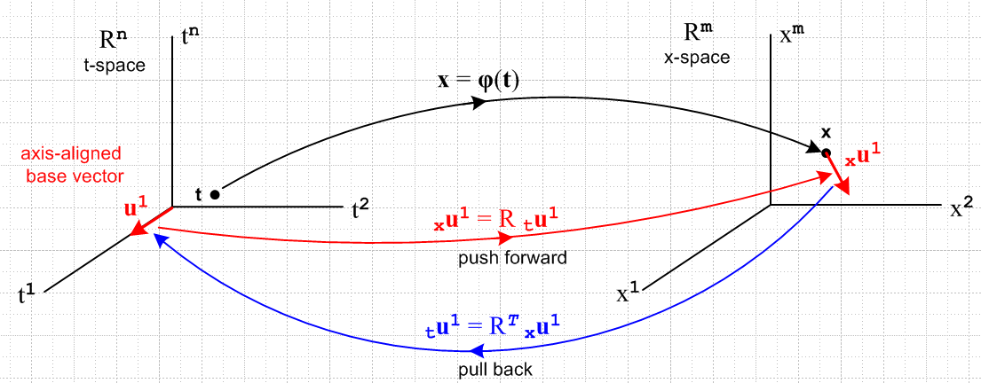
(10.7.11) (10.8.15)

We now translate equations (10.7.12) through (10.7.20) to the new notation:

tλi ≡ <tui| = basis functional in dual t-space ϵ Λ1(Rn) i = 1..n
xλi ≡ <xei| = basis functional in dual x-space ϵ Λ1(Rm) i = 1..m (10.7.12) (10.8.16)

φ* = R (Dφ) = R // see comment (2.11.g.7) about operator R versus matrix R
φ* : Λ1(Rm) → Λ1(Rn) (10.8.17)

φ*(xλi) ≡ <xei| φ* = <xei| R = Rij<tuj| = Rij tλj
φ*(dxi) ≡ <xei| φ* = <xei| R = Rij<uj| = Rijdxj (10.7.13) (10.8.18)

φ*(xλi) = Rij tλj = (Dφ)ij tλj pullback of a simple 1-form
φ*(dxi) = Rij dtj = (Dφ)ij dtj same in cosmetic notation (10.7.14) (10.8.18)

[φ*(xλi)](v) = tλi(Rv) tensor function form
[φ*(dxi)](v) = dti(Rv) tensor function form (10.7.15) (10.8.19)

αx = Σi=1m αi(x) tλi αx ϵ Λ1(Rm) general 1-form
αx = Σi=1m αi(x) dxi αx ϵ Λ1(Rm) general 1-form (10.7.16) (10.8.20)

βt ≡ φ*(αx) = Σiαi φ*(xλi) = Σiαi Rij tλj = Σiαi (Dφ)ij tλj
βt ≡ φ*(αx) = Σiαiφ*(dxi) = Σiαi Rij dti = Σiαi (Dφ)ij dti (10.7.17) (10.7.17)
[φ*(αx)](v) = αx(Rv) tensor function form of 1-form pullback (10.7.20) (10.8.22)

Implied sums are all 1..n.

Extra Stuff

I want to see φ*(xλ^I) = <xe^I | φ* = <xe^I | R appear somewhere in my writeup. With my new theorems, I know this would be

φ*xλ^I = <xe^I | R = <xe^i$_{1}$|R ^ <xe^i$_{2}$|R ^ .....

= φ*xλ^i$_{1}$ ^ φ*xλ^i$_{2}$ ^ ......

= (Ri1j1 tλj1) ^ (Ri2j2 tλj2) ^ ...

= RIJ (tλj1 ^ tλj$_{2}$ ^ ..... )

= RIJ tλ^J

So there you are: really want those parens now to contain my ugly many-symbol argument

φ*(xλ^I) = ΣJ RIJ tλ^J

Now maybe he makes up this name

(Ri1j1 tλj1) = dφi1

Then you could write

φ*(xλ^I) =

I see this is just my theorem to be proven below, but I have the main idea in a Ch 7 theorem. Then

φ*(dx^I ) = φ*(dxi$_{1}$) ^ φ*(dxi$_{2}$) ^ ......

= dφi$_{1}$ ^ dφi$_{2}$ ^ ...

Why would you use this name dφi$_{1}$ for these little forms? Well we do have this

dφi$_{1}$ = φ*(dxi$_{1}$) = Ri1j1 dtj1

So the equation dφi$_{1}$ = Ri1j1 dtj1 DOES look like the calculus equation

φi(t)

dφi(t) = Rij dtj

BUT notice now that dφi(t) ≠ dxi although that would be true in calculus.

Recall the similarity mentioned in (10.3.3) and (10.3.4),

df = (∂jf(x)) dxj 1-form (10.3.3)

df = (∂jf(x)) dxj calculus (10.3.4)

Thinking of x = φ(t) we can similarly write,

dxi = dφi = (∂φi/∂tj) dtj 1-form

At the 2-form level one has

dxi$_{1}$ ^ dxi$_{2}$ = Σj$_{1}$j$_{2}$ [ (∂φi$_{1}$/∂tj$_{1}$) dtj$_{1}$] ^ [(∂φi$_{2}$/∂tj$_{2}$) dtj$_{2}$ ]

= Σj$_{1}$j$_{2}$ (∂φi$_{1}$/∂tj$_{1}$)(∂φi$_{2}$/∂tj$_{2}$) dtj$_{1}$ ^ dtj$_{2}$

= Σj$_{1}$j$_{2}$ Ri$_{1}$j$_{1}$Ri$_{2}$j$_{2}$ dtj$_{1}$ ^ dtj$_{2}$ 2-form

At the k-form level one then has

dxi$_{1}$ ^ dxi$_{2}$ ....^ dxi$_{2}$ = Σj$_{1}$Ri$_{1}$j$_{1}$Ri$_{2}$j$_{2}$ .... dtj$_{1}$ ^ dtj$_{2}$ ....^ dti$_{k}$
or
dx^I = ΣJ RIJ dt^J k-form

From Appendix A we know from the second line of (A.8.36) with I ↔ J that

Fact : ΣJ TIJ x^J = Σ'J det(TIJ) x^J if TIJ has factored form (A.8.36)

As written, the generic vector x^J is a vector in the wedge space Lk(V), but the Fact can be transposed to the dual space Λk(V) where it has the same form since the functions are real. Just replace xi = |xi> by <xi|. Then set <xi| = <xei| = xλi = dxi . The object RIJ has exactly the factored form required, so we conclude that (10.8.25) can be rewritten using the ordered sum Σ'J as

dx^I = Σ'J det(RIJ) dt^J (10.8.26)

For example,
dxi$_{1}$ ^ dxi$_{2}$ = Σ1≤j$_{1}$<j$_{2}$≤n det $_{1}$$_{1}$$_{1}$$_{2}$$_{2}$$_{1}$$_{2}$$_{2}$ dtj$_{1}$ ^ dtj$_{2}$

10.9 More relationships

10.9 The pullback of a general differential k-form

Recall from (10.8.14) the action of operator φ* = R on the bra <xei |,

<xei | φ* = <xei | R = Σj=1n Rij <tuj | i = 1,2..m . (10.8.14) (10.9.1)

Any operator P which acts on a vector space V, has a natural extension to being an operator on the tensor product space Vn , while its transpose PT has an extension acting on the dual tensor product space V*n

P | v1,v2....vk> ≡ P [ | v1> ⊗ |v2>....⊗|vk> ] = P| v1> ⊗ P|v2>....⊗ P|vk> .

< v1,v2....vk| PT = [ < v1| ⊗ <v2|....⊗<vk| ] PT = < v1|PT ⊗ <v2|PT....⊗<vk|PT . (10.9.2)

Taking the operator PT to be φ* = R, one has

< xei, xei$_{2}$....xei$_{k}$| φ* = < xei$_{1}$, xei$_{2}$....xei$_{k}$| R // φ* ≡ R

= < xei$_{1}$|R ⊗ <xei$_{2}$|R....⊗ <xei$_{k}$|R // (10.9.2) with PT = R, and next line is (10.9.1)

= [Σj$_{1}$=1n Ri$_{1}$j$_{1}$ <tuj$_{1}$ | ] ⊗ [Σj$_{2}$=1n Ri$_{2}$j$_{2}$ <tuj$_{2}$ | ] ... ⊗ [Σj$_{k}$=1n Ri$_{k}$j$_{k}$ <tuj$_{k}$ | ]

= Σj$_{1}$j$_{2}$...j$_{k}$=1n Ri$_{1}$j$_{1}$ Ri$_{2}$j$_{2}$ ... Ri$_{k}$j$_{k}$ ( <tuj$_{1}$ | ⊗ <tuj$_{2}$ | ... ⊗ <tuj$_{k}$| )

= Σj$_{1}$j$_{2}$...j$_{k}$=1n Ri$_{1}$j$_{1}$ Ri$_{2}$j$_{2}$ ... Ri$_{k}$j$_{k}$ <tui$_{1}$, tui$_{2}$....tui$_{k}$ | . (10.9.3)

In multiindex notation this says (note that ΣJ is a full symmetric sum),

< xeI | φ* = ΣJ RIJ <tuJ | ϵ (Rn)*k = dual tensor-product t-space . (10.9.4)

A nearly identical result applies for wedge space Λk(Rn). Apply AltI to both sides of (10.9.4) to get

AltI [ < xeI | φ* ] = AltI [ ΣJ RIJ <tuJ | ] . (10.9.5)

According to (8.1.2) the left side is just

AltI [ < xeI | φ* ] = [ AltI < xeI | ] φ*

= < xe^I | φ* where <xe^I| ≡ <xej$_{1}$ | ^ <xej$_{2}$ | ... ^ <xej$_{k}$| . (10.9.6)

The right side of (10.9.5) takes more work :

AltI [ ΣJ RIJ <tuJ | ] = ΣJ [AltI(RIJ)] <tuJ | // = ΣJ (1/k!) det(RIJ ) <tuJ | by (A.8.30)

= ΣJ [(1/k!) ΣP(-1)P RP(I)J ] <tuJ | // (A.2.1) def of AltI

= (1/k!) ΣP(-1)P ( ΣJ RP(I)J <tuJ | ) // reorder

= [(1/k!) ΣP(-1)P ( ΣJ RP(I)P(J) ] <tuP(J) | ) // (A.1.20) that ΣJ fJ = ΣJ fP(J)

= [(1/k!) ΣP(-1)P ΣJ RIJ ] <tuP(J) | // (A.8.31) that RP(I)P(J) = RIJ

= ΣJ RIJ [(1/k!) ΣP(-1)P <tuP(J) | ] // reorder

= ΣJ RIJ AltJ <tuJ | // (A.2.1) def of AltJ

= ΣJ RIJ <tu^J | where <tu^I| ≡ <tuj$_{1}$ | ^ <tuj$_{2}$ | ... ^ <tuj$_{k}$| . (10.9.7)

Thus we have from (10.9.5) the following result, which we compare on the next line to (10.9.4),

< xe^I | φ* = ΣJ RIJ <tu^J | ϵ Λk(Rn) = dual wedge-product t-space (10.9.8)

< xeI | φ* = ΣJ RIJ <tuJ | ϵ (Rn)*k = dual tensor-product t-space . (10.9.4)

A general element of Λk(Rm) at a point x on our surface M (a general "differential k-form") can be written from (10.2.1),

αx = Σ'I fI(x) xλ^I or <αx | = Σ'I fI(x) < xe^I | . (10.9.9)

Applying φ* = R to the Dirac form then gives, using (10.9.8),

<αx | φ* = Σ'I fI(x) [ < xe^I | φ* ] = Σ'I fI(x) [ΣJ RIJ <tu^J | ] . (10.9.10)

Again using φ*(αx) ≡ <αx | φ* and <tu^J | = λ^J and x =φ(t), the above line can be restated,

φ*(αx) = Σ'I fI(φ(t)) ΣJ RIJ tλ^J (10.9.11)
which is then the pullback of an arbitrary differential k-form. If αx is just a function (0-form), the pullback is defined to be φ*(f) ≡ f(φ(t)).

We see from our operations above that:

Fact: The pullback of a k-form in x-space is a k-form in t-space, where k ≤ n ≤ m. (10.9.12)

After all, xλ^I is the wedge product of k dual basis vectors, and so is tλ^J .

There are now two paths leading off from this waypoint.

(a) The dual-space pullback equation for a k-form

Write (10.9.11) reordered as

φ*(αx) = ΣJ [ Σ'I fI(φ(t)) RIJ ] tλ^J

= ΣJ GJ(t) tλ^J GJ(t) ≡ Σ'I fI(φ(t)) RIJ

= Σ'J gJ(t) tλ^J gJ(t) ≡ k! AltJ[GJ(t)] , (10.9.13)

where the last line comes from (10.1.1) through (10.1.3). We have stated the result both in terms of symmetric ΣJ and ordered Σ'J summations. The coefficient functions gJ(t) can be re-expressed as,

gJ(t) ≡ k!AltJ[GJ(t)] = k!AltJ[ Σ'I fI(φ(t)) RIJ]

= k! Σ'I fI(φ(t)) AltJ[RIJ] // Alt is linear

= k! Σ'I fI(φ(t)) [ (1/k!) det(RIJ) ] // (A.8.30)

= Σ'I fI(φ(t)) det(RIJ) . (10.9.14)

The pullback of αx "along φ" is then

φ*(αx) = Σ'J Σ'I fI(φ(t)) det(RIJ(t)) tλ^J

= Σ'J Σ'I fI(φ(t)) det[(Dφ)IJ(t)] tλ^J ≡ βt // = (φ*αx) (10.9.15)

Being a linear combination of tλ^J, φ*(αx) is seen to be an element of Λk(Rn) which is associated with t-space. That is to say, φ*(αx) is a differential form at a point t in t-space, so we give it an arbitrary name βt.

We pause once again to rewrite our last several results in cosmetic Section 10.1 (subscript C) notation:

αx = Σ'I fI(x) xλ^I = Σ'I fI(x) dx^I (10.9.9)C

φ*(αx) = Σ'I fI(φ(t)) ΣJ RIJ dt^J R = (Dφ) (10.9.11)C

φ*(αx) = ΣJ [ Σ'I fI(φ(t)) RIJ ] dt^J

= ΣJ GJ(t) dt^J GJ(t) ≡ Σ'I fI(φ(t)) RIJ

= Σ'J gJ(t) dt^J gJ(t) ≡ k! AltJ[GJ(t)] , (10.9.13)C

φ*(αx) = Σ'J Σ'I fI(φ(t)) det(RIJ(t)) dt^J

= Σ'J Σ'I fI(φ(t)) det[(Dφ)IJ(t)] dt^J ≡ βt . (10.9.15)C

Using y = φ(x) in place of x = φ(t) and α = Σ'I fI(y) dy^I, writing function fI(φ(t)) as φ*(fI), and sliding
Σ'J to the right, the above becomes

φ*(α) = Σ'I φ*(fI) Σ'J det[(Dφ)IJ(x)] dx^J

and this is how Sjamaar [2015] presents his pullback result,

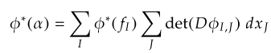
where his sums are both ordered sums which we call Σ'J and Σ'I .

It is useful to write out (10.9.15)C in full notation :

φ*(αx) = Σ1≤j$_{1}$<j$_{2}$<....<j$_{k}$≤n Σ1≤i$_{1}$<i$_{2}$<....<i$_{k}$≤m fi$_{1}$i$_{2}$...i$_{k}$(φ(t))

* det [RIJ] * ( dti$_{1}$ ^ dti$_{2}$ .....^ dti$_{k}$ ) (10.9.16)

where RIJ is this kxk matrix,

Ri$_{1}$j$_{1}$ Ri$_{1}$j$_{2}$ ... Ri$_{1}$j$_{k}$
RIJ = Ri$_{2}$j$_{1}$ Ri$_{2}$j$_{2}$ ... Ri$_{2}$j$_{k}$
.....
Ri$_{k}$j$_{1}$ Ri$_{k}$j$_{2}$ ... Ri$_{k}$j$_{k}$ (10.9.17)
with
Rij = (Dφ)ij = (∂φi/∂tj) = ∂jφi(t) . // (10.8.3)

The object det(RIJ) is a k x k minor of the full m x n matrix R, so k ≤ n ≤ m in our application. Remember that, due to the ordered sums, all the ir are different, and all the jr are different, so no row or column appears twice in RIJ.

Here is a hybrid picture where we add more detail to Fig. (10.8.15),

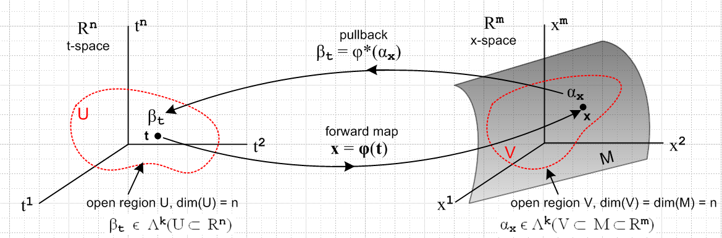
(10.9.18)

We have added an n-dimensional open domain region U in t-space which maps via x = φ(t) into an open region V which lies on the manifold M (a "surface"), which is of dimension n. Our point of interest t lies in U, and x lies in V. The picture is a bit symbolic since it shows t-space = Rn and x-space = Rm, but the differential forms αx and βt are really objects within the dual spaces (Rm)* and (Rn)*.

Here is a more practical picture for the special case n = 2 and k = 2:

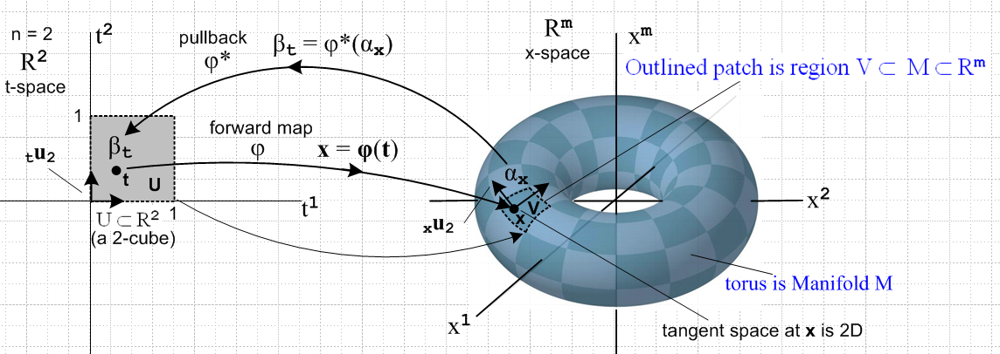
(10.9.19)

Here the open region U is a unit square [0,1]2 which maps into a patch on a torus. That is, if m = 3 the object on the right is a torus in R3, but we can imagine it to be a torus embedded in Rm for any m ≥ 3.
The space of vectors defined on U ⊂ R2 is a 2-dimensional dual space (R*2)(U). On this space we can define either 1-forms or 2-forms. The above picture suggests a 2-form since the region U is an area, and since we will later associate dt1 ^ dt2 with the calculus differential dt1dt2 which represents an area (we are not there yet).
The picture shows the "forward map" x = φ(t), suggesting that forward means left to right in the picture. Then αx is "pulled back" right to left from dual x-space to dual t-space where it becomes βt.
One could imagine a set of 16x6 = 96 mappings like the one shown above which would "cover the torus", using one little patch for each mapping (with some small overlap between patches). One would then have an atlas of 96 square maps like that on the left which would serve to cover the surface of Planet Toroid. This is the basic idea of a manifold. In the torus example, one could do the job with only 2 maps. Doing it with a single map does not fly since then some seam curve on the torus would map back to two boundaries of the square and the mapping is then not one-to-one and smooth. Manifold mappings have to be continuous in both mapping directions at every point, and a seam is a place without continuity.
The aspect ratio of the 2-cube on the left is not significant. One could change it to be an arbitrary rectangle in t-space and select a φ to make it map to the same small image patch in x-space. Or one could construct a mapping φ which maps the unit 2-cube [0,1]2 to the entire left half of the torus. See Sjamaar.
The black arrows on the left are the t-space basis vectors tui (only tu2 is labeled). As shown in (10.8.6), these map according to xui = R tui into basis vectors which are tangent to M, and these vectors then span the tangent space TxM at point x on M. It is clear that the two xui vary as the point x on M is varied.

As another example consider this situation with n = 1 and k = 1,

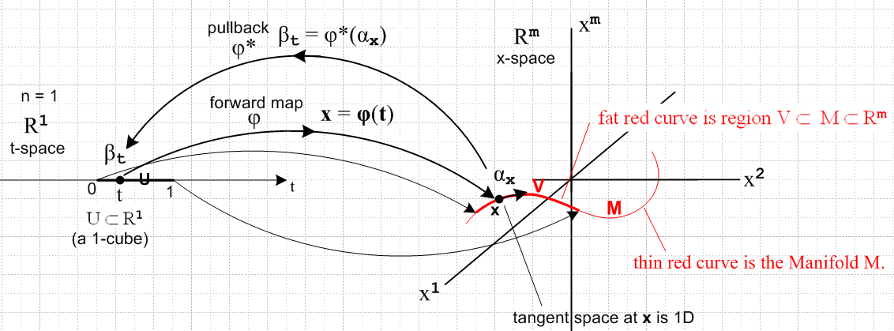
(10.9.20)

Now the domain in t-space is a U = 1-cube [0,1] which maps to a (generally non-planar) red curve which is embedded in Rm . Here αx and βt are 1-forms. The red curve segment V lies on the manifold curve M as shown, just as the patch of the previous example lay on the torus. There is only one basis vector tu in t-space (not shown) and it maps to the unlabeled black arrow on the right which is xu and is of course tangent to the curve at x.

(b) The tensor-function pullback equation for a k-form

Recall (5.6.17)

P [ |T1> ⊗ |T2>...⊗ |TN>] = P |T1> ⊗ P|T2>...⊗ P |TN> (5.6.17)

which describes the effect of an operator P on a tensor product of N arbitrary tensors. If the tensors are just vectors and if the operator is R, then

R| v1,v2...vk> = R [ | v1> ⊗ | v2> ..... ⊗ | vk> ]

= R | v1> ⊗ R | v2> ..... ⊗ R | vk> = | Rv1> ⊗ | Rv2> ..... ⊗ | Rvk>

= | Rv1,Rv2...Rvk> . (10.9.21)

Therefore

<αx | φ*| v1,v2...vk> = <αx | R |v1,v2...vk> = <αx | Rv1,Rv2...Rvk> . (10.9.22)

In function notation this is written

[φ*αx] (v1,v2...vk) = αx(Rv1,Rv2...Rvk) for αx = Σ'I fI(x) dx^I (10.9.23)

and this is the pullback equation written in terms of tensor functions. Each side of this equation is a totally antisymmetric k-multilinear tensor function in the dual space Λkf(V) of (8.3.1a).

Traditionally one defines the original differential form to be α and not αx so (10.9.27) becomes,

[φ*α] (v1,v2...vk) = α(Rv1,Rv1...Rvk) for α = Σ'I fI(x) dx^I . (10.9.24)

Since [φ*α] is a t-space k form, we might indicate that by adding a subscript t to get [φ*α]t. Recall that earlier this was called βt. And since α is an x-space k-form, we add a label there as well to get αx, ]

[φ*α]t (v1,v2...vk) = αx(Rv1,Rv1...Rvk) for α = Σ'I fI(x) dx^I . (10.9.25)

Since x = φ(t), replace αx → αφ(t) to get

[φ*α]t (v1,v2...vk) = αφ(t)(Rv1,Rv1...Rvk) for α = Σ'I fI(x) dx^I . (10.9.26)

Finally, since Rij = (D(t)φ)ij = (∂φi(t)/∂tj) as in (10.9.17), we replace R = (D(t)φ) to get

[φ*α]t (v1,v2...vk) = αφ(t)( (D(t)φ)v1, (D(t)φ)v1... (D(t)φ)vk) α = Σ'I fI(x) dx^I . (10.9.27)

The entire right side depends only on the variable t, appropriate since it is a t-space k-form. Had we started with variables y = φ(x) instead of x = φ(t) the above would have t→x and x→ y to become

[φ*α]x (v1,v2...vk) = αφ(x)( (D(x)φ)v1, (D(x)φ)v1... (D(x)φ)vk) α = Σ'I fI(y) dy^I . (10.9.28)

This expression appears in Sjamaar [2015] page 96 from which we quote,

He writes (D(x)φ) as Dφ(x) and [φ*α]x as φ*(α)x .

The tensor function pullback equation also appears in Spivak but not quite as we have written it. Spivak says on the top of page 90 and the bottom of page 89,

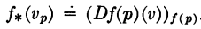

which we interpret to mean

[f*(ω)](p)(v1,v2...vk) = ω(f(p)) ( (D(p)f)v1, (D(p)f)v2, ... (D(p)f)vk ) .

Replacing ω→α, f→φ and p → x gives

[φ*(α)](x)(v1,v2...vk) = α(φ(x))( (D(x)φ)v1, (D(x)φ)v2, ... (D(x)φ)vk ) .

We then interpret (x) on the left and φ(x) on the right as tags indicating the space of the differential form, so the above becomes

[φ*(α)]x(v1,v2...vk) = αφ(x)( (D(x)φ)v1, (D(x)φ)v2, ... (D(x)φ)vk )

in agreement with (10.9.28) and with Sjamaar's form. Sjamaar 2015 refers to φ*α as the pullback of α, but Spivak writing in 1965 does not use the term pullback in his book. Having a name for something is always helpful.

(c) Properties of the pullback operator φ*
______________________________________________________________________________

Fact: φ* is linear, so φ*(s1α + s2β) = s1(φ*α) + s2(φ*β) where α, β are both k-forms. (10.9.28)

Proof: φ*( s1α + s2β) = [ s1<α| + s2<β| ] φ* // Dirac notation

[ s1<α| + s2<β| ] R // φ* = R

= s1<α| R + s2<β| R // R is a linear operator

= s1<α| φ* + s2<β| φ* // name change

= s1(φ*α) + s2(φ*β) // functional form of φ* QED

Basically φ* is linear because R is linear going way back to V' = Rij Vj and dx' = R dx. R is the linearization at a point x of the generally non-linear underlying transformation x' = F(x). More specifically, <xei| R = Rij<tuj| from (10.8.17).
___________________________________________________________________________

Fact: φ*(α1 ^ α2 ^...^ αN) = φ*(α1) ^ φ*(α2) ^...^ φ*(αN) where αi is an arbitrary ki-form. (10.9.29)

Proof: φ*(α1 ^ α2 ^....^ αN) = [ <α1| ^ <α2| ^ ... ^ <αN| ] | φ* // Dirac notation

= [ <α1| φ* ^ <α2| φ* ^ ... ^ <αN| φ* ] // (8.9.d.15)

= φ*(α1) ^ φ*(α2) ^...^ φ*(αN) // functional form for φ* QED

Add something here regarding 0-forms and how they can be added to this theorem.
___________________________________________________________________________

Fact: φ*(dα) = d(φ*α) (10.9.30)

Proof: A. α = Σ'IfI(x) xλ^I // (10.2.1)

dα = Σ'I dfI(x) xλ^I = Σ'I ( Σj=1n [∂jfI(x)] xλj) ^ xλ^I // (10.3.6)

φ*(dα) = Σ'I Σj=1n [∂jfI(x)]x=φ(t) φ*(xλj ^ xλ^I) // (10.9.28) linear

= Σ'I Σj=1n [∂jfI(x)]x=φ(t) φ*(xλj) ^ φ*(xλ^I) // (10.9.29)

B. φ*α = Σ'IfI(x(t)))φ*(xλ^I) // (10.9.28) linear

d(φ*α ) = Σ'I dfI(x(t))) φ*(λ^I) // (10.3.6)

= Σ'I Σj=1n[∂jfI(x) (∂xj/∂tr)] tλr ^ φ*(λ^I) // (10.3.6)

= Σ'I Σj=1n[∂jfI(x) Rir] tλr ^ φ*(λ^I) // (10.8.3) item (a)

= Σ'I Σj=1n[∂jfI(x)] (Rir tλr) ^ φ*(λ^I) // regroup

= Σ'I Σj=1n[∂jfI(x)] φ*(xλi) ^ φ*(λ^I) // (10.8.17)

The two results are the same, so φ*(dα) = d(φ*α) . QED

Corollary: d(φ*(dα)) = 0 since this is d2(φ*α), see (10.3.12) (10.9.31)
______________________________________________________________________________

Fact: φ*(ψ*α) = (ψ o φ)* α where α is a k-form (10.9.32)

Proof: This theorem involves two mappings φ and ψ which are composed to form a third Φ :

y = ψ(x) x = φ(t) t → x → y t → y
φ ψ Φ
y = ψ(φ(t)) = [ψ o φ ](t) = Φ(t) .

In Dirac notation we denote spaces by subscripts on the bras (dual space vectors)

t<α| // start with t-space k-form
t<α| φ* = x<β| // apply φ* to get an x-space k-form
x<β| ψ* = y<κ| // then apply ψ* to get a y-space k-form

Combining these two steps to get

(t<α| φ*)ψ* = y<κ| . // normally written t<α| φ*ψ*

Instead of taking two steps, do it in one step using Φ

t<α| Φ* = y<κ| . // apply Φ* to get a y-space form directly from t<α|

Since both methods give the same y<κ| conclude that

(t<α| φ*)ψ* = t<α| Φ* = t<α| (ψ o φ)*

or in function notation,

ψ*(φ*(α)) = (ψ o φ)*(α) QED

A Chapter 1 style category diagram for this scenario would be




