Section 10.6 PhL 3.6.16

10.6 The pullback of a simple differential form

About t-space and x-space

In Chapter 2 we discussed the transformation x' = F(x) from x-space to x'-space using this picture,

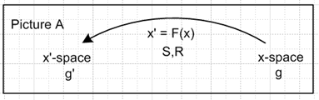 (2.1.1)

The differential (the R-matrix) of the transformation was given by

V'a = RabVb Rab ≡ (∂x'a/∂xb) = ∂bx'a ≡ (∇F)ab ≡ (DF)ab ≡ (DF)ab (2.1.2)

dx'a = Rabdxb dx' = Rdx . (2.1.12)

Here V'a = RabVb shows the transformation of a contravariant vector under x' = F(x). In matrix notation one would write V' = RV.

Above we have defined the objects ∇F and DF as being alternate names for matrix R because authors like Spivak use this notation. In (E.4.4) of Tensor we show that this is in fact a "reverse dyadic notation". Often (DF)ab is written unbolded as just (DF)ab so then R = (DF) with the idea that a matrix like R is normally not bolded.

We now change x' → t and x → x' to get instead the following Picture,

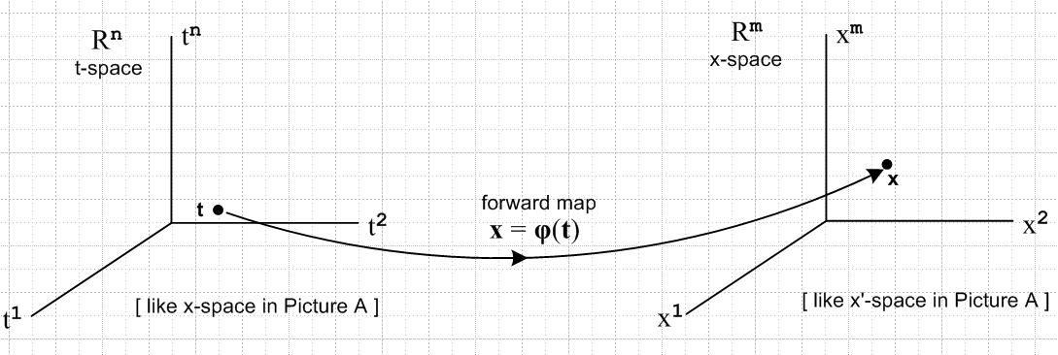
(10.6.1)

We have swapped the left and right sides of Picture A above, so the transformation arrow now points to the right. Instead of being x' = F(x), the new transformation is x = φ(t). The new (2.1.2) R matrix is this

(xVa) = Σb=1n Rab (tVb) Rab ≡ (∂xa/∂tb) = ∂bxa ≡ (∇φ)ab ≡ (Dφ)ab
or
(xV) = R (tVb) dx = R dt . (10.6.2)

In Chapter 2 (and in the underlying Tensor document) the two spaces had the same dimension, but now
t-space = Rn and x-space = Rm and we have in mind that m ≥ n. The R matrix is then in general no longer square, but is in fact an m x n matrix with m rows (first index a) and n columns (second index b). R is a "tall" matrix when m > n. We have chosen the symbols m and n to be consistent with Spivak and Sjamaar.

Basis vectors in the two spaces

We first define a standard set of n basis vectors in t-space,

{tei } i = 1,2...n basis for t-space

(tei )j = δij components of these basis vectors in t-space (10.6.3)

where the last equation was written (em(e))n = δmn in (2.6.8). Since these are basis vectors in t-space, we map them into x-space using (xV) = R (tVb) of (10.6.2),

(xei) = R(tei)
or
(xei)j = Σa=1n Rja (tei)a = Σa=1n Rja δia = Rji i = 1,2...n j = 1,2..m . (10.6.4)

Since there are m basis vectors in x-space, we define the rest of the xei arbitrarily such that the m basis vectors {xei} in Rm are linearly independent, so

xei = as needed i = n+1, n+2 .....m . (10.6.5)

Note that equation (xei) = R(tei) or (xei)j = Σa=1n Rja(tei)a is a "component transformation".

"Raising/lower components and maintaining tilts" as below (2.9.2) we can write a version of (10.6.4) for the dual basis vectors ei ,

(xei) = R(tei)
or
(xei)j = Σa=1n Rja (tei)a = Σa=1n Rja δia = Rji i = 1,2...n j = 1,2..m . (10.6.6)

Since (xei)j = Rji and (xei)j = Rji, we conclude that :

Fact: The first n x-space basis vectors xei for i = 1 to n are the columns of R** .
The first n x-space basis vectors xei for i = 1 to n are the columns of R** . (10.6.7)

That is to say, in (xei)j = Rji if we fix i and examine j = 1,2...m, we describe the column i of R**.

If the columns of R** [or R**] are denoted ci [ or ci ] then one can write,

R** = [ c1, c2.....cn ] = [xe1, xe2 ....xen ] ci = xei

R** = [ c1, c2.....cn ] = [xe1, xe2 ....xen ] ci = xei . (10.6.8)

Recall that R is a tall matrix with m rows and n columns, so each ci [ or ci ] has m components.

Comment: We have been quiet about the metric tensors tg and xg in the two spaces. By using covariant notation, this entire section should be valid for any choice of metric tensors. Usually one specifies a metric tensor in t-space, call it (tg)ab and then (xg)ab is determined by (xg)ab = (tea) • (teb) as in (2.3.2).

Normally the t-space metric tensor is taken to be Cartesian so

In terms of the basis vectors, the covariant metric tensors are (xgt)ij = tei • tej and (tg)ij = xei • xej , as shown in (2.3.2).

The pullback operator

Now we are going to "pull back" all m of the xei basis vectors in x-space to vectors in t-space which vectors will turn out to be the rows of the R matrix. Here we are not inverse-mapping the first n xei back to their corresponding tei in t-space, we are doing something different. We first define,

φ*T(xei) ≡ Σj=1n Rij (tej) i = 1..m (10.6.9)

where φ*T is a pull back operator which maps from x-space to t-space, φ*T : Rm→ Rn. The reason for writing this as the transpose of operator φ* will become clear below.
The sum on the right of (10.6.9) is a linear combination of t-space basis vectors, it is not a sum of vector components as in (10.6.4), so φ*T(xei) is a vector in t-space, not in x-space.
Now take the contravariant s component of both sides of (10.6.9),

[φ*T(xei)]s = Σj=1n Rij (tej)s i = 1,2...m s = 1,2...n

= Σj=1n Rij δjs // (10.6.3)

= Ris . (10.6.10)

Reversing the tilts as done earlier, we can rewrite (10.6.9) and (10.6.10) as

φ*T(xei) ≡ Σj=1n Rij (tej) i = 1..m

[φ*T(xei)]s = Ris . (10.6.11)

Therefore we have shown that

Fact: The m t-space vectors φ*T(xei) for i =1 to m are the rows of the R** matrix.
The m t-space vectors φ*T(xei) for i =1 to m are the rows of the R** matrix. (10.6.12)

If the rows of R** [ or R**] are denoted ri [ or ri ] then we can write

R** = $\left[\begin{matrix}r1 \\ r2 \\ ... \\ rm\end{matrix}\right]$ = $\left[\begin{matrix}φ*T(xe1) \\ φ*T(xe2) \\ ... \\ φ*T(xem)\end{matrix}\right]$ and ri = φ*T(xei) .

R** = $\left[\begin{matrix}r1 \\ r2 \\ ... \\ rm\end{matrix}\right]$ = $\left[\begin{matrix}φ*T(xe1) \\ φ*T(xe2) \\ ... \\ φ*T(xem)\end{matrix}\right]$ and ri = φ*T(xei) . (10.6.13)

Recall that R is a tall matrix with m rows and n columns, so each ri [ or ri ] has n components.

This drawing represents the three mappings so far described,

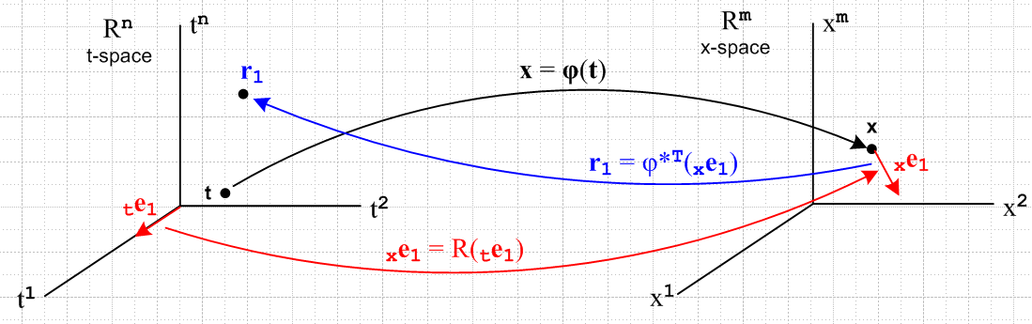
(10.6.14)

where we show the mappings for the basis vector te1.

In Dirac notation one can write (10.6.9) and (10.6.11) as ket equations,

φ*T | xei> = Σj=1n Rij | tej> i = 1,2..m

φ*T | xei> = Σj=1n Rij | tej> . (10.6.15)

Since the transpose of A|b> is <b|AT as in (2.11.d.7), and since the R matrix is real, the corresponding bra equations are

<xei | φ* = Σj=1n Rij <tej | i = 1,2..m

<xei | φ* = Σj=1n Rij <tej | . (10.6.16)

The bras in these equations are dual space vectors (rank-1 linear functionals) as discussed in Section 2.11.
The ket <xei | is an element of dual space (Rm)* while <tej | inhabits (Rn)*. Note that Fig (10.6.14) displays only the spaces Rn and Rm and not the corresponding dual spaces.

In terms of basis functionals λi in the dual spaces, this last equation may be written, using (2.11.c.2),

φ*(xλi) = Σj=1n Rij (tλj) = Σj=1n (Dφ)ij (tλj) i = 1,2..m (10.6.17a)

or in cosmetic notation

φ*(dxi) = Σj=1n Rij (dtj) = Σj=1n (Dφ)ij (dtj) i = 1,2..m . (10.6.17b)

Since xλi = dxi is a very simple example of a differential form, we see in (10.6.17) our first example of "the pull back of a differential form". What is being "pulled back" is the dual vector <xei| = xλi ϵ (Rm)* . The pulled back vector is φ*(xλi) ϵ (Rn)*. The mapping is φ*:(Rm)*→ (Rn)*.

The Tangent Space Basis Vectors

Assume that as t ranges over some portion of t-space, the mapping x = φ(t) describes a "smooth surface" M embedded in x-space, a manifold. If we start at some t and move to t + dt in t-space, we move from some point x on M to some nearby point x + dx on M. This dx is tangent to the surface M and thus lies in the tangent space TxM of M at point x, as discussed above in Section 10.2. Applying R to each of the n axis-aligned differentials dti = dti(tei) in t-space (no i sum), we thereby generate a set of n differential vectors dxi = Rdti which are in effect a set of short basis vectors which span the tangent space TxM. Since dxi = dxi (xei), we may take the basis vectors {xei, i=1,2..n} as spanning TxM, in agreement with our arrangement of things in Section 6.2. The vector set {xei, i=n+1,n+2..m} are then all orthogonal to the "surface" M.
We know from the fact xei • xej = δij that the set {xei, i=1,2..n} also form a basis for the tangent space TxM. This conclusion can be reached as well by raising all i indices in the previous paragraph. In this case, the set {xei, i=n+1,n+2..m} are then all orthogonal to the "surface" M.
According to (10.6.7) we may conclude that

Fact: The first n basis vectors xei, which are the columns of R** , span the tangent space TxM.
The first n basis vectors xei, which are the columns of R** , span the tangent space TxM.
(10.6.18)

The dual vectors (functionals) in the sense of xλi = <xei| then span the cotangent space of TxM.

10.7 The pullback of a general differential form

Recall the action of operator φ* on the bra <xei |,

<xei | φ* = Σj=1n Rij <tej | i = 1,2..m (10.6.12) (10.7.1)

An operator P which acts on a vector space V, has a natural extension to being an operator on the tensor product space Vn ,

P | v1,v2....vk> = P [ | v1> ⊗ |v2>....⊗|vk> ] = P| v1> ⊗ P|v2>....⊗ P|vk> . (10.7.2)

Similarly, an operator Q which acts on a dual vector space V*, has a natural extension to being an operator on V*n ,

< v1,v2....vk| Q = [ < v1| ⊗ <v2|....⊗<vk| ] Q = < v1|Q ⊗ <v2|Q....⊗<vk|Q . (10.7.3)

Setting Q = φ* we then define,

< xei$_{1}$,xei$_{2}$....xei$_{k}$| φ*

= < xei$_{1}$|φ* ⊗ <xei$_{2}$|φ*....⊗ <xei$_{k}$|φ*

= [Σj$_{1}$=1n Ri$_{1}$j$_{1}$ <tej$_{1}$ | ] ⊗ [Σj$_{2}$=1m Ri$_{2}$j$_{2}$ <tej$_{2}$ | ] ... ⊗ [Σj$_{k}$=1m Ri$_{k}$j$_{k}$ <tej$_{k}$ |]

= Σj$_{1}$j$_{2}$...j$_{k}$=1n Ri$_{1}$j$_{1}$ Ri$_{2}$j$_{2}$ ... Ri$_{k}$j$_{k}$ ( <tej$_{1}$ | ⊗ <tej$_{2}$ | ... ⊗ <tej$_{k}$| ) (10.7.4)

In multiindex notation this says

< xeI | φ* = ΣJ RIJ <teJ | . (10.7.5)

A nearly identical result can be obtained for wedge space Λk. Apply AltI to both sides of (10.7.5) to get

AltI [ < xeI | φ* ] = AltI [ ΣJ RIJ <teJ | ] (10.7.6)

According to (8.1.2) the left side is just

AltI [ < xeI | φ* ] = AltI [ < xeI | ] φ*

= < xe^I | φ* where <xe^I| = <xej$_{1}$ | ^ <xej$_{2}$ | ... ^ <xej$_{k}$| (10.7.7)

The right side is a little tricky:

AltI [ ΣJ RIJ <teJ | ] = ΣJ [AltI(RIJ)] <teJ |

= ΣJ [(1/k!) ΣP(-1)P RP(I)J ] <teJ | // def of Alt ***

= [(1/k!) ΣP(-1)P ΣJ RP(I)J ] <teJ | // reorder

= [(1/k!) ΣP(-1)P ΣJ RP(I)P(J) ] <teP(J) | // (A.1.20)

= [(1/k!) ΣP(-1)P ΣJ RIJ ] <teP(J) | // (A.1.31)

= ΣJ RIJ [(1/k!) ΣP(-1)P <teP(J) | ] // reorder

= ΣJ RIJ AltJ <teJ |

= ΣJ RIJ <te^J | where <te^I| = <tej$_{1}$ | ^ <tej$_{2}$ | ... ^ <tej$_{k}$| (10.7.8)

Thus we have shown that

< xe^I | φ* = ΣJ RIJ <te^J | (10.7.9)

which is identical in form to (10.7.5) but the basis vectors are wedge products instead of tensor products.

So far so good!

