Problems with the pullback being just R PhL 3.25.16

5.17.16: This is an early attempt to understand the meaning of "pullback" in my Dirac world. I really start off with the "push forward" equations. I think this stuff is finally all understood and written up in Section 10.7. I show the Spivak picture which does suggest the enlargement of R from m x n to m x m which I then pursued elsewhere but it was not really useful to me.

Here is our starting data

u'i = R ui |u'i> = R |ui>
or
(u'i)j = Rja (ui)a = Rja δia = Rji i = 1,2...n j = 1,2..m . (10.6.7)

u'i = R ui |u'i> = R |ui>
or (10.6.10)
(u'i)j = Rja (ui)a = Rja gib(ub)a = Rja gibδba = Rja gia = Rji .

One derivation pathway is this:

|u'i> = R |ui>

RT |u'i> = RTR |ui> = |ui>

<u'i | R = <ui | = pullback idea.

The middle line is questionable. Write out in matrix notation,

RT u'i = RTR ui = ui

Then write out in components to see if everything exists:

(RT)ab (u'i)b = (RTR)ac (ui)c = (ui)a

Rba (u'i)b = (RT)ab(R)bc (ui)c = (ui)a

Rba (u'i)b = RbaRbc (ui)c = (ui)a

The object shown in red does not exist, so this pathway is no good!

Consider again the desired result:

RT |u'i> = |ui>

RT u'i = ui

(RT)ab(u'i)b = (ui)a

Rba (u'i)b = (ui)a

So even the goal statement RT |u'i> = |ui> is "bad" because when you write it out, it includes an object which I claim does not exist!

What I really want however is this :

<u'i| R = <ui|

(u'i)T R = (ui)T

[(u'i)T R]a = [(ui)T]a

[(u'i)T R]a = [(ui)T]a

(u'i)TbRba = [(ui)T]a

(u'i)b Rba = (ui)a

Again this contains an object which I claim does not exist. So how can I claim that <u'i| R = <ui| is the R operator pulling back the <u'i| vector into the <ui| vector when in fact <u'i| R = <ui| "does not exist"?

Plan A: Go back to this statement: the equation x = F-1(x') exists only for x' on the Manifold . Give me an example of such an equation for m = 3 and n = 2. Suppose

x' = F(x)

x'1 = 2x1 + 3 x2
x'2 = x1 + (x2)2
x'3 = (x1)2 + 2x2

Solve for x1 and x2 to get the inverse equation. You have 3 equations in 2 unknowns.

Rij ≡ (∂x'i/∂xj)

R11 = (∂x'1/∂x1) = 2
R12 = (∂x'1/∂x2) = 3
R21 = (∂x'2/∂x1) = 1
R22 = (∂x'2/∂x2) = 2 x2
R31 = (∂x'3/∂x1) = 2 x1
R32 = (∂x'3/∂x2) = 2

As expected, no problem computing R**.

Discussion: We know that x = F-1(x') ≡ G(x') exists for all points x' on the manifold M. We can therefore differentiate this equation in any direction which lies ON the manifold, which is to say, in the direction of any tangent base vector. How can I write such a derivative?

Suppose the n tangent vectors are |u'i> . Let's define corresponding coordinates ξ'i where we use a prime because they are in x'-space, and ξ is a free variable name. Then a vector in the tangent space would be

ξ' = Σi=1n ξ'i u'i = (ξ'1, ξ'2, ... ξ'n) in the u'i basis

Can I write this same vector in the e'i basis?

|ξ'> = ξ'i |u'i> = ξ'i [1] |u'i> = ξ'i | e'j> <e'j| u'i> = ξ'i | e'j>Rji

= Rjiξ'i | e'j> = [Rξ']j | e'j> = ([Rξ']1, [Rξ']2, ... [Rξ']m) in the e'i basis

= (x'1, x'2, ... x'm) in the e'i basis
So it seems that

x'j = [Rξ']j = Rjiξ'i ?

and this is then how associate a vector ξ' in the tangent space with a point x' in x-space.
Well, I think that is not quite right. Suppose the tangent spaces is referred to point x'0 on the manifold. Then I think the correct answer is

x' = x'0 + Rξ'

x'j = x0'j + [Rξ']j = x0'j + Σi=1nRjiξ'i

So for any vector ξ' you give me in the tangent space, I can give you back the exact corresponding point x' in the x'-space. Note that for finite vectors ξ', the points x' do not lie on the manifold, they lie in the tangent "plane" to the manifold at point x'0 .

Fact: The coordinates x' and ξ' are related as shown above.

So consider two points close to each other on the manifold, call these points x'1 and x'2 . Then if we define dx' = x'2 - x'1 we surely have, from the above equation

dx' = R dξ' // dx' has m components, dξ' has n components (1)

Fact: For any dξ' in the tangent space ξ'-space at some point x'0 , the corresponding dx' in x'-space is given by the above equation dx' = R dξ'.

Now imagine that the basis vectors u'i are translated to the origin in x'-space. These basis vectors are related to the axis-aligned basis vectors this way

|u'i> = | e'j> <e'j| u'i> = | e'j>Rji = Σj=1m Rji | e'j> i = 1,2...n only

very simple. Sort of that they are related by a "rotation" but R can be more general than a rotation.

Fact: The basis vectors |u'i> and | e'j> are related as shown above.

Meanwhile we have

x' = F(x) and dx' = R dx. (2)

So compare these two equations:

dx' = R dξ' (1)
dx' = R dx (2)

I think it is fair to conclude (as I did in an earlier document) that

dξ' = dx = R dx where R = 1

Fact: The differential vectors dξ' and dx are related as shown above, dξ' = dx .

Question: Why can't I now think of a mapping between x-space coordinates xi and ξ'-space coordinates called ξ'i and have a "tensor doc" application to those coordinates? What is the transformation linking these coordinates?

Answer: The differential transformation linking the xi and ξ'i is as shown above, dξ' = dx so the R matrix for this transformation is the identity matrix.

Question: (repeat from above) We know that x = F-1(x') exists for all points x' on the manifold M. We can therefore differentiate this equation in any direction which lies ON the manifold, which is to say, in the direction of any tangent base vector. How can I write such a derivative?

x = F-1(x')

x+dx = F-1(x'+dx') dx' lies on manifold

dxi = Σj=1m [ ∂ (F-1)i /∂x'j] dx'j i = 1,2..n

= Σj=1m [ ∂xi /∂x'j] dx'j

= Σj=1m [Sij] dx'j

It seems that Sij must exist for dx' lying on the manifold. But when you write

Sij = ∂xi /∂x'j

Typically NONE of these derivatives is along the manifold, so I am not happy saying Sij exists.

Try again this way:

x0 + dx = F-1(x'0 + Rdξ') ≈ F-1(x'0) + [ ∂ (F-1)i /∂x'j] [Rdξ']j

But same problem.

Realization #1. I am starting to understand now why Spivak wants to have elbow-room buffer regions around objects in the mapping.

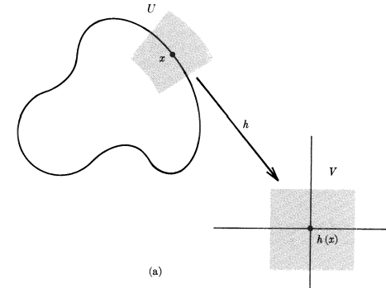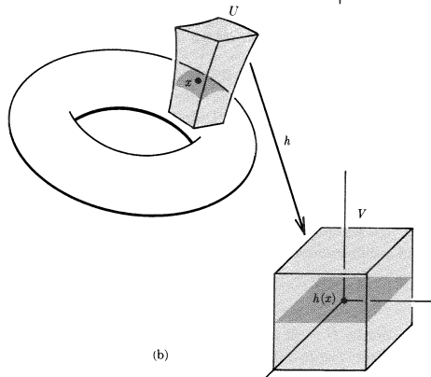

Having these extra regions shown in light gray here has two implications:

(1) The mapping that was F : Rn → Rm becomes F : Rm → Rm = tensor doc friendly

(2) In either space, you can differentiate in any direction you want.

Example on the left above: the curve segment shown solid is a mapping from the portion of the real axis shown to its right. This is F: R1 → R2. But the gray areas are F: R2 → R2.

Example on the right above: the curved patch on the toroid is a mapping from the gray square shown on the right which is F: R2 → R3 . But the gray areas are F: R3 → R3 .

Why then can't I restrict my interest to functions x' = F(x) which HAVE such buffer regions, perhaps I restrict to diffeomorphisms I think was the Spivak word.

How exactly to you "add buffer regions" or make sure they can be added? I tried this in a separate doc yesterday, and came up with this idea,

x'1 = F1(x1, x2, x3... xn, xn+1....xm) = F1(x1, x2, x3... xn)
x'2 = F2(x1, x2, x3... xn, xn+1....xm) = F2(x1, x2, x3... xn)
...
x'n = Fn(x1, x2, x3... xn, xn+1....xm) = Fn(x1, x2, x3... xn)
x'n+1 = Fn+1(x1, x2, x3... xn, xn+1....xm) = Fn+1(x1, x2, x3... xn) + xn+1
x'n+2 = Fn+2(x1, x2, x3... xn, xn+1....xm) = Fn+2(x1, x2, x3... xn) + xn+2
...
x'm = Fm(x1, x2, x3... xn, xn+1....xm) = Fm(x1, x2, x3... xn) + xm

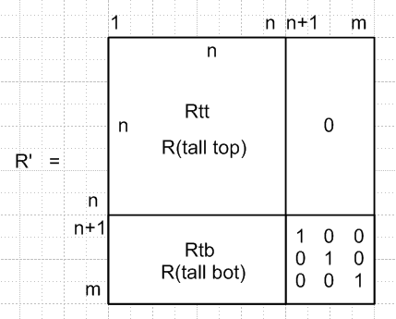

The idea is then that the "dark" areas on both sides of the map are for xn+1 = ... = xm = 0, but then we have our elbow room in x-space when one or more of these is non-zero but small, and those are Spivak's light gray regions. I have "extended" the mapping which started out as F : Rn → Rm to one which is F : Rm → Rm and to which tensor doc can then be applied. After doing this, I did not pursue the idea.

What is the inverse of the above R matrix?

