Applying tensor doc to differential forms PhL 3.23.16

The Plan attempted here is to reduce dimensions in an attempt to find an n x n R-matrix which links the small x-space on the left to just the tangent space on the right. Despite efforts below, I was not able to make this Plan fly. Not quite sure why, tried to find dx' = Rdx where R is nxn and where dx' has only n components. When I try this below I end up in effect with R = 1, not what I was looking for. In another document I will try to enlarge dimensions in an attempt to find an m x m R-matrix. I think this is a method that Bucks used.

Reviewed the above paragraph on 5.16.16 and will just archive this doc away, no need for it.

I have just finished spending some time reviewing tensor doc in the scenario of a non-square R matrix, as is encountered in the differential forms application, with this characteristic picture

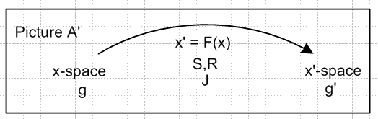

x-space x'-space
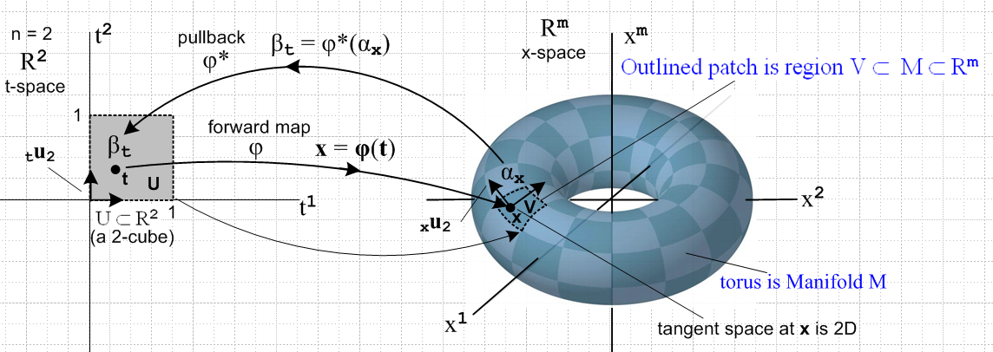

I always think of going from R2 on the left to R3 on the right with some embedded smooth surface, In general the left is Rn and the surface is dim n but within Rm with m > n.

My conclusion on reviewing tensor doc is that the great bulk of the theory presented in tensor doc is invalidated in this scenario.

It seems that the right thing to do instead is to apply tensor doc between x-space being as shown above on the left, and the tangent space Tx'M at point x' on the toroid above. These spaces both have dimension n and so tensor doc should be applicable.

So here I want to figure out HOW you would do this.

The first thing I would do is this:

We select as a basis for x-space the set of n axis-aligned basis vectors ui,

{ui } i = 1,2...n basis for x-space

(ui )j = δij components of these basis vectors in x-space . (10.6.6)

These map into a set of n tangent base vectors u'i in x'-space as shown in (10.6.4),

u'i = R ui |u'i> = R |ui>
or
(u'i)j = Σa=1n Rja (ui)a = Σa=1n Rja δia = Rji i = 1,2...n j = 1,2..m . (10.6.7)

Notice that Rik ≡ (∂x'i/∂xk) [ the downtilt R matrix] exists from x' = F(x).

Since there are n basis vectors in x-space, we define the rest of the u'i arbitrarily such that the m basis vectors {u'i} in Rm are linearly independent, so

u'i = as needed i = n+1, n+2 .....m . (10.6.8)

I can argue as in Section 10_6 v4 doc that the u'i for i = 1,2..n span Tx'M and the remaining ones are orthogonal to M at the point x'.

Now I think what comes next is that we need some names for coordinates in the tangent space. Perhaps call them ξi since this is a non-used symbol and Stak does this kind of thing. Maybe I could call this ξ-space connecting with x-space on the left.

Another choice, however, would be to redefine these variables to be the x' so then tensor doc facts can be used without alteration. But then we have something like y = F(x) as our general transformation. But that transformation is then not really the one that counts. This approach would involve this kind of picture

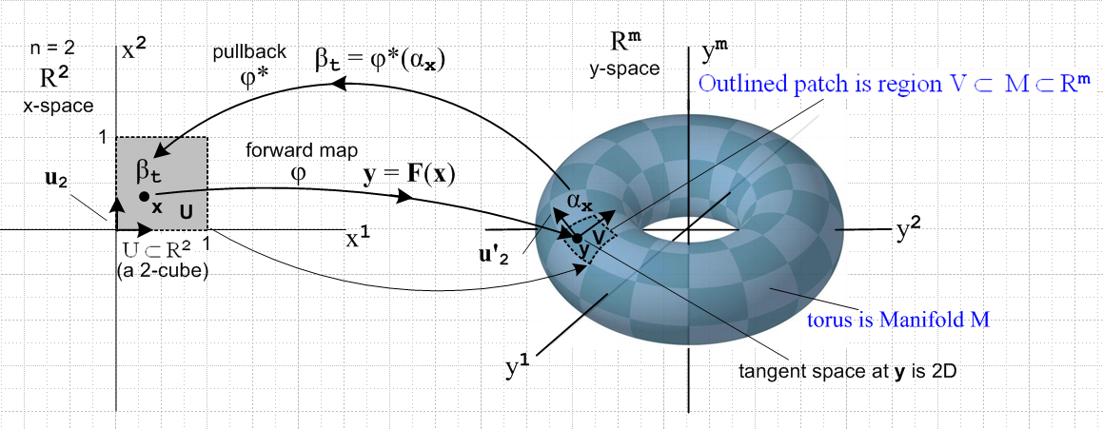

where the little tangent space shown is the new x'-space. Then we do exactly as outlined above which I repeat here.

We select as a basis for x-space the set of n axis-aligned basis vectors ui,

{ui } i = 1,2...n basis for x-space

(ui )j = δij components of these basis vectors in x-space . (10.6.6)

These map into a set of n tangent base vectors u'i which span x'-space,

u'i = R ui |u'i> = R |ui>
or
(u'i)j = Σa=1n Rja (ui)a = Σa=1n Rja δia = Rji i = 1,2...n j = 1,2..m . (10.6.7)

Notice that Rik ≡ (∂x'i/∂xk) [ the downtilt R matrix] exists from x' = F(x).

Since there are m basis vectors in y-space, we define the rest of the u'i arbitrarily such that the m basis vectors {u'i} in Rm are linearly independent, so

u'i = as needed i = n+1, n+2 .....m . (10.6.8)

I can argue as in Section 10_6 v4 doc that the u'i for i = 1,2..n span Tx'M and the remaining ones are orthogonal to M at the point x'.

OK, we at least are now talking about x-space and x'-space. One thing we know is this:

Rik ≡ (∂yi/∂xk) for y = F(x) R = tall matrix

but perhaps this is no interest in our new context. We need a new equation x' = G(x) which relates our new tangent space variables to the x-space ones. Do we have such an equation somewhere? Well, go back to y = F(x) which in fact defines our manifold M inside y-space. We have dy = Rdx with the R matrix just stated above. I think dy will lie on the manifold. In fact

dy(i) = R dx(i) = R [ dx(i) ui] = dx(i) Rui = dx(i)u'i i = 1..n

Now we know that this dy(i) lies in the tangent space at point x'. So repeat for a general differential vector in x-space,

dy = R dx = R [ Σi=1ndxi ui] = Σi=1n dxi Rui = Σi=1n dxiu'i

Our problem now is that this vector dy has m components, not n components. If we write it in the u'i basis we find that

dy = Σi=1n dxiu'i = (dx1, dx2, ...dxn, 0,0...0) = (dylo, dyhi) dyhi = 0,0,,0

where the last m-n components are 0 (in this basis!) However, if we write this in the x-space e'n basis we will get

dy = Σi=1n dyie'i = (dy1, dy2, ...dyn, dyn+1, ....dym)

and none of the components in general are 0.
Now using the non-square R matrix we can obtain the latter form from dy = R dx, so we KNOW all these dyi components. But we also KNOW all the n dxi components.

I want to produce a version of the u'i which have only n components, not m components. But in x'-space they really do have m components.

Suppose I could somehow rotate the rigid frame of the n u'i vectors so that u'1 lines up with the ξ1 axis, and so that u'2 lies in the ξ1-ξ2 plane with a positive ξ2 component, of this new space. This new space is n-dimensional. This is just some rotation of that frame we can call Q.

But instead of doing this complicated rotation, why not align a cage of axes right with the u'i axes, so we have this cage hanging at an obscure orientation in y-space.

Target (do not erase): I want to somehow define dx' which has only n components, and then I want to find an n x n matrix R such that dx' = Rdx and dx'i = Σj=1n Rijdxj . The differential dx' sits in some space of n-dimensions which is then x'-space.

Plan A. Just think of the n u'i for i = 1,.n as being abstract basis vectors spanning this new x'-space. Consider the above

dy = Σi=1n dxiu'i = (dx1, dx2, ...dxn, 0,0...0) = (dylo, dyhi) dyhi = 0,0,,0

where recall that dy has m components. Define dx' to be the first n of those components, so

dylo = dx' = vector with n components

Then we have

dx' = (dx1, dx2, ...dxn) components are in in the u'i basis

dx = (dx1, dx2, ...dxn) components are in in the ui basis

We know that u'i = Rui. I should be able to write this equation in different bases. The basis that first comes to mind is where you use the e'n basis in y-space (axis aligned) and in that case the u'i vectors generally have m non-vanishing components. You then are implying

[u'i(e')]a = Σb [R(e',u)]ab [ui(u)]b = [R(e',u)]ai a = 1..m, b = 1..n, i = 1..n

<e'a | u'i> = Σb <e'a | R | ub> <ub | uj> = <e'a | R | ui> Rai = <e'a | R | ui>

But you could do this another way as follows

[u'i(u')]a = Σb [R(u',u)]ab [ui(u)]b = [R(u',u)]ai = δai a = 1..m, b = 1..n, i = 1..n

<u'a | u'i> = Σb <u'a | R | ub> <ub | uj> = <u'a | R | ui> = δai Rai = δai

In this case, recall that a = 1..m but i = 1..n on that delta function. So the last m-n rows of this R matrix are all zeros. So this R matrix has this form

n columns
1 0 0 .. 0
0 1 0 .. 0
...
0 0 0 .. 1
0 0 0 .. 0 last rows all zeros
...
0 0 0 .. 0 total of m rows, first n are non-zero

Now in this basis consider again

dx' = (dx1, dx2, ...dxn) components are in in the u'i basis

dx = (dx1, dx2, ...dxn) components are in in the ui basis

We then write

dx' = R dx where R is the top square part of the matrix shown above, which is 1n

so we end up basically in this basis with

dx' = 1 dx = dx

just as it shows above!

Review: The Target above shows that I was trying to find a meaning for dx' such that dx' = Rdx where the matrix R was some non-trivial square n x n matrix and where dx' had n components only.

