Sjamaar and Buck vs wedge doc PhL 1.28.16

5/16/16: Things all OK here, but it took a while to ponder these two author's work.

Finally wedge doc is done and stable [ ha! ] (though I may add a few things), and the time has come to correlate my wedge doc results with stuff in the Sjamaar paper and also with Buck. I will start with Buck.

Buck

I start into my Chapter 7 notes with the book open. We have

ω(0-form) = f(r) a point function

ω(1-form) = A1(r)dx1 + A2(r)dx2 + ... + An(r)dxn = Aidxi

ω(2-form) = A12(r)dx1dx2 + A13(r)dx1dx3 + ... + A1n(r)dx1dxn
+ A23(r)dx2dx3 + A24(r)dx2dx4 + ... + A2n(r)dx2dxn
+ .... + A(n-1)ndxn-1dxn n! terms

with the idea that all these dxi factors are really wedge products. Here is our goal:

For example, integrate a 1-form over a region of dimension 1 which is a curve γ(t).
For example, integrate a 2-form over a region of dimension 2 which is a surface Σ(u,v).
For example, integrate a 3-form over a region of dimension 3 which is a surface V(u,v,w)

Comments: Are we in space or in dual space?? It seems at first blush that dx1^ dx2 is in V2 which is regular space, not dual space. Bucks show lots of integration examples, showing that the whole point of differential forms is being able to do this integrals over curves and surfaces and manifolds.

Issue: We have this idea :

ω = Adx + Bdy + Cdz

dω = dA dx + dB dy + dC dz

= (C2-B3)dydz + (A3- C1)dzdx + (B1-A2)dxdy B1 means ∂xB

This whole concept of ω to dω does not appear in my wedge doc anywhere. I have

v = Σiviei = my 1-form me

ω = Σi(Aidxi)ei = Σi Ai dxi = Σi A • dx Buck

α(v) = α • v me

I must say, right now I do NOT see the connection, so good to be doing this doc! Is it dual or non-dual?

Sjamaar starts talking about λi stuff white late in his pdf, it is Chapter 7 page 90. Sja has

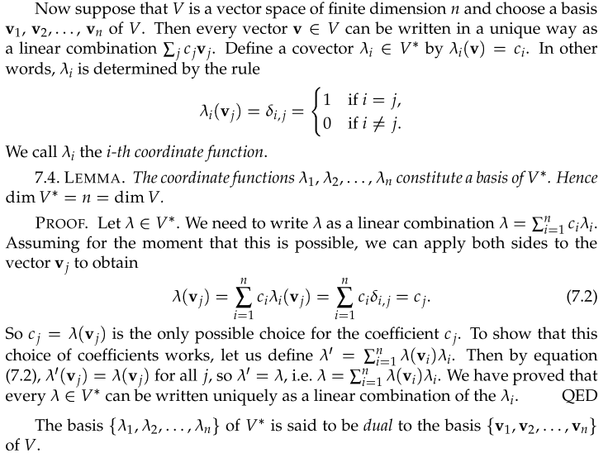

I have to make this translation:

me Sjamaar
ei vi basis in V
λi(ei) = δij λi(vi) = δij
c(ej) = Σiciλi(ej) = cj λ(vj) = Σiciλi(vj) = cj so his λ is then my c
cj = c(ej) cj = λ(vj)

Now we come to

Here he is saying

dxi(ej) = eiTej = <ei| ej> = δij

So really then he is making this identification

dxi = λi

and then this dxi thing is an object in the dual space V*, NOT in the regular space V. This is very confusing right now to me. He says it again even more directly

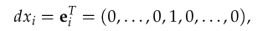

He then goes on

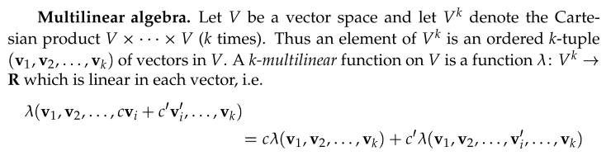

So now he is using the same symbol λ to represent a k-multilinear function. My symbol in this case is more like T rather than λ .
He goes on

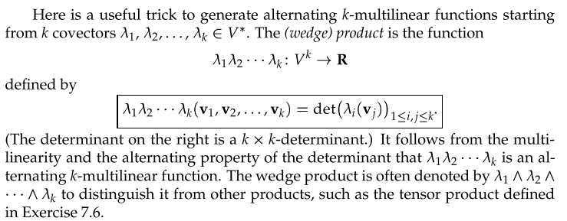

Can I match this with something? Yes, I have this:

(λj$_{1}$ ^ λj$_{2}$ ^ .... ^ λi$_{k}$)(vi$_{1}$,vi$_{2}$....vi$_{k}$) = (1/k!) det[ (vi$_{*}$)j$_{*}$]

so probably Sjamaar is in Spivak normalization.

He has

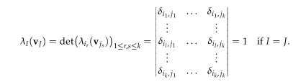

which matches my

(λj$_{1}$ ^ λj$_{2}$ ^ .... ^ λi$_{k}$)(ei$_{1}$,ei$_{2}$....ei$_{k}$) = (1/k!) det[ δj$_{*}$i$_{*}$] . (λ^J)(eI) = (1/k!) det(δJI)

He even has my vector transformation thing

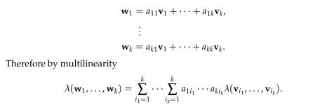

But I am somehow missing the Main Point. Why is he associating the differentials with dual space vectors? It must be that he is going to close them onto a set of vi to make a tensor function. For example,

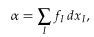 this is a linear functional in V* where dxI = eI = λI for me

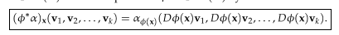
OK, here we see some tensor functions for sure. This is a pullback.

OK, I have to get back into all of this Sjamaar stuff, there won't be any quick understanding here!

