Sum of squared minors theorem.

5/16/16. This is all Appendix G now

F.6 Theorem: det(RTR) is the sum of the squares of the full-width minors of R

We saw and verified an example of this theorem in Section 10.10 for a 3 x 2 R matrix,

K2 = det(RTR) (10.10.22)
K2 = det2 $\left(\begin{matrix}R11 & R12 \\ R21 & R22\end{matrix}\right)$ + det2 $\left(\begin{matrix}R11 & R12 \\ R31 & R32\end{matrix}\right)$ + det2 $\left(\begin{matrix}R21 & R22 \\ R31 & R32\end{matrix}\right)$ . (10.10.18)'

Before proving the theorem, we have Maple test it for a messy case, just to make sure it is true. Enter a generic 6x4 R matrix as follows:

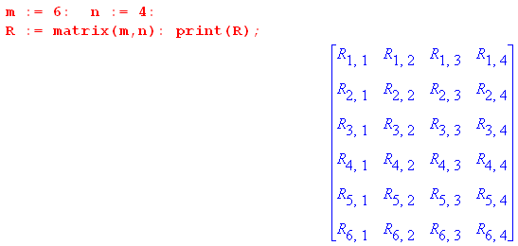

Compute and accumulate the squares of all (6,4) = 15 full-width minors,

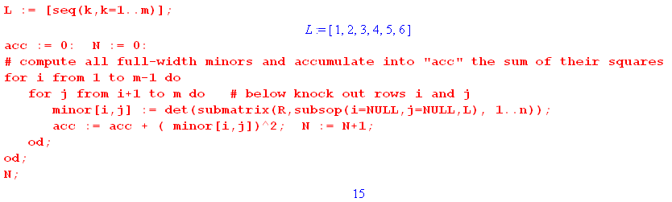
If we take the resulting "acc" and expand it, we get a series of 4,230 terms each of which contains a product of eight matrix elements of R,

Here are four of these terms

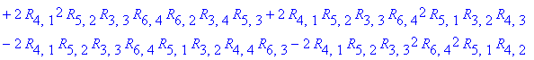.

We next compute det(RTR), note that it also has 4230 terms, and then we show that det(RTR) = acc.

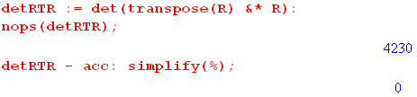 (F.6.1)

Fortified with the knowledge that the theorem seems to be true, we proceed:

Theorem: Let R be an m x n matrix with m ≥ n. There are (m,n) full-width minors.
The claim is that det(RTR) = sum of the squares of the full-width minors.

Comment: For m = n there is only one minor for square R which is det(R), the sum of the squares of the minors is then just det2(R), and indeed det(RTR) = det2(R).

Proof for n < m :

Define a multiindex I as follows

I = i1, i2, .... in (F.6.2)

where the ir indicate which n rows of the R matrix are included in a certain minor. Each ir takes values in the range 1 to m since R has m rows. Denote a full-width minor of R by

minorI . (F.6.3)

We shall need the following

Lemma:

Σ'I [minorI]2 = (1/n!) ΣI [minorI]2 (F.6.4)

where

Σ'I = Σ1≤i$_{1}$<i$_{2}$<....<i$_{n}$≤m = ordered sum
ΣI = Σi$_{1}$,i$_{2}$,...i$_{n}$=1m = symmetric sum (F.6.5)

Proof of Lemma:

ΣI [minorI]2 = Σi$_{1}$,i$_{2}$,...i$_{n}$=1m [minorI]2

= Σi$_{1}$≠i$_{2}$≠..≠i$_{n}$ [minorI]2 // minorI = 0 if two rows are the same

= (Σi$_{1}$<i$_{2}$<....<i$_{n}$ + n! - 1 other orderings) [minorI]2

= (ΣP [ΣP(i$_{1}$)<P(i$_{2}$)<...<P(i$_{n}$)]) [minorI]2

= Σi$_{1}$<i$_{2}$<...<i$_{n}$ [ΣP fP(i$_{1}$)P(i$_{2}$)...P(i$_{n}$)] . // by (A.9.1) with fi$_{1}$i$_{2}$...i$_{n}$ = [minorI]2

But fi$_{1}$i$_{2}$...i$_{n}$ = [minorI]2 is a totally symmetric function of the indices since row swaps don't affect a squared determinant. Thus we continue the above to get

= Σi$_{1}$<i$_{2}$<...<i$_{n}$ [ΣP fi$_{1}$i$_{2}$...i$_{n}$] = Σi$_{1}$<i$_{2}$<...<i$_{k}$ fi$_{1}$i$_{2}$...i$_{n}$ [ΣP 1 ]

= Σi$_{1}$<i$_{2}$<...<i$_{n}$ fi$_{1}$i$_{2}$...i$_{n}$ [n! ] = Σi$_{1}$<i$_{2}$<...<i$_{k}$ [minorI]2 [n! ]

= n! Σ'I [minorI]2 QED Lemma

Proof of Theorem:

We can write minorI as the determinant of a matrix using (A.1.19)

minorI = ΣP(-1)S(P) Ri$_{1}$P(1) Ri$_{2}$P(2) ....Ri$_{n}$P(n)

= Ri$_{1}$1 Ri$_{2}$2 ....Ri$_{n}$n + all signed permutations

≡ ΣP(-1)S(P)RIP(Z) . // in multiindex notation, Z = 1,2....n (F.6.6)

Then we first claim that

Sum ≡ sum of all full-width squared minors = Σ'I [minorI]2 . (F.6.7)

In this ordered sum, each full-width minor of R is included exactly once. For example, for a 3x2 R matrix we had above

K2 = det2 $\left(\begin{matrix}R11 & R12 \\ R21 & R22\end{matrix}\right)$ + det2 $\left(\begin{matrix}R11 & R12 \\ R31 & R32\end{matrix}\right)$ + det2 $\left(\begin{matrix}R21 & R22 \\ R31 & R32\end{matrix}\right)$ . (10.10.18)'
i1,i2 = 1,2 i1,i2 = 1,3 i1,i2 = 2,3

Then using the above Lemma we write

Sum = Σ'I [minorI]2 = (1/n!) ΣI [minorI]2 = (1/n!) ΣI [minorI] [minorI]

= (1/n!) ΣI [ ΣP(-1)S(P) Ri$_{1}$P(1) Ri$_{2}$P(2 ...Ri$_{n}$P(n)] [ ΣP'(-1)S(P') Ri$_{1}$P'(1) Ri$_{2}$P'(2)..Ri$_{n}$P'(n)]

= (1/n!) ΣI [ ΣP(-1)S(P)RIP(Z)] [ ΣP'(-1)S(P')RIP'(Z)] // multiindex notation

= (1/n!) ΣP(-1)S(P) ΣP'(-1)S(P')ΣI RIP(Z)RIP'(Z) // reorder

= (1/n!) ΣP(-1)S(P) ΣP'(-1)S(P')ΣI (RT)P(Z)IRIP'(Z) // matrix transposes

= (1/n!) ΣP(-1)S(P) ΣP'(-1)S(P')(RTR)P(Z)P'(Z) // n matrix multiplications

= (1/n!) ΣP(-1)S(P) ΣP'(-1)S(QP')(RTR)P(Z)QP'(Z) // ΣP' rearrangement theorem (A.1.3)

= (1/n!) ΣP(-1)S(P) ΣP'(-1)S(PP')(RTR)P(Z)PP'(Z) // select Q = P

= (1/n!) ΣP(-1)S(P) ΣP'(-1)S(PP')(RTR)ZP'(Z) // (A.8.31) since factored form

= (1/n!) ΣP ΣP'(-1)S(P')(RTR)ZP'(Z) // (A.1.11)

= (1/n!) ΣP'(-1)S(P')(RTR)ZP'(Z)[ΣP 1] = (1/n!) ΣP'(-1)S(P')(RTR)ZP'(Z)[n!]

= ΣP'(-1)S(P')(RTR)ZP'(Z)

= ΣP(-1)S(P)(RTR)ZP(Z)

= det(RTR) // (A.1.19) QED Theorem (F.6.8)

F.7 The Connection between Theorem F.6 and Differential Forms

Recall from (10.11.7) that the integral of a k-form for F: Rn → Rm is given by

αx' = Σ'I fI(x') dx'^I (F.7.1)

∫S' αx' = ∫S Σ'J Σ'I fI(F(x)) det(RIJ) dxj$_{1}$ ^ dxj$_{2}$ ^ ... ^ dxj$_{k}$

= ∫S Σ'J Σ'I fI(F(x)) det(RIJ) dx^J . // R = (DF) (F.7.2)

The context here is that x' = F(x) is a point on a manifold M created by the mapping F: Rn→ Rm as illustrated for example in (10.7.26) which we replicate here

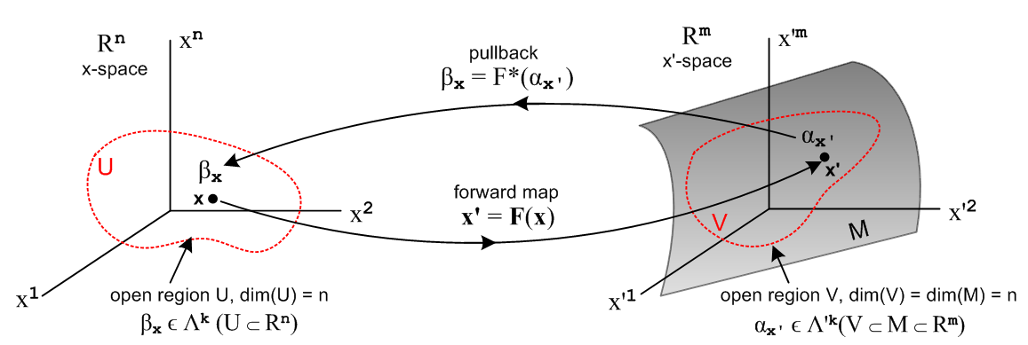
(10.7.26)
A case of frequent interest is k = n, and in this case there is only one term in the Σ'J sum, so

∫S' αx' = ∫S Σ'I fI(F(x)) det(RIZ) dx1 ^ dx2 ^ ... ^ dxn

= ∫S Σ'I fI(F(x)) det(RIZ) dx^Z . Z ≡ 1,2...n (F.7.3)

Here the letter Z is our multiindex stand-in so that J = Z means j1 = 1, j2 = 2, ... jn = n. The object det(RIZ) is then in fact a full-width minor (a number) of the m x n R matrix, and in (F.6.3) we called this minorI so

det(RIZ) = minorI ≡ mI . (F.7.4)

where mI is a compact notation for minorI. Since Rij(x) is generally a function of x (or x' = F(x)), we may regard mI = mI(x'), so this minor value is a function of x' on manifold M.

Then, suppressing the arguments fI and mI, we have

∫S' αx' = ∫S [ Σ'I fI mI ] dx^Z . (F.7.5)

We may consider fI and mI to be vectors with (m,n) components which we can dot together to get,

∫S' αx' = ∫S [ f • m ] dx^Z . // f • m ≡ Σ'I fI mI . (F.7.6)

For example, for n = 2, m = 3 we would write, showing components of each vector in "standard order",

f • m = (f12, f13, f23) • (m12, m13, m23) = f12m12+ f13m13+ f23m23 = Σ'I fI mI (F.7.7)

One could create a minor unit vector in this manner

≡ $\frac{m}{|m|}$ (F.7.8)

where

|m|2 = Σ'I (mI)2 = Σ'I (minorI)2 = det(RTR) // (F.6.8) ! (F.7.9)

and then we have

∫S' αx' = ∫S [ f • ] |m| dx^Z

= ∫S [ f • ] [ $\sqrt{det(RTR)}$ dx^Z] . (F.7.10)

The objects in red above are all functionals in the space Λn(Rn). According to the "second definition" described in (10.1.3) we are always allowed to replace the functional dx^Z by dxZ to obtain a normal calculus integral that can be evaluated by normal methods,

dx^Z ≡ dx1 ^ dx2 ^ ... ^ dxn → dxZ ≡ dx1dx2.....dxn . (F.7.11)

Now consider the special case where the function f = . Then,

∫S' αx' = ∫S [ • ] [ $\sqrt{det(RTR)}$ dx^Z] = ∫S$\sqrt{det(RTR)}$ dx^Z

= ∫S$\sqrt{det(RTR)}$dxZ . (F.7.12)

which displays the tangent space volume measure dV' = $\sqrt{det(RTR)}$dx1dx2.... dxn shown in (F.5.2). This last integral gives the volume (area) of the surface S' (example below) and for this reason we refer to the n-form α'x with this value of f as the volume measure form μ' . From (F.7.1) then,

μ' = Σ'I fI dx'^I = f • dx^' = • dx^' . (F.7.13)

Here we use the same dot product idea as in (F.7.5), where fI and dx'^I are each treated as vectors having (m,n) components.

The pullback of this measure form is the integrand of (F.7.10),

F*(μ') = $\sqrt{det(RTR)}$ dx^Z

= $\sqrt{det((DF)T(DF))}$dx1 ^ dx2 ^ ... ^ dxn // Sjamaar p 105 above item 8.12 (F.7.14)

Consider now a different situation where

f(x') = | f(x') | (F.7.15)

so that our new function f, considered as a vector with those (m,n) components, points in the direction. In this case we get

∫S' αx' = ∫S [ f • ] [ $\sqrt{det(RTR)}$ dx^Z] = ∫S | f((F(x))| $\sqrt{det(RTR)}$dx^Z (F.7.16)

and this is how one treats the integration of a scalar function over the surface S' such as the temperature function in (10.10.20). In this case we can write the corresponding n-form in x'-space as

αx' = Σ'I fI dx'^I = f • dx^' = | f | • dx^' = (f • ) • dx^' = (f • ) μ' (F.7.17)

from which we extract this equation

f • dx^' = (f • ) μ' . (F.7.18)

Special case: Hypersurface where n = m - 1

Suppose now that n = m-1, so that the manifold M embedded in Rm is a hypersurface, meaning it has one dimension less than Rm. In this case, (m,n) = (m,m-1) = m and each of our "vectors" above has exactly m components.

One can define the following Hodge star objects as discussed at the start of Section 10.3,

*dx'i = (-1)i+1 dx'1 ^ dx'2 .. [dx'i]... ^ dx'm where dx'i is missing (F.7.19)

so that each *dx'i object is an (m-1)-form (that is, an n-form). These m Hodge dual objects can be combined to form a vector

*dx' ≡ (*dx'1, *dx'2, ....*dx'm) . (F.7.20)

We now define new vectors F and n' as follows,

Fi ≡ (-1)i+1f12.[i]..m
n'i ≡ (-1)i+1m12.[i]..m (F.7.21)

where the notation [i] means that index i is missing from 12...m. It follows that

F • *dx' = f • dx^' (F.7.22)

n' • *dx' = m • dx^' (F.7.23)

n' • F = m • f . (F.7.24)

The proofs of the above three lines are basically the same, so we prove just the first line :

F • *dx = Σi=1m Fi (*dx'i )

= Σi=1m (-1)i+1f12.[i]..m (-1)i+1 dx'1 ^ dx'2 .. [dx'i]... ^ dx'm

= Σi=1m f12.[i]..m dx'1 ^ dx'2 .. [dx'i]... ^ dx'm

= [ f234..m dx'2 ^ dx'3 ^ dx'4 ..... ^ dx'm + f134..m dx'1 ^ dx'3 ^ dx'4 ..... ^ dx'm + .... ]

= Σ'IfI dx'^I with series terms reordered from standard order

= f • dx^' . (F.7.25)

Because vector n is a reordering of vector m where certain terms have minus signs, the sum of the squares of the components of the two vectors is the same, so

|n'| = |m| . (F.7.26)

Then dividing (F.7.23) and (F.7.24) by |n| one finds

'• *dx = • dx^' . (F.7.27)
' • F = • f (F.7.28)

Recall from above that

μ' = • dx^' (F.7.13)

f • dx^' = (f • ) μ' . (F.7.18)

Using (F.7.27), (F.7.22) and (F.7.28) these may be written

μ' = ' • *dx' // Sjamaar p 109 item 8.17 (F.7.29)

F • *dx' = (F • ') μ' // Sjamaar p 107 item 8.16 (F.7.30)

Sjamaar's equations are written in the x = φ(t) context rather than x' = F(x) so have *dx, and μ.

Example: F : R2→ R3 , k = n = 2 , m = 3. (F.7.31)

This example was first treated in Section 10.10 as a no-differential-forms problem, and was then reconsidered as a 2-form problem in Section 10.13 (but there in the x = φ(t) context). Here we write out various objects defined above and show how equations come out with equation number references in italics.

αx' = Σ'I fI(x') dx'^I = f12 dx'1 ^ dx'2 + f13 dx'1 ^ dx'3 + f23 dx'2 ^ dx'3 // a 2-form

= f • dx^' = F • *dx' = F • dA' = (F • ') dA' // see below (F.7.1)

f = (f12, f13, f23) (F.7.7)
m12 = minor12 = det(R1212) = det $\left(\begin{matrix}R11 & R12 \\ R21 & R22\end{matrix}\right)$ // R is a 3 x 2 matrix with 3 full-width minors
m13 = minor13 = det(R1312) = det $\left(\begin{matrix}R11 & R12 \\ R31 & R32\end{matrix}\right)$
m23 = minor23 = det(R2312) = det $\left(\begin{matrix}R21 & R22 \\ R31 & R32\end{matrix}\right)$ (F.7.4)

m = (m12, m13, m23) = ( det $\left(\begin{matrix}R11 & R12 \\ R21 & R22\end{matrix}\right)$), det $\left(\begin{matrix}R11 & R12 \\ R31 & R32\end{matrix}\right)$, det $\left(\begin{matrix}R21 & R22 \\ R31 & R32\end{matrix}\right)$ ) (F.7.7)

F = (f23, -f13,f12) // agrees with (10.13.16) (F.7.21)

n' = (m23, -m13,m12) = ( det $\left(\begin{matrix}R21 & R22 \\ R31 & R32\end{matrix}\right)$), - det $\left(\begin{matrix}R11 & R12 \\ R31 & R32\end{matrix}\right)$, det $\left(\begin{matrix}R11 & R12 \\ R21 & R22\end{matrix}\right)$ ) (F.7.21)
= ( det $\left(\begin{matrix}R21 & R22 \\ R31 & R32\end{matrix}\right)$), + det $\left(\begin{matrix}R31 & R32 \\ R11 & R12\end{matrix}\right)$, det $\left(\begin{matrix}R11 & R12 \\ R21 & R22\end{matrix}\right)$ )

= agrees with (10.10.19) where n' is shown as normal to the surface

| m |2 = | n' |2 = det2 $\left(\begin{matrix}R21 & R22 \\ R31 & R32\end{matrix}\right)$ + det2 $\left(\begin{matrix}R31 & R32 \\ R11 & R12\end{matrix}\right)$ + det $\left(\begin{matrix}R11 & R12 \\ R21 & R22\end{matrix}\right)$ (F.7.26)

≡ K2 = det(RTR) // agrees with (10.10.18) and (10.10.22) (F.7.9)

dx^' = (dx'1 ^ dx'2, dx'1 ^ dx'3, dx'2 ^ dx'3 ) // standard order

*dx' ≡ (*dx'1, *dx'2,*dx'3 ) = (dx'2 ^ dx'3 , - dx'1 ^ dx'3, dx'1 ^ dx'2 ) ≡ dA' (10.13.23)

f • dx^' = (f12, f13, f23) • (dx'1 ^ dx'2, dx'1 ^ dx'3 , dx'2 ^ dx'3 )

= f12 dx'1 ^ dx'2 + f13 dx'1 ^ dx'3 + f23 dx'2 ^ dx'3 = Σ'I fI dx'^I

F • *dx = (f23, -f13,f12) • (dx'2 ^ dx'3 , - dx'1 ^ dx'3, dx'1 ^ dx'2)

= f23 dx'2 ^ dx'3 + f13 dx'1 ^ dx'3 + f12 dx'1 ^ dx'2 = Σ'I fI dx'^I (F.7.18)

n • F = (m23, -m13,m12) • (f23, -f13,f12) = m23f23 + m13f13 + m12f12

= m12f12 + m13f13 + m23f23 = (m12, m13, m23) • (f12, f13, f23) = m • f (F.7.24)

μ' = ' • *dx' = ' • dA' = dA' // area measure on surface (F.7.29)

F • dA' = (F • ') dA' = (F • ') μ' // this is αx (F.7.30)

