Relation between a differential form and the dual space 2.10.16

This was a painful phase of wedge doc development, and the list below is a good one, trying to find someone who could explain why λi = dxi. As of 5/6/16 I have come to my own explanation which is stated now in wedge doc Chapter 10 in terms of cosmetic notation. Keep this document, however!

Plan A: The idea of using |dx^{i}| as an extra factor. 2
Plan B: Wolfram 3
Plan C: Clelland 3
Plan D. Faris 5
Plan E. Watkins 9

Background: from the wedge edit log:

I am blocked by this basic equation: Why can you say dxi = ei = λi and have things like dxi(v)? I just do not GROK the connection between the dual space and differential forms. I looked at Sja, at Spivak, at Benn Tucker. Most diff forms discussions don't even mention the dual space business with λi and those that do are too complicated for me to translate, it would take 6 months for me to get into Benn Tucker's book. So I am simply missing this very major connection and will have to spend maybe a week searching the web to find a person who explains it. It seems to me that for a given basis ei, the dual basis ei is completely determined, so why can you willy-nilly say ei = dxi ? Maybe you are working only in Cartesian space and you are saying dxi = |dxi| ei and so you have this extra scalar factor |dxi| just sort of hanging around? I need to find someone who speaks my language and who understands why this connection is not obvious to the newbie reader.

Note added 2.16.16. Six days have passed, and I have now done a complete review of all 10 chapters of the Sjamaar. I realized that it is really only in his Section 7.2 that this connection arises in the context of his discussion of differential forms on manifolds. This is then a very small part of the Sjamaar presentation. In other sections he has much to say about forms and dxi , but it is only in Section 7.2 that he makes the association between differential forms and elements of a dual space. I do have this new idea that I did not have 6 days ago which is this:

New idea: For a given point x on manifold M there exists a tangent space TxM. It has a set of basis vectors which I might call xei where I want only to show that this basis varies smoothly with x. There is a corresponding dual space to this tangent space which is the set of functionals defined on the tangent space. So if f is such a functional of degree k in this dual space, then the corresponding tensor function would be f(v1,v2....vk) where all the vi are vectors in TxM. This dual space is called the cotangent space. My new idea is that this tangent/cotangent space scenario is the context in which Sjamaar makes the identification λi = dxi. I would write this as

λi = <ei| = dxi so λi(v) = <ei| v> = dxi(v) = vi

It is true that: suppose you want to talk about the notion of differential area at point x on M. Suppose M is a hypersurface in dimension 2 in R3. Then there are only two basis vectors and you would define differential area as dA = dx1^dx2 where dx1 = differential in the xe1 direction and similarly for dx2. I think this idea is close to what I want, and I will return to it in some Plan below. Resuming original notes now of 6 days ago:

Plan A: The idea of using |dxi| as an extra factor.

Can I somehow rewrite my wedge theory where ei = dxi ?

dxi = |dxi| ei = |dxi| λi ?

T^ = Σi$_{1}$i$_{2}$....i$_{k}$ Ti$_{1}$i$_{2}$....i$_{k}$ (λi$_{1}$^ λi$_{2}$ .....^ λi$_{k}$) . T^ = ΣI TI λI (8.4.4)

T^ = Σ1≤i$_{1}$<i$_{2}$<....<i$_{k}$≤n Ai$_{1}$i$_{2}$...i$_{k}$ (λi$_{1}$ ^ λi$_{2}$ .....^ λi$_{k}$) . T^ = Σ'I AI λI (8.4.7)

T^ = Σ'I fI dxI

Comparing the last two expansions, λi = (ei)T = <ei|

T^ = Σ'I AI λ^I // near (8.7.1)

T^ = Σ'I fI dxI

Suppose I set

dxI = |dxI| λ^I functional in λ notation

<dxI| = |dxI| <e^I| functional in bra notation ( I rarely or never use notation | <e^I| )

Then I can write

T^ = Σ'I fI dxI = Σ'I [ fI |dxI| ] λ^I = Σ'I gI λ^I

where the differential mags are grouped with fI . This is just an idea right now, nothing more. What does this idea do? It allows me to write a general differential form Σ'I fI dxI of degree k as a rank-k tensor in the dual space Λk. This seems at odds with Sja page 84 where he writes (7.5 Example)

dxi = eiT

whereas in my idea above I am writing

dxi = |dxi| eiT

Well maybe I resolve that by saying

dxi = λi = < dxi| = |dxi| <ei|

where the bolding is very important! My notation clarifies things I think. With the above interpretation we have λi(v) = < dxi| v> = dxi(v) = |dxi| <ei| v> = |dxi| vi so we then fail to have λi(v) = vi . There is probably some truth to this path, but let's hold for a while. Maybe it is OK to redefine your basis such that λi(v) = |dxi| <ei| v> which is to say we have a new basis φi = |dxi| λi where we are just rescaling λi. If the |dxi| are a set of constants, then certainly φi is a basis of the dual space.

I now seek help on this from the web.

"differential form" "dual space" search tokens

Plan B: Wolfram

-- not useful to me

Plan C: Clelland



This source gets right to my issue on its first page, but I don't understand it. Sja defines a differential form on page 17 as being "an expression of the form ΣIfIdxI." There is no mention of any tangent space. however, I know that if you want to do say a surface integral, then dxI = dξ1^dξ2 would be the wedge product of two vectors in the tangent space at some patch point, so there certainly is a connection here.

OK, I will now try to parse this last pdf. First,

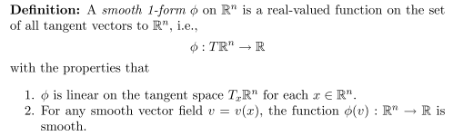
I guess this says that φ is a mapping from the tangent space (I guess at some point on a surface) to the reals. If could be for example an area integral, or the integral of a scalar function. This definition looks more like the Sja pullback idea? But the pullback φ acts on a diff form, it is not itself a diff form. I am quite puzzled by the above definition! This lecture fails to define tangent space, it fails to give any simple examples. So I will put this ref aside for now.

2.16.16. I will try again on this same source.
First I want to dispel a wrong interpretation. Recall in Sjamaar we had a manifold defined by ψ(t) where t ranges over some U so you could say M = ψ(U) to map out the manifold M. You could consider U = Rn and then you could talk about M = ψ(Rn) and then Rn is the domain of ψ. But that is NOT what Clelland is saying above, so we canNOT identify his φ with the Sjamaar ψ. Clelland's domain is clearly the tangent space, it is not the domain U of t.
I know about TxM on a manifold M. It is true that Rn is an example of a manifold M, so I admit that the object TxRn does have a well-defined meaning. If I think M = Rn , then Clelland's manifold is of dimension n and has n basis vectors. But in Sjamaar, when you are talking 1-forms you are talking about a manifold of dimension 1, not n, and that manifold is a curve with only 1 tangent vector. So this seems to be a flaw in my interpretation of Clelland's clip above. I am misunderstanding something.
In any event, I can then regard his object φ as a functional being an element of the cotangent space or dual space to TxRn . Then φ : TxRn → R, so I think he has a small typo as shown above where the x is left off (but see below). Maybe it is just implied. But this mapping does make sense to me. So Clellend is basically defining a 1-form as being an element of this dual space. There is no mention of dxi in this definition. He notes that φ is a linear functional, which is correct for his item 1. His item 2 is something new to me. Let v(x) be a vector field on Rn. Then at the point x in Rn this is just a vector v. Then I can certainly understand that there is a tensor function φ(v) = <φ|v> which I think is similar to my α(v) = <α|v>. Since he is talking only 1-forms, the tensor function has just 1 argument. And if this is correct, he is just saying that the tensor function φ(v) must be "smooth" in some sense.
So I see how 1-form goes with a tensor function of one argument φ(v) . But I do NOT see how the above 1-form is related to a curve which has 1 tangent vector, when he has a tangent space with n tangent vectors. So something is still wrong, but I will TRY to parts more of his encoded text:

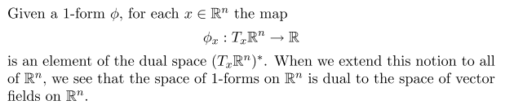

I agree with the first sentence, and I think (TxM)* is the name I would use for the dual space. Here it tags both Tx and φx with the point x of interest. What about the 2nd sentence? My only view on this is that he is associating a 1-form with a tensor function of 1 vector argument, and the rest of his notation makes no sense. Since that vector v = v(x), he is associating a 1-form with a vector field on Rn which seems OK.
Although his notation makes no sense to me, I will continue for another clip:

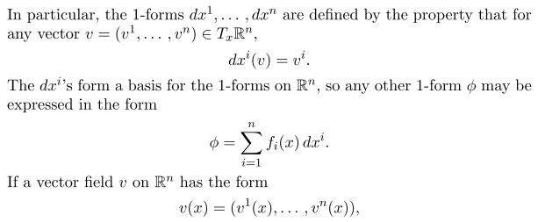
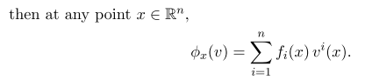

The first sentence is making the identification λi = dxi I would say, which is what I am studying right now, though the connection is indirect and based on λi(v) = vi . He refers to dxi = λi as a 1-form, but really they are just 1-tensors in the dual space of V = TxM = TxRn.
So OK, Clelland has flunked my test. He is just stating that dxi = λi and giving no justification for why he would do that. This is the same problem I have with Sjamaar. So Clelland at lest "got right to it" on about his first page, but he fails to make it clear to me WHY he does what he does.
Time to move on. I had great hopes, they were dashed.

Plan D. Faris

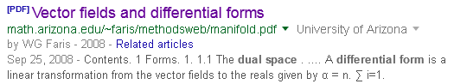

This source says that a 1-form is

So this author Bill Faris says that a 1-form is a linear functional in V* like my α. I am reading this source, it is very good, getting the connection between forms and dual space right at the get go. Clip:

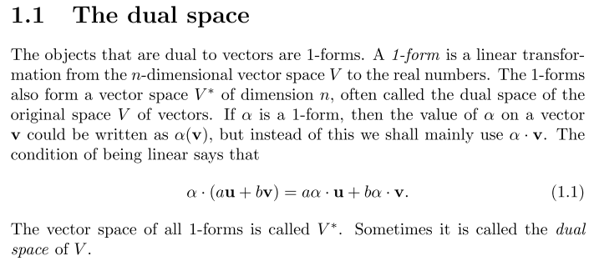

So Bill Faris says that my guy α = Σiαiλi is a 1-form. There is no mention of any "dx" here. The 1 form is then a rank-1 functional, a vector functional, this guy "speaksa my language". He then makes a Hilbert space comment similar to me

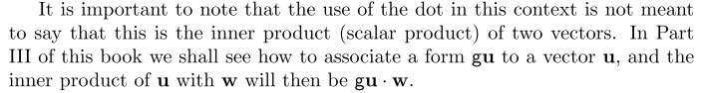

except I do think of it as a scalar product.

Now consider his next paragraph which requires parsing:

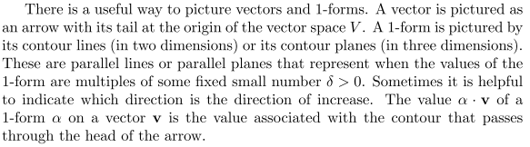

OK, now comes the parsing. We have a linear function α(v) = α • v . This is the most general form for writing a scalar function which is linear in v and it happens that we use the same symbol α for the name of the scalar function and for the vector which defines the scalar function. One to one.
Now consider a set of loci defined by α(v) = di for a set of constant values di . Then we are talking about α • v = di. I happen to know that this equation defines a plane in n dimensions (v ϵ V of dim n) which passes distance di from the origin and which has a normal vector n = α. So as you vary di you get a set of parallel lines for n = 2 or a set of parallel planes for n = 3. In v-space, if you draw the line or plane α • v = di, you think of the tip of the v arrow being on that line and at every single point on that line, you have α • v = di . The author thinks of α(v) as being the 1-form ( that is, his 1-form is this tensor function associated with functional α), so a 1-form is a line in the v-plane which passes through the tip of the arrow v. You could consider the set of all 1-forms then to be the set of all lines which pass through the tip of your arrow.

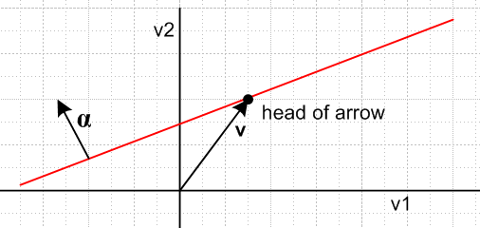

I don't have a perfect parsing, but I think I understand what he is talking about in the above clip paragraph. Here is the next clip:

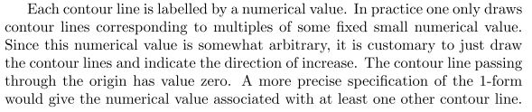

Parse: I take the numerical label value to be my di above, the distance from the origin of the line. I could set di = i δ where δ is a "fixed small numerical value". Yes, di = 0 for line passing through origin. I could draw a set of lines with an arrow in the α direction showing direction of increase in di. So I think I am 100% on the above paragraph. I continue to his next clip

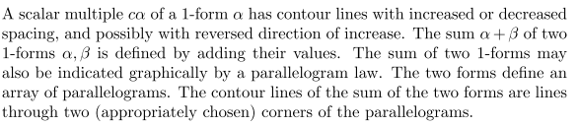

So he is trying to give a "graphical interpretation" if what it means to scalar-multiply or to add two of these 1-forms. I will let this paragraph ride for now, though I give my own interpretation in wedge doc.

Next, he defines a differential 1-form, as opposed to a general 1-form as a functional in V*. Go on

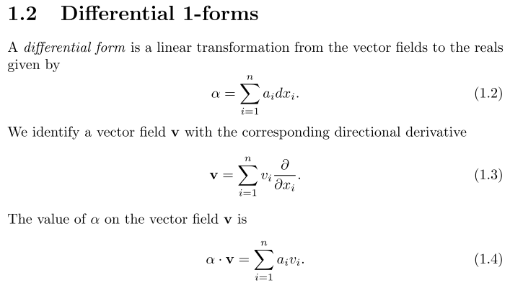

In the previous clip, α(v) was a linear function on space V containing vector v. There was no mention of any space having points x, but now suddenly x is appearing. Look at (1.3) above where we have

v = v1 ∂1 + v2∂2 + v3∂3

So how can he have a vector on the left, but a scalar on the right? Is there a typo somewhere? Normally I would write

v = v1 e1 + v2e2 + v3e3

where both sides are vectors. He is trying to make the connection between ei and ∂/∂xi and I know that is what we "want to do somehow", but I don't follow his notational path here!
I can write things like

∂n = ni∂/∂xi = n • ∇

so I could then write

∂v = v • ∇ = "directional derivative in the v direction"

and perhaps this is what he means by (1.3) above? Of course item (1.2) is the "goal" we all want to see for a 1-form. What is the connection to the identity stated in (1.4) ? This author's notation (1.3) is simply "illogical" and has zero meaning. Look next at his (1.6),

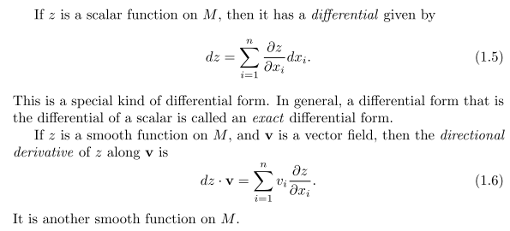

In (1.6) he is dotting a scalar into a vector, again makes no sense.
So this author "had his chance" to help me out, and flunked that "opportunity". I invested a bit into this author, but got no payoff. Time to move on.

Plan E. Watkins

http://www.sjsu.edu/faculty/watkins/difforms0.htm

This is a web page that I am now reading. It first defines di as my λi and then it sneaks in the differentials this way.

so that now dx is just a new name for λx. It then makes the point that if you have a vector field in your space V, so a vector might be v(P) ϵ V, then in the dual space you also have a vector field, and in my notation I would write

α(P) = Σiαi(P) λi = αx(P)dx + ... using the newly named λi

So my vector functional α is extended to be a vector field functional. I recall this from Sja somewhere, but this author is emphasizing this point. The author says that a 1-form is a vector field functional! But then the author is off on more conventional forms stuff and I lose interest. Plus I don't like data from websites, much prefer PDF. So let this guy rest.

Plan F. Janson



This author has an interesting equation

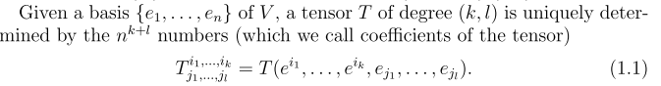

which looks like my evaluation of a tensor function at the basis vectors. He makes a distinction between the up and down indices, while I just think of them all as the same thing, but I could maybe comment on this somewhere. I have seen this concept elsewhere. Going on, I like this

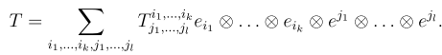

where again the author breaks down into two groups which I don't feel is necessary. For this author, a tensor is what I call a tensor function.

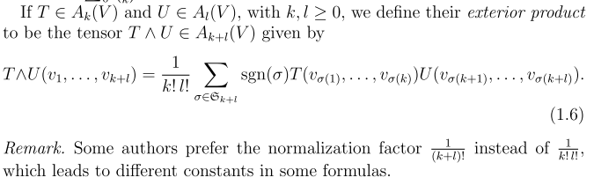

Author then uses gij as raising and lowering, but does not call it the metric tensor. Now we are on to tangent space stuff on his page 8 which starts section "tensors on a manifold".

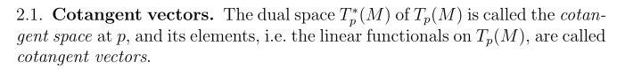

OK I have seen this before, cotangent in the sense of covector. Since Tp(M) is indeed a vector space, you are allowed to define its dual space and the name Tp*(M) seems quite reasonable! The linear functionals in this dual space are "cotangent vectors". No problem. He uses p instead of x for a point on the manifold, fine.
But then I lose this author as follows:

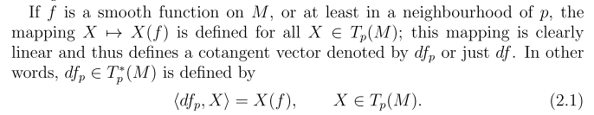

Parsing the above. Suppose p lies on M, and suppose p' = f(p) is some other point on M. Suppose X is some vector in TpM (fine so far). Perhaps X' is the corresponding vector in Tp'M where perhaps p' is close to p. Then X' = element of Tf(p)M so we could say X' = X(f) in the sense that X' has dependence on the mapping p' = f(p). Suppose we do this for a continuum of points p. For each p, we get X' = X(f) as the tangent vector at p'. So then X' is a set of vectors and so is X and then set X' = X(f) really is a function of the function f. So that is what he must mean by X → X' = X(f) under the smooth mapping p defined on M.
Now where does the cotangent space fit into this model? An element of the cotangent space at point p would be a functional intended to act on vectors like X. So as p moves due to p' = f(p), the tangent space moves, and the cotangent space moves. But where does the object dfp fit into this picture? He claims this object is an element of that cotangent space. Maybe his Remark will help which follows:

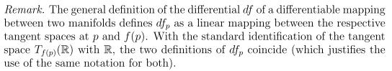

Well p' = f(p) is a mapping from M to M in my interpretation above so df would be "the differential" of that mapping. So yes, we have a mapping between the two tangent spaces, and we have a mapping between the two corresponding cotangent spaces, I agree.
I am still unhappy with this author. His next clip goes to the heart of my Big Mystery,

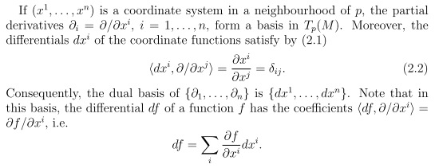

The first sentence makes no sense to me. Yes, you can define a coordinate system for the tangent space TpM at point p. Each coordinate goes along some basis vector ei of the tangent space. So I would denote a point in the tangent space by x = Σixiei and then {xi} are the coordinates of x in the tangent space. Now how can he claim that the ∂i form a basis in TpM ? The basis is ei, not ∂i. So this author is saying the same strange indecipherable thing said by the previous author. They are both dancing around the little statement that somehow ∂i and ei are the same thing -- they are a basis for the tangent space. They are trying to argue that

∂i = ei dxi = ei ⇒ ∂i • dxj = ei • ej = ∂i(xj) = ∂ij

Once again, I do see the "goal" of the argument, but I don't buy the argument itself. It just seems like BS slight of hand. The Duck BS-O-Meter swings up on this argument. So I give up on this author. He flunks my simple "clarity test".

Plan G. Spivak

This long section has been moved to "spivak book notes.doc" since I am just continuing to parse that book.

7. Lang, Fundamentals of Differential Geometry. (google books)

Let's try to read a bit of this source:

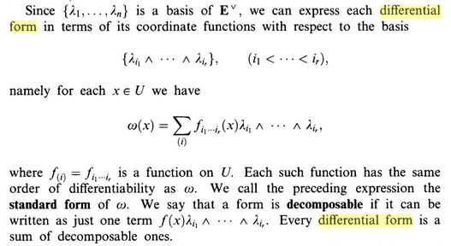

Notice that there an argument (x) here, like the p mentioned above.
Notice that there is no dxi yet, but he talking "differential form".
It must be that his E^ space is my Λn space, dual spaces of degree n.

I am happy with the above clip, so let's move on:

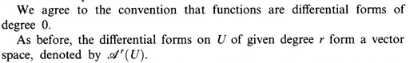

I am unclear as to the meaning of Ak(U), it is a space of differential forms, but why is that different from his space E^ ? Continue on,

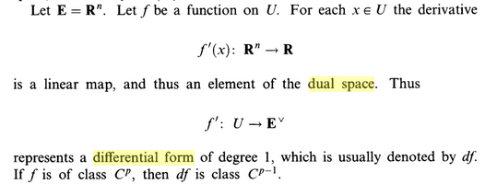

I think his f' is what I would call df, a differential, and I would write

df(x) = Σi=1n *(∂if(x))dxi = a scalar.

So for each point x in U which is in Rn you get some scalar df(x) in R, so his first mapping makes sense.
Now here is the nubbins statement:

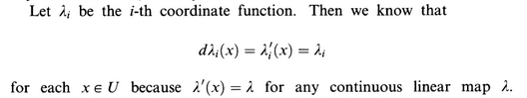

This is a new operation for me, applying d to λi. How would I do that solo?

dλi(x) = d [ xi ] = Σj ∂j[xi] dxj = Σj δijdxj = dxi

So I suddenly have this fact

dλi(x) = dxi

and this brings in the dxi thing for the first time. Connection between dxi and dλi.

But why is he saying λ'(x) = λ for any continuous linear map? I lose it here, too bad. But he goes on

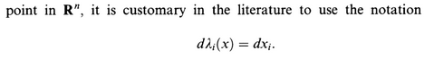

I agree with the above equation! I just derived the fact that dλi(x) = dxi since λi(x) = xi .

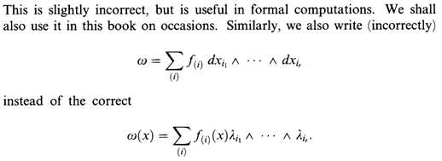

So at least Lang is commenting on the distinction! In his book, a differential form is the second item which really is an element of that dual space.

[ On 5.16.16 I added the above text as a quote in Section 10.2 of wedge doc ]

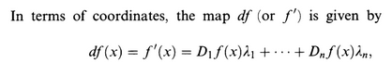

so start here with a function f(x) and apply "d" to get a 1-form in its "true" notation.

But things are confused because x is not the usual argument of the λi . In fact we have

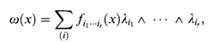

But maybe each really is λi(x)! Recall Spivak from just above

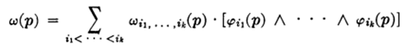

and for me the last factor would involve the λi(p), so that argument really is in there! Suppose I have

f(x) = a function = rank-0 tensor

df(x) = Σj(∂jf)dxi

OK, enough of this author, time to move on again.

8. Arnold



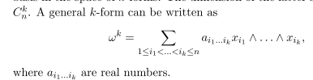

So this guy writes a k-form with full vectors in there!

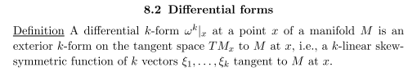

His vectors ξi are my vectors vi, the tensor function arguments.

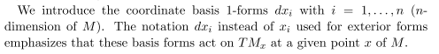

So that is an interesting data point. If you think of a vector x whose tail is at point p on M , and if you think of it as a small vector since M is a curved surface, then maybe notation dx is better. So that is his little "spin" on why dxi appears. But he has no connection to dual spaces.

9. Kovalev

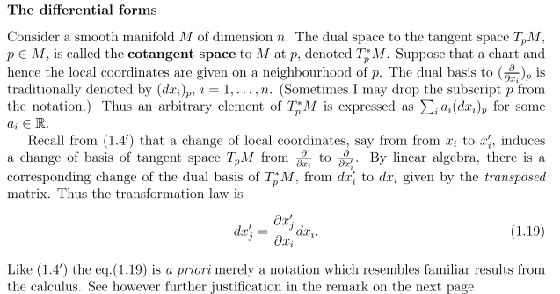

You see this author's "take" on the dxi idea, local to point p on M. He seems to say

ei → (∂i) ei → dxi

Then you have

ei • ej = dxi • (∂j)

but it really makes no sense to have your basis be a set of operators so I cannot fly on this plane.

10. Hitchin

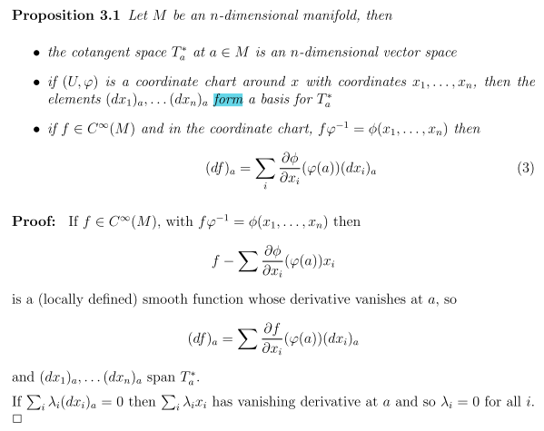

His take is that you write out df as shown and then claim that the dxi "span" the cotangent space and so they must be your λi. Sja just says that you define dxi to be λi = eiT, but that just begs the question for me. My search continues!

11. Kurz and Auchmann

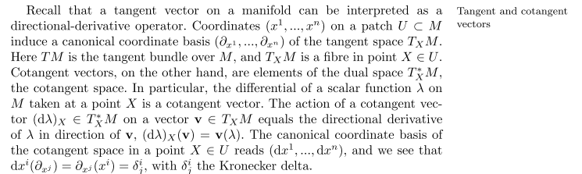

So here is another author setting ei = ∂i so the non-dual space basis vectors are operators. So this author is amplifying this idea with more detail. He states the idea of the δij . So maybe this is the idea I need to pursue. The entire paragraph above is very good, but I fade toward the end when v(λ) appears. Maybe I should hunt up more on the tangent space idea and how this could be a basis. I have never seen that claim stated and proved.

I think I will restudy Sja Ch 6 on manifolds and the tangent space, it has all faded away.

