Vector vs Scalar 4_6_16

5.16.16: This involves the Three Experiments and meaning of transformations issue. Somehow I managed to keep all this stuff out of wedge doc! I think the need for it went away when I got the λi and α stuff cleaned up. I no longer say that one vector moves and the other does not, for example.
I do have a version of the discussion in wedge doc starting at (2.7.10) and another version in tensor doc in the tensor expansions section startup.

See very end for section now used in Chapter 2. // old comment

First of all, here is what I say in my tensor doc release that is the last release as of today 4.6.16:
_______________________________________________________________________________

Preamble: A seeming paradox and how it is resolved

Before attacking tensor expansions below, we wish to head off a possible confusion between a quantity transforming as a scalar under some transformation x' = F(x) versus transforming as a component of a tensor. The "paradox" is presented in a few simple examples.

Example 1: Consider the vector r = (x,y,z) and a transformation r' = F(r) = Rr which is a rotation. Assume x-space is Cartesian so g = 1. Consider the dot product s = r • . As noted in (5.10.2), this dot product transforms as a scalar under F. In x'-space we still find that r' • ' = s. After all, the projection of one vector onto another cannot change when the two vectors are rotated together.
On the other hand, direct calculation shows that r • = x, and x is a component of the vector r = (x,y,z). So how can one say that quantity r • is a scalar when r • = x which is a component of a vector? This type of question arises frequently in the study of tensor analysis: there seems to be a paradox that needs resolving.
The physicist considers several different "thought experiments".
In Experiment 1, two measurements are made. The first is made in Frame S and one finds that s = x. The second measurement is made of rotated vector r' = Rr in rotated Frame S' and there one finds that s = x'. The two measurements give the same number, so in Experiment 1 one finds that x' = x and the quantity so measured is a scalar. In this experiment x = r • and x' = r' • '.
In Experiment 2, everything is done in Frame S. One draws a vector r and measures x. One then rotates this vector within Frame S to get a new vector r' = Rr where r' = (x',y',z') . One then measures x' and finds x' ≠ x. In this experiment, x = r • and x' = r' • where has no prime.
In Experiment 3 one observes unrotated r from rotated Frame S' so x = r • and x' = r • ' and this again results in x' ≠ x
Thus, in these three experiments, x has the same definition, but x' has three different definitions. That is why one can have x' = x in Experiment 1 and x' ≠ x in Experiments 2 and 3. The concept of r • as a scalar applies to Experiment 1 where s = r • = x = r' • ' = x'.

Example 2. Consider the vector expansion (7.13.10) which says V = Σn V'n en with V'n = V • en . Here we have the same paradoxical situation: we know that s = V • en must be a scalar with respect to F, yet it is equal to the component of a contravariant vector V'n under F. If we write V = ΣnVnen, then in Frame S we find that V • en = Vn which is like r • = x of the previous Example. In Frame S' we find instead that V' • e'n = V'i(e'n)i = V'iδni = V'n which is like r' • ' = x' in Example 1. In Experiment 1 outlined above, it is not a paradox to have s = en • V = Vn = V'n be a scalar.

Example 3. Below we expand a rank-3 tensor A = Σijk αijk (bi⊗bj⊗bk) and we find that
αijk = A • (bi⊗bj⊗bk) where • is a the dot product (E.1.5). We know that this quantity αijk, analogous to s in the two Examples above, must be a scalar under x' = F(x). Yet when we take bn = en we find in (E.2.8) that αijk = A'ijk so our scalar αijk is equal to the component of a rank-3 tensor in x'-space. Once again, in Experiment 1 this is not a contradiction. It just happens that in x'-space the scalar αijk appears as the value of a tensor component A'ijk in x'-space, just the way s in Example 1 appears as the value x' of vector r' in Frame S'.
___________________________________________________________________________

I think the above is WRONG and I am now going to try to edit it to make it right.

___________________________________________________________________________

Preamble: A seeming paradox and how it is resolved

Before attacking tensor expansions below, we wish to head off a possible confusion between a quantity transforming as a scalar under some transformation x' = F(x) versus transforming as a component of a tensor. The "paradox" is presented in a few simple examples.

Example 1: Consider the vector r = (x,y,z) and a transformation r' = F(r) = Rr which is a rotation. Assume x-space is Cartesian so g = 1. Consider the dot product s = r • . As noted in (5.10.2), this dot product transforms as a scalar under F. In x'-space we still find that r' • ' = s. After all, the projection of one vector onto another cannot change when the two vectors are rotated together.
On the other hand, direct calculation shows that r • = x, and x is a component of the vector r = (x,y,z). So how can one say that quantity r • is a scalar when r • = x which is a component of a vector? This type of question arises frequently in the study of tensor analysis: there seems to be a paradox that needs resolving.
The physicist considers several different "thought experiments".
In Experiment 1, two measurements are made. The first is made in Frame S and one finds that s = x. The second measurement is made of rotated vector r' = Rr in rotated Frame S' and there one finds that s =
r' • ' = r • = x. Both measurements give the same number x = r • and x' = r' • '.

x. The two measurements give the same number, so in Experiment 1 one finds that x' = x and the quantity so measured is a scalar. In this experiment x = r • and x' = r' • '.
In Experiment 2, everything is done in Frame S. One draws a vector r and measures x. One then rotates this vector within Frame S to get a new vector r' = Rr where r' = (x',y',z') . One then measures x' and finds x' ≠ x. In this experiment, x = r • and x' = r' • where has no prime.
In Experiment 3 one observes unrotated r from rotated Frame S' so x = r • and x' = r • ' and this again results in x' ≠ x
Thus, in these three experiments, x has the same definition, but x' has three different definitions. That is why one can have x' = x in Experiment 1 and x' ≠ x in Experiments 2 and 3. The concept of r • as a scalar applies to Experiment 1 where s = r • = x = r' • ' = x'.

Example 2. Consider the vector expansion (7.13.10) which says V = Σn V'n en with V'n = V • en . Here we have the same paradoxical situation: we know that s = V • en must be a scalar with respect to F, yet it is equal to the component of a contravariant vector V'n under F. If we write V = ΣnVnen, then in Frame S we find that V • en = Vn which is like r • = x of the previous Example. In Frame S' we find instead that V' • e'n = V'i(e'n)i = V'iδni = V'n which is like r' • ' = x' in Example 1. In Experiment 1 outlined above, it is not a paradox to have s = en • V = Vn = V'n be a scalar.

Example 3. Below we expand a rank-3 tensor A = Σijk αijk (bi⊗bj⊗bk) and we find that
αijk = A • (bi⊗bj⊗bk) where • is a the dot product (E.1.5). We know that this quantity αijk, analogous to s in the two Examples above, must be a scalar under x' = F(x). Yet when we take bn = en we find in (E.2.8) that αijk = A'ijk so our scalar αijk is equal to the component of a rank-3 tensor in x'-space. Once again, in Experiment 1 this is not a contradiction. It just happens that in x'-space the scalar αijk appears as the value of a tensor component A'ijk in x'-space, just the way s in Example 1 appears as the value x' of vector r' in Frame S'.

_______________________________________________________

To resolve this issue of the vector versus scalar interpretation of the Vn, consider these three Experiments which are described below:

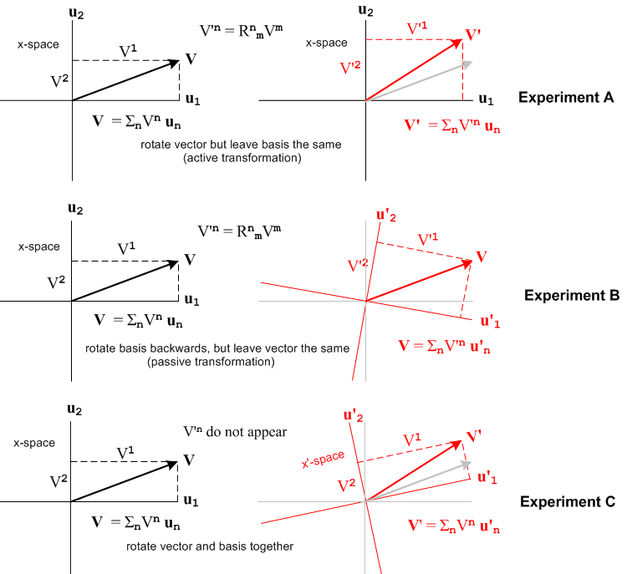

In the above three "thought Experiments" there is an apparatus, and there is an observer. The apparatus is described by some set of tensors (including vector V). The observer takes measurements using a grid which is aligned with some basis vectors.

In Experiment A, the observer first measures the components of the vector V using a grid aligned with the un and writes down the numbers Vn. The apparatus (including vector V) is then rotated 10o counterclockwise and the observer makes a new set of measurements of the vector components and writes down numbers V'n. The observer notes that V'n = RnmVm and declares that the components Vm transform as a vector under the rotation of this experiment. Experiment A is sometimes called an "active" transformation since the apparatus is actively rotated and the basis vectors stay put.

In Experiment B, the observer first measures the components of the vector V using a grid aligned with the un and writes down the numbers Vn . The observer then switches to a new measurement grid which is aligned with basis vectors u'n = R-1un. These basis vectors are rotated backwards 10o compared to our earlier definition u'i = Rui shown in (2.5.1). The observer then measures the components of the vector V relative to this new grid and calls them V'n. The observer notes that these are the same numbers V'n measured in Experiment A, that V'n = RnmVm, and that the components Vm therefore transform as a vector under the rotation of this experiment. Experiment A is sometimes called an "passive" transformation since the apparatus stays put, but the basis vectors are passively rotated backwards.

In Experiment C, the observer first measures the components of the vector V using a grid aligned with the ui and writes down the numbers Vn. The observer then switches to a new measurement grid which is aligned with basis vectors u'i = Rui which matches (2.5.1) -- the basis vectors are rotated "forward". At the same time, the apparatus is also rotated forward by 10o as it was in Experiment A. The observer then measures the components of the vector and finds that they are exactly the same Vn and declares that the components Vn transform as scalars relative to this experiment.

In Experiment C one can consider the vector V' to be a vector in x'-space. Only in this experiment then does the expansion V' = ΣnVn u'n shown on the right appear in the list (2.7.1) (it is on line 8). In Experiment A, the vector V' exists in x-space, not x'-space, so the last four expansions of (2.7.1) do not apply, and that is why V' = ΣnVn u'n does not appear in (2.7.1). In Experiment B the axes labeled u'i are not the same u'i which appear in (2.5.1), so expansions in (2.7.1) involving the u'i do not apply, and that is why V' = Σn V'n u'n does not appear in (2.7.1).

In practice when one speaks generically of "a transformation" one really thinks of either Experiment A or Experiment B, and the components Vn transform a vector (rank-2 tensor) in these transformations.

Comments analogous to those above regarding the three experiments apply to tensors of any rank.

******************************************

Question: Consider only two things:

A. the list of 8 expansions shown in (2.7.1)

1 V = Σn Vn un where Vn = un • V axis-aligned basis
2 V = Σn Vn un where Vn = un • V axis-aligned basis
3 V = Σn V'n en where V'n = en • V tangent base vector basis
4 V = Σn V'n en where V'n = en • V tangent base vector basis
5 V' = Σn V'n e'n where V'n = e'n • V' axis-aligned basis
6 V' = Σn V'n e'n where V'n = e'n • V' axis-aligned basis
7 V' = Σn Vn u'n where Vn = u'n • V' tangent base vector basis
8 V' = Σn Vn u'n where Vn = u'n • V' tangent base vector basis (2.7.1)

B. Experiment 2

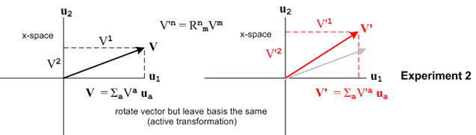

Here is the question: On the right in Experiment 2 we have V' = ΣnV'nun . Why does this equation not appear on the list of expansions given in (2.7.1) ?

Answer: The last four expansions in (2.7.1) are for a vector V' located in x'-space. But the vector V' appearing on the right side of Experiment 2 is located in x-space, so the (2.7.1) expansions don't apply.

An expansion that DOES appear in (2.7.1) is V' = Σn Vn u'n . This expansion describe a vector V' located in x'-space. But the vector V' appearing on the right in Experiment 2 is in x-space.

**************************************************88

We shall start with Experiment 2 in the middle drawing.

Some "apparatus" described by various vectors and tensors (including vector V) and this is all in x-space as shown on the left.

In Experiment 1 the vector and the basis vectors are rotated together, as if a camera were rotate clockwise 10o while viewing a scene. The vector V' is really the same vector as V; it is just viewed in a different frame of reference (x'-space instead of x-space). Both vector expansions shown in (a) appear in the list of expansions (2.7.1), lines 1 and 8. There are no components called V'a involved. For the transformation as viewed in this Experiment 1, the components Vn = un • V = u'n • V' are "scalars".

In Experiment 2 the basis vectors stay put, while the vector V is actively rotated 10o CCW about the z axis (pointing at the viewer) to create a new and different vector V' . The old vector is V shown in gray. The expansion V' = ΣaV'aua does not appear in (2.7.1) because V' and V are not the same vector. For Experiment 2, the equation V'n = RnmVm is applicable and the components Vm transform as a vector. For example, if V = $\left(\begin{matrix}V1 \\ V2\end{matrix}\right)$ = $\left(\begin{matrix}10 \\ 3\end{matrix}\right)$ then

V' = RV = Rz(10o) V = $\left(\begin{matrix}cos(10o) & -sin(10o) \\ sin(10o) & cos(10o)\end{matrix}\right)$$\left(\begin{matrix}10 \\ 3\end{matrix}\right)$ = $\left(\begin{matrix}.98 & -.17 \\ .17 & .98\end{matrix}\right)$$\left(\begin{matrix}10 \\ 3\end{matrix}\right)$ = $\left(\begin{matrix}9.3 \\ 4.6\end{matrix}\right)$ = V'

Experiment 3 is Experiment 2 viewed by a camera rotated 10o CCW. In this experiment the vector V is drawn the same on paper, but the basis vectors are rotated "backwards" 10o. In the rotated frame with the rotated basis vectors, V is a different vector because it has different components.

*************************

Recall these two expansions taken from (2.7.1),

V = Σn Vn un line 1
V' = Σn Vn u'n line 7 V' = RV

In the case that both x-space and x'-space are Cartesian, and the R matrix is just a rotation, we can draw a simple picture representing a graphical interpretation of these two expansions,
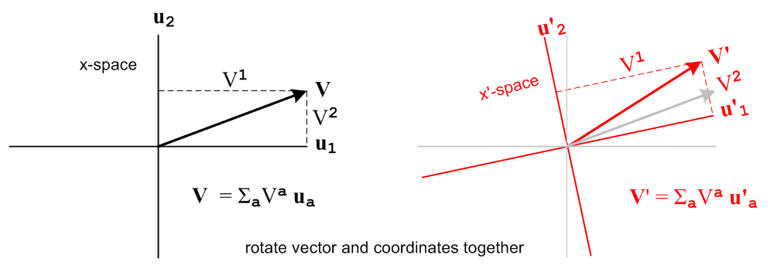 (2.7.14)

Going from the left picture to the right picture, both the vector and the axes are rotated together, so the components of the vector on the right are the same as those on the left. V' is the same vector as V, just viewed in x'-space instead of x-space.

________________________________________________________________________

This section is archived here and I don't want it anymore in Section 2.7. Maybe I will want it or something like it somewhere else. It did answer some questions I had.

Vector or Scalar?

We now wish to head off a possible confusion regarding transformations and expansions of vectors and other tensors. Consider these facts,

V'n = RnmVm // (2.1.2)

Vn = un • V = u'n • V' // (2.7.1) or (2.2.6)

The first equation says that Vn transforms as a contravariant vector, while the second line says that Vn transforms as a scalar since the dot product is the same in both x-space and x'-space. How can Vn be both a vector and a scalar? This question is discussed in Tensor Appendix E.2, and here we repeat that discussion in an expanded form. The answer is that for transformations of interest to us, the Vn transform as vector components, not as scalars.

Consider these three Experiments each of which involves a different kind of "transformation":

In the above three "thought Experiments" there is an apparatus, and there is an observer. The apparatus is described by some set of tensors (including vector V). The observer takes measurements using a grid which is aligned with some basis vectors.

In Experiment A, the observer first measures the components of the vector V using a grid aligned with the un and writes down the numbers Vn. The apparatus (including vector V) is then rotated 10o counterclockwise and the observer makes a new set of measurements of the vector components and writes down numbers V'n. The observer notes that V'n = RnmVm and declares that the components Vm transform as a vector under the rotation of this experiment. Experiment A is sometimes called an "active" transformation since the apparatus is actively rotated and the basis vectors stay put.

In Experiment B, the observer first measures the components of the vector V using a grid aligned with the un and writes down the numbers Vn . The observer then switches to a new measurement grid which is aligned with basis vectors u'n = R-1un. These basis vectors are rotated backwards 10o compared to our earlier definition u'i = Rui shown in (2.5.1). The observer then measures the components of the vector V relative to this new grid and calls them V'n. The observer notes that these are the same numbers V'n measured in Experiment A, that V'n = RnmVm, and that the components Vm therefore transform as a vector under the rotation of this experiment. Experiment B is sometimes called an "passive" transformation since the apparatus stays put, but the basis vectors are passively rotated backwards.

In Experiment C, the observer first measures the components of the vector V using a grid aligned with the ui and writes down the numbers Vn. The observer then switches to a new measurement grid which is aligned with basis vectors u'i = Rui which matches (2.5.1) -- the basis vectors are rotated "forward". At the same time, the apparatus is also rotated forward by 10o as it was in Experiment A. The observer then measures the components of the vector and finds that they are exactly the same Vn and declares that the components Vn transform as scalars relative to this experiment.

In Experiment C one can consider the vector V' to be a vector in x'-space. Only in this experiment then does the expansion V' = ΣnVn u'n shown on the right appear in the list (2.7.1) (it is on line 8). In Experiment A, the vector V' exists in x-space, not x'-space, so the last four expansions of (2.7.1) do not apply, and that is why V' = ΣnVn u'n does not appear in (2.7.1). In Experiment B the axes labeled u'i are not the same u'i which appear in (2.5.1), so expansions in (2.7.1) involving the u'i do not apply, and that is why V' = Σn V'n u'n does not appear in (2.7.1).

In practice when one speaks generically of "a transformation" one really thinks of either Experiment A or Experiment B, and the components Vn transform a vector (rank-2 tensor) in these transformations.

Comments analogous to those above regarding the three experiments apply to tensors of any rank.

