This is the Title PhL 1.11.15

This was installed on 4.13.16, do not edit here.

Appendix E: Chapter 10 with x' = F(x) changed to x = φ(t)

The material here is just for completeness and is intended only for perusal. It shows how the development of Chapter 10 appears for x = φ(t) in place of x' = F(x). In some ways, the x = φ(t) results concerning differential forms are simpler that those expressed in the x' = F(x) notation. The less pleasant aspect is that tensors (including metric tensors), basis vectors, and their spaces need an extra x or t label to distinguish the two spaces (now t-space and x-space), whereas in the x' = F(x) approach this distinction is accomplished by a prime versus no prime. We do use part of this notation in Section 10.9 since it brings our results into a more standard form for comparison with other sources.

Translation Table

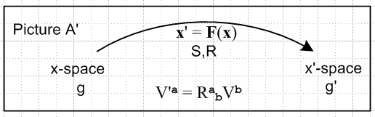 → 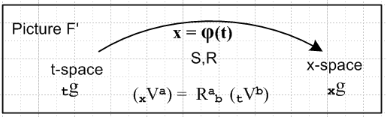

x-space → t-space
x'-space → x-space

F → φ general transformation name
x' = F(x) → x = φ(t) general transformation equation
R,S → R,S differential matrices (no change in name)
F* → φ* pullback function

V → tV vector in t-space
V' → xV vector in x-space

e → te tangent base vectors in t-space
u → tu axis-aligned basis vectors in t-space
g → tg metric tensor in t-space

u' → xu tangent base vectors in x-space
e' → xe axis-aligned basis vectors in x-space
g' → xg metric tensor in x-space

Λ'k → xΛk dual space to Rm
Λk → tΛk dual space to Rn

λ'i = dx'i → xλi = dxi basis vector in dual space to Rm
λi = dxi → tλi = dti basis vector in dual space to Rm (E.1)

In this new notation, the "kinematics package" of (10.6.a.1) with adjustment (10.6.d.1) for "tall" R appears as
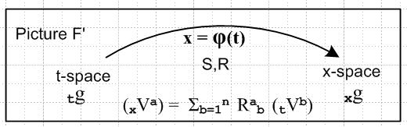

(a) x = φ(t) xform Rij ≡ (∂xi/∂tj) = ∂j(t)xi R = (Dφ)
xV = R tV vector Sij ≡ (∂ti/∂xj) = ∂j(x)ti

(b) xei with (xei)j = δij axis-aligned basis vectors in x-space (i = 1..m)
tei tei = S xei tangent base vectors in x-space (i = 1..n)

(c) tui with (tui)j = δij axis-aligned basis vectors in t-space (i = 1..n)
xui xui= R tui tangent base vectors in t-space (i = 1..n)
(xui)j = Rjk (tui)k

(d) x1 = | xei> <xei| = | xei> <xei| = | xui> <xui| = | xui> <xui| completeness in x-space
t1 = | tei> <tei| = | tei> <tei| = | tui> <tui| = | tui> <tui| completeness in t-space

(e) (tuj)i = tui • tuj = <tui | tuj > = tgij = xui • xuj = <xui | xuj >
(tej)i = tui • tej = <tui | tej > = Sij = Rji
(xej)i = xei • xej = <xei | xej > = xgij = tei • tej = <tei | tej >
(xuj)i = xei • xuj = <xei | xuj > = Rij = Sji

(f) tei = xgij tej xei = xgij xej tui = tgij tuj xui = tgij xuj
tei = xgij tej xei = xgij xej tui = tgij tuj xui = tgij xuj

(g) <tej | S | xei> = <xei | R | tej> = xgij
<tej | S | xui> = <xui | R | tej> = Sij = Rji
<tuj | S | xei> = <xei | R | tuj> = Rij = Sji
<tuj | S | xui> = <xui | R | tuj> = tgij .

(h) S = RT Sij = (RT)ij = Rji
R = ST Rij = (ST)ij = Sji

(i) SR = 1 SST = RTR = 1 (10.6.a.1) (E.2)

The uniqueness table of (10.6.d.2) becomes the following

Metric tensors
tgij, tgij unique
xgij unique, since xgij = RiaRjb tgab
xgij not unique, since xgij = RiaRjb tgab = SaiSbj tgab and Sij not unique

Transformation matrices
Rij = Sji unique (tall R matrix from x' = F(x))
Rij = Sji unique since Rij = tgjaRia and both tgja and Ria are unique
Rji = Sij not unique, see (10.6.c.3)
Rij = Sji not unique, since Rij = xgia Raj and xgia not unique

Axis-aligned basis vectors
(tuj)i unique since (tuj)i = tgji (xej)i unique since (xej)i = xgij (= δij)
(tuj)i unique since (tuj)i = tgji (xej)i not unique since (xej)i = xgij
(tuj)i unique since (tuj)i = tgji (xej)i unique since (xej)i = xgij
(tuj)i unique since (tuj)i = tgji (xej)i unique since (xej)i = xgij

Tangent base vectors
(tej)i not unique since (tej)i = Rji (xuj)i unique since (xuj)i = Rij
(tej)i not unique since (tej)i = Rji (xuj)i not unique since (xuj)i = Rij
(tej)i unique since (tej)i = Rji (xuj)i unique since (xuj)i = Rij
(tej)i unique since (tej)i = Rji (xuj)i not unique since (xuj)i = Rij
(10.6.d.2) (E.3)

Other parts of the development translate as follows:

Basis Vectors

{tui} i = 1,2...n basis for t-space , axis-aligned
(tui)j = δij components of these basis vectors in t-space . (10.6.e.1) (E.4)

xui = (10.6.e.4) (E.5)

R** = [xu1, xu2 ....xun] R has full rank n ⇒ basis for TxM complete (10.6.e.5) (E.6)

Non-Dual Pull Backs

xui = R tui |xui> = R |tui> i = 1,2..n push forward (10.7.1) (E.7)
tui = S xui |tui> = S |xui> i = 1,2..n pull back (10.7.2) (E.8)

xui = R tui |xui> = R |tui> i = 1,2..n push forward
tui = RT xui |tui> = RT |xui> i = 1,2..n pull back (10.7.4) (E.9)

xei = R tei |xei> = R |tei> i = 1,2..n push forward
tei = RT xei |tei> = RT |xei> i = 1,2..n pull back (10.7.5) (E.10)

Dual Pull Backs

(xui)T= (tui)T RT <xui| = <tui|RT i = 1,2..n push forward
(tu)T = (xu)T R <tui| = <xu|R i = 1,2..n pull back (10.7.6) (E.11)

(xei)T= (tei)T RT <xei| = <tei|RT i = 1,2..n push forward
(tei)T = (xei)T R <tei| = <xei|R i = 1,2..n pull back (10.7.7) (E.12)

<xei| φ* = <xei| R = Rij<tuj| pullback operator φ* = R

<xui| φ* = <xui| R = <tui| (10.7.9) (E.13)
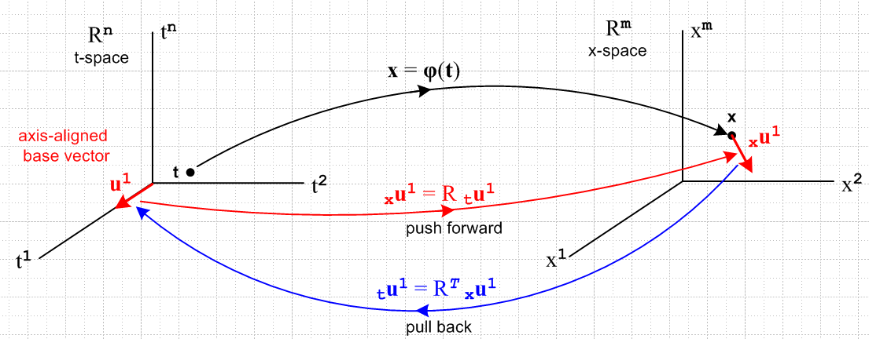
(10.7.11) (E.14)

Further translations of significant equations appear in Section 10.9

