Appendix F: The Volume of an n-piped embedded in R^{m} 1
F.1 Volume of a 2-piped in R³ 1
F.2 Volume of a 2-piped in R⁴, R⁵ and R^{m} 4
F.3 Volume of a 3-piped in R⁴ 5
F.4 Volume of a n-piped in R^{m} 7
F.5 Application: The differential volume element of the tangent space T_{x'}M 8

Do not edit, this has been installed on 5/9/16

Appendix F: The Volume of an n-piped embedded in Rm

The volume of an n-piped in Rn spanned by vectors e1, e2....en is given by

V = det(e1, e2....en) = det(S) . (F.1)

We shall not derive this fact here since it is derived in Tensor. One starts with an n-cube in x'-space which is spanned by axis-aligned unit basis vectors e'i and which has volume V' = 1. One then transforms this n-cube into an n-piped spanned by the tangent base vectors ei = Se'i where S is the nxn matrix that maps the vectors e'i into the ei. One then finds that the n-piped has the volume shown above. The ei are the columns of S because (ei)b = Sbc(e'i)c = Sbcδic = Sbi where i is the column index. See Tensor equations (3.2.4), (3.2.7) and (B.5.d.13). Tensor Appendix B concerns the geometry of n-pipeds in Rn.

For the case n = 2 the fact that V = det(e1, e2) is easily shown, see text below (4.3.14).

Our task here concerns the different problem of finding the volume of an n-piped embedded in Rm where m > n. The solution to this problem is stated in (F.4.11) below which we quote here:

Fact : Let ui for i = 1...n be n axis-aligned unit basis vectors in Rn. Let a1,a2,...an be n arbitrary vectors in Rm where m ≥ n. These vectors span an n-piped in Rm which has a volume V = $\sqrt{det(RTR)}$ where RTR is a nxn matrix, R = [a1,a2,...an] is a m x n matrix, and the arbitrary n vectors may be written ai = Rui . (F.4.11)

Our derivation below is a seat-of-the-pants "geometric" approach, appropriate for people like the author who like to "see" what is going on. Sjamaar provides an "axiomatic" derivation on pp 99-102. Basically we start with simple examples and progress toward the general case.

Warning: In the discussion below R1, R2 and R3 are linear transformations, while R2, R3 are Cartesian spaces. It just happens that the same symbol R is used for both kinds of objects.

F.1 Volume of a 2-piped in R3

The simplest case to consider is that of a 2-piped embedded in R3. Consider then this set of four spaces connected by three transformations (this picture will be reused several times) :

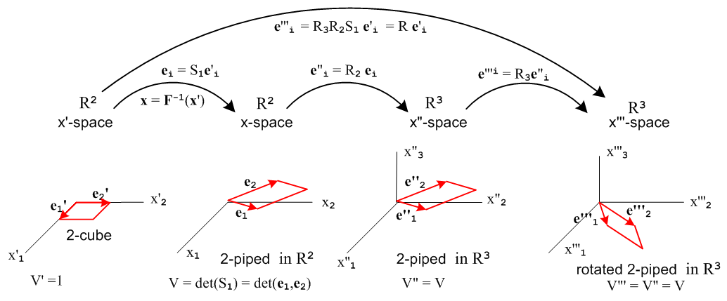
(F.1.1)

The names and symbols for the left two spaces are chosen to be compatible with Chapter 2 based on Fig (2.1.1). The remaining two spaces are given the arbitrary names x"-space and x'''-space.
The leftmost picture shows a unit square (2-cube) lying in the x'1-x'2 plane. The square is spanned by two axis-aligned unit basis vectors e'1 and e'2 as described in (2.5.3). The volume (area) of the square is 1 unit.
The second picture is obtained from the first by a general non-linear transformation x = F-1(x') which has a linearized form dx' = R1dx and correspondingly dx = S1dx' where R1S1 = 1. These 2x2 R1 and S1 matrices are called R and S in Chapter 2, but here we add subscript 1 since this is the first of three transformations shown above. The volume of the 2-piped is det(S1) = det(e1,e2) as noted in (F.1). The transformed basis vectors ("tangent base vectors") are ei = S1e'i (and e'i = R1ei) as shown in (2.5.1).
The third picture is obtained from the second merely by adding a third axis called x"3. The 2-piped has not moved and still lies in the x"1-x"2 plane. Then e"i = (ei,0) where we add a third zero component to the basis vectors. The 2-piped volume is still det(S1). Below we shall discuss the linear transformation R2 which links x-space to x"-space.
The fourth picture is obtained from the third by an arbitrary rotation R3 in R3 space. The 2-piped then ends up in some arbitrary orientation in R3. It's volume is still det(S1) since shape and volume are not changed by a rotation. R3 is a 3x3 real orthogonal matrix.

The linear transformation R2 connecting x"-space and x-space is this

R2 = $\left(\begin{matrix}1 & 0 \\ 0 & 1 \\ 0 & 0\end{matrix}\right)$ for example: e"i = $\left(\begin{matrix}1 & 0 \\ 0 & 1 \\ 0 & 0\end{matrix}\right)$$\left(\begin{matrix}(ei)1 \\ (ei)2\end{matrix}\right)$ = $\left(\begin{matrix}(ei)1 \\ (ei)2 \\ 0\end{matrix}\right)$ = $\left(\begin{matrix}ei \\ 0\end{matrix}\right)$ . (F.1.2)

This matrix R2 is just the 2x2 identity matrix with a null third row added. This transformation simply adds a third null coordinate to a 2D vector in R2 as shown in the example above. Notice that

R2TR2 = $\left(\begin{matrix}1 & 0 & 0 \\ 0 & 1 & 0\end{matrix}\right)$$\left(\begin{matrix}1 & 0 \\ 0 & 1 \\ 0 & 0\end{matrix}\right)$ = $\left(\begin{matrix}1 & 0 \\ 0 & 1\end{matrix}\right)$ = 1 . (F.1.3)

As shown at the top of Fig (F.1.1), the concatenated effect of the three transformations on the basis vectors is this,

e'''i = R e'i where R ≡ R3R2S1 . i = 1,2 (F.1.4)

The combined matrix R is in fact a "tall" 3 x 2 R matrix which we verify with the following schematic conformation picture,

R = R3R2S1 = $\left(\begin{matrix}* & * & * \\ * & * & * \\ * & * & *\end{matrix}\right)$ $\left(\begin{matrix}1 & 0 \\ 0 & 1 \\ 0 & 0\end{matrix}\right)$ $\left(\begin{matrix}* & * \\ * & *\end{matrix}\right)$ = $\left(\begin{matrix}* & * \\ * & * \\ * & *\end{matrix}\right)$ $\left(\begin{matrix}* & * \\ * & *\end{matrix}\right)$ = $\left(\begin{matrix}* & * \\ * & * \\ * & *\end{matrix}\right)$ . (F.1.5)

In fact, from (F.1.4) and (2.5.2) we find that

(e'''i)a = Rab (e'i)b = Rab δib = Rai i = 1,2 a = 1,2 (F.1.6)

which tells us that the final vectors e'''i are the columns of the matrix R, so

R = [e'''1, e'''2] (F.1.7)

which we then verify is a matrix with 3 rows and 2 rows as shown at the right of (F.1.5).

Note that non-square R does not have a determinant. But consider,

RTR = (R3R2S1)TR3R2S1

= S1TR2TR3TR3R2S1 // rule for transpose of a product of matrices

= S1TR2TR2S1 // R3TR3 = 1 because R3 is a rotation (real-orthogonal)

= S1TS1 . // R2TR2 = 1 as just shown in (F.1.3) (F.1.8)

As shown in Fig (10.6.c.1), the matrix RTR is a square matrix of dimension 2x2 and so RTR does have a determinant. In fact, from (F.1.8),

det(RTR) = det(S1TS1) = det(S1T)det(S1) = det2(S1) . (F.1.9)

In terms of the overall vector transformation R going from the left picture to the right picture above, we have just shown that the 2-piped volume can be written

V = det(S1) = $\sqrt{det(RTR)}$ where R = [e'''1, e'''2] (F.1.10)

where both S1 and RTR are 2x2 matrices.

F.2 Volume of a 2-piped in R4, R5 and Rm

The equation numbers here mimic those of the previous section. Since some equations need not be repeated, there are missing equation numbers below.

In blue we make very slight modifications to the previous picture :

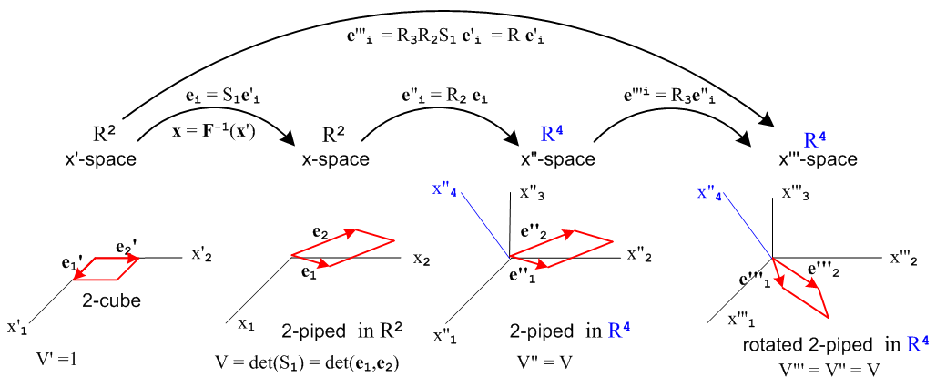
(F.2.1)

R3 is now a real-orthogonal 4x4 rotation matrix in R4. The new R2 transformation has two rows of zeros added at the bottom instead of one row,

R2 = $\left(\begin{matrix}1 & 0 \\ 0 & 1 \\ 0 & 0 \\ 0 & 0\end{matrix}\right)$ for example: e"i = R2ei = $\left(\begin{matrix}1 & 0 \\ 0 & 1 \\ 0 & 0 \\ 0 & 0\end{matrix}\right)$$\left(\begin{matrix}(ei)1 \\ (ei)2\end{matrix}\right)$ = $\left(\begin{matrix}(ei)1 \\ (ei)2 \\ 0 \\ 0\end{matrix}\right)$ = $\left(\begin{matrix}ei \\ 0 \\ 0\end{matrix}\right)$ . (F.2.2)

This transformation R2 simply adds a third and fourth null coordinate to a 2D vector in R2 as shown in the example above. And as before,

R2TR2 = $\left(\begin{matrix}1 & 0 & 0 & 0 \\ 0 & 1 & 0 & 0\end{matrix}\right)$$\left(\begin{matrix}1 & 0 \\ 0 & 1 \\ 0 & 0 \\ 0 & 0\end{matrix}\right)$ = $\left(\begin{matrix}1 & 0 \\ 0 & 1\end{matrix}\right)$ = 1 . (F.2.3)

The new conformation picture is this

R = R3R2S1 = $\left(\begin{matrix}* & * & * & * \\ * & * & * & * \\ * & * & * & * \\ * & * & * & *\end{matrix}\right)$ $\left(\begin{matrix}1 & 0 \\ 0 & 1 \\ 0 & 0 \\ 0 & 0\end{matrix}\right)$ $\left(\begin{matrix}* & * \\ * & *\end{matrix}\right)$ = $\left(\begin{matrix}* & * \\ * & * \\ * & * \\ * & *\end{matrix}\right)$ $\left(\begin{matrix}* & * \\ * & *\end{matrix}\right)$ = $\left(\begin{matrix}* & * \\ * & * \\ * & * \\ * & *\end{matrix}\right)$ (F.2.5)

and now the tall R matrix has 4 rows and 2 columns. Equation (F.1.6) still applies for this new R, so we still conclude that

R = [e'''1, e'''2] (F.2.7)

but now each vector has 4 components instead of 3 as in (F.1.7).

Apart from these matrix shape changes, the steps (F.1.8) through (F.1.10) proceed exactly as above and again one concludes that

V = det(S1) = $\sqrt{det(RTR)}$ where R = [e'''1, e'''2] (F.2.10)

where both S1 and RTR are 2x2 matrices.

In going from R4 to R5 the reader can see that R2 will acquire yet another null row, one still has R2TR2 = 1, and everything goes through as before again giving V = $\sqrt{det(RTR)}$where R = [e'''1, e'''2] now has 5 rows since the two vectors exist in R5. The result clearly extends to a 2-piped in Rm for any m ≥ 2.

We then arrive at the following Fact, where we rename e'i → ui and e'''1,2 → a,b :

Fact : Let u1 = (1,0) and u2 = (0,1) be two axis-aligned basis vectors in R2. Let a and b be two arbitrary vectors in Rm. These vectors span a 2-piped in Rm which has a volume (area in this case) V = $\sqrt{det(RTR)}$ where RTR is a 2x2 matrix, R = [a,b] is a 3 x 2 matrix, and the arbitrary two vectors may be written a = Ru1 and b = Ru2. (F.2.11)

Comment: Recall from (10.6.c.6) that rank(RTR) = rank(R). If a and b are linearly dependent, R = [a,b] has less than full rank 2 and so does square RTR which means det(RTR) = 0 so V = 0. This is the result one would expect if a and b are collinear, so the above Fact applies to any pair of vectors a, b.

F.3 Volume of a 3-piped in R4

The logic flows as in the previous examples, so we omit the words. We start with a new but similar transformation picture,
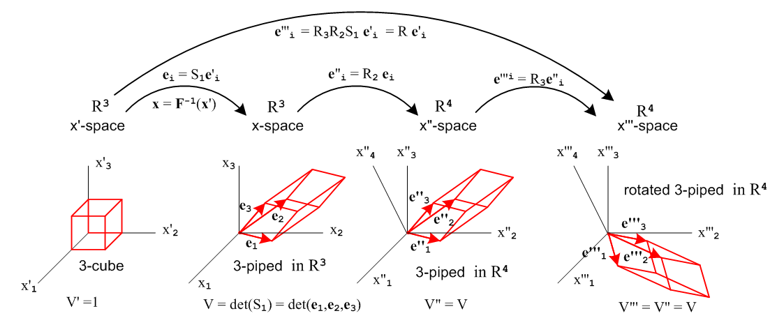
(F.3.1)
The R2 matrix (3x3 identity with a null added 4th row) adds a null 4th component to any 3-vector,

R2 = $\left(\begin{matrix}1 & 0 & 0 \\ 0 & 1 & 0 \\ 0 & 0 & 1 \\ 0 & 0 & 0\end{matrix}\right)$ for example: ei" = R2ei = $\left(\begin{matrix}1 & 0 & 0 \\ 0 & 1 & 0 \\ 0 & 0 & 1 \\ 0 & 0 & 0\end{matrix}\right)$$\left(\begin{matrix}(ei)1 \\ (ei)2 \\ (ei)3\end{matrix}\right)$ = $\left(\begin{matrix}(ei)1 \\ (ei)2 \\ (ei)3 \\ 0\end{matrix}\right)$ = $\left(\begin{matrix}ei \\ 0\end{matrix}\right)$ . (F.3.2)
R2TR2 = $\left(\begin{matrix}1 & 0 & 0 & 0 \\ 0 & 1 & 0 & 0 \\ 0 & 0 & 1 & 0\end{matrix}\right)$$\left(\begin{matrix}1 & 0 & 0 \\ 0 & 1 & 0 \\ 0 & 0 & 1 \\ 0 & 0 & 0\end{matrix}\right)$ = $\left(\begin{matrix}1 & 0 & 0 \\ 0 & 1 & 0 \\ 0 & 0 & 1\end{matrix}\right)$ = 1 . (F.3.3)

e'''i = R e'i where R ≡ R3R2S1 . i = 1,2,3 (F.3.4)

R = R3R2S1 = $\left(\begin{matrix}* & * & * & * \\ * & * & * & * \\ * & * & * & * \\ * & * & * & *\end{matrix}\right)$ $\left(\begin{matrix}1 & 0 & 0 \\ 0 & 1 & 0 \\ 0 & 0 & 1 \\ 0 & 0 & 0\end{matrix}\right)$ $\left(\begin{matrix}* & * & * \\ * & * & * \\ * & * & *\end{matrix}\right)$ = $\left(\begin{matrix}* & * & * \\ * & * & * \\ * & * & * \\ * & * & *\end{matrix}\right)$ $\left(\begin{matrix}* & * & * \\ * & * & * \\ * & * & *\end{matrix}\right)$ = $\left(\begin{matrix}* & * & * \\ * & * & * \\ * & * & * \\ * & * & *\end{matrix}\right)$ (F.3.5)

(e'''i)a = Rab (e'i)b = Rab δib = Rai i = 1,2,3 a = 1,2,3 (F.3.6)

R = [e'''1, e'''2, e'''3] = a 4 x 3 matrix (F.3.7)

RTR = S1TS1 = a 3x3 matrix (F.3.8)

det(RTR) = det2(S1) (F.3.9)

V = det(S1) = $\sqrt{det(RTR)}$ where R = [e'''1, e'''2, e'''3] . (F.3.10)

Fact : Let u1 = (1,0,0), u2 = (0,1,0) and u3 = (0,0,1) be three axis-aligned basis vectors in R3. Let a,b,c be three arbitrary vectors in R4. These vectors span a 3-piped in R4 which has a volume V = $\sqrt{det(RTR)}$ where RTR is a 3x3 matrix, R = [a,b] is a 4 x 2 matrix, and the arbitrary three vectors may be written a = Ru1,b = Ru2 and c = Ru3 . (F.3.11)
Comment: Recall from (10.6.c.6) that rank(RTR) = rank(R). If a,b,c are linearly dependent, R = [a,b,c] has less than full rank 3 and so does square RTR which means det(RTR) = 0 so V = 0. This is the result one would expect if a,b,c are linearly dependent: they all lie in the same plane and thus span no 3D volume. Thus, the above Fact applies to any triplet of vectors a, b, c.

F.4 Volume of a n-piped in Rm

In the general case we have an n-piped in Rm. The method outlined in the previous examples prevails with generalizations for the objects involved. Again we omit the words.

Picture generously supplied by the reader capable of making hyperspace drawings (F.4.1)
[ This is one reason mathematicians don't like geometric derivations! ]

R2 = $\left(\begin{matrix}1nxn \\ m-n rows of zeros\end{matrix}\right)$ which is an m x n tall R matrix (F.4.2)

R2TR2 = 1nxn (F.4.3)

e'''i = R e'i where R ≡ R3R2S1 . i = 1,2..,n (F.4.4)

R = R3R2S1 = (m x m rotation matrix R3) (m x n R2 matrix) (n x n matrix S1) = m x n (F.4.5)

(e'''i)a = Rab (e'i)b = Rab δib = Rai i = 1,2...n a = 1,2...n (F.4.6)

R = [e'''1, e'''2 .... e'''n] = m x n tall R matrix (F.4.7)

RTR = S1TS1 = an nxn matrix (F.4.8)

det(RTR) = det2(S1) (F.4.9)

V = det(S1) = $\sqrt{det(RTR)}$ where R = [e'''1, e'''2 .... e'''n] . (F.4.10)

Fact : Let ui for i = 1...n be n axis-aligned unit basis vectors in Rn. Let a1,a2,...an be n arbitrary vectors in Rm where m ≥ n. These vectors span an n-piped in Rm which has a volume V = $\sqrt{det(RTR)}$ where RTR is a nxn matrix, R = [a1,a2,...an] is a m x n matrix, and the arbitrary n vectors may be written ai = Rui . (F.4.11)

Comment 1: Recall from (10.6.c.6) that rank(RTR) = rank(R). If the ai are linearly dependent, R = [a1,a2,...an] has less than full rank n and so does square RTR which means det(RTR) = 0 so V = 0. This is the result one would expect if ai are linearly dependent: they span no nD volume. Thus, the above Fact applies to any set of n vectors ai.

Comment 2: The discussion above is presented for n < m. In the case n = m, things simplify. Looking at Fig (F.3.1) we can ignore the x"-space and x'''-space pictures and in effect set R2 = R3 = 1 so that R = S1. The final vectors are the ei in x-space which we then take to be are arbitrary vectors ai. The general formula still works, but now the R matrix is square, so

V = $\sqrt{det(RTR)}$ = $\sqrt{det(S1TS1)}$ = =

= det(S1) where S1 = [e1,e2,...em] = R = [a1,a2,...an]

in agreement with (F.1).

F.5 Application: The differential volume element of the tangent space Tx'M

Recall Fig (10.7.5) which shows how the axis-aligned basis vectors ui of x-space are pushed forward to become the tangent base vectors u'i which span the tangent space Tx'M at point x' in x'-space,

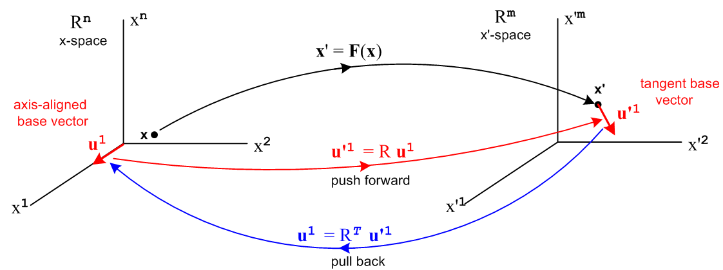
(10.7.5)
If we take a differential n-cube located at position x in x-space, it has differential volume

dV = dx1dx2.... dxn . (F.5.1)

This volume is mapped into an n-piped in x'-space by the mapping u'i = R ui. According to Fact (F.4.11), we may conclude that the volume of the tangent space n-piped in x'-space at point x' is this,

dV' = $\sqrt{det(RTR)}$dx1dx2.... dxn . (F.5.2)

We have already seen an example of this fact. Recall these equations from Section 10.10,

A' = ∫S' dA' = ∫S K(x) dx1dx2 . (10.10.21)

K2 = det(RTR) (10.10.22)

In the area integral, the differential "volume" is dA' = K(x) dx1dx2 = $\sqrt{det(RTR)}$dx1dx2.

