Do not edit, this was installed on 5/9/16

Appendix G : The det(RTR) theorem and its relation to differential forms

G.1 Theorem: det(RTR) is the sum of the squares of the full-width minors of R

We saw and verified an example of this theorem in Section 10.10 for a 3 x 2 R matrix,

K2 = det(RTR) (10.10.22)
K2 = det2 $\left(\begin{matrix}R11 & R12 \\ R21 & R22\end{matrix}\right)$ + det2 $\left(\begin{matrix}R11 & R12 \\ R31 & R32\end{matrix}\right)$ + det2 $\left(\begin{matrix}R21 & R22 \\ R31 & R32\end{matrix}\right)$ . (10.10.18)'

Before proving the theorem, we have Maple test it for a messy case, just to make sure it is true. Enter a generic 6x4 R matrix as follows:

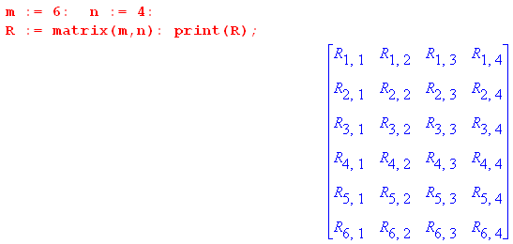

Compute and accumulate into "acc" the squares of all (6,4) = 15 full-width minors,

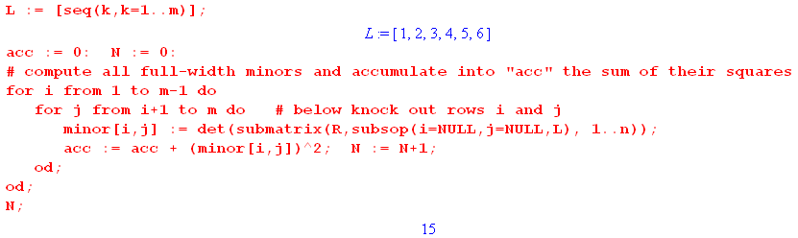
If we take the resulting "acc" and expand it, we get a series of 4,230 terms each of which contains a product of eight matrix elements of R,

Here are four of these terms

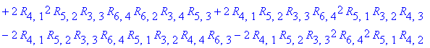.

We next compute det(RTR), note that it also has 4,230 terms, and then we show that det(RTR) = acc.

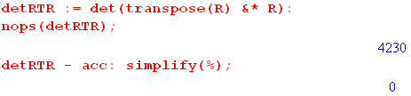 (G.1.1)

Fortified with the knowledge that the theorem seems to be true, we proceed:

Theorem: Let R be an m x n matrix with m ≥ n. There are (m,n) full-width minors.
The claim is that det(RTR) = sum of the squares of the full-width minors.

Comment: For m = n there is only one minor for square R which is det(R), the sum of the squares of the minors is then just det2(R), and indeed det(RTR) = det2(R).

Proof for n < m :

Define a multiindex I as follows

I = i1, i2, .... in (G.1.2)

where the ir indicate which n rows of the R matrix are included in a certain minor. Each ir takes values in the range 1 to m since R has m rows. Denote a full-width minor of R by

minorI . (G.1.3)

We shall need the following

Lemma:

Σ'I [minorI]2 = (1/n!) ΣI [minorI]2 (G.1.4)

where

Σ'I = Σ1≤i$_{1}$<i$_{2}$<....<i$_{n}$≤m = ordered sum
ΣI = Σi$_{1}$,i$_{2}$,...i$_{n}$=1m = symmetric sum (G.1.5)

Proof of Lemma:

ΣI [minorI]2 = Σi$_{1}$,i$_{2}$,...i$_{n}$=1m [minorI]2

= Σi$_{1}$≠i$_{2}$≠..≠i$_{n}$ [minorI]2 // minorI = 0 if two rows are the same

= (Σi$_{1}$<i$_{2}$<....<i$_{n}$ + Σi$_{2}$<i$_{1}$<....<i$_{n}$ + n!-2 other orderings) [minorI]2

= (ΣP [ΣP(i$_{1}$)<P(i$_{2}$)<...<P(i$_{n}$)]) [minorI]2

= Σi$_{1}$<i$_{2}$<...<i$_{n}$ [ΣP fP(i$_{1}$)P(i$_{2}$)...P(i$_{n}$)] . // by (A.9.1) with fi$_{1}$i$_{2}$...i$_{n}$ = [minorI]2

But fi$_{1}$i$_{2}$...i$_{n}$ = [minorI]2 is a totally symmetric function of the indices since row swaps don't affect a squared determinant. Thus we continue the above to get

= Σi$_{1}$<i$_{2}$<...<i$_{n}$ [ΣP fi$_{1}$i$_{2}$...i$_{n}$] = Σi$_{1}$<i$_{2}$<...<i$_{k}$ fi$_{1}$i$_{2}$...i$_{n}$ [ΣP 1 ]

= Σi$_{1}$<i$_{2}$<...<i$_{n}$ fi$_{1}$i$_{2}$...i$_{n}$ [n! ] = Σi$_{1}$<i$_{2}$<...<i$_{k}$ [minorI]2 [n! ]

= n! Σ'I [minorI]2 QED Lemma

Proof of Theorem:

We can write minorI as the determinant of a matrix using (A.1.19)

minorI = ΣP(-1)S(P) Ri$_{1}$P(1) Ri$_{2}$P(2) ....Ri$_{n}$P(n)

= Ri$_{1}$1 Ri$_{2}$2 ....Ri$_{n}$n + all signed permutations

≡ ΣP(-1)S(P)RIP(Z) . // in multiindex notation, Z = 1,2....n (G.1.6)

Then we first claim that

Sum ≡ sum of all full-width squared minors = Σ'I [minorI]2 . (G.1.7)

In this ordered sum, each full-width minor of R is included exactly once. For example, for a 3x2 R matrix we had above

K2 = det2 $\left(\begin{matrix}R11 & R12 \\ R21 & R22\end{matrix}\right)$ + det2 $\left(\begin{matrix}R11 & R12 \\ R31 & R32\end{matrix}\right)$ + det2 $\left(\begin{matrix}R21 & R22 \\ R31 & R32\end{matrix}\right)$ . (10.10.18)'
i1,i2 = 1,2 i1,i2 = 1,3 i1,i2 = 2,3

Then using the above Lemma we write

Sum = Σ'I [minorI]2 = (1/n!) ΣI [minorI]2 = (1/n!) ΣI [minorI] [minorI]

= (1/n!) ΣI [ ΣP(-1)S(P) Ri$_{1}$P(1) Ri$_{2}$P(2) ...Ri$_{n}$P(n)] [ ΣP'(-1)S(P') Ri$_{1}$P'(1) Ri$_{2}$P'(2)..Ri$_{n}$P'(n)]

= (1/n!) ΣI [ ΣP(-1)S(P)RIP(Z)] [ ΣP'(-1)S(P')RIP'(Z)] // multiindex notation

= (1/n!) ΣP(-1)S(P) ΣP'(-1)S(P')ΣI RIP(Z)RIP'(Z) // reorder

= (1/n!) ΣP(-1)S(P) ΣP'(-1)S(P')ΣI (RT)P(Z)IRIP'(Z) // matrix transposes

= (1/n!) ΣP(-1)S(P) ΣP'(-1)S(P')(RTR)P(Z)P'(Z) // n matrix multiplications use up ΣI

= (1/n!) ΣP(-1)S(P) ΣP'(-1)S(QP')(RTR)P(Z)QP'(Z) // ΣP' rearrangement theorem (A.1.3)

= (1/n!) ΣP(-1)S(P) ΣP'(-1)S(PP')(RTR)P(Z)PP'(Z) // select Q = P

= (1/n!) ΣP(-1)S(P) ΣP'(-1)S(PP')(RTR)ZP'(Z) // (A.8.31) since factored form

= (1/n!) ΣP ΣP'(-1)S(P')(RTR)ZP'(Z) // (A.1.11)

= (1/n!) ΣP'(-1)S(P')(RTR)ZP'(Z)[ΣP 1] = (1/n!) ΣP'(-1)S(P')(RTR)ZP'(Z)[n!]

= ΣP'(-1)S(P')(RTR)ZP'(Z)

= ΣP(-1)S(P)(RTR)ZP(Z)

= det(RTR) . // (A.1.19) QED Theorem (G.1.8)

G.2 The Connection between Theorem F.6 and Differential Forms

Recall from (10.11.7) that the integral of a k-form for F: Rn → Rm is given by

αx' = Σ'I fI(x') dx'^I (G.2.1)

∫S' αx' = ∫S Σ'J Σ'I fI(F(x)) det(RIJ) dxj$_{1}$ ^ dxj$_{2}$ ^ ... ^ dxj$_{k}$

= ∫S Σ'J Σ'I fI(F(x)) det(RIJ) dx^J . // R = (DF) (G.2.2)

The context here is that x' = F(x) is a point on a manifold M created by the mapping F: Rn→ Rm as illustrated for example in (10.7.26) which we replicate here

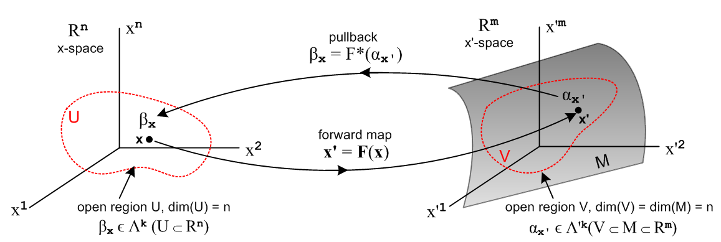
(10.7.26)
A case of frequent interest is k = n, and in this case there is only one term in the Σ'J sum, so

∫S' αx' = ∫S Σ'I fI(F(x)) det(RIZ) dx1 ^ dx2 ^ ... ^ dxn

= ∫S Σ'I fI(F(x)) det(RIZ) dx^Z . Z ≡ 1,2...n (G.2.3)

Here the letter Z is our multiindex stand-in so that J = Z means j1 = 1, j2 = 2, ... jn = n. The object det(RIZ) is then in fact a full-width minor (a number) of the m x n R matrix, and in (G.1.3) we called this minorI so

det(RIZ) = minorI ≡ mI . (G.2.4)

where mI is a compact notation for minorI. Since Rij(x) is generally a function of x (or x' = F(x)), we may regard mI = mI(x'), so this minor's value is a function of x' on manifold M.

Then, suppressing the arguments fI and mI, we have

∫S' αx' = ∫S [ Σ'I fI mI ] dx^Z . (G.2.5)

We may consider fI and mI to be vectors with (m,n) components which we can dot together to get,

∫S' αx' = ∫S [ f • m ] dx^Z . // f • m ≡ Σ'I fI mI (G.2.6)

For example, for n = 2, m = 3 we would write, showing components of each vector in "standard order",

f • m = (f12, f13, f23) • (m12, m13, m23) = f12m12+ f13m13+ f23m23 = Σ'I fI mI . (G.2.7)

One could create a minor unit vector in this manner

≡ $\frac{m}{|m|}$ (G.2.8)

where

|m|2 = Σ'I (mI)2 = Σ'I (minorI)2 = det(RTR) // (G.1.8) ! (G.2.9)

where we just invoked the det(RTR) theorem of Section G.1. One then has,

∫S' αx' = ∫S [ f • ] |m| dx^Z

= ∫S [ f • ] [ $\sqrt{det(RTR)}$ dx^Z] . (G.2.10)

The objects in red above are all functionals in the space Λn(Rn) in our "cosmetic notation". According to the "second definition" described in (10.1.3) we are always allowed to replace the functional dx^Z by dxZ to obtain a normal calculus integral that can be evaluated by standard methods,

dx^Z ≡ dx1 ^ dx2 ^ ... ^ dxn → dxZ ≡ dx1dx2.....dxn . (G.2.11)

Now consider the special case where the function f = . Then,

∫S' αx' = ∫S [ • ] [ $\sqrt{det(RTR)}$ dx^Z] = ∫S$\sqrt{det(RTR)}$ dx^Z

= ∫S$\sqrt{det(RTR)}$dxZ . (G.2.12)

which displays the tangent space volume measure dV' = $\sqrt{det(RTR)}$dx1dx2.... dxn shown in (F.5.2). This last integral gives the volume (area) of the surface S' (example below) and for this reason we refer to the n-form α'x with this value of f as the volume measure form μ' . From (G.2.1) then,

μ' = Σ'I fI dx'^I = f • dx^' = • dx^' . (G.2.13)

Here we use the same dot product idea as in (G.2.5), where fI and dx'^I are each treated as vectors having (m,n) components.

The pullback of this measure form appears in the integrand of (G.2.10),

F*(μ') = $\sqrt{det(RTR)}$ dx^Z

= $\sqrt{det((DF)T(DF))}$dx1 ^ dx2 ^ ... ^ dxn // Sjamaar p 105 above item 8.12 . (G.2.14)

Consider now a different situation where

f(x') = | f(x') | (G.2.15)

so that our new function f, considered as a vector with those (m,n) components, points in the direction. In this case we get

∫S' αx' = ∫S [ f • ] [ $\sqrt{det(RTR)}$ dx^Z] = ∫S | f((F(x))| $\sqrt{det(RTR)}$dx^Z (G.2.16)

and this is how one treats the integration of a scalar function over the surface S' such as the average temperature calculation in (10.10.20). In this case we can write the corresponding n-form in x'-space as

αx' = Σ'I fI dx'^I = f • dx^' = | f | • dx^' = (f • ) • dx^' = (f • ) μ' (G.2.17)

from which we extract this equation

f • dx^' = (f • ) μ' . (G.2.18)

Special case: Hypersurface where n = m - 1

Suppose now that n = m-1, so that the manifold M embedded in Rm is a hypersurface, meaning it has one dimension less than Rm. In this case, (m,n) = (m,m-1) = m and each of our "vectors" above has exactly m components.

One can define the following Hodge star objects as discussed at the start of Section 10.3,

*dx'i = (-1)i+1 dx'1 ^ dx'2 .. [dx'i]... ^ dx'm where dx'i is missing (G.2.19)

so that each *dx'i object is an (m-1)-form (that is, an n-form). These m Hodge dual objects can be combined to form a vector

*dx' ≡ (*dx'1, *dx'2, ....*dx'm) . (G.2.20)

We now define new vectors F and n' as follows,

Fi ≡ (-1)i+1f12.[i]..m
n'i ≡ (-1)i+1m12.[i]..m (G.2.21)

where the notation [i] means that index i is missing from 12...m. It follows that

F • *dx' = f • dx^' (G.2.22)

n' • *dx' = m • dx^' (G.2.23)

n' • F = m • f . (G.2.24)

The proofs of the above three lines are basically the same, so we prove just the first line :

F • *dx = Σi=1m Fi (*dx'i )

= Σi=1m (-1)i+1f12.[i]..m (-1)i+1 dx'1 ^ dx'2 .. [dx'i]... ^ dx'm

= Σi=1m f12.[i]..m dx'1 ^ dx'2 .. [dx'i]... ^ dx'm

= [ f234..m dx'2 ^ dx'3 ^ dx'4 ..... ^ dx'm + f134..m dx'1 ^ dx'3 ^ dx'4 ..... ^ dx'm + .... ]

= Σ'IfI dx'^I with series terms reordered from standard order

= f • dx^' . (G.2.25)

Because vector n' is a reordering of vector m where certain terms have minus signs, the sum of the squares of the components of the two vectors is the same, so

|n'| = |m| . (G.2.26)

Then dividing (G.2.23) and (G.2.24) by |n'| one finds

' • *dx = • dx^' (G.2.27)
' • F = • f . (G.2.28)

Recall from above that

μ' = • dx^' (G.2.13)

f • dx^' = (f • ) μ' . (G.2.18)

Using (G.2.27), and then (G.2.22) and (G.2.28), these may be written

μ' = ' • *dx' // see Sjamaar p 109 item 8.17 (G.2.29)

F • *dx' = (F • ') μ' . // see Sjamaar p 107 item 8.16 (G.2.30)

Sjamaar's equations are written in the x = φ(t) context rather than x' = F(x) so have *dx, and μ.

Example: F : R2→ R3 , k = n = 2 , m = 3. (G.2.31)

This example was first treated in Section 10.10 as a no-differential-forms problem, and was then reconsidered as a 2-form problem in Section 10.13 (but there in the x = φ(t) context). Here we write out various objects defined above and show how equations come out with equation number references in italics.

αx' = Σ'I fI(x') dx'^I = f12 dx'1 ^ dx'2 + f13 dx'1 ^ dx'3 + f23 dx'2 ^ dx'3 // a general 2-form

= f • dx^' = F • *dx' = F • dA' = (F • ') dA' // see below (G.2.1)

f = (f12, f13, f23) (G.2.7)
m12 = minor12 = det(R1212) = det $\left(\begin{matrix}R11 & R12 \\ R21 & R22\end{matrix}\right)$ // R is a 3 x 2 matrix with 3 full-width minors
m13 = minor13 = det(R1312) = det $\left(\begin{matrix}R11 & R12 \\ R31 & R32\end{matrix}\right)$
m23 = minor23 = det(R2312) = det $\left(\begin{matrix}R21 & R22 \\ R31 & R32\end{matrix}\right)$ (G.2.4)

m = (m12, m13, m23) = ( det $\left(\begin{matrix}R11 & R12 \\ R21 & R22\end{matrix}\right)$), det $\left(\begin{matrix}R11 & R12 \\ R31 & R32\end{matrix}\right)$, det $\left(\begin{matrix}R21 & R22 \\ R31 & R32\end{matrix}\right)$ ) (G.2.7)

F = (f23, -f13,f12) // agrees with (10.13.16) (G.2.21)

n' = (m23, -m13,m12) = ( det $\left(\begin{matrix}R21 & R22 \\ R31 & R32\end{matrix}\right)$), - det $\left(\begin{matrix}R11 & R12 \\ R31 & R32\end{matrix}\right)$, det $\left(\begin{matrix}R11 & R12 \\ R21 & R22\end{matrix}\right)$ ) (G.2.21)
= ( det $\left(\begin{matrix}R21 & R22 \\ R31 & R32\end{matrix}\right)$), + det $\left(\begin{matrix}R31 & R32 \\ R11 & R12\end{matrix}\right)$, det $\left(\begin{matrix}R11 & R12 \\ R21 & R22\end{matrix}\right)$ )

= agrees with (10.10.19) where n' is shown as normal to the surface

| m |2 = | n' |2 = det2 $\left(\begin{matrix}R21 & R22 \\ R31 & R32\end{matrix}\right)$ + det2 $\left(\begin{matrix}R31 & R32 \\ R11 & R12\end{matrix}\right)$ + det $\left(\begin{matrix}R11 & R12 \\ R21 & R22\end{matrix}\right)$ (G.2.26)

≡ K2 = det(RTR) // agrees with (10.10.18) and (10.10.22) (G.2.9)

dx^' = (dx'1 ^ dx'2, dx'1 ^ dx'3, dx'2 ^ dx'3 ) // standard order

*dx' ≡ (*dx'1, *dx'2,*dx'3 ) = (dx'2 ^ dx'3 , - dx'1 ^ dx'3, dx'1 ^ dx'2 ) ≡ dA' (10.13.23)

f • dx^' = (f12, f13, f23) • (dx'1 ^ dx'2, dx'1 ^ dx'3 , dx'2 ^ dx'3 )

= f12 dx'1 ^ dx'2 + f13 dx'1 ^ dx'3 + f23 dx'2 ^ dx'3 = Σ'I fI dx'^I

F • *dx = (f23, -f13,f12) • (dx'2 ^ dx'3 , - dx'1 ^ dx'3, dx'1 ^ dx'2)

= f23 dx'2 ^ dx'3 + f13 dx'1 ^ dx'3 + f12 dx'1 ^ dx'2 = Σ'I fI dx'^I (G.2.18)

n' • F = (m23, -m13,m12) • (f23, -f13,f12) = m23f23 + m13f13 + m12f12

= m12f12 + m13f13 + m23f23 = (m12, m13, m23) • (f12, f13, f23) = m • f (G.2.24)

μ' = ' • *dx' = ' • dA' = dA' // area measure on surface (G.2.29)

F • dA' = (F • ') dA' = (F • ') μ' // this is αx, the integration integrand (G.2.30)

