Order interchange for double limits. PhL 2.12.11

1. An example where limit interchange gives different results 1
2. A conjectured reason why we have this problem. 1
3. Apply this conjecture to our example. 2
4. The Interchanging Limits Theorem 3
5. How does this apply to the PBM identity? 4
6. How does this apply to the our T(z) series? 6
Appendix A: Think it is OK to move $\sqrt{z-1}$ through summation. 7
7. Another example of limit order interchange: term by term differentiation. 7
8. Term by term diff of an infinite sum written as an order-interchange limit situation: 11
9. A specific Theorem about passing ∂_{x} through an infinite sum 13

1. An example where limit interchange gives different results

Consider this example taken from a PDF,

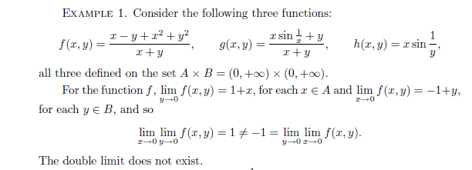

2. A conjectured reason why we have this problem.

I think the reason the double limit does not work is that our limits are not "uniformly convergent" .

Sadly, this definition does not make sense, though I think I know what the author means. I might say this

We say that lims→a f(s,t) = L(t) uniformly over T if, for every ε > 0, we can find a δ>0 such that, for all t in the specified set T, we have

|s-a| < δ => | f(s,t)-L(t)| < ε t in T

The main point is that the same δ must work for all points t in T. If you can only find δ = δt that works, then you only have pointwise convergence on T. Rewrite this way

|y-a| < δ => | f(x,y)-L(x)| < ε x in X

where we are free to change the order in f(x,y). L(t1) L(t2) f(s,t2)

3. Apply this conjecture to our example

Now let's see what the above example has to do with this uniform business.

Case 1: If the y→0 limit were uniform on the full interval x in 0,∞, then we would be claiming that for any ε we can find δ such that

|y-0| < δ => | f(x,y) -(1+x)| < ε for all x

y < δ => | f(x,y) -(1+x)| < ε for all x
We have
f(x,y) – (1+x) = $\frac{(x-y+x2+y2)}{(x+y)}$ - $\frac{1+x}{1}$ = $\frac{x-y+x2+y2 - (1+x)(x+y)}{x+y}$

= $\frac{x-y+x2+y2 - x-y-x2-xy}{x+y}$ = $\frac{-y +y2 -y -xy}{x+y}$= $\frac{-2y +y2 -xy}{x+y}$ = y $\frac{-2 +y -x}{x+y}$

Then, for any ε > 0, we need to find δ such that

y < δ => |y| | $\frac{-2 +y -x}{x+y}$| < ε for all x in (0,∞)

At x = 0 we need to then find

y < δ => |y| | $\frac{-2 +y}{y}$| < ε
or
y < δ => | y-2 | < ε

But as we grind down on δ, this says we need 2 < ε but for ε ≤ 1 (for example) this inequality cannot be met. We conclude therefore that

limy→0 $\frac{(x-y+x2+y2)}{(x+y)}$ = (1+x)

converges pointwise, but does not converge uniformly over x in (0,∞) because we have just seen that for x = 0 we cannot find any tiny δ > 0 that works.

Case 2: If the x→0 limit were uniform on the full interval y in 0,∞, then we would be claiming that for any ε we can find δ such that

|x-0| < δ => | f(x,y) -(y-1)| < ε

x < δ => | f(x,y) -(y-1)| < ε
We have
f(x,y) – (y-1) = $\frac{(x-y+x2+y2)}{(x+y)}$ - $\frac{y-1}{1}$ = $\frac{x-y+x2+y2 - (y-1)(x+y)}{x+y}$

= $\frac{x-y+x2+y2 -yx-y2+x +y}{x+y}$ = $\frac{2x +x2 -yx}{x+y}$ = x $\frac{2 + x -y}{x+y}$

Then, for any ε > 0, we need to find δ such that

x < δ => | x | | $\frac{2 + x -y}{x+y}$| < ε for all y in (0,∞)

At y = 0 we need to then find

x < δ => |x| | $\frac{2 + x}{x}$| < ε
or
x < δ => | x+2 | < ε

But as we grind down on δ, this says we need 2 < ε but for for ε = 1 (for example) this inequality cannot be met. We conclude therefore that

limx→0 $\frac{(x-y+x2+y2)}{(x+y)}$ = (y-1)

converges, but does not converge uniformly over y in (0,∞) because we have just seen that for y = 0 we cannot find any tiny δ > 0 that works.

It is not obvious to me how you construct an f(x,y) that has this problem on [0,∞]. But having the denominator be x+y certainly helps since it blows up when both variables are in legal range! The PDF (which I have) does the other two examples. In some cases, the single limits don't even exist, but one of the double limits does, etc.

4. The Interchanging Limits Theorem

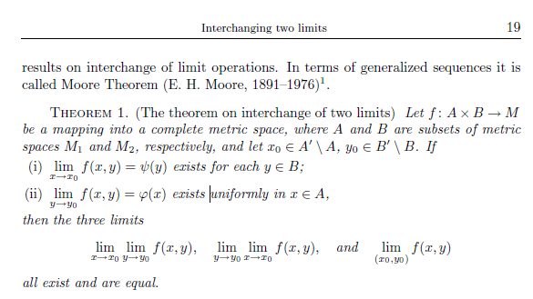

So first of all, both single limits have to exist. Note that xsin(1/y) has no y→0 limit, for example (the PDF does not talk about distributions). Secondly, at least one of the limits has to indicate uniform convergence. The theorem is general in that it allows each variable its own little metric space and all that good stuff. And the theorem is proven in the paper (again, which I have)

5. How does this apply to the PBM identity?

limN→∞ [$\sqrt{z-1}$Σn=0N εn Qn-1/2(z)] = (π/$\sqrt{2}$) // valid for all z

This thing has a single limit. Now it should be true for z = 1, so this seems to be true:

A ≡ limz→1 limN→∞ [$\sqrt{z-1}$Σn=0N εn Qn-1/2(z)] = (π/$\sqrt{2}$)

I think this is true. But let's just blindly look at the other order

B ≡ limN→∞ limz→1 [$\sqrt{z-1}$Σn=0N εn Qn-1/2(z)]

= limN→∞ Σn=0N εn limz→1 [$\sqrt{z-1}$Qn-1/2(z)]

Now we know that

Qn-1/2(z) = [ - ln(z-1) + (1/2)ln2 - γ - ψ(n+1/2) ]

and therefore

limz→1 [$\sqrt{z-1}$Qn-1/2(z)] = limz→1 { $\sqrt{z-1}$[ - ln(z-1) + (1/2)ln2 - γ - ψ(n+1/2) ] } = 0

Therefore we find that

B = 0

No question about it! A power beats a log any day.
So here we find that reversing the ordering of the limits gives different results, and that both limits exist. I think we must then find that neither limit is uniform! The ranges here are (1,∞) for z, and integers in range (1,∞) for N.
Our single limits of interest are these:

limz→1 [$\sqrt{z-1}$Σn=0N εn Qn-1/2(z)] f(z,N) = [$\sqrt{z-1}$Σn=0N εn Qn-1/2(z)]
limN→∞[$\sqrt{z-1}$Σn=0N εn Qn-1/2(z)]

But gee, if the PBM identity is true, the second limit must be valid for all z in (1,∞). Then we know that at least one of our limits is uniform, we satisfy Moore, and both limits should be the same. So, as usual, "we have a contradiction". But look again at the second line which we are thinking of as saying

limN→∞[$\sqrt{z-1}$Σn=0N εn Qn-1/2(z)] = (π/$\sqrt{2}$)

Is this really uniformly true for all z in (1,∞)? Right at z = 1 it says

limN→∞[0 Σn=0N εn Qn-1/2(1)] = (π/$\sqrt{2}$)

But here, we really have

limN→∞[ 0 x ∞ ] = (π/$\sqrt{2}$)

So I guess no, this limit does not exist right at z = 1, and so is not uniformly convergent. Even if we think of a limit of $\sqrt{z-1}$ times ln(z-1), we get 0 for this limit, not (π/$\sqrt{2}$). But THAT would be OK. The limit is some function of z, it doesn't have to be a constant function. So it must be then that the limit does not exist because it is limN→∞[ 0 x ∞ ] at z = 1. We are not taking any z=1 limit here, we are asking what happens AT z=1.

What about the other limit, is it uniform?

limz→1 [$\sqrt{z-1}$Σn=0N εn Qn-1/2(z)] = limz→1 f(z,N)

For finite N, I think this limit does exist and is 0. For N=∞ I think the limit exists and is (π/$\sqrt{2}$). So the limit exists for the full range of N. But are we UNIFORM or not in this limit? Let's first look at a value of N which is finite, so the limit is 0. Then we have to find

| z-1| < δ => | fN(z)-L(N)| < ε N in (1,∞)

We want a δ that works for all N. Write it out like this

| z-1| < δ => | $\sqrt{z-1}$Σn=0N εn Qn-1/2(z)-L(N) | < ε N in (1,∞)

Let's then grant that ε is very small and δ is very very small, so we can use our Q limit to get (we just wrote it symbolically, showing only part of the limit, omitting constants and factors)

| z-1| < δ => | $\sqrt{z-1}$Σn=0N εn ln(z-1)-L(N) | < ε N in (1,∞)

We need to find δ such that

| $\sqrt{δ}$Σn=0N εn ln(δ)-L(N) | < ε

At the problem point N= ∞ we have L(∞) = (π/$\sqrt{2}$) so our condition at this point in the set is

| $\sqrt{δ}$Σn=0N εn ln(δ)- (π/$\sqrt{2}$) | < ε

But given ε = .01, say, there is no value of δ small enough to make this be true. Even δ = 0 does not work. For any finite N, there IS a small enough δ that works. Thus, there is no δ that works for the entire range of N, so we do NOT have uniform convergence.

Now go back to the other limit.

limN→∞[$\sqrt{z-1}$Σn=0N εn Qn-1/2(z)]

Now our uniformity check looks like this

N > Nδ => | $\sqrt{z-1}$Σn=0N εn Qn-1/2(z)-R(z) | < ε z in (1,∞)

We need then this to be true

| $\sqrt{z-1}$Σn=0Nδ εn Qn-1/2(z)-R(z) | < ε

Now for z away from z = 1, our limit is R(z) = (π/$\sqrt{2}$) so we need to find Nδ such that

| $\sqrt{z-1}$Σn=0Nδ εn Qn-1/2(z) - (π/$\sqrt{2}$) | < ε

It seems likely that we can do this OK. Then for z = 1, our limit is 0 and we have

| 0 Σn=0Nδ εn ln (0) - 0 | < ε

Now it depends on how you read this thing. One way, you say f(1,Nδ) does not exist since you have 0 * ∞, and therefore Moore is violated. A different way you say the limit exists and is 0, and therefore any Nδ satisfies the < ε condition. So I guess the first way must be the truth.

6. How does this apply to the our T(z) series?

T(z) = limN→∞ { $\sqrt{z2 - 1}$ Σn=0N εn [Qn-1/2(z)/ Pn-1/2(z)] }

So T(z) really is a single limit situation. I think we just repeat everything of the previous section, and the P really makes no difference since near z = 1 it is 1. We conclude that neither limit is uniformly convergent over the full range of the other variable:

limz→1 [$\sqrt{z-1}$Σn=0N εn [Qn-1/2(z)/ Pn-1/2(z)]] f(z,N) = [$\sqrt{z-1}$Σn=0N εn Qn-1/2(z)]
limN→∞[$\sqrt{z-1}$Σn=0N εn [Qn-1/2(z)/ Pn-1/2(z)]

f(z,N) = [$\sqrt{z-1}$Σn=0N εn [Qn-1/2(z)/ Pn-1/2(z)]

Therefore we cannot conclude that "the three limits exist and are equal". This then allows that the two different ordered limits can be different, and that is just what we find with T(z). Namely:

limN→∞ limz→1 [$\sqrt{z-1}$Σn=0N εn [Qn-1/2(z)/ Pn-1/2(z)]] = 0

limz→1 limN→∞ [$\sqrt{z-1}$Σn=0N εn [Qn-1/2(z)/ Pn-1/2(z)]] = T(1) = (π/$\sqrt{2}$)

Appendix A: Think it is OK to move $\sqrt{z-1}$ through summation.

Maybe I have paid too little attention to that $\sqrt{z-1}$ factor. Let's start over with what the PBM identity really says:

limN→∞ [Σn=0N εn Qn-1/2(z)] = (π/$\sqrt{2}$)/$\sqrt{z-1}$

Now we ask: is this limit uniformly convergent for z in (1,∞)? Well, the limit doesn't even exist at the z = 1 end of the interval! Thus condition (i) of Moore above is violated -- remember that the limit has to exist for all z in your set of interest, and here that set includes z = 1.

So this then gets us into the limit of a product of functions:

limz→1 [ f(z)g(z) ] =

where we have f(z) = $\sqrt{z-1}$ and g(z) = limN→∞ [Σn=0N εn Qn-1/2(z)]. So we are thinking then about

limz→1 { $\sqrt{z-1}$limN→∞ [Σn=0N εn Qn-1/2(z)] } = (π/$\sqrt{2}$)

This is definitely valid as stated, given the PBM identity. But it is not clear that you can now move the factor of $\sqrt{z-1}$ to the right. If we forget the z limit, we can ask

$\sqrt{z-1}$limN→∞ [Σn=0N εn Qn-1/2(z)]

limN→∞ [$\sqrt{z-1}$ Σn=0N εn Qn-1/2(z)]

Are these the same? I think yes, because

1 = $\sqrt{z-1}$limN→∞ [Σn=0N εn Qn-1/2(z)] = $\sqrt{z-1}$ (π/$\sqrt{2}$)/$\sqrt{z-1}$ = (π/$\sqrt{2}$)

2 = limN→∞ [$\sqrt{z-1}$ Σn=0N εn Qn-1/2(z)] = ?? = $\sqrt{z-1}$ limN→∞ Σn=0N εn Qn-1/2(z)

You would think you could treat $\sqrt{z-1}$ as "a constant", even allowing for it to be 0, and you should be able to move a constant through a limit. So I think it is the same.

7. Another example of limit order interchange: term by term differentiation.

This example arose in the context of my trying to handle the heat conduction equation using a Fourier Sine transform. In this section I will just present the example and show where it fails, then in the next section I will show why this is a double limit order interchange. The problem involves taking a half-rod and applying a boundary schedule Aθ(t) thermal source to the finite end at x = 0. Here, we are just trying to convert the PDE in x and t into an ODE just in t, using a Fourier Sine Transform, and we end up getting an ODE in t that is just plain wrong!

I had this sequence of steps going

1 (∂t - ∂x2) u(x,t) = 0 // since no q sources inside the rod

2 u(x,t) = (2/π) $^{\int_{0}^{∞}{}}$dk sin(kx) U(k,t) // the sine transform expansion of u(x,t)

3 (∂t - ∂x2) {(2/π) $^{\int_{0}^{∞}{}}$dk sin(kx) U(k,t) } = 0 // insert expansion 2 into 1

4 LHS = (∂t - ∂x2) {(2/π) $^{\int_{0}^{∞}{}}$dk sin(kx) U(k,t) } // LHS is LHS of 3
5 = {(2/π) $^{\int_{0}^{∞}{}}$dk (∂t - ∂x2) [sin(kx) U(k,t)] } // assuming convergence etc
6 = {(2/π) $^{\int_{0}^{∞}{}}$dk (∂t+k2) [sin(kx) U(k,t)] } // ∂x2 hits only on sin(kx)
7 = (2/π) $^{\int_{0}^{∞}{}}$dk sin(kx) {(∂t+k2)U(k,t)}

so at this point we have

8 $^{\int_{0}^{∞}{}}$dk sin(kx) {(∂t+k2)U(k,t)} = 0 (*)

and we use completeness of the basis functions to conclude that

9 (∂t+k2)U(k,t) = 0 // but the correct ODE in fact is (∂t+k2)U(k,t) = Ak !

The logic flow is flawed and the error is in step 5 where I said "assuming convergence". It turns out from other methods that we in fact know all about U(k,t), to wit,

U(k,t) = A (1/k) [ 1 - exp(-k2t) ]

So looking back at step 5, the big question is whether the following is justified:

∂x2 [$^{\int_{0}^{∞}{}}$dk sin(kx) U(k,t) ] =?= $^{\int_{0}^{∞}{}}$dk ∂x2 [sin(kx) U(k,t) ]

a classic case of order interchange of two limits. We can first consider

(2/π)$^{\int_{0}^{∞}{}}$dk sin(kx) U(k,t) = (2A/π)$^{\int_{0}^{∞}{}}$dk sin(kx) [ (1/k) - exp(-k2t)/k ]

The two inverse Fourier Sine integrals are nicely convergent and we can easily look up the two terms and we find this result, which is a sort of expo decaying thing starting at A for x = 0 and dropping off for x>0:

= A {1 – erf( x / [2 $\sqrt{t}$]) } = A erfc( x / [2 $\sqrt{t}$])

the known answer to our heated half rod problem.
Now consider first this possibility, where we try just to push one derivative through the integral:

∂x [$^{\int_{0}^{∞}{}}$dk sin(kx) U(k,t) ] = $^{\int_{0}^{∞}{}}$dk ∂x [sin(kx) U(k,t) ]

Not knowing U(k,t) we cannot really justify this action because we don't know if the RHS will converge. So let's test it with our known U(k,t) and see what happens. We have

RHS = $^{\int_{0}^{∞}{}}$dk cos(kx) k U(k,t) = $^{\int_{0}^{∞}{}}$dk cos(kx) k A (1/k) [ 1 - exp(-k2t) ]

= A $^{\int_{0}^{∞}{}}$dk cos(kx) [ 1 - exp(-k2t) ]

= A [ π δ(x) - A p(x,t) ]

where the second integral I call p(x,t) is convergent and given by

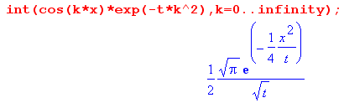

So in passing a single derivative through, we barely survive by the skin of our teeth, which is to say, the first integral "barely converges" to a distributional object.
But now consider trying to pass ∂x2 through the integral:

∂x2 [$^{\int_{0}^{∞}{}}$dk sin(kx) U(k,t) ] =?= $^{\int_{0}^{∞}{}}$dk ∂x2 [sin(kx) U(k,t) ]

As just noted, [...] is an erfc object which can be differentiated twice and all is well on the LHS. However, on the RHS we have

RHS = $^{\int_{0}^{∞}{}}$dk ∂x2 [sin(kx) U(k,t) ] = – $^{\int_{0}^{∞}{}}$dk sin(kx) k2U(k,t) ]

= – $^{\int_{0}^{∞}{}}$dk sin(kx) k2{A (1/k) [ 1 - exp(-k2t) ]}

= – A $^{\int_{0}^{∞}{}}$dk sin(kx) [ k - k exp(-k2t) ]}

The second integral converges just fine and is similar to p(x,t) above

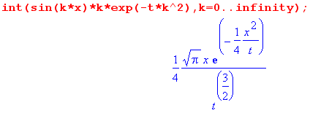

but the first integral involves this

$^{\int_{0}^{∞}{}}$dk k sin(kx)

No matter what you say, this is a divergent integral, the integrand for x=1 looks like this

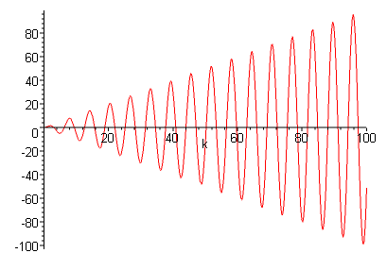

If we set the integral upper endpoint to y, we can define (again, for x = 1)

f(y) = $^{\int_{0}^{y}{}}$dk k sin(kx) = sin(y) - ycos(y)

and we can plot this thing as well

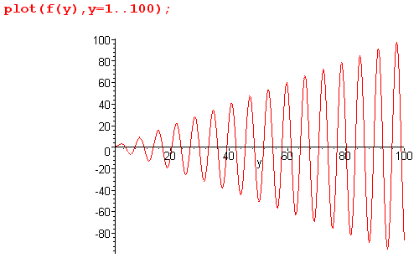

so the actual integral looks very much like the integrand, but there is no way as y→∞ that one can claim that this converges to something! As y→∞, it swings wildly between -∞ and +∞ so to speak, always at the frequency shown. It is unbounded. It is completely undefined. It does not exist!

Therefore, for our known U(k,t) function, we may conclude decisively that

∂x2 [$^{\int_{0}^{∞}{}}$dk sin(kx) U(k,t) ] ≠ $^{\int_{0}^{∞}{}}$dk ∂x2 [sin(kx) U(k,t) ]

since the LHS is some function and the right side does not even exist. So here is a rock solid example of a failing double limit interchange.
If we think of the dk integral here as a sum, then the issue is whether you can apply the derivative to the infinite sum, evaluate it "term by term" and get the right answer. In our example, you cannot!

8. Term by term diff of an infinite sum written as an order-interchange limit situation:

I was a little surprised by this when I first saw it. Consider the expansion of a reasonable function on a complete basis φn(x) :

f(x) = Σn=0∞anφn(x) = Σn=0∞ un(x) where un(x) = anφn(x)

The question is whether or not this is true: (ie, can you differentiate term by term? )

f '(x) = Σn=0∞anφn'(x) = Σn=0∞ un'(x) (*)

You would think it might just be OK, and maybe φn'(x) is also a complete basis, etc etc. But it turns out that this is generally NOT true, though it might be true, and you have to examine the series Σn=0∞ un'(x) explicitly to see if it converges! Here is the reason this is an order interchange of limits. The LHS of (*) is given by

f ' (x) = limh→0 { [ f(x+h)-f(x) ]/h }

= limh→0 { [Σn=0∞ un(x+h) - Σn=0∞ un(x) ]/h }

= limh→0 limN→∞{ [Σn=0N un(x+h) - Σn=0N un(x) ]/h }

= limh→0 limN→∞{ Σn=0N ( [un(x+h) - un(x)] /h ) }

where in the last step we use the fact that we are dealing with a finite sum.
Now look at the far RHS of (*)

Σn=0∞ un'(x) = limN→∞ Σn=0N un'(x)

= limN→∞ Σn=0N limh→0 { [un(x+h)- un(x) ]/h }

= limN→∞ limh→0 Σn=0N{ ( [un(x+h)- un(x) ]/h ) }

If we define this function of two variables (the first an integer, the second a real number)

S(N,h) ≡ Σn=0N{ ( [un(x+h)- un(x) ]/h ) }

we then have

LHS = f '(x) = limh→0 limN→∞ S(N,h)

RHS = Σn=0∞ un'(x) = limN→∞ limh→0 S(N,h)

and there we see that our two equation sides are the order-interchanged limits of a function of two variables, just as we studied in Section 4 above. We have these metric spaces for Moore's Theorem:

A: N in {1,2,3....} = the metric space of the positive integers, d(n1-n2) = || n1-n2|| = |n1-n2|

B: h in (0,ε) say = closed interval of the real axis, same notion of metric d, ε > 0.

So in order for the limits to be the same, both limits must exist, and at least one must converge uniformly over the range of "the other variable". One would have to study this carefully.
In our Section 7 example we saw a case involving the second derivative and we could repeat everything above perhaps using this, which is easily shown from doing two limits and setting h = k,

f '(x) = limh→0 { [ f(x+h) - 2f(x) + f(x-h) ] / h2 }

so then we would have a different function S,

S(N,h) ≡ Σn=0N{ ( [un(x+h)- 2un(x) + un(x-h) ]/h2 ) }

but we would have the same order interchange consideration. In the example of Section 7, one limit exists and the other does not, so in that case you could not do ∂x2 "term by term".
It is not hard to restate all this for an integral in fact, where I will just use 0 and ∞ as endpoints:

f(x) = $^{\int_{0}^{∞}{}}$dk akφk(x) = ∫dk uk(x) where uk(x) = akφk(x)

f '(x) = $^{\int_{0}^{∞}{}}$dk akφk'(x) = ∫dk uk'(x)

Then we have

f ' (x) = limh→0 limN→∞{ $^{\int_{0}^{N}{}}$dk ( [uk(x+h) - uk(x)] /h ) }

$^{\int_{0}^{∞}{}}$dk uk'(x) = limN→∞ limh→0 { $^{\int_{0}^{N}{}}$dk ( [uk(x+h) - uk(x)] /h ) }

and now

S(N,h) = $^{\int_{0}^{N}{}}$dk ( [uk(x+h) - uk(x)] /h )

where now N is a continuous real variable

9. A specific Theorem about passing ∂x through an infinite sum

This was taken from a PDF called "uniform.pdf".

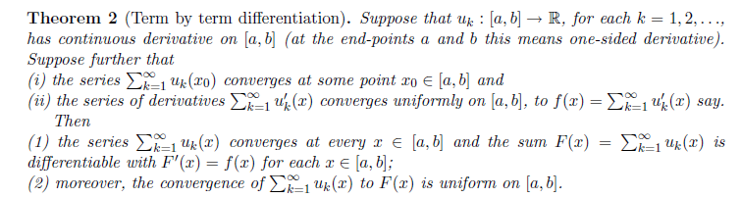

There are many things assumed by this Theorem.

* All the functions uk(x) have continuous derivatives on the interval ( ie, uk(x) = C1, uk'(x) = C0 )
* The series Σk=0∞ uk(x) converges at some point x0 in our interval.
* The series Σk=0∞ uk'(x) converges to some f(x) and does so uniformly on the interval

Then the theorem states that (a) the series Σk=0∞ uk(x) converges not just at x0, but at all x in the interval, and it does so uniformly, and we call the result F(x) = Σk=0∞ uk(x) . (b) F'(x) = f(x), which means that you can do term-by-term differentiation.

This theorem I would say has pretty severe conditions. It assumes right from the start that the term-by-term differentiated series converges, so it is not giving any conditions that make that happen. It also is requiring that the derivative series converge uniformly, which means one has more checking work to do to do a solid test.

