Special case of order interchange PhL 3.26.05

Comment: When I started writing this little side document, I thought I was going to come up with some general rule for interchanging integration with differentiation for a general kernel k(x,y) inside an integral equation. But I ended up making a slew of assumptions about k(x,y) so I did not end up with any general rule, just a rule for a very special case of k(x,y) functions. This was the special case that Stak dealt with on page 11 where he did his "careful differentiation". I will keep this little doc here, but it does not address the general problem at all.

1. Computing the derivative of a special form integral.

This question is treated to some extent in Stak Chap 1. The integral we have in mind is this:

f(x) = $^{\int_{a}^{b}{}}$dy F(x,y)

where F(x,y) might be the kernel of a Fredholm integral equation. If we think of F(x,y) as a surface plotted over the (a,b) square, this integral involves a vertical slice of the surface parallel to the y axis at some fixed value of x.

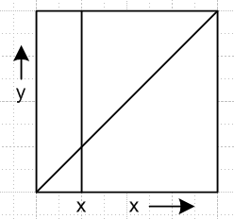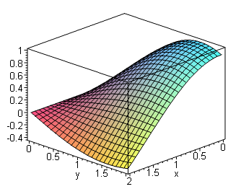

We have plotted some function which is "smooth". We want now to consider a very special class of functions for F(x,y), namely, those which are smooth except possibly at x = y which is the diagonal. Here is a function which is not smooth on the diagonal x = y:
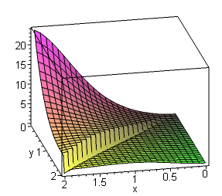

For this sample function, as we do our integral shown above, we have a "jump" when we reach the point y = x in the integral. If we fix x and consider g(y) = F(x,y), then g(y) has a jump at y = x and we would say that g(y) was PC on (a,b) with a jump at y = x. When we say that F(x,y) is "smooth" away from the diagonal, we shall define that to mean it is differentiable in either direction, so it is C1 in both x and y, away from the diagonal. This means for example that ∂xF(x,y) is well defined away from the diagonal.
Now, since y = x is our only problem region of F(x,y), we break our integral above into two parts

f(x) = $^{\int_{a}^{x}{}}$dy F-(x,y) + $^{\int_{x}^{b}{}}$dy F+(x,y) F+ = F for y>x F- = F for y<x

where each side is mean to be a limit as we approach the diagonal. Notice that we are not allowed to have something like a δ(x-y) on the diagonal, because PC means a finite jump. We are also not allowed to have any "asymptotes" by the usual PC definition, so we rule out things like F(x,y) = (x-y)-1/2 even though this would be integrable so f(x) would make sense. So there is no confusion about breaking the integral into two parts. We have made up names for the function to the left and to the right of the diagonal.

Now, finally, we want to apply ∂x to f(x). According to the usual rules for doing this, we get

∂xf(x) = { F-(x,x) + $^{\int_{a}^{x}{}}$dy ∂xF-(x,y)} + { - F+(x,x) + $^{\int_{x}^{b}{}}$dy ∂x F+(x,y) }

Since F is PC at the diagonal, we know that there can be no asymptotes there, so ∂xF(x,y) must be finite on either side of the diagonal. This means there is no issue integrating this quantity, there is no hidden delta function or infinite asymptote spike at the diagonal, so we can glue together the two integrals shown above into a single integral, and we get

∂xf(x) = { F-(x,x) - F+(x,x) } + $^{\int_{a}^{b}{}}$dy ∂xF(x,y)

So for our very special class of functions F(x,y), this is ∂xf(x). In addition to the expected integral term, we pick up the jump in F across the diagonal as a separate term.

Do I believe this result? Let's try an example.

Example: F(x,y) = θ(x-y). F+ = 0 for y>x F- = 1 for y<x

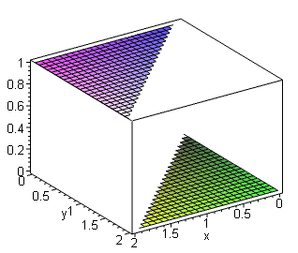

This seems to by smooth except it is PC at the diagonal, so falls within our assumed function class. Now by direct calculation we get

f(x) = $^{\int_{a}^{b}{}}$dy F(x,y) = $^{\int_{a}^{b}{}}$ dy F(x,y) θ(x-y) = $^{\int_{a}^{x}{}}$dy = (x-a) => ∂xf(x) = 1

On the other hand, our formula gives (since ∂xF =0 on both sides of the diagonal)

∂xf(x) = { F-(x,x) - F+(x,x) } + $^{\int_{a}^{b}{}}$dy ∂xF(x,y)

= { F-(x,x) - F+(x,x) }

= 1 - 0 = 1

So we see that it does work, and in this example, the entire ∂xf(x) comes from F-(x,x) - F+(x,x) .

2. Computing the second derivative.

Imagine we have done the first step above and we have obtained

df(x)/dx = { F-(x,x) - F+(x,x) } + $^{\int_{a}^{b}{}}$dy ∂xF(x,y)

We want do apply another d/dx to the LHS. The first step I suppose would be this:

d2f(x)/dx2 = d/dx { F-(x,x) - F+(x,x) } + d/dx {$^{\int_{a}^{b}{}}$dy ∂xF(x,y)}

We now want to add more assumptions:

(a) assume that F(x,y) had no jump at the diagonal, negating our part 1 assumption. Then

df(x)/dx = $^{\int_{a}^{b}{}}$dy ∂xF(x,y)

(b) Assume that ∂xF(x,y) has at worst a jump at its diagonal, so is PC with possible problem there. Then we apply part (1) to get

d2f(x)/dx2 = { ∂x F-(x,x) + $^{\int_{a}^{x}{}}$dy ∂x2F-(x,y)} + { - ∂x F+(x,x) + $^{\int_{x}^{b}{}}$dy ∂x2 F+(x,y) }

Now add

(c) assume that ∂x2F = 0 away from the diagonal (Laplace equation). Then we get

d2f(x)/dx2 = ∂x F-(x,x) - ∂x F+(x,x)

and if this is the string problem and F is the Green's function, we get the jump rule.

