The Notion of Uniform Convergence PhL 10.2.14

This has always been a difficult concept for me. I can write down the definition, but I don't seem to really understand what it says. So let's try some pictures. Consider:

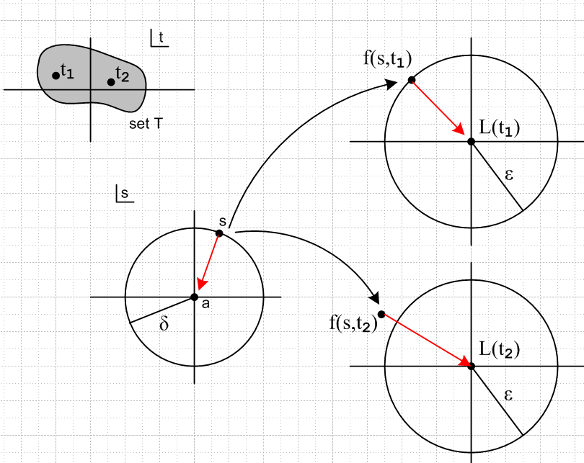

We have some function of two variables that is "of interest" called f(s,t). The second argument t lies in some well-defined set T like that shown in grey on top left.
We want to think about this idea:

lims→a f(s,t) = f(a,t) ≡ L(t)

The parameter a is fixed, it never changes (it could be a = 0).

Suppose we pick a point t1 in T and we pick some ε > 0. We then pick a certain δ and we find that all points inside the disc on the left map into the disk on the upper right. We show a sample point on the boundary which maps to the boundary. As we take s→a, we find that f(s,t1) → L(t). All is well. This just means that at t = t1, the function f(s,t1) actually converges to f(a,t1). The limits in the two spaces are shown as red arrows. This is called "pointwise convergence". For any t in T, we get this pointwise convergence.

Now suppose we pick a different value t2 from the set T, and we draw the lower target image on the right. The disk there has exactly the same radius ε. But it happens that for t2 our boundary point in s pace happens to land outside the circle of radius ε on the lower right. We don't want this to happen. So we can perhaps rectify the problem by making the δ radius smaller on the left, and then we have this

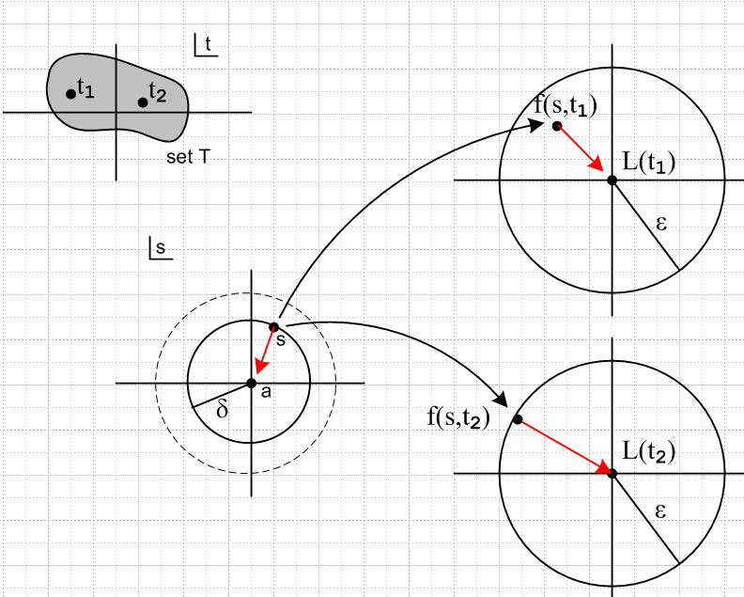

Now for the given ε, we find that all points in the δ disk shown map into the ε disk for both t1 and t2.
Suppose now there is some point t3 in T such that the point s maps outside the ε disk on the right which surrounds the complex number L(t3). Well, then we could make the δ disk still smaller in order to force the point f(s,ti) to lie inside the ε disk for all three points t1 and t2 and t3.

It may happen that as we keep considering more points in T, we have to keep making δ smaller and smaller in order to accommodate all the ti points considered so far. It might happen that, in order to accommodate all the points ti in T, the only δ that works is δ = 0!! If this is the case, then this limit

lims→a f(s,t) = f(a,t) ≡ L(t)

is said to converge NON-uniformly over the set T. The convergence is NOT uniform. Probably for all points in t, we will have lims→a f(s,t) = f(a,t) ≡ L(t) occurring without any problem, so probably the convergence for any particular t is OK, and there is some δ that works for that value of t. This is called pointwise convergence. But for a given ε, to have uniform convergence have to have a δ > 0 value that works for ALL points in T.
So it is possible that we have a perfectly fine pointwise convergence for all points in T, but we do not have uniform convergence over T.

Often the problem is localized to a neighborhood of some point in the set T, and that point might be t = 0 as in the following example.
Example 1: Consider the case where a= 0 and f(s,t) = $\frac{1}{s+t}$. We pick some ε, and on the right we require that this be true:

| $\frac{1}{s+t}$ - $\frac{1}{0+t}$ | < ε or | $\frac{s}{t(s+t)}$| < ε or |s| < |t| |t+s| ε

Suppose set T contains the neighborhood of t = 0. We know that |t + s| is some finite value for any finite s and finite t. So we won't have |t+s| being infinite. And ε is some selected positive constant. So we see that as t→ 0, we will be forced to have |s| < 0 which basically means we need δ = 0. Thus, in this example

lims→0 $\frac{1}{s+t}$ = $\frac{1}{t}$ ≡ L(t)

we find that we do have pointwise convergence for any t. For t = 0, our pointwise convergence is that the limit is ∞, which is OK, just another point. But we do not have uniform convergence for any set T which contains t = 0.

Authors often talk about uniform convergence of a sequence, whereas above we are talking only about functions. Suppose however in the above picture we defined a sequence of points like this

sk k = 1,2,3.....∞

and suppose this sequence converges to some value a,

limk→∞ (sk) = a. fs$_{k}$

We can think of the sequence as a set of points along our red arrow on the left in the drawings above. Or that arrow could be any curved path which gets from s to a. Each such path is a different sequence. Then the limit of interest is this

lims→a f(s,t) = f(a,t) ≡ L(t)

limk→∞ fs$_{k}$(t) = fa(t) ≡ L(t)

Examples 2 and 3: Go look at Case 1 and Case 2 in the "order interchange" doc.

