Meaning of saying: A is an open subset of B. PhL 3.1.16

1. First, go look at the definition of an open set given as defined in Topology World:

[ I already have some notes in "compactness.doc" ]

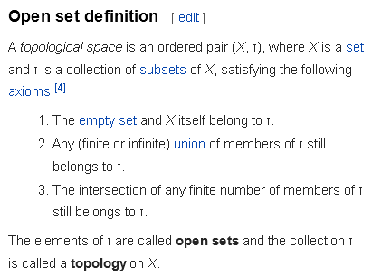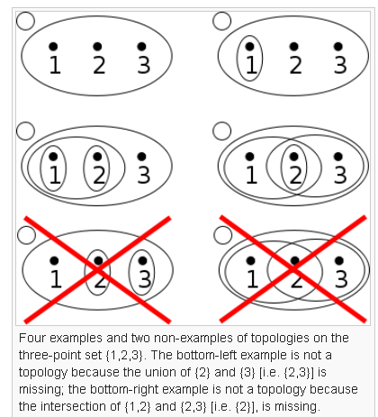

My first question: What is the connection between this and my usual notion of an open set in terms of an open ball around a point in the set being in the set?

Well, the above topo definition can be applied to spaces which have no distance (no metric) and can be used to sort of replace the idea of distance, examples being those shown above where there is no meaning of distance.

I presume that when you do have a metric, you can show that the open ball definition of open set implies the topo open sense as well. Is this a trivial thing I can show right now?

The topology that consists of ALL subsets of a set is called the power set.

Consider a set of sets of R where the sets are "open neighborhoods" around all elements of R, where open is in the usual metric sense, plus the null set. Does this set of sets form a topology? Rule 1 is OK since the full R axis is a neighborhood of any point in R. If A and B are two neighborhoods, their intersection is either null, which is OK, or it is an open neighborhood around any point in the intersection. Union is OK too, so the answer is yes. This is called the metric topology on a metric space, and if you also are a vector space, then it is called the standard topology.

Now consider U being [0,1] or [0,1). The problem here is that the endpoint 0 fails to have any neighborhoods! Thus you cannot put open balls around all points, so you cannot construct the metric topology on [0,1). Remember that you need to be able to have an open ball around all points of your set.

2. Now look at wiki Open-set page:

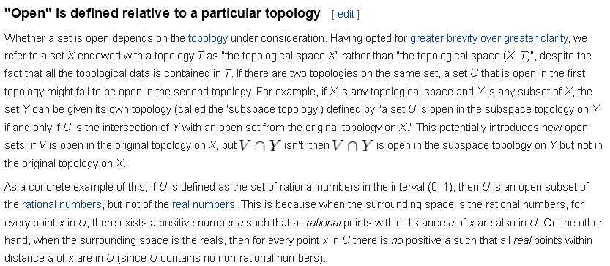

I am pretty sure this idea is the same as Buck's idea of "open relative to" on page 31.

The subsets of all rational numbers form open sets relative to the rationals, but such subsets are not open relative to the reals. The reason is that any ball around a rational that includes only the nearby rationals does not include any reals so every rational number is on a boundary relative to the reals!

Application: Consider Sjamaar's φ(U) = V where φ is 1-to-1 so if U is open, then V is open. But suppose U is a small open patch in R2 so that V is an open patch of dimension 2 which lies on some 2D surface in R3. The set V is open relative to that 2D surface on which it lies, but V is not open relative to R3 ! On page 36 bottom Sjamaar says his k-form is defined on an open subset V of Rm, then he has famous picture on the bottom of page 37. I think V as an n-dimensional surface (the map of U) is open in an n-dimensional sense, but not relative to Rm where m > n. It would then be correct to say that V was an open subset in Rm but it is not open relative to Rm , it is open relative to the n-dimensional manifold.
Think of V containing no boundary points on the manifold so it is open on the manifold. Fine. But you cannot put Rm open balls around points on the manifold which balls lie in the manifold, so I would say that manifold M is not open relative to Rm.

