Canonical-Structures notes PhL 7.16.10

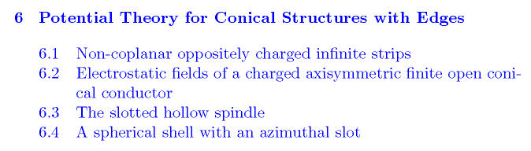
Chapter 6: Potential theory for conical structures. 1
6.1 Non-coplanar oppositely charged infinite strips. 1
6.2 Problems with a cone as a bounding surface. 8

As you can see from my contents above, I have not read the last two sections of this Chapter.

Chapter 6: Potential theory for conical structures.

A very nice introduction, main idea is that things will be different for the cone geometry. They point out that the inversion of a cone through an origin on the axis is a "spindle". They will pay special attention to the situation of an incomplete azimuth situation, which we would call a slotted cone or spindle. A picture is shown of a cross section of a cone, and the authors want to examine this situation in 2D first.

Comment: I was hoping authors would say WHY we need ν = -1/2 + iτ for our locus of ν in our atomic forms for this problem. They claim it is a finite-energy thing, but they don't support that claim. One reason seems to be that the MF transform has this range, and it gets much mention below. But the key fact I was looking for (the WHY) is not well explained. In any event, it seems pretty clear that this type of ν is required for problems with conical boundaries, and that is why they are called conical functions!

6.1 Non-coplanar oppositely charged infinite strips.

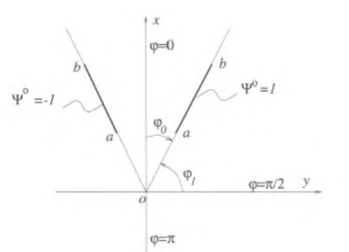

As a 2D problem with the two segments shown, the corresponding 3D problem is one of two strips. This is a capacitor with V=1 on the right plate and V=-1 on the left plate. The planes of these strips intersect at an origin as shown. The authors set this up in cylindricals with z coming out of the plane of paper, and of course the 2D problem only has Φ(ρ,φ). The strips are at angles φ1 and at π-φ1, and so are symmetrical, as we will later see in the cross section of a cone.
Before going a step further, authors create a dimensionless version of the ρ variable,

r = ρ/$\sqrt{ab}$ => r lies in ($\sqrt{a/b}$,$\sqrt{b/a}$) b > a

and rewrite the Laplace equation using it.

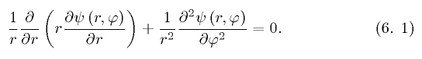

I just showed by hand that if you take r = 1/s and rewrite the above equation, it has exactly the same form with r replaced by s everywhere. This means that if ψ(r,φ) is a solution, then so is ψ(1/r,φ) . When we convert from r to σ below, we will know that if ψ(σ,φ) is a solution, then so is ψ(-σ,φ). This does not tell us that the solution is even in σ, but see below.

Now, the normal atoms for such a scaled 2D problem are these

[ rn, r-n, A + Blog(r) for n=0] [ sin(nφ),cos(nφ)] // Stak page 92 C.

where I would have used θ, but "Canon" uses φ so fine. Now, we could consider n = iτ and then our form is

[ sin(τlog(r)), cos(τlog(r))] [ e+τφ , e-τφ] // Stak page 92 C.

where I guess we drop the log possibility since it will blow up near or far. So this is our Mellin like situation in the radial coordinate which has now been made oscillatory. Authors define obvious new variable

σ = log(r) => σ lies in (log($\sqrt{a/b}$,log($\sqrt{b/a}$) = ( - (1/2) log(b/a), (1/2) log(b/a) )

we define

σo = (1/2) log(b/a) => our strip lies in this nice range: σ in (-σo,+σo)

It is interesting to redraw the above picture in a space where the axes are φ horizontal, and σ vertical:

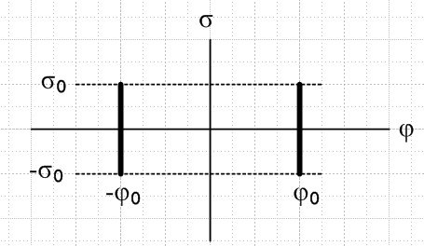

The symmetry tells us that the potential is symmetric on the top and bottom half of this picture, so we know that our solution must have the symmetry Φ(-σ) = Φ(σ) and this rules out the sin(στ) term later.

Now, our atoms are just these

[ sin(τσ), cos(τσ)] [ e+τφ , e-τφ] -φ0 -σ0

Now without much discussion, we are going to assume that the spectrum of τ is (0,∞). We have done this elsewhere. I think we are talking SL problems with real variables, so you would not take a spectrum to be some other set in the complex τ plane. Thus, we arrive at 6.2.
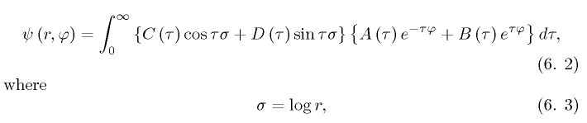
and this, then, is our opening gambit for a Smythian form, which we shall now immediately refine. The result has to be symmetric in angle φ, so the correct φ function is really sinh(τφ). On the other side of the right side strip boundary, we know that we need "some other φ form" because if we take the same form, then you cannot have a strip there because Φ and Φ' would be continuous through it, meaning it is not there. That "other φ form" is taken to be as shown below. This form makes Φ = 0 at φ = π, though it is not clear why we want this. We know Φ = 0 at φ = 0. The form makes the potential continuous at our boundary. So we just accept it as a "trial Smythian form": { 6" below we set g(τ) = 0 by symmetry }
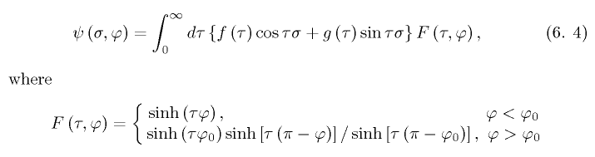

So far so good. Authors now want us to consider "the φ problem" which we will soon obtain by doing a separation. As usual with a problem where we have "a hole" (in an obscure sense -- this just means that a surface of constant coordinate is not completely filled with metal, like an iris), we have mixed BC's. One BC is that V = 1 on the right strip, as you approach it from either side. The other is that there is no charge on the line holding the strip but away from the strip, which means ∂φV is continuous through the strip. Thus, we have the following completely correct statement of our φ BC's .

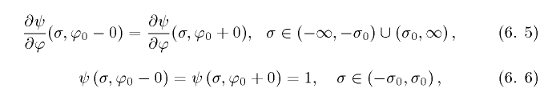

We set g(τ) = 0 by the symmetry argument given earlier. Then the first BC above gives 6.8 below (I did it by hand on scratch), while the second gives 6.7 :

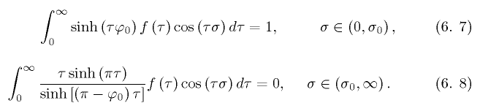

and sho' 'nuff, we have a pair of dual integral equations. I will be very interested to see what happens next! They are going to actually "solve" this dual pair before my eyes, but their "definition" method. I started reading about this with the sphere, but let's just do it here. We "fill in the hole" in 6.8 with some TBD function g(τ),

so now we have a full range of τ and σ, so we can ponder doing a normal transform. This is just a Fourier Cosine transform, so let's accept his result that
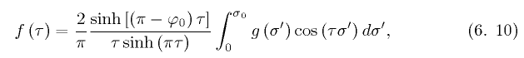

Slap this back into 6.7. I again did this by hand and got their results:

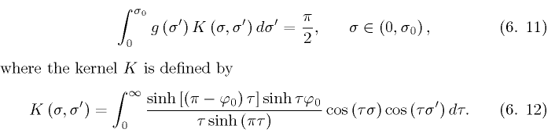

so the one integral equation (6.7) for f(τ) has been converted to integral equation (6.11) for g(σ). We have traded one integral equation for another, so how have we gained?
They go on to do the above integration for K and they write the result two ways. First, the general result, and second, the result for the specific case that φ = π/2 (where the strips are then coplanar in real space), note that φ1 = π/2 - φ0.

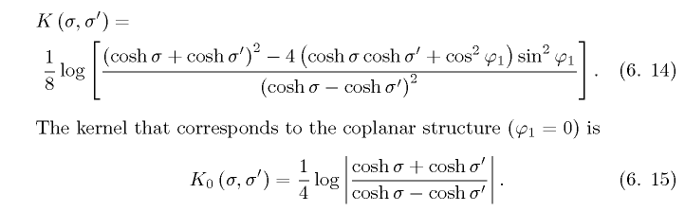

Now comes their "method of regularization" which reminds me of QED a bit. The K0 result above is regarded as "singular", and we want to write

K = K0 + K1

where we "expose" this singular part and the residual part is called K1. They claim you can show that
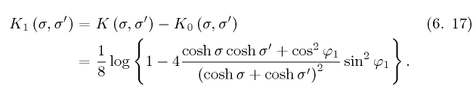
Next, we look at our coplanar-case integral equation,

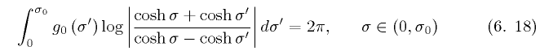

and they pull a solution to this "out of a hat", ( a VERY obscure reference 48)

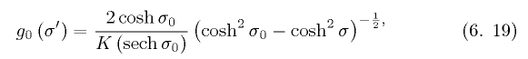
claiming this is a well-known "canonical form" of an integral equation. He then does the FT to obtain
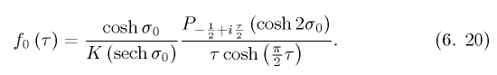

and ATTENTION! : suddenly a conical function has appeared in our problem, it came out of nowhere! True, it is only appearing in the coplanar strips limit of our original problem, but it is appearing! He computes next the charge on the strips, and in doing so quotes this "well known integral"

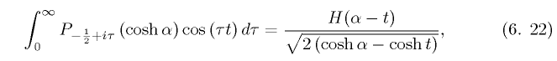

which must be a special case of this PBM integral

and it also appears in GR7 page 788

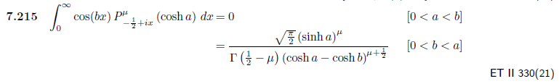
and I see it in my copied ET II integrals list!

Now authors resume with the non-coplanar strip case, and they are going to call upon Mehler Fock! They first give a very nice accurate statement of this transform and when it actually applies and converges. So here come some fancy moves. First, write the MF in this manner:
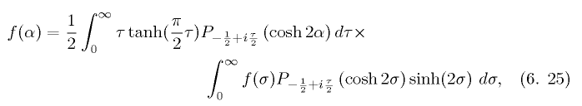

Then throw in the following integral representation for P,

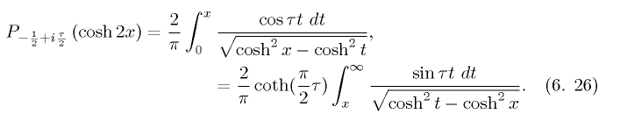

The dust flies, and out comes a new version of our dual integral equations:

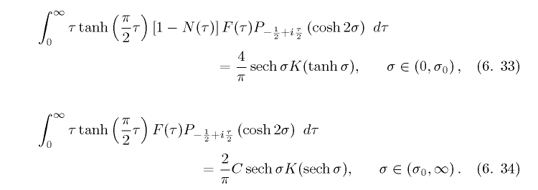

which now both contain conical P functions! The function F(τ) is just a rescaled f(τ)

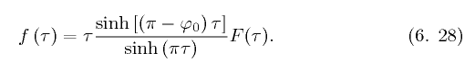

Then they convert one of the integral equations above to this one:

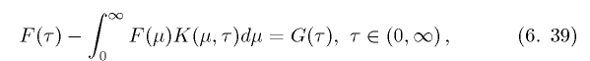

where K and G are then stated. This is second kind Fredholm.
At this point, they simply stop! They state the coplanar strips solution for F(τ), but for the general solution they are suddenly talking "numerical work". At this point, I lose interest. I thought they were going to get the full solution, and more importantly, I was hoping to hear something about the conical P functions and why they appear!
Stakgold discusses many methods for finding approximate solutions to second-kind Fredholm equations. For example, put it on a lattice and treat as a matrix problem of some dimension N.

6.2 Problems with a cone as a bounding surface.

Here we are back to talking atomic forms for spherical coordinates. We are told that ν = -1/2+iτ is an "appropriate choice" for the atoms. The claim is that ν has to have such a value in order to have a finite energy integral for the E field, but that is to be shown later (but it never is shown).
So we do what we did above in the 2D case and express our radial atomic form in this manner

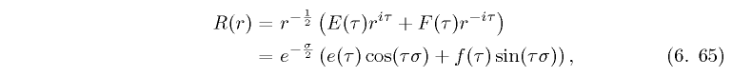
with σ = log(r) as before. Authors then discuss forms for inside and outside conical structures. Then they start in on a specific problem. But first they develop a form for 1/R in our cone type coordinates, which is certainly not too far-fetched,
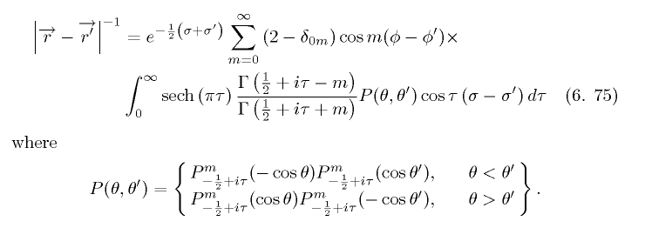

If you place your point charge on the cone axis, this simplifies to become ( no φ dependence, m=0)
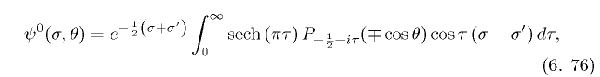
Now off we go: they are going to do the Green's function for the cone, and here is their Smythian form for the potential due to the induced charge only, [ osc in σ ~ r; expo in θ; osc in φ not shown ]

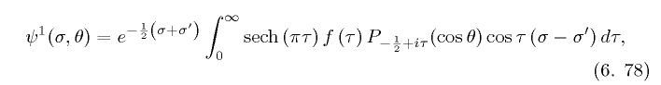
The on-axis Green's charge is located at σ = σ' , where recall σ = log(r). The above form mimics the form above for the point charge, so they are going to use "my Dirichlet method" to get this Green's function. If we evaluate 6.78 on the cone, we have to get minus 6.76, and this tells us that
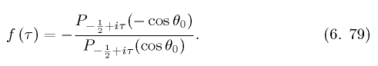

and we then add our two pieces to get the Green's function! The charge density on the cone comes out being a simple form (as usual)

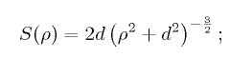

where ρ is just the usual cylindrical coordinate. It is finite everywhere (this is an infinite cone).
Authors then redo the problem with point charge outside the cone.
Finally they do the conic frustum and end up with a pair of Fredholm equations. I guess this type of equation is suitable for numeric work.
Then it is on to the spindle and slots and all that stuff.

Comment: Their method for doing the on-axis Green's function for a cone is basically a Smythian form approach using my spherical coordinates atomic form (2).

