Canonical PhL 7.19.10

Preface: I read this for the first time today. The authors have a two-part book, and Amazon wants $240 for the pair. I have only Part I. Published 2002. The main author I think is SS "Sergei" Vinogradov, who seems to be an expert in practical applications of scattering theory. I think the third author Elena ("lecturer") is his wife (just a guess), and Paul D Smith is Head of Math Dept at Macquarie University in Sydney,

http://www.maths.mq.edu.au/~pdsmith/
http://www.maths.mq.edu.au/staff/pdsmith.html

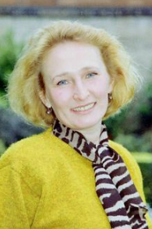

The authors develop tools in Part I mostly on the canvas of electrostatics, then apply these tools to scattering in Part II. So in some sense Part I goes with Chap 6 of Stak, and Part II with later chapters. They claim to have a method they call "regularization" which clarifies the singular part of a problem and in some way separates it off. I saw this somehow happen in their cone discussion. Everything is going to involve mixed boundary conditions, dual integral sums or equations. The regularization makes numerical work more controllable. The word "canonical" I suppose refers to standard simple geometries which serve up lessons about more complex situations.
They give credit in this preface to two books, one of course is Sneddon's which I still cannot get hold of.

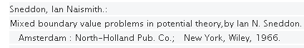

I should get over there and at least take a look at this thing. Their other reference is a 3 author scattering book. I see Sneddon has been a busy fellow with lots of books.

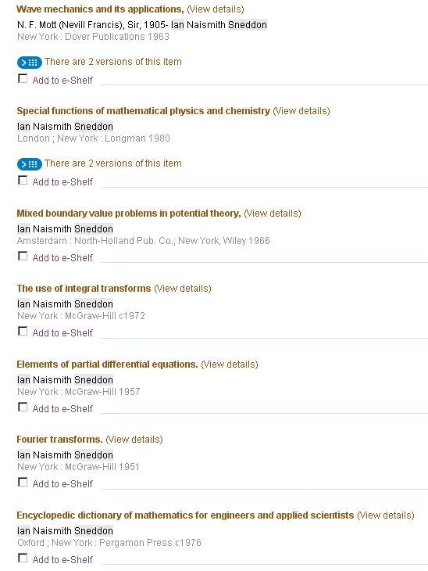

Well OK, I went today and paid the $54 for a library card and checked out the Sneddon book! It is about 270 pages, I could copy the whole thing 2-up if it seems a good book. // I not only copied the whole thing, but I read the whole thing, pretty much. I then veered off into the toroidal world, got a website launched, and now I am back to canonical with focus on "the bowl".

Chapter 1 : The Laplace Equation

1.1 Laplace in various Curvilinear Systems: Laplacian is Δ = ∇2.

Then handle 7 systems here including spheroidals, toroidals and elliptic cylinders.

1.2 Separation of Laplace in these systems.

Here the write the ODE's and one atomic form for each of their 7 systems of interest.

1.3 Theory and structures with edges.

This is a theory section talking about solution uniqueness and energy integrals. They talk about dual series equations, mixed BV problems, Dirichlet and Neumann words are implied but not used I guess because this is a Russian book. I think all this stuff is readable, but I skip it for now.

1.4 Dual Equations: Classification of Solution Methods

They mention three methods which sound like Williams, Noble and Noble right from Sneddon, just general at this point.

1.4.1 The Definition-Extension Method (Williams [76])

This small section occupies 1.5 pages of the Canonical book, but these few equations require a huge amount of work to derive! I had long been mystified by this little section and am quite happy to finally have it understood. So much work is required that I broke out this separate document:

"canonical -- Section 1_4_1 The Definition Method for the Bowl.doc" 23 pages !

Here are the major steps (using the Method 2 path)

(a) derive a bunch of equations relating to the bowl problem with V0 = 1 on the bowl (angle θ0):

Σn=0∞ anPn(z) = 1 θ in (0,θ0) g*(θ) = sinθ g(θ) 1.100
Σn=0∞ an(2n+1) Pn(z) = 0 θ in (θ0, π) 1.101
Σn=0∞ an(2n+1) Pn(z) = g(θ) θ in (0, π) 1.103
an = (1/2) $^{\int_{0}^{θ0}{}}$dθ sinθ Pn(cosθ) g(θ) 1.104
1 = $^{\int_{0}^{θ0}{}}$dθ' sinθ g(θ') K(θ,θ') // valid for θ ≤ θ0 only 1.105
K(θ,θ') = (1/2) Σn=0∞ Pn(z) Pn(z') // symmetric 1.106
K(θ,θ') = (1/2π) $^{\int_{0}^{min(θ,θ')}{}}$dφ { 1/$\sqrt{cosφ-cosθ}$ 1/$\sqrt{cosφ-cosθ'}$} 1.107
Pn(cosθ) = ($\sqrt{2}$/π)$^{\int_{0}^{θ}{}}$dφ cos[(n+1/2)φ]/$\sqrt{cosφ-cosθ}$ 1.108
Σn=0∞ cos[(n+1/2)φ] Pn(cosθ) = (1/$\sqrt{2}$) 1/$\sqrt{cosφ-cosθ}$ * Heaviside(φ < θ) 1.109
2π = $^{\int_{0}^{θ}{}}$dφ 1/$\sqrt{cosφ-cosθ}$$^{\int_{φ}^{θ0}{}}$dθ' g*(θ') 1/$\sqrt{cosφ-cosθ'}$ θ ≤ θ0 1.110
where g*(θ) ≡ sinθ g(θ)

Perhaps a few words are in order! The first two equations are the usual "dual series" setup for this problem in spherical coordinates. Equation 1.101 says there is no charge density on the cap. We know there is charge density on the bowl, but we don't know what it is, so we call it g(θ), an unknown function which we do know is 0 on the cap. I think we are "defining" g(θ) by doing this, and this gives the name to the method as "the definition method". I show that g(θ) = 4πR (σo+σi) so it is roughly the sum of the charge densities on the bowl of radius R. I know g(θ) from my Kelvin/toroidal work, and it is the goal of this section to obtain this g(θ) independently using this "definition method". Unfortunately, there are three typos in the claimed result 1.111 which I corrected in a separate document, so here is the "target" of the calculation: (the last two terms can be combined into cos-1 )

g(θ) = (2/π) { $\sqrt{2}$ cos(θ0/2)/ $\sqrt{cosθ - cosθ0}$ + π/2 – sin-1[ cos(θ0/2) / cos(θ/2) }
// 1.111 corrected

Note: As part of the derivation of 1.107 above, we had to investigate a certain Sturm-Liouville problem in Appendix A which gave this not-very-familiar result: (it might appear in Sneddon somewhere)

Σn=0∞ cos([n+1/2]x) cos([n+1/2]x') = (π/2) δ(x-x') interval x in (0,π)

(b) Equation 1.110 shown above contains our unknown function g(θ) evaluated on all points of the bowl's surface θ < θ0. In order to solve for g*, we have to do a "double Abel transform". It is the clever equation 1.107 which gets us to this point.
We break the double-Abel equation 1.110 into two parts as follows,

2π = $^{\int_{0}^{θ}{}}$dφ h(φ)/$\sqrt{cosφ-cosθ}$ // valid for θ ≤ θ0 (P2.2)
h(φ) ≡ $^{\int_{φ}^{θ0}{}}$dθ' g*(θ') 1/$\sqrt{cosφ-cosθ'}$ // valid for φ ≤ θ0 (P2.1)

In our "first Abel transform" we solve (P2.2) for h(φ). We use our "S1 Sneddon trig form" to do this transform, since it is the upper endpoint which is the variable. We find that

h(φ) = + π-1 ∂φ { $^{\int_{0}^{φ}{}}$du sinu (2π) / $\sqrt{cosu - cosφ}$ } = 2 ∂φ {$^{\int_{0}^{φ}{}}$du sinu/ $\sqrt{cosu - cosφ}$}

where red 2π is the LHS of equation (P2.2) above. Maple shows that

$^{\int_{0}^{φ}{}}$du sinu / $\sqrt{cosu - cosφ}$ = 2 $\sqrt{1-cosφ}$

and we then quickly find that

h(φ) = 2 sinφ/$\sqrt{1-cosφ}$ // valid for φ ≤ θ0 (P2.3)

In our "second Abel transform" , knowing h(φ), we then set about solving (P2.1) above for g*(θ). This is an "S2 Sneddon form" since the variable endpoint is now the lower endpoint. The Sneddon formula tells us that

g*(t) = – π-1 ∂t { $^{\int_{t}^{θ0}{}}$du sinu [2 sinu/$\sqrt{1-cosu}$] / $\sqrt{cost - cosu}$ }

where red shows the LHS of (P2.1) above, and which we rewrite this way

g*(t) = – (2/π) ∂tI g*(t) = sint g(t) (P4.1)

I ≡ $^{\int_{t}^{θ0}{}}$du sin2u [1/$\sqrt{1-cosu}$] [1 / $\sqrt{cost - cosu}$ ] (P4.2)

Since Maple threw up on this integral, we did several variable changes to get it into a simpler form.

x = cosu => I = $^{\int_{a}^{b}{}}$dx $\sqrt{1+x}$/$\sqrt{b - x}$ -1 < a < b < 1, a = cos(θ0) and b = cos(t)

y = b-x => I = $^{\int_{0}^{b-a}{}}$dy $\sqrt{b+1-y}$/$\sqrt{y}$

=> I = $^{\int_{0}^{c}{}}$dy $\sqrt{d-y}$/$\sqrt{y}$ c = b-a and d = b+1 (P5.2)

y=x2 => I = 2$\sqrt{c}$!Syntax Error, Idx $\sqrt{d-x2}$ (P6.1)

d = b+1 = cost+1
c = b-a = cost - cosθ0
d-c = 1+a = 1+cosθ0 > 0 => d > c

and one must admit, this last form is certainly easier for Maple to chew on. Maple finds that

I = $\sqrt{c}$$\sqrt{d-c}$+ d sin-1($\sqrt{c}$/$\sqrt{d}$) (P6.3)

We now need ∂tI and to this end we show that

∂t = -sint (∂c+ ∂d) (P5.5)

Maple then tells us that (recall that g*(θ) ≡ sinθ g(θ))

g(t) = – (2/π) ∂tI = (2/π) { $\sqrt{d-c}$/ $\sqrt{c}$ + sin-1($\sqrt{c}$/$\sqrt{d}$) }

If we insert c and d, this becomes

gme(θ) = (2/π) [ $\sqrt{1+cosθ0}$/ [$\sqrt{cosθ - cosθ0}$] + sin-1 ($\sqrt{cosθ - cosθ0}$/$\sqrt{cosθ+1}$) (P6.5)

which we then compare to the corrected 1.111 result (with half angles undone)

g(θ) = (2/π) {$\sqrt{1+cosθ0}$/$\sqrt{cosθ - cosθ0}$ + π/2 – sin-1[$\sqrt{1+cosθ0}$/$\sqrt{1+cosθ}$] } (P6.6)

The first terms are the same, and to show the other terms match we have to show that

sin-1 ($\sqrt{b - a}$/$\sqrt{b+1}$) = π/2 – sin-1[$\sqrt{1+a}$/$\sqrt{1+b}$] (P6.8)
a=cosθ0 b=cosθ
or, using x = 1+b and y = 1+a,

sin-1 ($\sqrt{x - y}$/$\sqrt{x}$) = π/2 – sin-1[$\sqrt{y}$/$\sqrt{x}$] (P6.9)

where a,b and x,y are just dummy variables, having nothing to do with earlier variables. Showing this last equality is a trivial exercise by thinking of the equation as θ1 = π/2 - θ2 and taking sin of both sides.
Thus, we have derived the correction 1.111 using "the definition method".

(c) the final part of this problem is to obtain the an from g(θ) . This turned out to require two external documents, both in this folder. I was finally able to do it.

1.4.2 The Substitution Method ( Noble [46] )

It is suggested that we try this expansion for an

an = $^{\int_{0}^{θ0}{}}$dt cos[(n+1/2)t] U(t) 1.113

Our second dual equation from above is this

Σn=0∞ an(2n+1) Pn(z) = 0 θ in (θ0, π) 1.101

If we insert our integral rep for an into the LHS we get

LHS = Σn=0∞ an(2n+1) Pn(cosθ) θ > θ0

= Σn=0∞ {$^{\int_{0}^{θ0}{}}$dt cos[(n+1/2)t] U(t)}(2n+1) Pn(cosθ)

= $^{\int_{0}^{θ0}{}}$dt U(t) { Σn=0∞ cos[(n+1/2)t] (2n+1) Pn(cosθ) }

= 2 $^{\int_{0}^{θ0}{}}$dt U(t) ∂t{ Σn=0∞ sin[(n+1/2)t] Pn(cosθ) }

In Section 8 of the 1_4_1 doc I show that

Σn=0∞ sin[(n+1/2)t] Pn(cosθ) = ($\sqrt{2}$/π) 1/$\sqrt{cosθ-cost}$ * Heaviside( t>θ)

So we then have

LHS = 2 $^{\int_{0}^{θ0}{}}$dt U(t) ∂t { ($\sqrt{2}$/π) 1/$\sqrt{cosθ-cost}$ * Heaviside( t>θ) }

If we try parts integration, the parts part will be

[ U(t) ($\sqrt{2}$/π) 1/$\sqrt{cosθ-cost}$ * Heaviside( t>θ) ] |t=θ00

But Heaviside( θ0>θ) = 0 because we are assuming θ > θ0.
Similarly Heaviside( 0>θ) = 0. So we are left with

LHS = - 2 $^{\int_{0}^{θ0}{}}$dt ∂t U(t) { ($\sqrt{2}$/π) 1/$\sqrt{cosθ-cost}$ * Heaviside( t>θ) }

But this also vanishes because for all t in the range shown we have Heaviside = 0. A detail of zero measure that someone could worry about.

Therefore, as claimed, our assumed form 1.113 satisfies the second dual series equation, and we have only then to deal with the first equation which is this

Σn=0∞ anPn(cosθ) = 1 θ in (0,θ0) 1.100

We then have

1 = Σn=0∞ anPn(cosθ) θ < θ0

= Σn=0∞ {$^{\int_{0}^{θ0}{}}$dt cos[(n+1/2)t] U(t)}Pn(cosθ)

= $^{\int_{0}^{θ0}{}}$dt U(t) { Σn=0∞ cos[(n+1/2)t] Pn(cosθ) }

Now we get to use 1.108 above which says

Σn=0∞ cos[(n+1/2)t] Pn(cosθ) = (1/$\sqrt{2}$) 1/$\sqrt{cost-cosθ}$ * Heaviside(t < θ) 1.109

So we have then

1 = $^{\int_{0}^{θ0}{}}$dt U(t) (1/$\sqrt{2}$) 1/$\sqrt{cost-cosθ}$ * Heaviside(t < θ)

= (1/$\sqrt{2}$) $^{\int_{0}^{min(θ,θ0)}{}}$dt U(t) (1/$\sqrt{2}$) 1/$\sqrt{cost-cosθ}$

But if θ < θ0 as we have assumed, then min(θ,θ0) = θ and we have

$\sqrt{2}$ = $^{\int_{0}^{θ}{}}$dt U(t) 1/$\sqrt{cost-cosθ}$ θ < θ0 1.114

If I use their suggested solution U(t) = (2/π)cos(t/2) = ($\sqrt{2}$/π)$\sqrt{1+cost}$ Maple gives - $\sqrt{2}$ because it somehow gets the wrong branch of the denominator square root. Assuming the positive root of both radicals, it is pretty obvious that we are integrating something positive definite.

Let's solve this thing by our usual Abel Transform:

S1: $^{\int_{0}^{θ}{}}$dt U(t) / $\sqrt{cost - cosθ}$ = g(θ) = $\sqrt{2}$
=> U(t) = π-1 ∂t { $^{\int_{0}^{t}{}}$du sinu g(u) / $\sqrt{cosu - cost}$ }

So we get

U(t) = $\sqrt{2}$π-1 ∂t { $^{\int_{0}^{t}{}}$du sinu / $\sqrt{cosu - cost}$ }

We have seen this one before. Maple says

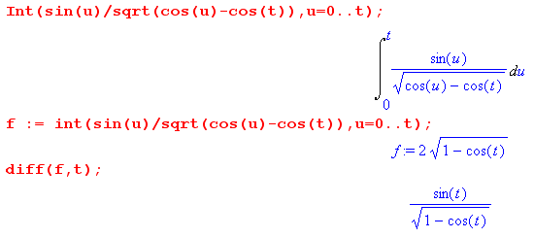
Therefore we get

U(t) = ($\sqrt{2}$/π) sin(t)/$\sqrt{1-cos(t)}$ = ($\sqrt{2}$/π) 2 sin(t/2)cos(t/2) / [ $\sqrt{2}$sin(t/2)]

= (2/π) cos(t/2) // just as they claim

Now comes the computation of an :

an = $^{\int_{0}^{θ0}{}}$dt cos[(n+1/2)t] U(t) 1.113

= (2/π) $^{\int_{0}^{θ0}{}}$dt cos[(n+1/2)t] cos(t/2)

And here is what Maple says

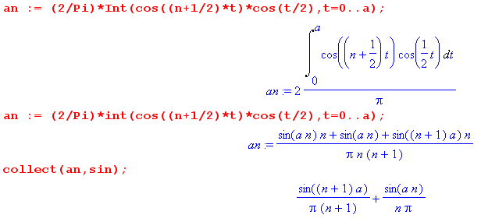

which happily is the right answer and we don't have to do 22 pages of algebra!

1.4.3 Noble's multiplying factor method.

If we start with

Pn(cosθ) = ($\sqrt{2}$/π)$^{\int_{0}^{θ}{}}$dφ cos[(n+1/2)φ]/$\sqrt{cosφ-cosθ}$ 1.108

and if we apply our usual Abel transform, we should get

cos[(n+1/2)θ] = (1/$\sqrt{2}$) ∂θ $^{\int_{0}^{θ}{}}$dφ sinφ Pn(cosφ) /$\sqrt{cosφ-cosθ}$ 1.115

I could do it, but won't since I am now not worried about such. Alternatively, if we start with

Pn(cosθ) = ( $\sqrt{2}$/π) $^{\int_{θ}^{π}{}}$dx sin[(n+1/2)x] / $\sqrt{cosθ-cosx}$ // see Canon 1_4_1 doc

then we should get this

sin[(n+1/2)θ] = – (1/$\sqrt{2}$) ∂θ $^{\int_{θ}^{π}{}}$dφ sinφ Pn(cosφ) /$\sqrt{cosφ-cosθ}$

But now write this as

– (n+1/2)-1 ∂θ cos[(n+1/2)θ] = – (1/$\sqrt{2}$) ∂θ $^{\int_{θ}^{π}{}}$dφ sinφ Pn(cosφ) /$\sqrt{cosφ-cosθ}$

If we integrate both sides from θ to π, both π terms are 0 and we get

cos[(n+1/2)θ] = (n+1/2) (1/$\sqrt{2}$) $^{\int_{θ}^{π}{}}$dφ sinφ Pn(cosφ) /$\sqrt{cosφ-cosθ}$ 1.116

So we can now write these two results as

cos[(n+1/2)θ] = (1/$\sqrt{2}$) ∂θ $^{\int_{0}^{θ}{}}$dφ sinφ Pn(cosφ) /$\sqrt{cosφ-cosθ}$ = K1 Pn 1.117
cos[(n+1/2)θ] = (n+1/2) (1/$\sqrt{2}$) $^{\int_{θ}^{π}{}}$dφ sinφ Pn(cosφ) /$\sqrt{cosφ-cosθ}$ = (n+1/2) K2 Pn 1.118

Now here are our original dual series equations.

Σn=0∞ anPn(z) = 1 θ in (0,θ0) 1.100
Σn=0∞ an(2n+1) Pn(z) = 0 θ in (θ0, π) 1.101

Apply K1 to the first and K2 to the second:

Σn=0∞ anK1 Pn(z) = K1 1
Σn=0∞ an (2n+1) K2 Pn(z) = 0

Σn=0∞ an cos[(n+1/2)θ] = K1 1
Σn=0∞ an (2n+1) (n+1/2)-1 cos[(n+1/2)θ] = 0

Σn=0∞ an cos[(n+1/2)θ] = K1 1 θ < θ0
Σn=0∞ an cos[(n+1/2)θ] = 0 θ > θ0

Meanwhile,

K1 1 = (1/$\sqrt{2}$) ∂θ $^{\int_{0}^{θ}{}}$dφ sinφ /$\sqrt{cosφ-cosθ}$ = (1/$\sqrt{2}$) ∂θ [ 2 $\sqrt{1-cosθ}$ ] // Maple

= 2 ∂θ [$\sqrt{1-cosθ}$ /$\sqrt{2}$] = 2 ∂θ sin(θ/2) = cos(θ/2)

So we end up with these very simple equations

Σn=0∞ an cos[(n+1/2)θ] = cos(θ/2) θ < θ0
Σn=0∞ an cos[(n+1/2)θ] = 0 θ > θ0 1.119

This series is like a "discontinuous integral" but its a "discontinuous series". We now have the "same left hand side" over the full range, so it can be inverted, just as in my general matrix discussion. I showed in Appendix B (other doc) that

$^{\int_{0}^{π}{}}$dθ cos([n+1/2]θ) cos([n'+1/2]θ) = δn,n' (π/2) 1.119a

So, apply $^{\int_{0}^{π}{}}$dθ cos([n'+1/2]θ)to both sides of 1.119 to get

Σn=0∞ an $^{\int_{0}^{π}{}}$dθ cos([n'+1/2]θ)cos[(n+1/2)θ] = $^{\int_{0}^{θ0}{}}$dθ cos([n'+1/2]θ) cos(θ/2)

an (π/2) = $^{\int_{0}^{θ0}{}}$dθ cos([n+1/2]θ) cos(θ/2)

an = (2/π) $^{\int_{0}^{θ0}{}}$dθ cos([n+1/2]θ) cos(θ/2)

Maple gives this integral as

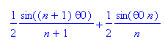

so we obtain the famous result

an = (1/π) { sin(nθ0)/n + sin[(n+1)θ0]/(n+1) }

1.4.4 The Abel integral transform method.

In this section, we note that the usual integral representations of P involve 1 / $\sqrt{cosφ-cosθ}$ and therefore tie into Abel Transforms. Using this tie in, authors obtain the result as section 1.4.3. That is, they just fiddle things a bit differently and show that
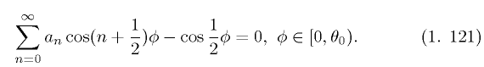
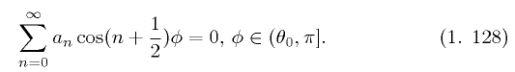

which is 1.119 above.

1.5 The Abel Transform Stuff

The transforms are stated in the linear, h(u), quadratic and coshξ forms (for some reason, the trig form is missing). Some existence theorems are stated, and the h(u) form is derived without reference to Srivastav.

1.6 Abel-type integral representations of the F function

In this section the authors make tie-ins to the Abel transform world from a wide class of functions. The Legendre P, the Bessel J0, the Jacobi P and hypergeometric F. They even have some E-K looking things, and they claim they will be using this math heavily in future chapters.

1.7. Dual equations and layers.

This section concerns Stakgold integral-equation-method looking potential theory with 1/R stuff as I use it. They derive completeness relations in various coordinate systems.

Chapter 2 : Series and Integral Equations

Basically this chapter is a rehash, probably with some modern improvements, of Sneddon's entire book. Here is the contents of this chapter

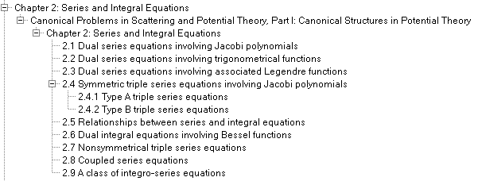

Perhaps a newbie could learn it all here and not need Sneddon, but I like Sneddon's book!

Remainder of the Book: Applications of the above theory.

