Doing the an integral PhL 3.2.11

1. Setting up. 1
2. Diff wrt the parameter b ? 2
3. Restatement of the problem 3
4. Try the case n=0 5
Another restatement of the problem: 7
5. Try the case n = 1 7
6. Examine the induction proof idea. 8
7. Try to do the arc trig integral by parts 9
8. Try an integral rep for P 10
9. Try a power series for the arc trig function 11
10. Try a power series for P_{n} 12
11. Try integrating the first term instead 14
12. Another approach to the arc trig integral term 14
13. Another way to do the R integral? 22

1. Setting up.

Our starting point is this

an = (1/2) $^{\int_{0}^{θ0}{}}$dθ sinθ Pn(cosθ) g(θ) 1.104

and I have the following known-good formula for g(θ)

g(θ) = (2/π) {$\sqrt{1+cosθ0}$/$\sqrt{cosθ - cosθ0}$ + π/2 – sin-1[$\sqrt{1+cosθ0}$/$\sqrt{1+cosθ}$] } (P6.6)

The very first order of business is to define (same b and d as before)

z = cosθ b = cosθ0 d = b+1

Then we have

an = (1/2) $^{\int_{b}^{1}{}}$dz Pn(z) g(z)

g(z) = (2/π) {$\sqrt{1+b}$/$\sqrt{z -b}$ + π/2 – sin-1[$\sqrt{1+b}$/$\sqrt{1+z}$] }

We can use Schaum p 18 5.74 to write this g as

g(z) = (2/π) {$\sqrt{1+b}$/$\sqrt{z -b}$ + cos-1[$\sqrt{1+b}$/$\sqrt{1+z}$] }

We then have

an(b) = (1/π) $^{\int_{b}^{1}{}}$dz Pn(z) {$\sqrt{1+b}$/$\sqrt{z -b}$ + cos-1[$\sqrt{1+b}$/$\sqrt{1+z}$] }

2. Diff wrt the parameter b ?

[ See notes at end of section. ] At least for the arc trig term, we MUST get rid of the arc trig function or we have a very messy problem on our hands. You have to thread the right path here. So let's just do both terms thinking there might somehow be some interaction, and also knowing that the first term along involves fat polynomials which do not appear in the known final answer for an. We consult with Maple:

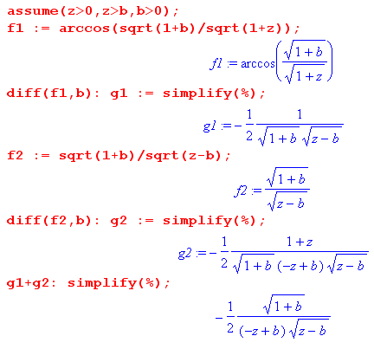
This is very good news, the result is relatively simple. Therefore we have shown that

∂ban(b) = (1/π) $^{\int_{b}^{1}{}}$dz Pn(z) { (1/2) $\sqrt{1+b}$ (z-b)-3/2 }

= (1/2π) $\sqrt{1+b}$ $^{\int_{b}^{1}{}}$dz Pn(z) (z-b)-3/2 (**)

This looks like an integral one might actually be able to do! Write things as

∂ban(b) = (1/2π) $\sqrt{1+b}$ In(b)

In(b) = $^{\int_{b}^{1}{}}$dz Pn(z) (z-b)-3/2

Maybe convert to a power by defining

x = z-b z = x+b dx = dz $^{\int_{0}^{1-b}{}}$

so we then find that

In(b) = $^{\int_{0}^{1-b}{}}$dx x-3/2 Pn(x+b)

but this does not match my one GR7 find on page 775, too bad.

(1) BUT, in computing ∂ban(b), I have omitted terms that arise from the fact that b is the lower endpoint of the integral. If we try to evaluate the integrand at the lower endpoint, it diverges.

(2) Correspondingly, notice that the integral in (**) above diverges at the z = b end!

(3) You might be able to do a regulation in this manner:

π ∂ban(b)/ $\sqrt{1+b}$ = (1/2) $^{\int_{b+ε}^{1}{}}$dz Pn(z) (z-b)-3/2 - Pn(b) /$\sqrt{z -b-ε}$

3. Restatement of the problem

Let's return to the trig parameterization of things. We have

an = (1/2) $^{\int_{0}^{θ0}{}}$dθ sinθ Pn(cosθ) g(θ) 1.104

g(θ) = (2/π) {$\sqrt{1+cosθ0}$/$\sqrt{cosθ-cosθ0}$ + cos-1[$\sqrt{1+cosθ0}$/$\sqrt{1+cosθ}$] } (P6.6)

an = (1/π) $^{\int_{0}^{θ0}{}}$dθ sinθ Pn(cosθ) {$\sqrt{1+cosθ0}$/$\sqrt{cosθ-cosθ0}$ + cos-1[$\sqrt{1+cosθ0}$/$\sqrt{1+cosθ}$] }

Knowing the answer might provide some direction. The answer is this:

an(b) = (1/π) { sin[nθ0]/n + sin[(n+1)θ0]/(n+1) }

We then conclude that

$^{\int_{0}^{θ0}{}}$dθ sinθ Pn(cosθ) {$\sqrt{1+cosθ0}$/$\sqrt{cosθ-cosθ0}$ + cos-1[$\sqrt{1+cosθ0}$/$\sqrt{1+cosθ}$] }

= sin[nθ0]/n + sin[(n+1)θ0]/(n+1)

Suppose we define

Fn(θ0) = sin[nθ0]/n

Then our solution is this: In(θ0) = πan

In(θ0) ≡ $^{\int_{0}^{θ0}{}}$dθ sinθ Pn(cosθ) {$\sqrt{1+cosθ0}$/$\sqrt{cosθ-cosθ0}$ + cos-1[$\sqrt{1+cosθ0}$/$\sqrt{1+cosθ}$] }

= Fn+1(θ0) + Fn(θ0) Fn(θ0) = sin[nθ0]/n n = 0, 1,2,3...

where for n=0 it is understood we take the obvious limit so

F0(θ0) = θ0

Our task is to show this is true. As in our first setup, the big question is how are we going to deal with that arc trig function? The Canonical authors give ref 76 for the "definition method" which is a Williams paper which I was able to quickly find, but it does not treat this problem. It has the Sneddon matrix stuff so I saved the paper.

Random ideas:

• elevate Pn as on Sneddon page 57 where you can make sin[(n+1/2)x] functions appear.

• same page, it is noted that sin[(n+1/2)x]/sinx is a Jacobi polynomial with α,β = 1/2,1/2

• do an induction proof.

• expand something in a power series

The first idea here uses this:

Pn(cosθ) = ( $\sqrt{2}$/π) $^{\int_{θ}^{π}{}}$dx sin[(n+1/2)x] / $\sqrt{cosθ-cosx}$

But recall that Canonical actually shows this result (which I found in GR7)

Pn(cosθ) = ($\sqrt{2}$/π)$^{\int_{0}^{θ}{}}$dφ cos[(n+1/2)φ]/$\sqrt{cosφ-cosθ}$ 1.108

I point these out only because they get is involved with trig(nx) type functions which we see appearing in the answer. By the way, the answer Canon gives matches Sneddon page 271 so I don't think they have typos in their an , so our target is clean.

Let's replace θ0 by a to make things simpler: a = θ0

Restatement of the Problem: Show that the following is true:

In(a) ≡ $^{\int_{0}^{a}{}}$dθ sinθ Pn(cosθ) {$\sqrt{1+cosa}$/$\sqrt{cosθ-cosa}$ + cos-1[$\sqrt{1+cosa}$/$\sqrt{1+cosθ}$] }

= Fn+1(a) + Fn(a) Fn(a) = sin[na]/n F0(a) = a n = 0, 1,2,3... an = In / π

where for n=0 it is understood we take the obvious limit so

4. Try the case n=0

I0(a) ≡ $^{\int_{0}^{a}{}}$dθ sinθ{$\sqrt{1+cosa}$/$\sqrt{cosθ-cosa}$ + cos-1[$\sqrt{1+cosa}$/$\sqrt{1+cosθ}$] }

= F1(a) + F0(a) F1(a) = sin[a] F0(a) = a

Even here, we have to deal with that arc trig function of a complicated algebraic argument. We can get rid of the radicals at least by doing to half angles, so maybe we should try that

$\sqrt{1+cosa}$ = $\sqrt{2}$cos(a/2) $\sqrt{cosθ-cosa}$ = $\sqrt{2}$$\sqrt{cos2(θ/2) - cos2(a/2)}$

$\sqrt{1+cosa}$/$\sqrt{1+cosθ}$ = cos(a/2)/cos(θ/2)

Then we have

In(a) ≡ $^{\int_{0}^{a}{}}$dθ sinθ Pn(cosθ) {$\sqrt{1+cosa}$/$\sqrt{cosθ-cosa}$ + cos-1[$\sqrt{1+cosa}$/$\sqrt{1+cosθ}$] }

= $^{\int_{0}^{a}{}}$dθ sinθ Pn(cosθ) {$\sqrt{2}$cos(a/2)/[ $\sqrt{2}$$\sqrt{cos2(θ/2) - cos2(a/2)}$]+ cos-1[cos(a/2)/cos(θ/2)] }

= $^{\int_{0}^{a}{}}$dθ sinθ Pn(cosθ) {cos(a/2)/[ $\sqrt{cos2(θ/2) - cos2(a/2)}$]+ cos-1[cos(a/2)/cos(θ/2)] }

Maybe at this point define [ recall a = θ0 ]

cos(a/2) = α cos(θ/2) = x cosθ = 2 cos2(θ/2) - 1 = 2x2-1 d(cosθ) = 4xdx

In(a) = $^{\int_{0}^{a}{}}$dθ sinθ Pn(cosθ) { α/ + cos-1[α/x] }

= $^{\int_{0}^{a}{}}$dθ sinθ Pn(cosθ) { α/ + sec-1[x/α] }

I am trying to simplify that arc trig element as much as possible. Our integral is really

$^{\int_{0}^{a}{}}$dθ sinθ = – $^{\int_{1}^{cosa}{}}$d(cosθ) = $^{\int_{cosa}^{1}{}}$d(cosθ) = $^{\int_{α}^{1}{}}$[4xdx]

But θ = a => x = α and θ = 0 => x = 1 so get what is on the right above. So we then have

In(a)/4 = $^{\int_{α}^{1}{}}$dx x Pn(2x2-1) { α/ + sec-1 [x/α] }

Finally we could define y = x/α with x = yα and we then get

In(a)/4 = $^{\int_{1}^{1/α}{}}$[αdy] (αy)Pn(2α2y2-1) { α/ + sec-1[y] }

In(a)/(4α2) = $^{\int_{1}^{1/α}{}}$dy y Pn(2α2y2-1) { 1/$\sqrt{y2 - 1}$ + sec-1y }

In(a)/(4α2) = $^{\int_{1}^{1/α}{}}$dy y Pn(2α2y2-1) { 1/$\sqrt{y2 - 1}$ + sec-1y }

and now we have done the best job possible (I think) on simplifying the trig function.

NOW let's try the case n = 0 and see if we can at least do the integrals.

I0(a)/(4α2) = $^{\int_{1}^{1/α}{}}$dy y { 1/$\sqrt{y2 - 1}$ + sec-1y }

Note that 1/α = 1/ cos(a/2) = sec(a/2). So rewrite as

I0(a) = 4α2 $^{\int_{1}^{1/α}{}}$dy y { 1/$\sqrt{y2 - 1}$ + sec-1y } α = cos(a/2)

= 4cos2(a/2) $^{\int_{1}^{sec(a/2)}{}}$dy y { 1/$\sqrt{y2 - 1}$ + sec-1y } a = θ0

Maple gives a bit of a mess, so try the two integrals separately. The first integral is this

$^{\int_{1}^{sec(a/2)}{}}$dy y { 1/$\sqrt{y2 - 1}$ } = tan(a/2)

The second integral is this

$^{\int_{1}^{sec(a/2)}{}}$dy y sec-1y = -(1/2)tan(a/2) + (a/4) sec2(a/2)

and Maple continues to tell us that

$^{\int_{1}^{sec(a/2)}{}}$dy { 1/$\sqrt{y2 - 1}$ + sec-1y } = (1/2)tan(a/2) + (a/4) sec2(a/2)

and we then have that

I0(a) = 4 cos2(a/2) [(1/2)tan(a/2) + (a/4) sec2(a/2) ]

= cos2(a/2) [2tan(a/2) + a sec2(a/2) ]

= [2tan(a/2) cos2(a/2)+ a sec2(a/2) cos2(a/2) ]

= [2sin(a/2) cos(a/2)+ a]

= [sina + a] => an = In/π = [sina + a]/π

which is the correct answer! So finally after 2 days of work I have verified the case n = 0, good boy!

Another restatement of the problem:

We showed above that cos(a/2) = α

an = (4/π)α2$^{\int_{1}^{1/α}{}}$dy y Pn(2α2y2-1) { 1/$\sqrt{y2 - 1}$ + sec-1y } α = cos(a/2) = cos(θ0/2)

where we have maximized the simplicity of the arc trig function. We used this formula to verify the case n = 0

a0 = (4/π)α2$^{\int_{1}^{1/α}{}}$dy y { 1/$\sqrt{y2 - 1}$ + sec-1y } = [sina + a]/π

So probably this is a good "form" with which to try the higher n cases. There is nothing in GR7 which mates P functions with arc trig functions, so our main issue has not gone away.

5. Try the case n = 1

This would at least confirm that we have the argument of Pn right. So

a1 = (4/π)α2$^{\int_{1}^{1/α}{}}$dy y (2α2y2-1) { 1/$\sqrt{y2 - 1}$ + sec-1y } α = cos(a/2) = cos(θ0/2)

= (8α4/π) $^{\int_{1}^{1/α}{}}$dy y3 { 1/$\sqrt{y2 - 1}$ + sec-1y } – (4/π)α2 $^{\int_{1}^{1/α}{}}$dy y { 1/$\sqrt{y2 - 1}$ + sec-1y }

= (8α4/π) $^{\int_{1}^{1/α}{}}$dy y3 { 1/$\sqrt{y2 - 1}$ + sec-1y } – [sina + a]/π

where we recognize the second integral as the n=0 case. I run this through my Maple processing routine and it seems that

$^{\int_{1}^{1/α}{}}$dy y3 { 1/$\sqrt{y2 - 1}$ + sec-1y } = (1/8) sec4(a/2) [ sina + 2 cos2(a/2) sina + a ]

which then says

a1 = (8cos4(α/2)/π) * (1/8) sec4(a/2) [ sina + 2 cos2(a/2) sina + a ] – [sina + a]/π

= (1/π) [ sina + 2 cos2(a/2) sina + a ] – [sina + a]/π

= (1/π) { sina + 2 cos2(a/2) sina + a - sina - a }

= (1/π) {2 cos2(a/2) sina } =

= (1/π) { [1+cosa] sina } = (1/π) {sina + sinacosa } =(1/π) {sina + (1/2)sin(2a) }

which we can compare with the known result

an = (1/π) { sin(na)/n + sin[(n+1)a]/(n+1) }

a1 = (1/π) { sina + sin(2a)/2 }

so now we have verified the case n = 1.

6. Examine the induction proof idea.

We assume the following is true for n :

(4/π)α2$^{\int_{1}^{1/α}{}}$dy y Pn(2α2y2-1) { 1/$\sqrt{y2 - 1}$ + sec-1y } = (1/π) { sin(na)/n + sin[(n+1)a]/(n+1) }

which we will simplify to say α = cos(a/2) a = θ0

4α2$^{\int_{1}^{1/α}{}}$dy y Pk(2α2y2-1) { 1/$\sqrt{y2 - 1}$ + sec-1y } = sin(ka)/k + sin[(k+1)a]/(k+1) (6.1)

where I switch now to the traditional induction proof index k. Given the above, we want to show that

4α2$^{\int_{1}^{1/α}{}}$dy y Pk+1(2α2y2-1) { 1/$\sqrt{y2 - 1}$ + sec-1y } = sin(k+1a)/(k+1) + sin[(k+2)a]/(k+2) (6.2)

If we subtract these two equations we find

4α2$^{\int_{1}^{1/α}{}}$dy y[Pk+1(2α2y2-1)- Pk(2α2y2-1) ] {1/$\sqrt{y2 - 1}$ sec-1y } = sin[(k+2)a]/(k+2) - sin(ka)/k (6.3)

so if we could somehow proof (6.3), we are done. Unfortunately, none of the basic Schaum p 147 recursion relations involve this simple difference, so that path is maybe not so good. But we do know this fact

(k+1)Pk+1(x) = (2k+1) x Pk(x) - k Pk-1(x) Schaum p 147

In our induction hypothesis, we know that 6.1 is valid for k and k-1, namely, we know

4α2$^{\int_{1}^{1/α}{}}$dy y Pk(2α2y2-1) { 1/$\sqrt{y2 - 1}$ + sec-1y } = sin(ka)/k + sin[(k+1)a]/(k+1) (6.1)
4α2$^{\int_{1}^{1/α}{}}$dy y Pk-1(2α2y2-1) { 1/$\sqrt{y2 - 1}$ + sec-1y } = sin[(k-1)a]/(k-1) + sin(ka)/k (6.4)

Let's abbreviate our notation and write these as

4α2$^{\int_{1}^{1/α}{}}$dy y Pk(2α2y2-1) {..} = sin(ka)/k + sin[(k+1)a]/(k+1) (6.1)
4α2$^{\int_{1}^{1/α}{}}$dy y Pk-1(2α2y2-1) {..} = sin[(k-1)a]/(k-1) + sin(ka)/k (6.4)

Using these, we could "construct" something having Pk+1 on the left. We adjust each of the above 2 lines:

4α2$^{\int_{1}^{1/α}{}}$dy y (2k+1) (2α2y2-1)Pk(2α2y2-1) / (2α2y2-1) {..}
= (2k+1)sin(ka)/k + (2k+1)sin[(k+1)a]/(k+1)

4α2$^{\int_{1}^{1/α}{}}$dy y (-1)kPk-1(2α2y2-1) {..} = – ksin[(k-1)a]/(k-1) – k sin(ka)/k

But this construction does not work because of / (2α2y2-1) required in the first integrand. That is, we cannot just add the integrals in a trivial way. All the recursion relations have a factor of x somewhere. So I am at a loss on how to continue this induction proof.

7. Try to do the arc trig integral by parts

Consider this, our arc trig integral of interest, α = cos(a/2)

J = $^{\int_{1}^{1/α}{}}$dy y Pn(2α2y2-1) sec-1y

We would like to write

y Pn(2α2y2-1) = df(y)/dy => f(y) = $^{\int_{}^{y}{}}$dy y Pn(2α2y2-1)

our motivation being that if we could find f(y), we could do parts of the ∂y onto sec-1y and perhaps get something we can look up. Maple has this to say about f(y)

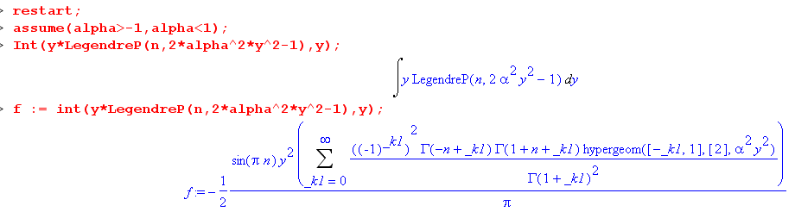

If n = integer, Maple punts. But I think in this case we really have a finite series for each integer n. But it is a series in F's, so not very nice. So this parts approach is not going to fly.

8. Try an integral rep for P

Our problem child integral is this

J = $^{\int_{1}^{1/α}{}}$dy y Pn(2α2y2-1) sec-1y

We could try

Pn(cosθ) = ( $\sqrt{2}$/π) $^{\int_{θ}^{π}{}}$dx sin[(n+1/2)x] / $\sqrt{cosθ-cosx}$

Pn(2α2y2-1) = ( $\sqrt{2}$/π) $^{\int_{2cos-1(αy)}^{π}{}}$dx sin[(n+1/2)x] / $\sqrt{2α2y2-1-cosx}$

We used these facts

cosθ = 2α2y2-1 2α2y2 = cosθ+1 = 2cos2(θ/2) αy = cos(θ/2) θ/2 = cos-1(αy)

Stick this in to get

J = $^{\int_{1}^{1/α}{}}$dy y Pn(2α2y2-1) sec-1y

= $^{\int_{1}^{1/α}{}}$dy y { ( $\sqrt{2}$/π) $^{\int_{2cos-1(αy)}^{π}{}}$dx sin[(n+1/2)x] / $\sqrt{2α2y2-1-cosx}$} sec-1y

and then we are faced with this kind of integral

∫ dy y sec-1y / $\sqrt{y2-c}$

More errata noted: GR7 9.913 has a minor obvious problem.

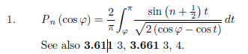

Here are some other integral reps: first from page 390

and these from page 405

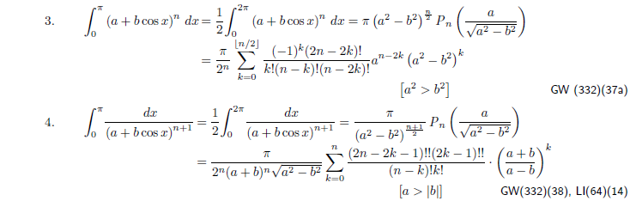

9. Try a power series for the arc trig function

Start with

In(a) ≡ $^{\int_{0}^{a}{}}$dθ sinθ Pn(cosθ) {$\sqrt{1+cosa}$/$\sqrt{cosθ-cosa}$ + cos-1[$\sqrt{1+cosa}$/$\sqrt{1+cosθ}$] }

Letting z = cosθ, we can write this as

In(a) ≡ $^{\int_{cosa}^{1}{}}$dz Pn(z) {$\sqrt{1+cosa}$/$\sqrt{z-cosa}$ + cos-1[$\sqrt{1+cosa}$/$\sqrt{1+z}$] }

Here is some data from page 60 GR7

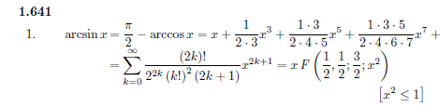

So let's just concentrate on

K ≡ $^{\int_{cosa}^{1}{}}$dz Pn(z) sin-1[$\sqrt{1+cosa}$/$\sqrt{1+z}$]

We can then replace

sin-1[$\sqrt{1+cosa}$/$\sqrt{1+z}$] = $\sqrt{1+cosa}$/$\sqrt{1+z}$ F(1/2,1/2; 3/2; (1+cosa)/(1+z) )

which is then an explicit power series in powers of 1/(1+z). We would then be faced with

$^{\int_{cosa}^{1}{}}$ dz Pn(z) (z+1)-1/2 (z+1)-n = $^{\int_{cosa}^{1}{}}$ dz Pn(z) (z+1)-n-1/2 n = 0,1,2,3...

Is this a doable integral? No!

Wow, I think this is the toughest integral I have ever attempted in my entire life. I see no pathway that works, and as you can see, I have tried a lot of pathways in the above sections.

10. Try a power series for Pn

After all, this is what I did for the only two cases I have been able to compute, n = 0 and n =1. Go back to

J = $^{\int_{1}^{1/α}{}}$dy y Pn(2α2y2-1) sec-1y

Let ξ = 2α2y2 so we have Pn(ξ-1). Suppose we use this series

Pn(z) ~ F(....; (1+z)/2) => Pn(ξ-1) ~ F(....; (1+[ ξ-1])/2) = F(....; ξ/2) = F(...; α2y2)

which looks mildly promising. But no, this one has those Γ(μ) poles. I think we have to just take B(14)

Pn(z) = F(-n,n+1;1; (1-z)/2) with z = 2α2y2-1, -z = 1-2α2y2, 1-z = 2-2α2y2, (1-z)/2 = 1-α2y2.

Pn(2α2y2-1) = F(-n,n+1;1; 1-α2y2) =

1 + (-n)(n+1) (1-α2y2) + (-n) (-n+1) (n+1)(n+2) (1-α2y2)2/2! + etc,

If n = 0, et 1. If n = 1 get 1+(-1)(2)( 1-α2y2) = 1-2+2 α2y2 = 2α2y2- 1 which is correct. So we then have this power series formulation

J = $^{\int_{1}^{1/α}{}}$dy y F(-n,n+1;1; 1-α2y2) sec-1y

The general required integral is going to be

$^{\int_{1}^{1/α}{}}$dy yn sec-1(y) where n is odd.

Maple can do any power you want but not the result for n = integer. Let's try manual mode:

K ≡ $^{\int_{1}^{1/α}{}}$dy yn sec-1(y) = $^{\int_{1}^{1/α}{}}$dy (1/(n+1))[∂yyn+1 ]sec-1(y)

(n+1)K = $^{\int_{1}^{1/α}{}}$dy [∂yyn+1 ]sec-1(y)

= [yn+1 sec-1(y)]|1/α1 – $^{\int_{1}^{1/α}{}}$dy yn+1[∂y sec-1(y)]

= (1/α)n+1 sec-1(1/α) - sec-1(1) – $^{\int_{1}^{1/α}{}}$dy yn+1 1/[y$\sqrt{y2-1}$]

= (1/α)n+1 sec-1(1/α) – $^{\int_{1}^{1/α}{}}$dy yn/$\sqrt{y2-1}$

Maple can do this integral for any power, but there is no super simple pattern. For example

∫dy y11/$\sqrt{y2-1}$ = $\sqrt{y2-1}$ * series where the series is this

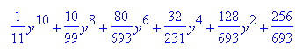

So again I can compute the result for any small n I want, but I cannot obtain the trivially simple general result! This is extremely frustrating to one who has been doing integrals daily for several years.

11. Try integrating the first term instead

We start this time with In = πan

In(a) ≡ $^{\int_{cosa}^{1}{}}$dz Pn(z) {$\sqrt{1+cosa}$/$\sqrt{z-cosa}$ + cos-1[$\sqrt{1+cosa}$/$\sqrt{1+z}$] }

and consider just the first term which has this integral

$^{\int_{cosa}^{1}{}}$dz Pn(z) / $\sqrt{z-cosa}$

Now this is where I started several days ago, quoting a GR result from page 790 which has its errata which I understand and which says

so I take x = cosa, and get

$^{\int_{cosa}^{1}{}}$dz Pn(z) / $\sqrt{z-cosa}$ = (n+1/2)-1 (1-cosa)-1/2 [ Tn(cosa) – Tn+1(cosa)]

Installing this in the above, I get

In(a)first_term = $\sqrt{1+cosa}$/$\sqrt{1-cosa}$[ Tn(cosa) – Tn+1(cosa)] / (n+1/2)

= cot(a/2){ Tn(cosa) – Tn+1(cosa)} / (n+1/2)

This brings to mind several comments:

(1) how did they obtain this integral, that is, what exactly is the Tn connection here?

(2) the arc trig integral must magically cancel these Tn functions.

So it just seems that we "have some kind of Tn connection" here.

12. Another approach to the arc trig integral term

Well, here is certainly an important fact from GR7 p 993

Tn(x) = cos(n cos-1x) = F(n,-n; 1/2; (1-x)/2)

Then we have

Tn(cosa) = cos(na)

so what I really have above is this:

In(a)first_term = 2 cot(a/2) {cos(na) – cos[(n+1)a]} / (2n+1)

So I should be able to deduce what the arc trig integral should be:

In(a) = πan = { sin[na]/n + sin[(n+1)a]/(n+1) }

In(a) ≡ $^{\int_{cosa}^{1}{}}$dz Pn(z) {$\sqrt{1+cosa}$/$\sqrt{z-cosa}$ + cos-1[$\sqrt{1+cosa}$/$\sqrt{1+z}$] }

= In(a)first_term + $^{\int_{cosa}^{1}{}}$dz Pn(z) cos-1[$\sqrt{1+cosa}$/$\sqrt{1+z}$]

Therefore it must be true that

S = $^{\int_{cosa}^{1}{}}$dz Pn(z) cos-1[$\sqrt{1+cosa}$/$\sqrt{1+z}$] = { sin(na)/n + sin[(n+1)a]/(n+1) }

– 2 cot(a/2) {cos(na) – cos[(n+1)a]} / (2n+1)

So for the first time I know the answer to this integral. I also know that

Pn(cosθ) = ($\sqrt{2}$/π) $^{\int_{θ}^{π}{}}$dφ sin[(n+1/2)φ]/$\sqrt{cosθ-cosφ}$
Pn(cosθ) = ($\sqrt{2}$/π)$^{\int_{0}^{θ}{}}$dφ cos[(n+1/2)φ]/$\sqrt{cosφ-cosθ}$

Somehow these things must be the ingredients. Can rewrite these as

Pn(z) = ($\sqrt{2}$/π) $^{\int_{cos-1z}^{π}{}}$dφ sin[(n+1/2)φ]/$\sqrt{z-cosφ}$
Pn(z) = ($\sqrt{2}$/π)$^{\int_{0}^{cos-1z}{}}$dφ cos[(n+1/2)φ]/$\sqrt{cosφ-z}$

Let's take the second one and install it

S = $^{\int_{cosa}^{1}{}}$dz Pn(z) cos-1[$\sqrt{1+cosa}$/$\sqrt{1+z}$]

= ($\sqrt{2}$/π) $^{\int_{cosa}^{1}{}}$dz {$^{\int_{0}^{cos-1z}{}}$dφ cos[(n+1/2)φ]/$\sqrt{cosφ-z}$} cos-1[$\sqrt{1+cosa}$/$\sqrt{1+z}$]

I think it would be better to put everything into angle variables

S = $^{\int_{0}^{a}{}}$dθ sinθ Pn(cosθ) cos-1[$\sqrt{1+cosa}$/$\sqrt{1+cosθ}$]

Pn(cosθ) = ($\sqrt{2}$/π)$^{\int_{0}^{θ}{}}$dφ cos[(n+1/2)φ]/$\sqrt{cosφ-cosθ}$

so we then get

S = ($\sqrt{2}$/π) $^{\int_{0}^{a}{}}$dθ sinθ{$^{\int_{0}^{θ}{}}$dφ cos[(n+1/2)φ]/$\sqrt{cosφ-cosθ}$} cos-1[$\sqrt{1+cosa}$/$\sqrt{1+cosθ}$]

= ($\sqrt{2}$/π) $^{\int_{0}^{a}{}}$dθ$^{\int_{0}^{θ}{}}$dφ sinθ cos[(n+1/2)φ]/$\sqrt{cosφ-cosθ}$* cos-1[$\sqrt{1+cosa}$/$\sqrt{1+cosθ}$]

The phase space is this, where upper corner is (a,a)
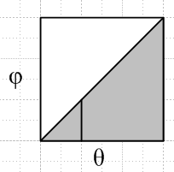
So we can say

$^{\int_{0}^{a}{}}$dθ$^{\int_{0}^{θ}{}}$dφ = $^{\int_{0}^{a}{}}$dφ$^{\int_{φ}^{a}{}}$dθ

so then

S = ($\sqrt{2}$/π) $^{\int_{0}^{a}{}}$dφ$^{\int_{φ}^{a}{}}$dθ sinθ cos[(n+1/2)φ]/$\sqrt{cosφ-cosθ}$* cos-1[$\sqrt{1+cosa}$/$\sqrt{1+cosθ}$]

= ($\sqrt{2}$/π) $^{\int_{0}^{a}{}}$dφ cos[(n+1/2)φ] { $^{\int_{φ}^{a}{}}$dθ sinθ/$\sqrt{cosφ-cosθ}$* cos-1[$\sqrt{1+cosa}$/$\sqrt{1+cosθ}$] }

so the great hope is that we can somehow do this internal integral

R ≡ $^{\int_{φ}^{a}{}}$dθ sinθ/$\sqrt{cosφ-cosθ}$ * cos-1[$\sqrt{1+cosa}$/$\sqrt{1+cosθ}$]

=$^{\int_{cosa}^{cosφ}{}}$ dz / $\sqrt{cosφ-z}$* cos-1[$\sqrt{1+cosa}$/$\sqrt{1+z}$] at this point a = θ0

Now define

b = cosφ a = cosθ0 forget the previous assignment on a

R = $^{\int_{a}^{b}{}}$dz (b-z)-1/2 cos-1[$\sqrt{1+a}$/$\sqrt{1+z}$]

Maple cannot do it. But parts does come to mind. Write

(b-z)-1/2 = - 2 ∂z(b-z)1/2

Then

R = -2 $^{\int_{a}^{b}{}}$dz [∂z(b-z)1/2] cos-1[$\sqrt{1+a}$/$\sqrt{1+z}$]

-R/2 =$^{\int_{a}^{b}{}}$dz [∂z(b-z)1/2] cos-1[$\sqrt{1+a}$/$\sqrt{1+z}$]

= [(b-z)1/2 cos-1[$\sqrt{1+a}$/$\sqrt{1+z}$] |ba – $^{\int_{a}^{b}{}}$dz (b-z)1/2 ∂z cos-1[$\sqrt{1+a}$/$\sqrt{1+z}$]

= – $^{\int_{a}^{b}{}}$dz (b-z)1/2 ∂z cos-1[$\sqrt{1+a}$/$\sqrt{1+z}$]

= – $^{\int_{a}^{b}{}}$dz (b-z)1/2 ∂z sec-1[$\sqrt{1+z}$/$\sqrt{1+a}$]

So far then we have

R = 2 $^{\int_{a}^{b}{}}$dz (b-z)1/2 ∂z sec-1[$\sqrt{1+z}$/$\sqrt{1+a}$]

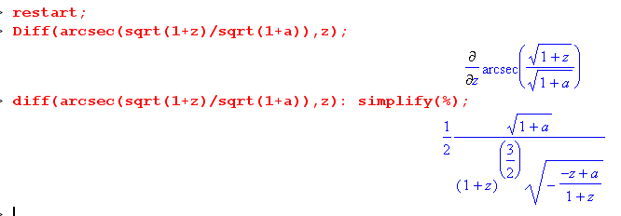

so we conclude that

∂z sec-1[$\sqrt{1+z}$/$\sqrt{1+a}$] = (1/2) $\sqrt{1+a}$$\sqrt{1+z}$ / [(1+z) $\sqrt{1+z}$$\sqrt{z-a}$]

= (1/2) $\sqrt{1+a}$ / [(1+z) $\sqrt{z-a}$]

and then we have

R = 2 $^{\int_{a}^{b}{}}$dz (b-z)1/2 {(1/2) $\sqrt{1+a}$ / [(1+z) $\sqrt{z-a}$] }

= $\sqrt{1+a}$$^{\int_{a}^{b}{}}$dz (b-z)1/2 / [(1+z) $\sqrt{z-a}$]

Maple can't do it. Let's start transforming. Let y = z-a to get

z = y+a b-z = b-a-y 1+z = 1+y+a z-a = y

R = $\sqrt{1+a}$$^{\int_{0}^{b-a}{}}$dy ([b-a]-y)1/2 (y + 1+a)-1 y-1/2

Now change to s = y-1 so

ds = -y-2dy = -s2dy => dy = -s-2ds

([b-a]-y)1/2 = ([b-a]-s-1)1/2 = s-1/2 (s[b-a]- 1)1/2 = s-1/2 (b-a)1/2 ( s - [b-a]-1)1/2

(y + 1+a)-1 = (s-1 + [1+a])-1 = s (1 + s [1+a])-1 = s (1+a)-1 (s + [1+a]-1)-1

y-1/2 = s1/2

$^{\int_{0}^{b-a}{}}$ → $^{\int_{∞}^{1/(b-a)}{}}$

so we then have

dy ([b-a]-y)1/2 (y + 1+a)-1 y-1/2

= -s-2ds s-1/2 (b-a)1/2 ( s - [b-a]-1)1/2 s (1+a)-1 (s + [1+a]-1)-1 s1/2

= -(b-a)1/2 (1+a)-1 ds s-2 s-1/2 s s1/2 ( s - [b-a]-1)1/2(s + [1+a]-1)-1

= -(b-a)1/2 (1+a)-1 ds s-1 ( s - [b-a]-1)1/2(s + [1+a]-1)-1

Then after this endless crapola processing we get

R = $\sqrt{1+a}$ (b-a)1/2 (1+a)-1 $^{\int_{1/(b-a)}^{∞}{}}$ ds s-1 ( s - [b-a]-1)1/2(s + [1+a]-1)-1

= (b-a)1/2 (1+a)-1/2 $^{\int_{1/(b-a)}^{∞}{}}$ ds s-1 ( s - [b-a]-1)1/2(s + [1+a]-1)-1

and we can now call upon our corrected Bateman formula which is this

$^{\int_{u}^{∞}{}}$ds s-λ (s-u)μ-1 (s+β)ν = u-λ (β+u)μ+ν B(λ-μ-ν,μ) F(λ,μ; λ-ν; -β/u)

and we then set

λ = 1 μ-1 = 1/2 => μ = 3/2 u = 1/(b-a) ν = -1 β = 1/(1+a)

The RHS of our corrected formula then reads μ+ν = 3/2-1 = 1/2

u-λ (β+u)μ+ν B(λ-μ-ν,μ) F(λ,μ; λ-ν; -β/u) β + u = 1/(1+a) + 1/(b-a) = (b+1)/[(a+1)(b-a)]

= u-1 (β+u)3/2-1 B(1-3/2+1,3/2) F(1,3/2; 1+1; -β/u) b = cosφ a = cosθ0

= u-1 (β+u)1/2 B(1/2,3/2) F(1,3/2; 2; -β/u) β/u = (b-a)/(1+a)

= (b-a)[ (b+1)1/2 (a+1)-1/2 (b-a)-1/2 ] B(1/2,3/2) F(1,3/2; 2 -β/u)

= (b-a)1/2 (b+1)1/2 (a+1)-1/2 (π/2) F(1,3/2; 2; -(b-a)/(1+a))

And then we have shown that

R = (b-a)1/2 (1+a)-1/2 $^{\int_{1/(b-a)}^{∞}{}}$ ds s-1 ( s - [b-a]-1)1/2(s + [1+a]-1)-1

= (b-a)1/2 (1+a)-1/2 * (b-a)1/2 (b+1)1/2 (a+1)-1/2 (π/2) F(1,3/2; 2; -(b-a)/(1+a))

= (π/2) (b-a) (b+1)1/2 (a+1)-1 F(1,3/2; 2; -(b-a)/(1+a))

Amazingly, this F function is just an elementary function and Maple claims that the F is this:

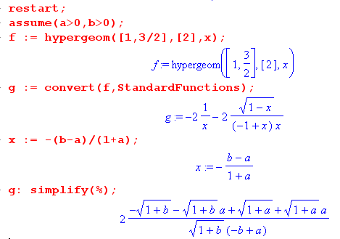

which is to say

F(1,3/2; 2; -(b-a)/(1+a)) = 2 [ $\sqrt{a+1}$(a+1) - $\sqrt{b+1}$(a+1) ] / [$\sqrt{b+1}$(a-b)]

= 2(a+1) [ $\sqrt{a+1}$ - $\sqrt{b+1}$] / [$\sqrt{b+1}$(a-b)]

= 2(a+1) [$\sqrt{b+1}$ - $\sqrt{a+1}$ ] / [$\sqrt{b+1}$(b-a) ]

Install this and we then have

R = (π/2) (b-a) (b+1)1/2 (a+1)-1 * 2(a+1) [$\sqrt{b+1}$ - $\sqrt{a+1}$ ] / [$\sqrt{b+1}$(b-a) ]

= π [$\sqrt{b+1}$ - $\sqrt{a+1}$ ] b = cosφ a = cosθ0

= π [$\sqrt{cosφ+1}$ - $\sqrt{cosθ0+1}$ ]

Now we restore our earlier definition of a = θ0 and this becomes

R = π [$\sqrt{cosφ+1}$ - $\sqrt{cosa+1}$ ]

and recall that this was the "internal integral" in a mess we had way back above,

S = $^{\int_{0}^{a}{}}$dθ sinθ Pn(cosθ) cos-1[$\sqrt{1+cosa}$/$\sqrt{1+cosθ}$]

= ($\sqrt{2}$/π) $^{\int_{0}^{a}{}}$dφ cos[(n+1/2)φ] { R }

= $\sqrt{2}$ $^{\int_{0}^{a}{}}$dφ cos[(n+1/2)φ] [$\sqrt{cosφ+1}$ - $\sqrt{cosa+1}$ ]

Now replace

$\sqrt{cosφ+1}$ = $\sqrt{2}$cos(φ/2) => R = $\sqrt{2}$ π [cos(φ/2) - cos(a/2) ]

to get

S = 2 $^{\int_{0}^{a}{}}$dφ cos[(n+1/2)φ] [cos(φ/2) - cos(a/2) ]

I throw this into Maple and find

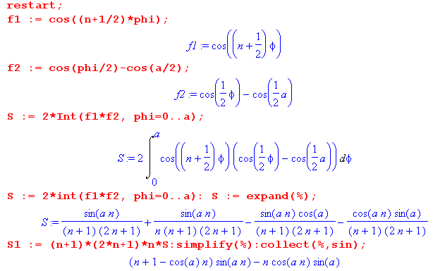

Now, here is the answer we were hoping to get: (taken from above)

SS = sin(na)/n + sin[(n+1)a]/(n+1) – 2 cot(a/2) {cos(na) – cos[(n+1)a]} / (2n+1)

Now since Maple is not too sharp on half angles, we can replace

cot(a/2) = (1+cosa)/sina

If we expand our "desired result" which I call SS, we get

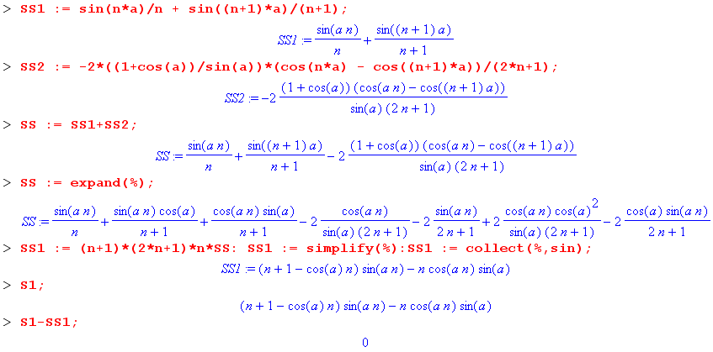

So, since we have now shown that S1 = SS1, we know that S = SS and finally, after 22 pages of effort, we have done our integral! Unbelievable.

13. Another way to do the R integral?

Doing a lot of work, I showed above that

R = $^{\int_{a}^{b}{}}$dz (b-z)-1/2 cos-1[$\sqrt{1+a}$/$\sqrt{1+z}$]
= $\sqrt{1+a}$$^{\int_{a}^{b}{}}$dz (b-z)1/2 / [(1+z) $\sqrt{z-a}$]
= π ( $\sqrt{b+1}$ - $\sqrt{a+1}$ )

I see now that I might have converted this to a (0,1) integral using

y = (z-a)/(b-a) z-a = (b-a)y dz = (b-a)dy

(b-z) = b - [a+(b-a)y] = (b-a) - (b-a)y = (b-a)(1-y)

1+z = 1 + a + (b-a)y = (1+a) + (b-a)y

Then we would have

R = $^{\int_{0}^{1}{}}$(b-a)dy [(b-a)(1-y)]-1/2 cos-1[$\sqrt{1+a}$/$\sqrt{(1+a) + (b-a)y}$]

= $\sqrt{b-a}$$^{\int_{0}^{1}{}}$ dy(1-y)]-1/2 cos-1[$\sqrt{1+a}$/$\sqrt{(1+a) + (b-a)y}$]

But that is not going to appear anywhere. The other form might be better

R = $\sqrt{1+a}$$^{\int_{0}^{1}{}}$ dy(b-a) (b-a)1/2(1-y)1/2 / [ { (1+a) + (b-a)y} (b-a)1/2y1/2 ]

= $\sqrt{1+a}$ (b-a) $^{\int_{0}^{1}{}}$ dy y-1/2(1-y)1/2 / { (1+a) + (b-a)y}

= $\sqrt{1+a}$ $^{\int_{0}^{1}{}}$ dy y-1/2(1-y)1/2 / { (1+a)/(b-a) + y}

so OK, this is just leading to the same F place, nothing really new on this path.

