Canonical -- Section 1.4.1: The Definition Method for the Bowl PhL 3.2.11

This small section occupies 1.5 pages of the Canonical book, but these few equations require a huge amount of work to derive! I had long been mystified by this little section and am quite happy to finally have it understood. So much work is required that I broke out this separate document. Then Section 7 below was so hard that I broke that out into two documents!

1. Getting it down to a double-Abel Transform. 1
2. Doing the First Abel Transform 8
3. Verify that the first transform is done correctly. 9
4. Doing setup for the Second Abel Transform 10
5. Transformation of the I integral: Method 1 11
Proving the weird identity (P5.10) 16
Summary of doing the second Abel transform by Method 1: 17
6. Transformation of the I integral: Method 2 19
7. Compute the a_{n} from g(θ) 22
8. Can we get something analogous to 1.109 but with sin? 23
Appendix A: A Sturm Liouville Problem of Interest. 24
Appendix B: Another Sturm Liouville Problem of Interest. 25

––––––––––––––––––––––––––––––––––––––––––––––––––––––––––––––––––––––––––––––––––

1. Getting it down to a double-Abel Transform.

In this notes section, we do brute force derivations of Canonical equations 1.100 through 1.110. This last equation is the "set up" which shows that we can solve the problem by doing a double Abel transform. Finally we comment on typos in equation 1.111.

We start out as usual with a spherical Smythian form for the charged bowl,

Vi(r,z) = Σn=0∞ an (r/R)nPn(z)
Vo(r,z) = Σn=0∞ an (r/R)-n-1Pn(z)

∂rVi = Σn=0∞ an n(r/R)n-1 (1/R)Pn(z)
∂rVo = Σn=0∞ an(-n-1)(r/R)-n-2 (1/R)Pn(z)

(∂rVo- ∂rVi)|r=R = Σn=0∞ an(-n-1)(r/R)-n-2 (1/R)Pn(z) - Σn=0∞ an n(r/R)n-1 (1/R)Pn(z)

= Σn=0∞ an(-n-1) (1/R)Pn(z) - Σn=0∞ an n (1/R)Pn(z)

= - Σn=0∞ an(2n+1) (1/R)Pn(z)

This difference is proportional to the sticky charge density on the cap of the bowl which is zero! So we get

Σn=0∞ an(2n+1) Pn(z) = 0

and the other equation comes from either of our V forms

Σn=0∞ anPn(z) = 1

So here then is our classic dual pair

Σn=0∞ anPn(z) = 1 θ in (0,θ0) 1.100
Σn=0∞ an(2n+1) Pn(z) = 0 θ in (θ0, π) 1.101

Now we are supposed to "define" g(θ) such that

Σn=0∞ an(2n+1) Pn(z) = g(θ) θ in (0, π) 1.103

so Sned would I think say g1 = unknown and g2 = 0 and g = (g1,g2). Fine. Now since we have a full range, we can invert using (transforms.doc)

$^{\int_{-1}^{1}{}}$dz Pnm(z)Pn'm(z) = δn,n' Knm n,n' =|m|, |m|+1, ...

Σn=|m|∞(1/Knm) Pnm(z') Pnm(z) = δ(z'-z) Knm = (n+1/2)-1 f(n,m)

which in our case says

$^{\int_{-1}^{1}{}}$dz Pn(z)Pn'(z) = δn,n' Kn0 = δn,n' (n+1/2)-1 = δn,n'2/(2n+1)

which is to say

$^{\int_{-1}^{1}{}}$dz Pn(z)Pn'(z) = δn,n'2/(2n+1)

So apply $^{\int_{-1}^{1}{}}$dz Pn'(z) to our equation to get

$^{\int_{-1}^{1}{}}$dz Pn'(z) Σn=0∞ an(2n+1) Pn(z) = $^{\int_{-1}^{1}{}}$dz Pn'(z) g(θ)

Σn=0∞ an(2n+1) $^{\int_{-1}^{1}{}}$dz Pn'(z) Pn(z) = $^{\int_{-1}^{1}{}}$dz Pn'(z) g(θ)

Σn=0∞ an(2n+1) δn,n'2/(2n+1) = $^{\int_{-1}^{1}{}}$dz Pn'(z) g(θ)

an'2 = $^{\int_{-1}^{1}{}}$dz Pn'(z) g(θ)

an = (1/2) $^{\int_{-1}^{1}{}}$dz Pn(z) g(θ)

but since we know that g(θ) vanishes above θ0 we can rewrite this as

an = (1/2) $^{\int_{0}^{θ0}{}}$dθ sinθ Pn(cosθ) g(θ) 1.104

Now we plug this back into our potential expression to get

Vi(r,z) = Σn=0∞ an (r/R)nPn(z)

1 = Σn=0∞ an Pn(z) // for θ ≤ θ0 only!

= Σn=0∞ { (1/2) $^{\int_{-1}^{1}{}}$dz' Pn(z') g(θ') }Pn(z)

= $^{\int_{-1}^{1}{}}$dz' g(θ') [(1/2) Σn=0∞ Pn(z') Pn(z)]
so
1 = $^{\int_{-1}^{1}{}}$dz' g(θ') K(θ,θ')

which is really

1 = $^{\int_{0}^{θ0}{}}$dθ' sinθ g(θ') K(θ,θ') // valid for θ ≤ θ0 only 1.105

where K(θ,θ') = (1/2) Σn=0∞ Pn(z) Pn(z') // symmetric 1.106

Now we pause to breathe. Recall how we had some interesting separated integral for a product of two Bessel functions (this is from Chap 6 Sneddon notes)

$^{\int_{0}^{∞}{}}$Jm(rx)Jm(r'x) dx = (2/π) (rr')-m $^{\int_{0}^{min(r,r')}{}}$ds s2m / [ $\sqrt{r2-s2}$$\sqrt{r'2-s2}$]

= (1/π) (rr')-1/2 Qm-1/2[ (r2+r'2)/(2rr')]

There is something similar going on here. The Bessel thing above set you up to do a double Abel transform by producing those two square roots.
Well here we need to roll something similar. We are not in the toroidal P argument range, we are in the spherical range. So we verify in GR7

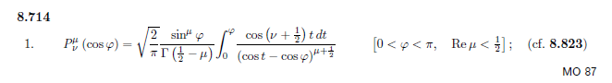
Then set μ=0 to get

Pν(cosφ) = $\sqrt{2/π}$ (1/$\sqrt{π}$) $^{\int_{0}^{φ}{}}$dt cos[(ν+1/2)t]/$\sqrt{cost-cosφ}$ agrees canon B.94

Pn(cosθ) = ($\sqrt{2}$/π)$^{\int_{0}^{θ}{}}$dt cos[(n+1/2)t]/$\sqrt{cost-cosθ}$ show t as an angle variable:

Pn(cosθ) = ($\sqrt{2}$/π)$^{\int_{0}^{θ}{}}$dφ cos[(n+1/2)φ]/$\sqrt{cosφ-cosθ}$ 1.108

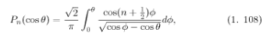 // from canonical, so agrees

so we are on track. Now let's throw two of these into our K and see what happens.

K(θ,θ') = (1/2) Σn=0∞ Pn(z) Pn(z')

= (1/2) Σn=0∞ {($\sqrt{2}$/π) $^{\int_{0}^{θ}{}}$dt cos[(n+1/2)t]/$\sqrt{cost-cosθ}$}{ ($\sqrt{2}$/π) $^{\int_{0}^{θ'}{}}$dt' cos[(n+1/2)t']/$\sqrt{cost'-cosθ'}$}

= (1/π)2 $^{\int_{0}^{θ}{}}$dφ 1/$\sqrt{cosφ-cosθ}$* $^{\int_{0}^{θ'}{}}$dφ' 1/$\sqrt{cosφ'-cosθ'}$ { Σn=0∞ cos[(n+1/2)φ] cos[(n+1/2)φ'] }

and this looks like a possible delta function sum. But somehow the sum is on half-integers instead of integers.

So I made up an appropriate SL problem and got this result in Appendix A below:

Σn=0∞ cos([n+1/2]x) cos([n+1/2]x') = (π/2) δ(x-x')

Therefore we may continue,

K(θ,θ') = (1/π)2 $^{\int_{0}^{θ}{}}$dt 1/$\sqrt{cost-cosθ}$* $^{\int_{0}^{θ'}{}}$dt' 1/$\sqrt{cost'-cosθ'}$ Σn=0∞ cos[(n+1/2)t] cos[(n+1/2)t']

= (1/π)2 $^{\int_{0}^{θ}{}}$dt 1/$\sqrt{cost-cosθ}$}* $^{\int_{0}^{θ'}{}}$dt' 1/$\sqrt{cost'-cosθ'}$ (π/2) δ(t-t')

= (1/2π) $^{\int_{0}^{θ}{}}$dt 1/$\sqrt{cost-cosθ}$ * [ 1/$\sqrt{cost-cosθ'}$ Heaviside( t ≤ θ') ]

= (1/2π) $^{\int_{0}^{θ}{}}$dt { 1/$\sqrt{cost-cosθ}$ 1/$\sqrt{cost-cosθ'}$ } Heaviside( t ≤ θ') ]

As long as θ < θ', we will have t < θ' so we have

= (1/2π) $^{\int_{0}^{θ}{}}$dt { 1/$\sqrt{cost-cosθ}$ 1/$\sqrt{cost-cosθ'}$} if θ < θ'

But K is symmetric, so we could do this the other way to get

= (1/2π) $^{\int_{0}^{θ'}{}}$dt { 1/$\sqrt{cost-cosθ}$ 1/$\sqrt{cost-cosθ'}$} if θ' < θ

so it is the lesser of θ and θ' in both cases that is the upper endpoint, so

K(θ,θ') = (1/2π) $^{\int_{0}^{min(θ,θ')}{}}$ dt { 1/$\sqrt{cost-cosθ}$ 1/$\sqrt{cost-cosθ'}$}
or
K(θ,θ') = (1/2π) $^{\int_{0}^{min(θ,θ')}{}}$ dφ { 1/$\sqrt{cosφ-cosθ}$ 1/$\sqrt{cosφ-cosθ'}$} 1.107

and finally (after perhaps a year!) I understand (1.107) of Canonical.

Now we can back up and say from 1.108 that

Pn(cosθ) = ($\sqrt{2}$/π)$^{\int_{0}^{θ}{}}$dt' cos[(n+1/2)t']/$\sqrt{cost'-cosθ}$

Apply Σn=0∞ cos[(n+1/2)t] to both sides to get

Σn=0∞ cos[(n+1/2)t] Pn(cosθ)

= Σn=0∞ cos[(n+1/2)t] ($\sqrt{2}$/π)$^{\int_{0}^{θ}{}}$dt' cos[(n+1/2)t']/$\sqrt{cost'-cosθ}$

= ($\sqrt{2}$/π)$^{\int_{0}^{θ}{}}$dt' 1/$\sqrt{cost'-cosθ}$ * { Σn=0∞ cos[(n+1/2)t] cos[(n+1/2)t'] }

= ($\sqrt{2}$/π)$^{\int_{0}^{θ}{}}$dt' 1/$\sqrt{cost-cosθ}$ * (π/2) δ(t-t')

= (1/$\sqrt{2}$) 1/$\sqrt{cost-cosθ}$ Heaviside(t < θ)

So we just showed that (change t to φ)

Σn=0∞ cos[(n+1/2)φ] Pn(cosθ) = (1/$\sqrt{2}$) 1/$\sqrt{cost-cosθ}$ * Heaviside(φ < θ) 1.109

which is a strange result only in that each side is a function of two variables φ and θ. I am not sure this result will be used or not, but there it is. We can interpret this result in two ways:

(1) It is the expansion of 1/$\sqrt{cost-cosθ}$ on the eigenfunctions cos[(n+1/2)φ] of the "one end raised string problem" addressed in Appendix A, and the coefficients turn out to be Pn(cosθ). Regarded this way, we can think of our P integral representation 1.108 as the corresponding projection.

(2) It is the expansion of 1/$\sqrt{cost-cosθ}$ on the Legendre polynomials and the coefficient comes out being just cos[(n+1/2)φ]

Now our goal is to find g(θ). We know this is true ( we are not expressing g = 0 above z0)

1 = $^{\int_{-1}^{1}{}}$dz' g(θ') K(θ,θ')

so this is the thing we want to invert! We have

1 = $^{\int_{-1}^{1}{}}$dz' g(θ') K(θ,θ')

= $^{\int_{-1}^{1}{}}$dz' g(θ') (1/2π) $^{\int_{0}^{min(θ,θ')}{}}$ dφ { 1/$\sqrt{cosφ-cosθ}$ 1/$\sqrt{cosφ-cosθ'}$}

I agree now to write the first part as

$^{\int_{-1}^{1}{}}$dz' g(θ') = $^{\int_{0}^{π}{}}$dθ' sinθ' g(θ') sinθ' g(θ') ≡ g*(θ') as Canonical does

so we have

2π = $^{\int_{0}^{π}{}}$dθ' g*(θ') $^{\int_{0}^{min(θ,θ')}{}}$ dφ { 1/$\sqrt{cosφ-cosθ}$ 1/$\sqrt{cosφ-cosθ'}$}

BUT, we know that g and g* both vanish when θ > θ0 (no σ beyond our bowl edge). So

g*(θ') = g*(θ') Heaviside(θ' < θ0)

so
2π = $^{\int_{0}^{π}{}}$dθ' g*(θ') Heaviside(θ' < θ0) $^{\int_{0}^{min(θ,θ')}{}}$ dφ { 1/$\sqrt{cosφ-cosθ}$ 1/$\sqrt{cosφ-cosθ'}$}

= $^{\int_{0}^{θ0}{}}$dθ' g*(θ') $^{\int_{0}^{min(θ,θ')}{}}$ dφ { 1/$\sqrt{cosφ-cosθ}$ 1/$\sqrt{cosφ-cosθ'}$}

Notice that both θ and θ0 are "constants" or free parameters in the above condition. It has to be true for all values of these two parameters.

We now absolutely need a picture to see the 2D integration space. We first consider the case θ ≤ θ0 shown here on the left:

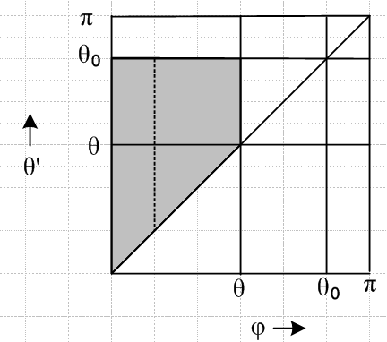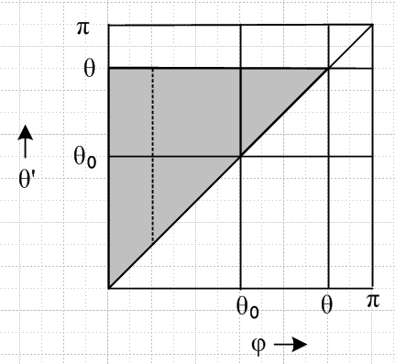

It takes a while to grok this picture. First of all, φ ≤ min(θ,θ'), so φ ≤ θ for sure, so I draw a vertical dotted line at a legal value of φ. The diagonal line is φ = θ', so since φ ≤ θ' as well, the dφ region of integration must be above the diagonal line only, where θ' ≥ φ. Therefore, the 2D integration region is that region shown in gray! We can reorder the integration to be a sum of vertical dotted lines like the one shown, so we get

2π = $^{\int_{0}^{θ}{}}$dφ $^{\int_{φ}^{θ0}{}}$dθ' g*(θ') { 1/$\sqrt{cosφ-cosθ}$ 1/$\sqrt{cosφ-cosθ'}$} θ ≤ θ0

Now we consider the case shown on the right where θ ≥ θ0 . Now the legal range of φ allows an extra triangle of integration area as shown. So this time the inner integral runs up to θ and we get

2π = $^{\int_{0}^{θ}{}}$dφ $^{\int_{φ}^{θ}{}}$dθ' g*(θ') { 1/$\sqrt{cosφ-cosθ}$ 1/$\sqrt{cosφ-cosθ'}$} θ ≥ θ0

We can rewrite our two results this way:

2π = $^{\int_{0}^{θ}{}}$dφ 1/$\sqrt{cosφ-cosθ}$$^{\int_{φ}^{θ0}{}}$dθ' g*(θ') 1/$\sqrt{cosφ-cosθ'}$ θ ≤ θ0 1.110

2π = $^{\int_{0}^{θ}{}}$dφ 1/$\sqrt{cosφ-cosθ}$ $^{\int_{φ}^{θ}{}}$dθ' g*(θ') 1/$\sqrt{cosφ-cosθ'}$ θ ≥ θ0

This second result is not quoted in the paper and is perhaps not useful, we shall see.

Now, in a separate doc "canonical -- correction to Equation 1_111.doc" I derive canonical 1.111 from the original Kelvin work and my toroidal work. I show that the correct interpretation of g(θ) is the following

g(θ) = 4πR (σo+σi)

where R is the bowl radius. Since I know the inner and outer σ's, it is easy to derive this fact

g(θ) = (2/π) { $\sqrt{2}$ cos(θ0/2)/ $\sqrt{cosθ - cosθ0}$ + π/2 – sin-1[ cos(θ0/2) / cos(θ/2) }
// 1.111 corrected
which we can compare with the wrongly stated 1.111 appearing in the DJVU
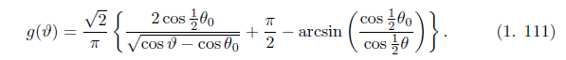 // wrong

The main error is a swapping of 2 and $\sqrt{2}$, and a minor one is θ should be script θ on the lower right. Our entire effort below will be to do the double Abel transform to obtain 1.111 with no intermediate waypoint given, so it is good in such work to have a correct target to aim for!

2. Doing the First Abel Transform

Let's try to apply this to the dφ integral first. Define

h(φ) ≡ $^{\int_{φ}^{θ0}{}}$dθ' g*(θ') 1/$\sqrt{cosφ-cosθ'}$ // valid for φ ≤ θ0 (P2.1)

Then 1.110 says

2π = $^{\int_{0}^{θ}{}}$dφ h(φ)/$\sqrt{cosφ-cosθ}$ // valid for θ ≤ θ0 (P2.2)

We call upon our S1 trig form Abel Transform which says this:

S1: $^{\int_{a}^{x}{}}$dt f(t) / $\sqrt{cost - cosx}$ = g(x)
=> f(t) = π-1 ∂t { $^{\int_{a}^{t}{}}$du sinu g(u) / $\sqrt{cosu - cost}$ }

So we now identify these items

g(x) = 2π
t = φ
x = θ
f = h
a = 0

and the transform then becomes

S1: $^{\int_{0}^{θ}{}}$dφ h(φ) / $\sqrt{cosφ - cosθ}$ = 2π // valid for θ ≤ θ0
=> h(φ) = π-1 ∂φ { $^{\int_{0}^{φ}{}}$du sinu (2π) / $\sqrt{cosu - cosφ}$ }

= 2 ∂φ { $^{\int_{0}^{φ}{}}$du sinu / $\sqrt{cosu - cosφ}$ }

The integral here from Maple is

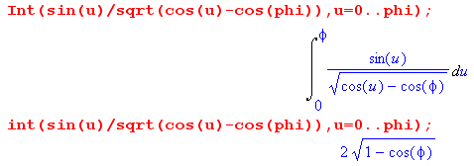
So we then have

h(φ) =2 ∂φ [ 2$\sqrt{1-cosφ}$] = 4 ∂φ (1-cosφ)1/2 = 4 * (1/2) * (1-cosφ)-1/2 * sinφ

= 2 sinφ/$\sqrt{1-cosφ}$ // valid for φ ≤ θ0 (P2.3)

and I hereby confirm this last step with Maple

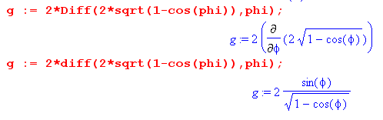

3. Verify that the first transform is done correctly.

I have no "waypoint" between the two transforms, so I want to make sure the first one was done correctly so we don't have garbage in, garbage out.

The key step is taking the inner integral above and defining it to be h(φ) as follows

h(φ) ≡ $^{\int_{φ}^{θ0}{}}$dθ' g*(θ') 1/$\sqrt{cosφ-cosθ'}$ // valid for φ ≤ θ0 (P2.1)

Then 1.110 appears as

2π = $^{\int_{0}^{θ}{}}$dφ h(φ)/$\sqrt{cosφ-cosθ}$ // valid for θ ≤ θ0 (P2.2)

And "the first transform" involves solving this for h(φ). My answer is

h(φ) = 2 sinφ/$\sqrt{1-cosφ}$ // valid for φ ≤ θ0 (P2.3)

In order to verify that this is correct, we must compute this integral

$^{\int_{0}^{θ}{}}$dφ h(φ)/$\sqrt{cosφ-cosθ}$ = $^{\int_{0}^{θ}{}}$dφ[2 sinφ/$\sqrt{1-cosφ}$]/$\sqrt{cosφ-cosθ}$ θ ≤ θ0

and we must then show that

$^{\int_{0}^{θ}{}}$dφ[sinφ/$\sqrt{1-cosφ}$]/$\sqrt{cosφ-cosθ}$ = π (P3.1)

a result which is independent of θ. After some work, I was able to verify the above fact being π, and I used it as a better example in my Maple user's guide, see there for the example and the code text!

Therefore I am 100% sure that my first Abel transform has been done correctly!

4. Doing setup for the Second Abel Transform

So we now have from (P2.1) and (P2.3) above,

h(φ) ≡ $^{\int_{φ}^{θ0}{}}$dθ' g*(θ') 1/$\sqrt{cosφ-cosθ'}$ = 2 sinφ/$\sqrt{1-cosφ}$ // valid for φ ≤ θ0

This is of the Sneddon S2 form, so we call now upon the S2 transform

S2: $^{\int_{x}^{b}{}}$dt f(t) / $\sqrt{cosx - cost}$ = G(x)
=> f(t) = – π-1 ∂t { $^{\int_{t}^{b}{}}$du sinu G(u) / $\sqrt{cost - cosu}$ }

This transform has a "lower Volterra endpoint", but is otherwise very similar to the S1 transform, apart from the endpoint change and one sign. I will adapt my "situation" to the transform variables instead of the other way around:

$^{\int_{φ}^{θ0}{}}$dθ' g*(θ') 1/$\sqrt{cosφ-cosθ'}$ = 2 sinφ/$\sqrt{1-cosφ}$ // now replace θ' with t

$^{\int_{φ}^{θ0}{}}$dt g*(t) 1/$\sqrt{cosφ-cost}$ = 2 sinφ/$\sqrt{1-cosφ}$ // now replace φ by x

$^{\int_{x}^{θ0}{}}$dt g*(t) 1/$\sqrt{cosx-cost}$ = 2 sinx/$\sqrt{1-cosx}$ // now compare:

$^{\int_{x}^{b}{}}$dt f(t) / $\sqrt{cosx - cost}$ = G(x)

so we can identify: f(t) = g*(t) G(x) = 2 sinx/$\sqrt{1-cosx}$ b = θ0

From our transform, the inversion should be

f(t) = – π-1 ∂t { $^{\int_{t}^{b}{}}$du sinu G(u) / $\sqrt{cost - cosu}$ }

g*(t) = – π-1 ∂t { $^{\int_{t}^{θ0}{}}$du sinu [2 sinu/$\sqrt{1-cosu}$] / $\sqrt{cost - cosu}$ }

g*(t) = – (2/π) ∂t { $^{\int_{t}^{θ0}{}}$du sin2u [1/$\sqrt{1-cosu}$] [1 / $\sqrt{cost - cosu}$ ] }

So here is our major starting point for the work to come:

g*(t) = – (2/π) ∂tI g*(t) = sint g(t) (P4.1)

I ≡ $^{\int_{t}^{θ0}{}}$du sin2u [1/$\sqrt{1-cosu}$] [1 / $\sqrt{cost - cosu}$ ] (P4.2)

If I just "throw this integral into Maple", it makes a big mess. We shall see that by changing variables, we can convert this integral into an amazingly simple form that is more chewable to Maple.

5. Transformation of the I integral: Method 1

Let's look more closely at the above integral (P4.2).

I(t,θ0) ≡$^{\int_{t}^{θ0}{}}$du sin2u [1/$\sqrt{1-cosu}$] [1 / $\sqrt{cost - cosu}$ ] (P4.2)

Suppose we write

sin2u = 1 - cos2u

Then we get

I = $^{\int_{t}^{θ0}{}}$du (1-cos2u) / [ $\sqrt{1-cosu}$ $\sqrt{cost - cosu}$]

Let's now change variables

x = cosu dx = -sinu du -du = dx/$\sqrt{1-x2}$ u = t => x = cos(t)

I = $^{\int_{cos(t)}^{cos(θ0)}{}}$[ - dx/$\sqrt{1-x2}$ ] (1-x2) / [ $\sqrt{1-x}$ $\sqrt{cost - x}$] t < θ0

= $^{\int_{cos(θ0)}^{cos(t)}{}}$ [ dx/$\sqrt{1-x2}$ ] (1-x2) / [ $\sqrt{1-x}$ $\sqrt{cost - x}$]

Let a = cos(θ0) and b = cos(t), and we maintain t < θ0 < π so that cos(t) > cos(θ0) > cos(π) if you look at a simple graph, so we have 1 > b > a > -1

I = $^{\int_{a}^{b}{}}$[ dx/$\sqrt{1-x2}$ ] (1-x2) / [ $\sqrt{1-x}$ $\sqrt{cost - x}$]

Now write out some factors

(1-x2) / [$\sqrt{1-x2}$$\sqrt{1-x}$] = $\sqrt{1-x2}$/ $\sqrt{1-x}$ = $\sqrt{1+x}$

and we then have

I = $^{\int_{a}^{b}{}}$dx $\sqrt{1+x}$/$\sqrt{b - x}$ b = cos(t) -1 < a < b < 1 (P5.1)

which is a pretty simple looking integral with this cut structure:

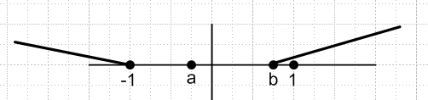

so our integration region appears clean. The integral seems unusually messy according to Maple. Maybe further processing will help. Let

y = b-x dy = -dx x = b-y 1+x = b+1-y

I = $^{\int_{b-a}^{0}{}}$[-dy ] $\sqrt{b+1-y}$/ $\sqrt{y}$

I = $^{\int_{0}^{b-a}{}}$dy $\sqrt{b+1-y}$/$\sqrt{y}$

Now define c = b-a and d = b+1 so this becomes

I = $^{\int_{0}^{c}{}}$dy $\sqrt{d-y}$/$\sqrt{y}$ (P5.2)

and this is the form of the integral I we shall work with in this "Method 1" section. Now we have a branch point to the left at y = 0 which touches the left end of the integration. And we have a branch point at y = d going to the right. Where is this?

d = b+1 b = d-1
c = b-a
d-c = 1+a > 0 => d > c (P5.3)

We know now that

-1 < a < b < 1

We see that c = b-a is positive, and that at most this is 2. So 0 < c < 2.
We see that -1 < b < 1 so that 0 < b+1 < 2 so that 0 < d < 2.
And we have d > c. So I put all this stuff into an assume, and here is what Maple says:

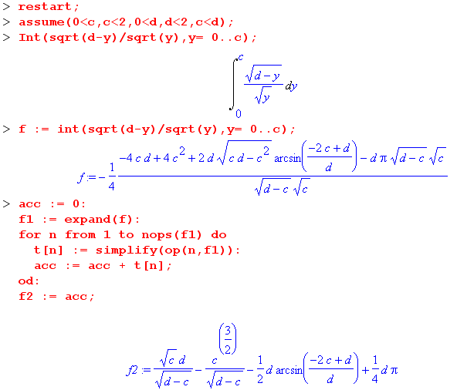 (P5.4)

This is the simplest form I have obtained so far for this integral. We then need a complicated derivative, and here is a way we can get it:

b = cos(t) db = -sin(t)dt

d = b+1 dd = db = -sin(t)dt dd/dt = -sin(t)
c = b-a dc = db = -sin(t)dt dc/dt = -sin(t)

d/dt = d/dc * dc/dt + d/dd * dd/dt =
= dc/dt * d/dc + dd/dt * d/dd

= (-sint) [d/dc + d/dd ]

So here is our big fact

∂t = -sint (∂c+ ∂d) (P5.5)

So I will have Maple compute (∂c+ ∂d) f2 where f2 = I, our starting integral!

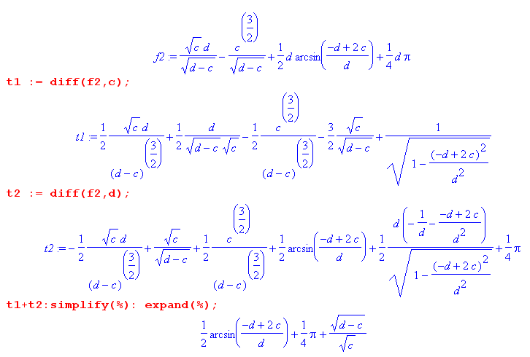(P5.6)

and I am very happy to see a simple result. Going to manual, we then have

g*(t) = – (2/π) ∂t { $^{\int_{t}^{θ0}{}}$du sin2u [1/$\sqrt{1-cosu}$] [1 / $\sqrt{cost - cosu}$ ] }

= – (2/π) ∂t { I} = – (2/π) ∂t { f2}

= – (2/π) [-sint] ( ∂c+ ∂d) f2

= (2/π) sint { (1/2) sin-1 [(2c-d)/d] + π/4 + $\sqrt{d-c}$/$\sqrt{c}$ }

But earlier we said sinθ' g(θ') ≡ g*(θ') which means g*(t) = sint g(t) so we now have

g(t) = (2/π) { (1/2) sin-1 [(2c-d)/d] + π/4 + $\sqrt{d-c}$/$\sqrt{c}$ } (P5.7)

where

a = cos(θ0) and b = cos(t)

c = b-a and d = b+1 d-c = 1+a = 1+cos(θ0)

c = cost - cosθ0

d = cost+1

2c-d = 2(cost - cosθ0) - (cost+1) = cost -2cosθ0 - 1

so our answer is then
(P5.8)
g(t) = (2/π) { (1/2) sin-1 [(cost -2cosθ0 - 1)/( cost+1)] + π/4 + $\sqrt{1+cos(θ0)}$/$\sqrt{cost - cosθ0}$ }

The numerator of the sin-1 argument now looks wrong! But let's ignore that for a moment and look at all the rest. [ At this time, I did not realize that you don't have to match the known-result argument of sin-1 in order to get the right answer. This was a major cause of delay. ]

g(t) = (2/π) { (1/2) sin-1 [(cost -2cosθ0 - 1)/( cost+1)] + π/4 + $\sqrt{2}$cos(θ0/2) /$\sqrt{cost - cosθ0}$ }

g(t) = (1/π) { sin-1 [(cost -2cosθ0 - 1)/( cost+1)] + π/2 + 2$\sqrt{2}$cos(θ0/2) /$\sqrt{cost - cosθ0}$ }

g(t) = (1/π) { 2$\sqrt{2}$cos(θ0/2) /$\sqrt{cost - cosθ0}$ + π/2 + sin-1 [(cost -2cosθ0 - 1)/( cost+1)] }

g(θ) = (1/π) { 2$\sqrt{2}$cos(θ0/2) /$\sqrt{cosθ - cosθ0}$ + π/2 + sin-1 [(cosθ -2cosθ0 - 1)/( cosθ+1)] }

g(θ) = (2/π) { $\sqrt{2}$cos(θ0/2) /$\sqrt{cosθ - cosθ0}$ + π/4 + (1/2) sin-1 [(cosθ -2cosθ0 - 1)/( cosθ+1)] }
(P5.9)
Here (see external doc or note above) is the Canonical corrected result:

g(θ) = (2/π) {$\sqrt{2}$ cos(θ0/2)/$\sqrt{cosθ - cosθ0}$ + π/2 – sin-1[ cos(θ0/2) / cos(θ/2)] }
// 1.111 corrected
In order to show these two results agree, we would have to show this:

π/4 + (1/2) sin-1 [(cosθ -2cosθ0 - 1)/( cosθ+1)] = π/2 – sin-1[ cos(θ0/2) / cos(θ/2)]
or
π/2 + sin-1 [(cosθ -2cosθ0 - 1)/( cosθ+1)] = π – 2sin-1[ cos(θ0/2) / cos(θ/2)]
or
sin-1 [(cosθ -2cosθ0 - 1)/( cosθ+1)] = π/2 – 2sin-1[ cos(θ0/2) / cos(θ/2)]
or
sin-1 [(cosθ -2cosθ0 - 1)/( cosθ+1)] = π/2 – 2sin-1[$\sqrt{1+cosθ0}$ / $\sqrt{1+cosθ}$]
or (P5.10)
sin-1 [(a -2b - 1)/( a+1)] = π/2 – 2sin-1[$\sqrt{1+b}$ / $\sqrt{1+a}$] // a=cosθ b=cosθ0

Now GR7 have lots of "identities" relating sin-1 functions. These are images in the inverse trig space of the many trig identities that we know exist. Maybe these could be used to prove the above equation. But before attempting this, I could just plug in some numbers and show it is wrong as I expect. We know that θ < θ0 which tells us that cosθ > cosθ0 which says a > b. So we could try a = 0.3 and b = 0.1 as a test:

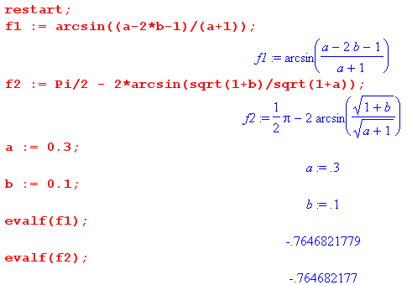

Oops! I big surprise for me here. They DO agree, at least at this one test point. I am indeed surprised.

Proving the weird identity (P5.10)

I now think the following is true, but I don't know an easy way to prove it:

sin-1 [(a -2b - 1)/( a+1)] = π/2 – 2sin-1[$\sqrt{1+b}$ / $\sqrt{1+a}$] // a=cosθ b=cosθ0

Let's start by writing

(a -2b - 1) = a +1 -2b - 2 = a +1 -2(b+1)

Then define

x = 1+a a>b => x > y
y = 1+b

Then we have to show this:

sin-1 [(x-2y)/x] = π/2 – 2sin-1[$\sqrt{y}$/$\sqrt{x}$] y < x

and at least this is a simpler form. Now forget those identities, lets transcribe this into trig function space from angle space this way

θ1 = sin-1 [(x-2y)/x]

θ2 = sin-1[$\sqrt{y}$/$\sqrt{x}$]

θ1 = π/2 - 2θ2 ?

sinθ1 = sin(π/2 - 2θ2) = cos(2θ2) = 1 - 2 sin2(2θ2) ?

[(x-2y)/x] = 1 - 2 [$\sqrt{y}$/$\sqrt{x}$]2 ?

[(x-2y)/x] = 1 - 2y/x = (x-2y)/x QED!

Summary of doing the second Abel transform by Method 1:

The equation we are trying to invert is this one

2 sinφ/$\sqrt{1-cosφ}$ = $^{\int_{φ}^{θ0}{}}$dθ' g*(θ') 1/$\sqrt{cosφ-cosθ'}$ // valid for φ ≤ θ0

Applying our Abel Transform theorem for this case gives [ variable t = θ ]

g*(t) = – (2/π) ∂tI
where
I = $^{\int_{t}^{θ0}{}}$du sin2u [1/$\sqrt{1-cosu}$] [1 / $\sqrt{cost - cosu}$ ]

By changing integration variables we are able to write [a = cos(θ0) and b = cos(t) ]

I = $^{\int_{a}^{b}{}}$dx $\sqrt{1+x}$/$\sqrt{b - x}$ b = cos(t) -1 < a < b < 1

By changing integration variables again, we can write

I = $^{\int_{0}^{c}{}}$dy $\sqrt{d-y}$/$\sqrt{y}$ c = b-a and d = b+1

Maple is able to compute this integral and gets this result
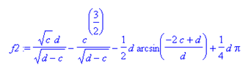

We then show that

∂t = -sint (∂c+ ∂d)

which allows us to compute ∂tI and we find from Maple that ∂tI is given by

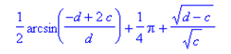

We then note that g*(t) = sint g(t) and we then have

g(t) = (2/π) { (1/2) sin-1 [(2c-d)/d] + π/4 + $\sqrt{d-c}$/$\sqrt{c}$ }

Installing our quantities for c and d and changing from t to θ we then have this result

g(θ) = (2/π) { $\sqrt{2}$cos(θ0/2) /$\sqrt{cosθ - cosθ0}$ + π/4 + (1/2) sin-1 [(cosθ -2cosθ0 - 1)/( cosθ+1)] }

which we compare to our known correct result

g(θ) = (2/π) {$\sqrt{2}$ cos(θ0/2)/$\sqrt{cosθ - cosθ0}$ + π/2 – sin-1[ cos(θ0/2) / cos(θ/2)] }
// 1.111 corrected

We see that the first terms exactly agree, so in order to prove they really do agree we have to show

π/2 + sin-1 [(cosθ -2cosθ0 - 1)/( cosθ+1)] = π – 2sin-1[ cos(θ0/2) / cos(θ/2)]

We then take this to be a little "trig problem". We first define new a=cosθ b=cosθ0

and our trig problem is to show this

sin-1 [(a -2b - 1)/( a+1)] = π/2 – 2sin-1[$\sqrt{1+b}$ / $\sqrt{1+a}$]

We change variables to x = 1+a and y = 1+b and our problem is then to show this:

sin-1 [(x-2y)/x] = π/2 – 2sin-1[$\sqrt{y}$/$\sqrt{x}$] y < x

θ1 = π/2 - 2θ2

We then do a little 6 line proof to show that this is valid seemingly for any x and y. In this proof we use a few general purpose trig identities where nothing at all is assumed!

Therefore, we have in fact obtained a result for g(θ) which agrees with the corrected 1.111 ! This is the very first time I have obtained agreement. The big lesson here is that a result you get might be right even if the sin-1 argument differs from what 1.111 shows!

6. Transformation of the I integral: Method 2

Let's now back up to this integral (P5.2)

I = $^{\int_{0}^{c}{}}$dy $\sqrt{d-y}$/$\sqrt{y}$ (P5.24)
d = b+1 b = d-1
c = b-a
d-c = 1+a > 0 => d > c

I cannot find this in GR7 so let's make yet another change of variable

y = x2 dy = 2x dx

I = $\sqrt{c}$!Syntax Error, I[2x dx] $\sqrt{d-x2}$/ x

= 2$\sqrt{c}$!Syntax Error, Idx $\sqrt{d-x2}$ (P6.1)

This is certainly the simplest form yet for the I integral!

Here is what Maple says about this guy: c = cost - cosθ0 d = cost+1 d-c = 1+cosθ0

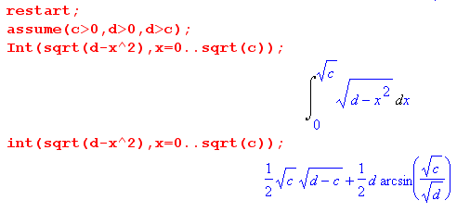 = I/2 (P6.2)

So when evaluated THIS way, I get still another answer for I

I = $\sqrt{c}$$\sqrt{d-c}$+ d sin-1($\sqrt{c}$/$\sqrt{d}$)

= $\sqrt{cost - cosθ0}$$\sqrt{1+cosθ0}$+ d sin-1($\sqrt{cost - cosθ0}$/$\sqrt{cost+1}$) (P6.3)

We now have Maple compute the following which is (∂c+ ∂d) [$\sqrt{c}$!Syntax Error, Idx $\sqrt{d-x2}$ ] = (∂c+ ∂d) (I/2):

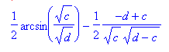 (P6.4)

And recall from (P2.1) that g*(t) = – (2/π) ∂t I, so we then have

g*(t) = – (2/π) ∂tI = – (2/π) [-sint (∂c+ ∂d)] I = (2/π) sint (∂c+ ∂d)] I

so that

g(t) = (2/π) (∂c+ ∂d)] I = (4/π) (∂c+ ∂d)] (I/2)

= (4/π) { (1/2) sin-1($\sqrt{c}$/$\sqrt{d}$) + (1/2) (d-c)/ [$\sqrt{c}$$\sqrt{d-c}$] }

= (4/π) { (1/2) (d-c)/ [$\sqrt{c}$$\sqrt{d-c}$] + (1/2) sin-1($\sqrt{c}$/$\sqrt{d}$) }

= (2/π) { (d-c)/ [$\sqrt{c}$$\sqrt{d-c}$] + sin-1($\sqrt{c}$/$\sqrt{d}$) }

= (2/π) { $\sqrt{d-c}$/ $\sqrt{c}$ + sin-1($\sqrt{c}$/$\sqrt{d}$) }

where

c = cost - cosθ0 d = cost+1 d-c = 1+cosθ0

So we fill in to get our result by this new method

g(t) = (2/π) [ $\sqrt{1+cosθ0}$/ [$\sqrt{cost - cosθ0}$] + sin-1 ($\sqrt{cost - cosθ0}$/$\sqrt{cost+1}$)
or
gme(θ) = (2/π) [ $\sqrt{1+cosθ0}$/ [$\sqrt{cosθ - cosθ0}$] + sin-1 ($\sqrt{cosθ - cosθ0}$/$\sqrt{cosθ+1}$) (P6.5)

which we again want to compare to our known result

g(θ) = (2/π) {$\sqrt{2}$ cos(θ0/2)/$\sqrt{cosθ - cosθ0}$ + π/2 – sin-1[ cos(θ0/2) / cos(θ/2)] }
// 1.111 corrected
Let's rewrite this known correct result undoing the half-angle guys,

g(θ) = (2/π) {$\sqrt{1+cosθ0}$/$\sqrt{cosθ - cosθ0}$ + π/2 – sin-1[$\sqrt{1+cosθ0}$/$\sqrt{1+cosθ}$] } (P6.6)

Now let's use our new a=cosθ b=cosθ0 with a>b to write

gme(θ) = (2/π) [ $\sqrt{1+b}$/ $\sqrt{a - b}$ + sin-1 ($\sqrt{a - b}$/$\sqrt{a+1}$)

g(θ) = (2/π) {$\sqrt{1+b}$/$\sqrt{a - b}$ + π/2 – sin-1[$\sqrt{1+b}$/$\sqrt{1+a}$] } (P6.7)

In order for these two equations to agree, since first terms already agree we have to show that

sin-1 ($\sqrt{a - b}$/$\sqrt{a+1}$) = π/2 – sin-1[$\sqrt{1+b}$/$\sqrt{1+a}$] (P6.8)

Now as before define

x = 1+a a>b => x > y
y = 1+b

a-b = x-y

and we then have

sin-1 ($\sqrt{x - y}$/$\sqrt{x}$) = π/2 – sin-1[$\sqrt{y}$/$\sqrt{x}$] (P6.9)

Could this possibly be true? Let's again test it, this time x = 0.3 and y = 0.1, and this time things do NOT work:

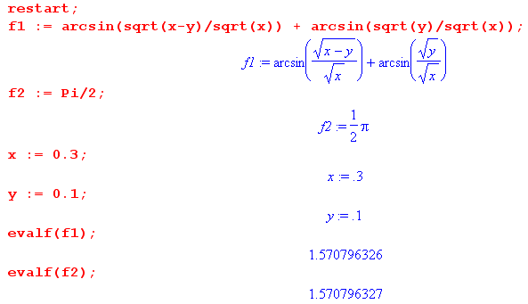

and we are on the money. So now we attempt a little proof:

sin-1 ($\sqrt{x - y}$/$\sqrt{x}$) = π/2 – sin-1[$\sqrt{y}$/$\sqrt{x}$] (P6.9)
θ1 θ2

θ1 = π/2 - θ2

sinθ1 = sin(π/2 - θ2) = cos(θ2) = $\sqrt{1-sin2θ2}$ ?

$\sqrt{x - y}$/$\sqrt{x}$ = $\sqrt{1-(y/x)}$ QED

7. Compute the an from g(θ)

This turned out to be a 3-day 22-page gala extravaganza. See these docs where I finally obtain the correct result for an. A summary is given in the meta notes.

Doing the an integral.doc
Doing the an integral META notes.doc

The integral in question is this (where I also state the result I finally obtained)

an = (1/π) $^{\int_{0}^{θ0}{}}$dθ sinθ Pn(cosθ) {$\sqrt{1+cosθ0}$/$\sqrt{cosθ-cosθ0}$ + cos-1[$\sqrt{1+cosθ0}$/$\sqrt{1+cosθ}$] }

= (1/π) { sin[nθ0]/n + sin[(n+1)θ0]/(n+1) }

The big problem is the cos-1 term which must be eliminated by parts integration, but that cannot be done until an integral representation is used for the P function,

Pn(cosθ) = ($\sqrt{2}$/π)$^{\int_{0}^{θ}{}}$dφ cos[(n+1/2)φ]/$\sqrt{cosφ-cosθ}$ 1.108

The idea is to insert this integral representation, swap order of integration, evaluate the dθ integral by doing parts to remove the cos-1 function, then evaluate the remaining dφ integral.

8. Can we get something analogous to 1.109 but with sin?

Suppose we use the other integral rep for P which is this

Pn(cosθ) = ( $\sqrt{2}$/π) $^{\int_{θ}^{π}{}}$dx sin[(n+1/2)x] / $\sqrt{cosθ-cosx}$

Apply Σn=0∞ sin[(n+1/2)t] to both sides to get

Σn=0∞ sin[(n+1/2)t] Pn(cosθ)

= Σn=0∞ sin[(n+1/2)t] ($\sqrt{2}$/π) $^{\int_{θ}^{π}{}}$dx sin[(n+1/2)x] / $\sqrt{cosθ-cosx}$

= ($\sqrt{2}$/π) $^{\int_{θ}^{π}{}}$dx / $\sqrt{cosθ-cosx}$ * Σn=0∞ sin[(n+1/2)t] sin[(n+1/2)x]

But we show in Appendix B that

Σn=0∞ sin([n+1/2]x) sin([n+1/2]x') = (π/2) δ(x-x')

so we then have

Σn=0∞ sin[(n+1/2)t] Pn(cosθ) = ($\sqrt{2}$/π) $^{\int_{θ}^{π}{}}$dx / $\sqrt{cosθ-cosx}$ * (π/2) δ(x-t)

= ($\sqrt{2}$/π) 1/$\sqrt{cosθ-cost}$ * Heaviside( t>θ) Heaviside(t<π)

Appendix A: A Sturm Liouville Problem of Interest.

Remember: each SL problem defines a transform, orthogonality and completeness. Do I know a SL problem whose eigenfunctions are φn(θ) = cos[(n+1/2)θ] as suggested above in Section 1.4.1? How about this "string problem" where the left end of the string is offset by 1 unit:

u"(θ) = -n2u(θ) u(0) = 1 u(π) = 0 // could also use u'(0) = 0 I think, Stak p 284

We rule out sines due to u(0) = 1, so we have u(θ) = cos(aθ) which meets u(0) = 1, and we have to find values of a. So u(π) = cos(aπ) = 0. Choices are a = 1/2, 3/2, etc. So solutions are

un(θ) = cos([n+1/2]θ) n = 0,1,2.... covers spectrum only once.

Then our eigenfunctions form a complete and are orthogonal since L is self-adjoint. So we have

$^{\int_{0}^{π}{}}$dx cos([n+1/2]x) cos([n'+1/2]x) = δn,n' Kn

Is this really true? Maple suggests yes! I enter different values of n and n' integers, always 0 when different. But you don't find such integrals in any table! This is a custom SL problem. So now we can find Kn

$^{\int_{0}^{π}{}}$dx cos2([n+1/2]x) = π/2 = Kn // says Maple with assume n integer!

So we can write

φn(x) = $\sqrt{2/π}$ cos([n+1/2]x)

$^{\int_{0}^{π}{}}$dx φn(x) φn'(x) =$\sqrt{2/π}$$\sqrt{2/π}$ $^{\int_{0}^{π}{}}$dx cos([n+1/2]x) cos([n'+1/2]x) = (2/π) δnn'(π/2) = δnn'

So there are the orthogonal basis functions. So here is an expansion

f(x) = Σn=0∞ an φn(x)

an = $^{\int_{0}^{π}{}}$dx φn(x)f(x)

Then we have

f(x) = Σn=0∞ {$^{\int_{0}^{π}{}}$dx' φn(x')f(x')} φn(x) = $^{\int_{0}^{π}{}}$dx' f(x') [Σn=0∞ φn(x') φn(x)]

and this gives our famous result

Σn=0∞ φn(x') φn(x) = δ(x-x')

so we have shown that

Σn=0∞$\sqrt{2/π}$ cos([n+1/2]x) $\sqrt{2/π}$ cos([n+1/2]x') = δ(x-x')

Σn=0∞ cos([n+1/2]x) cos([n+1/2]x') = (π/2) δ(x-x') interval x in (0,π)

and this is the result we need.

Appendix B: Another Sturm Liouville Problem of Interest.

Remember: each SL problem defines a transform, orthogonality and completeness. Do I know a SL problem whose eigenfunctions are φn(θ) = sin[(n+1/2)θ]? How about this "string problem" where the right end of the string is offset by 1 unit:

u"(θ) = -n2u(θ) u(0) = 0 u(π) = 1

We rule out cosines due to u(0) = 0, so we have u(θ) = sin(aθ) which meets u(π) = 1, and we have to find values of a. So u(π) = sin(aπ) = 1. Choices are a = 1/2, 3/2, etc. So solutions are

un(θ) = sin([n+1/2]θ) n = 0,1,2.... covers spectrum only once.

Then our eigenfunctions form a complete and are orthogonal since L is self-adjoint. So we have

$^{\int_{0}^{π}{}}$dx sin([n+1/2]x) sin([n'+1/2]x) = δn,n' Kn

Is this really true? Maple suggests yes! I enter different values of n and n' integers, always 0 when different. But you don't find such integrals in any table! This is a custom SL problem. So now we can find Kn

$^{\int_{0}^{π}{}}$dx sin2([n+1/2]x) = π/2 = Kn // says Maple with assume n integer n = 0,1,2...

So we can write

φn(x) = $\sqrt{2/π}$ sin([n+1/2]x)

$^{\int_{0}^{π}{}}$dx φn(x) φn'(x) =$\sqrt{2/π}$$\sqrt{2/π}$ $^{\int_{0}^{π}{}}$dx sin([n+1/2]x) sin([n'+1/2]x) = (2/π) δnn'(π/2) = δnn'

So there are the orthogonal basis functions. So here is an expansion

f(x) = Σn=0∞ an φn(x)

an = $^{\int_{0}^{π}{}}$dx φn(x)f(x)

Then we have

f(x) = Σn=0∞ {$^{\int_{0}^{π}{}}$dx' φn(x')f(x')} φn(x) = $^{\int_{0}^{π}{}}$dx' f(x') [Σn=0∞ φn(x') φn(x)]

and this gives our famous result

Σn=0∞ φn(x') φn(x) = δ(x-x')

so we have shown that

Σn=0∞$\sqrt{2/π}$ sin([n+1/2]x) $\sqrt{2/π}$ sin([n+1/2]x') = δ(x-x')

Σn=0∞ sin([n+1/2]x) sin([n+1/2]x') = (π/2) δ(x-x') interval x in (0,π)

and this is the result we need.

