Green's Functions using the Smythe Method PhL 1.1.10

See META doc!
1. Introduction. 2
2. Smythe Green's Function for a Cone. 2
(a) Setting things up to match the BC's 2
(b) Understanding things as distributions. 5
(c) The eigenfunctions of the θ ODE BV problem on (0,α) are complete and orthogonal. 6
(d) Computation of the A_{mn} coefficients. 10
(e) Comments on Smythe's Method. 11
2a. Adding two walls to make a conical box. 11
Conclusion: 14
3. Green's Function for a Sphere using this Smythe Method. 16
4. How does Smythe compare to Stak's list of ways to compute Green's Functions? 20
5. Smythe Method for other orthogonal coordinate systems. 21
6. Review of Smythe Oblate Spheroidal Work (Previously Read) 22
7. Smythe Oblate Spheroidal Neumann Problem [ 165 ] 24
(a) Setting up the problem. 25
(b) Review of the scale factors for oblates. (comparing Smythe and MF) 26
(c) Condition at the surface where the charge is 28
(d) Digression on the Wronskian. 28
(e) Resuming now that we have the right Wronskian. 30
(f) Comments on the mysterious σ_{n} 32
(g) The M and N constants 33
(h) Shape of the spheroid. 34
(i) Why do you only use P_{n}^{m}(jζ) inside the spheroid? Why not Q_{n}^{m}(jζ) as well? 35
8. Smythe Oblate Spheroidal Dirichlet Problem 36
9. Application: Potential of conducting spheroid of potential V₀. 37
(a) Capacitance. 40
(b) Other forms of the solution 40
(c) Circular plate limit. 40
10. Application Comparison: Potential of conducting ellipsoid of potential V₀. 41
Comment on Ellipsoidals. 42
11. Comment on the non-factorization of the 3D volume element, and on orthogonality. 43
12. Comment on oblate "spheroidal harmonics" 44
13. Comment on Full 3D Fourier Expansion and Recovery in Curvilinear Coordinates 46
Appendix A. Azimuthal Orthogonality (integral is 0 to 2π) 48
Appendix B. P Function Orthogonality (integral is -1 to 1) 50
Appendix C. Combined P Function and φ orthogonality. 51
Appendix D. Use the Neumann Result to find an oblate 1/R expansion 52
Appendix E. Show that j Q_{n}^{m}(jx) P_{n}^{m}(jy) is real for n,m integers and x,y real. 54

1. Introduction.

Recall in Stak Vol 1 how, in order to find a 1D Green's function, we found a Laplace solution on the left that met the left BC, and a Laplace solution on the right that met the right BC, then at the meeting point we had a jump condition which just meant that you integrate the Green 's ODE over the δ(x-ξ) and pick up a requirement of a jump in the first Green derivative. If you think of δ(x-ξ) as the charge density ρ, you are really just applying a little 1D Gauss's Law:

-∇2V = δ(x-ξ) V = the Green's Function G L = -∇2
∇•E = ρ E = -∇V ρ = 1 δ(x-ξ)
∫V dV∇•E = ∫S dS•E // divergence theorem = Gauss's Law
$^{\int_{ξ-ε}^{ξ+ε}{}}$dx δ(x-ξ) = Ex(ξ+ε) - Ex(ξ-ε) = ΔEx(ξ)
1 = -∂xV(ξ+ε) + ∂xV(ξ-ε)

∂xV(ξ+ε) – ∂xV(ξ-ε) = - 1

where the last line is "the jump condition on G" as in Stak p 62 (1.49)for L = - ∇2.
In multiple dimensions, we can do a similar thing, but it is not a "left and right" situation exactly. Instead, we find some general "form" for V that meets all the BC's if possible, then we apply a Gauss's theorem in a tiny ε volume about the point charge. Sometimes we have to have multiple regions for V that meet different BC's (perhaps inside some point, and outside that point, radially, eg). Then we have to make sure V is continuous (∂V as well) at any boundaries between regions, away from the point charge. We shall now examine Smyth's cone Green's function from this viewpoint.

2. Smythe Green's Function for a Cone.

(a) Setting things up to match the BC's

His starting point is to imagine two regions, one below the point charge toward the vertex of the cone (which we imagine pointing up in the spherical coordinate z direction), and a second region above the point charge, where we go off to infinity. Smythe writes (with my adaptations)

r<a Vi = Σm=0∞ Σn Amn (r/a)n Pnm(z) cos(mφ)

r<a Ve = Σm=0∞ Σn Amn (r/a)-n-1 Pnm(z) cos(mφ)
______________________________________________________________________________

Note added 2.3.10. Why don't we need negative m contributions? Suppose we included them and called our coefficients Bnm. Look at one such term, and let m = -m1 < 0. [ cos(-x) = cos(x) ]

B-m1,n (r/a)-n-1 Pn-m1(z) cos(m1φ)

Now use Leg prop that says

[ Γ(ν+m+1)/ Γ(ν-m+1) ] Pν-m(z) = Pνm(z) = f(ν,m) Pν-m(z)

=> Pn-m1(z) = f(ν,-m1) Pνm1(z)

then we write our term as:

B-m1,n (r/a)-n-1 f(ν,-m1) Pνm1(z)cos(m1φ)

The sum also has a positive term of this form

Bm1,n (r/a)-n-1 Pνm1(z)cos(m1φ)

so we can combine these two terms together as:

(r/a)-n-1 [ Bm1,n + B-m1,n f(ν,-m1)] Pνm1(z)cos(m1φ)

So we then just define Am1,n = [ Bm1,n + B-m1,n f(ν,-m1)] and we have then successfully folded the negative m into the positive m with no loss of generality in the form.
___________________________________________________________________________

The cone opening angle is θ = α, and we require in the Σn all the values of n such that Pnm(cosα) = 0. In other words, our sum is over the "zeros of Pnm(cosα) in degree". Of course for any particular α and particular m, we have to go off and compute this infinite number of zeros! I suspect the lower values of n have unusual zero positions, then for large n the pattern becomes regular. For example, here is the plot showing the zeros of Pn3(0.7) [ have to remember to set the cut right! ]

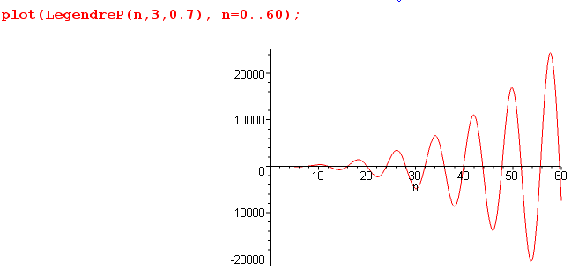

Bateman p 162 shows that for large n we have (no integers implied here)

Pnm(cosθ) = [ π sinθ/2]-1/2 Γ(n+m+1)/Γ(n+3/2) * cos [ (n+1/2)θ - π/4 + mπ/2 ]

so the Γ ratio is providing the growth envelope (Maple confirms), and the cosine the periodic shape, so the zeros are going to be at these locations:

[ (n+1/2)θ - π/4 + mπ/2 ] = Nodd (π/2)
(n+1/2)θ = Nodd π/2 +π/4 - mπ/2
n = -1/2 + [Nodd π/2 +π/4 - mπ/2]/θ = -1/2 + (π/2) [ Nodd + 1/2 - m ] /θ

In our example above, we have m = 3 and there seems to be a zero at n=60 or so. We have cosθ = .7 so that θ = .795 radians.

Nodd = (2/π) [ (60 + 1/2) * .795 - π/4 + 3π/2 ]

Maple says this is 33.1 which I guess we have to think of as 33. The spacing between the zeros should be

Δn θ = 2 π/2 Δn = π/θ = 3.95 ≈ 4 which seems right

This is a bit ugly, I have to admit, but it is doable.

Now back to our starting forms:

r<a Vi = Σm=0∞ Σn Amn (r/a)n Pnm(z) cos(mφ)

r<a Ve = Σm=0∞ Σn Amn (r/a)-n-1 Pnm(z) cos(mφ)

where the point charge is at (r,θ,φ) = (a,β,0). You can see φ = 0 assumed in the form since we are then symmetric about this point in azimuth. We have two regions for the "usual" r = 0 and ∞ reasons. So our forms meet all BC's. What about continuity of V? If we set r = a, we have it! Built in! But continuity of ∂rV is not built in, so let's go apply that constraint,

r<a ∂rVi = Σm=0∞ Σn Amn n(r/a)n-1 (1/a) Pnm(z) cos(mφ)

r<a ∂r Ve = Σm=0∞ Σn Amn (-n-1)(r/a)-n-2 (1/a)Pnm(z) cos(mφ)

At any matching point away from the point charge, we then have:

∂rVi = Σm=0∞ Σn Amn n (1/a) Pnm(z) cos(mφ)
∂rVe = Σm=0∞ Σn Amn (-n-1) (1/a)Pnm(z) cos(mφ)

0 = ∂rVi- ∂rVe = (1/a) Σm=0∞ Σn Amn (2n+1) Pnm(z) cos(mφ) (*)

Notice that we only need m = 0,1,2... since this gives cos(mφ) as a complete set for φ even functions. In other words, we don't need negative m integer values, they would be redundant. For a partial-azimuth cone, however, with some orange slice walls at V = 0, we would get those equally spaced m values and I know in that case we have to choose the negative m values to make things work (at least when α = π). See ODE/Legendre for details on this and other related subjects.

(b) Understanding things as distributions.

But we have to be very careful here. This result (*) above is true "everywhere" except "near" φ = 0 and z = cosβ. At that point, ∂rVi- ∂rVe = ∞ since in some rough sense the fields point away from the point charge. So we have a distribution going on here, and you have to think of ∂rVi- ∂rVe as a symbolic function. Away from the singular point, the "sum rule = 0" must be valid as shown in (*) above.
Let's ignore this sum rule fact for now, and try our Gauss's law integration. First, let's modify our 1D results (we use the 1/4πε SI normalization here for charge)

-∇2V = δ(x-ξ) V = the Green's Function G L = -∇2
∇•E = ρ/ε E = -∇V ρ = 1δ(x-xβ)
∫V dV∇•E = ∫S dS•E // divergence theorem = Gauss's Law
LHS = ∫V dV∇•E = ∫V dV ρ/ε = ∫V dx δ(x-ξ)/ε = 1/ε
RHS = ∫S dS•E = – ∫S dS•∇V = – ∫S dS ∂nV
- 1/ε = ∫S dS ∂nV

Here V is a small volume surrounding our point charge. Now comes a slightly subtle move which Smythe quietly does. Instead of dealing with a point charge at point β, let's imagine the charge is diffused into a uniform surface charge layer σ of zero thickness somewhere inside our Δr, such that the total amount of charge in a little patch of size ΔS = a2ΔΩβ is exactly 1 unit. In the limit that ΔΩβ → 0, we recover our point charge. Thus, we can still say ρ ≈ 1δ(x-xβ) as our 3D charge density, so the steps above are justified. In other words, the total charge in our "box" is 1 no matter how we shape the box or the charge in the box before taking the limit of an infinitesimal box. So, we can now approximate the surface integral shown above in this manner, where as usual we have ignored dS•E flux out the sides of the box since it is a super flat pillbox,

- 1/ε = ∫S dS ∂nV ≈ ΔS [ ∂rVe – ∂rVi ] = a2ΔΩβ [ ∂rVe – ∂rVi ]

1/ε = a2ΔΩβ [ ∂rVi – ∂rVe ] '' jump condition"

We can see by inspection that [ ∂rVi – ∂rVe ] must be some kind of distribution, as already noted above, since it blows up as we close our pillbox patch thing in about the point β and take ΔΩβ → 0. We shrink our little patch about the magic point, the E fields on each side of the patch become infinite since σ becomes infinite. As for sign, each term in the difference makes a similar positive contribution, it is not like we are taking the difference of two positive numbers. We have ∂rVi > 0 since increasing r takes us closer to the charge, whereas ∂rVe < 0 since dr takes us away from the charge.
We now want to get the above result into official delta function notation. I stumbled along here for a while, but I think I found the right path. [ Smythe does not use delta functions in his 1950 book, though he must have known about them. Schwartz theory of distributions was also 1950. ]
Consider first, where the integral covers our point β,

∫dΩ δ(z-zβ)δ(φ-φβ) = 1

Now undo the limit a bit by replacing the delta functions with box functions δbox of such a range that they exactly match the small pencil beam ΔΩβ. In this case, the entire integral can be replace as follows

1 = ∫dΩ δ(z-zβ)δ(φ-φβ) ≈ ΔΩβ δbox(z-zβ)δbox(φ-φβ)

where you might imagine that δbox has an extent of ±ε, and ΔΩβ matches that in both directions. Then we can take the following somewhat unusual limit:

lim (1/ΔΩβ) = lim δbox(z-zβ)δbox(φ-φβ) = δ(z-zβ)δ(φ-φβ)

The main point is that we now have set the scale of things. Our result above then becomes

[ ∂rVi – ∂rVe ] = (1/εa2) (1/ ΔΩβ ) → (1/εa2) δ(z-zβ)δ(φ-φβ)

We can think of this as the 3D version of the Green's Function "jump condition" in 1D. So we can now write our result above in a full distributional form with delta functions instead of violent arm-waving,

∂rVi- ∂rVe = (1/a) Σm=0∞ Σn Amn (2n+1) Pnm(z) cos(mφ) = (1/εa2) δ(z-zβ)δ(φ-φβ)

Each of the three items here (including the sum) is a distribution. Each term is "positive" in the sense that it would be positive if you back off with normal δbox shaped functions (which is the way I usually think of these things, knowing there are counterexample δ shapes as Stak showed. )

(c) The eigenfunctions of the θ ODE BV problem on (0,α) are complete and orthogonal.

We need those Amn coefficients, and to pick them off, we need some orthogonal functions. So this is going to send me off on a voyage regarding the orthogonality and completeness of eigenfunctions of an ODE, but I am prepared for this now! When we separate variables into r,θ,φ as usual, we get m quantization from the φ function for our full cone situation. But now for each m, we have an associated Legendre equation to think about. But now, unlike the case in my notes on this subject, we have a homo BC which is that Pnm(cosα) = 0. So I think my interval can be regarded as θ in (0,α) which is something new for me. In other words, we have replaced the -1 end of things with cosα. We are away from the regular singular point of the ODE, and this becomes a more "regular BV problem" BC. The eigenfunctions of this ODE are the functions Pnm(z) where n are the zeros in degree for a given fixed m and fixed z = cosα. In other words, we have Pnim(cosα) = 0 for ni = list of zeros.

Side Question: Do we need only consider the "positive" values of n which are zeros of P, due to the reflection symmetry of P which says P-ν-1m = Pνm ? [ yes ] Suppose you know f(ν) = f(-ν-1). You could plot f(ν) for all real ν and locate all the zeros νi, both positive and negative. But you will find that the zeros occur in "pairs". For each positive zero νi there corresponds a negative zero νi' :

f(νi) = 0 νi>0 => f(-νi-1) = 0 νi' = -νi-1 is a negative zero

Similarly, for every negative zero of f(ν) you will find a corresponding positive zero

f(νi) = 0 νi<0 => f(-νi-1) = 0 νi' = -νi-1 is a positive zero

If you are trying to assemble a complete set of Pνm functions, you could create two sets, one with positive νi and one with negative νi. But we could then regard each negative νi function as "not independent" since it is the same as one of the positive νi functions. So the set of positive νi functions by themselves form a complete set. We have shown this is true, even through when plotted versus ν the positive and negative zeros are not exact mirror images due to the offset of 1. Here is a little plot illustrating this "side question" where you see the symmetry of the curve about ν = -1/2, not about ν = 0.

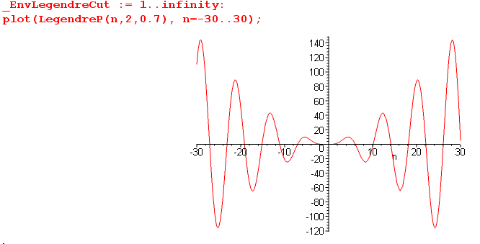

End of side question.

Now, since we have a standard SL problem, as CH pointed out, we always have an orthogonal and complete set of EF's. So it must be true that orthogonality looks like this:

$^{\int_{0}^{α}{}}$dθ sinθ Pn1m(cosθ) Pn2m(cosθ) = Kn1m(α) δn1,n2

which we can compare to our more conventional Legendre result for the full (0,π) interval which was

$^{\int_{-1}^{1}{}}$dz Pnm(z)Pkm(z) = δn,k (n+1/2)-1 (n+m)! / (n-m)! n,k = m, m+1, m+2 ...... ∞

= δn,k Knm Knm = (n+1/2)-1 (n+m)! / (n-m)!

This last result is valid for both integer and non-integer m, but for m not an integer, we must have m < 0.
Let's see if we can find the (0,α) orthogonality result in Smythe: Well, he quotes Dwight Dw and another source Pc which is the "Pierce integral tables", but this is not the result we want. Rather, he directly derives the result we want for the above orthogonality, and I will now quote his work. He uses Θ to be either the P or the Q function, and in fact it could be any linear combination, because his only use of it is that it solves the ODE. So here is his excellent Stakgold-like derivation of orthogonality: [ p 156 ]
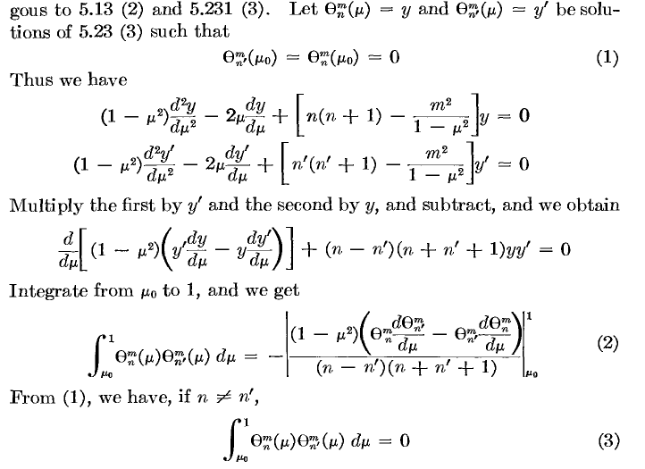
So we get the functions being orthogonal for those weird zeros n! Notice that when you process the first two equations, you get a perfect differential and that is where the result is coming from in (2). Of course μ0 is his cosα. When n ≠ n', both terms on the RHS of (2) vanish because, at μ = 1 the (1-μ2) factor = 0, and at the other end, the two Θ functions vanish! When n = n' we have a zero in the denominator so we need further processing, which he promptly does:

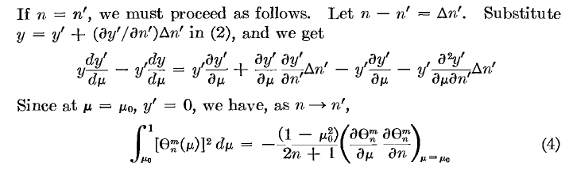
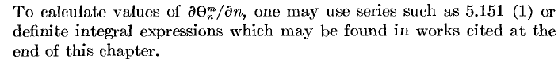

Maple cannot analytically compute ∂nPnm(z) derivatives. I think the best approach there would be to use an integral representation for the P function. Or do a numerical computation of each derivative.

So that is a pretty powerful cone-world orthogonality result I would say. This result does NOT appear in the Bateman Legendre chapter. Nor does it appear in AS. Nor can I find anything in GR. I don't think the functions we have here are polynomials, so not in an ortho poly section. Neither volume of MF has anything on "cone" to speak of, and I don't see the above result! Wow! Nor in CH either volume. The web? Have to look up "cone Legendre" or some such. I think our friend Smythe has a monopoly on this result. Perhaps in the Gegenbauer extended world or HG you might find something, but I want it for P and Q.

Comment: Remember that every single interval and ODE with self adjoint L defines a set of complete and orthogonal functions. You cannot expect every ODE to be catalogued with every possible interval! Usually data is provided only for a standard interval like (-1,1) for associated Legendre. So our friend Smythe has given me something I could never find that goes with his method of doing things, and he shows exactly how you derive the result! This method could be applied to other ODE's I think, so keep it stored on a back burner somewhere. [ One imagines that for a boundary between two cones, for example, you would be dealing with interval (α1, α2) instead of (-1,1), and this problem too would have some similar P and Q orthogonal function solutions. Maybe Smythe attacks that somewhere. ]

So here is the answer to orthogonality of the P's

$^{\int_{0}^{α}{}}$dθ sinθ Pnm(cosθ) Pn'm(cosθ) = Knm(α) δn,n'

Knm(α) = - sin2α /(2n +1) * ∂zPnm(cosα) ∂nPnm(cosα)

Probably the corresponding completeness would be this:

Σn Pnm(z') Pnm(z)/ Knm(α) = δ(z'-z)

where the sum is over the positive set ni. We shall use only the orthogonality below.

(d) Computation of the Amn coefficients.

Now let's go back to our earlier result, end of Section 2 above, where φβ= 0,

(1/εa2) δ(z-zβ)δ(φ-φβ) = (1/a) Σm=0∞ Σn Amn (2n+1) Pnm(z) cos(mφ)

First, apply $^{\int_{0}^{2π}{}}$dφ cos(m'φ) to both sides and use Schaum p 96 15.27 on the RHS to get

$^{\int_{0}^{2π}{}}$dφ cos(m'φ) cos(mφ) = π δm,m' // m and m' are integers! ( m ≠ 0 see later)

so we then have

(1/εa2) δ(z-zβ) = (1/a)π Σn Am'n (2n+1) Pnm'(z)

Now apply $^{\int_{0}^{α}{}}$dθ sinθ Pn'm'(cosθ) to both sides of the above to get

(1/εa2)Pn'm'(cosβ) = (π/a) Σn Am'n (2n+1) $^{\int_{0}^{α}{}}$dθ sinθ Pn'm'(cosθ) Pnm'(z)

and use our orthogonality result above to get

(1/εa2) Pn'm'(cosβ)/ε = (π/a) Am'n' (2n'+1) { - sin2α /(2n' +1) * ∂zPn'm'(cosα) ∂n'Pn'm'(cosα)}

Now remove all the primes, cancel two a factors, cancel 2n'+1, and we have

Pnm(cosβ)/(πεa) = Amn { - sin2α ∂zPnm(cosα) ∂nPnm(cosα)}

where α is the cone angle, and β is the location of our point charge. Then we get

Amn = – (πεa)-1 Pnm(cosβ)/ { sin2α ∂zPnm(cosα) ∂nPnm(cosα)}-1 m ≠ 0

which we can compare to Smythe's result [ he shows q, I have q = 1 ]

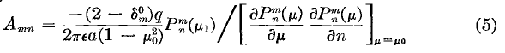

I have failed to handle the anomaly at m = 0. Notice that

$^{\int_{0}^{2π}{}}$dφ cos(mφ) cos(mφ) = 2π in the case m = 0

so we need to replace π with 2π when m = 0. This just means Amn is half as large as the general formula says when m = 0. You can see how Smythe does this with a factor that is 2 for m≠0 but 1 for m = 0. So, we have 100% agreement. Here then is my final result which agrees with his:

Amn = – (2-δm,0) (2πεa)-1 Pnm(cosβ) { sin2α ∂zPnm(cosα) ∂nPnm(cosα)}-1

(e) Comments on Smythe's Method.

His first step is to break the solution zone into the traditional two regions, interior and exterior to the Green's point charge. In each region, he comes up with a "form" which is a sum of known solution terms of the Laplace PDE. This form builds in the cone BC by its choice of n values which appear in the n sum. The form also builds in the correct r=0 and r=∞ values. Finally, the form builds in the requirement that the potential be continuous at r = a, the radius of the Green's charge:

r<a Vi = Σm=0∞ Σn Amn (r/a)n Pnm(z) cos(mφ)
r>a Ve = Σm=0∞ Σn Amn (r/a)-n-1 Pnm(z) cos(mφ)
or
V = Σm=0∞ Σn Amn (r</a)n (r>/a)-n-1 Pnm(z) cos(mφ) r< = min(r,a) r> = max(r,a)

So a huge amount of "the work" has already been done just writing down the above "forms", as I keep calling them. The problem is then to evaluate the Amn coefficients. He does this by insisting that the radial electric field be continuous everywhere but at the point charge, and near that point charge, we make use of Gauss's Law to handle things correctly in a distributional sense. Then by using the known orthogonality of the Φ and Θ functions, we can evaluate the Amn, all details shown above. Smythe provided just the right amount of detail in his text to allow me to reconstruct all the details. I was also able to tie this in with other strands of my increasing knowledge surrounding this subject.
It really is very similar to the 1D Green's problem. There we have two forms like the above, where each meets a BC. Instead of x in (a,b) for a string, we have r in (0,∞). Then at the boundary where the two Laplace solutions meet, where the point charge is located (the point force on the string), we first make the solution continuous (string does not break, V is continuous). Then we have to handle the singular location correctly. For the string, our little Gauss's 1D law gives the jump condition in the slope. For the potential in 3D, Gauss's 3D law tells us again about the jump condition for ∂rV, the slope of the solution, near the singular point. In the 1D problem, the slope jump is finite, but in the 3D problem it is infinite and we require a distribution to describe it, ∂rVi- ∂rVe = (1/εa2) δ(z-zβ)δ(φ-φβ). The 3D problem has the extra cone BC which has no analog in the 1D problem and is just an indicator of the enhanced "richness" of having more dimensions, to use a favorite writing term.

2a. Adding two walls to make a conical box.

This is Smythe's next example, and I feel some comments are in order. Following exactly the above approach, we have exactly the same "forms", but the radial situation is more complicated. I am tempted to write something like this:

r<a Vi = Σm=0∞ Σn Amn [ Cn(r/a)n + Dn (r/a)-n-1] Pnm(z) cos(mφ) // wrong
r>a Ve = Σm=0∞ Σn Amn [ Cn(r/a)n + Dn (r/a)-n-1] Pnm(z) cos(mφ)

where now the two forms are identical. We still have n to make things vanish on the cone, and we still have continuity at r = a, both built in. If we want things to vanish also at r = c and r = d > c, then obviously we are going to need

Cn(c/a)n + Dn (c/a)-n-1 = 0
Cn(d/a)n + Dn (d/a)-n-1 = 0

which we can solve Cramer style for Cn and Dn.
But there is an immediate problem with this approach. We have a form for Vi and Ve which solve Laplace and which meet all the BC's (cone and two walls). The problem is that the solutions are identical, and that means we cannot possibly do the required "matching" at the point charge. So the forms above are too restrictive for this problem.
So let's try these more general forms:

r<a Vi = Σm=0∞ Σn Amn [ Cn(r/a)n + Dn (r/a)-n-1] Pnm(z) cos(mφ) c
r>a Ve = Σm=0∞ Σn Amn [ C'n(r/a)n + D'n (r/a)-n-1] Pnm(z) cos(mφ) d

Then continuity at r = a requires that Cn + Dn = Cn' + Dn' and we then have

Cn(c/a)n + Dn (c/a)-n-1 = 0
Cn'(d/a)n + Dn' (d/a)-n-1 = 0
Cn + Dn = Cn' + Dn'

This is three equations in four unknowns, but one degree of freedom is just the overall scale of the result so we can just pick some number for one of the constants, then all are determined. Let's pick that scaling in the same way Smythe does just so we can compare his results to ours. He seems to have this:

Cn/an = (a2n+1 - d2n+1) / [an(c2n+1 - d2n+1)]
C'n /an = (a2n+1 - c2n+1) / [an(c2n+1 - d2n+1)]

Dn an+1 = (–c2n+1) (a2n+1 - d2n+1) / [an(c2n+1 - d2n+1)]
D'n an+1 = (–d2n+1) (a2n+1 - c2n+1) / [an(c2n+1 - d2n+1)]

which simplify to

Cn = (a2n+1 - d2n+1) / (c2n+1 - d2n+1)
C'n = (a2n+1 - c2n+1) / (c2n+1 - d2n+1)

Dn = (–c2n+1) (a2n+1 - d2n+1) / [a2n+1 (c2n+1 - d2n+1)]
D'n = (–d2n+1) (a2n+1 - c2n+1) / [a2n+1 (c2n+1 - d2n+1)]

which I rewrite again this way

Cn = (a2n+1 - d2n+1) / (c2n+1 - d2n+1)
C'n = (a2n+1 - c2n+1) / (c2n+1 - d2n+1)

Dn = (–c2n+1) (1 - (d/a)2n+1) / (c2n+1 - d2n+1)
D'n = (–d2n+1) (1 - (c/a)2n+1) / (c2n+1 - d2n+1)

and let's call the common denominator factor 1/k, so we then have

Cn = k(a2n+1 - d2n+1)
C'n = k(a2n+1 - c2n+1)

Dn = k(–c2n+1) (1 - (d/a)2n+1)
D'n = k(–d2n+1) (1 - (c/a)2n+1)

It seems unlikely this solves my third equation, but let's give it a shot. We can throw out the common factor of k (just set it to 1) so we have

Cn + Dn = (a2n+1 - d2n+1) + (–c2n+1) (1 - (d/a)2n+1) = a2n+1 - d2n+1 –c2n+1 + (cd/a)2n+1

Cn' + Dn' = (a2n+1 - c2n+1) + (–d2n+1) (1 - (c/a)2n+1) = a2n+1 –d2n+1 - c2n+1 + (cd/a)2n+1

and my equation #3 is in fact solved.

My first equation:

Cn(c/a)n + Dn (c/a)-n-1 = 0

(c/a)n (a2n+1 - d2n+1) / (c2n+1 - d2n+1) + (c/a)-n-1 (–c2n+1) (1 - (d/a)2n+1) / (c2n+1 - d2n+1)

Throw out the common denominator to get

(c/a)n (a2n+1 - d2n+1) + (c/a)-n-1 (–c2n+1) (1 - (d/a)2n+1)

(c/a)n (a2n+1 - d2n+1) + (c/a)-n-1 (–(c/a)2n+1)a2n+1 (1 - (d/a)2n+1)

= (c/a)n (a2n+1 - d2n+1) + (c/a)n (–a2n+1) (1 - (d/a)2n+1)

Throw out the common (c/a)n

= (a2n+1 - d2n+1) - a2n+1(1 - (d/a)2n+1)

= a2n+1– d2n+1 - a2n+1 + (d)2n+1 = 0

So his coefficients solve my first equation. I won't bother verifying my second equation.

Conclusion: He has selected one of the four constants and derived expressions for the three others. You could pick any starting point, so let's just say he did this choice:

Cn = (a2n+1 - d2n+1) / (c2n+1 - d2n+1)

and that forced the other three. So in effect, I have now completely verified Smythe's forms:
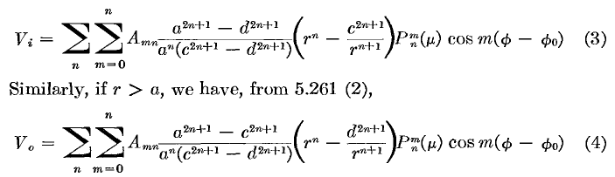

His method got there faster than mine, fine. I will still write things this way

r<a Vi = Σm=0∞ Σn Amn [ Cn(r/a)n + Dn (r/a)-n-1] Pnm(z) cos(mφ) c
r>a Ve = Σm=0∞ Σn Amn [ C'n(r/a)n + D'n (r/a)-n-1] Pnm(z) cos(mφ) d

Now finally we can move onto the next step. Take those derivatives

r<a ∂rVi = (1/a) Σm=0∞ Σn Amn [ nCn (r/a)n-1 - (n+1) Dn (r/a)-n-2] Pnm(z) cos(mφ)
r>a ∂rVe = (1/a) Σm=0∞ Σn Amn [ nC'n(r/a)n-1 - (n+1) D'n (r/a)-n-2] Pnm(z) cos(mφ)

Now take the difference of these two equations, and note that away from point charge, get 0

0 = ∂rVi- ∂rVe
= (1/a) Σm=0∞ Σn Amn [n(Cn-Cn') (r/a)n-1 - (n+1) (Dn-Dn') (r/a)-n-2] Pnm(z) cos(mφ)

When we apply our pillbox, we only really care about r = a, so simplify to get

∂rVi- ∂rVe = (1/a) Σm=0∞ Σn Amn [n(Cn-Cn') - (n+1) (Dn-Dn')] Pnm(z) cos(mφ) r = a

Now we can compute the coefficient differences using his values.

Cn = (a2n+1 - d2n+1) / (c2n+1 - d2n+1)
C'n = (a2n+1 - c2n+1) / (c2n+1 - d2n+1)

Dn = (–c2n+1) (1 - (d/a)2n+1) / (c2n+1 - d2n+1)
D'n = (–d2n+1) (1 - (c/a)2n+1) / (c2n+1 - d2n+1)

Cn-Cn' = (a2n+1 - d2n+1) / (c2n+1 - d2n+1) - (a2n+1 - c2n+1) / (c2n+1 - d2n+1)

= (c2n+1 - d2n+1) / (c2n+1 - d2n+1) = 1 // !

Dn-Dn' = ?

Rewrite the above as

Dn = – (1 - (d/a)2n+1) / (1 - (d/c)2n+1)
D'n = – (1 - (c/a)2n+1) / (1 - (d/c) 2n+1)

Dn-Dn' = ( (c/a)2n+1 – (d/a)2n+1 ) / (1 - (d/c) 2n+1) ≡ – En // reason for minus below

So we now see that he scaled his coefficients just to get that first difference be 1. Big deal. So we now have:

∂rVi- ∂rVe = (1/a) Σm=0∞ Σn Amn [n + (n+1) En] Pnm(z) cos(mφ) r = a

We now make the exact same argument as in the regular cone problem (without the two walls). We apply our little pillbox to get

[ ∂rVi – ∂rVe ] = (1/εa2) (1/ ΔΩβ ) → (1/εa2) δ(z-zβ)δ(φ-φβ)

This fact is not affected one iota by "extra boundaries". So we then have

(1/εa2) δ(z-zβ)δ(φ-φβ) = (1/a) Σm=0∞ Σn Amn [n+ (n+1) En] Pnm(z) cos(mφ) (**)

We do all the previous steps exactly as before. However, where we had (2n+1) before, we now have the expression [n+ (n+1) En] . So let's go back to our previous intermediate result which was this:

(1/εa2) Pn'm'(cosβ)/ε = (π/a) Am'n' (2n'+1) { - sin2α /(2n' +1) * ∂zPn'm'(cosα) ∂n'Pn'm'(cosα)}

And now make that replacement to get

(1/εa2) Pn'm'(cosβ)/ε = (π/a) Am'n'[n'+(n'+1) En'] { - sin2α /(2n' +1) * ∂zPn'm'(cosα) ∂n'Pn'm'(cosα)}

and now we no longer get cancellation and we have this extra factor sitting around

[n'+(n'+1) En']/ (2n' +1)

and here then are the new Amn coefficients:

Amn = – (2-δm,0) (2πεa)-1 Pnm(cosβ)/ { sin2α ∂zPnm(cosα) ∂nPnm(cosα)}-1 * (2n+1)/ [n+(n+1) En]

where - En = ( (c/a)2n+1 – (d/a)2n+1 ) / (1 - (d/c) 2n+1)

which result he does not quote.

Suppose to this box we added orange slice walls centered at φ = 0. This merely changes the spectrum of the m quantum numbers so they will be equally spaced but no longer integers. I know that you must then consider Pnm(z) as the ODE solutions where m takes on only the negative values (and 0). This of course causes the ni which are the zeros to be different numbers, but I think our formulas all stay exactly the same! So we could do this both for the full cone and for the cone + walls. Smyth comments on this but prefers to put the slice walls to get sines which vanish at both ends instead of cosines which do the same.

3. Green's Function for a Sphere using this Smythe Method.

Yes, the method of images works fine for this, but let's just see what it looks like in this Smythe method. Inside r=a we can have only rn but outside we can have both, so let's steal from above, sphere radius d which was the larger of Smythe's two cone box things. Our "cone" now is just z = -1 and we know that m are integers and so must be the n, with the usual spherical harmonic values. We put the Green's charge as before at φ = 0 so we have only cos(mφ).

r<a Vi = Σm=0∞ Σn Amn [ Cn(r/a)n + Dn (r/a)-n-1] Pnm(z) cos(mφ) c
r>a Ve = Σm=0∞ Σn Amn [ C'n(r/a)n + D'n (r/a)-n-1] Pnm(z) cos(mφ) d

We know that Dn = 0 for the sphere. Let's see if we can just "steal" our radial coefficient results from the previous problem by setting c = 0:

Cn = (a2n+1 - d2n+1) / (c2n+1 - d2n+1) = (a2n+1 - d2n+1) / ( - d2n+1)
C'n = (a2n+1 - c2n+1) / (c2n+1 - d2n+1) = (a2n+1 ) / ( - d2n+1)

Dn = (–c2n+1) (1 - (d/a)2n+1) / (c2n+1 - d2n+1) = 0
D'n = (–d2n+1) (1 - (c/a)2n+1) / (c2n+1 - d2n+1) = (–d2n+1)/ ( - d2n+1) = 1

which we summarize as

Cn = 1 - (a/d)2n+1 Dn = 0
C'n = - (a/d)2n+1 D'n = 1

which seem pretty reasonable. As before we have Cn-Cn' = 1 and now Dn-Dn' = -1 = -En. [ Aside: This method might leave a tiny radial fiber of V = 0 at the south pole.]

So I think we can cut to the chase here and claim our coefficient results based on the previous problem: ]

Amn = – (2-δm,0) (2πεa)-1 Pnm(cosβ)/ { sin2α ∂zPnm(cosα) ∂nPnm(cosα)}-1 * (2n+1)/ [n+(n+1) 1]

= – (2-δm,0) (2πεa)-1 Pnm(cosβ)/ { sin2α ∂zPnm(cosα) ∂nPnm(cosα)}-1 * (2n+1)/ [(2n+1)]

= – (2-δm,0) (2πεa)-1 Pnm(cosβ)/ { sin2α ∂zPnm(cosα) ∂nPnm(cosα)}-1

where our point charge is at (a,β,0). But now we have a much messier than necessary result and we have to take tricky limits as α → π. Therefore, let's "back up" a bit to this point: (En = 1 now)

(1/εa2) δ(z-zβ)δ(φ-φβ) = (1/a) Σm=0∞ Σn Amn(2n+1) Pnm(z) cos(mφ) // = ∂rVi- ∂rVe

where we have inserted En = 1 into result (**) from above. Now we do what we did in the first cone problem above, and I just quote it:

First, apply $^{\int_{0}^{2π}{}}$dφ cos(m'φ) to both sides and use Schaum p 96 15.27 on the RHS to get

$^{\int_{0}^{2π}{}}$dφ cos(m'φ) cos(mφ) = δm,m'2π/(2-δm,0)

so we then have

(1/εa2) δ(z-zβ) = (1/a) 2π/(2-δm,0) * Σn Am'n (2n+1) Pnm'(z)

Now apply $^{\int_{0}^{π}{}}$dθ sinθ Pn'm'(cosθ) to both sides of the above to get (here setting α = π)

(1/εa2)Pn'm'(cosβ) = 2π/(2-δm,0) (1/a) Σn Am'n (2n+1) $^{\int_{0}^{π}{}}$dθ sinθ Pn'm'(cosθ) Pnm'(z)

Now we retake control, remove primes, change to z, replace m' with m,

(1/εa2)Pn'm(cosβ) = 2π/(2-δm,0) (1/a) Σn Amn (2n+1) $^{\int_{-1}^{1}{}}$dz Pn'm(z) Pnm(z)

Now instead of the nasty non-integral orthogonality (which will be valid if we take its limit) we can just use our normal associated Legendre result which is this (from ODE/Legendre area ).

$^{\int_{-1}^{1}{}}$dz Pnm(z)Pn'm(z) = δn,n' (n+1/2)-1 (n+m)! / (n-m)! n,n' = m, m+1, m+2 ...... ∞

so we then have

(1/εa2)Pn'm(cosβ) = 2π/(2-δm,0) (1/a) Σn Amn (2n+1) $^{\int_{-1}^{1}{}}$dz Pn'm(z) Pnm(z)

= 2π/(2-δm,0) (1/a) Σn Amn (2n+1) { δn,n' (n+1/2)-1 (n+m)! / (n-m)!}

= 2π/(2-δm,0) (1/a)Amn' (2n'+1) { 2 (2n'+1)-1 (n'+m)! / (n'-m)!}

Cancel factors and replace n'→n to get

(1/εa2)Pnm(cosβ) = (4π/a)/(2-δm,0) * Amn (n+m)! / (n-m)!

Amn = (2-δm,0) (a/4π)(1/εa2)Pnm(cosβ) (n–m)! / (n+m)!

Amn = (2-δm,0) /[4π εa] Pnm(cosβ) (n–m)! / (n+m)!

So our solution to this sphere Green's problem must be: [ charge at (a, β, 0) , sphere radius d ]

r<a Vi = Σm=0∞ Σn=m∞ Amn [1 - (a/d)2n+1] (r/a)n Pnm(z) cos(mφ)
r>a Ve = Σm=0∞ Σn=m∞ Amn [ - (a/d)2n+1 (r/a)n + (r/a)-n-1] Pnm(z) cos(mφ)

Amn = (2-δm,0) /[4π εa] Pnm(cosβ) (n–m)! / (n+m)!

and now we are allowed to write the double sum as Σn=0∞ Σm=0n if we want. The -m don't appear because we put our charge at φ = 0 so cos(mφ) does the trick and not independent etc etc. So this is a little different from the usual spherical harmonic result where we have an embedded eimφ .

Let's do a few quick checks. When r = a we have

[1 - (a/d)2n+1] (r/a)n = [1 - (a/d)2n+1]

[ - (a/d)2n+1 (r/a)n + (r/a)-n-1] = [ - (a/d)2n+1 + 1 // check!

When r = d we have

[ - (a/d)2n+1 (r/a)n + (r/a)-n-1] = [ - (a/d)2n+1 (d/a)n + (d/a)-n-1]

= [ - (a/d)n+1 + (d/a)-n-1] = [ - (a/d)n+1 + (a/d)n+1] = 0 //check

What happens at z = -1 and some r < d ? We have Pnm(-1) = δ0m(-1)n so only m=0 survives. For r>a
get

Ve = Σn=0∞ A0n [ - (a/d)2n+1 (r/a)n + (r/a)-n-1] (-1)n

A0n = 1 /[4π εa] Pn(cosβ)

which does not seem to give V = 0 on the south pole radial segment.

Why is the above the solution?
(1) it is constructed of terms each of which satisfies Laplace
(2) at r = a, V is continuous (even at the location of the point charge)
(3) at r = 0, V = finite
(4) at r = d, V = 0
(5) the "jump condition" around the point charge has been satisfied. That condition was this:
∂rVi- ∂rVe = (1/εa2) δ(z-zβ)δ(φ-φβ)

Note Added: I have now written Appendices A,B,C on orthogonality for this kind of problem. So let's repeat the above using Appendix C. We start with,

(1/εa) δ(z-zβ)δ(φ-φβ) = Σm=0∞ Σn Amn (2n+1) Pnm(z) cos(mφ) = f(z,φ)

To get into Appendix C form, set fmn = Amn (2n+1) and φm = 0. The inversion is

fmn = (2n+1)/4π * (2-δm,0) (n-m)!/ (n+m)! * ∫dz∫dφ f(z,φ) Pnm(z) cos(mφ)

= (2n+1)/4π * (2-δm,0) (n-m)!/ (n+m)! * ∫dz∫dφ (1/εa) δ(z-zβ)δ(φ-φβ) Pnm(z) cos(mφ)

= (1/εa) (2n+1)/4π * (2-δm,0) (n-m)!/ (n+m)! * Pnm(zβ) cos(mφβ)

Then we get

Amn = (1/4π εa) (2-δm,0) (n-m)!/ (n+m)! * Pnm(zβ) cos(mφβ)

which agrees with the above result if we have φβ = 0. (n-m)!/ (n+m)! = f(n,-m)

Note added June 24, 2010. Somehow my sphere result above must come out being the same as the sum of the simple potential of the unit point charge inside the sphere, plus the simple potential of the image charge outside. For example, we know now that the potential of the Green's charge at (a,β,0) is this (where think of 4πε = 1 for the time being)

Vgreen's = 1/R = 1/|r-rg| = Σn=0∞ Σm=0∞ εm f(n,-m) (r<)n(r>)-n-1 Pnm(z) Pnm(zβ) cos(mφ)

Vimage = 1/R' = qi/|r-ri| = qi Σn=0∞ Σm=0∞ εm f(n,-m) (r)n(ri)-n-1 Pnm(z) Pnm(zβ) cos(mφ)

where I think ri = (d2/a) and qi = -(d/a). In the second case, r> = ri since it lies outside the sphere. So we can now look at our two cases. If r < a we have

Vgreen's = Σn=0∞ Σm=0∞ εm f(n,-m) (r)n(a)-n-1 Pnm(z) Pnm(zβ) cos(mφ)

Vimage = -(d/a) Σn=0∞ Σm=0∞ εm f(n,-m) (r)n(d2/a)-n-1 Pnm(z) Pnm(zβ) cos(mφ)

If we add these together we get

V = Σn=0∞ Σm=0∞ εm f(n,-m) [(r)n(a)-n-1 - (d/a) (r)n(d2/a)-n-1] Pnm(z) Pnm(zβ) cos(mφ)

= Σn=0∞ Σm=0∞ εm f(n,-m) [(r)n(a)-n-1 - (d/a) (r)n(d2/a)-n-1] Pnm(z) Pnm(zβ) cos(mφ)

= Σn=0∞ Σm=0∞ Amn a [(r)n(a)-n-1 - (d/a) (r)n(d2/a)-n-1] Pnm(z) cos(mφ)

= Σn=0∞ Σm=0∞ Amn [(r)n(a)-n - d (r)n(d2/a)-n-1] Pnm(z) cos(mφ)

= Σn=0∞ Σm=0∞ Amn [(r/a)n - (r/a)n an d (d2/a)-n-1] Pnm(z) cos(mφ)

= Σn=0∞ Σm=0∞ Amn [1 - an d (d2/a)-n-1] (r/a)n Pnm(z) cos(mφ)

= Σn=0∞ Σm=0∞ Amn [1 - a2n+1 d-2n-1] (r/a)n Pnm(z) cos(mφ)

= Σn=0∞ Σm=0∞ Amn [1 - (a/d)2n+1] (r/a)n Pnm(z) cos(mφ)

which is exactly right. I will just assume that for r > a things also agree. Pretty cool stuff.

4. How does Smythe compare to Stak's list of ways to compute Green's Functions?

The above method just outlined is very much like Stakgold "manual method" for finding the 1D Green's functions. Here is a little review of Stakgold's later Chapter 6 "methods" of computing Green's functions:

(1) The Integral Equation Method
Only Example of the Integral Equation Method: the unit disk. (147)
(1.5) Digression to show that two 2D point charges generate circles of constant potential

(2) The Method of Images
Comment on the 3D dipole equipotential lines.
Example 1: Green's function for the unit sphere (3D) (150)
(a) Stakgold's method (150)
(b) My method
Example 2: Green's function for a half space (3D)
Example 3: Neumann's function for a half space (3D)
Example 4: Line charge parallel to a plane (3D)

(3) The Method of Full Eigenfunction Expansion (153) (nD)

(4) The Method of Partial Eigenfunction Expansion (154) (2D only)
Example 1. Green's function for the rectangle. (155)
Example 2. Green's function for the unit circle. (159)
Example 3. Green's function for two horizontal plates with a line charge (2D strip). (161)

(5) Complex Variable Method for 2D (164)

(6) The Smythe manual method ( I add this to the list right now!)

We know that the image method (2) directly applies to our sphere. And we also could do the full eigenfunction method where we would use that general formula g(x|ξ) = Σn φλn(x)λn(ξ) / λn and the eigenfunctions are then something like jl(kr)Ylm(θ,φ) and we would say something like

V(r,θ,φ| a,β,0) = (1/$\sqrt{ar}$) Σlm Σk jl(klmr)Ylm(θ,φ) jl(klma)Ylm(β,0)/λlmk λlmk = klm2

Yes, the eigenfunctions of the sphere are given in Stak page 145 H. This is a triple sum where the third sum is over an index that enumerates the eigenvalues klmk. Stak just calls it k. This certainly is more complex that our double sum formula above whose r-functions are just powers

r<a Vi = Σm=0∞ Σn=m∞ Amn [1 - (a/d)2n+1] (r/a)n Pnm(z) cos(mφ)
r>a Ve = Σm=0∞ Σn=m∞ Amn [ - (a/d)2n+1 (r/a)n + (r/a)-n-1] Pnm(z) cos(mφ)
Amn = (2-δm,0) /[4π εa] Pnm(cosβ) (n–m)! / (n+m)! = εm/[4π εa] Pnm(cosβ) f(n,-m)

but still it or something close to it (constants) must be correct.

Let's see if I can find this stated somewhere [ before I found the Stak reference above] . Might be hard to find. Well, it is hard. Here is something at least similar:
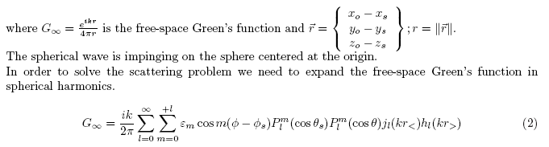
Well, I explain this expansion pretty well in " A study of (R)-1 expansions in spherical coordinates.doc", explaining its general appearance, so no more comments needed here.

5. Smythe Method for other orthogonal coordinate systems.

I can see it will work just fine. They key idea will be to "shape" the point charge in a manner which matches the coordinate system, and then come up with some appropriate form for the jump condition which will have delta functions. Something will then replace ∂rVi- ∂rVe = (1/εa2) δ(z-zβ)δ(φ-φβ). Then if we can find orthogonal functions, we can carry things through.

6. Review of Smythe Oblate Spheroidal Work (Previously Read)

(6a) Motivation: This has been one of my long-running unsolved problems. Many weeks ago I was interested in the potential of a partial sphere, and I learned it could be found by the inversion method from the Green's function of a disk. Knowing the Green's for an Oblate Spheroid would give that disk Green's and bring this whole voyage to a good conclusion. This voyage has been like an Odyssey, all along the way are creatures trying to shipwreck the traveler.

(6b)Reviews.

(a) First, let's review our own doc "Smythe on oblate spheroidals" with Smythe himself up in his DJVU at page 158 (d177) . Remember ζ is the "ellipse label" and ξ is "cone angle" animal which becomes the z of sphericals far away. 0 < ζ < ∞ for all those ellipses, and 0 < ξ < 1 for cone angle (cosine of). Right off the bat we get the main separation result

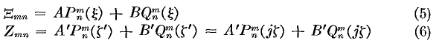

which I have no problem with whatsoever. And the distant spherical limits
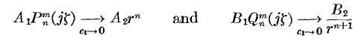
Smythe then does the "hole in metal plate" problem "his way". He writes down a certain "form" for the solutions that meets his BC's. That form is this:

where only n = 1 appears due to a certain distant requirement of that big plate, and only m=0 appears because the solution for the hole must have azimuthal symmetry. Only the P appears in cone angle again from that distance requirement, Q would blow up. But both P and Q are allowed in the ellipse label world. I decided that, although a clever "form", Smythe's presentation was not very "didactic" for me, so I redid the solution in a separate doc called "Smythe hole in plate problems.doc".

(b) Second, let's review "Smythe hole in plate problems.doc". Here I give a more complete review of the general solution method, and here it is from Smythe,

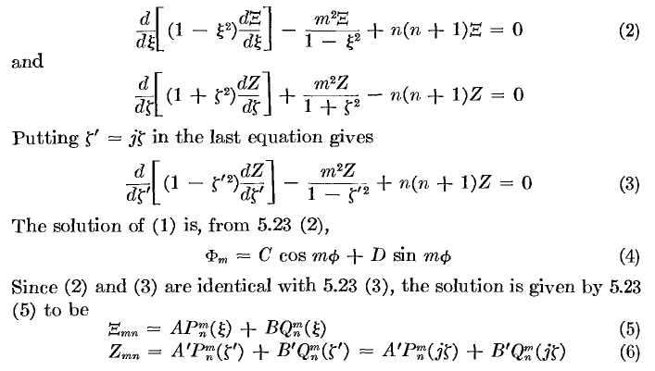

The origin of the imaginary coordinate is made very clear here. I then worried about the Sturm-Liouville ODE problem on this unusual interval jζ in (0,i∞) and concluded that the spectrum of n is continuous and that discrete values, should they arise, will come from the cone angle function ξ, not the ellipse function ζ. Any quantized real value of n that ξ requires will be fine with ζ . [ This issue was resolved in yet another doc called "questions about Legendre.doc" and its meta version. ]
So, I started again on the hole in plate problem (my way) using what I would now call "the Smythe Method", even though he did not quite use this method on this particular problem. I assumed the following "form"

V = ξ [ A'j ζ + B' (ζ cot-1(ζ) – 1) ] ξ ≥ 0
V = ξ [ A"j ζ + B" (ζ cot-1(ζ) – 1) ] ξ ≤ 0

where I have now written out the P1 and Q1 functions. Each ellipse has one constant ζ value, and the cone angle is positive above the plane, and negative below, just the way z is for spherical z = cosθ. [ This is why I like this labeling of things, rather than the tricky way Smythe did it in "his way". ]
The plate surface is ξ = 0 in cone angle so we get V = 0 on the plate, it is "built in" to the form, very Smythian. Going far "north" away from the plate tells us jA' = aE (a = hole diameter, E = distant applied field in this problem). Going far "south" tells use A" = 0, since we just get a tiny leakage of potential through the hole. So north and south set two of the four constants which appear in the Smythian "form" above.
Inside the hole, on the other hand, we are at ζ = 0. Requiring that V be the same at this hole boundary between our two regions says B" = -B'. There still remains one free variable to nail down. I first tried the tangential derivative match in the hole, but that gave nothing new. I would now know that it is the normal derivative you want. Doing that match gives B' π = – (Ea) and then the problem is fully solved including scaling to E. That is to say, using the above form, we have values for all four unknown constants. Our form satisfies Laplace, and it meets all BC's, so it must be the right answer.

V = (aE)ξ [ ζ – (1/π) (ζ cot-1(ζ) – 1) ] ξ ≥ 0
V = (aE)ξ [ + (1/π)(ζ cot-1(ζ) – 1) ] ξ ≤ 0

I might add that you have to be very careful at the hole boundary when you compute derivatives since the sign of ξ is different on the two sides of the hole. I plotted the above result and was happy with it.
Emboldened, I then went on to solve the simple "charged plate with hole in it" problem (charged iris), did it exactly the same Smythian way. Used exactly the same starting form. Match V in the hole gives same B" = -B'. Far north gives jA' = -aE, where now E is not imposed, but comes from E = σ/ε , ie, it is due to the charge density σ we assume sits on both sides of the plate. Going south says A"j = +Ea. Matching normal derivative (electric field) in the hole then gives B' = 2aE/π. The solution to the problem is then this

V = –(aE)ξ [ ζ – (2/π) (ζ cot-1(ζ) – 1) ] ξ ≥ 0 E = σ/ε
V = –(aE)ξ [ – ζ + (2/π) (ζ cot-1(ζ) – 1) ] ξ ≤ 0

which is very similar in form to the previous solution!
Here are plots of the solutions to these two problems:

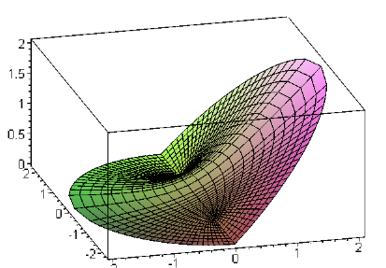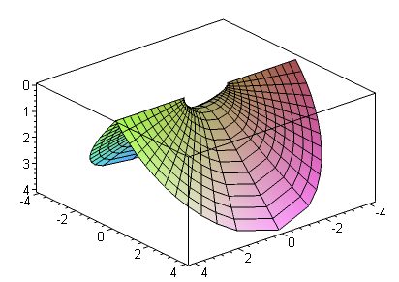
Hole in plate with E field to the right Hole in plate with σ on each side.

7. Smythe Oblate Spheroidal Neumann Problem [ 165 ]

He next attacks the what a modern writer would call the Neumann problem for an oblate spheroid. I appreciate more what he is doing here, now that I have filled in the many gaps in my understanding. In this problem, he assumes a certain σ(ξ,ζo,φ) on the surface of a physical spheroid having ζ = ζ0. Our problem is to compute the potential both inside Vi and outside Vo this spheroid.
Just to make the Neumann point, we would say (if it were a conducting surface so only one-sided)

σ(ξ,ζo,φ) = ε E(ξ,ζo,φ) = -ε ∂n V(ξ,ζo,φ) n meaning "normal"

and you have to worry about what ∂n means in these coordinates, related to ∂ζ with a scale factor. But he just works with σ(ξ,ζo,φ) so we don't have to worry about this. Lesson #1: problem with an arbitrary charge distribution on a surface is the Neumann problem. Problem with arbitrary potential on a surface is the Dirichlet problem.

(a) Setting up the problem.

Now Smythe never actually writes σ(ξ,ζo), and his presentation is a little fuzzy due to that fact. Let's hold on that for a moment, and look at his "form" for the potential:

You can see that these are all really (Vi)n,m components and you are supposed to sum over n and m to get the full potentials inside and outside of the spheroid ζ0. Let's first check on what is "built in" to his form here. As "usual", for the radial ζ coordinate we have P on the inside and Q on the outside. Recall from above that these have exactly the limits rn and r-n-1. Next, at ζ = ζ0 you see that the product QP is the same in both expressions! This then forces Vi and Vo to match on the spheroid ζ0. That is WHY he has chosen to put the inert Q and P constants into the two equations. Very clever I think.
Since we have a full spheroid here, we know that m = integers, and then the ξ ODE equation forces n = the usual integers since we are going all the way to ξ = -1. So there is no mystery at all about the quantization situation for this problem.
Now what remains is to match ∂nV at the spheroidal surface, and this is where σ comes in. For some reason I don't understand, he does not want to show Σm,n so he works with just the m,nth component of the sum. So here is his meaning of σn as best I can tell (why no m index on it? )

σ(ζo,ξ,φ) = Σn,m σn(ξ,φ) // should really be Σn,m σnm(ξ,φ)

He then writes this equation, which is then just one "n,m" term in the sum

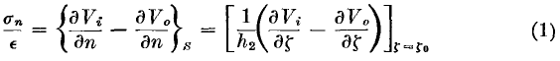

Let's just ignore σn for now and just solve the problem, then come back later to it.

So, I will now write things out in my notation:

Vi(ζ,ξ,φ) = (j /ε) Σn,m (-1)m Cn,m [ (n-m)!/(n+m)!] (1+ζ02) Qnm(jζ0) Pnm(jζ) Pnm(ξ) cos(m[φ-φm])

Vo(ζ,ξ,φ) = (j /ε) Σn,m (-1)m Cn,m [ (n-m)!/(n+m)!] (1+ζ02) Pnm(jζ0) Qnm(jζ) Pnm(ξ) cos(m[φ-φm])

All the other mysterious constant factors are going to make the Cn,m come out nice I am sure. So the above seems a more conventional way to write the potentials in the two regions. I highlight the swapped P and Q functions, everything else is the same in the two large expressions. Now our condition is

σ(ζ0,ξ,φ)/ε = Eo - Ei // where Eo > 0 , in r direction, positive charge σ etc

= –∂nVo + ∂nVi // ε = 4π for Jackson notation

(b) Review of the scale factors for oblates. (comparing Smythe and MF)

Now comes the scale factor. First, we go to our general curvilinear notes

ds2 = g'ijdqidqj = dqidqi = dq.dq q-space

Qi2 = g'ii

So in an orthogonal system we have

ds2 = Σi Qi2dqi2 = Q12dq12 + Q22dq22 + Q32dq32

and if we move in a direction in which only one of the curvilinear coordinates changes, we have
for example

ds = Q2dq2

In our current situation, we want to move in a direction normal to the spheroidal surface so that only coordinate ζ changes, so we have

dn = Qζ dζ Qζ = ??

Where does Smythe talk about the scale factors (he calls this one h2) ? Page 50-52 has his general discussion of curvilinears (with good pictures). Page 159 has our specific results

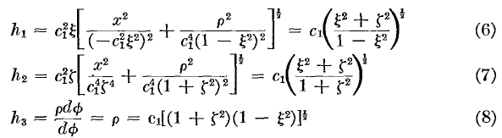

His coordinate ordering corresponding to the above is (1,2,3) = (ξ,ζ,φ) which is NOT what I would have used, but OK. Let's check these results with MF:
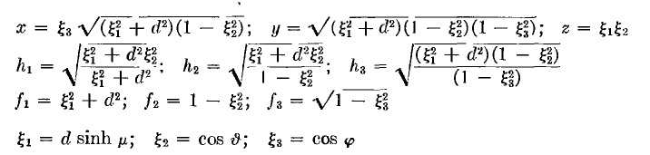

So we make this connection:

ξ1 = d ζ ξ2= ξ ξ3 = φ d = c1

So notice that MF put then in the right logical order, but MF include the focal distance as a factor in their definition of ξ1 . So consider then

h1MF = [ (d2 ζ2 + d2ξ2)/(d2ζ2 + d2)]1/2 = [ (ζ2 + ξ2)/(ζ2 + 1)]1/2 = h2SMY/ c1

Something is wrong here? Well, let's just compare :

ds = h1MF dξ1 = h1MF (d dζ)

ds = h2SMY dζ => d h1MF = h2SMY

So OK, nothing is wrong, and MF and Smythe agree. So, we will be using this

h2 = h2SMY = c1 [ (ζ2 + ξ2)/(ζ2 + 1)]1/2

In a way, Smythe's coordinates are nicer since his ζ at least has dimensions like r has dimensions. But I don't like Smythe's ordering, nor his confusing choice of Greek letters, but as usual, OK, we get what we get.

Note added 1.14.10. Strangely, MF use different oblate coordinates in their volume 2, page 1292, from which I quote:

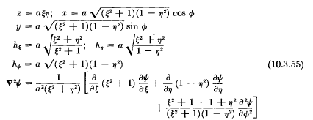

These are the ones I remember better, ξ and η. We can compare these to Smythe,

and this shows the direct connection that (η,ξ)MF = (ξ,ζ)Smythe.

(c) Condition at the surface where the charge is

We can now resume where we were:

σ(ζ0,ξ,φ)/ε = Eo - Ei // where Eo > 0 , in r direction, positive charge σ etc

= –∂nVo + ∂nVi

But dn = ds = h2SMY dζ = h2dζ so ∂n = 1/h2 ∂ζ and we then get

= [ –∂ζVo + ∂ζVi]/h2

and these are now derivatives we can compute, to wit: [ ∂ζ Pnm(jζ) = P'nm(jζ) * j ]

∂ζVi(ζ,ξ,φ) = (j /ε) Σn,m (-1)m Cn,m [ (n-m)!/(n+m)!] (1+ζ02) Qnm(jζ0) j P'nm(jζ) Pnm(ξ) cos(m[φ-φm])

∂ζVo(ζ,ξ,φ) = (j /ε) Σn,m (-1)m Cn,m [ (n-m)!/(n+m)!] (1+ζ02) Pnm(jζ0) j Q'nm(jζ) Pnm(ξ) cos(m[φ-φm])

Now take the difference to get (after difference, set ζ = ζ0 since that is where σ is located )

∂ζVi – ∂ζVo = (j /ε) Σn,m (-1)m Cn,m [ (n-m)!/(n+m)!] (1+ζ02) Pnm(ξ) cos(m[φ-φm])

* j [Qnm(jζ0) P'nm(jζ0) - Pnm(jζ0) Q'nm(jζ0) ]

and we have a nice Wronskian.

(d) Digression on the Wronskian.

Bateman gives this thing on page 123 bottom. The gamma functions don't seem right, but I will carry on and see what happens: ( m and n are general complex here! )

W[ Pnm(z), Qnm(z)] ≡ Pnm(z) Q'nm(z) – P'nm(z) Qnm(z)

= eimπ 22m Γ(1 + m/2 + n/2) Γ(1/2 + m/2 + n/2) / [Γ(1 - m/2 + n/2) Γ(1/2 - m/2 + n/2) (1-z2) ]

Let's try to simplify the gammas using Schaum p 102,

22x-1 Γ(x)Γ(x+1/2) = $\sqrt{π}$ Γ(2x)

For numerator, let x = 1/2 + m/2 + n/2 and we get 2x = 1+m+n and 2x-1 = n+m

Γ(1 + m/2 + n/2) Γ(1/2 + m/2 + n/2) = $\sqrt{π}$2-n-m Γ(1+m+n)

For denominator, just change sign of m

Γ(1 - m/2 + n/2) Γ(1/2 - m/2 + n/2) = $\sqrt{π}$2-n+m Γ(1-m+n)

Then the four gamma together give

Γ(1 + m/2 + n/2) Γ(1/2 + m/2 + n/2) / [Γ(1 - m/2 + n/2) Γ(1/2 - m/2 + n/2)

= $\sqrt{π}$2-n-m Γ(1+m+n) / [$\sqrt{π}$2-n+m Γ(1-m+n)

= 2-2m Γ(1+m+n)/ Γ(1-m+n)

= 2-2m (n+m)! / (n-m)!

Now let's back up to and write [ see below for clarification ]

W[ Pnm(z), Qnm(z)] ≡ Pnm(z) Q'nm(z) – P'nm(z) Qnm(z)

= eimπ 22m Γ(1 + m/2 + n/2) Γ(1/2 + m/2 + n/2) / [Γ(1 - m/2 + n/2) Γ(1/2 - m/2 + n/2) (1-z2) ]

= eimπ 22m 2-2m Γ(1+m+n)/ [Γ(1-m+n) (1-z2) ]

= eimπ Γ(1+m+n)/ [Γ(1-m+n) (1-z2) ] arbitrary m and n

= (-1)m (n+m)! / (n-m)! * 1/(1-z2) m and n integers // see below!

Why didn't Bateman say this in the first place? I cannot find this anywhere, but I do find this disturbing result in MF page 1328

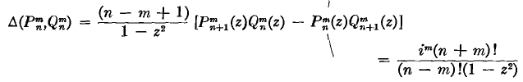

Why do MF have a different phase?? This no doubt relates to their T function stuff. I now need to find the exact MF definitions of their P and Q functions, this will be painful. Maybe just the integer formulas will help me out.

Bateman p 148 says the following, using "off the cut" definitions of things

Pνm = (z2-1)m/2 ∂mPν m = 0,1,2..
Qνm = (z2-1)m/2 ∂mQν m = 0,1,2..

MF on page 1328 say the following
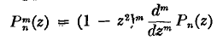 page 1325
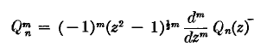 page 1328

So for m ≠ 0, they really are different! So a digression.

This was a very long digression, causing me to write "legendre on cut.doc" where I think I got everything figured out. There I also compare the P and Q functions of Bateman/me, MF and Smythe. It turns out that Smythe generally uses the on-the-cut P and Q functions, BUT Smythe adds an extra (-1)m phase for both these functions! This is the "non Condon Shortley phase". In computing a Wronskian, each of the two terms will have a factor (-1)2m so we can forget about that distinction between Smythe and Bateman for on the cut.
However, when he is dealing with P and Q with imaginary arguments, Smythe uses the regular Bateman form, not the on-the-cut version, so the Wronskian as I have written it above shall apply, including the (-1)m factor.

Now let's take another look at the MF result for this Wronskian

As I discuss in that document, MF use P on the cut, and Q not on the cut, so they have one foot in each camp. If both P and Q were off the cut, they would have a (-1)m phase in the above Wronskian. Somehow, because only one of the two functions is off the cut, they only build up half that phase and that is im as shown. Since MF don't give any reference for the above Wronskian, and since they don't really deal very well with Legendre functions, I am not going to worry any more about this im phase. I am happy with the phase shown above.

(e) Resuming now that we have the right Wronskian.

So let's then continue our Smythe saga, using the Wronskian above. We have

∂ζVi – ∂ζVo = (j /ε) Σn,m (-1)m Cn,m [ (n-m)!/(n+m)!] (1+ζ02) Pnm(ξ) cos(m[φ-φm])

* j [Qnm(jζ0) P'nm(jζ0) - Pnm(jζ0) Q'nm(jζ0) ]
and we are going to use

W[ Pnm(x), Qnm(x)] ≡ Pnm(x) Q'nm(x) – P'nm(x) Qnm(x) = (-1)m (n+m)! / (n-m)! * 1/(1-x2)

as discussed just above. Then we set x = jζ0 so that (1-x2) = 1+ζ02 and this cancels the numerator factor (which of course was put there just for that purpose). Then factorials are also going to cancel, for the same preplanned reason, as will the (-1)n. So we now have: [ notice Q is first, but in W P is first, so (-1) ]

∂ζVi – ∂ζVo = (j /ε) Σn,m (-1)m Cn,m [ (n-m)!/(n+m)!] (1+ζ02) Pnm(ξ) cos(m[φ-φm])

* j [Qnm(jζ0) P'nm(jζ0) - Pnm(jζ0) Q'nm(jζ0) ]

∂ζVi – ∂ζVo = (j /ε) Σn,m Cn,m [(-1)m (n-m)!/(n+m)!] (1+ζ02) Pnm(ξ) cos(m[φ-φm])

* (-1)j [(-1)m (n+m)! / (n-m)! ( 1/( 1+ζ02)]

= (j /ε) Σn,m Cn,m Pnm(ξ) cos(m[φ-φm])(- j)

= (1/ε) Σn,m Cn,m Pnm(ξ) cos(m[φ-φm])

At this point, then, here is what we know:

(1) ∂ζVi – ∂ζVo = (1/ε) Σn,m Cn,m Pnm(ξ) cos(m[φ-φm])

(2) [ –∂ζVo + ∂ζVi]/h2 = –∂nVo + ∂nVi = σ(ζ0,ξ,φ)/ε

We can rewrite these as

(1) ∂ζVi – ∂ζVo = (1/ε) Σn,m Cn,m Pnm(ξ) cos(m[φ-φm])

(2) ∂ζVi – ∂ζVo = = h2(ζo,ξ) σ(ζ0,ξ,φ)/ε

So I would "set these equal" and conclude that

h2(ζo,ξ) σ(ζ0,ξ,φ) = Σn,m Cn,m Pnm(ξ) cos(m[φ-φm])

We apply our Appendix C orthogonality result with fnm = Cnm to get

Cn,m = (2n+1) (2-δm,0) /4π * (n-m)!/ (n+m)! * ∫dξ Pnm(ξ) ∫dφ cos(m[φ-φ0]) h2(ζo,ξ) σ(ζ0,ξ,φ)

but here is what Smythe says (for m ≠ 0, he says)

and I am wondering why does he have h1h3 whereas I have h2 sitting in the integral? Consider

h1 = c1 $\sqrt{ξ2+ ζ2}$/ $\sqrt{1-ξ2}$
h2 = c1 $\sqrt{ξ2+ ζ2}$/ $\sqrt{1+ζ2}$
h3 = c1 $\sqrt{1+ζ2}$ $\sqrt{1-ξ2}$

h1h3 = c1 $\sqrt{ξ2+ ζ2}$/ $\sqrt{1-ξ2}$ c1 $\sqrt{1+ζ2}$ $\sqrt{1-ξ2}$ = c12 $\sqrt{1+ζ2}$ $\sqrt{ξ2+ ζ2}$
h2 = c1 $\sqrt{ξ2+ ζ2}$/ $\sqrt{1+ζ2}$

(1+ζ2) c1 h2 = h1h3

Then I could write my solution as

Cn,m = (2-δm,0) /2π * (n+1/2) (n-m)!/ (n+m)! * ∫dξ Pnm(ξ) ∫dφ cos(m[φ-φm]) h2(ζo,ξ) σ(ζ0,ξ,φ)

= (2-δm,0) /4πc1 * (2n+1) (n-m)!/ (n+m)! (1+ζ02)-1∫dξ Pnm(ξ) ∫dφ cos(m[φ-φm]) h1h3 σ(ζ0,ξ,φ)

compare ( we agree exactly except for m≠0)

I have no idea why he chose to write it this very strange way with the h1h3 inside like that. Here our solution gives both the interior and exterior results:

Vi(ζ,ξ,φ) = (j /ε) Σn,m (-1)m Cn,m [ (n-m)!/(n+m)!] (1+ζ02) Qnm(jζ0) Pnm(jζ) Pnm(ξ) cos(m[φ-φm])

Vo(ζ,ξ,φ) = (j /ε) Σn,m (-1)m Cn,m [ (n-m)!/(n+m)!] (1+ζ02) Pnm(jζ0) Qnm(jζ) Pnm(ξ) cos(m[φ-φm])

By the way, notice that h1h3 = c12 $\sqrt{1+ζo2}$ $\sqrt{ξ2+ ζo2}$ so in effect this is h1h3(ζo, ξ) and it fully factorizes in terms of the live variables ξ and φ.

(f) Comments on the mysterious σn

One of our results above was this:

h2(ζo,ξ) σ(ζ0,ξ,φ) = Σn,m Cn,m Pnm(ξ) cos(m[φ-φm])

and recall the strange σn thing from above

σ(ζo,ξ,φ) = Σn,m σn(ξ,φ)

Rewrite the first line as

σ(ζ0,ξ,φ) = Σn,m Cn,m / h2(ζo,ξ) Pnm(ξ) cos(m[φ-φm])

Then comparing the above two lines, we want to say

σn(ξ,φ) = Cn,m / h2(ζo,ξ) Pnm(ξ) cos(m[φ-φm]) = Snm / h2(ζo,ξ)

in his notation. So this agrees with what we see in the book,

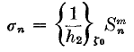

(g) The M and N constants

He wants to express his final results like this:

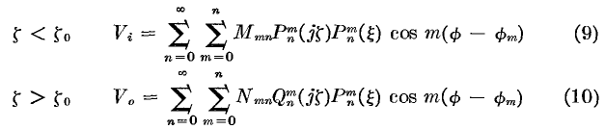

which I will now compare to my results:

Vi(ζ,ξ,φ) = (j /ε) Σn,m (-1)m Cn,m [ (n-m)!/(n+m)!] (1+ζ02) Qnm(jζ0) Pnm(jζ) Pnm(ξ) cos(m[φ-φm])

Vo(ζ,ξ,φ) = (j /ε) Σn,m (-1)m Cn,m [ (n-m)!/(n+m)!] (1+ζ02) Pnm(jζ0) Qnm(jζ) Pnm(ξ) cos(m[φ-φm])

Cn,m =(2-δm,0)/4πc1 * (2n+1) (n-m)!/ (n+m)! (1+ζ02)-1∫dξ Pnm(ξ) ∫dφ cos(m[φ-φ0]) h1h3 σ(ζ0,ξ,φ)

Therefore comparing I would say

Mmn = (j /ε) (-1)m Cn,m [ (n-m)!/(n+m)!] (1+ζ02) Qnm(jζ0)
Nmn = (j /ε) (-1)m Cn,m [ (n-m)!/(n+m)!] (1+ζ02) Pnm(jζ0)

so right off the bat we see that

Mmn/ Nmn = Qnm(jζ0)/ Pnm(jζ0)

which agrees with his claim

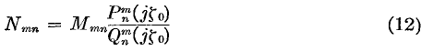
So for M we then have

Mmn = (j /ε) (-1)m [ (n-m)!/(n+m)!] (1+ζ02) Qnm(jζ0) *
(2-δm,0)/4πc1 * (2n+1) (n-m)!/ (n+m)! (1+ζ02)-1∫dξ Pnm(ξ) ∫dφ cos(m[φ-φm]) h1h3 σ(ζ0,ξ,φ)

= (j /ε) (-1)m [ (n-m)!/(n+m)!]2 Qnm(jζ0)
(2-δm,0)/4πc1 * (2n+1) ∫dξ Pnm(ξ) ∫dφ cos(m[φ-φm]) h1h3 σ(ζ0,ξ,φ)

= j (-1)m (2-δm,0) (2n+1) [ (n-m)!/(n+m)!]2 Qnm(jζ0)
1/[4πεc1] * (∫dξ Pnm(ξ) ∫dφ cos(m[φ-φm]) h1h3 σ(ζ0,ξ,φ)

and I am happy to say this agrees exactly with his result,

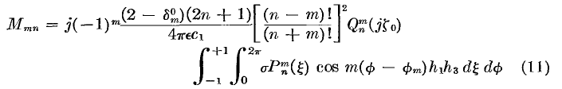
and this concludes our and his work on this problem!
The end of Appendix A shows how you pre-compute the required set of φm from σ and then that is what you need to put in the formula above for Mmn and in the V expansions.

(h) Shape of the spheroid.

Recall these facts from Smythe's oblate coordinates discussion,

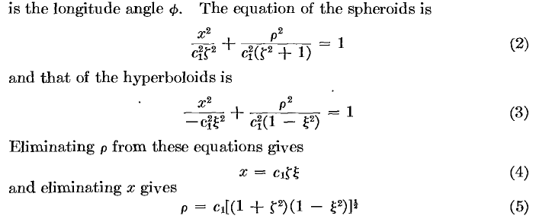

This (2) shows how the combination of ζ0 and c1 defines the spheroid. For a fixed c1, as ζ→∞ the shape approaches a sphere. But for ζ→0 the first term in (2) tends to get large unless x (the symmetry axis) is kept very small. This is the limit of a very compressed flattened spheroid and if you keep going in this limit, you get the circular disk in the x = 0 plane ( I don't know why Smythe chose x). One sees of course that both c1 and ζ0 appear in. If you hold ζ fixed and change c1, you are just changing the scale of the spheroid, not its shape.

(i) Why do you only use Pnm(jζ) inside the spheroid? Why not Qnm(jζ) as well?

First of all, the Q functions for small argument are NOT singular at ζ = 0, so that is not the issue. Here are some examples and then actual values at 0 !

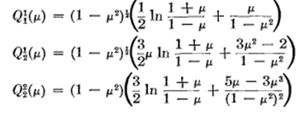

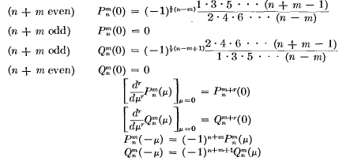

We know that we have to use Qnm(jζ) outside the spheroid. Look then at our problem setup

Vi(ζ,ξ,φ) = (j /ε) Σn,m (-1)m Cn,m [ (n-m)!/(n+m)!] (1+ζ02) Qnm(jζ0) Pnm(jζ) Pnm(ξ) cos(m[φ-φm])

Vo(ζ,ξ,φ) = (j /ε) Σn,m (-1)m Cn,m [ (n-m)!/(n+m)!] (1+ζ02) Pnm(jζ0) Qnm(jζ) Pnm(ξ) cos(m[φ-φm])

I think the reason we use Pnm(jζ) on the inside without any Qnm(jζ) contribution is in order to get continuity of V on the spheroidal surface! We know that Vo must have the form shown with only Q. Once we have that, we cannot put Qnm(jζ) as part of the Vi expansion and be continuous at ζ = ζo . Notice that in sphericals, we cannot use r-n-1 on this inside because this blows up at the origin. So the motivation in spheroidals is different on the inside, but the same on the outside.

8. Smythe Oblate Spheroidal Dirichlet Problem

I am doing this "on my own". Starting point is this

Vi(ζ,ξ,φ) = (j /ε) Σn,m (-1)m Dn,m [ (n-m)!/(n+m)!] (1+ζ02) Qnm(jζ0) Pnm(jζ) Pnm(ξ) cos(m[φ-φm])

Vo(ζ,ξ,φ) = (j /ε) Σn,m (-1)m Dn,m [ (n-m)!/(n+m)!] (1+ζ02) Pnm(jζ0) Qnm(jζ) Pnm(ξ) cos(m[φ-φm])

just as in the Neumann problem but with D instead of C coefficient names. We meet the same BC's including continuity at ζ0. So all we need to do is this: (pick either one)

Vo(ζ0,ξ,φ) = (j /ε) Σn,m (-1)m Dn,m [ (n-m)!/(n+m)!] (1+ζ02) Pnm(jζ0) Qnm(jζo) Pnm(ξ) cos(m[φ-φm])
= f(ξ,φ) // prescribed potential on the spheroid ζo

Then we invert this using our rule in Appendix C which is this

fmn = (2-δm,0) (2n+1)/4π * (n-m)!/ (n+m)! * ∫dξ∫dφ f(ξ,φ) Pnm(ξ) cos(m[φ-φm])

f(ξ,φ) = Σn,m fmn Pnm(ξ) cos(m[φ-φm])

and we can identify

fmn = (j /ε) Dn,m [ (n-m)!/(n+m)!] (1+ζ02) Pnm(jζ0) Qnm(jζo)

and therefore we may write

(j /ε) Dn,m [ (n-m)!/(n+m)!] (1+ζ02) Pnm(jζ0) Qnm(jζo)
= (2-δm,0) (2n+1)/4π * (n-m)!/ (n+m)! * ∫dξ∫dφ f(ξ,φ) Pnm(ξ) cos(m[φ-φm])

(j /ε) Dn,m (1+ζ02) Pnm(jζ0) Qnm(jζo)
= (2-δm,0) (2n+1)/4π * ∫dξ∫dφ f(ξ,φ) Pnm(ξ) cos(m[φ-φm])

Dn,m = (ε/j)(2-δm,0) (1+ζ02)-1 [Pnm(jζ0) Qnm(jζo)]-1 (2n+1)/4π * ∫dξ∫dφ f(ξ,φ) Pnm(ξ) cos(m[φ-φm])

where as before we determine the φm from an azimuthal analysis of f(ξ,φ). Notice that c1 does not appear in this result which just says the result is scale independent. In the Neumann case, the solution potential is linear in c1. This is pretty clear from

∂ζVi – ∂ζVo = = h2(ζo,ξ) σ(ζ0,ξ,φ)/ε = c1 $\sqrt{ξ2+ ζ2}$/ $\sqrt{1+ζ2}$σ(ζ0,ξ,φ)/ε

If you double the scale of the spheroid, you would have to halve the charge density to get the same answer for the potential. It is all coming from the h2 which relates dζ to dn.

9. Application: Potential of conducting spheroid of potential V0.

One approach is to think of this problem as a special case of the general Dirichlet problem. Our potential is now f(ξ,φ) = V0, so we can evaluate the Dn,m above in a few steps. First, we know that φm = 0 for all m from an azimuthal scan on our function f. Next, we see that we must have m = 0 otherwise D = 0 from the cos(mφ) factor. Next, we see that n = 0 from the dξ integration against Pn. The dφ integration gives 2π, the dξ integration gives 2 against P0(ξ) = 1. So our result is:

Dn,m = (ε/j)(2-δm,0) (1+ζ02)-1 [Pnm(jζ0) Qnm(jζo)]-1 (2n+1)/4π * ∫dξ∫dφ f(ξ,φ) Pnm(ξ) cos(m[φ-φm])

= (ε/j)(2-δm,0) (1+ζ02)-1 [Pnm(jζ0) Qnm(jζo)]-1 (2n+1)/4π * 4π δn,0 δm,0 V0

= δn,0 δm,0 V0 (ε/j)(1+ζ02)-1/Q0(jζo)

We can then install this into our forms to get

Vi(ζ,ξ,φ) = V0 Q0 (jζ0) P0(jζ) P0(ξ)/ Q0(jζo) = V0

Vo(ζ,ξ,φ) = V0 P0 (jζ0) Q0(jζ) P0(ξ)/ Q0(jζo) = V0Q0(jζ)/Q0(jζo)

There it is! Constant inside which we know is right, and a Q0 function on the outside. We could have deduced this final form at once by realizing that m = 0 azimuthally, and n = 0 polarly, and P0(jζ) is ruled out due to large ξ vanishing requirement, QED. Nothing is left but Q0(jζ) and then we scale it in the obvious way and we are done. So this was a good check on some of our general Dirichlet result's constants. Here are two Smythe facts that are helpful right here

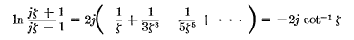

So in our case we have Q0(jζ) = -j cot-1(ζ) and our result above becomes

Vo(ζ,ξ,φ) = V0 cot-1(ζ)/ cot-1(ζ0)

The function cot-1(ζ) starts at π/2 and drops off

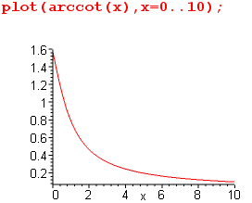

so the function cot-1(ζ)/ cot-1(ζ0) when plotted from (ζ0,∞) starts at 1 and drops off.
The obvious question to ask: what does this look like in Cartesians? The oblate basics are these
(note in passing that Ssmall = c1ζ = the small semi-major axis, and Slarge = c1 $\sqrt{1+ζ2}$)

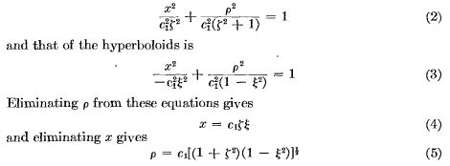

so we have to inverse solve for ζ. We do that from (2) above which gives this quadratic:

ζ4 + [ 1 - (x/c1)2 - (ρ/c1)2] ζ2 - (x/c1)2 = 0

where remember that x is the symmetry axis for Smythe, which I would always call z, but we will keep it as x, so that ρ2 = y2 + z2. If we define x' = x/c1 and ρ' = ρ/c1 as the above becomes

ζ4 + [ 1 - x'2 - ρ'2] ζ2 - x'2 = 0

But we might then think of x2 + ρ2 = r2 with same in primes, so we have

ζ4 + (1 - r'2) ζ2 - x'2 = 0

The solution is then the following (we rule out the negative solution since ζ2 > 0)

ζ2 = (1/2)[ r'2- 1 + $\sqrt{(r'2- 1)2 +4x'2}$ ] = 1/(2c12) * [ r2- c12 + $\sqrt{(r2- c12)2 +4x2}$ ]

ζ = $\sqrt{(r2- c12)2 +4x2}$/ ($\sqrt{2}$c1) x = symmetry axis of oblate

Vo(ζ,ξ,φ) = V0 cot-1(ζ)/ cot-1(ζ0)

From the first line above, we can confirm that for large r (not in x direction) we have ζ = r/c1. I don't see any obvious further way to simplify this result in Cartesian coordinates. Clearly ζ = constant is the curve of a spheroid in Cartesian space. If we look just at the y,x plane (x = up = symmetry axis), we can set r2 = x2 + y2 and do an implicit plot of ζ = constant for various constants. Here we are:

f := sqrt(x^2 + y^2 - c^2 + sqrt((x^2 + y^2 - c^2)^2 + 4*x^2))/(sqrt(2)*c);
implicitplot({seq(f=n/10,n=5..10)},y=-2..2,x=-2..2,grid = [40,40]);

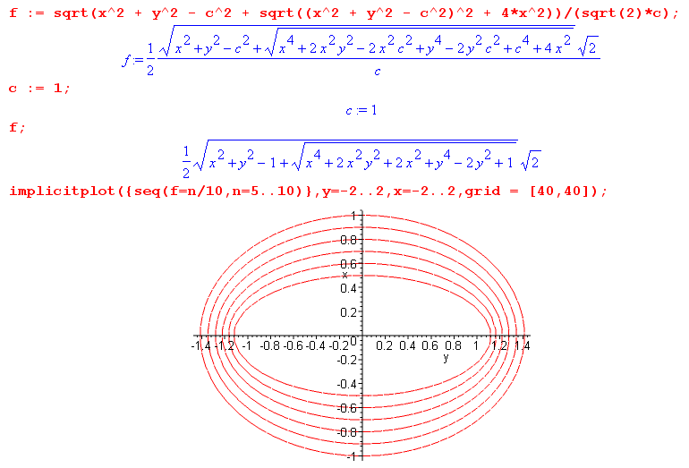

and there we have our nice oblate spheroidal surfaces of constant potential. As we move out from the inner ellipse, V drops off according to cot-1(ζ).

What else can one say?

(a) Capacitance. Well, one always wants to know the capacitance of the spheroid at this point. Q = C ΔV = CV0 so we need to find the charge Q on our spheroid. To do that, we go far away and look back at our "point charge". In this situation we have

ζ = r/c1 Vo(ζ,ξ,φ) = V0 cot-1(r/c1)/ cot-1(ζ0)

We need a large argument expansion of cot-1 which we find page 111 Schaum with p = 0, so we find simply that cot-1(x) = 1/x in this limit, so then

Vo(ζ,ξ,φ) = V0 (c1/r)/ cot-1(ζ0) = Q/(4πεr)

where we equate this to the potential of a distance point charge Q. Therefore

V0 (c1/r)/ cot-1(ζ0) = Q/(4πεr)

V0 c1/ cot-1(ζ0) = Q/(4πε)

Q = 4πε c1 V0 / cot-1(ζ0) // this is the total charge on our conducting spheroid!

C = Q/V0 = 4πε c1 / cot-1(ζ0) // and this is its capacitance against infinity

(b) Other forms of the solution

Above we noted that that Ssmall = c1ζ = the small semi-major axis, and Slarge = c1 $\sqrt{1+ζ2}$. If we draw the usual "little triangle picture" we can show that

θ ≡ cot-1ζ = sin-1(1/$\sqrt{1+ζ2}$) = sin-1(c1/Slarge) = sin-1(c1/A)

where we make up a symbol A for the large semi-major axis of our oblate spheroid. One can use this as an alternative to ζ as the spheroid label. Then the potential can be written

Vo(ζ,ξ,φ) = V0 cot-1(ζ)/ cot-1(ζ0) = V0 sin-1(c1/A) / sin-1(c1/A0)

In ellipsoidal coordinates, this largest semi-major axis is in fact one of the coordinates, ξ1 = A.

(c) Circular plate limit. We take the above results and set ζ0 = 0, noting that cot-1(0) = π/2. So:

Vo(ζ,ξ,φ) = V0 cot-1(ζ)/ cot-1(0) = (2/π)V0 cot-1(ζ)

Q = 4πε c1 V0 / cot-1(0) = 8εc1V0

C = Q/V0 = 8εc1 // in gaussian units divide by 4πε to get C = 2c1/π

I see that I solved these last two problems in " 2 Oblate Spheroidal Coordinates and the Metal Disk Problem.doc". I went on there to compute the electric field and surface charge density and to get the latter into the nice "Kelvin form" . I won't repeat all that here. Notice that (ζ,ξ)Smythe = (ξ,η)MF which is an unfortunate fact -- ξ having reverse meaning in the two systems! In each case, the first is "radial".

10. Application Comparison: Potential of conducting ellipsoid of potential V0.

This is just a reminder. In ellipsoidal coordinates, we construct the "form" for the solution to this problem in the following manner,

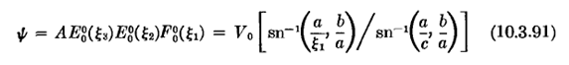

For the ξ2 and ξ3 coordinates we choose the first kind Lame function E00 = 1. But for the radial coordinate, we have to choose the second kind version F00 which we get by "the trick" and it ends up being as shown above. We can write this same result with the first kind elliptic function (I quote)

The MF solution is this (where a ≥ b are the two focal distances)

ψ(ξ1, ξ2, ξ3) = ψ(ξ1) = V0 F[sin-1(a/ξ1),b/a] / F[sin-1(a/c),b/a]
A = $\sqrt{c2-a2}$ B = $\sqrt{c2-b2}$ C = c
smallest semi middle semi largest semi
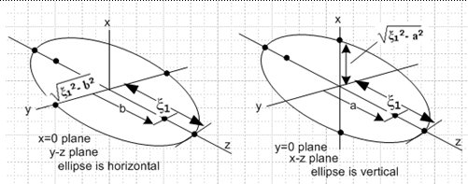

But the first form is really the nicest for taking the oblate limit of the ellipsoidal result. In the oblate limit, the focal distance b (shown above left) → 0 since the horizontal ellipses become circles. Note that

sn-1 (x,0) = sin-1(x)

Thus, the MF ψ expression shown above becomes this, where a is the other focal distance,

ψ = V0 sin-1(a/ξ1) / sin-1(a/c)

If we now replace a with c1, ξ1 with A, and c with A0 we get

ψ = V0 sin-1(c1/ A) / sin-1(c1/ A0)

which matches the alternative oblate form we found in item (2) in the last section.

Comment on Ellipsoidals. So this problem is one we can easily solve in ellipsoidals. However, we don't really have a useful general form expansion for ellipsoidals the way we do for oblates because we don't really know what all the Lamé functions are! We usually try to solve some simple ellipsoidal problem by fitting with the lowest Lamé functions and hoping we find a good fit. Well, in theory you can write them down and then have this for your general expansion

Σm.p[ Amp Emp(ξ1) + Bmp Fmp(ξ1)] [ A'mp Emp(ξ2) + B'mp Fmp(ξ2)] [ A''mp Emp(ξ3) + B''mp Fmp(ξ3)]

As noted elsewhere, the cross-link structure on the two quantum numbers m and p (really κ) goes across all three functions. The good news is you have the same functions for each variable. The bad news is that we don't have a complete list of these functions anywhere I know of. For that reason, we can't really use the "Smythe method" to solve the ellipsoidal Dirichlet, Neumann and Green's Function problems. For example, you would need some statement of orthogonality at least for the E functions. This would follow in a simple manner from the SL ODE problem, as would completeness. I don't think I have ever seen this done. It is not in MF, for example.
Well, Byerly does have this stuff! Instead of ξ1, ξ2, ξ3 he uses λ,μ,ν . He then defines his "tricky" variables α,β,γ in terms of these (and shows the inverse solutions as well)

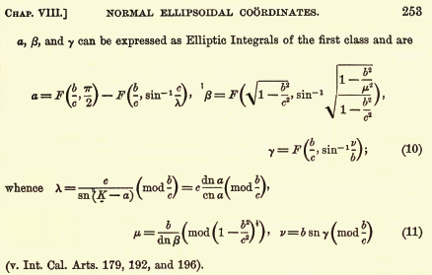

and then the orthogonality stuff looks like this

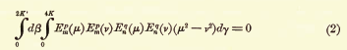

So OK, maybe I should retract my statement. If you really invest heavily, perhaps looking at Hobson and other books, perhaps even modern ones, you might find a complete expansion theory for handling problems with ellipsoids. I am not interested in learning that right now!

11. Comment on the non-factorization of the 3D volume element, and on orthogonality.

In our theory of PDE's, we try a separated solution and in each variable we get an ODE with its implied orthogonality and completeness within its 1D world. The PDE operator L as a whole (a multivariable thing) if self-adjoint (such as the Laplace operator is) has eigenfunctions which are orthogonal and complete in the larger 3D Hilbert Space of all the variables. This is discussed for multiple variables in Stak p 136, but only very briefly. Eigenvalues are real, eigenfunctions are orthogonal, it is implied that they are complete. The emphasis in that section is on Green's functions. Stak never seems to make a strong statement about PDE EF's being orthogonal and complete. On p 153 he talks about the "full EF expansion" and how you can write Green's as p 153 D, a sum over EF products. More of course was said back in Volume I in Chapter 2 on Hilbert Spaces, though that was I think 1D theory. So I guess this is a bit of a complaint I have on Stak, that he glosses over this important fact about PDE's. I should look elsewhere for better info on this, but OK, I know what the result is.
Now, when we talk about orthog of PDE solutions, we talk Hilbert Space and an integral and a volume element and Stak always writes this as simply dx. In curvilinear coordinates we know in general that this thing Stak calls dx is really this:

dV = $\sqrt{det(g')}$ dq1 dq2 dq3... = dx1 dx2 dx3..

and in an orthogonal system, we will have $\sqrt{det(g')}$ = h1h2h3 to use Smythe's notation. So this brings up the first question: do we know that this product factors in terms of our 3 orthogonal coordinates, so that we can associate portions of the product h1h2h3 with specific variables? We know that this works out this way for sphericals and cylindricals, but do we know that for all 11 systems? Well, here we are for the oblates, in Smythe notation:

We then have for our oblate product

h1h2h3 = c13 (ξ2 + ζ2)

so here is an immediate counterexample showing it does not factor. In other words, we have this

"dx" = dV = c13 (ξ2 + ζ2) dξ dζ dφ = dx dy dz

How then do we get from PDE EF orthogonality to the separated ODE orthogonality? This works in sphericals, but does not look good here in oblates. At least it is a sum of terms which each factor. Well, here would be a statement of full EF oblate orthogonality (see below for more details)

∫ h1h2h3 dζ dξ dφ um,n,k (ζ, ξ,φ) um',n',k'(ζ, ξ,φ) = δm,m' δn,n' δk,k'

∫ c13 (ξ2 + ζ2) dζ dξ dφ um,n,k (ζ, ξ,φ) um',n',k'(ζ, ξ,φ) = δm,m' δn,n' δk,k'

Now suppose our problem EF u factorizes, which is likely, into am,n,k (ζ)bm,n,k (ξ)cm,n,k (φ). Then the above would become

∫∫∫ c13 (ξ2 + ζ2) dζ dξ dφ am,n,k (ζ)bm,n,k (ξ)cm,n,k (φ)
am',n',k' (ζ)bm',n',k' (ξ)cm',n',k'(φ) = δm,m' δn,n' δk,k'
which we can write as

∫∫ c13 (ξ2 + ζ2) dζ dξ am,n,k (ζ)bm,n,k (ξ) am',n',k' (ζ)bm',n',k' (ξ)
{ ∫dφ cm,n,k (φ) cm',n',k'(φ) } = δm,m' δn,n' δk,k'

Now usually the φ functions are separately orthogonal so we remove that to get

c13∫∫ dζ dξ (ξ2 + ζ2) am,n,k (ζ)bm,n,k (ξ) am,n',k' (ζ) bm,n',k' (ξ) = δn,n' δk,k'

Now how are we supposed to break this down into separate orthogonal 1D situations? In a general sense, you cannot do it! But in some problem (such as our Smythe problem above), this full orthogonality is not required and we have ζ = ζ0, some constant, etc etc. In our problem, we could make use of 1D orthonormality in 2 of the 3 variables.
Conclusion: you cannot in general regard the full 3D Eigenfunction Problem orthogonality as a simple product of three 1D orthogonalities. But likely you can do make use of two 1D orthogonalities.

12. Comment on oblate "spheroidal harmonics"

Let's consider our motivating example above in this regard,

h2(ζo,ξ) σ(ζ0,ξ,φ) = Σn,m Cn,m Pnm(ξ) cos(m[φ-φm]) = f(ξ,φ)

[ Ignore the φm complication, see appendix A ]. Without any doubt, this is a complete expansion of any reasonable function f(ξ,φ) defined over an oblate spheroid. So in this sense, we can regard the functions shown here as "oblate harmonics on a spheroid".
In the sphericals world, we have an operator Lθ,φ which makes a 2D PDE (not 3D). Yet, the two variables θ,φ are part of a 3-variable curvilinear set r,θ,φ. We write dV = r2dr dΩ and we associate the part dΩ with the 2D PDE problem of Lθ,φ, so dΩ is what appears in the orthog of the Ylm.
How does this all work in oblates? We have three variables ζ,ξ,φ. On our spheroid, we have ζ=ζ0 just as we have r = a on a sphere. Is there a 2D PDE problem here with some Lξ,φ ? Well, we know how to write ∇2 in any curvilinear system, so what is it in oblates? On Smythe p 159 we have

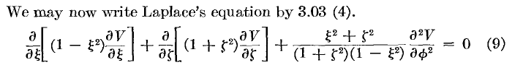
Let's review how "separation" works here. Mult through by inverse of last factor and get

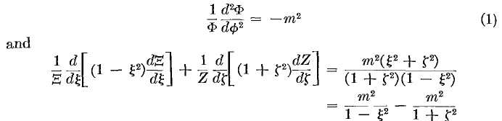

It is the very last "separation" into two terms that allows for ξ-ζ separation, and we then get our two other famous separated equations:

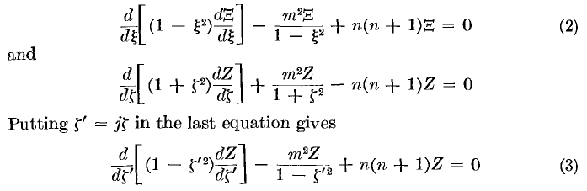

But in sphericals we get ∇2 = ∇r2 + ∇2θ,φ = ∇r2 + (1/r2) L2θ,φ . I don't see a similar thing happening in oblates. Can we write ∇2 = ∇ζ2 + f(ζ) ∇2ξ,φ ? What we have above is more like this:

∇2 = ∇ζ2 + ∇ξ2 + f(ζ,ξ) ∇φ2 = ∇ζ2 + ∇ξ2 +[ 1/(1-ξ2) – 1/(1+ζ2)] ∇φ2

I conclude that there does not exist an analogous L'ξ,φ operator here, and of course the reason is that we have lost our rotation group on the oblate surface.

Conclusions: For an oblate spheroidal problem, you can regard Pnm(ξ) cos(m[φ-φm]) ( or the more traditional form Pnm(ξ)eimφ ) as "spheroidal harmonics" since ξ is a spheroidal coordinate, and this is a complete set of functions for expansion on the spheroid. And it is true that these are eigenfunctions of the operator Lξ,φ . However, this operator Lξ,φ does not appear as part of ∇2 = ∇ζ2 + ∇ξ2 + f(ζ,ξ) ∇φ2 in oblate coordinates. We are just stealing operator Lξ,φ from the spherical coordinates ∇2 where it appears as ∇2 = ∇r2 + ∇2θ,φ = ∇r2 + (1/r2) Lθ,φ . The spheroidal harmonics are orthogonal and complete, just as are the spherical harmonics, we just replace z with ξ. We can still talk about dΩ = dξdφ . And for large ζ we can interpret dΩ as an angular beam. In oblate coordinates we know that dV = c13 (ξ2 + ζ2) dξ dζ dφ which we could write as

dV = c13 (ξ2 + ζ2) dζ dΩ

(and usually we would just set c1 = 1). So we can compare oblates to spherical dV

dVspherical = r2 dr dΩz,φ dVspherical = (ξ2 + ζ2) dζ dΩξ,φ

and we see that we don't get that nice "factorization" in oblates.

Note added 6.26.10. I have an interesting file "3Dhelmholtz and group theory.pdf" that talks about group theoretic aspects of coordinate systems, and I have not really read it, just perused it. It considers the Helmholtz equation (= Laplace equation when ω2= 0). When you do your "separation of variables", you end up with two separation constants and a situation like this:

where Δ3 means ∇2 in 3D. In sphericals, S2 might be ∂φ and S1 might be L2θ,φ . In this case we would associate S1 and S2 with J2 and J3 , two commuting operators for our symmetry group. In each of the 11 separable coordinate systems, he claims that you can find such S1 and S2 which are commuting Lie generators of some sort which form a "basis" for a 2D subspace of your 3D space (all a bit vague). For oblates here are the two operators

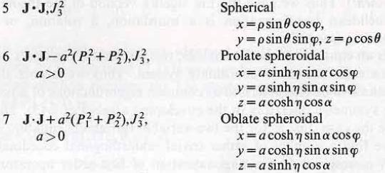

where Pi are the translation generators of the Galilean group. So this shows that there exists some sort of object that plays the role that L2θ,φ plays in spherical coordinates. I leave it at that.

13. Comment on Full 3D Fourier Expansion and Recovery in Curvilinear Coordinates

Let's first go back to sphericals and talk about eigenfunctions of a sphere. Where did Stak talk about this? (finding anything in the Stak book is always very hard because the index is completely anemic, and I have no searchable Stak, so I have to search my own notes). A scan shows this was treated on page 144 in Exercise 6.30. Let's just review this little problem. We assume a separated form R(r) Y(θ,φ) and we get a radial equation. Our starting EV problem is -∇2 u = λ u so there is the new λ number floating around. In the separation, we get something he calls μ which is n(n+1), the usual thing, so the radial equation then has both n and λ in it. The solution eigenfunctions are given by p 145 H

um,n,k (r,θ,φ) = (1/r) Jn+1/2(β(n+1/2)k r) Yn,m(θ,φ) λk,n,m = [β(n+1/2)k]2

where the three quantum numbers are m and n as usual, and then β(n+1/2)k are the zeros when r = 1, and they are indexed by k, so think of either k or these zeros as the third set of quantum numbers. Stak talks a little about getting these things orthonormalized. He states in p 145 I the orthogonality which involves the full 3D "dx" element. So this really is our prototype case.
Now, let's think about a full 3D Fourier transform in this context. We would have

Vmnk = ∫dx f(r,θ,φ) um,n,k (r,θ,φ) Fourier projection

V(r,θ,φ) = Σm,n,k fmnk um,n,k (r,θ,φ) Fourier expansion

and here you must use the correct volume or measure which is "dx" = r2dr sinθdθdφ = h1h2h3drdθdφ. I am thinking of V as a potential inside the sphere. Maybe there are various point sources inside the sphere, but this potential is going to vanish on the surface of the sphere because the um,n,k (r,θ,φ) vanish there. So this is how we set things up for a Green's Function V if we have one point charge in the sphere. [ In other words, just remember than in multidimensional problems, EF means u = 0 on bounding surface. ]
But our Smythe problem is a Neumann problem, not a Green's problem. So how do we talk about Dirichlet and Neumann problems for a sphere?
Stak treats the Dirichlet unit sphere p 108 Exercise 6.15. We first write this "form" for the potential

u(r,θ,φ) = Σn,m amn rn Ynm(θ,φ)

then on the surface we say

u(1,θ,φ) = Σn,m amn Ynm(θ,φ) = f(θ,φ)

and then we invert this thing using the orthog of the Y's. Notice that to solve this Dirichlet problem, we don't encounter those Jn+1/2(β(n+1/2)k r) functions, just the rn guys.
OK, what about the sphere Neumann problem? Stak does this page 127 Example 1. We use the same form as above

u(r,θ,φ) = Σn,m amn rn Ynm(θ,φ)

∂ru(r,θ,φ) = Σn,m amn n rn-1 Ynm(θ,φ)

∂ru(1,θ,φ) = Σn,m amn n Ynm(θ,φ) = g(θ,φ)

and then we invert this thing and we have that extra condition thing.
So in both these problems we "got off light" because we could do our inversions privately in the angle world of θ,φ.
Now let's ponder the Dirichlet interior problem for the oblate spheroid instead of a sphere. In the spherical case we did a sum of terms of the form rn Ynm(θ,φ) . For the oblate, this will be something more like

u(ζ,ξ,φ) = Σn,m amn Pnm(iζ) Pnm(ξ) cos(m[φ-φo])

where we somehow argue for P on the inside for the radial function (as Smythe does in his Neumann problem above). We obviously want to match on the surface so we have

u(ζo,ξ,φ) = Σn,m amn Pnm(iζo) Pnm(ξ) cos(m[φ-φo]) = f(ξ,φ)

You just invert this the same as with spherical harmonics!
I might comment that in the spheroidal EF case, I don't yet know what functions play the rule played by the functions (1/r) Jn+1/2(β(n+1/2)k r) in the spherical EF case. I suspect they are quite unpleasant, whatever they are.

Appendix A. Azimuthal Orthogonality (integral is 0 to 2π)

I = ∫dφ cos[m(φ-φm)] cos[m'(φ-φm')]

Let ψ = φ-φm and then φ-φm' = φ-φm + φm-φm' = ψ + dmm'

I = ∫dψ cos(mψ) cos[m'(ψ + dmm')]

= ∫dψ cos(mψ) { cos(m'ψ)cos(m'dmm') - sin(m'ψ)sin(m'dmm') }

= cos(m'dmm') ∫dψ cos(mψ) cos(m'ψ) – sin(m'dmm') ∫dψ cos(mψ) sin(m'ψ)

Schaum p 96 tells us that this second integral is always 0 for any integers m and m', [ well, the integrand is odd, so would be zero for any value of m' ] so

= cos(m'dmm') ∫dψ cos(mψ) cos(m'ψ) = cos(m'dmm') δm,m'π (1+δm,0)

= δm,m'π (1+δm,0) // since dmm = 0

So the point here is that you can give each cosine an m-dependent phase, and you still get orthogonality.
To summarize:

∫dφ cos[m(φ-φm)] cos[m'(φ-φm')] = δm,m'π (1+δm,0) m,m' = any integers

Notice that the set of functions cos[m(φ-φm)] provides a complete basis for m = 0,1,2,3... so we don't need the negative integers, but we will leave that up to somebody else.

What is the expansion theorem that goes along with this orthogonality?

f(φ) = Σm fm cos[m(φ-φm)]

fm = [ π (1+δm,0)]-1 ∫dφ cos[m(φ-φm)] f(φ)

Now consider from above that

cos[m(φ-φm)] = cos(mφ)cos(mφm) + sin(mφ)sin(mφm)

The amount of cos(mφ) and sin(mφ) is controlled by parameter φm. There are really two sets of parameters needed to describe f(φ), one set is the fm and other is the φm . We have not shown how to obtain the φm yet! Let's start over

f(φ) = Σm=0∞ fm [cos(mφm) cos(mφ) + sin(mφm)sin(mφ) ]

= Σm [ am cos(mφ) + bm sin(mφ) ] am = fm cos(mφm) bm = fm sin(mφm)

This is then a standard Fourier Series expansion with period 2π for φ, so we know what the projections must be from Schaum p 131 with L = π :

am = (1+δm0) (1/π) ∫dφ cos(mφ) f(φ)
bm = (1/π) ∫dφ sin(mφ) f(φ)

Assume we have computed these integrals for a given f(φ). Then we have

tan(mφm) = bm/am => mφm = tan-1 (bm/am)

fm = am/ cos(mφm) = bm/sin(mφm)

and this then tells us both fm and φm. So to work in the Smythe model, we really have to add something to our equations which is this:

f(φ) = Σm fm cos[m(φ-φm)]

am = (1+δm0) (1/π) ∫dφ cos(mφ) f(φ)
bm = (1/π) ∫dφ sin(mφ) f(φ)

tan(mφm) = bm/am

fm = am/cos(mφm) = bm/sin(mφm)

and this then tells us the specific φm that are required in our expansion of f(φ), as well as the fm.

How to find the right φm for Smythe's Neumann problem above?

So, Smythe's result for the oblate spheroidal Neumann problem above is incomplete because he does not tell us how to find the φm . But let's make it complete by adding these instructions:

" Treat σ(ζ0,ξ,φ) as f(φ) and compute am and bm as shown above, then tan(mφm) = -bm/am and that tells you the required φm. "

For σ(ζ0,ξ,φ) that is even in φ, we can just set all φm = 0 which makes things simple.

Notice the different ways of doing the φ expansion. We can do the am and bm method and use only non-negative values of m. Or we can do the fm and φm method with the same m. Or we can do the Am method with eimφ and then we need all integer m values to get enough coefficients.

Appendix B. P Function Orthogonality (integral is -1 to 1)

We know from our Legendre notes that, for this standard range, we have for m = 0, 1, 2...

$^{\int_{-1}^{1}{}}$dz Pnm(z)Pkm(z) = 2δn,k (2n+1)-1 (n+m)! / (n-m)! n,k = m, m+1, m+2 ...... ∞

For on-the-cut functions we also know that (see Legendre on the cut doc)

Pν-m(x) Γ(ν+m+1) = (-1)m Pνm(x) Γ(ν-m+1) // any integer m
or
Pn-m(x) (n+m)! = (-1)m Pnm(x) (n-m)! // any integer m

Therefore we can write (again, for m = 0,1,2..)

$^{\int_{-1}^{1}{}}$dz Pn-m(z)Pk-m(z) = $^{\int_{-1}^{1}{}}$dz Pnm(z) (n-m)! / (n+m)! * Pkm(z) (k-m)! /(k+m)!

= (n-m)! / (n+m)! * (k-m)! /(k+m)! $^{\int_{-1}^{1}{}}$dz Pnm(x) Pkm(x)

= (n-m)! / (n+m)! * (k-m)! /(k+m)! 2δn,k (2n+1)-1 (n+m)! / (n-m)!

= 2δn,k (2n+1)-1 (n-m)! / (n+m)! * (n-m)! /(n+m)! * (n+m)! / (n-m)!

= 2δn,k (2n+1)-1 (n-m)! / (n+m)!

= 2δn,k (2n+1)-1 (n-m)! / (n+m)!

So let m' = -m ≤ 0. Then we have

$^{\int_{-1}^{1}{}}$dz Pnm'(z)Pkm'(z) = 2δn,k (2n+1)-1 (n+m')! / (n-m')!

But this is exactly the same form we started with for positive m'. Therefore we have shown

$^{\int_{-1}^{1}{}}$dz Pnm(z)Pkm(z) = 2δn,k (2n+1)-1 (n+m)! / (n-m)! n,k = |m|, |m|+1, |m|+2 ...... ∞

where m can now be any integer.

Appendix C. Combined P Function and φ orthogonality.

Start with this expansion with the standard summation

f(ξ,φ) = Σn,m fmn Pnm(ξ) cos(m[φ-φm])

First apply cos(m'[φ-φm']) to both sides and integrate on φ going 0,2π.

∫dφ f(ξ,φ) cos(m'[φ-φm']) = Σn,m fmn Pnm(ξ) ∫dφ cos[m(φ-φm)] cos[m'(φ-φm')]

= Σn,m fmn Pnm(ξ) δm,m'π (1+δm,0)

= π (1+δm',0) Σn fm'n Pnm'(ξ)

where we have used our Appendix A result. Now apply Pkm'(ξ) to both sides to get

∫dξ∫dφ f(ξ,φ) Pkm'(ξ) cos(m'[φ-φm'])

= π (1+δm',0) Σn fm'n ∫dξ Pkm'(ξ) Pnm'(ξ)

= π (1+δm',0) Σn fm'n 2δn,k (2n+1)-1 (n+m')! / (n-m')!

= π (1+δm',0) fm'k 2(2k+1)-1 (k+m')! / (k-m')!

= 2π(2k+1)-1 (1+δm',0) fm'k (k+m')! / (k-m')!

Now replace m' by m, and replace n by n to get

∫dξ∫dφ f(ξ,φ) Pnm(ξ) cos(m[φ-φm]) = 2π(2n+1)-1 (1+δm,0) fmn (n+m)! / (n-m)!

We then have our coefficients"

fmn = (2n+1)/2π * (1+δm,0)-1 (n-m)!/ (n+m)! ∫dξ∫dφ f(ξ,φ) Pnm(ξ) cos(m[φ-φm])

We can write

(1+δm,0)-1 = (2-δm,0)/2

and then our result is
fmn = (2-δm,0) (2n+1)/4π * (n-m)!/ (n+m)! * ∫dξ∫dφ f(ξ,φ) Pnm(ξ) cos(m[φ-φm])

f(ξ,φ) = Σn,m fmn Pnm(ξ) cos(m[φ-φm])

Appendix D. Use the Neumann Result to find an oblate 1/R expansion

First, here is the Neumann solution from above

Vi(ζ,ξ,φ) = (j /ε) Σn,m (-1)m Cn,m f(n,-m)(1+ζ02) Qnm(jζ0) Pnm(jζ) Pnm(ξ) cos(m[φ-φm])
Vo(ζ,ξ,φ) = (j /ε) Σn,m (-1)m Cn,m f(n,-m)(1+ζ02) Pnm(jζ0) Qnm(jζ) Pnm(ξ) cos(m[φ-φm])

Cn,m = (2-δm,0) /2π * (n+1/2) f(n,-m) * ∫dξ Pnm(ξ) ∫dφ cos(m[φ-φm]) h2(ζo,ξ) σ(ζ0,ξ,φ)

h1 = c1 $\sqrt{ξ2+ ζ2}$/ $\sqrt{1-ξ2}$ = hξ q1, q2, q3 = ξ, ζ, φ
h2 = c1 $\sqrt{ξ2+ ζ2}$/ $\sqrt{1+ζ2}$ = hζ
h3 = c1 $\sqrt{1+ζ2}$ $\sqrt{1-ξ2}$ = hφ

h1h3 = c1 $\sqrt{ξ2+ ζ2}$/ $\sqrt{1-ξ2}$ c1 $\sqrt{1+ζ2}$ $\sqrt{1-ξ2}$ = c12 $\sqrt{1+ζ2}$ $\sqrt{ξ2+ ζ2}$

h2/h1h3 = c1-1(1+ζ2)-1

We now sneak a peak at our "the pillbox condition.doc", which tells us that that if σ lies on a surface q1 = constant then (this is just δ(q1-q1')/h1 * δ(q3-q3')/h3) where I pick ξ and φ as the non-fixed coords )

σ = q(1/h1h3) * δ(q1-q1') δ(q3-q3') = the charge density in our pillbox for a point charge

which we apply in our present circumstances with so that

σ(ξ,φ) = (1/h1h3) * δ(ξ-ξ0) δ(φ-φ0) = the charge density in our pillbox for a point charge

Regarding this as f(φ) we use our Appendix A stuff,

am = (1+δm0) (1/π) ∫dφ cos(mφ) f(φ)
bm = (1/π) ∫dφ sin(mφ) f(φ)

so conclude that

am = (1+δm0) (1/π) ∫dφ cos(mφ) (1/h1h3) * δ(ξ-ξ0) δ(φ-φ0)
= (1+δm0) (1/π) cos(mφ0) (1/h1h3) * δ(ξ-ξ0)
bm = (1/π) ∫dφ sin(mφ) (1/h1h3) * δ(ξ-ξ0) δ(φ-φ0)
= (1/π) sin(mφ0) (1/h1h3) * δ(ξ-ξ0)

tan(mφm) = bm/am = (1+δm0)-1 tan(mφ0)

For m ≠ 0, we learn that φm = φ0, and of course this is manifestly true for m = 0 as well!

So we install this for our σ and see what happens:

∫dξ Pnm(ξ) ∫dφ cos(m[φ-φm]) h2(ζo,ξ) σ(ζ0,ξ,φ)

= ∫dξ Pnm(ξ) ∫dφ cos(m[φ-φm]) h2 (1/h1h3) * δ(ξ-ξ0) δ(φ-φ0)

= (h2/h1h3) Pnm(ξ0) cos(m[φ0-φm])

= c1-1(1+ζ02)-1 Pnm(ξ0) cos(m[φ0-φm])

= c1-1(1+ζ02)-1 Pnm(ξ0)

so we then find that

Cn,m = (2-δm,0) /2π * (n+1/2) f(n,-m) * ∫dξ Pnm(ξ) ∫dφ cos(m[φ-φm]) h2(ζo,ξ) σ(ζ0,ξ,φ)

= (2-δm,0) /2π * (n+1/2) f(n,-m) c1-2(1+ζ02)-1 Pnm(ξ0)

So here then are the solutions

Vi(ζ,ξ,φ) = (j /ε) Σn,m (-1)m Cn,m f(n,-m)(1+ζ02) Qnm(jζ0) Pnm(jζ) Pnm(ξ) cos(m[φ-φ0])
Vo(ζ,ξ,φ) = (j /ε) Σn,m (-1)m Cn,m f(n,-m)(1+ζ02) Pnm(jζ0) Qnm(jζ) Pnm(ξ) cos(m[φ-φ0])

Cn,m = (2-δm,0) /2π * (n+1/2) f(n,-m) c1-1(1+ζ02)-1 Pnm(ξ0)

On the other hand, each of these potentials must be just 1/(4πεR) where R = | r - r0 | since we are just talking about the potential of a unit point charge. So look at Vi ,

1/R = 4πεVi(ζ,ξ,φ) = j Σn,m (-1)m cn,m f(n,-m)2Qnm(jζ0) Pnm(jζ) Pnm(ξ) cos(m[φ-φ0])

cn,m = εm (2n+1) (1/c1) Pnm(ξ0)

So we can combine our two results this way

1/R = j Σn,m (-1)m (εm/c1) (2n+1) f(n,-m)2Qnm(jζ>) Pnm(jζ<) Pnm(ξ) Pnm(ξ0) cos(m[φ-φ0])

and our only mystery is how this comes out being real with the j out front. Smythe computes the potential of a point charge q in exactly the way I have done it here, but in his notation, and he gets:

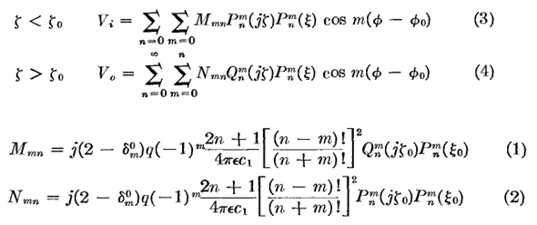
so we are in complete agreement, including the overall factor of j. But I shall show in the next appendix that j Qnm(jζ>) Pnm(jζ<) = real, so in fact each term in the double sum is real.

Appendix E. Show that j Qnm(jx) Pnm(jy) is real for n,m integers and x,y real.

This is not the best proof of this fact, but at least it is a proof so I leave it as is.

Remember that both P and Q are off the cut functions, and I have studied the reality of P and Q functions somewhere so I could probably show that 1/R is in fact real. Looking at my p and q stuff, I know that, for m and n both integers,

qnm(ζ) = (-i)2m (±i)n+1 Qnm(iζ) = (-1)m (±i)n+1 Qnm(iζ) Re(ζ) 0

pnm(ζ) = (±i)-n 2cos[(n+m)π/2] Pnm(iζ) – (±i)-m/2 (-i)2m (2/π) sinπ(n+m) Qnm(iζ)

= (±i)-n 2cos[(n+m)π/2] Pnm(iζ) // when n and m are integers

I can first invert to get

Qnm(iζ) = (-1)m (∓i)n+1 qnm(ζ)

2cos[(n+m)π/2] Pnm(iζ) = (±i)+n pnm(ζ)

For unrelated arguments, we have to say

Qnm(ix) = (-1)m (∓i signx)n+1 qnm(x)

2cos[(n+m)π/2] Pnm(iy) = (±isigny)+n pnm(y)

Then

2cos[(n+m)π/2] Pnm(ix) Qnm(iy) = (±isigny)+n pnm(y) (-1)m (∓i signx)n+1 qnm(x)

= (signy)n (signx)n+1 (±i)+n pnm(y) (-1)m (∓i)n+1 qnm(x)

= (signy)n (signx)n+1 pnm(y) (-1)m (∓i)qnm(x)

which says that Pnm(ix) Qnm(iy) is pure imaginary, at least when n+m = even integer where cos ≠ 0. For the case n+m = odd, we can go to page 30 of "Reality of P and Q...doc" and quote

for Pnm(iζ) and z2: see p 126 (22)
(±i)-m
(±i)-m z

as our template for the two terms. But for n+m = odd > 0, the first term is 0 due to a denominator gamma functions, so we have

Pnm(ix) ~ i (±isignx)-m ~ i (±i)-m // in terms of reality

We then have

Pnm(ix) Qnm(iy) ~ i (±i)-m (∓i)n+1 ~ i ∓i)n+m+1

When n+m = odd, the exponent is even and (∓i)n+m+1 = real, so Pnm(ix) Qnm(iy) = imaginary. So we have just proven this interesting fact:

Fact: Pnm(ix) Qnm(iy) = pure imaginary for any real x,y and for n,m = integers.

