Smythe in General and Review of Chapter 5 PhL 12.29.09

(1) First, here are some general facts about this book: 1
(2) Next, here is a contents of this 600 page book, 3
(3) Detailed Contents of Chapter 5 (3D electrostatics) 5
(4) A Walk-Through of Chapter 5. 7
Ellipsoidals. 7
Image Method 11
Neumann Sphere Problem 11
Azimuthally Symmetric Cone Dirichlet Problem 13
Comments only on the general Dirichlet Problem on the Cone 14
Green's Function for a Cone. (156). 14
Comments on the zeros in degree of the P function. 15
Green's Function for a Conical box. (157) 17
Oblate Spheroidal Coordinates (158). ( see other docs!) 18
Cylindrical Coordinates (169). 18
Green's Function for a Cylinder (178) 18
Green's Function for a Cylindrical Box (179) 18
More Bessel function stuff: 19
Problems! (199). 19

(1) First, here are some general facts about this book:

William R. Smythe, Professor of Physics, CIT ("Caltech") 1893-1988 (age 95)

There are not many web "reviews" and the various editions are all out of print.

First edition: 1939
Second edition: 1950 // what I have
Third edition: 1968
paperback 1989 "A Summa Book" Hemisphere Publishing

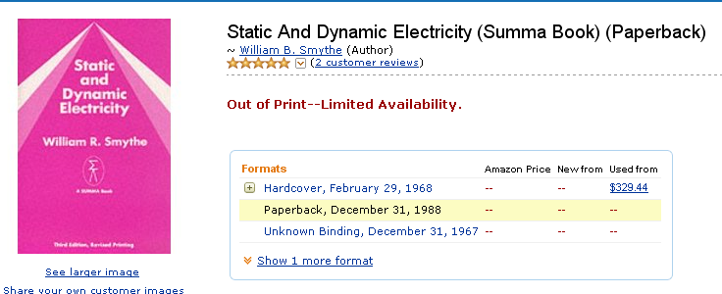

As best I can tell, Summa published a total of two books, the other also on electricity. I suspect the family had this published by this private label, set and printed by Hemisphere Publishing which still exists in some form.

I cannot find any bio info on this guy. I would guess PhD at Chicago 1921. Here are the few clips I can find:

Dr. Smythe, who will be awarded the title of
professor emeritus on July 1 (1964, see below) , has been a member
of the Caltech faculty since 1923. His classes in
electricity and magnetism at Caltech have been one
of the basic standards by which the graduate students
in physics have been measured for many
years, even though Dr. Smythe never really wanted
to become a professional teacher. He preferred to
concentrate on research and, in fact, regarded it as
a personal weakness when he found teaching almost
immediately enjoyable. In the field of research he
was the originator of a method of separating isotopes
in quantity, electromagnetically. Dr. Smythe
has long been the mainstay of the oral candidacy
examinations, and has also served for many years
on the graduate committee of the physics division
for the admittance of new students. He is now
concerned with research on the practical applications
of magnetic waves. He is the author of Static
and Dynamic Electricity, one of the most widely
used reference books on electricity and magnetism

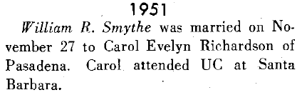

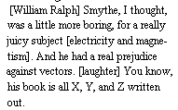

William R. Smythe, professor of
physics, emeritus, died July 6 (1988) at age
95 (so born 1893 or so). Smythe came to Caltech as a
research fellow in 1923. He was
named professor of physics in 1940
and became emeritus in 1964. He
was the Head of the Special Ballistics
Section of the Caltech Rocket Project
from 1942 to 1945, where he developed
a solar yaw camera to stabilize
spinning rockets in flight. Smythe
invented a method for separating isotopes
of an element electromagnetically,
and also solved various problems
in eddy currents and electromagnetic
theory.

I can see that this was the Jackson book of its era, perhaps, doing similar topics to Jackson. Here are two comments on the book (not many comments exist out there! ) [ the first commenter is a still-active aerospace engineer at BD systems, bought by SAIC. No personal data exists on the web, though he has commented on several books. ]]

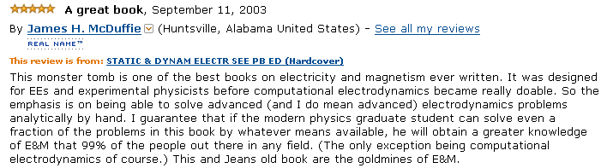

"(Smythe) The winner and still champion on the number of problems given (over 700 are listed in the second edition and more were added for the third.) Does only macroscopic electromagnetism, with almost no coverage of charged particle dynamics nor does it cover things like frequency dependence of the dielectric function. It has a good chapter on wave guides, and a comprehensive treatment of electrostatics. Smythe strangely avoids using the magnetic scalar potential for magnetostatic problems."

(2) Next, here is a contents of this 600 page book,

I had to cut and past for each chapter because there is only a fine detail contents. I just read all the headings other than Chapter 5, and I think everything is quite familiar. You can see evidence of Smythe's prefatory remarks that this book is geared to the engineer and experimental physicist, not to the "theory man". He minimizes theory. The book is famous for its huge collection of problems, perhaps 500 of them, a tradition which Jackson has carried on. Jackson includes Smythe without comment in his green book reference list. Maxwell's equations are first stated in the very last chapter. He does use curl and divergence symbols, but minimally.

Appendix on units, then a detailed 26 page index. He gives a Problems then References at the end of each Chapter. Jeans is another rated book, by the way.

(3) Detailed Contents of Chapter 5 (3D electrostatics)

(which runs for 107 pages, or maybe 20% of the book. Let's review the chapter 5 contents in a few whacks. The first part is this.

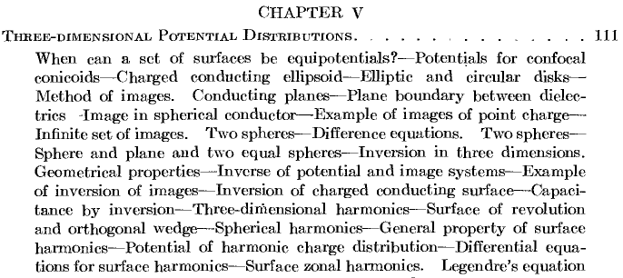

So we have ellipsoidal stuff right out of the box, with the elliptical disk hit early. Then images and inversion stuff. Then he gets into Legendre, so we continue:

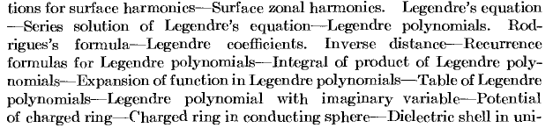

So here we have a mini-Bateman on Legendre, and then he starts into some problems. We continue:

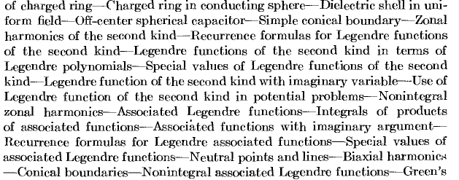

So he did maybe 4 problems here, then we are back to Bateman on Legendre for most of the above, now mostly for the Q functions! He wanted his book to be a standalone reference I think. I will be looking at some of the strange sounding sections in my review below. Moving right along,

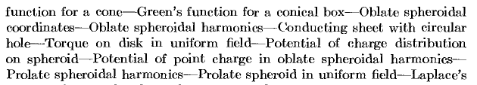

Notice that he does a lot of "cone" stuff. Then the above section on the spheroidals I have annotated in detail in another document "Smythe on oblate spheroidals.doc". He does a few sample problems like the hole in the plate thing, and I extended this a bit in my notes. We continue:

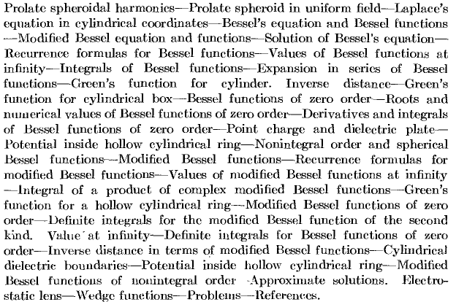

As you see, the entire reset of the Chapter 5 is on cylindrical coordinates and Bessel functions. This is the meat and potatoes of the engineering world!

(4) A Walk-Through of Chapter 5.

Ellipsoidals.

He opens with an interesting question: what sets of surfaces can be equipotential surfaces? He wants to label these surfaces by F(x,y,z) = C, where C is the label. Then V = f(C) gets you V from the label. He then requires V to satisfy Laplace. His conclusion is this

-f "(C)/f '(C) = Φ(C) that is, this ratio must be a function only of C, not of x,y or anything else

Integrate once and then twice to get a formula for V:

He next dives right into ellipsoidal coordinates using the generic conic equation variable θ,

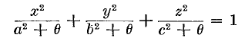 F(x,y,z) = C

c > b > a are his choice of the constants. The variable θ is his "C" and if you were to solve for θ as θ(x,y,z) then you have F(x,y,z) = C appearing as θ(x,y,z) = θ, just a bit confusing but I get it. I would have annotated differently. Think of θ as a "surface label" like ξ2 was in MF, and the type of surface you get depends on the range of θ. If θ > -c2 , eg, get an ellipsoid. If we make x,y,z all very large, then we have to make θ very large and a,b,c don't matter and then we have r2 = θ so the distant limit is θ = r2.

He then is able to show that

and since (2) is a function only of θ, we conclude that this set of curves can be equipotentials. But of course these are our friends the confocal conics! Moreover, we get from (3) above a formula for the potential V = f(θ) = as shown. The inner integral is terms like ln(a2 + θ)1/2 so the integrand of the second integration is (a2 + θ)1/2 (b2 + θ)1/2(c2 + θ)1/2 where the expo turns our sum of three terms into a product of three terms. So here somehow is the answer to our general ellipsoidal problem:

If we go far away, we have V(θ) = A ∫θ θ-3/2 dθ + B = -A (2) θ-1/2 + B and since we want this to vanish in the distance, B = 0 and we then have V = -A (2) θ-1/2 . In this limit θ-1/2 = 1/r as noted above. Therefore far away we have V = -2A/r . But in this limit, ellipsoid is a point charge, and the answer should be V = Q/4πεr . Therefore we have -2A = Q/4πε so Q = -8πεA. We can write the potential at θ = 0 (ie, on our reference ellipsoid) as V(0) = A int(θ=∞,0) since the ∞ end will give nothing. Then flip this around to remove the minus sign. This then explains his capacitance formula for our reference ellipsoid:

But he is not doing the integral! He sets V = V0 when θ = 0, our innermost ellipsoid. You can read off the "radial" derivative ∂θV from the formula

∂θV = A *

so at θ = 0 you get ∂θV = A/(abc), a Kelvin like result! But since θ ≠ r, this is not really the E field, you have to correct with a factor, and that factor is |∇θ| and he then ends up, lickety-split, with the famous formula for the charge density on an ellipsoid!

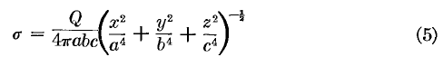

So that was pretty impressive I think. No ODE's, no Lamé equation, just a fast way to the result.
He then of course takes the limit a→ 0 and gets the charge density on an elliptical disk,

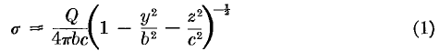

and for a circular disk we get

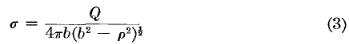

He then goes on to find the actual potential of a circular disk since the integral above simplifies:

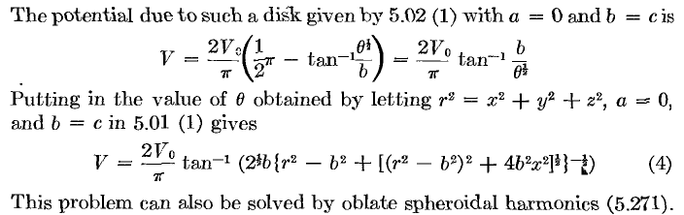

So there is the potential of a circular disk in both ellipsoidal and Cartesian coordinates!

So this is certainly a tour de force, getting these famously complicated problems solved in a few lines, not fancy analysis, just does it. No graphs, no mention of the infinity at the edge, just a practical guy untroubled by these kinds of questions.

Doing the integral. On scratch paper I was able to convert his integral into one of F(φ|m) form. You first change variables such that θ = x2, then to t2 = x2 + c2 where recall c > b > a. We then find that dθ = 2xdx = 2tdt but the third radical then becomes just 1/t and this cancels the t of 2tdt and then you are very close to the F function form. I was unable to find the integral as stated anywhere, however which seems odd.
Maple can do it! Here we are:

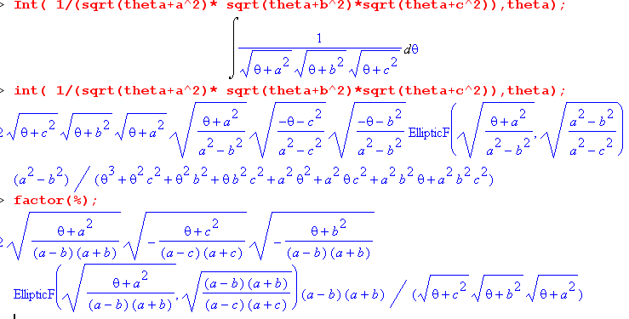

Maple as usual refuses to simplify things, so I have to do it manually:

[ a2 - c2]-1/2 * 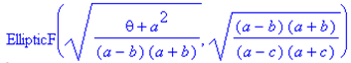

Wolfram's on-line integrator finds a similar answer,
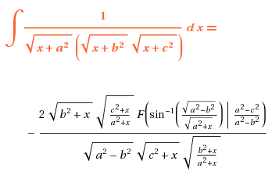

It seems to me I could simplify this manually to get

= - 2 / $\sqrt{a2- b2}$ * 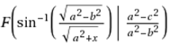

and this of course has a somewhat familiar Kelvin / MF form.

Smythe is claiming this: in any electrostatics problem where the potential is constant on some ellipsoidal surface (could be hyperboidal), you can write the solution potential in this manner! We know from Kelvin and MF and Smythe that in fact the potential outside an ellipsoid at fixed potential has this form. But for problems in ellipsoidal coordinates where you don't have V = constant on such a surface, you will still have to mess with the Lamé functions to create your general "terms" (my comment). This would include for example the usual Dirichlet problem on an ellipsoid. I have not seen that problem solved yet.

Image Method

Now suddenly he veers off on this topic. Spherical conductor is of course the main example. Then he applies the image method to what he calls a "spherical boss" (half sphere dome) on a metal ground plane. The word for grounded is "earthed". He puts a charge q near this "dome" somewhere, throws in 7 image charges Each pair maintains V = 0 on the dome, and then different pairwise gives V = 0 on the ground plane. So a great example I think.
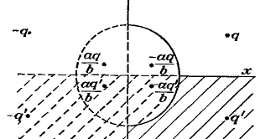

He then goes on to do the capacitance of two spheres (one case enclosing, one case nearby) using an infinite number of image charges. This is quite a long section, but I guess he gets his result, though I cannot really find it. He then lets one of the spheres be a plane.

Inversion. Our next topic. Lots of stuff on this, but I have this from green Jackson. He does an obscure example, no picture, OK.

Neumann Sphere Problem

Spherical Harmonics mostly with m=0. Solve Laplace in sphericals, get (notice S is his Y, sort of)

He does the usual separation with constant K = n(n+1). Here is where he fails to explain why n is an integer! Does orthogonality. Says this

where he sort of suppresses the m separation constant.

Next, he does something I took note of for spheroidals, but here he does it for sphericals I just quote the page to make short of it (this is The Neumann Problem on the sphere)

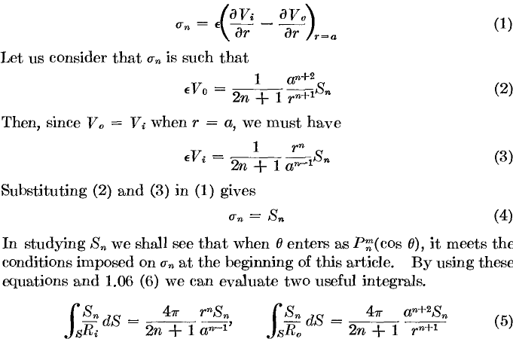

He then ends up with a multipole expansion for the inside and outside potentials,

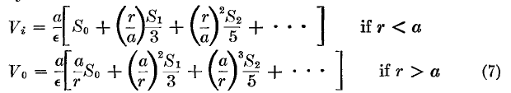

Note added: The above is just a spherical version of the Oblate Neumann problem which I study in detail in a separate doc. I never have to do his "useful integrals". I don't think there is anything new here.

He is then launched on "facts about P functions", sort of the way I got off on that subject in the last couple of weeks. Strangely, the usual z = cosθ variable is called μ, and the Legendre equation is for some function θn(μ). Smythe is strange on his symbol choice I think. He is off doing Frobenius, Rodrigues. On some pages Pn(μ) has the P bolded it seems, but this is some kind of printing or copying anomaly. He then expands 1/R in the Pn. Recurrence, integrals. Expanding in Pn and recovering. This is all regular Pn, not associated yet. Tables of lower polys, graphs, facts. He then mentions Pn(iζ) and is large-r limit ξn which I know comes up in spheroidals much later.
We then get some problems. The on-axis potential of a charged ring is just Q/R and you use the P expansion for 1/R, all done. He then does a ring charge inside a metal sphere.
Suddenly he is doing a dielectric spherical annulus ("shell"). The material has a "capacitivity K", an interesting word. He gets his answer.
Next problem: slightly off center spherical capacitor.

Azimuthally Symmetric Cone Dirichlet Problem

Cone of Revolution at Angle α In sphericals still. Can write down solution form by inspection if V has a "zonal" form on the cone. That is to say, V(r) on the cone is the same at all φ. We are NOT saying V = 0 on this cone, and the n's are the usual integer n's.

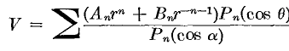

so that on the boundary θ = α and we just have the usual r dependence. But you have to tune An and Bn to your specific problem.

Legendre Q functions. (142) We are off and running on this Bateman type section through page 146. He includes imaginary arguments.
Then he wants to show how these Q functions might be useful. Here is a nice form thing for concentric cones whose angles are α and β, where V = 0 on the β cone, and V = just the r factor on the α cone. The form is this:

You see how V = 0 on the β cone, and approaches the simple r factor on the other cone. This is a rather clover form I think. You cannot do it with P or Q functions alone! It satisfies Laplace azimuthal symmetric manifestly, so this must be the result! Again, A and B from particular problem. But he is not doing any explicit problems here with cones, just general forms.

Now recall from Stakgold our problem of the eigenfunctions of a spherical cone cap thing.

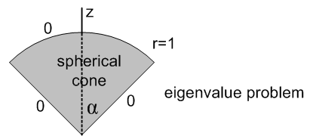

Pνm(cosα) = 0 νm,i = ν(mi) = the zeros i = 1,2.3... index λm,i = νm,i(νm,i+1)

The solution eigenfunctions are then these

um,i,k (r,θ,φ) = (1/r) Jν(mi)+1/2 [ β(ν(mi)+1/2k r] eimφ Pmν(mi)(cosθ)

Here we are forced to non-integral ν on the Pνm functions so that V = 0 on the conical surface. So here is an example of a case where you have to deal with P functions with non-integral ν, and that is what Smythe is now talking about.

Then he launches into the associated Legendre functions discussion. On and on its goes to page 153.

At this point, he mentions "neutral points and lines". A neutral point means the E field is 0 there. Not too interesting for me.

Then in "biaxial harmonics" he shows how to expand a Pn(z') in terms of Pn(z), where we have a change of z axis. Here is the famous result
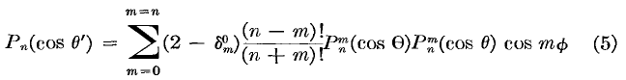
which appears in some form as Stak p 398 vol II (A.11). This is one of the "addition theorems"

Comments only on the general Dirichlet Problem on the Cone

Conical Boundaries (155). Here we have some new stuff. Dirichlet for the cone is the subject. Smythe claims that in this kind of problem, that R equation has to be solved in a way involving orthogonal R functions and he claims this forces ν = ip - 1/2 . Here is the reasoning for this:

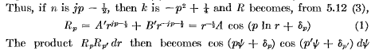

and you see how you sort of have an orthogonal set of functions somehow. I don't think I have seen this anywhere. This is not "conical coordinates" as far as I can tell. Perhaps this will appear later in Smythe, or I could find it in MF. His point is only that now you are stuck with Pip-1/2(z) Legendre functions to worry about which he says are "cone functions". Sure enough, AS page 337 has a few words to say on these guys (not much, "conical functions").

Next, Smythe is off on "non-integral n" P and Q functions. So he writes down a few Legendre facts in this case. I am not very clear what he is thinking about here.

Green's Function for a Cone. (156).

We are going to solve this problem by what I shall later call "the Smythe Method". The solutions here inside and out for Laplace are these

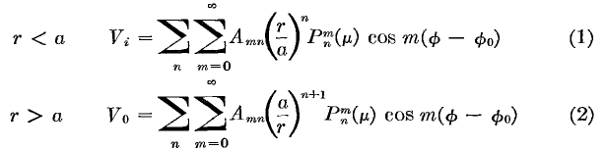

where the sum on n means you are summing over the n values (zeros) which cause Pnm(μ0) = 0, which I have done before. Then we have guaranteed V = 0 on the cone μ0. We then put a point charge at
(r,μ,φ) - (a,cosβ,φ0).
Now let's compare the above to Stak p 397 E where we have the Green's Function "in free space" in terms of the Y functions. We have the usual r>-n-1 r<n which you see above as well. The sum shown in Stakgold is just 1/R. in the above, it is some OTHER solution to the Laplace equation which meets the BC's shown. I think Smythe is doing what Stak is doing there in that appendix A. But here we don't have the "fundamental solution" 1/R, we have the solution in the presence of this huge object sitting at V = 0. How do we know the above is correct? It is the most general thing you can write that (1) solves Laplace everywhere off the cone; (2) has V = 0 on the cone. The Amn are then chosen so that the tangential E field is continuous across the cone boundary (there will be surface charge σ, but that won't affect the tangent E field which here is ∂rE where r goes out along the cone surface, we are in sphericals still. ). He gets a result for the Amn. This then gives the exactly solution to the Green's Function for a cone! Remember, you want V(σ) = 0 and here the cone is the surface. So this is a problem I am seeing solved for the first time! [ NOTE: I solve this cone problem in detail in a different doc! ]

Comment: Let's study the above Green's form very carefully. We have a point charge at some off-center location inside this cone, at some distance r = a from the origin. Anywhere away from this point charge and away from the cone, we have to solve Laplace. That means the "general form" has to be the usual rn,-n-1Pnm cos[m(φ-φ0)] at any such point. The φ function is quietly chosen to be symmetric about the azimuth φ0 of the point charge -- reflection symmetry of the problem is quietly made use of. Inside the point charge, we can only have rn powers, to avoid divergence at the origin. Outside, we can only have r-n-1 powers to avoid divergence at infinity. But what are the n? They are the zeros in the degree of the P function (upper index is called the order). This causes Pnm(z) to vanish on the cone, a key fact. Notice how the n sum is shown sort of blank above, hard to express zeros of the degree, but I know they exist and can be computed, etc. Surely they are not evenly spaced. The notation makes it seem that the zeros are the same for every m, but I think that is wrong. Let's investigate: ( But first, notice that we are assuming that the zeros n are positive numbers, so that the powers selected in the form above are correct.)

Comments on the zeros in degree of the P function.

GR page 1012 comment that the function Pν-μ for fixed argument and fixed general μ ≥ 0 has an infinite number of zeros. So GR are using negative order just as I did since this provides a clean hypergeometric definition of P for an argument in the open range (-1,1). They don't say whether the zeros depend on μ, but they certainly do!
I have found a strange 1951 paper on the subject of radar cross sections of "ogive" front ends of missiles. Those zeros are somehow involved here and they compute them. They use a function Π(z) = Γ(z+1) as a form of the gamma function I have never even heard off, the Gaussian operator, wiki has it, fine:
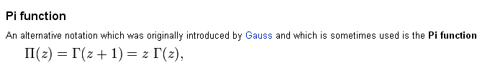

Here are some conclusions of this paper http://deepblue.lib.umich.edu/handle/2027.42/7630

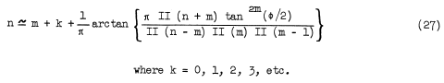
They then do some approximations for their case and end up with

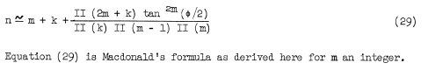

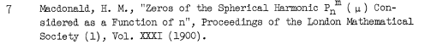

What is μ' and how related to φ? He has earlier

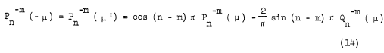
so μ' = -μ, so his region of interest is then μ close to +1. And yes, μ = cosφ. So, although we are in the case m = integer and z close to -1, we see that the zeros (those n values shown in 29 above) are indeed a function of not only φ, but also m. The k is of course just an index listing off these zeros.
The above paper, by the way, was from Willow Run Research Center which was a military lab during WWII at the U of Michigan. It ran 1946-1972 and Viet protests caused Willow Run to separate from the university and become the ERIM (Env Res Inst of Mich) which continued military work, but then the thing was converted to a private company and sold circa 1997 time frame.
Therefore, I feel the proper form for the sums in Smythe's series above should be this: Σm=0∞ Σn where the Σn is over those values n(m,φ) which are zeros of Pnm(cosφ). The paper later claims that these zeros are important in computing backscattering from a cone. Probably the reason is the same as in my little Green's function problem here -- you need V = 0 on the metallic cone.

So we are still "go" with the Smythe forms above, assuming the zeros are for positive ν. The reflection rule -ν-1 probably handles this little issue. And the n are positive in the case shown above.
Now the question is: how to you find the Amn in the above formulas? Notice that we have not really made any use of the point charge's presence, except for the φ0 symmetry and the r=a dividing line for the two regions. We have not used the polar position cosβ of the point charge. What does Smythe do here? Now he does think about the point charge, modeling it as a little "patch" on the r=a sphere, since he is not using delta functions. You have to carefully read his words on this, but he muddles through and gets Amn. The modern physics person would rather see a delta function method of course. I might somehow argue that close to the point charge, you know what the potential V has to look like and that forces the Amn. Basically Smythe is saying that ∂rVi = ∂rVo at all points r=a away from the point charge, and then he has to do a Gaussian pillbox thing near the charge which is modeled as a tiny patch on the r=a surface. I think his claim is that on the two sides of this little patch, the E field is equal and opposite, as if the charge really were on a little patch of surface there. This is then the boundary condition that makes things work. So this agrees with my idea of requiring that the V do the right thing very close to the point charge, except he has the point charge as a little patch with some σ on the two sides. [ Again, see my full solution of this problem in another doc. ]

So we can summarize his method: (1) find general forms for the Laplace solution in various regions of the Green's functions, which forms meet the boundary conditions V = 0 on various surfaces. (2) require that the potential be continuous at math boundaries where the regions meet, even at the point charge however it is modeled. (3) require that the electric field also be continuous at boundaries, but near the modeled point charge, require that it be appropriate for a point charge. So basically this is another method that Stakgold just did not mention, I will call it the Smythe Method.

Green's Function for a Conical box. (157)

[ See my other doc! ] This "box" refers to terminating the cone on a sphere at two radii he calls c and d with c < d. This is a shape I have not worked with before, but I understand it. You now have to make V = 0 on the two spherical surfaces, which puts more requirements on the R function. Our point charge is still at the same location (inside this box thing). So the difference is just that we have a linear combination of the radial powers with different coefficients. He states the result for this problem and shows how you get it. He then says what to do if you want to add two V = 0 "walls" inside the box.

Comment: Here, the radial function is still just rn,-n-1 combinations done in a tricky way that makes V vanish on the two new spherical surfaces at r = c and r = d. The same Amn appear in his "forms". For example, on the inside r < a he has

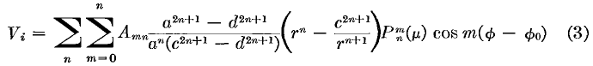
Now here is my question: how do I relate this to Stakgold's method of full eigenfunctions? Let's think instead about the 2D problem of the curved quadrilateral, sort of the analog of his conical box. Well, how about the full disk for Green's which Stak does. Since this is an EV problem, he gets that extra constant floating around and it converts the radial equation to a Bessel function. Obviously that conversion to Bessel function type radial is not occurring in the above, so I guess I cannot identify Smythe's method with the "full eigenfunction method". Nor is it the partial EF method. In fact, it doesn't really fit any of Stakgold's five methods which are integral equation, images, full and partial EF, and complex for 2D. Smythe's method is a sort of "fit and fiddle" method. Maybe it is the partial EF method. Smythe has the eigenfunctions for the θ,φ problem and perhaps this implies a 1D Green's problem in variable r. The R functions are of the form Rn,m(r) and solve some residual ODE.

Oblate Spheroidal Coordinates (158). ( see other docs!) Here begins the section I have annotated elsewhere. See two separate documents on this! The first is just " smythe on oblate spheroidals.doc" with some support docs, the second is "the Smythe method for Green's Functions, cone examples.doc" in which Dirichlet and Neumann problems are also done!

Cylindrical Coordinates (169). We are off on properties of Bessel functions up the wazoo. Then on page 176 he is expanding things on Bessel functions Jn just as we did with the Pn, but in a different world. This would be some kind of Bessel Fourier transform deal.

Green's Function for a Cylinder (178) Our expansion form here is this:

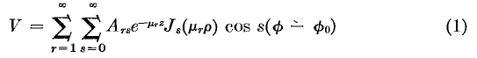

where we have our usual φ quantization, but now it is the Js (why not n I wonder). The μr are making the Bessel functions vanish on the cylinder surface, and then radial function is now the e-μz function you get from separated coordinates. I recall Jackson doing this somewhere. Here is his final answer:

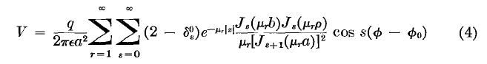
The point charge is placed at radius ρ = b and at φ0 and z = 0. Cylinder radius is a. This looks like Stakgold's "full eigenfunction method" of computing a Green's function. In fact, in Stak p 154, we have the above result in a 2D version of the problem. The above gives the Stak result if we set z = 0, meaning we only care about V in a 2D cross section. Stak has a = 1 and q = 1 sort of, and we have the usual units issue. Smythe might have an error here because Stak shows the μr squared in the denominator. Maybe the 2D problem is a little different and gives a different denominator power. I cannot quickly find a web solution to this problem, perhaps in MF>

Green's Function for a Cylindrical Box (179) The obvious extension of the above, now in the z direction we are doing to have sinh(μz) stuff I am sure. Here is the answer

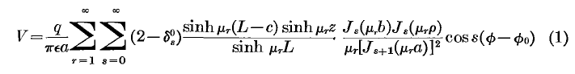

which seems completely reasonable to me. We still have that single power which must be right in 3D.

More Bessel function stuff: J0 and the two modified Bessels he does call I and K.

Wrap Up. Problem of an electrostatic lens, but the physical description is opaque. Then the last subject is called "wedge functions". This is for a specific box thing made from two concentric cylinders and some end plates and some azimuthal Dirichlet prescriptions.

Problems! (199). There are 126 problems here! One catches my interest:

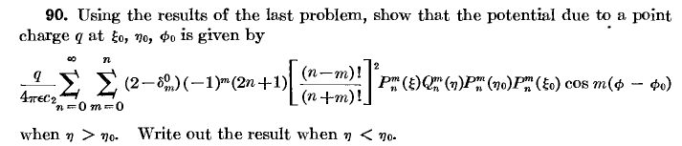

This is the Green's Function in prolate spheroidals with the point charge placed as shown. I think I could get this result if I wanted, it is just the "full eigenfunction method" at work. The previous problem asks for V inside such a spheroid with σ on it, which is modeled on stuff Smythe did earlier. Here are some of his reference comments:

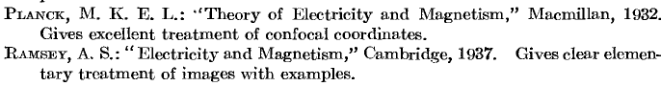

and many more.

And so ends, in a single sitting session, my little review of Smyth Chapter 5 on 3D potential stuff. At least I know what is in this collection now!

