Smythe on Oblate Spheroidals PhL 12.3.09

Section 5.27. Oblate Spheroidal Coordinates (p 158)

Section 5.27. Oblate Spheroidal Coordinates (p 158) 1
Section 5.27.1 Oblate Spheroidal Harmonics. (160). 2
Section 5.27.2 Problem: Conducting Sheet with Circular Hole (161) . 2
Section 5.27.3 Torque on a Disk in an E field (162). 5
Section 5.27.4 The Arbitrarily Charged Spheroid Problem (165). [ Neumann on Spheroid ] 5
Section 5.275 Potential of a point charge expressed in oblate spheroidals. (166). 8
5.28 Prolate Spheroidal Harmonics (167) 9
5.281. Prolate Spheroid in Uniform Field. 10
5.29 Cylindrical Coordinate Laplace 10

He introduces the coordinates in a manner similar to how MF do the ellipsoids (and how he does it as well at the start of Chapter 5). He writes the equation of the conic section in terms of a "generic" coordinate he calls θ, then considers some ranges and these are then the usual ξ,η coordinates of MF, but for Smyth they are called ζ,ξ which is certainly painful, but I can live with it (zeta, zeye). So you have to remember which one is the "ellipse label" (ζ) and which is the cone angle (ξ). He uses c1 as the focal distance (of the ellipses you get by slicing an oblate spheroid in any azimuthal plane). By the way, some people use the word conicoid for a hyperbola of revolution, and perhaps even for an ellipsoid where the slices are conics, meaning conic sections. He then writes down the usual h scale factors, he has his own way to get these from earlier work. And finally he states the Laplacian bottom of page 159.

More detail: The coordinates have these ranges:

0 ≤ ζ2 ≤ ∞ 0 ≤ ξ2 ≤ 1

Now look at the picture on page 163 of these elliptical coordinates. The inner most ellipse has ζ = 0 and as you move out, ζ gets more positive. So for this picture we in fact have 0 ≤ ζ ≤ ∞. We can identify

ξ = sin(θlat) where θlat is the latitude angle of hyper V. ξ = cos(θ)

In the "northern hemisphere" this angle increases from 0 to π/2 and so ξ increases from 0 to 1.
In the "southern hemisphere" this angle increases from 0 to -π/2 and so ξ decreases from 0 to -1.
All the labeling on page 163 matches this description. To summarize

0 ≤ ζ ≤ ∞ ellipse label thin line ellipse has ζ = 0
-1 ≤ ξ ≤ 1 hyperbola label corresponds to -π/2 ≤ θlat ≤ π/2
corresponds to π ≤ θ ≤ 0.

Section 5.27.1 Oblate Spheroidal Harmonics. (160).

Here he does the expected separation of variables, and then states the two functions just the way I did in my previous oblate notes, equations (5) and (6)

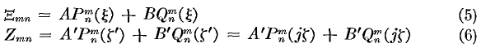

So you see that the cone angle label has real argument ξ, while the ellipsoid label ζ (radial marker) ends up as iζ. So I am very happy with this result so far. At page bottom he considers c1→ 0 which makes the ellipsoids all spheres and he finds that ξ → cosθ (spherical, I always call z, he calls this μ). and ζ → r/c1 . He also takes the limits of the P and Q functions and finds useful results, as we shall see shortly,

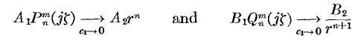

Comment: of course these last results are what you expect, since oblate spheroidal coordinates become spherical coordinates when you go far away, or equivalently when you send focus → 0. Keep in mind that the ellipse label ζ is basically the scaled radial coordinate ζ → r/c1

Section 5.27.2 Problem: Conducting Sheet with Circular Hole (161) .

This has been long on my list, so good to see it done. Red Jackson does this as well, surely in a different way. When I first saw this problem, I was thinking some kind of subtraction deal solid plate and disk. But here he has a basic approach. Obviously you are not going to put some charge on the infinite plate and get anywhere that way (why not, I do this later...). He says to put this plate with a hole into a uniform E field perp to the plate and see what happens. I expect some E field to sort of leak through somehow. His page 161 picture notes that the plate with the hole is the hyperboloid with ξ = 0. He puts at x = +∞ a uniform E field so V = Ex, so I guess the E field points down toward the plate with hole. But this is V = Ercosθ where θ here would be the spherical coordinate cone angle (polar angle). But "far away", this will be ξ = cosν (he does not use ν) and the only Legendre that does the right thing is P1(ξ). Cannot have m≠0 since expect no azimuthal variation. But then this fixes the nature of the full solution based on our form above,

so we are practically done! The ellipsoids are confocal with the hole, and ζ is the spheroid label. Here is a plot of the arc cotangent function

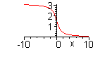
As you take ζ → +∞, you go to the right, and you find that ζ cot-1ζ → 1 by l'Hopital (Maple agrees). Then V = jA'ξζ in this limit ( far from hole). But we know that ζξ = x/c1 so we get V = (jA'/c1)x = Ex => jA' = c1E. This is from the x = +∞ limit above the plate where we have full E field. The other way at x = -∞ he has chosen to make by negative half ellipsoid coordinate ζ → -∞. Now cot-1ζ → π so we neglect the 1 (the constant term) and we have jA'ζ + B'ζπ = 0 =? πB' = -jA'.
OK, so the complete exact answer is (6) p 162.
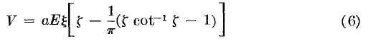
Here is my plot, x is the left right bottom axis, and a range of ρ = 0,2 but doubled so you get a full picture.

> plot3d({[x,rho,V],[x,-rho,V]}, xi = 0..1, zeta = -2..2, axes=boxed, scaling=constrained);

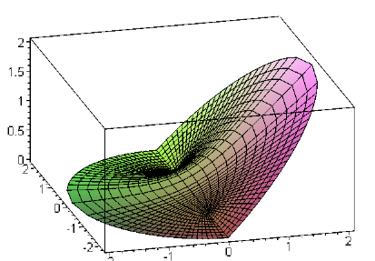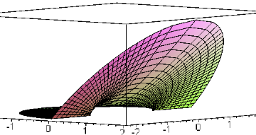

The x = +∞ is to the right, and as we go off in the direction, the potential is a flat fan/plane of fixed slope which gives the potential x on the right. And to the left we have basically V = 0. But you can see that at the hole location, which is radius 1 here, there is some leakage of V through the hole to the left side. You can see how V = 0 on the metal outside the hole going perp to the symmetry axis.
A top view shows you that the lines on this surface really are the ζ,ξ lines

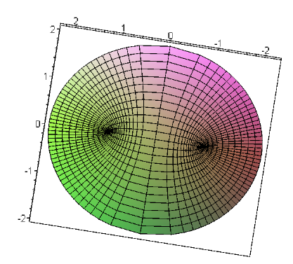

Now we can do a derivative to get the charge density σ. The calculation to get (8) seems straightforward. [ I actually do this later in recorded detail, for slightly different problem.] The two sides have different values because ζ is negative on the bottom side and positive on the top. And as I now know, the cot-1 function is very different for + and - argument. See Schaum p 19. This function is defined so it is continuous at arg 0, so runs (0,π), which might not be what you were expecting. The tan-1 function in contrast runs (-π/2,π/2) so have to be careful. So here is my plot of the two charge densities, where the left edge of the plot is the rim and everything is symmetric around the rim:
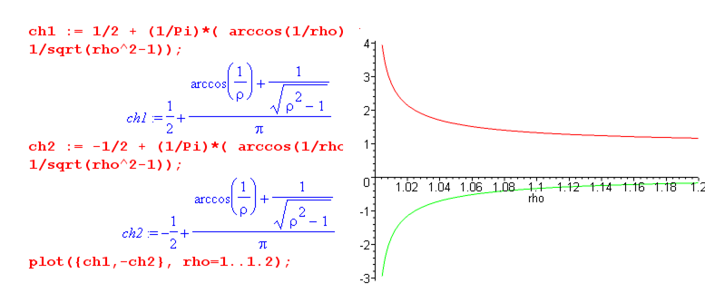
On the top, far away σ = +1 since it is just "terminating" the uniform E field -- it is the bottom plate of a large capacitor. Far away on the bottom side we have σ = 0. But right at the lip, the charge blows up in the usual fashion, and things are equal on both sides of the rim! Both charge densities are really negative everywhere as (8) shows, but I plot the near side one as positive just as a graphic aid.
Question: suppose you took a 10 foot square plate with a 1" hole in it and put some charge on it. This is a slightly different problem that I could now solve I think. At x = +∞ we get E = -Vx but at x = -∞ we get E = +Vx, both being just fed by the plate, with ground at infinity in both directions.

Phil's Charged Plate problem (false set up). The solution must still have the same form as shown in (2) because we have the same situation at x = + ∞. The expression for jA' stays the same for this same reason. But the B' equation would be this:

-Ercosθ = |cosθ| (jA'r/a + πB'r/a) =>

-Eacosθ = |cosθ| (jA' + πB')

my idea being that at x = -∞, the potential is V = +Ex so E = -E whereas at x = ≠∞ it is V = -Ex. The main point is that E has opposite sign on the two sides. Yes, E comes from our charge density, but ignore that and just call it E. So we still get jA' = Ea. So maybe our second equation says:

-Ea = (jA' + πB') = Ea + πB' => πB' = -2Ea.

I'm sure this is wrong, but if it were true, then B' is just double what it was before. But in (8) we still get the two sides having a different σ, so I have done this BC wrong.
Suppose instead we take as our second BC that V = 0 in the center of the hole. That says B' = 0, so that is wrong too. Something is strange here. I wanted a big enough plate to make the approximations OK, but of course it if is a finite plate no matter how big, get q/r in the distance, not a uniform E field, so this probably blocks my solution.
I know what the answer is going to look like, however. It will just be a symmetric version of the above plot, where we really do have an infinite plate with a constant σ on it everywhere far from the hole.

Debug the above problem. If I can't do such a simple problem, there is no reason to continue. Go to separate document, don't clutter this one please.

// OK, I have finished that separate document. I did both the one-sided hole problem and the two sided one using the more conventional "my way" method and got good answers. I don't think his "single form" (1) can suffice for the second problem which has to be symmetrical in ζ, but maybe it can work. In other words, if you stare at (1), it is hard to imagine how you would find a result that says V(-ζ) = V(ζ). The reason I say this is that neither the P nor Q function has this property. The P function is in fact antisymmetric, and the Q function has no symmetry. He is silent on this topic and it sent me off very confused, but I think I am happy now.

Now I have to remember where I am heading with this oblate stuff! I really liked the hole problems, very real world stuff.

Section 5.27.3 Torque on a Disk in an E field (162).

The disk is at some angle of course, and probably you just induce a dipole in it, and then that dipole wants to get aligned, and that appears as a torque. I am skipping this section, because I want to get to the results of the next two sections.

Section 5.27.4 The Arbitrarily Charged Spheroid Problem (165). [ Neumann on Spheroid ]

[ See full treatment of this problem in another doc.]

This spheroid is not metal. Instead, you specify some charge distribution on it which he calls σn. The game is then to find the potential inside and out as a function of σn. I am mainly interested in this section because it leads to the next section which is something I have always wondered about: how to express the potential of a point charge in some curvilinear coordinates using a set of harmonic functions. This takes a while to show even in "simple" spherical coordinates. I think this result will in turn lead to Green's function results, and that will take me back to my Jackson inversion problem. I can see that I might be wandering through this desert for quite a while before all these puzzle pieces are in place. Stop for today.

Resume here post Cod.

Maybe I would like to ponder the second Legendre equation and make some statement of completeness and orthogonality, as we did very many times in Stakgold for various situations. // I did this, it took quite a while, and results are in the ODE/Legendre area.

Back now to a fresh start on Section 5.27.4. His method is a little strange. He starts by assuming that the spheroidal surface has a charge density I would call σn,m and not just σn. This charge density activates only one of the n,m terms of the solution. I agree with (1) which relates σ to the field difference at the surface, and he converts this to spheroidals with a scaling factor.

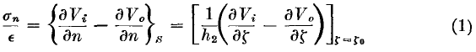

In (2) and (3) he is simply writing out the (n,m) term. For the external problem Vo (o = outer) the spheroid radial ζ appears as Qnm(iζ) to be clean at infinity. For the inside solution, we of course get P instead. All the "angular" portion is in the Snm function which is a sort of spherical harmonic for this problem. He puts an arbitrary constant Cmn inside Snm which is fine. He has very cleverly put "the other function" at the spheroid surface ζ0 as an extra constant in each form. Then when you insist that the two potentials match at ζ = ζ0, the matching is now automatic. So we now have:

He then computes the difference in fields at the surface and set this equal to σn,m . But this just brings in the Wronskian of P and Q (Bateman p 123 bottom where you see constant * 1/(1-z2) for a normal argument, this will become 1/(1+ζ2) for our imaginary argument. He then finds the simple result (5).
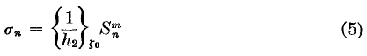

He then defines a certain constant Amn ( he likes to put m first, I am the reverse), and he then claims that this constant appears in the two strange integrals shown in (7). These integrals need comment.
Look at the left integral in (7).
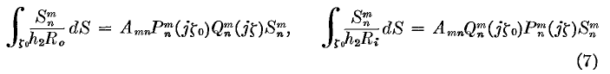We are integrating over the entire spheroidal surface dS. So somehow you have to get the area dS in terms of the ξ and φ coordinates. Of course Snm is function of ξ and φ as shown. The factor Snm/h2 is just the σ charge density as he found in (5). So this integral is just a statement of the potential due to this σ where we integrate against 1/4πR doing superposition (but he has no 4π I suspect) and so this should equal the potential at some point. But we know what the general form of the result has to be at some point outside the sphere because that form has to be our n,m term in the Laplace solution. Since again the two results must be the same at the surface, both have the same Amn coefficient. It is then only a matter of determining the constant which is Amn and it turns out it is as in (6).
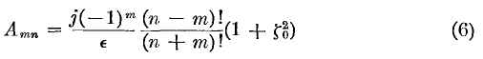
The next step is to superpose a full set of σn,m charge density terms.
where he has now confused us by replacing σnm with σrs, but fine. The C coefficients are then found by using orthogonality on the angular functions ( which I now know all about), and the result is this:
So you could call these things the spheroidal multipole moments of the charge distribution σ on the surface of your spheroid. We can then insert these moments into our inside and outside original forms to get

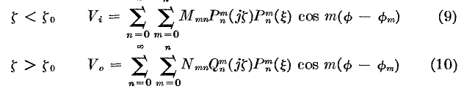

where the M and N coefficients absorb both the Cmn constants and those P and Q of jζ0 factors, so the constants are different, and they are given by

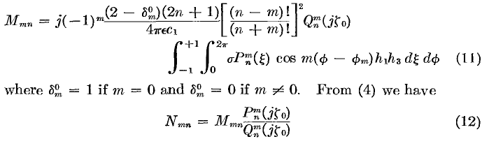
where the last equation shows just this difference I mentioned.
So let's review what we have done here. If we have some arbitrary σ charge density on the surface of a (non-conducting!) spheroid, we have computed exactly the potential inside and outside the spheroid! This is not a Dirichlet problem. It's more of a Neumann problem. We could think of there being an inner and an outer charge density each being ∂V/∂n , but then we add the two charge densities together as in (1) above. This section is completely reasonable, and I think I could do all the details if I wanted. Right now I just want the logic flow and a clear understanding of each step.
Note: in the above he has allowed each "component" to have its own azimuthal reference angle φm but I would be inclined to set φm = 0 for all m, and he does that in the next section.

Section 5.275 Potential of a point charge expressed in oblate spheroidals. (166).

He decides to place the point charge at the point (ξ0, φ0) on the spheroid of the previous problem. The integral for Mmn shown above (φm = 0) is then defined on a tiny patch of area at (ξ0, φ0) . The integral shown on the second line of (11) above then becomes ---

Note added: For Smythe, we have 1,2,3 means ξ, ζ,φ. Then dsξ = h1dξ and dsφ = h3dφ as Cartesian distances. So the total charge in a small patch would be dq = σ dsξ dsφ = (σ h1 h3) dξ dφ . We then want to represent a "point charge q" as σ = q δ(φ)δ(ξ-ξ0)/h1h3. Why? Then if we integrate over a patch enclosing our "point charge" we get

∫∫ dq = ∫∫ dξ dφ (σ h1 h3) = ∫∫ dξ dφ q δ(φ)δ(ξ-ξ0) = q

so things are normalized properly and scale factors handled. This is WHY he did put h1h3 in the answer of the previous problem, something I was wondering about earlier. The following line is then explained as being the integral shown on the second line of (11) above:

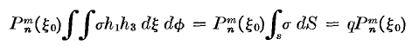

Jackson would have used delta functions, but Smythe either avoids these or doesn't know about distribution theory (his book is 2nd Ed 1950, first was 1939, so I guess he does do delta functions, but not here. But "delta function" has no hits.) Recall that the distribution theory was in the 1940's, so maybe Smyth just missed this. His method above works fine, and implies of course some test function around his point charge, etc.
So, now that we have done the equation (11) integral, we have our full result for the point charge potential:

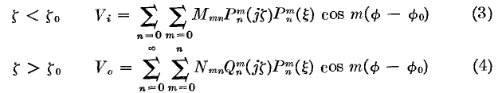

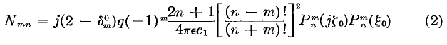

Remember, this is for a point charge located in space at position (ζ0, ξ0, φ0) ( we just shifted from φ = 0 to φ = φ0),
The spherical coordinates analog of this result would be Stak Vol II p 397 E, which on the web looks like this [ potential of a point charge at r' as seen at point r , charge at r' is at (r', θ', φ' ) ]
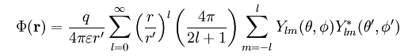

Here r is r> and r' is r<. Here the radial functions are just powers of r, but in spheroidals above they are P and Q of imaginary coordinate. The forms for the ξ and φ factors are pretty much the same! Of course this last uses eimφ type functions instead of cosmφ, etc.
So, it is nice to finally understand where this oblate spheroidal point charge formula comes from! That has been on my list now for maybe two weeks.

Comment: Just to summarize, we are in oblate spheroidal coordinates and we position a point charge q at location ξ=ξ0, ζ = ζ0 and φ = φ0. There are no surfaces anywhere around, so this is a sort of fundamental solution. The combination of Vi and Vo above tell us in full the potential due to this point charge. We could set ζ0 = 0 to put this point charge on the line between -c1 and c1. We could then set ξ0 =1, and then we would have our result for a point charge at the origin, in oblate spheroidal coordinates!

5.28 Prolate Spheroidal Harmonics (167)

When the dust settles here, something changes sign, so the general form of a solution term is this:

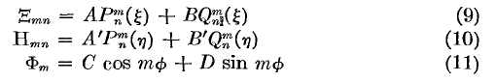
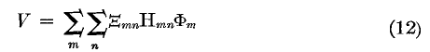

Here ξ is still the cone angle, but the cone (upper) is for a pencil tip instead of for an open-bottomed hyperboloid. Of course φ is still the azimuth. The coordinate ζ which was the radial marker of the spheroid now appears as variable η, and its P and Q functions are of real argument. What has changed is a sign in the generic starting equation. I could do it all out, but the result seems reasonable. He points out that arc lamp carbon tips work well in spheroidal coordinates, and electric field is obviously important for such tips. An application.

5.281. Prolate Spheroid in Uniform Field.

His example here is a half-spheroidal dome (haystack or tree!) sitting on the ground in an electrical storm where the sky is a uniform plate. I guess he could have done the corresponding oblate problem, but there he did the hole in plate instead. He arrives at a result for V in his usual compact manner.

5.29 Cylindrical Coordinate Laplace

I note this heading just to show that Smythe is now done talking about spheroidal coordinates in this section of his book! In my notes here, we have covered only a small part of Smythe's 107 page Chapter 5 on 3D potential distributions.

