Smythe Hole in Plate Confusion PhL 12.3.09

Overview (2 pages, written 12.4.10) 1
VERY LONG DIGRESSION 3
A complete summary of this digression: (so you don't have to read the details) 3
Back to the separated ODE's for oblate spheroidal coordinates. 8
First, comments along the line of the above digression. 8
Doing the Hole-in-Plate with E field on one side "My Way". 10
Doing the Charged-Plate-with-Hole problem, "My Way". 16
Now, how do we "understand" Smythe's way of doing the one-side-E field hole problem? 20
Comments on hole-in-charged-plate problem added June 25, 2010 21
Note added 12.4.10: charged bloid problem? 23

__________________________________________________________________________________

Overview (2 pages, written 12.4.10)

This is a very early document, and many things were new to me all at the same time.
In the "very long digression" and its summary, I am just reviewing SL theory for the Legendre equation with its regular singular endpoints in (-1,1), as taught by Stak. If your range of interest includes the endpoint -1, you must have n be an integer to have a finite P function (Q is hopeless). In the non-singular SL case, it is a pair of homo BC's that causes quantization, and I show how this happens in terms of detM=0 for a certain matrix. I did not resolve the issue of how an L becomes fully self adjoint (no parts) in the singular case, since there seem to be no BC's to "kill off the parts", but I think Stak did all this and there are "effective" BC's. I remind myself that in N dimensions the "homo BC's" which cause quantization become Dirichlet, Neumann or Mixed BC's on a bounding surface.
After this digression, I review the oblate atomic forms (I did not call them that, then), and I immediately wonder what happens to the Legendre SL theory if your range is (+i0, +i∞) or the like. I concluded eventually that no quantization of n arises from this SL problem. If you have a localized charge distribution, Q is the only allowed solution since it decays at ∞. [ I now know this is non-oscillatory for normal integer n.]
Iris with E field, my way. In my reading notes on Smythe (see nearby doc) I had encountered his hole-in-plate problem (with distant E field up top). I later started calling such a plate an iris. I was "unhappy" with the way Smythe did his parameterization, allowing -∞ < ζ < +∞. So I decided to solve this iris problem "my way" using my own preferred ranges for the coordinates. The distant E field required potential -kz for z = cosθ in distant polar, but in that distance, z = η = his ξ, so this forced n=1 in the atomic form. I then set about this problem using one of my first "Smythian forms" (not called such at this time)

V = ξ [ A'j ζ + B' (ζ cot-1(ζ) – 1) ] ξ ≥ 0 Q1(jζ) = ζ cot-1(ζ) – 1
V = ξ [ A"j ζ + B" (ζ cot-1(ζ) – 1) ] ξ ≤ 0

where the second term is the Q1(iζ) function, jζ is P1(iζ) function, and the external ξ is the P1(ξ) function. So this is what the Smythian form looks like. I then did various boundary and continuity conditions and ended up with this solution to the problem:

V = (Ea) ξ [ζ - (1/π)(ζ cot-1(ζ) – 1) ] ξ ≥ 0
V = (Ea)ξ [ (1/π)(ζ cot-1(ζ) – 1) ] ξ ≤ 0

I then showed how you can switch from my parameterization to his. The upper equation stays the same, and the lower equation ends up being a duplicate of the upper. I did plots of this in the adjacent doc. In the adjacent notes I also computed the σ on both sides of the iris and plotted them too, all very interesting.
Charged iris problem, my way. I then went after this problem, again in my preferred parameterization. Here the iris starts as a stable plane with some σo on it which makes an E field on both sides out to ∞. You punch a hole and ask what happens. My solution to this problem is this:

V = – (aE) | ξ | [ζ – (2/π) (ζ cot-1(ζ) – 1) ] // compare to above, 2 instead of 1

and I did plots here of V. I computed the σ's and plotted them as well. We get the usual peaking of σ around the hole, then goes off to a constant. I had doubts about whether such a configuration could exist theoretically, but I think yes. As a limit, it could be the region close to center of a huge but finite disk. I argue (and I think prove) that the hole simply displaces the charge that was there before you created the hole. And I give an argument for why the charge peaks up at the edge which really applies to any edge situation. [ I just wrote a doc on this subject but could find no easy way to prove the 1/sqrt behavior.]
When I wrote Understand Smythe's Parameterization, I had not made the simple connection between my answer and his answer, so I was mystified. He is taking the Q1(jζ) down through its cut going to negative ζ. I think I correctly note that Smyth's "form" cannot be used for the charged iris problem, whereas my form works. So this section is not too interesting any more to me.
The last section is Comments on the iris problem. In (a) I first review the oblates method of finding the solution for a charged disk (this is still the simplest disk method! ) Then in (b) I switch to the charged iris problem as I had just finished doing it above! I wrongly conjecture that I might invert the V = 0 iris to get a charged bowl. This was all well before I did the Smythe Five Problems.
I added another Notes section today. I first review how one finds the potential of a charged spheroid in oblates using atomic forms. In order to get V = V(ξ), you must take n = 0 and already m=0 so problem is solved. Then limit gives the charged disk. Then I ponder the "charged bloid" problem and ask if there is some solution to that problem similar to the charged iris solution given above. If so, then maybe the limit of that solution would match my charged iris solution. My efforts are inconclusive. If a solution exists, I don't know what it is, and I don't know how to find it, and I don't know it would be unique. The conical type functions Piτ-1/2m(η) could be involved here. This is a very obscure backwater probably not worth paddling in any more.
__________________________________________________________________________________

Motivation: I am unhappy about having the oblate variable ζ take negative values. The separated equation on page 160, when written out, is always quadratic in ζ. On page 159 we have the official range 0 < ζ2 < ∞ which I like. I don't see how the ODE can have a solution which is not invariant under ζ → -ζ. Now look at the general solution form which is this

A' Pnm(iζ) + B'Qnm(iζ)

How is this invariance maintained here? Just look at this simple case

A' P1(iζ) + B' Q1(iζ) = A'(iζ) + ???

Pause for a digression, then return at large heading far below. Read digression summary only!

VERY LONG DIGRESSION

A complete summary of this digression: (so you don't have to read the details)

I show how, in "regular ODE theory", if you have homogeneous (!!!) BC's at your interval endpoints, you get both quantization of eigenvalues and you get "full" (not just formal) self-adjointness of your operator L. It is this full adjointness which allows you to say (u,Lv) = (Lu,v) where u and v are in the space of functions that meet the BC's at both ends (the "domain" of L). This in turn allows you to show things like eigenvalues are real and eigenfunctions of different EV's are orthogonal. Example 1 fails to have homogeneous BC's and we fail to get "quantization". Example 2 does have homo BC's and you do get quantization.
I comment in passing on how this idea of a homo BC is generalized in N dimensions as a combination of Neumann and Dirichlet at every point on a closed boundary σ. In particular, the Green's Function is based on u(σ) = 0 on the boundary, an example of a homo BC of the Dirichlet type.
Unfortunately, the Legendre problem (the one I am interested in today) on the interval (-1,1) does not have explicit "homo BC's" (or any BC's) because, it turns out, both the endpoints are singular points (limit circle). In this situation, the quantization comes about by a different mechanism: it arises by requiring that your solutions be finite everywhere in the interval, which really means at the problematic point z = -1. If you study the Pν(z) hypergeometric form, you find that you fail to get finiteness at z = -1 unless the series truncates, and that truncation is what is caused by ν = integer. Thus you arrive with {Pn(z)} as a set of eigenfunctions on the interval (-1,1). Somehow, the "effective homo BC's" at the two singular endpoints also cause the operator L to be fully self-adjoint, and you obtain all the "usual" properties of a set of eigenfunctions. The Qν(z) functions blow up at both z = +1 and z = -1 even if ν = integer, so these are not eigenfunctions in any sense [ although perhaps see PhL thesis ]. The general study of an EV problem like the Legendre one where one or both endpoints are singular is the subject of Sturm-Liouville Theory.

End of summary, start of details:

Back Up. Let's go back to the "theory of ODE's" for a bit. We often say that the range (a,b) of the variable is part of the ODE "system". I guess I am not clear on what that means. And how does this interact with the notion that an ODE has "two independent solutions" (2nd order ODE)? Does the range only affect "the eigenvalue problem" ? The range is really part of the "boundary conditions".

This example shows that, if you choose BC's which are not homogeneous, you

Example 1: The 1D Laplace, L = ∂x2 . The homo ODE is Lu = 0. Solution is u = Ax + B. If we add BC's that say u(0) = 1 and u(1) = 0, then we have B = 1 and A + B = 0 so A = -1 and solution is u = -x+1. This is the only solution, it is unique, there are not "two independent solutions". But without BC's, we can regard u1 = x and u2 = 1 as two independent solutions.
The eigenvalue equation is Lu = λu. The solution to this equation is u = exp(± $\sqrt{λ}$x) since Lu = λu for both these solutions. There are now two independent solutions ignoring BC's. We can write the general solution as u = A exp($\sqrt{λ}$x) + B exp(-$\sqrt{λ}$x). If we now apply the same BC's we get

A + B = 1 A exp($\sqrt{λ}$) + B exp(-$\sqrt{λ}$) = 0 A exp($\sqrt{λ}$) + (1-A) exp(-$\sqrt{λ}$) = 0.

Usual thing at this point is to let λ = k2 so have Aek + (1-A)e-k = 0

A[ ek- e-k] = -e-k Ak = -e-k/[ ek- e-k] = and B = 1-A

For any value of k, we now have an Ak and Bk so uk = Ak exp(kx) + (1-Ak) exp(-kx) is the unique solution. Nothing quantizes the value of k. The spectrum seems to be the entire complex k plane! This seems wrong, what is going on here?

Example 2: Suppose we consider "another problem" which is similar. Suppose we have the same ODE, but we have BC's u(0) = 0 and u(1) = 0. Our general form is still uk(x) = Ak exp(kx) + Bk exp(-kx) . Our conditions are then

uk(0) = Ak exp(k0) + Bk exp(-k0) = Ak + Bk = 0
uk(1) = Ak exp(k1) + Bk exp(-k1) = Ak ek+ Bke-k = 0

We still have a solution for any k, so spectrum is still the entire complex k plane ? But before jumping to this conclusion, let's solve here for Ak and Bk :

Ak ek+ (-Ak) e-k = 0 Ak(ek - e-k) = 0 Ak sh(k) = 0.

Now there is a discrete spectrum!!! It is described by sh(k) = 0. k = 0 is one point in this spectrum. We can write this as sin(ik) = 0 and then we have ik = ±nπ as other spectrum points. So kn = ±inπ is the spectrum of this ODE system! The solutions are then

un(x) = An exp(knx) + Bn exp(-knx) = An exp(+iπnx) + Bn exp(-iπnx) n = 0, ± 1, ±2...

= An eiπnx + Bn e-iπnx = An ( eiπnx – e-iπnx) = 2An sin(nπx) An arbitrary

Now we have quantization of the eigenvalue, and a single solution for each eigenvalue. But n = +1 and n = -1 are not independent functions. So independent functions are

un(x) = 2An sin(nπx) n = 0,1,2,3.... λ = k2 = real

Are the solutions orthogonal on our interval? Yes, we know they are.

Lessons learned from these examples.

(a) Look at Stak Chap 4 page 268 where he talks about the "regular boundary value problem". This means the L shown is formally self-adjoint (my example is because two parts integrations restores L to itself without a sign change.) In general L is formally self-adjoint for any p and q. There are three distinct ODE's of interest, and in each of them we see λ. But the critical equation is the EV equation which is Lφ = λφ, which is slightly generalized to Lφ(x) = λs(x)φ(x). We have various conditions that p and q are real and p and s are positive in our interval (a,b). Then in 4.26 we have the critical fact which I seem to have overlooked: You must have a pair of unmixed homogeneous BC's. In my first example above, one of the BC's was u(0) = 1. This cannot be put in the form au(0) + bu'(0) = 0. That is the missing ingredient.

Question: How does having homo BC's cause orthogonality of eigenfunctions?

It is really the "fully" self-adjointness of L. Look at 4.29b. To get full self-adjoint, we have to have the Wronskian terms vanish at the endpoints. Look at endpoint "a"

W(u,; a) = but α1u(a) + α2u'(a) = 0 and same for (αi are real)

I just added a note to my Chap 4 notes on this. The functions u and v which appear in <u,Lv> type things are elements of DL = DL* , the domain, and this domain is ONLY of functions which meet the two BC's. So, the above Wronskian does NOT vanish just because α1u(a) + α2u'(a) = 0 . But it is the fact that this is ALSO true for the function v ( the αi are REAL!) Consider in detail:

α1u(a) + α2u'(a) = 0
α1(a) + α2'(a) = 0

This says that the two rows are dependent

α1 + α2 = 0

and therefore the Wronskian vanishes. SO, the point is this: it is the homogeneous FORM of the BC that makes all the "parts" stuff go away (expressed here as Wronskians) and then <Lu,v> = <u,Lv> and the operator L is then "fully " self-adjoint. Then, once you can "swing" L between the two sides, proofs of things like orthogonality of eigenfunctions of different eigenvalues as on page 270 "go through".

Question: How does having homo BC's cause quantization of eigenvalues?

We saw this "happen before our very eyes" in Example 2 above. Imagine your homo BC's are Ba(u) = 0 and Bb(u) = 0. Imagine we write our generic EF (λ = k2) as uk = Aku1k + Bk u2k as we did in that example. Then of course u'k = Aku'1k + Bk u'2k . Then Ba(uk) = 0. This equation has the form

αa [Aku1k(a) + Bk u2k(a)] + βa [Aku'1k(a) + Bk u'2k(a)] = 0 Ba(uk) = 0
or
{ αa u1k(a) + βa u'1k(a)} Ak + { αa u2k(a)+ βa u'2k(a)} Bk = 0
or
ck,a Ak + c'k,a Bk = 0

We have a similar deal at b, so here are our two homo BC's

ck,a Ak + c'k,a Bk = 0
ck,b Ak + c'k,b Bk = 0

Write this in trivial matrix form to see this fact: in order for non-zero coefficients (Ak, Bk) to exist, we must have det(c) = 0 so the matrix cannot be inverted. But det (c) = 0 only for certain values of k, and this is WHY you get quantization of the eigenvalues! It is the fact that the homo conditions are linear and that each has a zero RHS that causes quantization. Just a Cramer's Rule matrix thing, not "rocket science".

(b) If you have these proper "homogeneous" BC's, then you will find that the operator L has some kind of "spectrum". If the everything is "regular" ( p does not vanish, a,b are finite, etc) then the spectrum will in fact be discrete and real. In our example, if we took L = – D2, then λK would be on the positive real axis.
So the whole notion of quantization arises also from these homo BC's ! [ detailed out above. ]

(c) In volume 2, we usually just use the homo BC of the form u(σ) = 0 on the surface σ when we are talking about finding eigenfunctions -- this is Dirichlet in N dimensions. Then Green's Theorems have lots of useful stuff to say, whole surface integrals are 0. We could in theory have a mixed BC of the form αu(σ) + β ∂nu(σ) = 0 and this would be a combination Dirichlet/Neumann situation. Just the generalization of the usual 1D case! In the 1D case we talk about "unmixed BC" where we just mean we don't mix two points on the boundary (a and b) into the same BC, and that same thing carries over to N dimensions as just shown.

(d) the above discussion generalizes to n-th order ODE with n independent solutions. The Wronksian would be n x n and have more derivatives as would the homo unmixed BC's, (talking 1D here), and the conclusion would be the same: the fact that functions satisfy the homo BC's is what makes the parts garbage go away and makes L be fully self adjoint. And this would also cause quantization by the argument that det(c) = 0, just as above.

Example 3: Consider the Legendre ODE on (-1,1). What are "the usual BC"s one uses here?

Where can I just read about this example in detail? I think both points are regular singular points so we don't fit into the simple regular case. From my own meta meta notes for Chap 4 I quote:

5. Legendre on (-1,1) is limit circle at both endpoints, two s-norm solutions are Pl(x) and Ql(x) where λ = 2l + 1 with l being any complex value you want. Test value here is λ = 0.

So yes, both endpoints are regular singular. Notice that nothing has been said about any boundary conditions at these endpoints. Finite s-norm means that both functions shown are square integrable on this interval with weight function s(x) = 1, and this is true for any complex l .

Question: What are the BC's for the Legendre ODE eigenfunction system?

Bateman has a chapter on Legendre, but they don't talk about an "eigenvalue problem". They just observe what happens if the general μ and ν parameters take special values, you might get "polynomials" in that case. GR also don't mention any EV equation. I want to see why the parameters get quantized, this has long been on "my list", so maybe now is the time.

Here is a good quote on the subject that I grok:

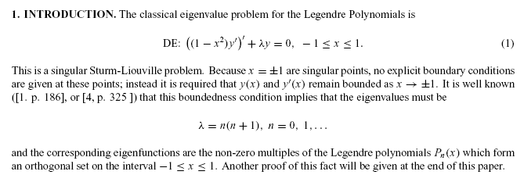

References are two books I don't have: Churchill and Hobson (cannot get Hobson anywhere I look) . The subject of "quantization" of the eigenvalues is part of Sturm-Liouville theory, see comment in Chap 4 Stak notes (one of). So I guess I need to show that something is unbounded unless you take the usual values of things like l. I think this might apply only to the P functions.

Question: if you look at the general hypergeometric formulas for P and Q functions, what happens at the points z = ± 1? Start with Bateman p 122 (3) for Pνμ(z).

Pνμ(z) = 1/Γ(1-μ) [ (z+1)/(z-1)]μ/2 F(-ν, ν+1; 1-μ; (1-z)/2)

Well, what do I know about F(a,b;c,z) ? [ had to go off and read my Bateman notes on this, now back ]

Let's first do the simpler case with μ = 0:

Pν (z) = 1/Γ(1) F(-ν, ν+1; 1; (1-z)/2)

I know that if a or b is a negative integer, the series truncates.
I know that this series has a radius of convergence |z-1| < 2 so z=1 is OK, but z = -1 is doubtful for convergence, unless of course we take ν integer so the series truncates. So maybe we have our first little discovery here: For Pν(z), in order to have the solution be bounded at z = -1, we must have ν = integer.
Here from M&F:

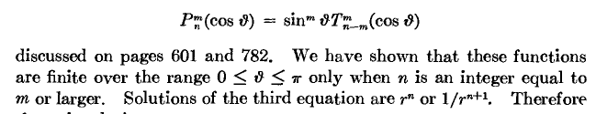

What about Qν(z) on this same issue? Let's go with

Qν(z) = 2-ν-1$\sqrt{π}$ Γ(ν+1)/Γ(ν+3/2) z-ν-1 F(ν/2+1, ν/2+1/2; ν+3/2; z-2)

In general this think has a problem at z = 0 from the z-ν-1 factor, a branch cut there unless ν = integer. The F part also have problems at z = ±1, very unclear what is going to happen. I would guess this diverges at both places even if ν = integer. For example, we have

Q0(z) = (1/2) ln [ (z+1)/(z-1)]

This has ν = integer, and it does in fact diverge at both z = +1 and z = -1. The same idea appears to be true for all the Qν(z). So I am inclined to say:

"The eigenvalue problem on the interval (-1,1) involves only the Pν(z) functions, not the Qν(z) functions. Both endpoints are of concern. If ν ≠ integer, but P and Q are unbounded at z = -1. But if ν = n, then at least Pν is bounded at z = -1 and also at z = +1. In the context of singular points of ODE's, this is enough to say that the Pn(z) are eigenfunctions with n = integer as eigenvalues. So that is how and why n gets quantized. It causes the series to truncate. "

Stakgold, to his credit, does a detailed analysis showing how you "in effect" have a BC of the homogeneous form acting at a singular endpoint, this is the Weyl theorem Sturm Liouville theory. But I don't want to get all into that detail right now. I just want to know "the basic facts".

.end of digression

Back to the separated ODE's for oblate spheroidal coordinates.

First, comments along the line of the above digression.

Here are the separated equations (from Smythe)

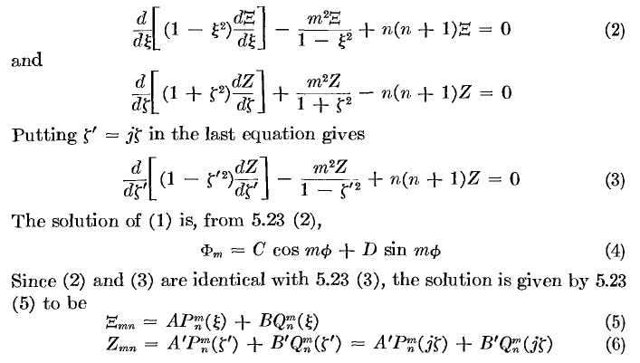

Let's just stare at equation (3) above, It looks like a bone fide Legendre equation with integer n and m already, so let's not worry about them being non-integral. My issue concerns the "general form" of the solution shown in (6). If we think of equation (3), we have a Legendre equation, but the variable ζ' runs over the range (0,+i∞), which is an unusual range. It is not the usual (-1,1) range I am used to. How do you cast this equation with interval (0,i∞) as either an EV problem or a Sturm-Liouville problem? There does not seem much problem at the 0 end since all the usual Q's and P's are fine there. In other words, this endpoint is not a singular endpoint. The far one is just fine since it is infinite. Do we need a homo BC at the 0 end? But we are "already quantized" with m and n. [ I resolve this matter in ODE "questions about Legendre META.doc" and its raw notes doc. For the (0,i∞) problem, the spectrum for n is continuous, and the ξ equation just sets specific integer values of n. For partial surfaces where we don't get ξ all the way to the endpoints, -1 and +1, you could have a Qnm(ξ) component, but not for a full spheroid problem.]
But this is exactly one of those situations where m got quantized and we wonder how n is getting quantized. Perhaps we can appeal to the ξ equation which has the more conventional (-1,1) range and require that n = integer so the P function is finite at the -1 end. But Smythe is still allowing the Q function which blows up there for sure. Perhaps I will just pretend the Q function is not there for ξ. As I look at M&F page 1285 where they discuss prolates, they rule out the Q function altogether for the reason I just stated. Here is MF on prolates:

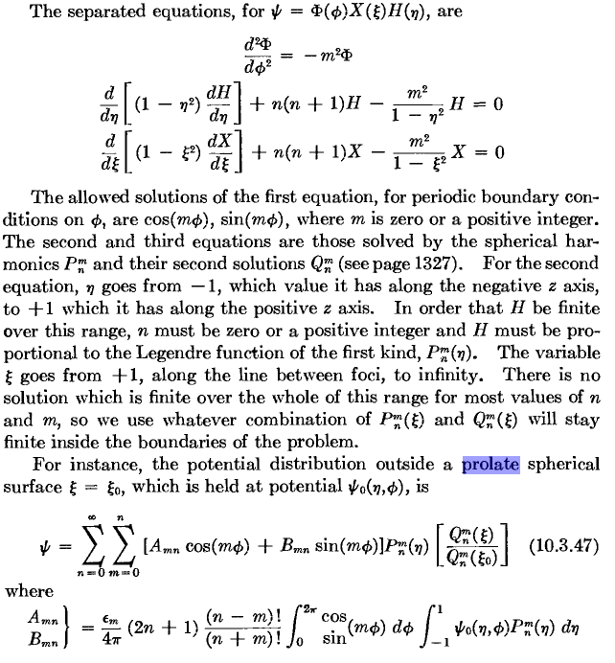
[ This entire MF discussion makes complete sense, though it is for the prolate case I have not studied yet. Neither P/Q has an imaginary coordinate in this case, I guess. The last item is the solution of the full spheroid external Dirichlet problem which picks off the Q(ξ) function. The coefficients are found using the completeness relations in φ and η which I have written down in ODE "questions about Legendre META.doc". I could verify this result easily. ]

The range of ξ is (1,∞) [ prolate] and they seem to pick Q only because it is the one no doubt that decays for large argument. Then later talking oblates, MF just don't "say much" and just put in the imaginary argument. They do comment that ξ runs 0 to infinity. So I think they would claim just P for any problem that includes η = -1, and allow both for their ξ variable, but only the Q if required to vanish at ∞.
Of course in the Smythe problem, we do NOT have V = 0 far away, so Q and P can be mixed. Fine.

Doing the Hole-in-Plate with E field on one side "My Way".

Why can't we "set up" this hole-in-plate problem in E-field using the labeling of page 163 where the entire ellipse has the same label. Why is this such a big problem for him? Let's just try it and see what happens. [ it took me a while to get this right! ] [ We are in the oblate spheroidal world again here.]

I will still write Smythe page 162 (1) as the general solution:

V = P1(ξ) [ A'P1(jζ) + B' Q1(jζ). ]

We go look up these simple functions somewhere. MF have

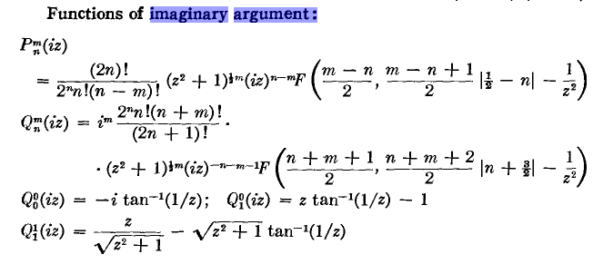

So there it is and I accept then that

Q1(jζ) = [ζ cot-1(ζ) – 1]

and I am only going to use this for ζ in (0,∞).

Note added: What are the limits of the above quantity:

(1) If ζ → 0, we have cot-1(0) = π/2, so [ζ cot-1(ζ) – 1] → -1

(2) If ζ → +∞, we have ζ cot-1(ζ) → 1 (l'Hopital) and so [ζ cot-1(ζ) – 1] → 0

(3) If ζ → – ∞, we have cot-1(-∞) = π, so [ζ cot-1(ζ) – 1] → πζ - 1

In my parameterization, the case (3) never occurs.

So I accept Smythe p 162 (2). I will consider next his +∞ limit on ζ and this leads to his (3) which says Ea = jA'. BUT, if we allow ξ full range, this would seem to say that this also applies at negative ξ which is far below the plate! This is then the first sign of trouble. I guess I want more equations with more constants: [ Smythe's method cleverly avoids the need to talk about two regions like this, but I think I like talking about two regions. ]

V = ξ [ A'j ζ + B' (ζ cot-1(ζ) – 1) ] ξ ≥ 0
V = ξ [ A"j ζ + B" (ζ cot-1(ζ) – 1) ] ξ ≤ 0

We need to have continuity at the boundary. The boundary inside the hole is ζ = 0, and the boundary outside the hole is ξ = 0.

(1) We claim the metal plate is at V = 0, and that goes with ξ = 0 and we see that is satisfied with no restrictions on the four constants.

(2) Inside the hole we don't know the value of V, but it should be the same coming from either direction. This is the ζ = 0 region, so we have in the hole cot-1(0) = π/2 so ζ cot-1(ζ) = 0 and we get

V = ξ [+ B' (– 1) ] ξ > 0
V = ξ [+ B" (– 1) ] ξ < 0

Remember, however, that if you are somewhere near the hole and you pass through the plane, you get a sudden discontinuity in ξ. In fact, it changes sign right at the plane! [ See M&M early section of " 2 Oblate Spheroidal Coordinates and the Metal Disk Problem.doc"]

We could thus write the above as

V = |ξ| [+ B' (– 1) ] ξ ≥ 0
V = – |ξ| [+ B" (– 1) ] ξ ≤ 0

So, if we want V to have the same value when approached from either direction, we need B" = - B'.
So at this point we have

V = ξ [ A' jζ + B' (ζ cot-1(ζ) – 1) ] ξ ≥ 0
V = ξ [ A"j ζ – B' (ζ cot-1(ζ) – 1) ] ξ ≤ 0

with three unknown constants.

(3) Now let's go to the upper distance. Then we get Ea = jA' by his existing argument. In this limit, the B' term I think vanishes, so we don't learn much about it.

(4) Next, let's go the lower distance. Again the B' term is small, and we set A" = 0 to kill this direction off. So at this point we have

V = ξ [ (Ea)ζ + B' (ζ cot-1(ζ) – 1) ] ξ ≥ 0 Ea = jA'

V = ξ [ – B' (ζ cot-1(ζ) – 1) ] ξ ≤ 0

and we still have to find constant B'. We won't learn about B' by looking far away.

(5) Let's try to match the derivatives in the hole. This is a tricky business. First, look just to each side of the plate plane, but in the hole, to the "right" of the center, so we can at least use our page 163 picture. There are two directions of interest where we want to match derivatives.

(5a) Imagine first moving to the right along the thin ellipse, call this the ρ direction. As we do this the cone angle ξ only is changing, so we want to relate dρ to dξ. We can do this I think from

ρ2 = a2(1+ζ2)(1-ξ2) // ρ does let you move around inside the hole, ρ < a

2ρdρ = a2(1+ζ2) ( -2ξdξ) => ρdρ = – a2(1+ζ2) ξdξ

Then we can say:

dV/dρ = dV/dξ * dξ/dρ dξ/dρ = -ρ/[ ξa2(1+ζ2)]

dV/dρ = dV/dξ { -ρ/[ ξa2(1+ζ2)] }

and we can do this on both sides of the plane and "match" at the interface. We need to think carefully about the signs of things here. ρ,dρ,a,ζ are all positive, but what about ξ and dξ ? Our derivative direction of interest is in the ρ direction which, looking at our page 163 picture, is "to the right". Above the plane, if we move to the right, we cross hyperbolas and we find that ξ is decreasing down to 0 from a positive value. So above the plane, ξ is positive and dξ is negative, and of course ξdξ is negative, which makes our equation to the right above look good. Below the plane, ξ is negative and dξ is positive, as we move from a negative value up toward 0. Again, ξdξ < 0. Now, we know dV/dξ to be as follows on the two sides of the plane:

dV/dξ = [(Ea)ζ + B' (ζ cot-1(ζ) – 1) ] top

dV/dξ = [ – B' (ζ cot-1(ζ) – 1) ] bottom

Therefore we have, filling in for ρ from above,

[dV/dρ]top = [(Ea)ζ + B' (ζ cot-1(ζ) – 1) ] { -[a2(1+ζ2)(1-ξ2)]1/2/[ ξa2(1+ζ2)] }

= [ – B' ] { -[(1-ξ2)]1/2/[ ξa] } = (B'/a) $\sqrt{1-ξ2}$/ξ

where in the second line we take the limit ζ → 0 for the super thin hole-filling ellipse. As expected, the side of this derivative varies with ξ as we consider different radial locations in the hole.
Now we can do the same thing on the bottom. The only difference here is the absence of the first ζ linear term, and the difference in sign of the second term. Since the first vanishes in the limit, we get the same result but with a minus sign

[dV/dρ]bot = – (B'/a) $\sqrt{1-ξ2}$/ξ

So at this point we have

[dV/dρ]top = (B'/a) $\sqrt{1-ξ2}$/ξ ξ > 0
[dV/dρ]bot = – (B'/a) $\sqrt{1-ξ2}$/ξ ξ < 0

As we did above, we install abs value to get

[dV/dρ]top = (B'/a) $\sqrt{1-ξ2}$/|ξ| ξ > 0
[dV/dρ]bot = (B'/a) $\sqrt{1-ξ2}$/|ξ| ξ < 0

and by requiring these to be the same, we learn nothing new. So due to the form of our potential, matching the tangential derivative of the potential gives the same information as matching the potential itself.

(5b) Now imagine moving "down" from a starting position just above the hole to the right of the center and inside the hole region. We are now moving along a hyperbola of constant ξ and it is now ζ that is changing. We can then say that (remember x = "up")

x = aξζ => dx = aξ dζ

Then we can say:

dV/dx = dV/dζ * dζ/dx dζ/dx = 1/(aξ)

dV/dx = dV/dζ { 1/(aξ) }

Above the plane, ζ is positive and dζ is negative as we approach the plane, changing from a positive value toward 0. Below the plane, ζ is positive, and dζ is negative as we approach the plane. Let's start with top:

(dV/dζ)top = ∂ζ{ξ [(Ea)ζ + B' (ζ cot-1(ζ) – 1) ]}

= ξ [(Ea) + B' ∂ζ { ζ cot-1(ζ)} ]

Now go compute

∂ζ [ (ζ cot-1(ζ) ] = ζ ∂ζ cot-1(ζ) + cot-1(ζ) = ζ [ -1/(1+ζ2) + cot-1(ζ) = -ζ/(1+ζ2) + cot-1(ζ)

so we then have

(dV/dζ)top = ξ [(Ea) + B' { -ζ/(1+ζ2) + cot-1(ζ)} ]
(dV/dζ)bot = ξ [0 – B' { -ζ/(1+ζ2) + cot-1(ζ)} ]

Here we also show the bottom derivative. The only difference is the missing first term. It seems that we should be able now to take the limit ζ→0 to be super close to the hole plane. Here, cot-1ζ = π/2 according to Schaum, so we then have

(dV/dζ)top = ξ [(Ea) + B' { π/2} ] ξ ≥ 0
(dV/dζ)bot = ξ [0 – B' { π/2 } ] ξ ≤ 0

Suppose B' were a positive number and E small. This would say that (dV/dζ)top is positive, while (dV/dζ)bot is also positive since ξ is negative. Now do the next step:

(dV/dx)top = (dV/dζ)top { 1/(aξ) } = (1/a) [(Ea) + B' { π/2} ]
(dV/dx)bot = (dV/dζ)bot { 1/(aξ) } = (1/a) [ 0 – B' { π/2} ]

We now require this normal derivative to be the same on both approaches, which tells us

(Ea) + B' { π/2} = – B' { π/2} B' π = – (Ea)

and this is, in fact, exactly the result "we want", as shown Smythe p 162 equation (4) . Thus we were able to obtain his result without dealing with Q1(iζ) with a negative imaginary argument.

Summary: We started with this form

V = ξ [ A'j ζ + B' (ζ cot-1(ζ) – 1) ] ξ ≥ 0
V = ξ [ A"j ζ + B" (ζ cot-1(ζ) – 1) ] ξ ≤ 0

To make V be continuous in the hold, we needed B" = - B'. To kill things off far away on the quiet side, we needed A" = 0. Going for away on the upper side requires Ea = jA'. So at this point we have

V = ξ [ (Ea)ζ + B' (ζ cot-1(ζ) – 1) ] ξ ≥ 0
V = ξ [ – B' (ζ cot-1(ζ) – 1) ] ξ ≤ 0

I then required that the perp E field be continuous in the hole, which gave B' π = – (Ea). Our final result is then this:

V = (Ea) ξ [ζ - (1/π)(ζ cot-1(ζ) – 1) ] ξ ≥ 0
V = (Ea)ξ [ (1/π)(ζ cot-1(ζ) – 1) ] ξ ≤ 0

As we go far up or far down, in either case ζ → +∞ for me, so Vbot → 0 and Vtop→ (Ea) ξ ζ. = Ez.
Now, we know that

cot-1(-ζ) = π - cot-1(ζ)

so if we want to switch to Smythe's parameterization, we take ζ → -ζ in my second line above, and at the same time we take ξ → -ξ :

V = (Ea)ξ (1/π)[ζ cot-1(ζ) – 1]
→ (Ea) (-ξ) (1/π)[ (-ζ)( π - cot-1(ζ)) – 1]
= (Ea) (-ξ) (1/π)[ ζ( cot-1(ζ)-π) – 1]
= (Ea) (-ξ) (1/π)[ (ζcot-1(ζ)-1) -ζπ ]
= (Ea) (-ξ) [(1/π) (ζcot-1(ζ)-1) -ζ ]
= (Ea)ξ [-(1/π) (ζcot-1(ζ)-1)+ζ ]
= (Ea)ξ [ζ -(1/π) (ζcot-1(ζ)-1)]

which then replicates the first line! So we are then in agreement with Smythe's solution to the problem in his parameterization which I quote from page 162,

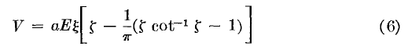
so yes, his parameterization gives a more compact statement of the result. I did some plots of this potential in the adjacent doc.

Doing the Charged-Plate-with-Hole problem, "My Way".

Imagine a large metal plate with some σ uniform density (charge/area) on both sides, out in space. With this σ idea instead of a total charge, we can sort of think of this as an infinite plate. It creates oppositely directed E fields on the two sides which go off forever. What is the potential for this situation? On a given side, we have E = constant, so I guess V = -Ez and more generally, V(x,y,z) = -E|z|. This is the bent piece of paper plot below without any hole. The potential is V = 0 everywhere on the plane, and as you go off to either side, you have V → -∞. This is OK for a non-localized object I think.
Question: is such an infinite plate possible in theory? If a metal vs a sticky charge situation, the charge would repel itself off to infinity? On the other hand, at any point on such a plate, the force on a piece of charge is the same from all directions, so why would such charge move? This must be a stable theoretical situation for that reason! Once you put a finite boundary and make it a disk, you lose translation invariance, and you end up with charge peaking at the edges to make things be stable.
Now take the infinite charged metal plate and punch a hole in the "middle" of the plate somewhere and describe the potential and charge everywhere. That is the problem.

Let's try setting up as before, and just mimic the steps:

(1) We claim the metal plate is at V = 0, and that goes with ξ = 0 and we see that is satisfied with no restrictions on the four constants. [ Well, I guess V = 0 is OK for the plate, any constant you want will do, it is constant on the plate and our setup works nicely for V = 0 ]

(2) Inside the hole where ζ = 0 we do the match as before, thinking of |ξ| as before, get B" = -B'.

V = ξ [ A' jζ + B' (ζ cot-1(ζ) – 1) ] ξ ≥ 0
V = ξ [ A"j ζ – B' (ζ cot-1(ζ) – 1) ] ξ ≤ 0

(3) Now far above the plate, I want to see an outward directed E field, and σ > 0 on either side of the plate. So far above the plate want to see E = E with E>0 and V = -Ex therefore. But x = aζξ exactly, and thus we want V = -Eaζξ . We get exactly this from our first form if we set A'j = -Ea. The second term as before is small far away.

(4) Go below the plate now. We want to see E = -E down there E > 0 (same E) and so V = +Ex and in the second equation we will then get A"j = +Ea. So here we are so far:

V = ξ [ – aEζ + B' (ζ cot-1(ζ) – 1) ] ξ ≥ 0
V = ξ [ + aEζ – B' (ζ cot-1(ζ) – 1) ] ξ ≤ 0

(5) Now skip 5a and go to 5b where we want to make the normal gradient match in the hole. I think everything goes through exactly as before, except we have an A" term, so we have

(dV/dx)top = (dV/dζ)top { 1/(aξ) } = (1/a) [– Ea + B' { π/2} ]
(dV/dx)bot = (dV/dζ)bot { 1/(aξ) } = (1/a) [ + Ea – B' { π/2} ]

where I have adjusted the sign of E relative to former problem. We then match these to find

– Ea + B' { π/2} = + Ea – B' { π/2} => 2Ea = πB' => B' = 2aE/π

Here then is my final result:

V = ξ [ – aEζ + 2aE/π (ζ cot-1(ζ) – 1) ] ξ ≥ 0
V = ξ [ + aEζ – 2aE/π (ζ cot-1(ζ) – 1) ] ξ ≤ 0

V = (aE)ξ [ – ζ + (2/π) (ζ cot-1(ζ) – 1) ] ξ ≥ 0
V = (aE)ξ [ + ζ – (2/π) (ζ cot-1(ζ) – 1) ] ξ ≤ 0

We could combine these in one equation:

V = – (aE)| ξ | [ζ – (2/π) (ζ cot-1(ζ) – 1) ]

We can compare this to the Smythe result (6) p 162 for the previous problem. Apart from overall sign, we now 2/π instead of 1/π. And here is a new plot

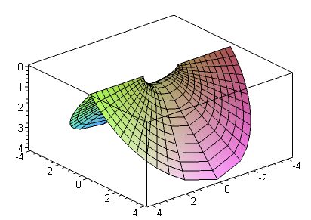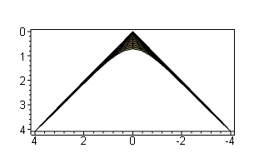

Smythe would have loved these plots. Far away, the hole makes no difference at all, we just have our flat V planes as both the above pictures show. In hole center plane we see slope = 0, no E field of course. The potential pulls down to some negative max value in the hole center! Just set ζ = 0 and ρ = 0 so ξ = 1:

V = – (aE)| 1 | [0 – (2/π) (0 cot-1(0) – 1) ] = – (aE) (2/π)

What about charge density? It is of course the same on both sides, so let's just look at the upper side. Our previous results dV/dx were done "in the hole" where ζ was the variable that varies as you move normal to the hole. But on the metal, it is the other variable, the hyperboloid label, that varies in normal action. We then want to use

x = aξζ => dx = aζ dξ

The other coordinate surface (the spheroid) is coming in for a perp landing on the metal so dζ = 0 for this kind of normal business, so we are "ok". Then we want

dV/dx = dV/dξ * dξ/dx dξ/dx = 1/(aζ)

This is a pretty easy calculation: (work only on the top surface)

dV/dx = dV/dξ * dξ/dx = (aE) [ – ζ + (2/π) (ζ cot-1(ζ) – 1) ] * 1/(aζ)

= (E) [ – 1 + (2/π) (cot-1(ζ) – 1/ζ) ]

On the plane we have ρ2 = a2 (1+ζ2)(1-ξ2) = a2 (1+ζ2) so a2ζ2 = ρ2 - a2 aζ = $\sqrt{ρ2 - a2}$

Now there are various ways to write the θ ≡ cot-1(ζ) term. Draw little triangle to show that

sinθ = a/ρ; cos(π/2-θ) = a/ρ ; π/2-θ = cos-1(a/ρ) ; θ = π/2 - cos-1(a/ρ)

where I am trying to get a form similar to Smythe bottom page 162 for the previous problem. Then

dV/dx = E [ – 1 + (2/π) (cot-1(ζ) – 1/ζ) ]

= E [ – 1 + (2/π) ({π/2 - cos-1(a/ρ)} – (a/$\sqrt{ρ2 - a2}$) ]

= E [ – 1 + 1 – (2/π) cos-1(a/ρ) – (2/π) (a/$\sqrt{ρ2 - a2}$) ]

= - E(2/π) [ cos-1(a/ρ) + (a/$\sqrt{ρ2 - a2}$) ]

In Jackson units we have, above a metal surface, E = 4πσ = -dV/dx so σ = -(1/4π)∂xV and then

σ = -(1/4π)∂xV = (1/4π) E(2/π) [ cos-1(a/ρ) + (a/$\sqrt{ρ2 - a2}$) ]

= (E /4π) (2/π) [ cos-1(a/ρ) + (a/$\sqrt{ρ2 - a2}$) ]
or
σ(ρ) = σ∞ (2/π) [ cos-1(a/ρ) + (a/$\sqrt{ρ2 - a2}$) ]

It is similar to Smythe, but I had a factor of 2 which causes cancellation of the first term and puts a 2 out front. Here of course σ∞ is the constant charge density on our plane far from the hole

How can we test this answer? As ρ → ∞, get σ = (2/π) E[ π/2 + 0] = E, which is correct! Far away, the uniform E field comes right down to the surface and is E perp there. So I am liking my result so far.
Here is a Maple plot where I show the two terms separately and their sum in red

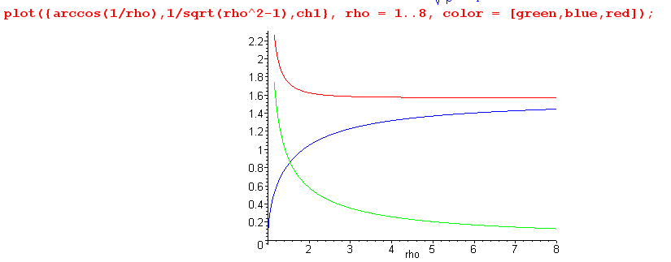

As we come in from far away on ρ, the σ is pretty constant and starts peaking up only around ρ = 2a which is to say about 3 radii away from the hole center.

Comments: This is I think a great classroom problem for oblates. One might ask: what makes the charge peak up around the hole? Consider a piece of charge near the hole rim but not at it, it is "looking at the hole" . It is repelled toward the rim by the infinite wedge of charge behind it. Anywhere else, this would be balanced by the charge in front of it, but we have this gaping hole with no charge! So there has to be extra charge between our test charge and the rim to get our charge to have no net force.

In fact, I conjecture that the total "extra charge" due to the hole is equal to the amount of charge that would have been on the area of the hole were there no hole. If this is true, it would be saying that if you start with a pinhole and then open up to some finite radius, you just "push back" the charge, and no charge runs off to infinity (although in theory it could). Here is a Maple check on my conjecture, showing it is true:

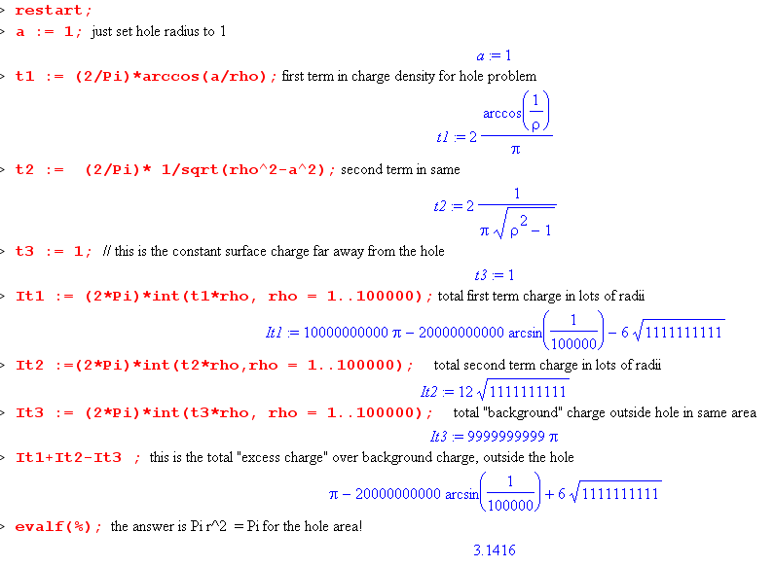
So the mystery question is this: how can you show that as the charge is pushed back, none of it goes off to infinity ? Here is an outline of how you would prove this. Put a large cylinder as the boundary far away. Estimate the deviation of the E field from plane-normal on this sphere, so there is some small flux going through the cylinder. Then take the limit as the cylinder gets infinitely large, and show the total flux through the cylinder in this limit is exactly 0. Then by Gauss's law, you know the charge enclosed did not change, so no charge "ran off to infinity". Of course for any finite radius of the large cylinder, some amount of charge has gone through it. It is sort of a limit problem I think.

Now, how do we "understand" Smythe's way of doing the one-side-E field hole problem?

He uses the coordinate system "method" of page 161 where the ellipse is split in half, and the entire hyperboloid has a single label. This does avoid the discontinuity in ξ going through the hole. You could say that ζ has a discontinuity at the hole, but not really since the limiting ellipse has ζ = 0. So in a way, things are "nicer" in the hole region with this system.

The puzzler here is that we are now going to go into the "unauthorized" region of Q1(jζ). Recall that the function is

Q1(z) = (z/2) ln[ (z+1)/(z-1)] - 1 // analytic

This thing has cuts all the way from +1 left to -∞. So, Q1(jζ) is going to go right through that cut as we go down with negative ζ. We just go onto the next sheet. We could arrange the z=+1 cut direction to clear this area if we wanted. So OK, maybe not such a big deal.

Why do we only need to consider one "form" instead of one form above the plane and another below it, as done in "my way" solutions above? All I can say is this: if you "try" his single form and do the limits with the coordinates "his way", you arrive at the right answer, so his method must be OK.

Suppose we just think of it as two equations like this:

V = ξ [ A'j ζ + B' (ζ cot-1(ζ) – 1) ] ζ ≥ 0
V = ξ [ A"j ζ + B" (ζ cot-1(ζ) – 1) ] ζ ≤ 0

where now "above and below" the plane are controlled by the ζ variable. If you do the "top" limit, you find that A'j = Ea as always in all methods. In the hole region, ζ = 0 and is continuous, and ξ does not take any "jumps" either. So continuity in the hole tell us that B' = B" but tells us nothing about A' and A" because ζ = 0 at the plane. At this point we have

V = ξ [(Ea) ζ + B' (ζ cot-1(ζ) – 1) ] ζ ≥ 0
V = ξ [ A"j ζ + B' (ζ cot-1(ζ) – 1) ] ζ ≤ 0

Now we do the lower limit and find that cot-1(ζ) = π so [A"j ζ + B'πζ ] is the large ζ limit, and to make this zero, we have to set A"j = - B'π. Then we have this:

V = ξ [ (Ea) ζ + B' (ζ cot-1(ζ) – 1) ] ζ ≥ 0
V = ξ [ (-B'π)ζ + B' (ζ cot-1(ζ) – 1) ] ζ ≤ 0

The nailing down of the one remaining constant must come from one of the derivative matches. It will force (-B'π) = (Ea), and then we have his single form. But just the fact that the starting single form gives you V = 0 far below the plane is good enough. There can only be one Laplace solution, and if you have found it this way, then you have found it. It has to be the same as any other method like "my way". I guess you know things are continuous through the hole because the coordinates are continuous there, that is a point he makes early on.
One benefit of the "my way" method is that it solves the charged plate problem as well as the one sided plate problem. "His way" fails on this second problem. The reason I know this is that I know the Q1(iζ) function is not symmetrical in ζ so you cannot get a symmetrical solution with his "form".

Comments on hole-in-charged-plate problem added June 25, 2010

(a) First, go back to Jackson's charged disk problem. He gives us the Weber form for the potential in Cartesian coordinates, and he gives us a very simple expression for the charge density σ. It peaks at the edge, but does not vanish at the center. (disk radius is a)
We know that we can also solve this problem in oblate coordinates. I did this in " 2 Oblate Spheroidal Coordinates and the Metal Disk Problem.doc". You do it first for the oblate spheroid, then take the limit as that thing becomes a disk. The potential of the disk comes out being [ here is use MF ξ, whereas Smythe would use ζ ]

V(x,y,z) = V0 Q0(iξ)/Q0(0) Q0(iξ) = -i cot-1(ξ) Q0(iξ=0) = -i cot-1(0) = -i(π/2)

= V0(2/π) cot-1(ξ)

where ξ2 = (1/2a2) |r2-a2|{ sign(r2-a2) + $\sqrt{1 + 4z2/(r2-a2)2}$ } r2 = ρ2 + z2

Note: cot-1(ξ) = tan-1(1/ξ) = cos-1(ξ/$\sqrt{1+ξ2}$) = sin-1(1/$\sqrt{1+ξ2}$)

and: [ $\sqrt{(ρ-a)2+ z2}$ + $\sqrt{(ρ+a)2+ z2}$] = 2a$\sqrt{1+ξ2}$ "ellipse theorem"

V = V0(2/π) tan-1(1/ξ) + ξ → (r/a) large => V → V0(2/π)(a/r) = q/r

=> q = V0(a2/π) => C = (2/π)a V0(2/π) = (q/a)

V = V0(2/π) sin-1(1/$\sqrt{1+ξ2}$) = (q/a) sin-1(2a/ [ $\sqrt{(ρ-a)2+ z2}$ + $\sqrt{(ρ+a)2+ z2}$])

E = 4πσ = -∂zV|z=0 => σ = (q/4πa) 1/$\sqrt{a2-ρ2}$ on each side of the disk

where I have converted to cylindrical coordinates and added various useful facts. Basically I show above how the Weber form arises from the oblate result. I am using Jackson conventions here for things.
So this is our charged disk summary.

(b) We turn now to our "charged iris" situation. Whereas we give the disk a total charge q, for the iris problem we have to start with an infinite plane with some σ∞ on each side, then we make a pinhole and enlarge it to get a finite hole of radius a. We did this above and found that, as in the disk problem, the charge piles up on the edge of the iris surrounding the hole. In the disk problem you might conjecture that all the charge goes to the edge with none in the center, but that is wrong. In the iris problem, you might conjecture that charge just pushes away from the hole to ∞, but that is wrong as well. I give an argument above for why there has to be a little pileup of charge around the hole. The charge density on this iris is this (according to my unverified calculation above),

σ(ρ) = σ∞ (2/π) [ cos-1(a/ρ) + (a/$\sqrt{ρ2 - a2}$) ] V = 0 on the iris

V(ξ,ζ) = – (aE)| ξ | [ζ – (2/π) (ζ cot-1(ζ) – 1) ] E =4πσ∞ z = aξζ

ξ2 = (1/2a2) |r2-a2|{ sign(r2-a2) + $\sqrt{1 + 4z2/(r2-a2)2}$ } r2 = ρ2 + z2

ζ = z/(aξ)

It suddenly occurs to me that:

(1) I can probably write this in some "Weber form" similar to the disk potential so I would have the potential in cylindrical coordinates centered at hole center, let us say. [ yes, I think so ]

(2) Since this iris has V=0, I could relate it by inversion to a V=0 spherical bowl (facing right). I think this would then give me the potential and charge density on a charged spherical bowl, a problem I have long been trying to solve in some simple manner !!! [ not so, because a V = 0 bowl is not a charged bowl. If you add a constant potential to make it one, the other space becomes the on-axis Green's for a disk. ]

Be sure to first check the above Φ and σ before trying this exercise! [ won't be trying it! ]

Note added 12.4.10: charged bloid problem? Above, we note how it is possible to solve the "charged disk problem" in oblates. We start with spheroid at V0. We know we can have these atomic forms in general [ using MF now]

osc expo osc
(1) [ Pnm(η), Qnm(η) ] [Pnm(iξ), Qnm(iξ) ] [ sin(mφ),cos(mφ)]

expo osc osc
(2) [ Piτ-1/2m(η), Q iτ-1/2m(η) ] [P iτ-1/2m(iξ), Q iτ-1/2m(iξ) ] [ sin(mφ),cos(mφ)]

Azisym sets m = 0 so potential can be constant over φ on the spheroid. Varying η somehow moves us on the surface of the spheroid, analog of polar angle. If we want no η variation either, we go with n=0.

osc expo osc
(1) [ P00(η) = 1 ] [P00(iξ), Q00(iξ) ] [ 1]

Then for the disk we choose Q in the middle to get distant decay, and we end up with

V = V(ξ) = V0 Q0(iξ)/ Q0(iξ0)

as our potential of the spheroid. Then we crush it to a disk ξ0 = 0 and we get

Vdisk = V(ξ) = V0 Q0(iξ)/ Q0(0) = V0(2/π) cot-1(ξ)

We then fiddle this into Cartesians and we get the Weber form.

Now, how would you do the "charged one-sheet bloid problem" ? In this case we still have azisym so we get quickly to this point

osc expo osc
(1) [ Pn0(η), Qn0(η) ] [Pn0(iξ), Qn0(iξ) ] [ 1]

Now we want a potential depending only on η so we can be constant on bloid. Choose n = 0 and we get

osc expo osc
(1) [ P00(η), Q00(η) ] [P00(iξ) = 1 ] [ 1]

If we allow Q0(η), then our potential blows up everywhere on the z axis (because this is the limit of a bloid as η → 1) , which seems pretty unphysical. So I think the conclusion is that the potential must be a constant everywhere if it is constant on a bloid! But in the limit that we take the bloid to be an iris, we suddenly have the stable possibility discussed as the "charge iris problem" above. In that case if we assign V = 0 to the iris, then V = -∞ as you go off in either ±z direction. If we were to required that V = 0 on the great sphere in this problem, that would destroy our delicate solution. That solution requires that V = 0 at the perimeter of the iris, but is different elsewhere on the great sphere. Knowing the distant V up and down led us to choose n = 1. But n = 1 makes the potential be a function of two variables,

V = – (aE) | η | [ξ – (2/π) (ξ cot-1(ξ – 1) ]

but this does not stop this formula from providing V = 0 = const on the iris which is η = 0.
So the iris can have this strange solution in theory. What about a bloid that is not an iris? Why can't we have a solution for that case which is a function of two variables, but which still manages to be a constant on the bloid? Maybe this is possible, and it would involve atoms of different values of n. I don't know the large z limit of the potential in this case, whereas I do know it for the iris. So this "far distance" boundary condition is mysterious for a charged bloid.
What would the charge σ look like on such a charged bloid? If we start with a cone and deform that into a bloid, we have to ask: could you have some stable non-zero σ on an infinite metal cone? If so, I think it would not be constant: as you get toward the tip, there is a lot of pressure from the rest of the cone, so σ has to build up infinitely at the tip. We don't get our nice iris uniform plane starting point. But maybe there is some σ that works here. Then as we open to a bloid, there is some local movement of σ near the hole only, and far away things are stable.
I guess the solution would have to have the form

V(η,ξ) = Σn Pn(η) [ AnPn(iξ) + BnQn(iξ)]

such that

V(η0,ξ) = Σn Pn(η0) [ AnPn(iξ) + BnQn(iξ)] = independent of ξ

For the iris we have a very special case since we had the option of P1(η0) = η0 and η0 = 0 for the iris, so we got V(η0,ξ) = 0 which is a constant independent of ξ. But how could such a thing happen for a bloid which has η0 ≠ 0 ? There is no P function which has the form (η-η0) for arbitrary η0? Well, if we pick some η0 I guess eventually this would be the zero for some Pn(η) function with some large n. We can certainly pick some nice η0 which are zeros of a P. For example, η0 = 1/$\sqrt{3}$ works for n = 2. Then we have to have V = 0 on our bloid. This seems pretty haphazard!
Perhaps the solution uses the other atomic form with conical like functions.
I give up. Uncle!!! There are certainly not practical problems, and perhaps the solutions are not even unique since you don't have a true enclosing boundary, etc etc.

