Attempting the Charged Bowl by the Kelvin Method PhL 1.15.10

The goal here is to solve this problem using the method of inversion. I started on this more than 2 months ago and would like now to finish it. The problem has been "on the stack" for that long!

Overview (9.27.10 2 pages) 1
0. Introduction. 2
1. The Plan. 3
2. Geometrical Kinematics. 4
3. Finding the charge on the bowl for the Green's Problem 6
4. What do you do next??? 7
5. Notion of a Sticky Surface. 7
6. Parsing Kelvin Bowl Section 8

______________________________________________________________________________

Overview (9.27.10 2 pages)

In this doc, I find σ for the bowl Green's function problem with point charge at the pole. I then attempt to review Kelvin's solution of this problem (charge on cap) as well as the charged bowl problem. In the Kelvin method for the charged bowl problem, doing the Green's function bowl problem is a preliminary step.

In Section 0 "Introduction" I describe the 2 situations relating bowl and disk by inversion. In Choice A, the bowl is in a Green's function situation with point charge at the pole and the disk is simply charged. In Choice B the bowl is charged, and the disk is in a Green's function with an on-axis point charge. This doc treats Choice A and thus does not solve the "charged bowl" problem in spite of the doc's title. So I am here solving the bowl Green's function problem, but I do quote Kelvin later on the charged bowl problem.

In Section 1 "The Plan" I give a wordy description of case A and draw a picture. I was new at the inversion game and it helped to describe every tiny fact. At this time I did not think of offsetting the disk and hence moving the Green's point charge to another point on the bowl's cap.

In Section 2 "Geometrical Kinematics" I draw a detailed picture of the sphere and disk, assigning names to the many variables involved -- the same names I used 2.5 months earlier in a previous attempt to solve this problem ( where was this??? ). These variable names served me well and are embedded in all my future efforts. I will just list them here, look at the picture to see what they are: a,d ; r,R,r0,ρ ; θ,α,θ0,α0. Of special importance is the half-angle relationship between the two polar angles α = θ/2. I write down everything I know relating these variables. Then I write σ'disk(r) and φ'disk(r) with origin at the inversion center, where the prime means these are R' space quantities.

In Section 3 I use σ'(r) = (a/r)3 σ(r') to find the charge density σ on the bowl from that on the disk. Because σ' is the same on both sides of the disk, we find that σ is the same on both sides of the bowl. This is obviously a simple thing to do, but one is always faced with the issue of expressing an R space quantity without using R' space variables and parameters (and vice versa). Here is my result:

σbowl[θ] = Q / (4πar0) * [ cos3(θ/2) $\sqrt{1- tan2(θ/2)/ tan2(θ0/2)}$ ] -1

where b = d tan(θ0/2) determines d, and then d = a2/(2r0) determines a, so a = $\sqrt{2r0bcot(θ0/2)}$. Q is the charge on either side of the disk. I did not seek verification of this result, though it has correct dimensions. Nor did I integrate this to find the total charge on each side of the bowl in this Green's problem.

In Section 4 I naively try to "make the point charge vanish" so I am left with just a charged bowl. Sorry, this does not work. I erroneously thought this is what Kelvin was saying you could do.

In Section 5 I define for the first time the notion of a sticky surface which holds surface charge in place. Such a surface is non-conducting and charge on it has no mobility. A useful "thought experiment" concept. Such a surface does not have two sides, it is infinitely thin and it a single surface.

In Section 6 I do my "parsing of Kelvin" I think for the first time, alternating screen clips from Thomson's paper with my own comments. Kelvin uses the offset disk which I did not do above, and this picture is shown in my first clip (but left/right reversed from mine), and he is doing the bowl Green's Function problem with point charge on the bowl's cap. He comments on where the point charge comes from, but his writing is not clear to me in many places. He then states the transformation rules for V and σ. This shows his method of naming distances, QP3 means (QP)3 which is my R3 since Q = origin and P = point on bowl. Then he uses QΠ where Π is an arbitrary space point, and so on. Hard for the "modern reader". He next states the Jacksonian charge density on the charged disk of radius a (charge densities are ρ, not σ) and credits Green 1832 for its first derivation. Kelvin quotes experimental data confirming this disk charge distribution! By integrating this σ, he finds that C = 2a/π, and again he quotes Cavendish who measured it! Then using the circle chord theorem, Kelvin replaces a2- r2 with the product of two distances KP and PL which appear in his picture. This is followed by some "wall to wall geometry" as I call it. Using this stuff, he then comes up with a formula (17) for the charge on the bowl in this Green's problem. I don't recognize his σ as either what I have above, or what I found much later when I did this problem more seriously. But there it is. I am not even sure (17) represents the bowl's charge. Kelvin then goes on to do something like the Smythe sequence of steps which leads to the charge distribution for the charged bowl, and his result (18) is the famous result which Kirk (a Kelvin reviewer) writes this way

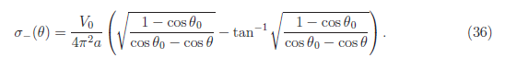

Kelvin credits Liouville 22 years earlier with the above result, but no proof, so Kelvin is the first to publish this formula with a proof, year is maybe 1847. We should not be surprised that a published first proof of something is likely to seem "tortuous" to a later reader. Note that Kelvin's paper first solves the bowl Green's function, then solves the charged bowl problem.

I think I have done my own solution to the charged bowl, but don't know right now where it is.
_______________________________________________________________________________

0. Introduction.

With the inversion method you get two choices for the bowl-disk situation-pair you can study:

Choice A:
R-space: metal bowl at V = 0 with Green's charge at the opposite pole
R'-space: charged metal disk in isolation with a cancelling constant -A added so disk is at V = 0

Choice B:
R-space: charged metal bowl in isolation with a cancelling constant -A added so bowl is at V = 0
R'-space: metal disk at V=0 with Green's charge at the origin.

Basically, both these choices let you link V=0 metal situations on both sides. One side is a charged metal object in isolation with an offset added, while the other side is a Green's Function situation for a piece of metal with a point charge.
In this document I work with Choice A, because I thought somehow that is what Kelvin was doing. In R' space I know everything there is to know about the disk situation (potential, charge). I am able to compute things for the R-space picture.
But alas, I am unable to relate this picture to that of the isolated charged bowl. I now think that Choice A is useless for solving the charged bowl problem, and I think Kelvin somehow solved it directly in R-space without using the inversion method. His inversion method does, however, provide information about the bowl + pole point charge situation, but this is not the general on-axis Green's Function situation, so all Choice A does is gives you some particular bowl + point charge situation which does not seem particularly useful.
If there is a method of doing the bowl by Choice A, it certainly has something to do with the very particular location of the Green's point charge.

1. The Plan.

Here is the "method of inversion" set up for this problem:

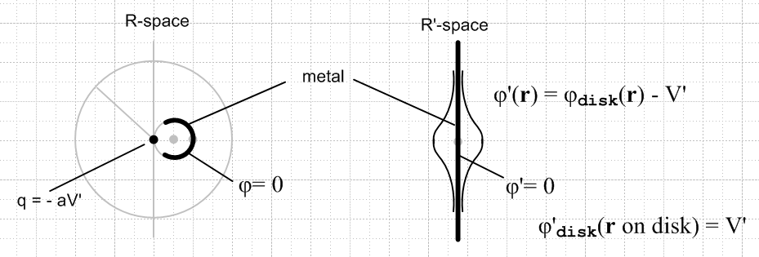

Let's describe this situation now in more detail. The Inversion and 2D Charge Theorems say this, where a is the radius of the inversion sphere :

φ'(r) = (a/r) φ(r') r' = a2/r
σ'(r) = (a/r)3 σ(r')

Initial situation: We see above a grounded metal bowl in R-space, and (at first) an ungrounded, charged metal disk in R'-space which is at some constant potential V' relative to φ'=0 at infinity in R' space. The disk has some capacitance, so we know that Q=CdiskV' would relate V' to the total charge Q on the disk. From our quote below, in fact, we have Cdisk = (2/π)b for radius b, so we have then that

V' = Q/Cdisk = (π/2)Q/b // disk assumed to have radius b and charge Q

q = -aV' = - (π/2)Q(a/b) // size of Green's point charge

Modified situation: We now add a constant potential φ' = -V' in R'-space which brings the potential of the disk to 0. So in R' we have φ'(r) = φdisk(r) - V', where φdisk(r) is the "traditional" potential of the disk relative to φ' = 0 at ∞. And φ'disk(r on disk) = V'. (We will do details of coordinates and origins later on, right now we are doing "conceptual" only. )
As we know, adding this potential in R'-space results in a point charge at the origin in R-space and I have drawn this in. Assuming the disk was charged up with a positive charge Q>0, we know that V' > 0 so our point charge is negative, and the charge on the bowl is positive.
What we have, then, in R-space for a potential is "the on-axis Green's Function for a spherical bowl", but specialized to where the Green's charge is at the pole opposite the bowl. It happens that the point charge has the negative value q = -aV' but we could scale our result to a unit positive Green's point charge if we wanted.
My immediate interest is to learn how the charge is distributed on the bowl in this Green's Function situation. We can find that by using the 2D charge rule shown above, if we know σdisk(r).

Facts about the charged disk: See " 2 Oblate Spheroidal..." for derivations. The facts are these, in cgs units, and all three are confirmed in green Jackson pp 92-93,

Cdisk =(2/π)b

σ'disk(r) = (Q/4πb) 1/$\sqrt{b2- ρ2}$ // this is on each side

φ'disk(r) = (q/b) sin-1 [2b / ($\sqrt{(ρ-b)2+ z2}$ + $\sqrt{(ρ+b)2+ z2}$) ]

where b is the disk radius, z is the symmetry axis of the disk, and ρ2 = x2+y2.

2. Geometrical Kinematics.

In "Jackson method of inversion.doc" I did all this setup work 2.5 months ago, and here are the results (all derived and explained there in great detail) . I finally get to use this work. Distance to the right of the inversion origin will be called "z".

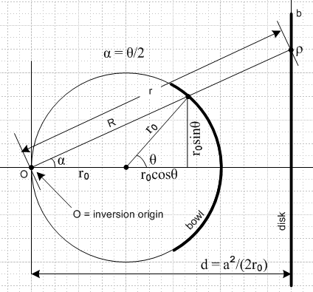 Where is this drawing ??

d = a2/(2r0) // definition of d
r2 = ρ2 + d2 // relates r and ρ
r = d /cos(θ/2) // relates r and θ
R = a2/r // relates r and R
R = 2r0cos(θ/2) // relates R and θ
tan(α) = tan(θ/2) = ρ/d // relates θ and ρ
tan α0 = tan(θ0/2) = b/d => b = d tan(θ0/2)

We have three useful origins to deal with, so must always be careful. First, these two equations have the disk center as origin for r. [ σ' is the charge on either side of the disk, by the way ]

σ'disk(r) = (Q/2πb) 1/$\sqrt{b2- ρ2}$

φ'disk(r) = (q/b) sin-1 [2b / ($\sqrt{(ρ-b)2+ z2}$ + $\sqrt{(ρ+b)2+ z2}$) ]

but this is a little dangerous since we are using "r" and "z" to have different meanings in our picture above. Let's try to express everything in terms of "polar coordinates" relative to the inversion origin. For a point on the disk, then, point = (r,α,0) = (r,α) where we will dispense with the azimuthal coordinate. So

σ'disk(r,α) = (Q/2πb) 1/$\sqrt{b2- ρ2}$ where ρ = d tan(α)

Shifting the origin for φ'disk we may similarly write

φ'disk(r,α) = (q/b) sin-1 [2b / ($\sqrt{(ρ-b)2+ (d-z)2}$ + $\sqrt{(ρ+b)2+ (d-z)2}$) ]

where ρ = d tan(α) z = r cosα

Unlike in the previous equation, here r can be any positive number, since the potential is defined at any point in space, meaning any point in our picture above.

Next, we shall attempt to interpret our two inversion transformation formulas stated earlier

σ'(r) = (a/r)3 σ(r')
φ'(r) = (a/r) φ(r')

3. Finding the charge on the bowl for the Green's Problem

Let's start with the first:

σ'disk(r,α) = (a/r)3 σbowl(R,α) R = a2/r

Because σ' is the same on both sides of the disk, we find that σ is the same on both sides of the bowl.
We seem to have:

σbowl(R,α) = (r/a)3 σ'disk(r,α) = (a/R)3 σ'disk(a2/R,α)

= (a/R)3 (Q/2πb) 1/$\sqrt{b2- ρ2}$ ρ = d tan(α)

Of course once we are talking about the bowl, we would like maybe to switch to "bowl spherical coordinates". Then we can write

σbowl[θ] = (a/[2r0cos(θ/2)])3 (Q/2πb) 1/$\sqrt{b2- ρ2}$ ρ = d tan(θ/2)

So we have our first result pretty quickly. The bowl is described by ro and θ0 and variable θ, so we don't want anything else appearing, So we have b = d tan(θ0/2) and ρ = d tan(θ/2) so

ρ/b = tan(θ/2)/ tan(θ0/2)

We then have

σbowl[θ] = (a/[2r0cos(θ/2)])3 (Q/2πb2) 1/$\sqrt{1- tan2(θ/2)/ tan2(θ0/2)}$

Then we have

a3/(ro3b2) = a3/(ro3d2) * 1/ tan2(θ0/2)

a3/(ro3d2) = a3d-2/(ro3) = a3(2r0/a2)2/(ro3) = (1/a) 4 (1/r0) = 4/(ar0)

so our charge on bowl is then

σbowl[θ] = (1/8)(1/2π) 4/(ar0) cos-3(θ/2) * Q * 1/$\sqrt{1- tan2(θ/2)/ tan2(θ0/2)}$

= Q / (4πar0) * [ cos3(θ/2) $\sqrt{1- tan2(θ/2)/ tan2(θ0/2)}$ ] -1

which at least has the right dimensions. As expected, the charge blows up at θ = θ0. We could integrate this over the bowl to find the total charge on each surface of the bowl (remember that Q is the charge on the disk). Increasing "a" moves the disk farther to the right and makes it bigger. At this point, a is just a free real parameter of our problem, and the picture requires that a > 2r0 to put the inversion sphere outside the bowl.

4. What do you do next???

Is there some way to gradually make the Green's point charge go to 0? It has size

q = - (π/2)Q(a/b)

What happens as we push the disk to the right? We know that d = a2/(2r0). If we double a, we then quadruple d, which means we quadruple b since b = d tan(θ0/2). This does say that (a/b) → 0. So this would be a way to make the Green's charge → 0. But I don't think this is the answer. We have

σbowl[θ] = Q / (4πar0) * [ cos3(θ/2) $\sqrt{1- tan2(θ/2)/ tan2(θ0/2)}$ ] -1

There are two problems! One is that that this then → 0. Second, the charge is the same on both sides of the bowl, which seems wrong.
So nice try. I was trying to find a way to get rid of the Green's charge so we had just a charged isolated bowl sitting there. I think there is some trick to this which Kelvin found (where he says "it is remarkable that" ) But I guess this was not it!

Conclusion for this day. I thought I could "get from" this Green's problem to the problem of the charged bowl, but I don't see any path. I tried to follow Kelvin's hint and picture, but that hint was apparently not enough for a stupid person, so tomorrow I will go back to "parsing Kelvin" to try for another bone that might get me seeing the path I am now blind to.

5. Notion of a Sticky Surface.

A "sticky surface" is one such that, if you place two electrons on it spaced closely, they will just maintain their positions on the surface, even though there is a force pushing them apart. A normal metal surface is therefore not a sticky surface because two electrons thusly placed would repel each other and move apart. The electrons have mobility on a metal surface. Similarly, a surface that was made of "vacuum" would not be sticky because electrons are free to move apart. Such a surface also allows electron mobility. A sticky surface must first be a non-conducting surface, but more than that, it must allow no charge mobility. Perhaps the classical electrostatics insulator materials have this property. Thinks like styrofoam or glass rods or rabbits' fur or human hair, or a sweater. The claim is that when you put two "dissimilar materials" in atomic-level contact and then separate them, one will end up with positive charge and the other with negative. On either material, the charges are held "locally" by atoms. Excess electrons are held locally, for example, by electrophilic atoms, and are therefore probably not very mobile, so perhaps a theoretical "sticky surface" really exists. But I suspect there is mobility even in these surfaces, so we will stick with our ideal theoretical sticky surface.
So here is the application of such a theoretical surface. We imagine a problem that causes a charge distribution on a metal surface. We than instantly transform that metal surface to a sticky surface and the charge is then glued in place and does not move no matter what happens nearby with other charges.

6. Parsing Kelvin Bowl Section

Back poking around in Kelvin around page 186. Serious sleuthing is going to be needed to figure out the path he is taking. Our famous picture is on page 182

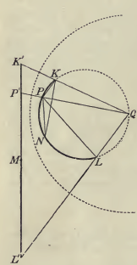

The origin at Q, big dotted is inversion circle a = R, disk off center on left, bowl shown clearly. After this picture we get a thicket of sentences about the geometry related to this picture.
But let's back up and start parsing on page 181, Section 237. He first sets up the inversion picture and it is as drawn above. The disk is S' at potential V', The bowl is S. My first confusion is this: he says the disk is at V', but at the same time he says there is a charge V'R at the origin Q. He says this charge is influencing the bowl. In my analysis, that point charge at the origin does not appear until you add -V' in the R'-space picture, and the charge you add there is -V'R, not +V'R. For now, ignore this confusion and keep parsing.
He now refers to points Π and Π' as I guess arbitrary point and inversion point (he calls these image points of each other I think). He claims this potential relation and this charge density relation: (a = R)

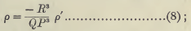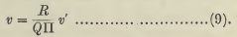

σ'(r) = (a/r)3 σ(r') φ'(r) = (a/r) φ(r')

So his QΠ is a line segment origin to some point Π which must be my "r" here. so (9) looks good. Then on the left P is not a general point, but a point on the bowl where charge is located, and QP is then my "r" for that. So far, so good. The word "electricity" means "charge".
He then notes that the disk is at constant V', but the bowl S has a varying potential. He then proposes to queue up a charge q = –RV' and I think he wants now to put this at point Q. Before doing this, he claims that the potential on both sides of bowl S is V = -q/(QP). I agree because I know that if we add the point charge q at the origin, the S will be at 0 potential.
So here is a good point he is saying: I know that without this added point charge at Q, the potential on the bowl is the negative of what that point charge would provide.

I need to stop and ponder this carefully. Let's go back to my problem (see separate doc) of the Green's function for a sphere with Green's point charge outside. The sphere has some potential on it which, in my problem, is the sum of the Green's charge and the image charge's potentials. This potential is in fact 0. If I delete the Green's charge only, letting the image charge still be there, it is true that the sphere would then have a potential equal to the negative of what that Green's charge was providing. This potential would obviously not be a constant on the sphere, so this would not be a stable charge distribution on the metal sphere, but we could imagine changing the sphere to "sticky plastic" just before doing this Green's charge deletion. The residual sticky plastic charge distribution would then be exactly that of the image charge.

Ready now to continue in Kelvin on page 181. We use "fit page" in the PDF and type a page number at the bottom window 181. Charged is "electrified". Page 182 is all "geometry" where he is computing what he calls ρ'. But now we are referenced by to equation (7) of the previous section which I have not yet parsed (ie, decoded). On page 179 we get this result for the charge on the disk, on either side,

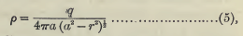 // "either side"
σ'disk(r) = (Q/4πb) 1/$\sqrt{b2- ρ2}$ // Jackson

so Kelvin and I are in step so far on page 179. Green 1832 is credited as being the first person to find the result (5). In section 234, Kelvin directly quotes from Green's paper. Green then reports on something that Biot said about some experiments Coulomb did. Coulomb died in 1809, Kelvin was born 1924, so these two "greats" missed each other and Green and Biot served as data intermediaries. Coulomb actually played with a 10" diameter Cu plate. So boom, Kelvin throws out a chart where he compares Coulomb's measured σ with the above equations predictions for σ. Data is normalized to 1 at plate center.

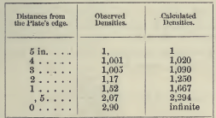

He then quotes Green saying that the differences are "trifling". Fascinating.

[ p 180 Section 235 ] The on-axis potential can be found be integrating σ/r over the disk, with σ as given by ρ above. This is just superposition of point charges. Evaluate this on the disk with 0 at infinity and you find V', the potential of the disk, and they you know capacitance C = 2a/π, and that is what Kelvin does next. The sphere has C = a, so the ratio of sphere/plate is π/2 = 1.57 and Kelvin quotes Cavendish as measuring this number!

[ p 180 Section 236 ] Now Kelvin wants us to rewrite the disk charge density using the picture below and he then gets result (7) [ CP = r, CA = BC = a, BP = a+r, PA = a-r. So BP.PA = a2-r2, all find. Then he suddenly claims that KP.PL is also a2-r2 for any chord through P. This is a typical Kelvin obscure geometry thing to do. He knows geometry, I do not.

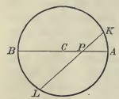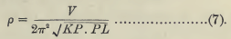

This fact is known by several names in wiki, for example

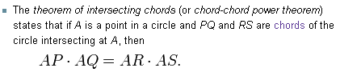

So OK, in our charged disk situation, we can then replace $\sqrt{a2-r2}$ in the denominator with what you see in (7) above. He has also q by CV = 2aV/π and we get

σ'disk(r) = (Q/4πa) 1/$\sqrt{a2- ρ2}$ = (V/2π2) / $\sqrt{a2- ρ2}$ = as shown in (7) above.

[ p 181 Section 237 ] This is the decoding we have already done. The method of inversion situation is set up here.

[ p 182 top ] Suddenly, ignoring what he has been saying about our little Green's point charge, Kelvin writes (7) with some new points inside the radical. He is suddenly claiming this equation:

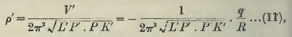

But OK, this is the same as (7) where he has just primed everything since that is his notation for points on the disk in the inversion picture. That explains the first equality in (11), where V' is the potential of this metal disk. Now why do we then say V' = -q/R? We know that this "q" cannot be the charge on the disk, so I think it is my Green's point charge in the inverted R-space. So just let this ride for a while.

[ p 182 Section 238 ] Now comes a section of wall to wall geometry. He even quotes "a theorem of geometry" I guess derived by Liouville.

[ p 183 Section 239.] He encapsulated all the geometry in the previous section. He then uses those geometry results along with the ρ inversion transform formula to write ρ ( the σ on the bowl!) in several ways called 15, 16, and 17. Here is the picture again and (17)

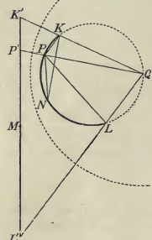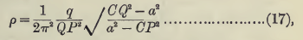

where a = disk radius, Q = my inversion origin, P = point on bowl, and C = "the central point (or pole) of the spherical segment S" which is point N in the picture above. Now, he claims this result (17) was stated earlier in "section 219". But the current paper begins with section 231, so this is from some earlier paper! This is a paper written in French on the subject of "electric images" and the result there is

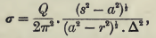

which is in fact similar in appearance to (17), Fine, don't care. Now it is true that the bowl radius does not appear in (17), but other sphere distances do appear such as QP (my R vector), CQ and CP, so it does not seem "remarkable" to me. Now he wants to take the radius of the bowl to be infinite. I don't think this is the same thing as going to the charged disk in R'-space, maybe it is. This disk he says will have radius a, will be grounded, and will be "influenced by" a point charge Q located at position Q. I don't know what he means by "charge Q" since that symbol has nowhere appeared as a charge, only as the origin. I think this result (17) is The Big Result, but I don't know what it means. Maybe it is the charge on the grounded bowl all by itself, the thing I have been after?
Well, lets go on.

[ p 183 Section 240] Well, now he is getting on to "my" problem:

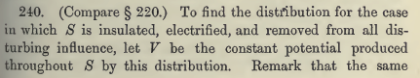

so he is heading in my direction. He is describing my R-space problem of an isolated metal bowl having some charge Q he does not mention, but having a constant potential he calls V. So far so good. Now what are we remarking?

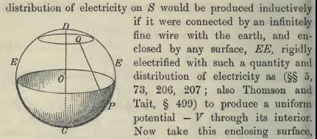

I think he is just saying this: if you add a constant potential -V in R-space, you will bring the bowl down to 0 potential so you can consider it then grounded. For me, this must means shifting the 0 of the potential so that φ(∞) = -V and φ(bowl) = 0. Physically, perhaps you do this by encircling everything with a great metal sphere held at -V. I guess in the figure, he represents this outer sphere by "EE", which is certainly a strange notation for a surface. This is his notation usually for line segments. Perhaps the shaded area is the actual metal bowl (C and P are then in the right place for this to make sense), and perhaps his EE surface lies "just outside" the bowl, and that is what he is trying to show here.
Now, when we add this constant potential, he claims this does not alter the charge distribution on the bowl. Well, σ comes from normal gradients of φ, and adding a constant to φ doesn't change these gradients, so OK.

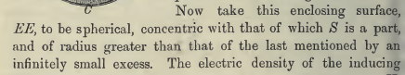

OK, he really wants to think of surface "EE" as a spherical one lying just outside the bowl. That works for me. Continuing along,

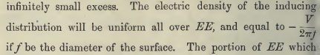

Well, suppose the outer EE sphere has radius A. It has area 4πA2. It has capacitance C = A, and so it will have potential -V = Q/C = Q/A. So charge is Q = -VA. The charge density on EE is then -VA/4πA2 = V/4πA = – V/2π(2A) = -V/2πf, just as he says. Again, this would be the "electric density" on the outer surface of sphere EE. Continuing along:

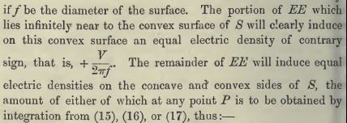

Think of this outer sphere as being a sticky plastic one, so it has σ = -V/2πf on it as he says. This surface likes right next to the bowl. What will this do to the bowl? He wants to argue that this will act as a capacitor and induce an opposite surface charge density on the bowl's outer surface. (the convex surface) This would be true to the extent that E = 0 outside the surface EE (and inside the bowl metal). I don't buy it, but let's play along. Well, I have completely lost the ball now, even with close decoding of every word. Let's try to keep going.

[ p 184 Section 241 ] He is here going to compute the charge densities on the two sides of the bowl. For the "concave side" (nowadays, we would say that was the "inside" of the bowl) he finds:
[ his angle η is my angle θ; his angle α is my angle θ0; f = 2r0 = diameter of the bowl sphere. ]

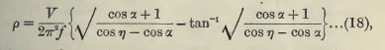 // inside

He then says to get the outer surface potential, you add the above to V/2πf.
Kelvin says he got these results in a letter from Liouville 22 years earlier, but without proofs. He thinks he is the first person to prove these results in published form.
He then goes on to consider different bowl angles (one he calls a "bason")

STOP parsing. He gets these results somehow from (17). I was hoping to find a "hint" as to what I was missing in my inversion analysis, and I have not found that hint. I cannot even tell clearly what his inversion scenario is! Nor is it clear that his solution of the charged bowl problem has anything to do with inversion!!

So what can I say about Kelvin and his writings? I would like to say that he did not understand what we now understand, and therefore his proofs of things are totally tortured and obscure. But to say that, I have to know what "we now understand" !

