Notes on Kirk on bowl problem + Kelvin review PhL 7.3.10

While finishing up Smythe Problem 42, I ran into a PDF of Kirk McDonald of Princeton that treats the "orifice in a spherical shell" problem, even if the orifice is large so we have a bowl. He seems to have read the Kelvin paper and is prepared to summarize it for the reader. But I think I will just do a full review of his entire PDF, just so I know what is in it.

Comment: This pdf is interesting because it contains a study of a particular problem, the spherical bowl, rather than being a study of a particular technique. So you get to see various ways to attack this problem in which I have long been interested.

1. The Problem. 1
2. Solution Methods. 1
2.1 Elementary Solution. 1
2.2 Solution by Legendre Series. (Set up, then approximation) 1
2.3 Solution via Green's Functions 2
2.4 Solution by Inversion (Kelvin) 2
2.5 Solution in Toroidal Coordinates: Lebedev 4
3. Appendix: Charge distribution on a conducting ellipsoid and its limits. 5
References. 6

1. The Problem. The polar hole angle will be θ0. He will get certain results simply. The idea that the difference between inner and outer charges is a constant follows at once from the superposition idea.

2. Solution Methods. Green 1828 gets credit,

2.1 Elementary Solution. Here he seems to be talking for the moment about a small hole, so you can pretend that when you punch the hole, the spherical σ is still there as a sticky charge. If Eo was the E field above the full sphere, then a simple argument says E = Eo/2 in cap region. Then you can imagine that all field lines getting onto the inner surface to make σ inside have to pass through the hole. A flux argument lets you estimate the total charge on the inner surface which is small. You then also know the outside total charge, so you find their difference is about θ02/8 (a constant) (2). He continues in this general vein to get some simple answers. I don't really see why he puts the word "superposition" in the title of this section. I think the real argument is that the field in the hole is mostly determined by exterior sphere charge other than that of the little cap, so whether you include or don't include the cap charge does not matter much. If you include it, then you can use it to compute the E field and the other stuff. A rather tricky argument.

2.2 Solution by Legendre Series. (Set up, then approximation) The z axis goes through the center of the hole. He does the usual inside and outside expansions with An coefficients. He notes that you have a "partial" BC, but that is enough to show that Δσ = V0/4πa. He then writes the second BC in the cap -- no charge there. This looks like the start of the canonical thing, but here he stops exact and moves into approximation. He assumes the infinite Legendre series ends at some reasonable max n value which is π/θ0. We don't have orthogonality so we get in (16) a sort of integral equation in the An. But then doing a little trick, he is able to approximate An for our low n values as shown in (21) He than goes on to compute everything in this approximation. Maybe the idea is that with a finite set of coefficients, you have a finite matrix problem for the An, but I did not go through his details. Just the idea of doing an approximate solution is interesting.

2.3 Solution via Green's Functions

Kirk first reviews an approximate method due to Green which gives two terms of the familiar form for σ. It sounds as if Green modeled the cap charge for a small hole by a disk, but details are not given. Well, Kirk starts on it but then stops in his notes, says "more to come".

2.4 Solution by Inversion (Kelvin)

This is the big Kelvin method of 1847, lots of geometry. The result is this:

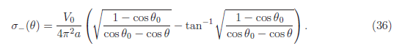

I will quote some of his statements:

"We now present details of a derivation leading to eq. (36), following Thomson [6]. The
starting point is based on the discussion of eqs. (32)-(33), that the difference between the
charge distribution on a conducting spherical bowl and the uniform charge distribution σ0 on
a complete sphere at the same potential is the same as that induced on a grounded spherical
bowl by charge distribution −σ0 on the spherical cap that completes the spherical bowl.
Thomson (ie, Kelvin) solved this problem by first finding the charge distribution induced on a grounded spherical bowl by a unit charge at an arbitrary point on the spherical cap, using his method
of inversion."

So it appears this is going to be similar to the Smythe approach. He starts with the "known" charge density on a charged disk at V0 (just as Smythe and I did). Then he relates B2-ρ2 = (B+ρ)(B-ρ) to the product of two geometric lengths in a certain picture of the disk which he has drawn. He then draws his inversion picture relating disk to bowl

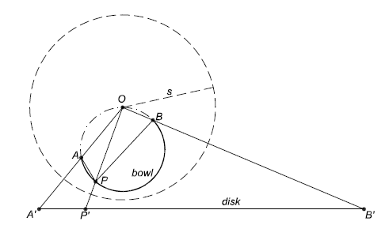

Just as I did this, we start with the disk offset so we get a tilted bowl. He then quotes in words the general inversion idea (below his eq 40), that a point charge will appear and σ transforms in a certain manner. He is looking now for the charge on the tilted bowl.

Aside: It is not easy to follow even his Kelvin parsing, but on page 11 he makes an interesting point I had not thought of. This is really an aside, not part of the main flow I think. Here is this aside:

What happens if you start with your charged disk and put your inversion origin somewhere in the plane of that disk, something I never did. The inversion picture then looks like this:

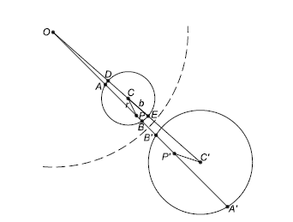

Let's say the lower larger disk is our original charged disk. The image of this disk is the smaller disk shown. This fact in itself is new to me. I thought of spheres to spheres, and spheres to planes. I knew I guess that circles went into circles. (Circle Theorem, Jackson raw notes). So this is just an interesting example of circle to circle, but both are in the same plane.
The Big Payoff of this example is this: if you start with the known charged disk and add the constant potential (this is R' space say), then in R space you will have the smaller disk shown and a point charge at the inversion origin. But this is then the Green's problem for a Green's charge in the plane of a disk!! This is a problem I wondered about several times and never knew how to do! Here it is, very simple, and you can of course get the charge distribution and the potential in the usual inversion manner. It is a simple single inversion problem! So my thanks to Kirk for pointing this out (perhaps Kelvin did too).

Kirk then resumes his main flow top page 12. Equation (48) seems to be the result of taking my θc Green's charge and just integrating over the cap to get a uniform cap charge. In Smythe, I did this in a very indirect manner by rotating the bowl, going to the iris, doing a ring in the hole of the iris, coming back to the bowl, and then integrating that ring to get a uniform cap. I guess I could have maybe just rotated the bowl, and then directly did some kind of integration of my point charge to create that surface cap uniform charge and dispense with the iris! So on page 13 Kirk finishes the calculation and gets the historical σ-(θ) result which I got in my Smythe problem 42. Remember the key fact: once you have your Green's for a cap of uniform charge, you just add your neutralizer sphere of charge to this which raises the bowl to V0 and clears the cap, so you end up with your charged bowl.

2.5 Solution in Toroidal Coordinates: Lebedev

This is something I thought about for several problems of this nature. The iso-surfaces are really bowls and disks in limit, etc. He just gives this reference [ which I now call Lebedev ]

This is a $16 Dover, but Amazon won't show you the list of solved problems! But I find this on scribd and in it comes (my login there still works). There is no search meta info, so I am now converting it to DVJU which I think will add that search capability. Great. I think there might be 500+ worked problems in this thing!
This bowl problem is problem 501 on page 239 (my index still is not working) Here is the whole thing:

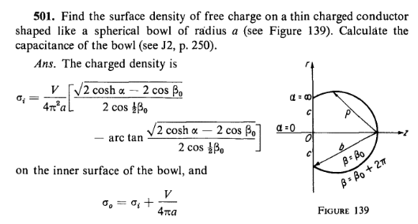

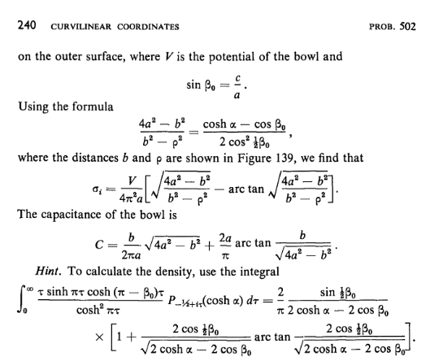

3. Appendix: Charge distribution on a conducting ellipsoid and its limits.

This is of course another Kelvin special that I read about somewhat. Kirk carefully explains Kelvin's argument, which I went through in great detail during my "Kelvin parsing" phase, that the gravitational field inside a mass shell between similar ellipsoids is 0. Kirk shows it first for a sphere, then distorts that into an ellipsoid.

"Hence, if the ellipsoidal shell, which is the transform of the spherical shell
of Fig. 5, contains a uniform volume charge density, the relation E1 + E2 = 0 remains true
at the vertex of any bicone in the interior of the shell, which implies that the total electric
field is zero there."

Kirk then goes through Kelvin's steps and ends up with the famous result

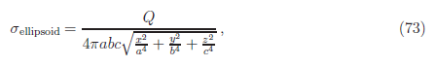

He then takes the circular disk limit of this ellipsoid and obtains Jackson's result (for each side)

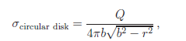

Kirk then computes V at disk center via ∫dA σ/r which is trivial and finds V = πQ/2b which tells you the disk capacitance. End of paper!

This last is certainly an excellent way to obtain σ on a disk and its capacitance. Of course you have to obtain (73) first. I did that somewhere in my own way and it did not seem all that difficult. Recall that I plotted this ellipsoid σ in a nice Maple color surface plot.

References.

[1] Green's collected papers published 1970.
[2] Smythe. This reference is to a Smythe proof that Δσ = constant no matter what shape hole you make in your sphere. But this reference is to Smythe problems 46 and 47. But he refers to 3rd Ed 1968 and I have 2nd ed 1950 which does not seem to have these two problems.
[3] Jackson 3rd edition. (blue). This refers to a picture of an orifice in a plane. Recall that this is the problem Jackson does in blue to replace the disk problem in green.
[4] Problem set solutions I already downloaded of Kirk. Shows derivation of the Stak Poisson kernel integral thing in 3D which you use for the Dirichlet problem for a 3D sphere.
[5] another Smythe reference for reader to read about "inversion" (I use green Jackson for this)
[6] the Kelvin reference, his papers (which I have had for a long time now)
[7] Maxell's stuff, he did not know about Green's work prior to Kelvin
[8] Jeans book: also gives the Kelvin bowl discussion by inversion. A book I never could get. Amazon shows out of print. I looked again, it is out there on rapidshare and hotfile. This latter makes you wait 60 seconds before a download, trying it now. Wow! It is coming in right now after 2 word "challenge". I got the 5th Ed 1927.
[9] another Smythe reference, obscure statement about the disk to disk inversion centers.
[10] the Lebedev Dover book I already downloaded, has the bowl done in toroidals.

