Y. Dan Agassi,

Although I have fiddled with toroidal coordinates as you have seen (for the Laplace equation), I certainly am not an expert in this subject. However, I am quite sure of item 1 below, which is not what you want to hear! Below are some notes which probably are not of much value. It is an interesting problem and I presume it has a reasonable numerical solution.

1. The (scalar) Helmholtz equation is not separable in toroidal coordinates. This is confirmed on page 101 of Moon and Spencer (see next page). It is only separable if k2 = 0 in which case it is really the Laplace equation and then all the stuff of my bowl paper applies. I suppose one could do perturbation theory for small k2 but that sounds pretty horrible. (The vector Helmholtz equation is then even more non-separable!) Here is a shot of the Moon and Spencer page where S means Simple-separable (R=1), R means R-separable (R≠1), and X means not separable: (g11 = h12) [ toroidal 4th up from the bottom ]

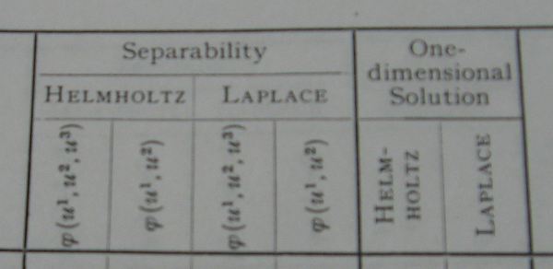

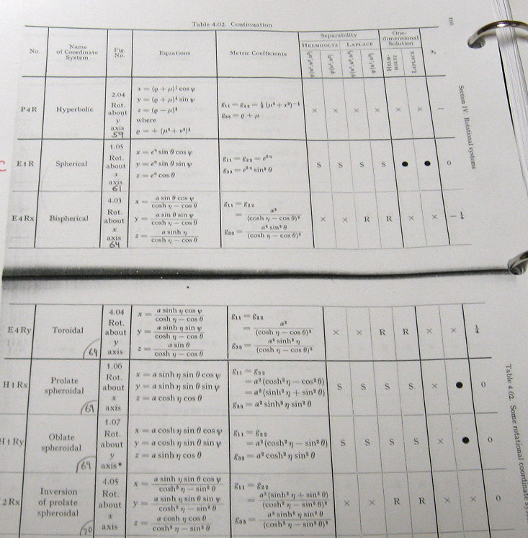

2. The Laplace equation is "R-separable" in toroidal coordinates with the "atom choices" shown in my bowl paper, section 2 (b) :

ξ in (0,∞) u in (0,2π) φ in (0,2π)

expo osc osc
(1) $\sqrt{chξ - cosu}$ [Pn-1/2m(chξ), Qn-1/2m(chξ) ] [ sin(nu),cos(nu)] [ sin(mφ),cos(mφ)]

osc expo osc
(2) $\sqrt{chξ - cosu}$ [Piτ-1/2m(chξ), Qiτ-1/2m(chξ) ] [exp(τu), exp(-τu) ] [ sin(mφ),cos(mφ)]

The "R-separable" means that there is a non-separable overall function sitting in all solutions, and here that function is $\sqrt{chξ - cosu}$ = 1/R. This is a Moon and Spencer term.

But of course this is not what you want.

3. Here is a picture showing a torus cross section taken from my bowl paper (this is a different R)

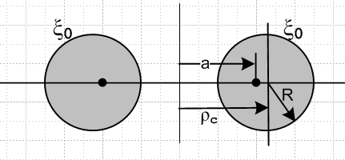

ρc = a cothξ0 R = a /shξ0 => $\sqrt{ρc2 - R2}$ = a , ρc/R = chξ0 (10.9)

Based on this, I think your desired "ring source" could be written

source = b' δ(a cothξ0 - ρ0) // δ(ρ-ρc) in cylindricals

and then your desired Green's Function problem is something like this (I think u' = 0 for your ring source location)

(∇2+k2) g(ξ,u|ξ',u') = b' δ(a cothξ' - ρ0) g(ξ,u|ξ0,u') = constant g(∞) = 0

where ∇2 needs to be expressed in toroidal coordinates. I am not sure one would call this a Green's Function, it is more the Helmholtz equation with a ring source (I am used to point sources for Green). I suppose then

δ(a cothξ' - ρ0) = b'δ(ξ' - ξ0)/ |∂ξ'(a cothξ')| = b'δ(ξ' - ξ0)/ [a csch2ξ'] = b'sh2(ξ0) δ(ξ' - ξ0)/a

≡ b δ(ξ' - ξ0)

so that

(∇2+k2) g(ξ,u|ξ',u') = b δ(ξ' - ξ0) // u' = 0

which gets things closer to your emailed form,

Here ξ0 is a label for the torus having the axis of interest. Also I have a different sign for k2, just a convention.

4. Since your ring source lies inside the torus ξ' and you want g = constant on the torus (inner) surface, you are doing an "interior problem" inside the torus. I am not sure that you are then allowed to require also that g(∞) = 0 which seems part of a problem exterior to the torus. That is, you may be over-specifying the problem.

5. Here are four different notations for the toroidal coordinates that I know of:

My Stackel paper: (ξ1,ξ2,ξ3) toroid, bowl, azimuthal plane
Moon & Spencer (η,θ,ψ) toroid, bowl, azimuthal plane
My bowl paper (ξ,u,φ) toroid, bowl, azimuthal plane p 101
Morse and Feshbach: (μ,θ,φ) toroid, bowl, azimuthal plane Vol 1 p 666

On p 666 M&F complicate the issue by using ξ1 = cosh(μ), ξ2 = cosθ and ξ3 = cosφ. These are different ξi from my Stackel document shown above. I think they regard toroidal coordinates as some kind of limit of the ellipsoidal ones.

6. I tried to get Maple to compute scalar ∇2 using the (ξ1,ξ2,ξ3) toroidal notation and

∇2f(ξ1,ξ2) = 1/(h1h2h3) { ∂1 [ (h2h3/h1) ∂1f(ξ1,ξ2) ] + cyclic }

where I assume azimuthal symmetry so no ξ3 dependence. The scale factors are

h1 = h2 = a/(chξ1–cosξ2)
h3 = shξ1 h1

Here is my result,

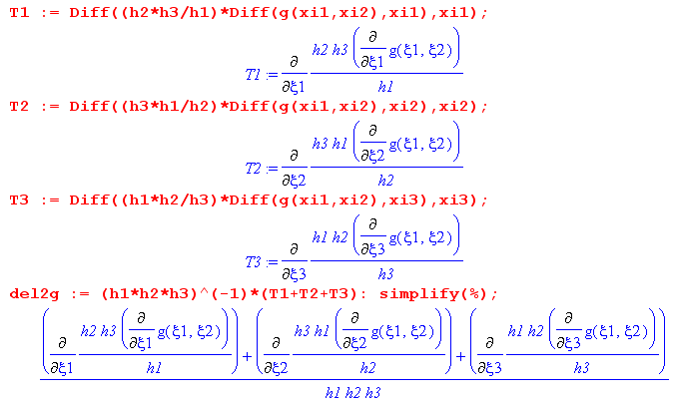

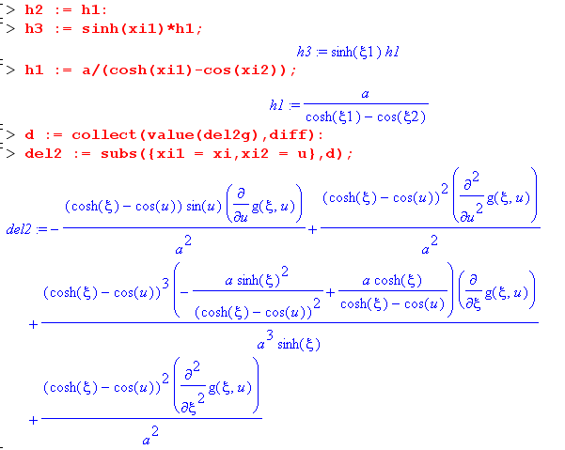

So this expression is ∇2g (unless I screwed up, which I often do) and your equation is then,

(∇2+k2) g(ξ,u|ξ',u') = b δ(ξ' - ξ0) g(ξ,u|ξ0,u') = constant g(∞) = 0

which I agree is not very nice. It really makes me think this is not such a good way to approach the problem. Maybe that small k2 perturbation theory is a better path, where one then starts with the known Laplace toroidal harmonics and can perhaps work up a solution for k2 not so small. Or maybe model the torus as a polygonal structure in cylindrical coordinates (if nothing else, a thick annular ring).

So this is all nothing new to you I am sure. Sorry that I have no magic bullet!

Maybe those Tokomak people know about this stuff. Or smoke-ring researchers ?

Best regards,
Phil Lucht
12/29/13

