The Mehler-Fock Transform PhL 12.29.15

This plays a crucial role in bowl doc, but I seem never to have derived it. It would be a good addition to bowl doc it not too hard. Here is the full thing

g(y) = $^{\int_{0}^{∞}{}}$dτ Pm-1/2+iτ(y) f(τ) // expansion
f(τ) = (τ/π) sh(πτ) Γ(1/2-m+iτ) Γ(1/2-m-iτ) $^{\int_{1}^{∞}{}}$dy Pm-1/2+iτ(y) g(y) // projection (2.4.1)

So I presume the interval for y is (1,∞) and for τ is (0,∞).

Mimic of bowl doc Section 1.5 1
Plans to determine the normalizing factor 3
Plan A: integrate orthog over dτ' 3
Plan B: insert int rep #1 for both P's in orthog (μ=0 only) 6
Plan C: insert int rep #2 for both P's in orthog 7
Plan D: try int rep #3 (μ=0 only) 8
Plan E: find out what the normalization factor must be 9
Plan F: Try completeness with int rep #1 and known f(τ,μ) 11
Plan G: Integrate both dies of completeness over z 11
Plan H: Rosenthal thesis int rep #4 12
Plan I: Use Rosen int rep #4 to replace just one of the P functions in orthog 13
Plan J: Use Rosen int rep #4 to replace both of the P functions in orthog 14
Plan K: Use Rosen int rep #4 to replace one of the P functions in completeness 15
Plan L: Use Rosen int rep #4 to replace one of the P functions in dz integration of completeness 15

Mimic of bowl doc Section 1.5

The differential operator must be the Legendre one somehow. Here is the ODE from GR7

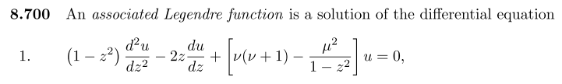

So in my theory I would say (don't know which sign)

L = (1-z2)∂z2 - 2z∂z + [ν(ν+1)-μ2/(1-z2)]

or
L = - (z2-1)∂z2 - 2z∂z + [ν(ν+1)+μ2/(z2-1)]

The general form is

L = -∂z[p(z)∂z] + q(z) = -p(z)∂z2 - (∂zp)∂z + q

So let's try

p(z) = (z2-1) ∂zp = 2z q = [ν(ν+1)+μ2/(z2-1)]

Then the general form says

L = -p(z)∂z2 - (∂zp)∂z + q

= - (z2-1)∂z2 - 2z∂z + [ν(ν+1)+μ2/(z2-1)]

and this matches the Legendre, so we have accomplished the first step. What's next? Let's rewrite using τ so that

ν(ν+1) = (iτ-1/2)(iτ+1/2) = -τ2 - 1/4 = -(τ2+1/4)

Then we have

L = - (z2-1)∂z2 - 2z∂z + [μ2/(z2-1) - (τ2+1/4)]

Think of μ as a bystander variable and τ is the item of interest, like the discrete n.

How do you find the weight function s(x) ? The eigenvalue problem is this

Lφn(x) = λns(x)φn(x)

which becomes

L φ(τ,x) = λ(τ) s(x) φ(τ,x)

Aha! Start over now that I recognize the eigenvalue. In this restart we write

L = - (z2-1)∂z2 - 2z∂z +μ2/(z2-1)

p(z) = (z2-1) ∂zp = 2z q = μ2/(z2-1)

Now the EV equation is this

Lφ(ν,z) = -ν(ν+1)s(z)φ(ν,z)

But I know that

LPνμ(z) = -ν(ν+1)Pνμ(z)

and then

LPμiτ-1/2(z) = +(τ2+1/4) Pμiτ-1/2(z) same for Qμiτ-1/2(z)

So luckily s(x) = 1 and we can forget about that. so we know that

λ(τ) = (τ2+1/4) = the eigenvalue!

Question: are both P and Q in the eigenfunction set? I know that Q diverges at z = 1 so am tempted to thing it is not allowed. So for now, assume only the P are eigenfunctions.

Now we come to orthogonality

$^{\int_{a}^{b}{}}$dx s(x) n(x) φm(x) = δn,m

which becomes

$^{\int_{1}^{∞}{}}$dz [Pμiτ-1/2(z)]* Pμiτ'-1/2(z) = K δ(τ-τ')

I think P-ν-1 = Pν says we can remove the * for real μ (z is real) so looking for

$^{\int_{1}^{∞}{}}$dz Pμiτ-1/2(z) Pμiτ'-1/2(z) = Kμ(τ) δ(τ-τ') // orthogonality

Plans to determine the normalizing factor

Plan A: integrate orthog over dτ'

Setup: Suppose the above were true. Then integrate both sides on dτ' from 0 to infinity

$^{\int_{0}^{∞}{}}$dτ'$^{\int_{1}^{∞}{}}$dz Pμiτ-1/2(z) Pμiτ'-1/2(z) = $^{\int_{0}^{∞}{}}$dτ' Kμ(τ) δ(τ-τ')

or
$^{\int_{1}^{∞}{}}$dz Pμiτ-1/2(z) $^{\int_{0}^{∞}{}}$dτ' Pμiτ'-1/2(z) = Kμ(τ)

Now I have the dτ' integral here from PBM

Therefore,

$^{\int_{0}^{∞}{}}$dτ' Pμiτ'-1/2(z) = $\sqrt{π/2}$ (z-1)-(μ+1)/2 (1/Γ(1/2-μ)) (z+1)μ/2

I then have

Kμ(τ) = $^{\int_{1}^{∞}{}}$dz Pμiτ-1/2(z) [ $\sqrt{π/2}$ (z-1)-(μ+1)/2 (1/Γ(1/2-μ)) (z+1)μ/2 ]

= $\sqrt{π/2}$(1/Γ(1/2-μ)) $^{\int_{1}^{∞}{}}$dz Pμiτ-1/2(z)(z-1)-(μ+1)/2(z+1)μ/2

Search: Does this integral exist somewhere?

(z-1)-(μ+1)/2(z+1)μ/2 = (z-1)-(μ+1)/2(z+1)μ/2 * (z-1)μ/2(z-1)-μ/2

= (z2-1)μ/2 (z-1)-μ-1/2

so then I am looking for

$^{\int_{1}^{∞}{}}$dz Pμiτ-1/2(z) (z2-1)μ/2 (z-1)-μ-1/2

How about this

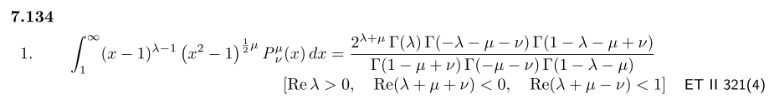

Set λ-1 = -μ-1/2 so λ = -μ+1/2 so need μ< 1/2 . Just try it.

λ = 1/2-μ λ+μ = 1/2 λ+μ+ν = 1-μ < 0 ouch cannot have μ = 0

-λ-μ-ν = -λ - 1/2 = μ-1/2 - 1/2 = μ-1

1-λ - μ+ν = μ+1/2 - μ - ν = 1/2-ν

1-μ+ν = itself

-μ-ν = -1/2

1-λ-μ = μ+1/2 - μ = 1/2

so integral from GR7 is then

$\sqrt{2}$ Γ(1/2-μ)Γ(μ-1)Γ(1/2-ν) / (Γ(1-μ+ν)Γ(-1/2) Γ(1/2))

So here is what I then have

Kμ(τ) = $\sqrt{π/2}$(1/Γ(1/2-μ)) $\sqrt{2}$ Γ(1/2-μ)Γ(μ-1)Γ(1/2-ν) / (Γ(1-μ+ν)Γ(-1/2) Γ(1/2))

now

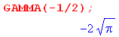

so rewrite the above as

Kμ(τ) = - $\sqrt{π/2}$(1/Γ(1/2-μ)) $\sqrt{2}$ Γ(1/2-μ)Γ(μ-1)Γ(1/2-ν) / (Γ(1-μ+ν)2$\sqrt{π}$ $\sqrt{π}$)

= - $\sqrt{π/2}$(1/2π) $\sqrt{2}$Γ(μ-1)Γ(1/2-ν)/Γ(1-μ+ν)

= - (1/2$\sqrt{π}$) Γ(μ-1)Γ(1/2-ν)/Γ(1-μ+ν) ouch pole at μ = 0

Now set ν = iτ-1/2 . Then

1/2-ν = 1/2 - (iτ-1/2) = 1-iτ

1-μ+ν = 1-μ+( iτ-1/2 ) = iτ + 1/2 - μ

so then

Kμ(τ) = - (1/2$\sqrt{π}$) Γ(μ-1)Γ(1-iτ)/Γ( iτ + 1/2 - μ)

At least I have something! But I was hoping to get

Kμ(τ) = 1/f(τ,μ) where f(τ,μ) = (τ/π) sh(πτ) Γ(1/2-μ+iτ) Γ(1/2-μ-iτ)

If his were true, I would need

Kμ(τ)f(τ,μ) = 1
or
- (1/2$\sqrt{π}$) Γ(μ-1)Γ(1-iτ)/Γ( iτ + 1/2 - μ) * (τ/π) sh(πτ) Γ(1/2-μ+iτ) Γ(1/2-μ-iτ) = 1
or
- (1/2$\sqrt{π}$) Γ(μ-1)Γ(1-iτ) * (τ/π) sh(πτ) Γ(1/2-μ-iτ) = 1

Stop. This is singular when μ = 0 due to Γ(μ-1) and I now see that way back above.

Plan B: insert int rep #1 for both P's in orthog (μ=0 only)

But you have to prove this somehow. So we need an integral rep for P. How about

P-1/2+iτ(z) = ($\sqrt{2}$/π ) ch(πτ) $^{\int_{0}^{∞}{}}$dx cos(τx) /$\sqrt{z+chx}$ int rep #1 (L.3.5)

Insert this twice to get (doing μ = 0 only here)

$^{\int_{1}^{∞}{}}$dz Piτ-1/2(z) Piτ'-1/2(z)

= $^{\int_{1}^{∞}{}}$dz[ ($\sqrt{2}$/π ) ch(πτ) $^{\int_{0}^{∞}{}}$dx cos(τx) /$\sqrt{z+chx}$] [($\sqrt{2}$/π ) ch(πτ') $^{\int_{0}^{∞}{}}$dx' cos(τ'x') /$\sqrt{z+chx'}$]

= ($\sqrt{2}$/π )2 $^{\int_{0}^{∞}{}}$dx cos(τx)$^{\int_{0}^{∞}{}}$dx' cos(τ'x')$^{\int_{1}^{∞}{}}$dz 1/[$\sqrt{z+chx}$$\sqrt{z+chx'}$ ]

I suspect that dz integral gives f(x) δ(x-x'). If I assume that then I can continue

= ($\sqrt{2}$/π )2$^{\int_{0}^{∞}{}}$dx cos(τx)$^{\int_{0}^{∞}{}}$dx' cos(τ'x') f(x)δ(x-x')

= ($\sqrt{2}$/π )2$^{\int_{0}^{∞}{}}$dx cos(τx)cos(τ'x) f(x)

Now I suspect that f(x) = f0 = constant and then we get

= ($\sqrt{2}$/π )2 f0$^{\int_{0}^{∞}{}}$$^{\int_{0}^{∞}{}}$dx cos(τx)cos(τ'x)

Now I need to quote the Fourier Cosine Series Transform

f(z) = $\sqrt{2/π}$$^{\int_{0}^{∞}{}}$dk cos(kz) fk // expansion
fk = $\sqrt{2/π}$$^{\int_{0}^{∞}{}}$dz cos(kz) f(z) // projection
$^{\int_{0}^{∞}{}}$dz cos(kz) cos(k'z) = (π/2)δ(k-k') // orthogonality
$^{\int_{0}^{∞}{}}$dk cos(kz) cos(kz') = (π/2)δ(z-z') // completeness

Using the last two lines, I can continue the above

= ($\sqrt{2}$/π )2f0(π/2) δ(τ-τ')

= (2/π2)(π/2)f0 δ(τ-τ')

= (1/π) f0 δ(τ-τ')

So now then do I do this integral

$^{\int_{1}^{∞}{}}$dz 1/[$\sqrt{z+chx}$$\sqrt{z+chx'}$ ]

Oops, it diverges at the high end, so this path is a no go, wrong integral rep for P! Also, this is an integral of a positive-always integrand, so cannot possibly give 0 when x ≠ x'.

Plan C: insert int rep #2 for both P's in orthog

$^{\int_{1}^{∞}{}}$dz Pμiτ-1/2(z) Pμiτ'-1/2(z) = K δ(τ-τ') // orthogonality

Need an integral rep for P. Try this one

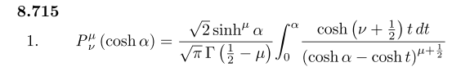
Set ν = iτ-1/2 so then ν+1/2 = iτ. Then we have

Pμiτ-1/2(chα) = $\sqrt{2}$$\sqrt{π}$ $^{\int_{0}^{α}{}}$ dt ch(iτt) / (chα-cht)μ+1/2 int rep #2

= $\sqrt{2}$$\sqrt{π}$ $^{\int_{0}^{α}{}}$ dt cos(τt) / (chα-cht)μ+1/2

If I try this rep, I get

$^{\int_{1}^{∞}{}}$dz Pμiτ-1/2(z) Pμiτ'-1/2(z)

= $^{\int_{1}^{∞}{}}$d(chα) ( $\sqrt{2}$$\sqrt{π}$)2$^{\int_{0}^{α}{}}$ dt cos(τt) / (chα-cht)μ+1/2 $^{\int_{0}^{α}{}}$ dt' cos(τ't') / (chα-cht')μ+1/2

= $\sqrt{2}$$\sqrt{π}$$^{\int_{1}^{∞}{}}$dz (z2-1)μ/2
$^{\int_{0}^{arccosh z}{}}$ dt cos(τt) / (z-cht)μ+1/2 $^{\int_{0}^{arccosh z}{}}$ dt' cos(τ't') / (z-cht')μ+1/2

This seems a huge mess, so no go.

Plan D: try int rep #3 (μ=0 only)

I am in over my head, it is not so simple as I hoped. I look on the web. Here is one idea I see

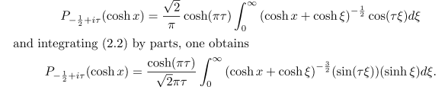

By doing parts, he fixes my convergence problem! Let's assume this last line is valid. Then

Piτ-1/2(z) = ch(πτ)/( $\sqrt{2}$πτ) $^{\int_{0}^{∞}{}}$dξ shξ sin(τξ) (z + chξ)-3/2 int rep #3

where z is still nicely isolated. Then I would need to find this integral

$^{\int_{1}^{∞}{}}$dz (z + chξ)-3/2 (z + chξ')-3/2

= $^{\int_{1}^{∞}{}}$dz $\frac{1}{((z+a)(z+b))3/2}$

This is a doable integral according to Maple

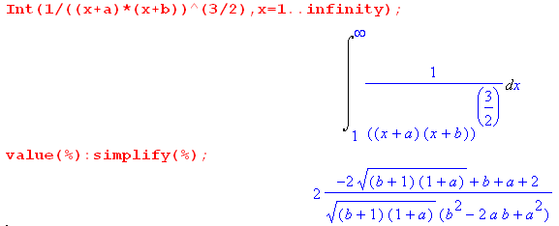

So just for fun, let's pursue this a bit

$^{\int_{1}^{∞}{}}$dz Piτ-1/2(z) Piτ'-1/2(z) =

= $^{\int_{1}^{∞}{}}$dz [ ch(πτ)/( $\sqrt{2}$πτ) $^{\int_{0}^{∞}{}}$dξ shξ sin(τξ) (z + chξ)-3/2] [ ch(πτ')/( $\sqrt{2}$πτ') $^{\int_{0}^{∞}{}}$dξ' shξ' sin(τ'ξ') (z + chξ')-3/2]

[ch(πτ)/( $\sqrt{2}$πτ)][ ch(πτ')/( $\sqrt{2}$πτ')] *

$^{\int_{0}^{∞}{}}$dξ shξ sin(τξ)$^{\int_{0}^{∞}{}}$dξ' shξ' sin(τ'ξ') $^{\int_{1}^{∞}{}}$dz(z + chξ)-3/2(z + chξ')-3/2

But then I am stuck with three integrals to worry about, and the dz one is a bit ugly. So this seems a hopeless path. Once again, the dz integral cannot give δ(ξ-ξ') because it is the integral of an all positive integrand, so when ξ ≠ ξ' you won't get 0. I think I am doing non-uniform convergence somehow.

Plan E: find out what the normalization factor must be

OK, I give up on this effort for now. Let's go back to the claimed transform itself,

g(y) = $^{\int_{0}^{∞}{}}$dτ Pμ-1/2+iτ(y) f(τ) // expansion
f(τ) = (τ/π) sh(πτ) Γ(1/2-μ+iτ) Γ(1/2-μ-iτ) $^{\int_{1}^{∞}{}}$dy Pμ-1/2+iτ(y) g(y) // projection (2.4.1)

My theory above says no s(z) weight functions What happens if I use these in the above transform. OK do the "two ways" thing:

g(y) = $^{\int_{0}^{∞}{}}$dτ Pμ-1/2+iτ(y) f(τ)

= $^{\int_{0}^{∞}{}}$dτ Pμ-1/2+iτ(y)[ (τ/π) sh(πτ) Γ(1/2-μ+iτ) Γ(1/2-μ-iτ) $^{\int_{1}^{∞}{}}$dy' Pμ-1/2+iτ(y') g(y')]

= $^{\int_{1}^{∞}{}}$dy' g(y') { $^{\int_{0}^{∞}{}}$dτ Pμ-1/2+iτ(y)Pμ-1/2+iτ(y') (τ/π) sh(πτ) Γ(1/2-μ+iτ) Γ(1/2-μ-iτ) }

So the implication here is that

$^{\int_{0}^{∞}{}}$dτ Pμ-1/2+iτ(y)Pμ-1/2+iτ(y') (τ/π) sh(πτ) Γ(1/2-μ+iτ) Γ(1/2-μ-iτ) = δ(y-y')

Now go the other way

f(τ) = (τ/π) sh(πτ) Γ(1/2-μ+iτ) Γ(1/2-μ-iτ) $^{\int_{1}^{∞}{}}$dy Pμ-1/2+iτ(y) g(y)

= (τ/π) sh(πτ) Γ(1/2-μ+iτ) Γ(1/2-μ-iτ) $^{\int_{1}^{∞}{}}$dy Pμ-1/2+iτ(y) $^{\int_{0}^{∞}{}}$dτ' Pμ-1/2+iτ'(y) f(τ')

= (τ/π) sh(πτ) Γ(1/2-μ+iτ) Γ(1/2-μ-iτ) $^{\int_{0}^{∞}{}}$dτ' f(τ') { $^{\int_{1}^{∞}{}}$dy Pμ-1/2+iτ(y) Pμ-1/2+iτ'(y) }

with the implication that

(τ/π) sh(πτ) Γ(1/2-μ+iτ) Γ(1/2-μ-iτ)$^{\int_{1}^{∞}{}}$dy Pμ-1/2+iτ(y) Pμ-1/2+iτ'(y) = δ(τ-τ')

So rewrite this implications:

$^{\int_{0}^{∞}{}}$dτ [(τ/π) sh(πτ) Γ(1/2-μ+iτ) Γ(1/2-μ-iτ) ] Pμ-1/2+iτ(y)Pμ-1/2+iτ(y') = δ(y-y') // comp

$^{\int_{1}^{∞}{}}$dy [(τ/π) sh(πτ) Γ(1/2-μ+iτ) Γ(1/2-μ-iτ) ] Pμ-1/2+iτ(y) Pμ-1/2+iτ'(y) = δ(τ-τ') // orthog

So why is there a kernel in there when I thought not from my simple theory? OK, not function of z.

Now define

f(τ,μ) = (τ/π) sh(πτ) Γ(1/2-μ+iτ) Γ(1/2-μ-iτ)

Then here is what things must look like:

$^{\int_{0}^{∞}{}}$dτ f(τ,μ) Pμ-1/2+iτ(y)Pμ-1/2+iτ(y') = δ(y-y') // completeness
$^{\int_{1}^{∞}{}}$dy f(τ,μ) Pμ-1/2+iτ(y) Pμ-1/2+iτ'(y) = δ(τ-τ') // orthogonality

Now you can remove f(τ,μ) from the second line to write

$^{\int_{0}^{∞}{}}$dτ f(τ,μ) Pμ-1/2+iτ(y)Pμ-1/2+iτ(y') = δ(y-y') // completeness
$^{\int_{1}^{∞}{}}$dyPμ-1/2+iτ(y) Pμ-1/2+iτ'(y) = δ(τ-τ')/ f(τ,μ) // orthogonality

Comment: Notice that ANY f(τ,μ) makes "both directions work", and so "both directions" does not determine f(τ,μ)

Plan F: Try completeness with int rep #1 and known f(τ,μ)

OK. I have now written up the above in Section J.5 of bowl doc. But now I would like to use

P-1/2+iτ(z) = ($\sqrt{2}$/π ) ch(πτ) $^{\int_{0}^{∞}{}}$dx cos(τx) /$\sqrt{z+chx}$ int rep #1 (L.3.5)

to show that

$^{\int_{0}^{∞}{}}$dτ f(τ,μ) Pμiτ-1/2(z) Pμiτ-1/2(z') = δ(z-z')

with

f(τ,μ) = (τ/π) sh(πτ) Γ(1/2-μ+iτ) Γ(1/2-μ-iτ) .

I had trouble in the other direction, maybe I can do this direction?

$^{\int_{0}^{∞}{}}$dτ f(τ,μ) Pμiτ-1/2(z) Pμiτ-1/2(z')

= $^{\int_{0}^{∞}{}}$dτ f(τ,μ)
[($\sqrt{2}$/π ) ch(πτ) $^{\int_{0}^{∞}{}}$dx cos(τx) /$\sqrt{z+chx}$] [($\sqrt{2}$/π ) ch(πτ) $^{\int_{0}^{∞}{}}$dx' cos(τx') /$\sqrt{z'+chx'}$]

= ($\sqrt{2}$/π )2 $^{\int_{0}^{∞}{}}$dx (1/$\sqrt{z+chx}$) $^{\int_{0}^{∞}{}}$dx' (1/$\sqrt{z'+chx'}$) $^{\int_{0}^{∞}{}}$dτ f(τ,μ) cos(τx) cos(τx')

so again I am faced with a painful dτ integral, namely

$^{\int_{0}^{∞}{}}$dτ (τ/π) sh(πτ) Γ(1/2-μ+iτ) Γ(1/2-μ-iτ) cos(τx) cos(τx')

Plan G: Integrate both dies of completeness over z

Assume that

$^{\int_{0}^{∞}{}}$dτ f(τ,μ) Pμiτ-1/2(z) Pμiτ-1/2(z') = δ(z-z')

Integral both sides 1 to infinity to get

$^{\int_{1}^{∞}{}}$dz' $^{\int_{0}^{∞}{}}$dτ f(τ,μ) Pμiτ-1/2(z) Pμiτ-1/2(z') = $^{\int_{1}^{∞}{}}$dz' δ(z-z')
or
$^{\int_{0}^{∞}{}}$dτ f(τ,μ) Pμiτ-1/2(z) $^{\int_{1}^{∞}{}}$dz' Pμiτ-1/2(z') = 1

Now I know that integral (I think). It is not a Mehler integral. But this integral only converges for the Mehler value if ν, so no one has this integral. But it certainly looks like one that could be done.

Comment: The real problem here is that the functions Pμiτ-1/2(z) are just completely different from the normal Legendre functions and all the usual methods just don't apply! The integrals in the references are not geared to this conical function.

Plan H: Rosenthal thesis int rep #4

I just looked at Rosenthal's thesis, and he seems interested in this integral rep,

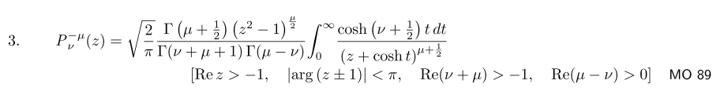

though he quotes it from page 156 of HTF 1. Here is his quote

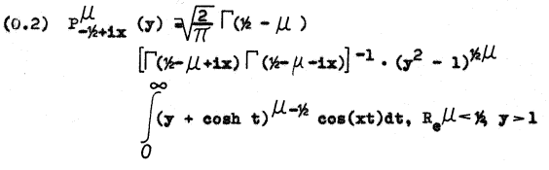
Can I connect these two? Well, the first step is to negate μ everywhere in my quote above,

Here is my negation of the GR7 quote above

Pνμ(z) = $\sqrt{2/π}$ Γ(1/2-μ) (z2-1)-μ/2 / [ Γ(ν-μ+1)Γ(-μ-ν) ] * $^{\int_{0}^{∞}{}}$dt cosh[(ν+1/2)t] / (z+cht)-μ+1/2

Now set ν = iτ-1/2 so that

-μ+ν+1 = -μ + (iτ-1/2)+1 = -μ+iτ + 1/2 = 1/2-μ+iτ

-μ-ν = -μ - iτ + 1/2 = 1/2 - μ -iτ

cosh[(ν+1/2)t] = cosh[(iτ)t] = cos(τt)

Then my translation of the HTF 1 result is

Piτ-1/2μ(y) = $\sqrt{2/π}$ Γ(1/2-μ) (y2-1)-μ/2 / [ Γ(1/2-μ+iτ)Γ( 1/2 - μ -iτ ]
* $^{\int_{0}^{∞}{}}$dt cos(τt) * (y+cht)μ-1/2 int rep # 4

Comments:
(1) this agrees with Rosenthal except I think he is missing a minus sign I show in red, let's assume this is just a local typo in his thesis.

(2) Now recall that

f(τ,μ) = (τ/π) sh(πτ) Γ(1/2-μ+iτ) Γ(1/2-μ-iτ)

So the good news is that you see exactly that product of gamma functions showing up in his integral rep!! That I think is very significant. Let's now look at the adjusted conditions:

Re(z) > -1 just fine ν = iτ - 1/2

Re(ν-μ)> - 1 ⇒ -1/2 - μ > -1 ⇒ -μ > -1/2 ⇒ μ < 1/2 ok

Re(-μ-ν) > 0 ⇒ -μ + 1/2 > 0 ⇒ μ < 1/2 same condition!

So I like these conditions very much. He even writes Re(μ) < 1/2 and adds y > 1.

OK, so we are sitting on this interesting integral representation,

Piτ-1/2μ(z) = $\sqrt{2/π}$ (z2-1)-μ/2 $\frac{Γ(1/2-μ)}{Γ(1/2-μ+iτ)Γ(1/2 - μ -iτ)}$ $^{\int_{0}^{∞}{}}$dt cos(τt) * (z+cht)μ-1/2 ir #4

Can this somehow help me in either of these problems:

$^{\int_{1}^{∞}{}}$dz Pμiτ-1/2(z) Pμiτ'-1/2(z) = δ(τ-τ') / f(τ,μ) // orthogonality
$^{\int_{0}^{∞}{}}$dτ f(τ,μ) Pμiτ-1/2(z) Pμiτ-1/2(z') = δ(z-z') // completeness

where f(τ,μ) = (τ/π) sh(πτ) Γ(1/2-μ+iτ) Γ(1/2-μ-iτ) (J.5.15)

Plan I: Use Rosen int rep #4 to replace just one of the P functions in orthog

It seems that I only want to replace ONE of the P functions with this integral rep. Let's try orthogonality and see what happens:

$^{\int_{1}^{∞}{}}$dz Pμiτ-1/2(z) Pμiτ'-1/2(z)

= $^{\int_{1}^{∞}{}}$dz [$\sqrt{2/π}$ (z2-1)-μ/2 $\frac{Γ(1/2-μ)}{Γ(1/2-μ+iτ)Γ(1/2 - μ -iτ)}$ $^{\int_{0}^{∞}{}}$dt cos(τt) * (z+cht)μ-1/2] Pμiτ'-1/2(z)

= $\sqrt{2/π}$$\frac{Γ(1/2-μ)}{Γ(1/2-μ+iτ)Γ(1/2 - μ -iτ)}$ $^{\int_{1}^{∞}{}}$dz (z2-1)-μ/2$^{\int_{0}^{∞}{}}$dt cos(τt) * (z+cht)μ-1/2] Pμiτ'-1/2(z)

= $\sqrt{2/π}$$\frac{Γ(1/2-μ)}{Γ(1/2-μ+iτ)Γ(1/2 - μ -iτ)}$ $^{\int_{0}^{∞}{}}$dt cos(τt) $^{\int_{1}^{∞}{}}$dz (z2-1)-μ/2 (z+cht)μ-1/2 Pμiτ'-1/2(z)

Do I have any chance on this integral? I don't see it in GR7. If it came out being cos(τ't) then I would be in fat city!

Plan J: Use Rosen int rep #4 to replace both of the P functions in orthog

Suppose I use the expansion twice? Then we get

$^{\int_{1}^{∞}{}}$dz Pμiτ-1/2(z) Pμiτ'-1/2(z)

= $^{\int_{1}^{∞}{}}$dz *
$\sqrt{2/π}$ (z2-1)-μ/2 $\frac{Γ(1/2-μ)}{Γ(1/2-μ+iτ)Γ(1/2 - μ -iτ)}$ $^{\int_{0}^{∞}{}}$dt cos(τt) * (z+cht)μ-1/2
$\sqrt{2/π}$ (z2-1)-μ/2 $\frac{Γ(1/2-μ)}{Γ(1/2-μ+iτ')Γ(1/2 - μ -iτ')}$ $^{\int_{0}^{∞}{}}$dt' cos(τ't') * (z+cht')μ-1/2
Now I am faced with this integral

$^{\int_{1}^{∞}{}}$dz (z2-1)-μ (z+cht)μ-1/2 (z+cht')μ-1/2

which has this form

$^{\int_{1}^{∞}{}}$dz (z2-1)-μ [(z+a)(z+b)]μ-1/2

Do I have any chance on this integral? How about for μ = 0. Then it is this

$^{\int_{1}^{∞}{}}$dz [(z+a)(z+b)]-1/2

and we have that same convergence issue for μ = 0.

Plan K: Use Rosen int rep #4 to replace one of the P functions in completeness

OK, lets switch over to the completeness condition instead:

$^{\int_{0}^{∞}{}}$dτ f(τ,μ) Pμiτ-1/2(z) Pμiτ-1/2(z') = δ(z-z') // completeness

and insert his expansion for the first P function, so we get

$^{\int_{0}^{∞}{}}$dτ f(τ,μ) Pμiτ-1/2(z) Pμiτ-1/2(z')

= $^{\int_{0}^{∞}{}}$dτ f(τ,μ)[$\sqrt{2/π}$ (z2-1)-μ/2 $\frac{Γ(1/2-μ)}{Γ(1/2-μ+iτ)Γ(1/2 - μ -iτ)}$ $^{\int_{0}^{∞}{}}$dt cos(τt) * (z+cht)μ-1/2] Pμiτ-1/2(z')

Now
f(τ,μ)$\frac{Γ(1/2-μ)}{Γ(1/2-μ+iτ)Γ(1/2 - μ -iτ)}$

= (τ/π) sh(πτ) Γ(1/2-μ+iτ) Γ(1/2-μ-iτ)$\frac{Γ(1/2-μ)}{Γ(1/2-μ+iτ)Γ(1/2 - μ -iτ)}$

= (τ/π) sh(πτ) Γ(1/2-μ)

Then we continue

= $\sqrt{2/π}$$^{\int_{0}^{∞}{}}$dτ (τ/π) sh(πτ) Γ(1/2-μ)[ (z2-1)-μ/2 $^{\int_{0}^{∞}{}}$dt cos(τt) * (z+cht)μ-1/2] Pμiτ-1/2(z')

= $\sqrt{2/π}$Γ(1/2-μ)(z2-1)-μ/2 $^{\int_{0}^{∞}{}}$dτ τ sh(πτ) $^{\int_{0}^{∞}{}}$dt cos(τt) * (z+cht)μ-1/2] Pμiτ-1/2(z')

= $\sqrt{2/π}$Γ(1/2-μ)(z2-1)-μ/2 $^{\int_{0}^{∞}{}}$dt (z+cht)μ-1/2$^{\int_{0}^{∞}{}}$dτ τ sh(πτ)cos(τt) Pμiτ-1/2(z')

and I am then facing a Mehler integral. It is not one that I have done. It is not in the Boeing book either.

Plan L: Use Rosen int rep #4 to replace one of the P functions in dz integration of completeness

Go back to R's integral rep,

Piτ-1/2μ(z) = $\sqrt{2/π}$ Γ(1/2-μ) (z2-1)-μ/2 / [ Γ(1/2-μ+iτ)Γ( 1/2 - μ -iτ ]
* $^{\int_{0}^{∞}{}}$dt cos(τt) * (z+cht)μ-1/2 int rep #4

Go back to // f(τ,μ) = (τ/π) sh(πτ) Γ(1/2-μ+iτ) Γ(1/2-μ-iτ)

$^{\int_{0}^{∞}{}}$dτ f(τ,μ) Pμiτ-1/2(z) Pμiτ-1/2(z') = δ(z-z')

Now integrate both sides over z' as I did earlier in this doc.,

$^{\int_{1}^{∞}{}}$dz $^{\int_{0}^{∞}{}}$dτ f(τ,μ) Pμiτ-1/2(z) Pμiτ-1/2(z') = 1
or
$^{\int_{0}^{∞}{}}$dτ f(τ,μ) Pμiτ-1/2(z') $^{\int_{1}^{∞}{}}$dz Pμiτ-1/2(z) = 1
or
$^{\int_{0}^{∞}{}}$dτ Pμiτ-1/2(z') [ f(τ,μ)$^{\int_{1}^{∞}{}}$dz Pμiτ-1/2(z) ] = 1

So does int rep #4 help with this dz integral I could not do above?

f(τ,μ)$^{\int_{1}^{∞}{}}$dz Pμiτ-1/2(z) =

= f(τ,μ) $^{\int_{1}^{∞}{}}$dz { $\sqrt{2/π}$ Γ(1/2-μ) (z2-1)-μ/2 / [ Γ(1/2-μ+iτ)Γ( 1/2 - μ -iτ ]
* $^{\int_{0}^{∞}{}}$dt cos(τt) * (z+cht)μ-1/2}

= (τ/π) sh(πτ) $^{\int_{1}^{∞}{}}$dz { (z2-1)-μ/2 $^{\int_{0}^{∞}{}}$dt cos(τt) (z+cht)μ-1/2 }

= (τ/π) sh(πτ) $^{\int_{0}^{∞}{}}$dt cos(τt) $^{\int_{1}^{∞}{}}$dz { (z2-1)-μ/2 (z+cht)μ-1/2 }

Even if I could do this dz integral, I then have two more integrals dt and then dτ to deal with. I call this just too messy.

So every road I try has a blockade in the form of a messy integral. Go back to,

$^{\int_{0}^{∞}{}}$dτ f(τ,μ) Pμiτ-1/2(z) Pμiτ-1/2(z') = δ(z-z')

f(τ,μ) = (τ/π) sh(πτ) Γ(1/2-μ+iτ) Γ(1/2-μ-iτ)

I wonder if Maple would get zero if I numerically integrate this for some z ≠ z' ? Let's just try μ = 0

$^{\int_{0}^{∞}{}}$dτ f(τ,0) Piτ-1/2(z) Piτ-1/2(z') = δ(z-z')

f(τ,0) = (τ/π) sh(πτ) Γ(1/2+iτ) Γ(1/2-iτ) = (τ/π) sh(πτ) π/cosh(πτ) = τ tanh(πτ)

since Γ(1/2+iτ)Γ(1/2-iτ) = π/cosh(πτ). Then you want to show that

$^{\int_{0}^{∞}{}}$dτ τ tanh(πτ) Piτ-1/2(z) Piτ-1/2(z') = δ(z-z')

Question: Does this integral converge? I don't have data on the P's asym. I did some Maple plots and I now grok how the above equation works out.

I am giving up on trying to prove Mehler-Fock but my notes in J.5 of bowl doc are OK. It is now 9 PM or so on 12/29/15.

Next day 12/30/15 I added headings to all the above efforts.

I just paged through all of Sneddon. His only integrals with ∞ upper endpoint involve Bessel functions. He does nothing with Mehler. I need a source that is focused on this transform.

Jstor article few clips. They use the following L operator,

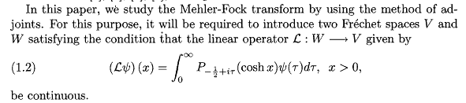

which basically describes transforming a function ψ(τ), so I would call this a Mehler integral. He then has a Mahler integral operator, so to speak. So the above defines the L operator.

They also define this Ax operator

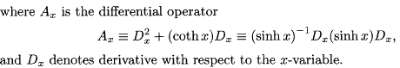

Then we get this fact

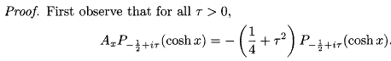

which must be the eigenvalue equation somehow. Ax does not look Legendre to me. I have

L = - (z2-1)∂z2 - 2z∂z +μ2/(z2-1)

but he is doing μ = 0 so then I have L = - (z2-1)∂z2 - 2z∂z. Then

(z2-1)-1L = -∂z2 - 2z(z2-1)-1 ∂z

Now change to z = chξ so that dz = shξdξ and then ∂z = (1/shξ)∂ξ then the above reads

(1/sh2ξ) L = - ((1/shξ)∂ξ)((1/shξ)∂ξ) - 2chξ (1/sh2ξ) (1/shξ)∂ξ

= - (1/shξ)2∂ξ2 + (1/shξ)(1/sh2ξ) chξ∂ξ - 2chξ (1/sh2ξ) (1/shξ)∂ξ

= - (1/shξ)2∂ξ2 - (1/shξ)(1/sh2ξ) chξ∂ξ

and then

L = - ∂ξ2 - (1/shξ)chξ∂ξ = - ∂ξ2 - cothξ ∂ξ

which is what he shows above. Thus, Ax is really Aξ = L and so the above really is the Legendre equation and those really are the eigenvalues. Fine.

Now if you apply the Ax operator k times (k = positive integer) they show that

which seems correct to me.
Next, he rolls out the same Rosenthal integral rep and parts it

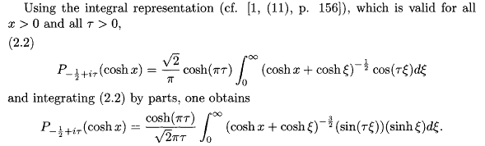

Next step is to claim

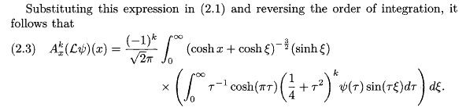

where he uses that second parts rep thing and applies Ax k times. They then say

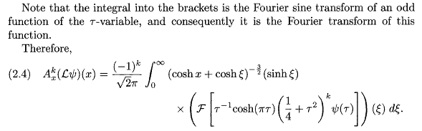

so that F means a full fourier transform. I wonder where this is all leading! They are defining a very special thread! The have somehow then shown in all this that L is continuous and that is the end of their section 2. We now start into section 3:

Section 3. Define the following ψφ operator.

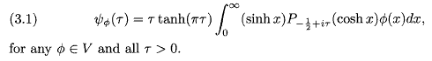

So this is basically just this definition,

ψφ(x) = πtanh(πτ) $^{\int_{0}^{∞}{}}$d(chx)Piτ-1/2(chx) φ(x).

They now define Ax' as the "adjoint" of Ax I guess in the Stak sense, so

Then using this they claim,

and then

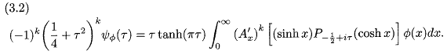
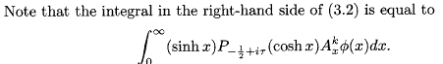

I could probably verify this just based on what is shown above. The second claim is k parts integrations I think. We then end up with

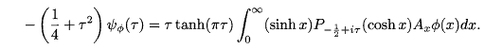

and then with more work of iteration they get

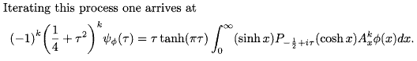

This work has all been to prove some Lemma 3.1 which is a technical issue.

Lemma 3.2 claims this, where the first = is just a definition from above

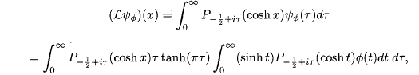

Most of their work is "technical" checking limits and convergence and all that stuff. The final conclusion is this,

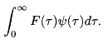
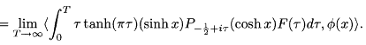

and somehow this is the regular MF transform. Wow, what a pile of work!

They then repeat it all for the generalized MF.

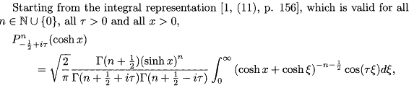

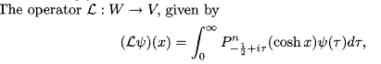

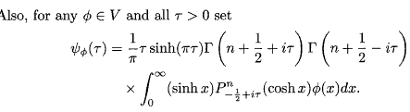

OK, they just summarize the generalized part. I could quote this reference for a good proof! I said it was hard, and here they show it is hard.
They do NOT ever talk about orthogonality or completeness.



Rosenthal has a later 1974 paper where he refers to Sneddon's integral transforms book and shows the class of functions which work in MF.

but this R paper has nothing useful to me.

Next I note an "Index Transforms" book on google of Semen and Yakubovich

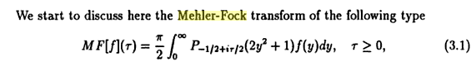

which is a new form for me. I had

g(y) = $^{\int_{0}^{∞}{}}$dτ Pμ-1/2+iτ(y) f(τ)

Notice the index has iτ/2 ! This source gets off on the K function stuff. a VERY long book section with stuff not helpful to me. pathway.

Footnote: MacDonald's function is just the Bessel K function, modified second kind.

I finally found something with delta functions!!! Saved the PDF. Here it is

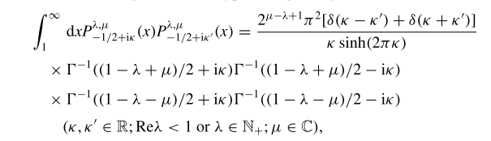

But the fancy P functions are not clearly defined! They are defined here

OK, here is the connection

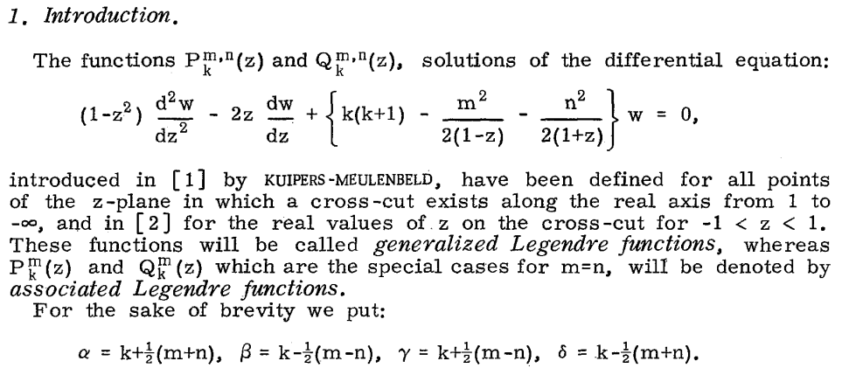

So go back the previous and set λ = μ

$^{\int_{1}^{∞}{}}$dyPμ-1/2+iτ(y) Pμ-1/2+iτ'(y) = δ(τ-τ')/ f(τ,μ) // orthogonality (mine)

so they are then claiming

$^{\int_{1}^{∞}{}}$dx Pμ-1/2+iτ(x) Pμ-1/2+iτ'(x) = 2 π2δ(τ-τ')[1/τ sh(2πτ) ] * 1/fourgamma

fourgamma = Γ(1/2+iτ)Γ(1/2-iτ)Γ(1/2-μ+iκ)Γ(1/2-μ-iκ) =

But recall Γ(1/2+iτ)Γ(1/2-iτ) = π/cosh(πτ) so we then have

fourgamma = π/cosh(πτ) * Γ(1/2-μ+iκ)Γ(1/2-μ-iκ)

So the right side of the above is then

2 π2δ(τ-τ')[1/τ sh(2πτ) ] * 1/[ π/cosh(πτ) * Γ(1/2-μ+iκ)Γ(1/2-μ-iκ)]

= 2 π2δ(τ-τ')[1/τ 2sh(πτ)ch(πτ) ] * 1/[ π/ch(πτ) * Γ(1/2-μ+iκ)Γ(1/2-μ-iκ)]

= π2δ(τ-τ')[1/τ sh(πτ) ] * 1/[ π * Γ(1/2-μ+iκ)Γ(1/2-μ-iκ)]

= π2δ(τ-τ')[1/(πτ sh(πτ)) ] * 1/[Γ(1/2-μ+iκ)Γ(1/2-μ-iκ)]

= π2δ(τ-τ') / [πτ sh(πτ)Γ(1/2-μ+iκ)Γ(1/2-μ-iκ)]

= δ(τ-τ') / [π-1τ sh(πτ)Γ(1/2-μ+iκ)Γ(1/2-μ-iκ)]

But recall from earlier that

f(τ,μ) = (τ/π) sh(πτ) Γ(1/2-μ+iτ) Γ(1/2-μ-iτ)

so their result is

= V

Hurray! Their paper is this



