Legendre Functions with Fractional degree?

Hi Rob, Nov 29, 2105

Responding in Word just so I can type things better. Your email is tacked on at the end below.

I notice from your home page:

" In my spare time, I'm a software engineer: I write and distribute free software."

Maybe I could say,

"In my spare time, I'm a technical writer: I write and distribute free documents. "

and you have stumbled onto one of these documents, the toroidal bowl business.

This bowl paper will be getting updated sometime soon for various reasons (it was an early effort), but that does not relate to your question.

By the way, at my link above is a "user guide" for using 2D bipolar coordinates (the basis of toroidal coordinates) which has been pretty well received. Naturally I use it myself when I get confused, which is quite often.

I have never seen fractional-degree Legendre functions in electrostatic problem solutions.

Took a quick look and noted in Zhou http://arxiv.org/pdf/1301.1735 various equations relating such functions to complete elliptic integrals, such as

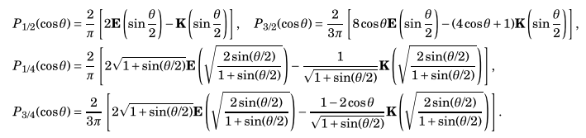

Perhaps this is how you arrived at your formulas, or could serve to explain them. I dimly recall that the K and E functions have various fancy relations as outlined in Bateman HTF 2 p 319. Perhaps there are similar relations obtainable using Erdélyi–Kober type operators. Sneddon uses these related to the Abel transform is his book on mixed boundary value problems.

But your question to me is an interesting one, and it is possible that there are toroidal electrostatic problems that would involve such fractional-degree functions. My toroidal atomic forms (harmonics) were,

ξ in (0,∞) u in (0,2π) φ in (0,2π)

expo osc osc
(1) $\sqrt{chξ - cosu}$ [Pn-1/2m(chξ), Qn-1/2m(chξ) ] [ sin(nu),cos(nu)] [ sin(mφ),cos(mφ)]

osc expo osc
(2) $\sqrt{chξ - cosu}$ [Piτ-1/2m(chξ), Qiτ-1/2m(chξ) ] [exp(τu), exp(-τu) ] [ sin(mφ),cos(mφ)]

so it seems, in theory at least, that there ought to be some geometry that would quantize n to non-integer values, as happens in electrostatics problems with wedges where the side wedge faces are set to zero potential which forces a sine behavior across the wedge which does in fact quantize the azimuthal n to non-integer values (cylindrical coordinates).

So can this happen in toroidal coordinates with the u coordinate?

I gave it a shot, but don't know if it really flies. A candidate geometry is the following which is a solid toroid except the inner part has been ground away by two spherical-tool grinding operations which result in the following asymmetric toroid cross section (black)

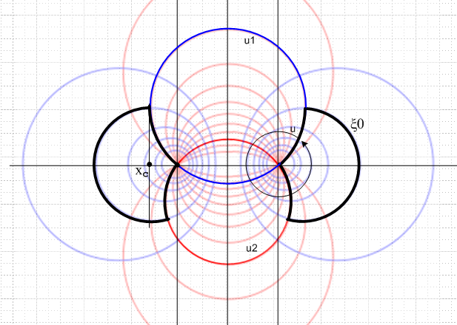

Pick the range of u to be ( u1, u1 + 2π) going counterclockwise (light black arrow circle).

Suppose we try this "Smythian form" for the potential outside the modified black toroid,

V(ξ,u) = $\sqrt{chξ - cosu}$ Σn Pn-1/2(chξ) Ansin(nu+φn)

where Σn is intentionally vague.

Suppose we want the toroid surface to be at V = V, and probably the above form delivers V = 0 at infinity, certainly from the first factor $\sqrt{chξ - cosu}$ since the r→ ∞ limit is ξ→0 and u→0 or 2π.

Here are the local boundary conditions (this has the flavor of a Sneddon type problem, such as where he has a bowl with two endcaps missing and he has to use a triple series instead of a dual series to solve the problem, so probably my simple form above is not viable, but I continue anyway).

On the outer regular toroid part:

V(ξ0,u) = $\sqrt{chξ0 - cosu}$ Σn Pn-1/2(chξ0) An sin(nu+φn) = V for u2 ≤ u ≤ 2π

The upper inner surface part:

V(ξ,u1) = $\sqrt{chξ - cosu1}$ Σn Pn-1/2(chξ) An sin(nu1+φn) = V for ξ0 ≤ ξ ≤ ∞

The lower inner surface part:

V(ξ,u2) = $\sqrt{chξ - cosu2}$ Σn Pn-1/2(chξ) An sin(nu2+φn) = V for ξ0 ≤ ξ ≤ ∞

The last two equations say

V/$\sqrt{chξ - cosu1}$ = Σn Pn-1/2(chξ) An sin(nu1+φn) for ξ0 ≤ ξ ≤ ∞

V/$\sqrt{chξ - cosu2}$ = Σn Pn-1/2(chξ) An sin(nu2+φn) for ξ0 ≤ ξ ≤ ∞

Dead end! These both have to be valid for a finite range of ξ. I don't see how to get n to quantize. Maybe more work would show that might happen.

One would like to set V = 0 on all the toroid surfaces instead of V = V, then by adjusting u1 and u2 one can cause n to quantize to any values (spaced by 1 in degree) one wants, including all your fractional degree functions. That is to say,

sin(nu1+φn) = 0 ⇒ nu1+φn = Nπ N = integer
sin(nu2+φn) = 0 ⇒ nu2+φn = Mπ M = integer

⇒ n(u1-u2) = (N-M)π = Jπ J = integer
⇒ n =Jπ / (u1-u2) = fractional order for J = 1

The problem is that one then needs to have V(ξ,u) → constant value ≠ 0 at infinity, which is ξ and u → 0. That is, one needs

V(ξ,u) = $\sqrt{chξ - cosu}$ Σn Pn-1/2(chξ) Ansin(nu+φn) → - V at infinity

Perhaps this is possible, but it is not obvious that it is possible. So that is as far as I got on that idea. Perhaps a more complicated starting form with An and Bn coefficients could be made to fit the regions of this problem outside the toroid.

Suppose you assume that n has a continuous spectrum, to be maybe more general, then these will say

V/$\sqrt{chξ - cosu1}$ = $^{\int_{0}^{∞}{}}$dn Pn-1/2(chξ) An sin(nu1+φn) for ξ0 ≤ ξ ≤ ∞
V/$\sqrt{chξ - cosu2}$ = $^{\int_{0}^{∞}{}}$ dn Pn-1/2(chξ) An sin(nu2+φn) for ξ0 ≤ ξ ≤ ∞

But I don't see this quantizing n either, and this may not even be meaningful.

There are some more subtle issues I suspect with trying to do this, and here are some very vague comments. In the Mehler transform world one integrates τ over the positive real axis for Piτ-1/2 and the
-1/2 is important for control of large argument behavior of P. Perhaps that contour can be extended to the total real τ axis by symmetry, and perhaps the contour can then be deformed and it picks up pole residues. I suspect those pole residues give a sum of Pn-1/2 with n being integers, not fractional integers, and that is how you morph from one set of atoms to the other. One really does have to have a valid "Sturm Liouville problem" to have a viable expansion and projection and orthogonality and completeness which allows one to actually do work. I don't think I have this stated for my "atoms" above, but here is what I mean for the Hankel (Fourier-Bessel) transform in its variable ρ and continuous parameter k

f(ρ) = $^{\int_{0}^{∞}{}}$dk k Jν(kρ) Fν(k) // expansion
Fν(k) = $^{\int_{0}^{∞}{}}$dρ ρ Jν(kρ) f(ρ) // projection
$^{\int_{0}^{∞}{}}$dρ ρ Jν(kρ) Jν(k'ρ) = δ(k-k')/k // orthogonality
$^{\int_{0}^{∞}{}}$dk k Jν(kρ) Jν(kρ') = δ(ρ-ρ')/ρ // completeness

or for the exponential Fourier Series Transform where the n spectrum is all integers,

f(θ) = Σn fn e-inθ // expansion all on (-π,π)
fn = (1/2π) $^{\int_{-π}^{π}{}}$dθ f(θ) e+inθ // projection
(1/2π) $^{\int_{-π}^{π}{}}$ dθ einθ e-in'θ = δnn' // orthogonality
(1/2π) Σn e-inθ' einθ = δ(θ-θ') // completeness

This is all connected to the related differential operator (say the Legendre ODE one) being self-adjoint on some interval and having a well-defined spectrum, discrete, continuous or both. I am not sure exactly what spectra are possible for the Legendre 2nd order differential operator, but probably my atoms answer the question for a (1,∞) range of the argument. Wonder about (1,Λ) for example.

As I say, very vague comments. Hope they are at least entertaining! You are the expert on these matters, not me. I just work here.

Best regards,

Phil Lucht
rimrock@xmission.com
________________________________________________________________________________

Greetings. I recently found your "Charged Bowl in Toroidal Coordinates" preprint on the web, and read it with much interest.
I am interested right now in the question of a charged toroid, which you treat in Chapter 10. As you say, "the potential must be periodic in u with period 2pi, and this fact causes quantization to integers of the parameter n appearing in the atomic form". That is, P_{n-1/2} appears, i.e., the degree is a half-odd-integer.
Have you by any chance encountered, or considered, the case when the domain does not include the full range of the coordinate u, so that the quantization of n is not to integers? I have looked in standard places such as Smythe's book, but have not found any examples of this.
The reason I am asking is that I have just discovered some formulas expressing such unusual functions as P_{1/3}, P_{1/4}, P_{1/6} in terms of P_{1/2}; and the same, with integer displacements of the subscripts. It would be nice to apply them in electrostatics problems.
Thanks,
Rob Maier
--
Robert S. Maier
Professor of Mathematics, Univ. Arizona
Professor of Physics, Univ. Arizona
Adjunct Professor of Mathematics, Univ. Colorado
Publications: http://www.researcherid.com/rid/C-4802-2014

