do not edit, has been installed on 12/18/15

This was later uninstalled and I decided it was not really needed since I
cleaned up my elem function version of the bowl potential.
It is something to keep for possible future use! I will call it Appendix Q for now.

I later decided to install this at the end of bowl doc as Appendix M. 1/3/16.

do not edit, has been installed on 1/3/16!

Appendix M: The behavior of f(z) = $\sqrt{a+cos(z)}$as an analytic function

The function f(x) = $\sqrt{1+cos(x)}$ appears in the results of Mehler integrals like (7.1.5) and other places in this document. We comment above (L.5.8) and elsewhere that " $\sqrt{1+cos(x)}$changes sign as x passes through odd multiples of π ". This fact is totally obvious when one replaces $\sqrt{1+cos(x)}$by $\sqrt{2}$cos(x/2). In writing the expression $\sqrt{1+cos(x)}$ one must be careful about its meaning. Maple (reasonably) interprets this as a positive quantity | $\sqrt{1+cos(x)}$| for all real x as seen in the black plot below

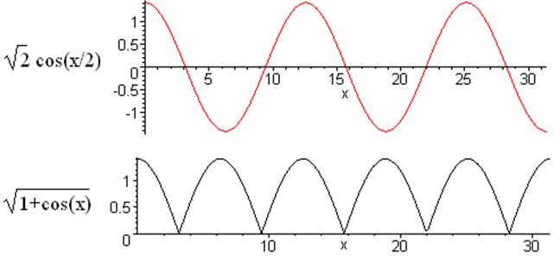 (M.1)

In normal integral evaluations like (7.1.5), if $\sqrt{1+cos(x)}$appears on the right side, the usual interpretation is that both sides of the equation are analytic in the complex variable x although one might be using the integral for real x. In this case, one gets "the wrong answer" if one uses the black curve above, and plots of potentials come out totally wrong.

This appendix explores the seemingly simple analytic function f(z) = $\sqrt{a+cos(z)}$ and shows when and in what sense it must change sign at odd multiplies of π as z moves "along the real axis". This subject is well addressed in Ahlfors Chapter 3 Analytic Functions as Mappings.

Some analytic mappings

Consider the following drawing :
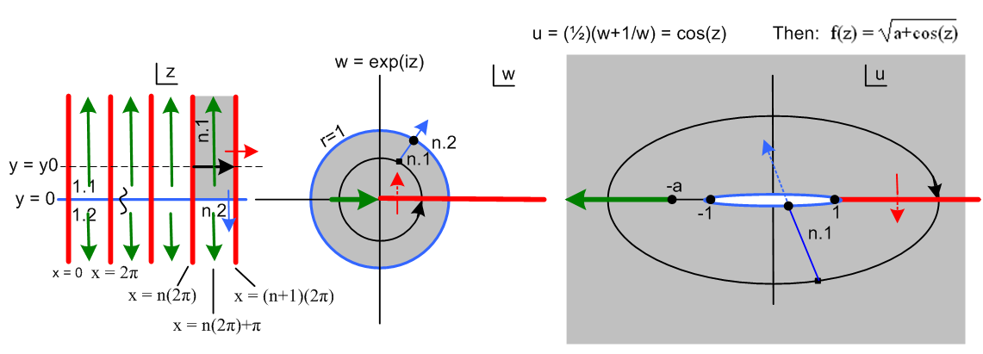
(M.2)

We are considering a three-step mapping of analytic functions:

w = eiz z-plane to w-plane

u = (1/2)(w+1/w) // = cos(z) w-plane to u-plane

f = $\sqrt{a+u}$ // = $\sqrt{a + cos(z)}$ u-plane to f-plane (not shown) (M.3)

The drawing shows the z-plane, the w-plane, and the u-plane.

In the z-plane, where z = x + iy, the red vertical lines show x = multiples of 2π. All the vertical red lines in the z-plane map into the single red half line in the w-plane and then in the u-plane. The red path in the u-plane folds back on itself since w = 0 and w = ∞ both map to u = ∞, while w = 1 maps to u = 1.

We select a particular region of the z-plane and mark it gray (region is a half-infinite vertical strip). This region maps to the gray disk in the w-plane (radius 1), and that disk in turn maps into all of the u-plane.

Following the Black Ants

We set up a "tracking ant" in the z-plane which wanders along a path indicated by the black arrow. This path is not along the real z axis, but is elevated above it at y = y0 as shown. The ant moves from n(2π) to (n+1)(2π) in x, while holding y = y0.

As this ant moves in the z-plane along its path, another ant makes a corresponding (mapped) movement in the w- plane, and yet another ant makes a corresponding movement in the u-plane. All ant paths are shown in black.

In the w-plane the ant's path maps into the black circle shown, a simple phasor path.

In the u-plane, the ant's path is an ellipse, and the traversal direction is now clockwise instead of counterclockwise. The reason for the ellipse is this:

eiz = eix e-y

u = (1/2)(w+1/w) = (1/2)(eix e-y + e-ix ey ) = (1/2)([cosx + isinx] e-y +[cosx-isinx] ey )

= cosx chy - i sinx shy = u1+ iu2 u1 = cosx chy u2 = - sinx shy (M.4)

Then setting y = y0 for the ant path,

$\frac{u12}{ch2y0}$ + $\frac{u22}{sh2y0}$ = cos2x + sin2x = 1 u = (u1,u2) (M.5)

This is an ellipse with semi-major axis chy0, semi-minor axis shy0, and focal points at u = (±1,0).

As x moves along the black arrow in the z-plane starting at x = n(2π), sinx > 0 so u gets a negative imaginary part in (M.4) and the ant moves south in the u-plane. That is why the u-plane ant moves clockwise.

The Green Cut

We are interested in the function

f(u) = $\sqrt{a+u}$ (M.6)

which has a branch point at u = -a. We draw the attached green cut off to the left as shown in Fig (M.2). This choice of cut direction makes $\sqrt{a+u}$ unambiguous and real on the positive real axis (the function is "real analytic"). We have then back-mapped this green cut into both the w-plane and the z-plane. There are no green cuts in these two planes, we are just marking the back-image of the u-plane cut location. In the w-plane one sees that the marked green cut location is encountered when the phasor angle x of eiz = eix e-y passes through odd multiples of π. Then in the z-plane these values of x appear as vertical green lines at odd multiples of π.

This function f(u) has two Riemann sheets which we can regard as

f(u) = f1(u) ≡ + $\sqrt{a+u}$ Sheet 1

f(u) = f2(u) ≡ – $\sqrt{a+u}$ Sheet 2 (M.7)

just as $\sqrt{4}$ = ± 2. Imagine that Sheet 1 is the one displayed in the u-plane above. Then Sheet 2 lies underneath Sheet 1. An ant moving on Sheet 1 passes through the cut onto Sheet 2. Since the ant is constrained to the surface, it cannot jump across the cut, but has to descent onto Sheet 2. The connection between the sheets is bidirectional which makes it impossible to model physically. Here is the cut seen edge on
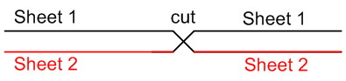 (M.8)

Think of Fig (M.8) as two levels of a parking garage that has separate up and down ramps between the levels. Thus for the particular path shown above in the z-plane, the function f(u) = $\sqrt{a+u}$ changes sign each time that z-plane path passes through an odd multiple of π. .

The real-axis path as a limit

The ant path shown in the z-plane is elevated at some y0 > 0. We now lower this path to the real axis (shown in blue). As this happens, the black circle in the w-plane moves toward the blue circle perimeter of the gray disk, and the black elliptical path in the u-plane shrinks to the thin blue path shown there. If
a > 1, this new elliptical path completely avoids the cut, and one finds that f(u) = $\sqrt{a + cos(z)}$ does not change sign, because we just stay on Sheet 1 for the entire path, so the effect of switching sheets does not occur. Notice that the blue thin ellipse in its limiting sense passes to the left of the focal point u = -1.

Now what happens if a = 1 and we have the function f(u) = $\sqrt{1 + u}$? Go back to the ant path up at y = y0, and draw the green cut starting at u = -1 in the u-plane. We then have the sign-switching action as the ant passes odd multiples of π. As we take this ant path down to the blue x axis in the z-plane, the elliptical path in the u-plane always encounters the cut, and we then still have the sign swapping effect. The ant path, no matter how thin its ellipse might be in the u-plane, always passes to the left of the point a = - 1 and this ant is forced to take the dive.

Our conclusions are:

1. The function f(x) = $\sqrt{a + cos(x)}$ for a > 1 does not change sign as x passes through odd multiples of π.
2. The function f(x) = $\sqrt{1 + cos(x)}$ does change sign as x passes through odd multiples of π. (M.9)

At x = 0 we assume that f(0) = $\sqrt{2}$ > 0.

Theorem: Given the analytic function f(z) = $\sqrt{1 + cos(z)}$, if we run z along a real path on the x-axis, taking that path to be the limiting path of a complex path above the real axis, then

f(x) = (-1)η | $\sqrt{1 + cos(x)}$| where η = floor[(x+π)/2π]. (M.10)

Here the factor (-1)η implements the sign changes discussed above. Each time x passes through an odd multiple of π, η increases by 1, causing the desired sign change.

It is of course a lot easier to implement $\sqrt{1 + cos(x)}$ as $\sqrt{2}$cos(x/2).

