Computation of T(z) at z near 1 PhL 12.12.15

This is all in bowl doc now in Appendix L including the little case studies. 12.31.15

I have probably done all this before somewhere, but today I will do it again.

A realization in bed this AM: App B is concerned with this function,

T(z) ≡ $\sqrt{z2 - 1}$ Σn=0∞ εn [Qn-1/2(z) / Pn-1/2(z)] an = εn$\sqrt{z2 - 1}$ [Qn-1/2(z) / Pn-1/2(z)]

This is an example of a series (that is, an finite series in Buck speak) with a parameter here z. What did I learn about such situations in my recent Buck reading? Chapter 4 was on Convergence. We had many tests for convergence such as "the comparison test". But I don't know much about inequalities involving these complicated functions. Doubtless my series is "on the edge". The integral comparison test might be something I could do here, but I think I know it converges, I want to know the limit!

Buck uniform convergence starts with Section 4.2. Write the above as

Σn=0∞ fn(x) fn(x) = εn$\sqrt{x2 - 1}$ [Qn-1/2(x) / Pn-1/2(x)]

then we are in Buck notation which helps me. Buck talks about uniform convergence on a range of x.

Study the convergence of the above series.

From Appendix H I have

$\frac{Qn-1/2(chξ)}{Pn-1/2(chξ)}$ → π e-2nξ as n→∞ (H.5.9)

Now if we want to use ξ instead of x that is fine. Then, incorporating the $\sqrt{x2 - 1}$ factor,

fn(ξ) = εn shξ π e-2nξ = εn(1/2)(eξ - e-ξ) π e-2nξ as n→ ∞

= (πεn/2)[ e-nξ - e-3nξ ] ≈ (πεn/2) e-nξ large n, ξ > 0

Buck page 162 Corollary says that if r = limn↔∞ an+1/an < 1, the series converges. We have

an+1/an = e-ξ

Thus the series for sure converges of ξ > 0. Notice that an → 0 when ξ > 0 as required for any convergent series (Buck Theorem 1 p 161).

What about for ξ = 0? We have to go back to

fn(ξ) = εn shξ π e-2nξ

Notice that fn → 0 as ξ → 0 so it at least has a chance of converging.

The same ratio test says

an+1/an = e-2ξ

For ξ = 0 the ratio is 1, and then we have no conclusion from this test. It could either converge or it could diverge.

How about Raabe's Test Buck p 163? We need ratio < 1-p/n beyond some n. But my ratio is 1, so Raabe does not help!

How about the Root Test of Buck p 162 Theorem 6. We are supposed now to compute

r = (an)1/n

In our case we get,

r = (shξ e-2nξ )1/n = (shξ)1/n e-2ξ

Now as ξ→0 the last factor is 1, and the first is (0)1/n . What is the limit of such a thing? Consider

0x = y x> 0

x ln(0) = ln(y) = -x ∞ so y = 0.

If x = 0, then

00 = y

0 ln0 = lny = 0 so y = 1

So I think (0)1/n → 1 and we get r → 1 so no conclusion!

How about the Buck test page 163 Theorem 7. We have

f(n) = shξ e-2nξ an → 0 for ξ in [1,∞)

Is this monotone decreasing? It is for ξ > 0. For ξ = 0 we have f(n) = 0, so not monotone. So cannot apply that theorem.

So none of Buck's fancy theorems seems to work on this series.

Interesting Case Study

Consider this series which is simpler than the Q/P series, but perhaps very similar to it:

f(ξ) = Σn=0∞ [ shξ e-2nξ ]

1. Analytically, I can start with ξ > 0 and write

f(ξ) = shξ Σn=0∞ e-2nξ = $\frac{shξ}{1-e-2ξ}$ = $\frac{shξeξ}{eξ-e-ξ}$ = (1/2) eξ

Now that I know the sum, I can take the limit to get

f(ξ) = 0.5

2. Numerically, here is how this works,

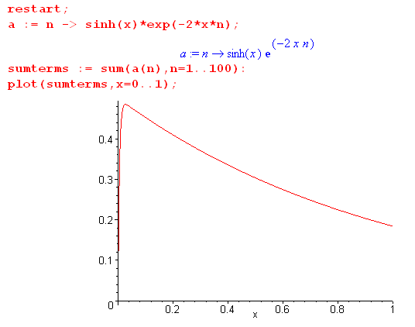

If you add up a finite number of terms, you always get f(0) = 0, but if you add up an infinite number of terms you know that f(0) will be 1/2.

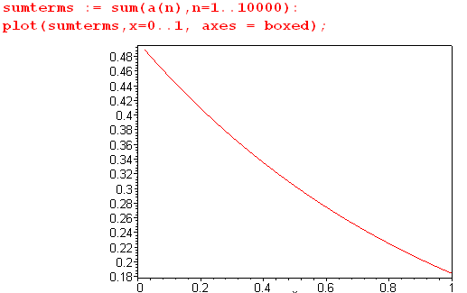

I think this is exactly what is happening in my capacitance case as R → 1 !!!!!

Now what can I say about uniform convergence with this little toy series?

f(ξ) = Σn=0∞ [ shξ e-2nξ ]

an = shξ e-2nξ

Does this meet the Cauchy condition (Buck p 183) for ξ ≥ 0

|an - am|E < ε

| shξ e-2nξ - shξ e-2mξ|E < ε n,m > N

BUT be careful about that E subscript. If the range is the full ξ ≥ 0, you are talking about a least upper bound (max) on the interval [0,∞). This is just a max norm. So where does the function above have its max value, and what is that max?

Let's consider the range ξ ϵ (0, .0000001). Then

shξ = ξ e-nξ = 1 - nξ

| shξ e-2nξ - shξ e-2mξ|E = | ξ(1-2nξ)- ξ(1-2mξ)|E

= |ξ - 2nξ2-ξ+2mξ2|E = | 2(m-n)ξ2|E

= | m-n | 2 ξmax2

Now pick some ε for N = 50. Then we are NOT Cauchy in this little model. But I don't like the model, since when m,n increase the expansion is no longer valid.

A similar Case Study

f(x) = x(e-nx - e-mx)

f'(x) = e-nx(1-nx) - e-mx(1-mx)

This is a transcendental equation which has some solution for x where f(x) has its max. So even though this is a simple example, I don't know analytically where the max is, and therefore I don't know the max value, so I am not able to do the Cauchy test because I cannot compute |f(x)|E on say (0,1).

OK, let's implement the Cauchy program. Select some ε like ε = .001. Then I need to find N such that we will be < ε for n,m > N, but uniformly on (0,1) say. If x = 0, then | |max = 0, so 0 < ε and things are OK. So the thing is decided then for x > 0. For some fixed x = x0 > 0 we have x0 < x < 1 for our range. I don't know exactly where the max will be in this range for a given pair n,m. Let's pick x0 = .001. All I can do is fiddle with Maple somehow.

Can I get Maple to numerically locate a max value? It has a bug, but works for my functions.

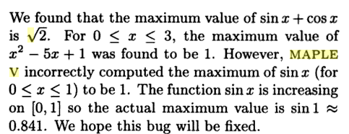

Proof of non-Cauchy. Consider this Maple code,

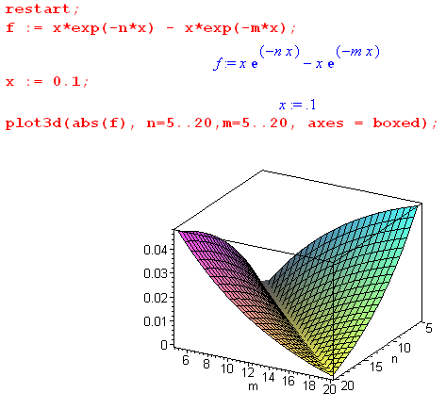

Suppose I have ε = .001 and x is in range (0,1). I can see that for the n,m range I have given, that abs(f) is reaching a value of .04. Thus, whatever max(f) is on (0,1) for these ranges, it is ≥ ,04, and thus does not meet my ε.

****************************************************
What about my sum rule?

$\sqrt{z - 1}$ Σn=0∞ εn Qn-1/2(z) = (π/$\sqrt{2}$) = 2.221441469 // sum rule

$\sqrt{z2 - 1}$ Σn=0∞ εn [Qn-1/2(z) / Pn-1/2(z)] = T(z)

Suppose I say that Pn-1/2(z) → 1 as z→ 1 and just throw that in. Then

$\sqrt{z - 1}$ Σn=0∞ εn Qn-1/2(z) = (π/$\sqrt{2}$) = 2.221441469 for all z > 1 certainly

$\sqrt{z2 - 1}$ Σn=0∞ εn [Qn-1/2(z)] = T(z) for z = 1+ε

In the second case write

$\sqrt{z2 - 1}$ = $\sqrt{(z+1)(z-1)}$ ≈ $\sqrt{2}$$\sqrt{z - 1}$.

Then we have

$\sqrt{z - 1}$ Σn=0∞ εn Qn-1/2(z) = (π/$\sqrt{2}$) = 2.221441469
$\sqrt{z - 1}$ Σn=0∞ εn [Qn-1/2(z)] = T(z)/$\sqrt{2}$ for z = 1+ε

Compare the right sides to get

T(z) = π

But I keep getting T(z) = 2.7353 . Just take a look at a few combinations for fun:

π/$\sqrt{2}$ = 2.221441469
Wrong answer, but method seems reasonable. Why is the answer wrong? Or is it right? Well, let's review that limit of P from Legendre properties,

the P(+1) finite cases: Pνμ(1) = 0 in these cases : [exception Pν0(1) =1] , else Pνμ(1)= ∞
ν = anything:
Re(μ) < 0 and μ ≠ integer
μ = integer Pνμ(1) = δ0μ

In my case μ = 0, so the last line applies: Pn-1/2(1) = 1 I should have plotted the Pn-1/2 functions the way I did the Piτ-1/2 functions, I need to add that.

Let's to plot those right now to make sure I have this right. Do in same file where I plot the Mehler ones. Index says this file is sqrt one plus cosx. It is done, here are the results!

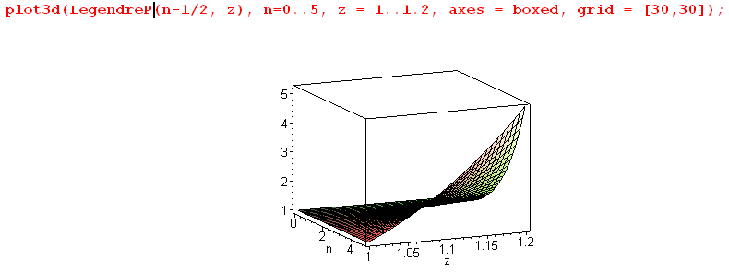

This confirms that at z = 1, P(z) = 1!!! That lower left edge says it all. Also we have
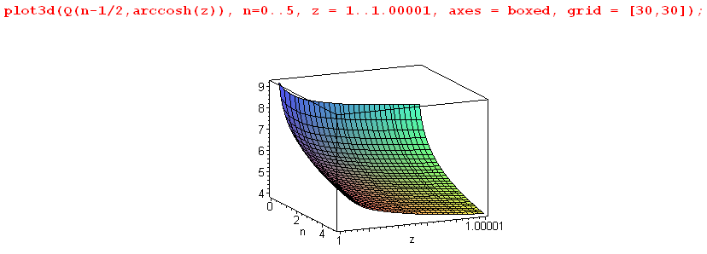

Both are "expo" as discussed in the atoms discussion. The P are 0 at the z = 1 boundary, The second one very slowly blows up at z = 1 with ln(z-1). Fine.

So my P→1 rough method above was not unreasonable!

OK, lets go for models of the P and Q for small argument. Maybe the divergent Q pulls some finite amount out of the P function?? My Leg prop doc does not talk about P(z) near z = 1, I will have to find that elsewhere. Try AS. Here is a battery of information

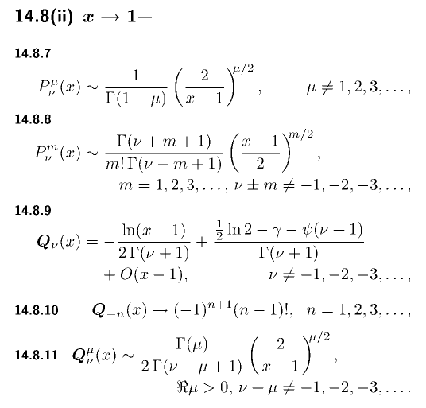

So I could say

Pν(x) = 1 + order(x-1) I would guess

Qν(x) = - ln(x-1)/[2Γ(ν+1)] + some other function to be careful about!

If I just set P = 1, I know that I get T(z) = π from the perfect sum rule. So let's try to find a correction for P near 1. I have this

Pν(z) = zν F(-ν/2, 1/2-ν/2; 1; 1-1/z2)

So set z = 1+ε to get

1-1/(1+ε)2 = [ (1+ε)2 - 1 ] / (1+ε)2 = (2ε ] / (1+ε)2 ≈ 2ε

So

Pν(1+ε) = zν F(-ν/2, 1/2-ν/2; 1; 2ε)

So I can just write out the first term of the series:

F(-ν/2, 1/2-ν/2; 1; 2ε) ≈ 1 + abx/c = 1 + (-ν/2)(1/2-ν/2)2ε/(1) = 1 + (-ν/2)(1-ν)ε

= 1 + (1/2)ν(ν-1)ε

Now let ν = n-1/2 so that

F ≈ 1 + (1/2)(n-1/2)(n-3/2)ε

Therefore

Pν(1+ε) = (1+ε)ν [ 1 + (1/2)ν(ν-1)ε + O(ε2)] as z→ 1

Now

(1+ε)ν = 1 + νε

so then

Pν(1+ε) ≈ [1 + νε] [ 1 + (1/2)ν(ν-1)ε + O(ε2)]

≈ 1 + { 1 + (1/2)(ν-1)}νε } = 1 + { 1 + ν/2 - 1/2}νε } = 1 + { ν/2 + 1/2}νε }

≈ 1 + (1/2)ν(ν+1)ε + O(ε2)

a perfectly clean result. Then

1/Pν(1+ε) = 1/ [ 1 + (1/2)ν(ν+1)ε + O(ε2)] ≈ [ 1- (1/2)ν(ν+1)ε + O(ε2)]

Meanwhile, look at Qν(z) near z = 1:

Qν(1+ε) ≈ { - lnε /[2Γ(ν+1)] + [(1/2)(ln2)-γ - ψ(ν+1)]/Γ(ν+1) + k(ν) ε }

As ε→ 0, the first term blows up positively as a log thing, the second term is fixed for ν. I just presume there is some O(ε) term added onto this which I write as unknown k(ν) ε.

Footnote. AS says this

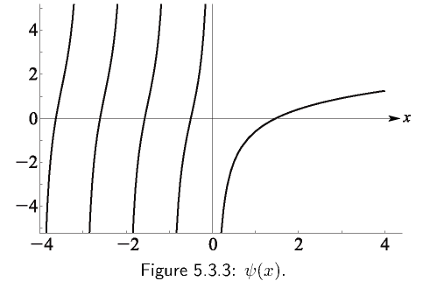

and I am interested in ν = n-1/2 so ν+1 = n+1/2

[(1/2)ln2 - γ -ψ(ν+1) ]/Γ(ν+1) = (1/2)ln2 - γ -ψ(n+1/2) ]/Γ(n+1/2)

So first of all, ψ is not singular for any value of n in my range n = 0..∞. Here is a plot

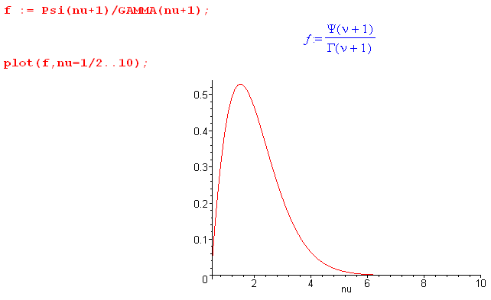

So as n→ ∞, this second term varies as shown, fading away eventually. But it is there!

So back to our modeling: We now have

1/Pν(1+ε) = [ 1 - (1/2)ν(ν+1)ε + O(ε2)]

Qν(1+ε) ≈ { - lnε /[2Γ(ν+1)] + [(1/2)(ln2)-γ - ψ(ν+1)]/Γ(ν+1) + k(ν) ε }

Qν(1+ε) //Pν(1+ε)

≈ { - lnε /[2Γ(ν+1)] + [(1/2)(ln2)-γ - ψ(ν+1)]/Γ(ν+1) + k(ν) ε } { 1 - (1/2)ν(ν+1)ε + O(ε2)}

This is the first time I think I have done this little analysis, by the way. Now let's drop everything of order ε or higher in this product, so then we just get

Qν(1+ε) /Pν(1+ε) = Qν(1+ε) = - lnε /[2Γ(ν+1)] + [(1/2)(ln2)-γ - ψ(ν+1)]/Γ(ν+1)

Now my sum rule applies again and we get T(z) = π. Rewrite the above as

Qν(z) /Pν(z) = Qν(z) = - ln(1-z) /[2Γ(ν+1)] + [(1/2)(ln2)-γ - ψ(ν+1)]/Γ(ν+1)

So how exactly does the sum work?

Σn=0∞ εn [$\sqrt{z2 - 1}$ Qn-1/2(z) / Pn-1/2(z)] = T(z)

Be careful, don't forget the $\sqrt{z2 - 1}$ factor!!

$\sqrt{z2 - 1}$ = $\sqrt{2ε}$

so then we have

T(1+ε) = Σn=0∞ εn $\sqrt{2ε}$ {- ln(ε) /[2Γ(ν+1)] + [(1/2)(ln2)-γ - ψ(ν+1)]/Γ(ν+1) }

So "how it works" is that somehow the $\sqrt{2ε}$ rescues the divergent ln(ε). The second term must go to 0 just from the $\sqrt{2ε}$ since everything there is finite. So I conclude that, since ν+1 = n+1/2

T(1+ε) = Σn=0∞ εn $\sqrt{2ε}$ {- ln(ε) /[2Γ(n+1/2)]
or
T(1+ε) = - (1/$\sqrt{2}$) Σn=0∞ εn [Γ(n+1/2)]-1 ε1/2 ln(ε)

= - (1/$\sqrt{2}$)ε1/2 ln(ε) Σn=0∞ εn [Γ(n+1/2)]-1

But this is a problem because consider

f(ε) ≡ ε1/2 ln(ε) = ε1/2 / [1/lnε)] = 0/0

Apply l'Hopital

∂ε [lnε]-1 = - [lnε]-2 ∂ε(lnε) = - [lnε]-2(1/ε)

∂ε ε1/2 = (1/2)ε-1/2

Then ratio of these is

f(ε) → (1/2)ε-1/2 / { - [lnε]-2(1/ε)} = - (1/2) (lnε)2 ε1/2

and I haven't learned a thing. I know that ε1/2 ln(ε) → 0 which saysT(z)→ 0 but we know that is wrong.

Summary of what was done above:

I considered this series

T(z) ≡ Σn=0∞ εn [$\sqrt{z2 - 1}$Qn-1/2(z) / Pn-1/2(z)]

I made the assumption that this is true,

limz→1 T(z) = Σn=0∞ εn limz→1 [$\sqrt{z2 - 1}$Qn-1/2(z) / Pn-1/2(z)]

But then I calculated that

limz→1 [$\sqrt{z2 - 1}$Qn-1/2(z) / Pn-1/2(z)] = limz→1 [$\sqrt{z2 - 1}$Qn-1/2(z)

= $\sqrt{2ε}$[ - lnε /[2Γ(ν+1)] + q(ν) ]

= 0

and then I concluded that

limz→1 T(z) = 0

which I know is the wrong result. Therefore, the "order interchange" must not be allowed.

Now go back to

F(x) = Σk=0∞ fk(x) fk(x) = εk$\sqrt{x2 - 1}$ [Qk-1/2(x) / Pk-1/2(x)]

Fn(x) = Σk=0n fk(x) = the nth partial sum

I now roll out some Buck info:

Def: [183A] A series Σfn(x) converges uniformly iff the sequence of partial sums Fn(x) converges uniformly to F(x) as per the following definition:

Def: [182A] A sequence {fn(x)} converges uniformly to F(x) on domain D if it converges for all x in D "with the same N". That is, there is an N such that || fn(x) - F(x) ||D < ε for n> N and for all x in D. The point is that the same large integer N works for all x in D, you don't need N(x).

The partial sums Fn(x) form a sequence. Let the domain D 1≤x≤2 say. Consider

|| Σk=0n fk(x) - F(x) ||D < ε for n> N and for all x in D

I think this is not true for my series. As you get closer and closer to x = 1, you need more and more terms, so there is no N that works for all x in 1≤x≤2 . Thus, my series does not converge uniformly on [1,2].

Probably this means you are not allowed to do the order interchange!!! And that is why my result above which says T(z) → 0 is not valid.

Buck does not tell us how to compute the limiting function F(x) at x = 1.

What about my sum rule?

$\sqrt{z - 1}$ Σn=0∞ εn Qn-1/2(z) = (π/$\sqrt{2}$) = 2.221441469 // sum rule

If I could interchange order, I would conclude that this sum was 0!

Plan B: Does any source list sums involving ring functions or Legendre functions in general?

AS has nothing to say about such sums. AS is really about the functions themselves, not what you can do with them.

T(z) ≡ $\sqrt{z2 - 1}$ Σn=0∞ εn [Qn-1/2(z) / Pn-1/2(z)]

GR7 page 1021 has this

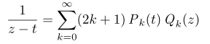

There is a tiny section on "toroidal functions" in GR7, but no sums are given.

Web search on toroidal functions? I did some, then I reread my previous search on this.

I should add that T(z) < π. !

OK, once again I give up on doing this limit analytically, just wanted to give it another shot.

