P and Q functions for large ν PhL 12.10.15

Now in Appendix H of bowl doc 12.31.15
I was still using the problematic Q function at this point, causing breakups and various problems as you see looking at what is below.

Motivation: I want to know how many terms you should keep in toroidal sums for potential and capacitance. These equations are these:

V(ξ,u) = V0 $\sqrt{2}$ $\sqrt{chξ - cosu}$ Σn=0∞ εn Pn-1/2(chξ) $\frac{Qn-1/2(chξ0)}{Pn-1/2(chξ0)}$cos(nu) , (10.1.11)
C = (2a/π ) Σn=0∞ εn $\frac{Qn-1/2(chξ0)}{Pn-1/2(chξ0)}$ εn = 2-δn,0 . (10.2.3)

So today at least I am only interested in z ≥ 1.

Tools: I have these home-grown P and Q functions

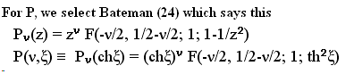

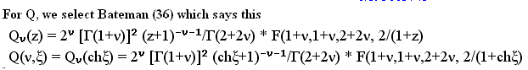

Comment: Since ν is not isolated into the c argument of F(a,b,c;z), these are not natural forms with which to study large ν limits. Still, to the extent that Maple implements F(a,b,c;z) correctly, these functions should be accurate for all values of ν and ξ. It is hard to imagine they suddenly become inaccurate if you take say ν > 10.

Theory Side. I start with this AS result ("as ν → ∞")

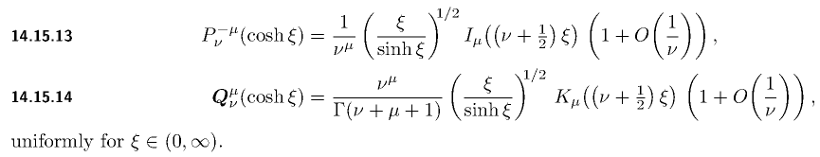

Supposedly OK for μ ≥ 0 and I only care about μ = 0. The I and K are Bessel functions. I think the above come from work of Older.

Experiment #1. Let's test the above claims in Maple.

BesselI(v, x)
BesselK(v, x)

So let's construct the right sides and compare to the left sides for large ν. I will call the right sides of the above equations P1 and Q1, so keeping just the first terms,

P1ν(chξ) = $\frac{ξ}{shξ}$ I0[(ν+1/2)ξ] (14.15.13)AS
Q1ν(chξ) = $\frac{ξ}{shξ}$ K0[(ν+1/2)ξ] / Γ(ν+1) (14.15.14)AS

I enter these as follows

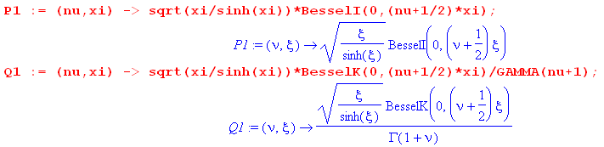
and verify that things are entered correctly. I then evaluate

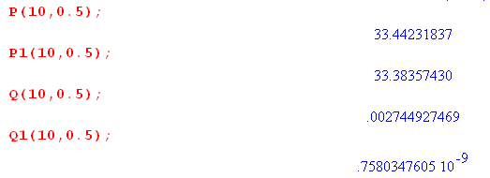

The P look good, the Q look suspicious. I raise ν from 10 to 20

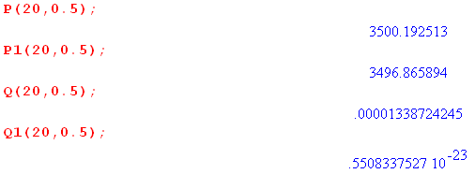

So without going any further, I know that something is wrong with (14.15.14)AS for Q. Now I notice that this Q is bolded and in italics. What does this mean? First at the very start of the AS chapter I see this

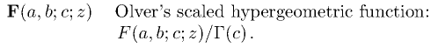

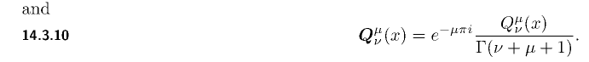

Well there it is! AS are using

Qν(z) = Qν(z)/Γ(ν+1)

I don't care about bolded Q functions, so I will rework things above:

So let's construct the right sides and compare to the left sides for large ν. I will call the right sides of the above equations P1 and Q1, so keeping just the first terms,

P1ν(chξ) = $\frac{ξ}{shξ}$ I0[(ν+1/2)ξ] (14.15.13)AS
Q1ν(chξ) = $\frac{ξ}{shξ}$ K0[(ν+1/2)ξ] (14.15.14)AS

I enter these as follows

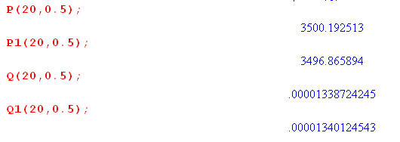

and the train is now back on the track!!!

I updated H.5 with this fix, and now my claim is this

Pn-1/2(chξ) $\frac{Qn-1/2(chξ0)}{Pn-1/2(chξ0)}$ = $\frac{1}{shξ}$e-n(2ξ$_{0}$-ξ) for large n.

Let's test this equation in Maple ! I define

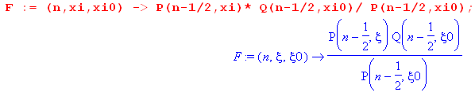
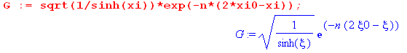

I now compare these two expressions for a range of ξ and ξ0 values but with ξ < ξ0 since that will always be the case for my toroid plot -- only care about region outside the torus.

Case ξ0 = 0.1

Here is what I find with this plot command where I start the ξ0 scan at 0.1 which is fairly small value:

plot3d(G-F, xi0 = 0.1..2, xi = 0.1..xi0, axes = boxed);

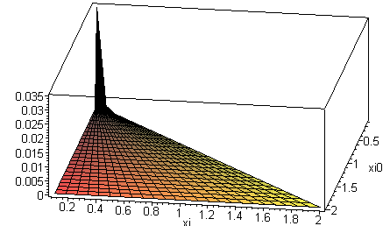

With n = 10, the max difference G-F occurs at the corner where xi = xi0 and is about 0.7

With n = 20, difference drops to 0.3

With n = 30, difference drops to 0.1

With n = 40, difference drops to 0.035

Above n = 40 I start getting anomalies. So the above as about as good as I can do.

Here is the 0.1 case

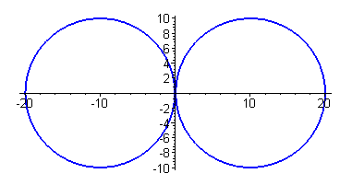

so the toroid is very close to being "degenerate".

Conclusion: For n = 40 I can get the difference between the exact function G and the asymptotic limit F to be as small as about .04 for the challenging ξ0 = 0.1 value.

Case ξ0 =1

For a more typical case with ξ0 = 1 here is what happens:

With n = 1, difference drops to - 3 x 10-2
With n = 2, difference drops to 2 x 10-2
With n = 3, difference drops to 10-2
With n = 5, difference drops to 10-3
With n = 10, difference drops to 10-5
With n = 20, difference drops to 10-9
With n = 30, difference drops to 10-13
With n = 40, difference drops to 10-18
With n = 50, difference drops to 10-22
With n = 60, difference drops to 10-26

So in this case, I have unlimited accuracy, and 5 terms is just fine for a plot.

Restatement. I know from doing many plots that that the worst case error in F - G always occurs when ξ = ξ0. But in that case we have this equation

Pn-1/2(chξ) $\frac{Qn-1/2(chξ0)}{Pn-1/2(chξ0)}$ = $\frac{1}{shξ}$e-n(2ξ$_{0}$-ξ) for large n.

becomes this equation

Qn-1/2(chξ0) = $\frac{1}{shξ0}$e-nξ$_{0}$

So then the question is this: how close are these two functions for values of ξ0 and n ?

Now simple 1D plots are fine. For example,

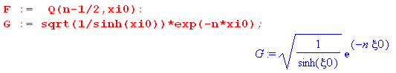

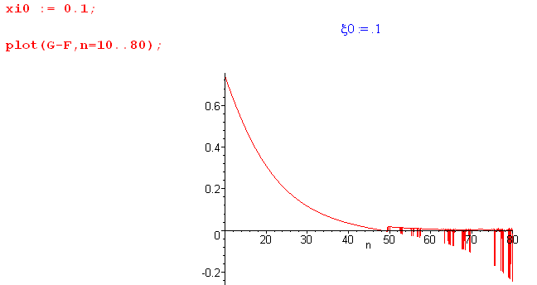

Here you see the error going down nicely to about n = 45, but then Maple has problems of some sort. Here is a plot of Qn-1/2(chξ0) rather than the difference

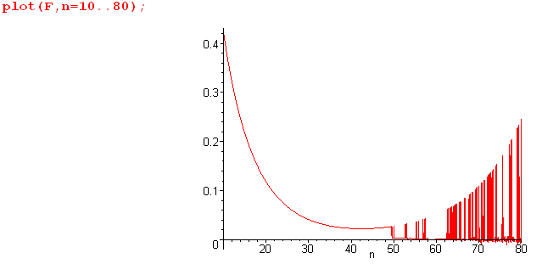

What is this plot telling us?? In theory, we know that

Qn-1/2(chξ0) → $\frac{1}{shξ0}$e-nξ$_{0}$

Here I plot the two curves separately,

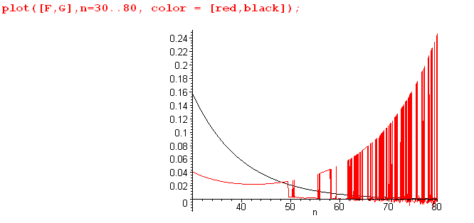

The black curve is what we know must happen in theory, whereas the red curve is what happens in Maple.

Explanation #1. Go back to

How does Maple actually compute such a thing? I don't really know, but I can consider the Q function above to be the product of two factors: F, and everything else, which I will call H. Now let's see how Maple does with this H function,

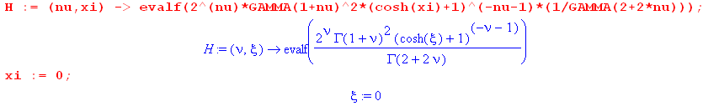

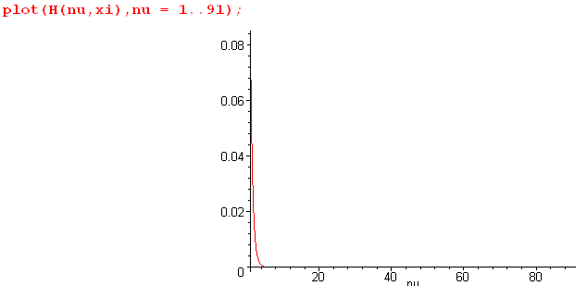

The value of ξ does not matter for H, since ch(ξ) → 1.What we find is that for n up to 91, Maple seems able to compute the H function. Here is a log plot

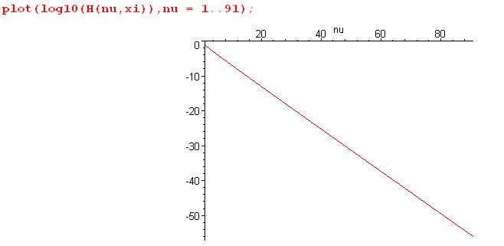

If cannot plot beyond n = 91! How consider this situation,

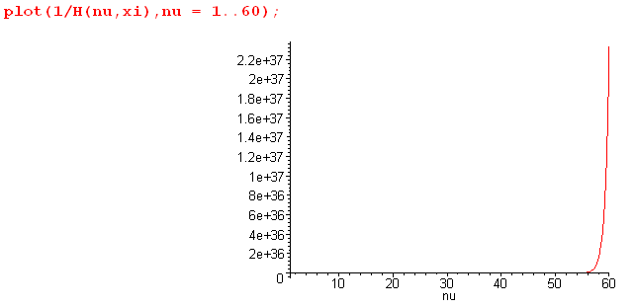

I think Maple has a max and min FP number which it can handle, and we are getting close here. I forget where this is discussed in Maple help. I do have this

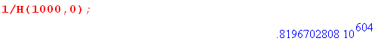

I remember now. This came up in one of my docs where it is a plotting problem only.

"Maple is uncomfortable plotting numbers larger than about 1040 so we pre-scale Ω down by 101519 to make the scaled Ω be Maple-digestible. This scaling process in turn creates numbers smaller than 10-40 which are also rejected by the Maple plotter, so we use a Heaviside function to pin small numbers to 0 "

from Lagrange doc.

Conclusion: I don't think Maple has any problem computing the H part of the Q function, even up to n = 1000 as you see. So the problem is, not surprisingly, with the F part of the function.

Here is a plot

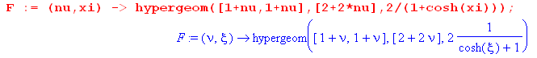

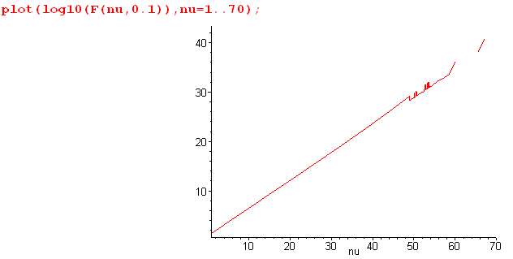

You see that trouble starts brewing around n = 50 when ξ = 0.1. When ξ = 1 the above plot is clean. It seems clean all the way with ξ = .01 up to ξ = .08, but then trouble again at ξ = .09. Has trouble at ξ = 0.2. So something is "spotty" in the way Maple computes this F function!

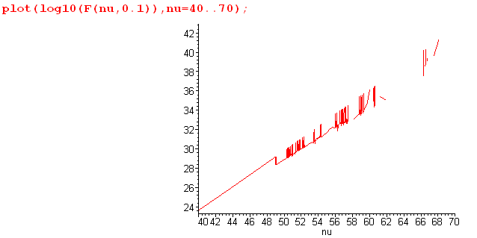

Here is another way to look at the problem.

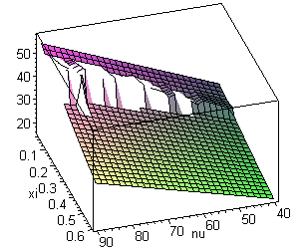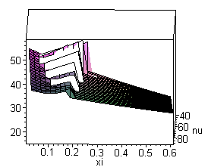

Here you see the breakup in the region above n = 40 and in the small ξ region.

Raising Digits to 30 has no effect on this breakup.

There is nothing I can do about this.

Fact: As you increase n in the high range further, the problems with ξ move higher.

For example, with n = 40 you are OK with ξ > .25, but at n = 90 you break up there.

New Question: Does our series

Σn=0∞ εn Pn-1/2(chξ) $\frac{Qn-1/2(chξ0)}{Pn-1/2(chξ0)}$cos(nu)

have the property that if you truncate somewhere, the error is less in magnitude than the last term.! I recall a theorem from Buck on this which I will go and find right now and quote here: Oops, I see that rule only applies to an alternating series.
Is our series monotonically decreasing for any compatible pair ξ and ξ0?

