The strange min effect on torus sigma PhL 1.1.16

A. The problem 1
B. Discomfort 4
C. Detailed check on my σ calculation in Section 10 9
10.5 Surface charge density on a torus 9
D. Did I enter the Maple code correctly? 11

A. The problem

What happens if I plot versus u instead of θ ? Since we are doing σ, we have ξ = ξ0 everywhere.

dQ = σdA = σ (hudu)(hφdφ) = σ huhφdudφ

= σ shξ hu2dudφ = σ shξ [a 1/(chξ - cosu)]2dudφ

= σ a2 shξ (chξ-cosu)-2 dudφ = σ (Rshξ)2 shξ (chξ-cosu)-2 dudφ

= σ R2 sh3ξ (chξ-cosu)-2 dudφ

"dQu" ≡ dQ/(dudφ) = σ(u; ξ0) R2sh3ξ0 (chξ0-cosu)-2

Compare this with the other dQ

"dQθ" ≡ dQ/(dθdφ) = σ(u(θ); ξ0) R2 (chξ0+cosθ)

Divide these to get

"dQθ"/ "dQu" = (chξ0+cosθ) * (chξ0-cosu)2 sin-3ξ0

Now use table entry

chξ - cosu = $\frac{sh2ξ}{chξ + cosθ}$

to get

"dQθ"/ "dQu" = (chξ0+cosθ) * ($\frac{sh2ξ}{chξ + cosθ}$)2 sin-3ξ0

= (chξ0+cosθ)-1 shξ0 = $\frac{shξ0}{chξ + cosθ}$

But why does this differ from

$\frac{du}{dθ}$ = $\frac{shξ}{chξ + cosθ}$

Something is wrong here!

Thus suggests a boost at θ = π, not before?? Maybe this boost creates the tail??

Well, here is what I get when I plot dQu versus u

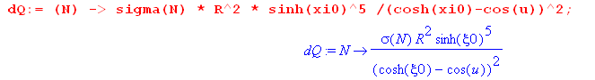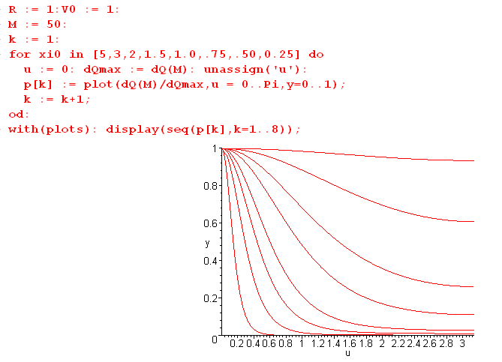
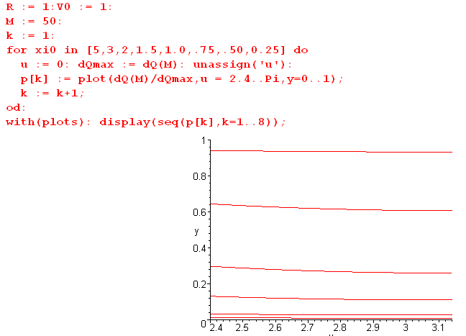

Now that minimum effect is gone and σ tapers off smoothly to its constant value at π which is the inner ring of the toroid.

Now go back to

"dQθ"/ "dQu" = (chξ0+cosθ)-1 /shξ0

This increases as θ increases toward π.

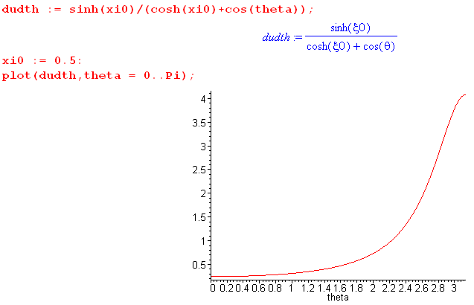

Recall that

$\frac{du}{dθ}$ = $\frac{shξ}{chξ + cosθ}$

This effect of a minimum in σ before θ = π arises from the relation between u and θ, namely

"dQθ" = "dQu" x $\frac{du}{dθ}$

$\frac{du}{dθ}$ = $\frac{shξ}{chξ + cosθ}$ = "dQθ"/ "dQu"

B. Discomfort

Yesterday 1/1/16 I concluded that the "minimum effect" is caused by the multiplication of a rising function times a falling function. That is fine, but I have a physical problem with the result. I see no physical reason why σ should fall and then rise again as you get toward the center of a far toroid. It just seems wrong, and may be an indicator that I have something wrong with my σ formula.

OK, do I have the torus potential right or not? My only external reference on that was M&F and they have an error. Is there some other verification source I can quote right here? I want that to be correct before I worry about σ.

In "Electrostatics I" I get verification of my toroid Smythian form

which agrees with my (10.1.3)

V(ξ,u) = $\sqrt{chξ - cosu}$ Σn=0∞ Pn-1/2(chξ) An cos(nu) (10.1.3)

This same source does what I did and gets this result

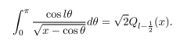

which then DOES provide another reference for my result,

V(ξ,u) = V0 $\sqrt{2}$ $\sqrt{chξ - cosu}$ Σn=0∞ εn Pn-1/2(chξ) $\frac{Qn-1/2(chξ0)}{Pn-1/2(chξ0)}$cos(nu) . (10.1.11)

Here is the link

http%3A%2F%2Fwww.victoria.ac.nz%2Fscps%2Fabout%2Fstaff%2Fpdf%2FElectrostatics_of_a_family_of_conducting_toroids.pdf&usg=AFQjCNG4tU_AjxbXFruFKCIZYNKdhNfpSA&sig2=X9cVnKRzWj6NIK9GcZo71Q

http%3A%2F%2Fphysics.usask.ca%2F~hirose%2Fp812%2Fnotes%2Fch1.pdf&usg=AFQjCNGijNBaSm-ghctEjosiqFwrRGBifw&sig2=Vq6ybha2VfIzDz22Demq6Q

I think the notes are those of this guy

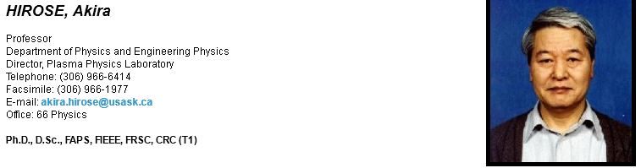
at usask which is university of saskatchewan Canada. At least this is one of a set of about 10 chapters he has on his site. Here are his references

Jackson: Classical Electrodynamics (3rd ed.) (standard textbook)
Smythe: Static and Dynamic Electricity (classic textbook with good chapters on statics)
Landau, Lifshits: Electrodynamics in Continuous Media (classic book with mathematical rigor)
Landau, Lifshits: Classical Theory of Fields (radiation of E&M and gravity waves)
Cohen-Tannoudji, Dupont-Roc, Grynberg: Photons and Atoms, Introduction to QED (good introduction to QED)
Van Bladel: Electromagnetic Fields (probably most advanced E&M book with difficult practical examples)
Ramo, Whinnery, van Duzer: Fields and Waves in Communication Electronics (easy reading with practical applications)
Collins: Field Theory of Guided Waves (2nd ed.) (Dr. Collins was our EP graduate.) (advanced theory of guided waves)
Batygin, Toptygin: Problems in Electrodynamics (some 700 collected problems with solutions)
Moon, Spencer: Field Theory for Engineers (good reference for some 40 coordinates)
Morse, Feshbach: Methods of Theoretical Physics (classic textbook on theoretical physics)
Abramowitz: Handbook of Mathematical Functions (good reference for special functions)

The new ones to me are these

Cohen-Tannoudji, Dupont-Roc, Grynberg: Photons and Atoms, Introduction to QED (good introduction to QED)
Van Bladel: Electromagnetic Fields (probably most advanced E&M book with difficult practical examples)
Collins: Field Theory of Guided Waves (2nd ed.) (Dr. Collins was our EP graduate.) (advanced theory of guided waves)

Here are his "lecture notes"

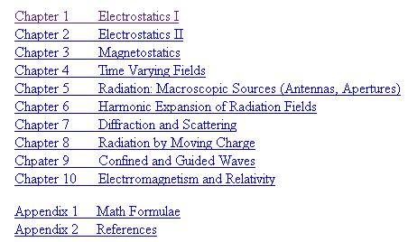

It sure looks like a book to me! So he is preparing his own Jackson book. He has two books now on Amazon with another author on waves.
I could quote his Lecture notes. He has the epsilon in there, that is the main thing. So his solution is then a second opinion and makes me think at least I have the potential right.

He also gives the C formula

and mine is his / 4πε

C = $\frac{2a}{π}$Σn=0∞ εn $\frac{Qn-1/2(chξ0)}{Pn-1/2(chξ0)}$ εn = 2-δn,0 . (10.4.3)

So now let's look for σ somewhere. Hirose does not have it, he goes off onto other topics. Nothing in his problems or in his Chapter 2, so I need someone else.

family of conducting -- no go
on the dependence of charge -- no go
DNA inspired -- no go

How about my canonical pdf? In Chap 5 they do torus with cuts of all sorts, but not the basic torus. They give ref 26 and 36 for field. The 36 is Lebedev "special functions and their applications" which I do not have. 26 is russian only. I just found that and got it, and am adding OCR text layer. But I don't think it addresses my question. While OCR, let's keep web searching

So canonical is -- no go

OCR done on Lebedev. It looks promising when I look up toroidal.

He gets the potential right away

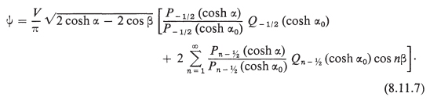

which agrees with me, so now I have a third source on the toroid potential. But then he says

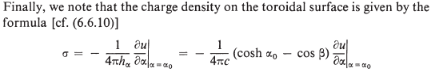

but then he stops! So as for α I can say of Lebedev: -- no go

Here is another hopeful:



They do a torus, but they have a current I going through it! But in Section 4 they do no current and find:

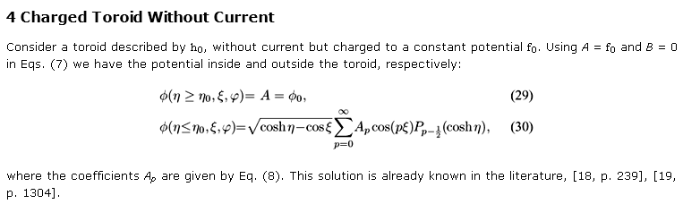
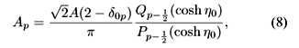

so this is yet another confirmation of the potential. Then C

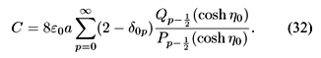\
which looks good. But then no σ! Nobody wants to do it! But they have some refs.

This solution is already known in the literature, [18, p. 239], [19, p. 1304].

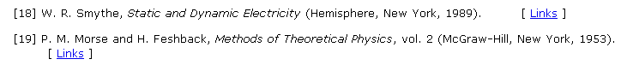

They also have the thin ring result

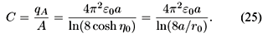

and this agrees with me as well. But for σ they are -- no go

OK, I give up. I don't think this as ever been computed, maybe I am the first one, so I better get it right.

C. Detailed check on my σ calculation in Section 10

10.5 Surface charge density on a torus

The torus surface charge density may be obtained from the potential in this manner,

σ = + (1/4π) (1/hξ$_{0}$) [∂ξV(ξ,u)]|ξ=ξ$_{0}$ 1/hξ$_{0}$ = (chξ0 - cosu)/a . (10.5.1)

This at least agrees with Lebedev, but he shows a minus sign. He is also in cgs.

An explanation is given below (4.1.2), and the sign here is + because ξ decreases moving outward from the torus surface. The torus potential was found in (10.1.11) to be

V(ξ,u) = V0 $\sqrt{2}$ $\sqrt{chξ - cosu}$ Σn=0∞ εn Pn-1/2(chξ) $\frac{Qn-1/2(chξ0)}{Pn-1/2(chξ0)}$cos(nu) . (10.1.11) (10.5.2)

= V0 $\sqrt{2}$Σn=0∞ εn $\frac{Qn-1/2(chξ0)}{Pn-1/2(chξ0)}$cos(nu) [ $\sqrt{chξ - cosu}$Pn-1/2(chξ) ] .

Therefore (10.5.1) reads,

σ = + $\frac{1}{4π}$V0 $\sqrt{2}$Σn=0∞εn $\frac{Qn-1/2(chξ0)}{Pn-1/2(chξ0)}$cos(nu) * $_{0}$∂ξ [ $\sqrt{chξ - cosu}$Pn-1/2(chξ) ] |ξ=ξ$_{0}$ . (10.5.3)

We need then to compute,

∂ξ [ $\sqrt{chξ - cosu}$Pn-1/2(chξ) ]

= $\sqrt{chξ - cosu}$ [ P'n-1/2(chξ) shξ ] + [(1/2) (1/$\sqrt{chξ - cosu}$) * shξ ] Pn-1/2(chξ)

= shξ [ $\sqrt{chξ - cosu}$P'n-1/2(chξ) + (1/2) (1/$\sqrt{chξ - cosu}$) Pn-1/2(chξ) ] |ξ=ξ$_{0}$

= shξ0 [ $\sqrt{chξ0 - cosu}$P'n-1/2(chξ0) + (1/2)(1/$\sqrt{chξ0 - cosu}$) Pn-1/2(chξ0) ] , (10.5.4)

where P'ν(z) means ∂zPν(z). Then using 1/hξ$_{0}$ = (chξ0 - cosu)/a ,

(1/hξ$_{0}$) ∂ξ [ $\sqrt{chξ - cosu}$Pn-1/2(chξ) ] |ξ=ξ$_{0}$

= (shξ0/a) (chξ0 - cosu) [ $\sqrt{chξ0 - cosu}$P'n-1/2(chξ0) + (1/2)(1/$\sqrt{chξ0 - cosu}$)Pn-1/2(chξ0) ] .

= (shξ0/a) [ (chξ0 - cosu)3/2 P'n-1/2(chξ0) + (1/2)$\sqrt{chξ0 - cosu}$Pn-1/2(chξ0) ] . (10.5.5)

Inserting this into (10.5.3) gives

σ = + $\frac{1}{4π}$ V0 $\sqrt{2}$Σn=0∞ εn $\frac{Qn-1/2(chξ0)}{Pn-1/2(chξ0)}$cos(nu) * (shξ0/a) *

[ (chξ0 - cosu)3/2 P'n-1/2(chξ0) + (1/2)$\sqrt{chξ0 - cosu}$Pn-1/2(chξ0) ] . (10.5.6)

OK, this intermediate result seems correct to me! I could I suppose use it to plot σ to see about my minimum anomaly.

We now write this as the sum of the two terms σ = σ1 + σ2 where

σ1 = + $\frac{1}{4π}$ V0 $\sqrt{2}$Σn=0∞ εn $\frac{Qn-1/2(chξ0)}{Pn-1/2(chξ0)}$cos(nu) * (shξ0/a) (chξ0 - cosu)3/2 P'n-1/2(chξ0)

σ2 = $\frac{1}{4π}$ V0 $\sqrt{2}$Σn=0∞ εn $\frac{Qn-1/2(chξ0)}{Pn-1/2(chξ0)}$cos(nu) * (shξ0/a) * $\sqrt{chξ0 - cosu}$ * $\frac{1}{2}$Pn-1/2(chξ0) ]

which we then reorganize to get

σ1 = $\frac{1}{4π}$ V0 $\sqrt{2}$ (shξ0/a) (chξ0 - cosu)3/2 Σn=0∞ εn P'n-1/2(chξ0) $\frac{Qn-1/2(chξ0)}{Pn-1/2(chξ0)}$ cos(nu)

σ2 = $\frac{1}{4π}$ V0 $\sqrt{2}$ (shξ0/a) $\sqrt{chξ0 - cosu}$ $\frac{1}{2}$Σn=0∞ εn Qn-1/2(chξ0) cos(nu) . (10.5.7)

Recall (10.1.8a) with a = chξ0 and b = 1 and x = u,

1 = $\sqrt{chξ0 - cosu}$ $\sqrt{2}$Σn=0∞ εn Qn-1/2( chξ0) cos(nu) . (10.5.8)

This "sum rule" greatly simplifies σ2 so that now,

σ2 = $\frac{1}{4π}$ V0 (shξ0/a) $\frac{1}{2}$ = $\frac{1}{4π}$ V0 $\sqrt{2}$ (shξ0/a) { $\sqrt{2}$ } . (10.5.9)

Reconstruct the sum σ = σ2 + σ1 to get

σ(u; ξ0) = $\frac{1}{4π}$ V0 $\sqrt{2}$ (shξ0/a)
{ $\sqrt{2}$ + (chξ0 - cosu)3/2 Σn=0∞ εn P'n-1/2(chξ0) $\frac{Qn-1/2(chξ0)}{Pn-1/2(chξ0)}$ cos(nu) } .

Next, extract a factor π/$\sqrt{2}$ from {...} and replace (shξ0/a) = 1/R from (1.2.7) to get,

σ(u; ξ0) = $\frac{V0}{4πR}$ [ $\frac{1}{2}$ + $\sqrt{2}$(chξ0 - cosu)3/2 Σn=0∞ εn P'n-1/2(chξ0) $\frac{Qn-1/2(chξ0)}{Pn-1/2(chξ0)}$ cos(nu) ] .
(10.5.10)

I think this is correct, I checked every single step just now.

This is our final result for the surface charge density on a torus having label ξ0 and tube radius R held at potential V0. We have scanned all our known sources, but cannot find verification of this result, so we shall be extra attentive in doing "checks".

σ(N) = $\frac{V0}{4πR}$ [ $\frac{1}{2}$ + $\sqrt{2}$(chξ0 - cosu)3/2 Σn=0N εn P'n-1/2(chξ0) $\frac{Qn-1/2(chξ0)}{Pn-1/2(chξ0)}$ cos(nu) ] .

= $\frac{V0}{4πR}$ [ $\frac{1}{2}$ + $\sqrt{2}$(chξ0 - cosu)3/2 * sum1(N) ]
where
sum1(N) = Σn=0N εn P'n-1/2(chξ0) $\frac{Qn-1/2(chξ0)}{Pn-1/2(chξ0)}$ cos(nu) (10.6.7)

D. Did I enter the Maple code correctly?

These seem to be properly entered into the Maple code, just comparing to the above:

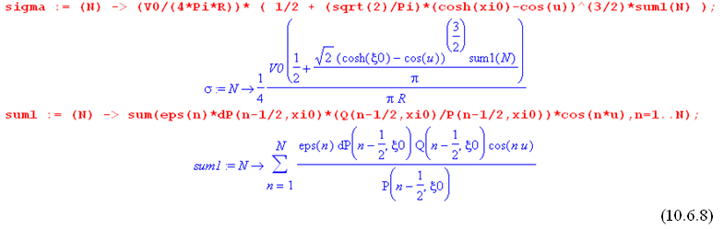
What about the P' business:

P'ν(chξ) = $\frac{dPν(chξ)}{d(chξ)}$ = $\frac{dPν(chξ)}{(shξ)dξ}$ = (1/shξ) ∂ξ Pν(chξ) = (1/shξ) ∂ξ P(ν,ξ) ≡ dP(ν,ξ)

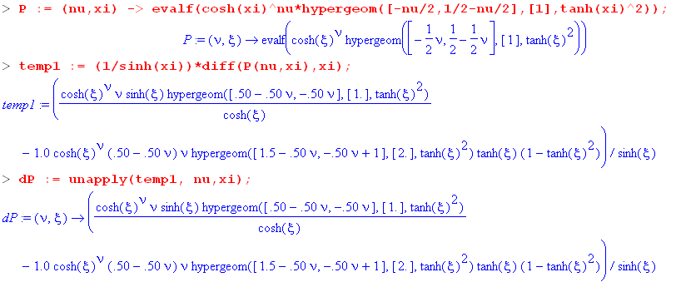

Let's check this directly. I have

P(ν,ξ) ≡ Pν(chξ) = (chξ)ν F(-ν/2, 1/2-ν/2; 1; th2ξ)

and I know that

∂zF(a,b,c,z) = (ab/c) F(a+1,b+1,c+1,z) from Schaum page 160

Then

∂zF(-ν/2, 1/2-ν/2; 1; z) = (-ν/2)(1/2-ν/2) F(-ν/2+1, 3/2-ν/2; 2; z)

So here we go

∂ξP(ν,ξ) = ∂ξ [ (chξ)ν F(-ν/2, 1/2-ν/2; 1; th2ξ)]

= (chξ)ν ∂ξF(-ν/2, 1/2-ν/2; 1; th2ξ)] + ν(chξ)ν-1shξ F(-ν/2, 1/2-ν/2; 1; th2ξ)]

= (chξ)ν ∂zF(-ν/2, 1/2-ν/2; 1; th2ξ)] ∂ξ(th2ξ) + ν(chξ)ν-1shξ F(-ν/2, 1/2-ν/2; 1; th2ξ)]

= (chξ)ν (-ν/2)(1/2-ν/2) F(-ν/2+1, 3/2-ν/2; 2; th2ξ) ∂ξ(th2ξ) + ν(chξ)ν-1shξ F(-ν/2, 1/2-ν/2; 1; th2ξ)]

= (chξ)ν (-ν/2)(1/2-ν/2) F(-ν/2+1, 3/2-ν/2; 2; th2ξ) 2thξ sech2ξ + ν(chξ)ν-1shξ F(-ν/2, 1/2-ν/2; 1; th2ξ)]

= - (chξ)ν ν(1/2-ν/2) F(-ν/2+1, 3/2-ν/2; 2; th2ξ) thξ (1-th2ξ) + ν(chξ)ν-1shξ F(-ν/2, 1/2-ν/2; 1; th2ξ)]

Now lets compare this with what Maple says, where Maple shows the overall 1/shξ as well

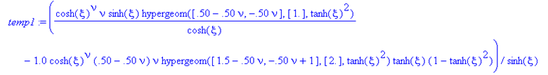

So Maple has it exactly right! So it is doing P' correctly.

Next, let's check the dQ object:

I will mark in blue bipolar results I will later check.

Relations between θ and (ξ,u) $\frac{du}{dθ}$ = $\frac{shξ}{chξ + cosθ}$ (7.10)'
sinθ = $\frac{|shξ| sinu}{chξ - cosu}$ sinu = $\frac{|shξ| sinθ}{chξ + cosθ}$ chξ - cosu = $\frac{sh2ξ}{chξ + cosθ}$

cosθ = $\frac{chξ cosu -1}{chξ-cosu}$ cosu = $\frac{chξ cosθ+1}{chξ + cosθ}$ $\frac{1}{chξ - cosu}$ = $\frac{chξ + cosθ}{sh2ξ}$

tanθ = $\frac{|shξ| sinu}{chξ cosu - 1}$ tanu = $\frac{|shξ| sinθ}{chξcosθ+1}$ h = $\frac{a}{chξ - cosu}$ = a $\frac{chξ + cosθ}{sh2ξ}$
(10.6.3)

Then, from (1.2.17) and the bottom right equation in the above box,

huhφ = shξ hu2 = shξ h2 = shξ a2 (chξ+cosθ)2/sh4ξ = a2 (chξ+cosθ)2/sh3ξ . (10.6.4)

Using $\frac{du}{dθ}$ = $\frac{shξ}{chξ + cosθ}$also from the above box we get, now setting ξ = ξ0 (torus label),

dQθ = σ huhφ $\frac{du}{dθ}$dθdφ = σ a2 (chξ0+cosθ)2/sh3ξ0 * shξ0 / (chξ0+cosθ) * dθdφ

= σ a2 (chξ0+cosθ)/sh2ξ0 * dθdφ

= σ R2 (chξ0+cosθ) dθdφ . // using R = a/shξ0 from box (1.2.17) (10.6.5)

The quantity we want to plot is then

"dQθ" ≡ dQθ/(dθdφ) = σ(u(θ); ξ0) R2 (chξ0+cosθ) . (10.6.6)

and here is my Maple code

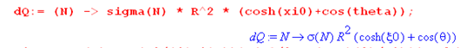

Now back up and check the two blue results from bipolar, I sure hope they are right. This will take a lot of work. I quote now from bipolar doc

fig 7.1
cosθ = sign(ξ) $\frac{x-xc}{R}$ = sign(ξ) $\frac{a shξ/(chξ - cosu) - a/thξ}{a/|shξ|}$ = $\frac{a shξ/(chξ - cosu) - a/thξ}{a/shξ}$

= $\frac{sh2ξ/(chξ - cosu) - chξ}{1}$ = $\frac{sh2ξ - chξ(chξ-cosu)}{chξ-cosu}$ = $\frac{chξ cosu - 1}{chξ-cosu}$ (7.2)

sinθ = $\frac{y}{R}$ = $\frac{a sinu/(chξ - cosu)}{a/|shξ|}$ = $\frac{|shξ| sinu}{chξ - cosu}$ (7.3)

tanθ = $\frac{sinθ}{cosθ}$ = $\frac{|shξ| sinu}{chξ cosu - 1}$ . (7.4)

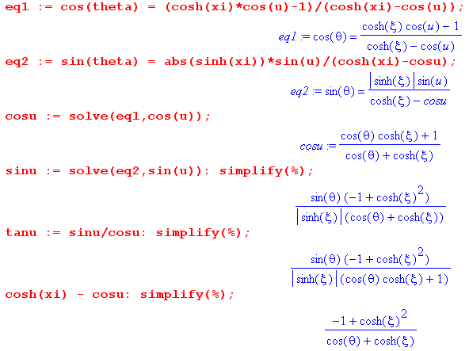
which we rewrite as

cosu = $\frac{chξcosθ+1}{chξ + cosθ}$ (7.5)

sinu = $\frac{|shξ|sinθ}{chξ + cosθ}$ (7.6)

tanu = $\frac{|shξ|sinθ}{chξcosθ+1}$ (7.7)

where the last Maple result says

chξ - cosu = $\frac{sh2ξ}{chξ + cosθ}$ . (7.8)

Holding ξ fixed and differentiating with respect to u gives

sinu du = sh2ξ d(chξ+cosθ)-1 = - sh2ξ(chξ+cosθ)-2 [ -sinθ dθ ] = sh2ξ sinθ (chξ+cosθ)-2dθ

or, using sinu from above,

$\frac{|shξ|sinθ}{chξ + cosθ}$du = sh2ξ $\frac{1}{(chξ + cosθ)2}$sinθdθ
or
du = $\frac{|shξ|}{chξ + cosθ}$dθ => $\frac{du}{dθ}$ = $\frac{|shξ|}{chξ + cosθ}$ (7.9)

All results can then be summarized in a box:

Relations between θ and (ξ,u) $\frac{du}{dθ}$ = $\frac{shξ}{chξ + cosθ}$ (7.10)
sinθ = $\frac{|shξ| sinu}{chξ - cosu}$ sinu = $\frac{|shξ| sinθ}{chξ + cosθ}$ chξ - cosu = $\frac{sh2ξ}{chξ + cosθ}$

cosθ = $\frac{chξ cosu -1}{chξ-cosu}$ cosu = $\frac{chξ cosθ+1}{chξ + cosθ}$ $\frac{1}{chξ - cosu}$ = $\frac{chξ + cosθ}{sh2ξ}$

tanθ = $\frac{|shξ| sinu}{chξ cosu - 1}$ tanu = $\frac{|shξ| sinθ}{chξcosθ+1}$ h = $\frac{a}{chξ - cosu}$ = a $\frac{chξ + cosθ}{sh2ξ}$

Do the last one by hand:

h = $\frac{a}{chξ - cosu}$ = a $\frac{chξ + cosθ}{sh2ξ}$

So just now I have verified everything in the box! So that means my "dQθ" is correctly derived and is correctly entered in Maple.

Let's check the equations that convert θ to u:

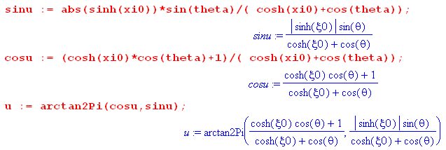

The first two lines come from the center column of my bipolar box and are correct, and the last is also OK showing the call with run then rise.

I don't see anything else I can check!!

E. Try plot with the earlier more complicated σ formula.

Well, I got this going finally.

BUG FOUND!!! I was starting series at n = 1 instead of n = 0. That took me 5 hours to locate, but now the anomaly is gone. I was right to be uncomfortable!

Also, this forced me to check lots of things. And plots of the intermediate and final σ look the same.

