Bug found with σ on the bowl. PhL 1.27.15

see red text below

I was getting wrong results for both the full sphere limit of σin and for the disk limit as well! I started to doubt my general formula for σin. But it was just simple mistakes as noted in red below. These limits are now properly done in bowl doc Section 4.3.

(a) The known disk result

The result, apart from constant overall factors, is this (both sides)

σ(ρ) = (1/π2) (a-ρ2)-1/2 Sneddon page 64 (3.1.7). Also quoted in bowl doc App C.

Look now at the toroidal coordinates,

x = a cosφ shξ/(chξ - cosu) ρ = a shξ/(chξ - cosu) = $\sqrt{x2+y2}$
y = a sinφ shξ/(chξ - cosu) hξ = hu = a/(chξ - cosu)
z = a sinu/(chξ - cosu) hφ = a shξ/(chξ - cosu) (5.1)

The disk limit is supposed to be u0→π in my version of the coordinates, where u0 is a bowl label.

If u = π then cos(u) = -1 and we have

ρ = a shξ/(chξ +1) . ok

Then the disk needs

a2 - ρ2 = a2[ 1 - sh2ξ / (chξ+1)2] = a2[ (chξ+1)2 - sh2ξ ] / (chξ+1)2

Now,
[ (chξ+1)2 - sh2ξ ] = ch2ξ + 2chξ + 1- sh2ξ = 1 + 2chξ + 1 = 2(1+chξ) ok
so
a2 - ρ2 = a2 2(1+chξ) / (chξ+1)2 = 2a2/(chξ+1) ok and Maple agrees.

Then the desired limit should be this

σ(ρ) = (1/π2) (a2-ρ2)-1/2 = (1/π2) [2a2/(chξ+1)]-1/2 = (1/π2) $\sqrt{chξ+1}$/( $\sqrt{2}$a)

= (1/[π2a$\sqrt{2}$])$\sqrt{chξ+1}$ = $\sqrt{chξ+1}$/ ($\sqrt{2}$π2a) ok

This is for a unit potential, so with potential V0 we would get

σ(ρ) = V0 $\sqrt{chξ+1}$/ ($\sqrt{2}$π2a) ok

This is the total charge density on the plane z = 0 for the disk based on Sneddon. Units are correct because dim(V) = q/L and so σ is q/L2 as shown above.

Meanwhile, Jackson green page 93 says this for two sides

σbothsides = (q/2πa)(a2-ρ2)-1/2 and (q/a) = 2V/π from page 92, so then

σboth = (1/2π)(2V/π)(a2-ρ2)-1/2 = (V/π2) (a2-ρ2)-1/2 // Jackson's claim, both sides

Recall that Sneddon above says this for two sides

σ(ρ) = (V/π2) (a-ρ2)-1/2 // Sneddon's claim, both sides

My claim is this both sides, just expressed in toroidal coordinates, derived from the above

σ(ρ) = V0 $\sqrt{chξ+1}$/ ($\sqrt{2}$π2a) // either in T.C, both sides

How about a units check. Since V = q/r in cgs, dim(V) = q/L. Then Jackson's result is q/L2 which is correct.

My prediction for one side would then be

σin(ρ) = V0 $\sqrt{chξ+1}$/ (2$\sqrt{2}$π2a) ok

At the center of the disk you have ξ = 0 which gives a finite value at the center of σin(0) = (1/π2)$\sqrt{2}$/a.
At the edge of the disk you have ξ → +∞ and so σ does diverge as $\sqrt{chξ}$

So this is our desired limit at u0 → π.

STOP: I thought we had this rule that the two sides differ by some amount. That amount is this

difference = V0/(4πR) but R→ ∞ so the difference is 0

Note added 12/31/5. Here is an interesting question:
(1) the σ's on the two sides of a bowl are supposed to differ by a constant amount
(2) but the σ's on the two sides of a disk (bowl in limit) are the same!
How can this be?

Resolution: The amount they differ by is V0/(4πR) and R = ∞ for the disk.

(a1) Limit of my bowl doc results for the full sphere

Here is my original

σin = ( V0/4π2R) { $\sqrt{chξ-cosu0}$/ ($\sqrt{2}$cos(u0/2)) – tan-1[ $\sqrt{chξ-cosu0}$/ ($\sqrt{2}$cos(u0/2))] } (4.7)

First, let's make sure the full sphere is OK, which is the limit u0 → 0

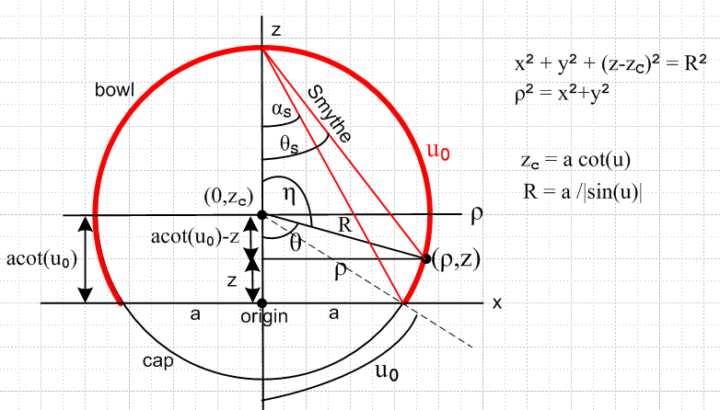

Then cos(u0) = 1 and cos(u0/2) = 1 and we get zC = a cot(u0)

σin = ( V0/4π2R) { $\sqrt{chξ-1}$/$\sqrt{2}$ – tan-1[ $\sqrt{chξ-1}$/$\sqrt{2}$] } (4.7) R = a / |sin(u0)|

STOP. I thought this was supposed to give 0! Both this limit and the disk one below are screwing up, what is going on here? I triple confirmed that the σin results agrees with Lebedev, Kelvin and Smythe!

I failed to realize here that $\sqrt{chξ-1}$ → 0 in the full sphere limit.

Let's try the Kelvin form of the result in the full sphere limit of u0 → 0 :

σK = (V0/4π2R) { $\sqrt{2}$sin(u0/2)/$\sqrt{cosu0 - cosθ}$ – tan-1 [ $\sqrt{2}$sin(u0/2)/$\sqrt{cosu0 - cosθ}$] } (4.8)

σK = (V0/4π2R) { $\sqrt{2}$0 /$\sqrt{1 - cosθ}$ – tan-1 [ 0/$\sqrt{cosu0 - cosθ}$] = 0 + 0 + 0

Huh? Look at our little relation thing,

$\sqrt{chξ-cosu0}$/ ($\sqrt{2}$cos(u0/2)) = $\sqrt{2}$sin(u0/2)/$\sqrt{cosu0 - cosθ}$. (4.9)

Take the limit u0→ 0 to get

$\sqrt{chξ-1}$/ ($\sqrt{2}$) = $\sqrt{2}$0/$\sqrt{1 - cosθ}$ ??

So this relation is failing in this limit!!!!! This is very strange. But look at this equation

R = a/sin(u0).

So to maintain radius R, you have also to take a→ 0. OK, I will keep that in mind. Now first step in derivation of the above relation is this:

cosθ = [a cotu0 - a sinu0/(chξ - cosu0)] / [ a/sinu0] = cosu0 - sin2u0/ (chξ - cosu0)

I cancelled the a factors. But suppose I write a = Rsin(u0). then I have

cosθ = [a cotu0 - a sinu0/(chξ - cosu0)] / [ a/sinu0]

= [Rsin(u0) cotu0 - Rsin(u0) sinu0/(chξ - cosu0)] / [ Rsin(u0)/sinu0]

= [cos(u0) - sinu0/(chξ - cosu0)]

→ 1 ??

I am staring at my picture. I want R and ρ to stay the same. I just want to stretch the red boundary to get a full sphere. This involves : reducing a, increasing z, reducing u0. Look

R = a/sin(u0) shows how a and sin(u0) have to scale down at the same rate to maintain R.

If I take the u0 → 0 limit of this equation I get

cosθ = 1 - 0/ (chξ - 1) = 1 ⇒ θ = 0

But θ is a free variable, how can it be forced to 0?

(a2) Limit of my bowl doc results for the full sphere: Plan B

I am at least onto the problem. In my figure, if you take u0 smaller, the red circle wants to get bigger, but I am not allowing it to do so because I am reducing a at the same time. Start again with that little triangle,

cosθ = (acot(u0)-z)/ R = [a cosu0/sinu0 - a sinu0/(chξ - cosu0)] / R

= [R cosu0 - a sinu0/(chξ - cosu0)] / R

= [R cosu0 - R sin2u0/(chξ - cosu0)] / R

= [cosu0 - sin2u0/(chξ - cosu0)]

Notice that θ is a function of both u0 and ξ. It is not an independent variable. If you want u0→ 0, you are forcing cosθ → 1 regardless of ξ. If I want θ not to move, then I have to adjust ξ along with u0.

(a3) Limit of my bowl doc results for the full sphere: Plan C

OK, here I just let R grow as we do the limit. It is going into an infinitely large sphere in the limit u0→ 0, So replace 1/R by a/sin(u0) right at the start,

σin = ( V0/4π2a) sinu0 { $\sqrt{chξ-cosu0}$/ ($\sqrt{2}$cos(u0/2)) – tan-1[ $\sqrt{chξ-cosu0}$/ ($\sqrt{2}$cos(u0/2))] }

Now do the limit,

σin → ( V0/4π2a) 0 { $\sqrt{chξ-1}$/$\sqrt{2}$ – tan-1[ $\sqrt{chξ-1}$/$\sqrt{2}$] } = 0

and then we get the right limit. But this is not very interesting because who knows what happens when you make the sphere huge!

In the OTHER limit, you WANT the spheres to shrink down because they then shrink down to become the disk of interest.

(a4) Limit for full sphere in a way that we keep R = constant.

Since R = a/sinu0, we need to install a = Rsinu0 somehow so they both go to zero together. Start:

σin = (V0/4π2R) { $\sqrt{chξ-cosu0}$/ ($\sqrt{2}$cos(u0/2)) – tan-1[ $\sqrt{chξ-cosu0}$/ ($\sqrt{2}$cos(u0/2))] } (4.7)

= (V0/4π2R) { A - tan-1A }

In the limit u0→ 0 we have

To observe the limit better, let u0 → ε, some small positive value. Then

cos(u0) = cos(ε) = 1 - ε2/2 cos(u0/2) = cos(ε/2) ≈ 1 - (ε/2)2/2 = 1 - ε2/8

Meanwhile, in this limit ξ also becomes small. We have

ξ = tanh-1[2aρ/(ρ2+z2+a2)] = tanh-1[2 Rsinu0ρ/(ρ2+z2+R2sinu02)]

≈ 2 Rsinu0ρ/(ρ2+z2+R2sinu02) ≈ 2 R ε ρ/(ρ2+z2) → 0

Then ch(ξ) ≈ 1 + ξ2/2, so

chξ - cosu0 ≈ (1 + ξ2/2) - (1 - ε2/2) = (ξ2+ε2)/2

$\sqrt{chξ-cosu0}$/ ($\sqrt{2}$cos(u0/2)) ≈ $\sqrt{ξ2+ε2}$/ 2 (1-ε2/8) ≈ $\sqrt{ξ2+ε2}$/ 2

σin = (V0/4π2R) { $\sqrt{ξ2+ε2}$/ 2 - tan-1 [$\sqrt{ξ2+ε2}$/ 2

$\sqrt{chξ-cosu0}$ ≈ $\sqrt{1 + ξ2/2-1}$ = ξ/$\sqrt{2}$ and $\sqrt{chξ-cosu0}$/ ($\sqrt{2}$cos(u0/2)) ≈ ξ/2

Then

σin = (V0/4π2R) { ξ/2 – tan-1[ ξ/2] }

(b-pre1) Limit of my bowl doc results for charge density of a disk no problem here

Let's now start with,

σin = ( V0/4π2a) sinu0 { $\sqrt{chξ-cosu0}$/ ($\sqrt{2}$cos(u0/2)) – tan-1[ $\sqrt{chξ-cosu0}$/ ($\sqrt{2}$cos(u0/2))] }

Now take the limit u0 → π but not fully there. So write u0 = π - x where x > 0 is very small but finite. Then we get

sinu0 = sin(π-x) = - sin(x-π) = +sin(x) ≈ x

cosu0 = cos(π-x) = cos(x-π) = -cos(x) ≈ -1

cos(u0/2) = cos(π/2-x/2) = +sin(x/2) ≈ x/2

Then we get

σin = ( V0/4π2a) x {$\sqrt{2}$$\sqrt{chξ+1}$/ x – tan-1[ $\sqrt{2}$$\sqrt{chξ+1}$/ x] }

The tan-1[...] = tan-1[ +∞] = π/2, so then

σin = (V0/4π2a) x {$\sqrt{2}$$\sqrt{chξ+1}$/ x – π/2 }

= (V0/4π2a)$\sqrt{2}$$\sqrt{chξ+1}$ + (V0/4π2a) x (-π/2)

≈ (V0/4π2a)$\sqrt{2}$$\sqrt{chξ+1}$ in the limit

= (1/2)(V0/2π2a)$\sqrt{2}$$\sqrt{chξ+1}$

= V0$\sqrt{chξ+1}$/ (2$\sqrt{2}$π2a) correct

and this agrees with the above !!!!!!!!! (2+ days). π2a

This is very similar to the Sneddon result which is

σin(ρ) =

(b) Limit of my bowl doc results for charge density of a disk

Just naively taking the limit u0 → π from below, say, we get

cos(u0) → cos(π) = -1 $\sqrt{chξ-cosu0}$ → $\sqrt{chξ+1}$

cos(u0/2) → cos(π/2) = 0 $\sqrt{chξ-cosu0}$ → $\sqrt{chξ-cosu0}$

This cos(u0/2) → 0 causes both terms to be singular so I need to be just a bit careful. Let

u0 = π - x where later we will take x→0+.

Then

cos(u0/2) = cos(π/2-x/2) = sin(x/2) ≈ x/2

$\sqrt{2}$cos(u0/2)) = x/$\sqrt{2}$

1/ [$\sqrt{2}$cos(u0/2))] = $\sqrt{2}$/x

$\sqrt{chξ-cosu0}$/ ($\sqrt{2}$cos(u0/2))] → $\sqrt{2}$$\sqrt{chξ+1}$/ x .

Then we have

σin = ( V0/4π2R) { $\sqrt{chξ+1}$$\sqrt{2}$/x – tan-1[ $\sqrt{chξ+1}$$\sqrt{2}$/x]

But I failed to say here that 1/R = x/a which makes all the difference!!

As x→ 0+, the tan-1 argument [] goes to +1/∞ and we can take

limx→0+ { tan-1[ $\sqrt{chξ+1}$$\sqrt{2}$/x] } = ±π/2 depending on where you want to be on the branch.

But the first term blows up, and here is what my result gives,

σin = ( V0/4π2R) { $\sqrt{chξ+1}$$\sqrt{2}$/x) → ∞ x = π-u0.

whereas the result is supposed to be

σin = (1/π2) $\sqrt{chξ+1}$/( $\sqrt{2}$a)

The conclusion is that my bowl charge density result is WRONG. [ no, it is not wrong ]

(c) Plan A: Suppose I am off by one or two factors of hu

Recall that

hu = a/(chξ–cosu)

In my limit u→π this becomes

hu → a/(chξ + 1).

This number is finite, so no number of such factors will repair my problem!

(d) Plan B: I thought Lebedev confirmed the charge result! And so did Kelvin!

I quote both these results in (4.8) and (4.9).

σL =( V0/4π2R) { $\sqrt{chξ-cosα}$/ ($\sqrt{2}$cos(α/2)) – tan-1[ $\sqrt{chξ-cosα}$/ ($\sqrt{2}$cos(α/2))] } // Lebedev (4.8)

σK = (V0/4π2R) { $\sqrt{1-cosα}$/ $\sqrt{cosα - cosθ}$ – tan-1 [$\sqrt{1-cosα}$/$\sqrt{cosα - cosθ}$] } // Kelvin (4.9)

σin = ( V0/4π2R) { $\sqrt{chξ-cosu0}$/ ($\sqrt{2}$cos(u0/2)) – tan-1[ $\sqrt{chξ-cosu0}$/ ($\sqrt{2}$cos(u0/2))] } // me (4.7)

These other guys are not going to have it wrong. Lebedev has this

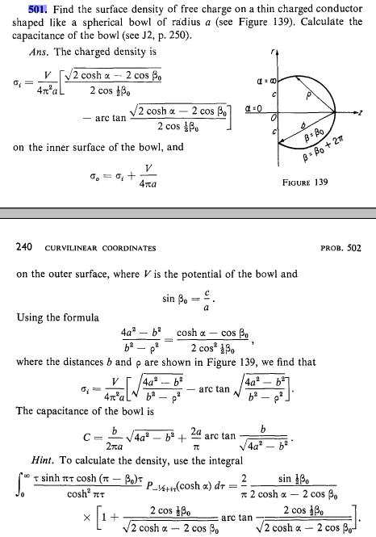

Notice that he says

sinβ0 = lip circle radius / bowl radius = a/R for me

IN my bipolar doc (2.6) I have

sinu = a/R

so that is why I think u = β0.

So I am totally stumped (as usual). How can all three of us agree on the σ result, but the disk limit fails?? Is it somehow related to the range of u? That might be it.

What range did I use? It is in my picture and it is same as Lebedev.
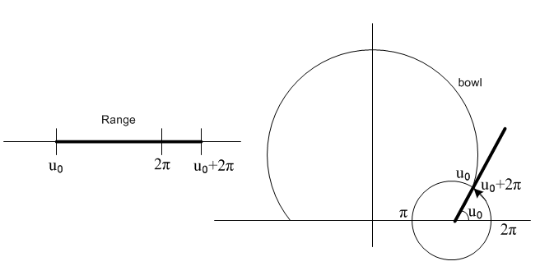
Now what does this mean for taking the disk limit? Imagine we have almost reached the disk limit, so u0 has reached π-ε. Then what is the range for u?

π-ε ≤ u ≤ 3π-ε

Then the lower surface of the disk is at u = π-ε, as I used above. So u→π is then the correct limit, and I continue to be getting the wrong result!

***********************************

Question 1: I say that σ is infinite at the bowl edge. How does that appear in my result? I never checked on that.

σ+ = σin = ( V0/4π2R) [ (B/A) – tan-1(B/A)]

A = $\sqrt{2}$cos(u0/2) and B = $\sqrt{chξ-cosu0}$

At the bowl edge, we are at the focal point so we have ξ → +∞. Then B → ∞ and

σin(near edge) = ( V0/4π2R) [ (B/A) – π/2 ] ≈ ( V0/4π2R) (B/A)

Now B/A = (chξ)1/2/ [$\sqrt{2}$cos(u0/2)] so the answer close to the edge is

σin(near edge) = ( V0/4π2R) (chξ)1/2/ [$\sqrt{2}$cos(u0/2)]

which does indeed blow up as claimed as ξ → ∞.

Question 2. How about at the bowl center? There ξ → 0 and we get B = $\sqrt{chξ-cosu0}$ = $\sqrt{1-cosu0}$. Then

B/A = $\sqrt{1-cosu0}$/ [$\sqrt{2}$cos(u0/2) ]

Now $\sqrt{1-cosu0}$ = $\sqrt{2}$ sin(u0/2)

B/A = $\sqrt{2}$ sin(u0/2)/ [$\sqrt{2}$cos(u0/2) ] = tan(u0/2)

and then we have

σin(at center) = ( V0/4π2R) [ tan(u0/2) – tan-1(tan(u0/2))]

= ( V0/4π2R) [ tan(u0/2) – u0/2]

Consider the sequence of upper bowls from large to small so u0 → π from below.

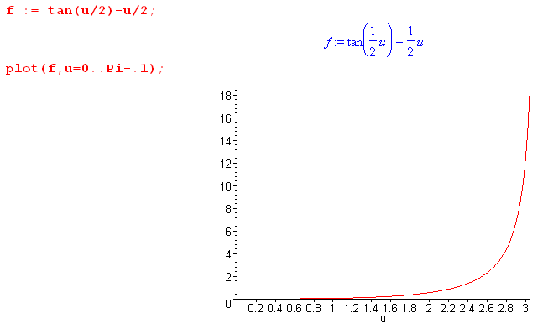
This says that σin (and σout which differs by a constant) blows up for the flat disk at disk center!
This result I am sure is wrong. So we have a new problem.

Time to check my calculation of σ starting with (4.1). I need to show that it replicates the flat disk charge distribution

Question 3: Let's start with the full σin result and take it to the flat disk limit. Here is my full result

σ+ = σin = ( V0/4π2R) [ (B/A) – tan-1(B/A)]

A = $\sqrt{2}$cos(u0/2) and B = $\sqrt{chξ-cosu0}$

The flat disk has u0 = π and then

A = $\sqrt{2}$cos(π/2) = 0 B = $\sqrt{chξ+1}$

The limit then says

σ+ = σin = ( V0/4π2R) [ (B/0) – tan-1(B/0)]

= ( V0/4π2R) [ ∞ – π/2]

So something is WRONG with my σ result! I should have checked this limit when I wrote the doc. Stupid.

Check the calculation of σ

I start with

V(ξ,u) = V0 $\sqrt{2}$ $\sqrt{chξ - cosu}$$^{\int_{0}^{∞}{}}$dτ Piτ-1/2(chξ) ch[(π–u0)τ] ch[(π+u0-u)τ]/ ch2(πτ) (2.8)

σ+ = – (1/4π) (1/hu) ∂uV(ξ,u)|u=u0 1/hu = (chξ - cosu)/a

Where do I get this second line from? No reference is given. Is this result in any of my web docs? I do have this in SI units,

Dn1 - Dn2 = nfree or [ε1E1n - ε2E2n] = nfree (1.1.47)

Consider a boundary like this

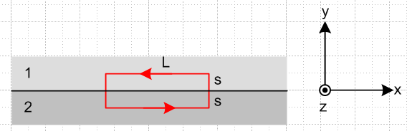

Suppose 2 = metal and 1 = vacuum. We then have

[ε1E1n - ε2E2n] = nfree → ε0E1n = nfree

Translate this to say

σ = ε0En SI units

So far so good. Meanwhile,

E = - grad V

We look this up in tensor doc where we have

[grad f](x) = (∂if ) ei
[grad f](x) = (∂if ) ei = (1/hi2) (∂if ) ei
[grad f](x) = hi(∂if ) i = (1/hi) (∂if ) // M&S 1.05 (10.1.17)

or

[grad V](x) = (∂iV ) ei
[grad V](x) = (∂iV ) ei = (1/hi2) (∂iV ) ei
[grad V](x) = hi(∂iV ) i = (1/hi) (∂iV ) i // M&S 1.05 (10.1.17)

where italic V means it is a function of the curvilinear coordinates. Assume that i is a unit vector in curvilinear coordinates which is normal to our surface of interest, which would be u for our case study. Then

[grad V](x) = (1/hu) (∂uV ) u

Then

E = - grad V ⇒ Euu = - (1/hu) (∂uV ) u ⇒ Eu = - (1/hu) (∂uV )

and then finally

σ = ε0Eu = - ε0 (1/hu) (∂uV )

and then divide by 4πε0 to get cgs units

σ = ε0Eu = - (1/4π) (1/hu) (∂uV )

and this is what I used.

Question: But there is something unclear to me here. Go back to

[ε1E1n - ε2E2n] = nfree

Are these E-field component covariant or contravariant !!! Go back to the derivation (where I have fixed the bad reference which was 1.1.13),

div D = ρfree ⇔ ∫V ρfree dV = ∫S D • dS (1.1.32)

Now how do you do this in covariant notation?

D • dS = DidSi = DidSi

My lines doc does not address this question. In the n-piped discussion I do mention area with covariant index stuff, and there fore example I have

dA'n = J2(Πi≠ndx'i) e'n since (e'n)i = δni (7.18.1) (8.4.c.5)

where we are in x'-space. I show in toroidals.doc that

J = hξhuhφ = $\frac{a3shξ}{(chξ-cosu)3}$

If I then set n = 2 for the u coordinate, we get

dA'n = J2(Πi≠ndx'i) e'n

dAu = J2 dξdφ eu

dSu = J2 dξdφ eu

Then we have

D • dS = ( Du eu) • ( J2 dξdφ eu) = Du J2 dξdφ

so it is the contravariant component ! Then we really have

[ε1En1 - ε2En2] = nfree

[ε1Eu1 - ε2Eu2] = σ

εoEu1 = σ

We now trace through the above discussion.

[grad V](x) = (∂iV ) ei
[grad V](x) = (∂iV ) ei = (1/hi2) (∂iV ) ei
[grad V](x) = hi(∂iV ) i = (1/hi) (∂iV ) i // M&S 1.05 (10.1.17)

E = - grad V ⇒ Euu = - (1/hu) (∂uV ) u ⇒ Eu = - (1/hu) (∂uV )

Eu = - (1/hu) (∂uV )

Then

σ = εoEu1 = - ε0 (1/hu)(∂uV ) // with an upper index!

So my document should say not this

σ+ = – (1/4π) (1/hu) ∂uV(ξ,u)|u=u0 1/hu = (chξ - cosu)/a
σ– = +(1/4π) (1/hu) ∂uV(ξ,u)|u=u0+2π // cgs units selected here (4.1)

but this

σ+ = – (1/4π) (1/hu) ∂uV(ξ,u)|u=u0 1/hu = (chξ - cosu)/a
σ– = +(1/4π) (1/hu) ∂uV(ξ,u)|u=u0+2π // cgs units selected here (4.1)

So this is the first thing I have found to be done wrong. Now we have

∂i = Σj gij∂j = gii∂i

For i = 2 = u this says

∂u = guu∂i = hu2 ∂u

∂u = hu-2∂u

Then I would seem to get

σ+ = – (1/4π) (1/hu)3 ∂uV(ξ,u)|u=u0 1/hu = (chξ - cosu)/a
σ– = +(1/4π) (1/hu)3 ∂uV(ξ,u)|u=u0+2π // cgs units selected here (4.1)

Basically this adds an extra factor of (1/hu)2 to my charge densities. Note that

1/hu = (chξ - cosu)/a

(1/hu)2 = (chξ - cosu)2/a2 = B4/a2

Then my new charge density results (if everything ELSE was done correctly) would be

σ+ = σin = ( V0/4π2R) [ (B/A) – tan-1(B/A)] (B4/a2)

A = $\sqrt{2}$cos(u0/2) and B = $\sqrt{chξ-cosu0}$ B2 = chξ - cosu0

How does this change the limit u0 ≠ π ? The problem remains unrepaired! A → 0 and σ → ∞ for any ξ.

I have some major problems here. I will respond to the guy first, and then tackle these problems. This might result in a major rewrite of bowl doc!

