Charge Density on the Charged Bowl (toroidal style) PhL 2.3.11

All is well here, and much of this stuff appears in bowl doc.

1. Computation of the Surface Charges on the Bowl Surfaces 1
2. An alternative method: 5
3. Comparing Lebedev with the Kelvin and Smythe results for σ 6
Appendix A: Doing the Lebedev Problem 501 Integral 8

__________________________________________________________________________________

Overview( 1/3 page, written 2.4.11)

In Section 1 I compute σ on the inner and outer bowl surfaces in toroidal coordinates starting from my toroidal bowl potential (which I STILL have not seen stated anywhere). Basically we just differentiate the potential at each surface in the usual fashion. In doing this, we end up needing a certain Mehler integral which I calculate in Appendix A, and which Lebedev states in his problem.

In Section 2 I just comment that I could have computed the σ's from my evaluated potential form, but I don't carry this out since it seems not to add much. It would be a Maple effort.

In Section 3 I show that Lebedev's toroidal expression for the σ's exactly agrees with those of Kelvin, and also of Smythe as we found a while ago in Smythe Problem 42.

In Section 4 I compute the critical integral. The τ factor sitting in the integral is made to vanish by doing a differentiation with respect to parameter. I have to make use of the Boeing p 20 #3 Mehler integral which is one I have NOT derived at this time, but I certainly believe it is correct since it gives the right Kelvin answer for the σ's!
__________________________________________________________________________________

[ This is now presented in bowl doc Section 4.1. Everything here is done correctly I think. ]

1. Computation of the Surface Charges on the Bowl Surfaces (Lebedev Problem 501)

We open with our potential for the charged bowl (see elsewhere)

V(ξ,u) = V0 $\sqrt{2}$ $\sqrt{chξ - cosu}$$^{\int_{0}^{∞}{}}$dτ Piτ-1/2(chξ) ch[(π–u0)τ] ch[(π+u0-u)τ] / ch2(πτ) (1.1)

= V0 $\sqrt{2}$ $\sqrt{chξ - cosu}$ f(u)

f(u) ≡ $^{\int_{0}^{∞}{}}$dτ Piτ-1/2(chξ) ch[(π–u0)τ] ch[(π+u0-u)τ] / ch2(πτ) (1.2)

As a reminder, above a simple z = 0 surface we would say that σ = (1/4π) Ez from a Gaussian pillbox that has one end in the metal, hence the 4π (green Jackson units). So we would say σ = -(1/4π)∂zV where z increases going away from the surface! In our bowl situation, on the inner surface this is the case, u increases going away from the surface. But on the outer surface the reverse is true, so there will be an extra minus sign there. Also, we have the scale factor to worry about. Since ds2 = gijdxidxj, in one direction ds = $\sqrt{guu}$du = hu du and then we have ∂sV = (1/hu)∂uV. So here is our opening position (± upper sign for inner)

Our charge density is going to be ( upper sign is inner surface of the bowl )

σ+ = -(1/4π) (1/hu) ∂uV(ξ,u)|u=u0 1/hu = [ ch(ξ) - cos(u)]/a
σ– = +(1/4π) (1/hu) ∂uV(ξ,u)|u=u0+2π

Notice that hu is the same on both surfaces. We can combine the above to say

σ± = ∓(1/4πa) [ ch(ξ) - cos(u0)] ∂uV(ξ,u)|u=u (1.3)

where u refers to either u0 for σ+ m or u0+2π for σ-.

Then we compute

∂uV = V0 $\sqrt{2}$ $\sqrt{chξ - cosu}$∂uf + V0 $\sqrt{2}$ f(u) (1/2) (1/$\sqrt{chξ - cosu}$) sinu

= V0 $\sqrt{2}$ $\sqrt{chξ - cosu}$∂uf + (1/2) sinu { V0$\sqrt{2}$ (1/$\sqrt{chξ - cosu}$) f(u)} (1.4)

We next compute

∂uf = ∂u$^{\int_{0}^{∞}{}}$dτ Piτ-1/2(chξ) ch[(π–u0)τ] ch[(π+u0-u)τ] / ch2(πτ)

= – $^{\int_{0}^{∞}{}}$dτ Piτ-1/2(chξ) ch[(π–u0)τ] τ sh[(π+u0-u)τ] / ch2(πτ)

Since we only want it on the boundaries, we can write

sh[(π+u0-u)τ] = sh[(π+u0-u0)τ] = + sh(πτ) u0 surface

sh[(π+u0-u)τ] = sh[(π+u0-[2π+u0])τ] = sh(-πτ) = – sh(πτ) 2π+u0 surface

We then find that on our two surfaces we have (upper sign is inner)

∂uf = – (±)$^{\int_{0}^{∞}{}}$dτ Piτ-1/2(chξ) ch[(π–u0)τ] τ sh(πτ) / ch2(πτ) ≡ ∓ X (1.5)

where

X = $^{\int_{0}^{∞}{}}$dτ Piτ-1/2(chξ) ch[(π–u0)τ] τ sh(πτ) / ch2(πτ) (1.6)

Lebedev gives this integral, I compute and verify it in Appendix A below. We both get

X = (2/π) [sin(u0/2) / (2chξ -2cosu0) ] *
x {1 + ($\sqrt{2}$cos(u0/2)/ $\sqrt{chξ-cosu0}$) tan-1 ($\sqrt{2}$cos(u0/2) / $\sqrt{chξ-cosu0}$) } (1.7)

Right now I will introduce these symbols to simplify manipulations

B = $\sqrt{chξ-cosu0}$ A = $\sqrt{2}$cos(u0/2) (1.8)

=> X = (1/π) [sin(u0/2)/B2] [1 + (A/B) tan-1 (A/B) ] (1.9)

We therefore have, from (1.5) and (1.4) and (1.3)

∂uf = ∓ X (1.10)

∂uV = V0 $\sqrt{2}$ B ∂uf + (1/2) sinu { V0$\sqrt{2}$ (1/ B) f(u)}

= V0 $\sqrt{2}$ B (∓ X) + (1/2) sinu { V0$\sqrt{2}$ (1/ B) f(u)} (1.11)
σ± = ∓(1/4πa) B2 ∂uV(ξ,u)|u=u (1.12)

We can then write the charge as ( trig functions sinu and cosu are the same on either surface, and also we know that f(u) is the same also on both surfaces, these are our boundary conditions)

σ± = ∓(1/4πa) B2 *
[ V0 $\sqrt{2}$ B(∓ X) + (1/2) sinu0 { V0$\sqrt{2}$ (1/B) f(u0)} ]

= ∓(1/4πa) *
[ V0 $\sqrt{2}$ B3 (∓ X) + (1/2) sinu0 { V0$\sqrt{2}$B f(u0)} ]

= ∓(1/4πa) [ V0 $\sqrt{2}$ B3 (∓ X) + (1/2) sinu0 { V0} ]

= ∓( V0/4πa) [ $\sqrt{2}$ B3 (∓ X) + (1/2) sinu0 ]

= ∓( V0/8πa) [ $\sqrt{2}$2 B3 (∓ X) + sinu0 ]

= ( V0/8πa) [ $\sqrt{2}$2 B3 X ∓ sinu0 ] (1.13)

Meanwhile, we had from (1.6),

X = (1/π) [sin(u0/2)/B2] [1 + (A/B) tan-1 (A/B) ]

So NOW we install X finally to get σ± = ( I had big trouble so doing one step per line! )

= ( V0/8πa) [ ∓ sinu0 + $\sqrt{2}$2 B3 {(1/π) [sin(u0/2)/B2] [1 + (A/B) tan-1 (A / B) ]} ]

= ( V0/8πa) [ ∓ sinu0 + $\sqrt{2}$2 B(1/π) [sin(u0/2)] [1 + (A/B) tan-1 (A / B) ] ]

= ( V0/8πa) [ ∓ sinu0 + $\sqrt{2}$2 (1/π) [sin(u0/2)] [B + A tan-1 (A / B) ] ]

= ( V0/8πa) [ ∓ sinu0 + $\sqrt{2}$2 (1/π) [sin(u0/2)] A [(B/A) + tan-1 (A / B) ] ]

= ( V0/8πa) [ ∓ sinu0 + $\sqrt{2}$2 (1/π) [sin(u0/2)] $\sqrt{2}$cos(u0/2) [(B/A) + tan-1 (A / B) ] ]

= ( V0/8πa) [ ∓ sinu0 + 2 (1/π) 2 [sin(u0/2)] cos(u0/2) [(B/A) + tan-1 (A / B) ] ]

= ( V0/8πa) [ ∓ sinu0 + 2 (1/π) sinu0 [(B/A) + tan-1(A/B) ] ]

= ( V0/8πa) sinu0 [ ∓ 1 + (2/π) [(B/A) + tan-1(A/B) ] ]

= ( V0/8πR) [ ∓ 1 + (2/π) [(B/A) + tan-1(A/B) ] ] Rsinu0 = a

= ( V0/8πR) (2/π) [ ∓ (π/2) + (B/A) + tan-1(A/B) ]

where B = $\sqrt{chξ-cosu0}$ A = $\sqrt{2}$cos(u0/2) B/A = $\sqrt{chξ-cosu0}$/ ($\sqrt{2}$cos(u0/2))

Now Leb wants B upstairs in the tan-1 so we use this identity

tan-1(A/B) = π/2 -cot-1(A/B) = π/2 -tan-1(B/A) (1.14)

and then with this we continue the litany above

= ( V0/8πR) (2/π) [ ∓ (π/2) + (B/A) + { π/2 -tan-1(B/A)} ]

= ( V0/8πR) (2/π) [ ∓ (π/2) + (B/A) + π/2 -tan-1(B/A)]

σ± = ( V0/4π2R) [ (π/2) ∓ (π/2) + (B/A) – tan-1(B/A)]

which says

σ+ = inner = ( V0/4π2R) [ (B/A) – tan-1(B/A)] (1.15)
σ– = outer = ( V0/4π2R) [ π + (B/A) – tan-1(B/A)] (1.16)

Therefore

outer - inner = ( V0/4π2R) [ π ] = (V0/4πR) (1.17)

inner = ( V0/4π2R) { (B/A) – tan-1(B/A) }

= ( V0/4π2R) { $\sqrt{chξ-cosu0}$/ ($\sqrt{2}$cos(u0/2)) – tan-1[ $\sqrt{chξ-cosu0}$/ ($\sqrt{2}$cos(u0/2))] } (1.18)

And we now compare with Lebedev's quoted result:

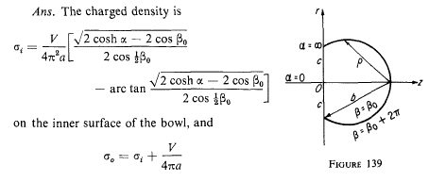

so we have obtained his answer exactly! So much for Problem 501.

[ this method is not attempted in bowl doc ]

2. An alternative method:

The other starting point would be to use our evaluated potential

V(ξ,u)= (V0/π ) $\sqrt{chξ - cosu}$ *
{ (1/$\sqrt{chξ -cosu}$) cot-1[(-1)η1| $\sqrt{1+cosu}$| / $\sqrt{chξ -cosu}$]
+ (1/$\sqrt{chξ-cos(2u0-u)}$) cot-1[(-1)η2| $\sqrt{1+cos(2u0-u)}$|/ $\sqrt{chξ -cos(2u0-u)}$] } (2.1)

where η1 = floor[(3π-u)/2π] u0 in (0,π)
η2 = floor[(2u0-u+π)/2π] u in (u0, u0+2π)

and apply ∂u to this thing. The η's act like constants under this operator. Rewrite this way

V(ξ,u)= (V0/π ) { cot-1[(-1)η1| $\sqrt{1+cosu}$| / $\sqrt{chξ -cosu}$]
+ ($\sqrt{chξ - cosu}$/$\sqrt{chξ-cos(2u0-u)}$) cot-1[(-1)η2| $\sqrt{1+cos(2u0-u)}$|/ $\sqrt{chξ -cos(2u0-u)}$] }

Maybe define

a(u) ≡ | $\sqrt{1+cosu}$|
b(u) ≡ $\sqrt{chξ -cosu}$
c(u) ≡ | $\sqrt{1+cos(2u0-u)}$|
d(u) ≡ $\sqrt{chξ -cos(2u0-u)}$

Then we have

V(ξ,u)= (V0/π ) { cot-1[(-1)η1a(u)/b(u)] + (b(u)/d(u)) cot-1[(-1)η2 c(u)/ d(u)] }

σ± = ∓(1/4πa) [ ch(ξ) - cos(u0)] ∂uV(ξ,u)|u=u (1.3)

Even if this came out right, it does not seem at all useful, adds little to one's understanding of the problem. This would be a big mess even for Maple since there are 6 functions of u involved. But it would eventually give the same answer we found above!

[ all these checks are incorporated into bowl doc ]

3. Comparing Lebedev with the Kelvin and Smythe results for σ

In my Smythe Problem 42 notes, we obtain results for the inner surface charge on the bowl:

θ' = θ/2 α' = α/2 θc' = θc/2
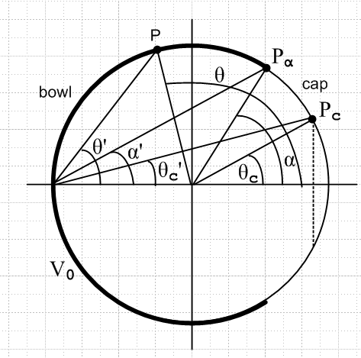

Here are the Smythe, Kelvin, and Lebedev results

σS = V0/(4π2A) { sin(α/2)/ $\sqrt{sin2(θ/2) -sin2(α/2)}$ – sin-1 [sin(α/2)/sin(θ/2) ] } // Smythe

σK = V0/(4π2A) { $\sqrt{1-cosα}$/ $\sqrt{cosα - cosθ}$ - tan-1 [$\sqrt{1-cosα}$/$\sqrt{cosα - cosθ}$] } // Kelvin

σL =( V0/4π2A) { $\sqrt{chξ-cosu0}$/ ($\sqrt{2}$cos(u0/2)) – tan-1[ $\sqrt{chξ-cosu0}$/ ($\sqrt{2}$cos(u0/2))] } //Leb

In that doc I already show that Smythe and Kelvin agree. Now u0 is our "outside bowl lip angle" which is going to be the same as angle α above. ( I proved this elsewhere, but it is pretty clear.) So write

σL(ξ) =( V0/4π2A) { $\sqrt{chξ-cosα}$/ ($\sqrt{2}$cos(α/2)) – tan-1[ $\sqrt{chξ-cosα}$/ ($\sqrt{2}$cos(α/2))] } //Leb

The trick is to relate the angle θ to something in the toroidal world. Here is a picture α = u0

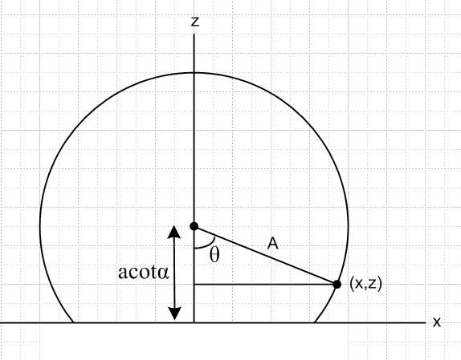

We know the acotα distance shown because our vertical circles are ρ2 + ( z- a cotα )2 = a2/sin2α. This happens to tell us also what we already know, that Asinα = a. So here is our connection: look at the right triangle shown which has

cosθ = adjacent/hypot = (acotα-z)/A = sinα (acotα-z)/a = sinα (cotα-(z/a))

But we know that z = a sinα/(chξ - cosα), so

cosθ = sinα (cotα - sinα/(chξ - cosα))

Maple tells us
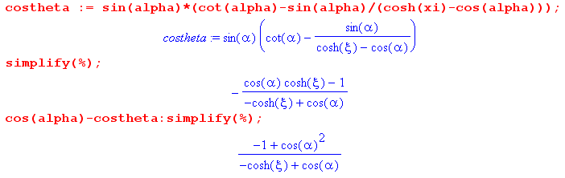

so the last line tells us that

cosα - cosθ = sin2α / (chξ-cosα) => $\sqrt{cosα - cosθ}$ = sinα / $\sqrt{chξ-cosα}$

Now recall Kelvin's and Lebedev's results

σK = (V0/4π2A) { $\sqrt{1-cosα}$/ $\sqrt{cosα - cosθ}$ – tan-1 [$\sqrt{1-cosα}$/$\sqrt{cosα - cosθ}$] } // Kelvin
σL =( V0/4π2A) { $\sqrt{chξ-cosα}$/ ($\sqrt{2}$cos(α/2)) – tan-1[ $\sqrt{chξ-cosα}$/ ($\sqrt{2}$cos(α/2))] } // Lebedev

So consider:

Kelvin = $\sqrt{1-cosα}$/$\sqrt{cosα - cosθ}$ = $\sqrt{1-cosα}$ $\sqrt{chξ-cosα}$/sinα

= $\sqrt{2}$sin(α/2) $\sqrt{chξ-cosα}$ / (2 sin(α/2)cos(α/2)) = $\sqrt{chξ-cosα}$ / ($\sqrt{2}$cos(α/2)) = Lebedev

These factors appear twice in each formula, and we have those shown that Lebedev's inner charge density matches Kelvin's, and thus Smythe's, QED.

[ this is also in bowl doc]

Appendix A: Doing the Lebedev Problem 501 Integral

My integral of interest is this:

X = $^{\int_{0}^{∞}{}}$dτ Piτ-1/2(chξ) ch(bτ) τ th(πτ) sech(πτ) b = π–u0

But consider

Y = $^{\int_{0}^{∞}{}}$dτ Piτ-1/2(chξ) sh(bτ) th(πτ) sech(πτ)

Then we get X from Y

X = ∂bY

But the integral Y appears in Boeing page 20 #3

Y = ($\sqrt{2}$/π) (1/$\sqrt{chξ+cosb}$) tan-1[ $\sqrt{1-cosb}$/$\sqrt{chξ+cosb}$ ]

I tell Maple to apply ∂b without the ($\sqrt{2}$/π) factor

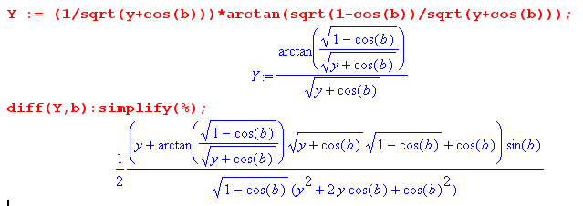

which I hand write, ignoring the 1/2, as

sinb [ (y+cosb) + $\sqrt{y+cosb}$$\sqrt{1-cosb}$tan-1 (stuff) ] / [ $\sqrt{1-cosb}$ (y+cosb)2]

= sinb [ 1 + ( $\sqrt{1-cosb}$/ $\sqrt{y+cosb}$) tan-1 (stuff) ] / [ $\sqrt{1-cosb}$ (y+cosb)]

= sinb [ 1 + ( $\sqrt{1-cosb}$/ $\sqrt{y+cosb}$) tan-1 (stuff) ] / [ $\sqrt{1-cosb}$ (y+cosb)]

Then we have, reinstalling the 1/2,

X = $^{\int_{0}^{∞}{}}$dτ Piτ-1/2(chξ) ch(bτ) τ th(πτ) sech(πτ)

= (1/2) ($\sqrt{2}$/π) ( sinb / [ $\sqrt{1-cosb}$ (y+cosb)]) [1 + ( $\sqrt{1-cosb}$/ $\sqrt{y+cosb}$) tan-1 (stuff) ]

= (1/) ($\sqrt{2}$/π) ( sinb / [ $\sqrt{2}$sin(b/2) (y+cosb)]) [1 + ($\sqrt{2}$sin(b/2)/ $\sqrt{y+cosb}$) tan-1 (stuff) ]

= (1/2) ($\sqrt{2}$/π) ($\sqrt{2}$cos(b/2)) / (y+cosb) [1 + ($\sqrt{2}$sin(b/2)/ $\sqrt{y+cosb}$) tan-1 (stuff) ]

= (1/2) (2/π) (cos(b/2)) / (y+cosb) [1 + ($\sqrt{2}$sin(b/2)/ $\sqrt{y+cosb}$) tan-1 (stuff) ]

Now replace b by π-β to match Lebedev, and we get

= (2/π) (sin(β/2)) / (2y-2cosβ) [1 + ($\sqrt{2}$cos(β/2)/ $\sqrt{y-cosβ}$) tan-1 (stuff) ]

where stuff = $\sqrt{1-cosb}$/ $\sqrt{y+cosb}$ = $\sqrt{2}$sin(b/2) / $\sqrt{y+cosb}$ = $\sqrt{2}$cos(β/2) / $\sqrt{y-cosβ}$

One more time

X = $^{\int_{0}^{∞}{}}$dτ Piτ-1/2(chξ) ch([π-β]τ) τ th(πτ) sech(πτ) = (2/π) [sin(β/2) / (2y-2cosβ) ] *
x [1 + ($\sqrt{2}$cos(β/2)/ $\sqrt{y-cosβ}$) tan-1 ($\sqrt{2}$cos(β/2) / $\sqrt{y-cosβ}$) ]

which we compare to

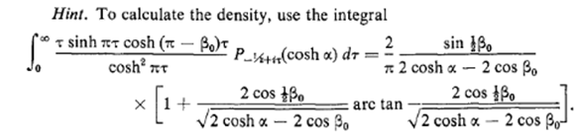

So I agree exactly with Lebedev!

Note added 12/2/15. [ this is now (7.1.6) in bowl doc, derived in App L ]

Let's try to do the Boeing integral quoted above:

Y = $^{\int_{0}^{∞}{}}$dτ Piτ-1/2(chξ) sh(bτ) th(πτ) sech(πτ)

= $^{\int_{0}^{∞}{}}$dτ Piτ-1/2(chξ) sh(bτ) sh(πτ)/ch2(πτ)

Recall the identity,

2 sh[(x+y)/2] sh[(x-y)/2] = ch(x) - ch(y) .

Set
(x+y)/2 = bτ x + y = 2bτ
(x-y)/2 = πτ x -y = 2πτ

2x = 2(b+π)τ x = (b+π)τ
2y = 2(b-π)τ y = (b-π)τ

Therefore

2 sh(bτ)sh(πτ) = ch[(b+π)τ] - ch[(b-π)τ]

Then we can write

Y = (1/2)$^{\int_{0}^{∞}{}}$dτ Piτ-1/2(chξ) { ch[(b+π)τ] - ch[(b-π)τ] }/ch2(πτ)

= (1/2) { $^{\int_{0}^{∞}{}}$dτ Piτ-1/2(chξ)ch[(b+π)τ]/ch2(πτ) - $^{\int_{0}^{∞}{}}$dτ Piτ-1/2(chξ)ch[(b-π)τ]/ch2(πτ) }

But we know that

$^{\int_{0}^{∞}{}}$dτ Piτ-1/2(y) ch(Bτ) / ch2(πτ) = ($\sqrt{2}$/π ) $\sqrt{y-cosB}$ cot-1[$\sqrt{1+cosB}$$\sqrt{y-cosB}$] (7.7)

Recall that $\sqrt{1 + cosB}$ = $\sqrt{2}$ cos(B/2) , so rewrite the above as

$^{\int_{0}^{∞}{}}$dτ Piτ-1/2(y) ch(Bτ) / ch2(πτ) = ($\sqrt{2}$/π ) $\sqrt{y-cosB}$ cot-1[$\sqrt{2}$$\sqrt{y-cosB}$] (7.7)

For the first term we will have B = b+π so cosB = cos(b+π) = -cos(b)
and cos(B/2) = cos(b/2+π/2) = cos(π/2 + b/2) = - sin(b/2).

For the first term we will have B = b-π so cosB = cos(b-π) = -cos(b)
and cos(B/2) = cos(b/2-π/2) = cos(π/2-b/2) = +sin(b/2)

Therefore

Y = (1/2) ($\sqrt{2}$/π ){ $\sqrt{y+cosb}$ cot-1[$\sqrt{2}$$\sqrt{y+cosb}$ - $\sqrt{y+cosb}$ cot-1[$\sqrt{2}$$\sqrt{y+cosb}$

Y = (1/2) ($\sqrt{2}$/π )$\sqrt{y+cosb}${ cot-1[$\sqrt{2}$$\sqrt{y+cosb}$ - cot-1[$\sqrt{2}$$\sqrt{y+cosb}$ }

= (1/2) ($\sqrt{2}$/π )$\sqrt{y+cosb}${ cot-1[- $\sqrt{1-cosb}$$\sqrt{y+cosb}$ - cot-1[$\sqrt{1-cosb}$$\sqrt{y+cosb}$ }

Now use Schaum 5.75 which says cot-1(x) = π/2 - tan-1(x) to get

= (1/2) ($\sqrt{2}$/π )$\sqrt{y+cosb}${ π/2 - tan-1[- $\sqrt{1-cosb}$$\sqrt{y+cosb}$ - π/2 + tan-1[$\sqrt{1-cosb}$$\sqrt{y+cosb}$ }

= (1/2) ($\sqrt{2}$/π )$\sqrt{y+cosb}${ - tan-1[- $\sqrt{1-cosb}$$\sqrt{y+cosb}$ + tan-1[$\sqrt{1-cosb}$$\sqrt{y+cosb}$ }

Now use Schaum 5.82 that tan-1(-x) = - tan-1(x) to get

= (1/2) ($\sqrt{2}$/π )$\sqrt{y+cosb}${ + tan-1[ $\sqrt{1-cosb}$$\sqrt{y+cosb}$ + tan-1[$\sqrt{1-cosb}$$\sqrt{y+cosb}$ }

= ($\sqrt{2}$/π )$\sqrt{y+cosb}$ tan-1[ $\sqrt{1-cosb}$$\sqrt{y+cosb}$

and this agrees with the Boeing result I quoted above, namely Boeing p 20 #3

Y = ($\sqrt{2}$/π) (1/$\sqrt{chξ+cosb}$) tan-1[ $\sqrt{1-cosb}$/$\sqrt{chξ+cosb}$ ]

Hurrah!

