Charged bowl in toroidals PhL 7.12.10

This doc is for historical interest only, pretty much nothing in it is correct! But it is fascinating.
12/31/15.
________________________________________________________________________________

Overview (written 2.2.11, 1.5 pages)

This was my "first attempt" at doing the charged bowl in toroidals, and it is historically interesting to me for that reason. Lebedev had two problems related to this subject, I thought, but I later realized that 501 just gave the σ results, and problem 503 involves a bowl with a flat lid on it, something I did not realize till much later. I thought therefore that his problem 501 was giving the potential of a charged bowl!
In the first section below, I at least have the right general Smythian form for V, and I learn for the first time why you want a u coordinate range in the form u0 to 2π+u0 (in later notation). My Smythian form has the integrand [ Apch(u) +Bpsh(u)] and later Ap sh(u - ap). I don't think I understood why I was using this particular toroidal atomic form instead of the other form.
The next section is called My Solution for the Charged Bowl. Right off the bat I make the big mistake of assuming that r→∞ ⇔ u=2π, though I now know that r→∞ ⇒ u=2π only. This seems to imply in the above form that ap = 2π and then my integrand is merely Apsh(u-2π) and I quickly end up with the following wrong solution to the problem: V(ξ,u,φ) = V0[ sh(u-2π)/ sh(u0-2π)]. Since it strongly resembles the charged ellipsoid solution in ellipsoidals, I am optimistic at this point! Although I have a solution here, I still would like to solve for my Ap, and that leads me to the Mehler-Fock. When I apply the Mehler-Fock to the problem of finding Ap, I need a certain Mehler projection integral which I was able to deduce from some horrible GR7 integral, (this is an "easy direction" integral)

$^{\int_{1}^{∞}{}}$dx Pip-1/2(x) / $\sqrt{x - cosu0}$ = $\sqrt{2}$ch[p(u0-π)]/ (p sh(πp))

I am then off looking for verification of this thing, and that leads me to downloading the PBM books. In another doc I verify the above equation by a different method. I have then arrived at this point

Ap = V0$\sqrt{2}$ch[p(u0-π)]/ (ch(πp) sh(u0-2π))

V(ξ,u,φ) = V0$\sqrt{2}$ [ $\sqrt{chξ - cosu}$ sh(u - 2π)/ sh(u0-2π) ] $^{\int_{0}^{∞}{}}$ dp Pip-1/2(chξ) ch[p(u0-π)]/(ch(πp)) (*)

Due to my opening mistake, all this stuff is totally wrong, but I was forced to go learn things. I can see now that if you were to look up the above dp integral ( I did it much later in 1/11)

$^{\int_{0}^{∞}{}}$dτ Piτ-1/2(y) cos(aτ) sech(πτ) = (1/$\sqrt{2}$) (y+cha)-1/2 // sec 7

you just end up with what I already had , namely, V(ξ,u,φ) = V0 [ sh(u-2π)/ sh(u0-2π)]. So at least my wrong result is consistent with itself. But at the time I did not know how to do the above integral, and I just assumed it was undoable and part of the answer.
At this point I tried comparing my solution (*) above to Lebedev's 501 and it did not agree. In retrospect, my solution is completely wrong, and Lebedev was doing a completely different problem (!), the bowl with lid, so it is a good thing things did not agree!
Not knowing this, I verified that my result was OK for r→∞ (wrongly so) and I tried taking that limit of his result (u = 2π) to see what it did. This sort of led nowhere.
I have tacked on a Note from 1.20.11 where I quote the Deegan two-bowl result, though I didn't really know what it is at that time, the thing with β1 and β2. I realize at this time that Prob 503 has a flat lid on it and it is in fact a two-bowl problem, and this is detailed in other docs.
At this point I think my simple result sh(u-2π)/ sh(u0-2π) might still be viable. It seems odd to me that this simple result appears nowhere on the web! I then get the idea of doing β1= β2 in Deegan to get a single-bowl result, and I do get the correct ch[(π-β0)τ] ch[(β-β0)τ - πτ] / ch2(πτ) integrand, but at this time I just ignore it because it does not match my form (*) above. So in fact I had the right single-bowl result in my hands here, but did not realize it yet. And I did not understand either why my simple solution was wrong. At this point, the doc just ends.
____________________________________________________________________________________

I am very confused. I thought Lebedev problem 503 was the charged bowl problem, but now I am not so sure. Adjacent doc "Notes on Kirk on bowl problem + Kelvin review.doc" quotes Lebedev problem 501 as being the charged bowl problem. I show the entire problem there and it sure looks like the charged bowl problem to me. So what is the problem below, 503 ?? Maybe 501 asks just for σ and this one is asking for Φ.

Note added 2.2.11. Lebedev's Problem 501 asks for σ on the charged bowl surfaces, using toroidals, and he uses the horrible Mehler integral noted below and refers the reader to a Jeans alternate solution. His Problem 503 I thought was a bowl problem, but it is really the bowl with a flat metal cap! That is why I did not get his answer in this doc. Eventually I did this problem elsewhere and got his answer. Neither of these problems appears in the "solutions" section of this book.

This doc is incomplete because my result disagrees with the Lebedev book result.

I conjecture that the charged bowl problem has this form: (m = 0 since azisym)

V(ξ,u,φ) = $\sqrt{chξ - cosu}$$^{\int_{0}^{∞}{}}$ dp Pip-1/2(chξ)[ Apch(u) +Bpsh(u)]

* For the exterior bowl problem, far away would mean small ξ (fat toroid), only P would appear.
? For the interior bowl problem, far away from bowl edge again means large ξ, so again only P.
Far top exterior means small u which suggests only sh(u).
Far bottom exterior means u near 2π, suggests only sh(2π-u).
I could imagine a different way to "range" the two variables.

* Note added 1.20.11. Consider this picture

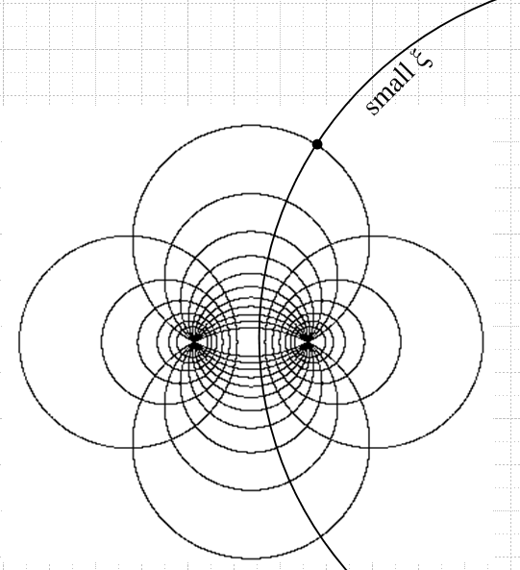

where bowls have label u and toroids label ξ. Suppose our metal bowl of interest were an inner shallow upper bowl. A point near the top right of the outermost upper bowl with coordinates (u,ξ) would have small ξ because small ξ describes a large toroid . Large ξ would describe points near the foci. Thus, if you want to talk about "going far away" from a charged bowl, you are definitely talking small ξ. Not all points with small ξ are far from the bowl, but all points far from the bowl have small ξ!

Lebedev has the solution of this problem on page 241, where he uses τ for p and β for u:
( this is the entire Lebedev problem, I have omitted nothing)
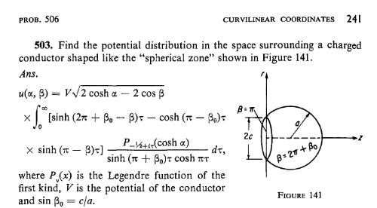

It has my conjectured form with a tricky [ Apch(u) +Bpsh(u)] form. The picture shows β = π on the end slice of the bowl which is correct. The radius of this slice is the toroid radius in the large ξ limit which is called "a" in my notes above, but is called "c" by Lebedev. The bowl radius in my notes above is a/|sin(uo)| so his would be c/|sin(βo)| and he calls this "a", so he has a = c/|sin(βo)| . Also, he has used a bowl which is what I call "upper" (positive z side), so β0> 0 and then c = a sin(βo), just as he states.

So I can regard this problem as "solved by me" if I can just explain the other factors in his result. I don't understand his labeling β = 2π + β0 on the picture. The bowl is defined by β = β0 in (0,π). I will ponder this when I solve this problem. Thank you Lebedev and friends for providing this solution. He has this comment earlier:

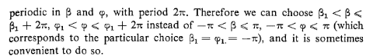

So OK, if the bowl is β = β0, you could choose this for your β range: βo < β ≤ β0+2π. Look at the first picture below and imagine that β0 is one of the bowls shown, perhaps that with β0 = 4π/8. As you increase β from this value (each β marks a "math bowl" = just a surface in space of bowl shape), you move down in the direction of the shallow math bowls such as 7π/8. This range is the left part of the range βo < β ≤ β0+2π. When you hit 8π/8 = π, you have reached the limit where the math bowl is a disk. As you continue to increase β, you move into the realm of the lower "math bowls" as shown in the second figure. Eventually you reach β = 2π which is then the limit of a lower iris. Keep going and you have the upper iris, then upper bowls, and eventually when you reach β ≤ β0+2π, you are back to your starting bowl. So this is just how β is describing one of the coordinates of space with respect to our bowl β0. Therefore, we have shown that β = β0+ε describes the inner (lower) surface of our starting upper bowl, and βo = β0+2π - ε describes the outer (upper) surface. Later if you want to find charge densities or potentials on these surfaces, you would use these limits! Note that this bowl label β is the one with the traditional range (0,2π) and is called u and later η by M&F. It is the ch(u) type label in my form above where I have selected the "second" toroidal atomic form from my general doc on that subject.

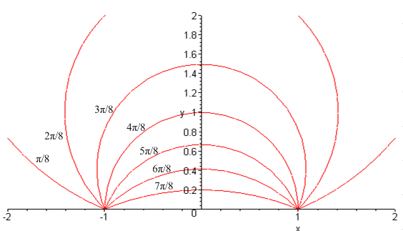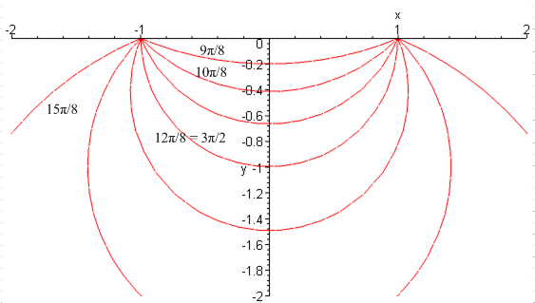

Lebedev quotes some integrals along his path:

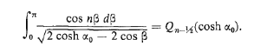

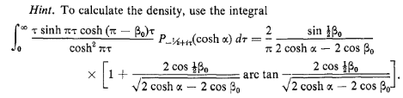

He also points out that you might want to do problems with regions that are bounded by two bowls, and various lenses (with spherical surfaces!) would be such regions. Pages 233-242 are where Lebedev does all his toroidal stuff. Problems are selected not just from electrostatics by the way!

Note added 12.8.10. Notice that his first integral above arises in my Fourier expansion of
1/ $\sqrt{a - b cos(x)}$and I wrote the integral this way

$^{\int_{0}^{π}{}}$dx cos(nx)/ $\sqrt{a - b cos(x)}$ = $\sqrt{2/b}$ Qn-1/2(a/b)

so if I set b = 1 and a = cosh(α0), I duplicate his result.
Unlike the first integral, the second one a Mehler type integral over dτ and this thing might appear in some form in the PBM book which contains such integrals.

Note added 2.2.11. I don't have the above Mehler integral in any table, but I know I could evaluate it if I wanted using methods in math/integral/ "doing Mehler". The form of Lebedev's result is very typical of these integrals.

My Solution for the Charged Bowl

Continuing from above

V(ξ,u,φ) = $\sqrt{chξ - cosu}$$^{\int_{0}^{∞}{}}$ dp Pip-1/2(chξ)[ Apch(u) +Bpsh(u)]

Far top exterior means small u which suggests only sh(u). Ie, far away in the upper red picture.
Far bottom exterior means u near 2π, suggests only sh(2π-u). Ie, far away in lower red picture.
In either case, far away means small ξ. All these facts are noted at the start of this doc.

Normally in toroidal coordinates one takes the u = β to be in the range 0 ≤ u ≤ 2π and this includes ALL the red bowls, upper and lower. The very large upper bowl has u = 0+ε and the red contour lines are (for the most part) "far away" we want V → 0 as u → 0. BUT, we need the potential to also vanish as we go to the very large lower bowl which is u = 2π.

But how do we get our result to vanish for both u = 0 and u = 2π ? I don't think you can do it! In order to vanish at u = 0, need Ap = 0. But then at u = 2π you have Bp sh(2π) = 0 needed as well, which would force Bp = 0 as well, whole solution collapses to nothing. So maybe you are actually FORCED to change the range of u! Consider this picture, where u0 is our charged top bowl: ("top" here means my upper Maple red picture in my toroidals doc ]

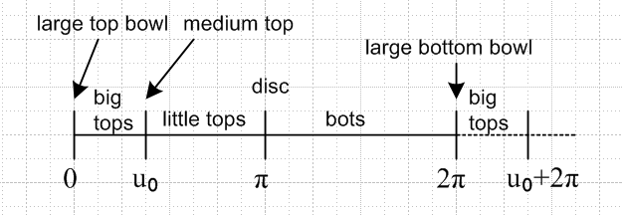

If we start at u0 instead of 0, as L suggests, then we start with our moderately sized top bowl, go inward through all the smaller top bowls, through the flat disk and then into shallow bottom bowls, all the way through the huge negative bowls, then we reflect around to the large top bowls and end up where we started when we get to u0 + 2π. In this scheme, both "huge bowl" regions occur at u = 2π±ε, so we need only make our formula vanish at that one point (rather than at two points for our starting range). That is to say, u = 0 is no longer part of our range, which is still 2π in size. [ Here I replicate the discussion above concerning the math bowls for this adjusted range. ]

Let's just try a Smythian form here and see what happens with our new range. So here is our form for the atomic form u function showing two unknown coefficients Ap and ap,

f(u) = Ap sh(u - ap)

f(2π) = Ap sh(2π - ap) = 0 // gives one condition on our 4 constants

Note added 1.20.11: Why am I setting this to 0? Because u = 2π represents r = ∞? But not all points with u = 2π are at infinity because u = 2π is the lower region iris which has points very close to our charged surface!

=> ap = 2π

=> f(u) = Ap sh(u - 2π)

and our Smythian form is now

V(ξ,u,φ) = $\sqrt{chξ - cosu}$ sh(u - 2π) $^{\int_{0}^{∞}{}}$ dp Pip-1/2(chξ) Ap

Our other condition is that V = constant on the bowl, which says (exterior problem ?)

V(ξ,u=u0,φ)= $\sqrt{chξ - cosu0}$ sh(u0 - 2π) $^{\int_{0}^{∞}{}}$ dp Pip-1/2(chξ) Ap = V0 (***)

Something is already wrong! The integral shown here has some value, call it F(ξ). Then we are saying in our last two equations

V(ξ,u,φ) =$\sqrt{chξ - cosu}$ sh(u - 2π) F(ξ)
V(ξ,u=u0,φ)= $\sqrt{chξ - cosu0}$ sh(u0 - 2π) F(ξ) = V0

We could solve the second equation for F(ξ) to get

F(ξ) = V0/ [$\sqrt{chξ - cosu0}$ sh(u0 - 2π)]

Then our general problem solution is this

V(ξ,u,φ) = $\sqrt{chξ - cosu}$ sh(u - 2π) { V0/ [$\sqrt{chξ - cosu0}$ sh(u0 - 2π)]}

= V0 [ sh(u - 2π)/ sh(u0 - 2π)]

and I KNOW this is not the right solution for a charged bowl! It does vanish at u = 2π. And on the bowl it does have the value V0. And it is independent of ξ.

Note added 1.20.11. Recall in ellipsoidals how the potential of a charged ellipsoid is a function only of the ellipsoid label. Here we are saying that the potential of a charged bowl is a function only of the bowl label. Maybe that is exactly right! Maybe the problem is completely solved right here!! I don't know Ap, but I think I know V(ξ,u,φ) which is what I really want! You could then find Ap from (***) which involves inverting a Mehler transform and this is described below.

How on earth are we going to arrange for this to be true, so integral is independent of ξ ? Let's think of this in the following way [ where we replace Ap by f(p; uo) ]

V(ξ,u=u0,φ)= $\sqrt{chξ - cosu0}$ $^{\int_{0}^{∞}{}}$ dp Pip-1/2(chξ) f(p; uo) = V0 (*) expansion

where f(p; uo) ≡ Ap sh(u0 - 2π)

We of course need the Mehler-Fock transform at this point. I have not yet developed this from the SL problem, so let's steal the result from somewhere. Lebedev calls it the MF theorem, but I want another source. I have it above from a certain book. Bateman (wrong) and AS and WW do NOT have it. Nor in GR7. Only a book that talks toroidals would have this thing I suspect, hence nothing in MF. Nothing in CH. But it is in Dan Z's book on ODE's! I copied his transforms into my transforms.doc, and here is the MF:

This following is from Dan Z ODE, page 351, and I think it is wrong! He quote Chapter 7 of Sneddon's book The Use of Integral Transforms. Dan has a 3rd Ed errata list and the end of his book, and nothing appears there.

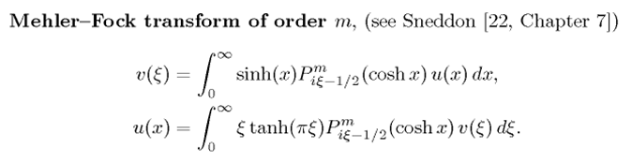
so this form has the cosh stuff preloaded for us. I will translate to my current variables: [ Note: this transform is correctly stated, see "doing Mehler transform integrals.doc" ]

G(p) = $^{\int_{0}^{∞}{}}$dξ sh(ξ) Pip-1/2(chξ) g(ξ) // projection
g(ξ) = $^{\int_{0}^{∞}{}}$ dp p th(πp) Pip-1/2(chξ) G(p) // expansion

Rewrite the above (*) as:

Vo/ $\sqrt{chξ - cosu0}$ = $^{\int_{0}^{∞}{}}$ dp Pip-1/2(chξ) f(p; uo) (**)

So here then is the plan. Let

f(p; uo) = p th(πp) G(p)

g(ξ) = Vo/ $\sqrt{chξ - cosu0}$

Then (**) is our standard expansion, and the projection coefficient is then

G(p) = $^{\int_{0}^{∞}{}}$dξ sh(ξ) Pip-1/2(chξ) g(ξ)
or
f(p; uo)/[ p th(πp)] = V0$^{\int_{0}^{∞}{}}$dξ sh(ξ) Pip-1/2(chξ) / $\sqrt{chξ - cosu0}$

Let x = chξ so dx = shξdξ and this is

G(p) = f(p; uo)/[ p th(πp)] = V0$^{\int_{1}^{∞}{}}$dx Pip-1/2(x) / $\sqrt{x - cosu0}$

So if we could do this integral we would have G(p), hence f(p; uo), hence Ap.

Aside: It was at this point that I found the difference between Russian and English Bateman ET II, see Bateman notes on that volume.

How about this GR7 offering, p 774 with λ = 1, μ=0 and ρ = 1/2

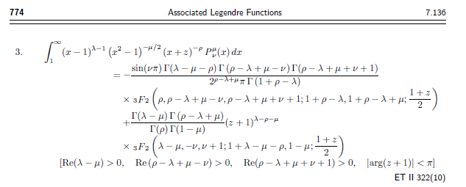
It is a bit heavy duty, but I would set λ = 1, μ = 0. I did a very serious Maple entry job (bowl in toroidals.mws) and careful processing, and I ended up with this nice result:
$^{\int_{1}^{∞}{}}$dx Pip-1/2(x) / $\sqrt{x - cosu0}$ = $\sqrt{2}$ch[p(u0-π)]/ (p sh(πp)) 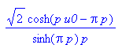

I am assuming u0 is in (0,π) and this means u0/2 is in (0,π/2) and that means sin(u0/2) and cos(u0/2) are positive, something I had to tell Maple. I bet I can find this somewhere now that I know the answer.

Aside: Can I get verification of the above integral somewhere? Not as such in GR or ET II or HT I. GR7 p 980 has the same as HT I really. This led to me downloading the PBM integral books, and in conical function data.doc I do verify the above integral from a completely different starting point!

So let's finish off our problem now. We then have

f(p; uo)/[ p th(πp)] = V0$\sqrt{2}$ch[p(u0-π)]/ (p sh(πp))

f(p; uo) = p th(πp) V0$\sqrt{2}$ch[p(u0-π)]/ (p sh(πp)) = V0$\sqrt{2}$ch[p(u0-π)]/ (ch(πp))

but we had earlier that

f(p; uo) = Apsh(u0 - 2π)

so we find that

Ap = V0$\sqrt{2}$ch[p(u0-π)]/ (ch(πp) sh(u0-2π))

and there is our coefficient! Our solution is then

V(ξ,u,φ) = $\sqrt{chξ - cosu}$$^{\int_{0}^{∞}{}}$ dp Pip-1/2(chξ) Ap sh(u - 2π)

= $\sqrt{chξ - cosu}$$^{\int_{0}^{∞}{}}$ dp Pip-1/2(chξ) sh(u - 2π) { V0$\sqrt{2}$ch[p(u0-π)]/ (ch(πp) sh(u0-2π))}

= V0$\sqrt{2}$ [ $\sqrt{chξ - cosu}$ sh(u - 2π)/ sh(u0-2π) ] $^{\int_{0}^{∞}{}}$ dp Pip-1/2(chξ) ch[p(u0-π)]/(ch(πp))

Maybe I can check what happens when u =u0 :

V(ξ,u0,φ) = V0$\sqrt{2}$ [ $\sqrt{chξ - cosu0}$ $^{\int_{0}^{∞}{}}$ dp Pip-1/2(chξ) ch[p(u0-π)]/(ch(πp))

but then I need this integral which I don't know without doing some work.

Compare my result to his result

Here is Lebedev's quoted result,

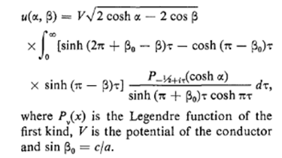

which I now translate

u(ξ,u) = V0$\sqrt{2}$$\sqrt{chξ - cosu}$ * $^{\int_{0}^{∞}{}}$ dp Pip-1/2(chξ) *

{ sh[(2π+u0-u)p] - ch[(π-u0)p] sh[(π-u)p] }/ ( sh[(π+u0)p] ch(πp) )

Our results would manifestly agree if I could show that

sh(u - 2π)/ sh(u0-2π) * ch[p(u0-π)]/(ch(πp)) // mine

= { sh[(2π+u0-u)p] - ch[(π-u0)p] sh[(π-u)p] }/ ( sh[(π+u0)p] ch(πp) ) // his
or
sh(u - 2π)/ sh(u0-2π) * ch[p(u0-π)] = { sh[(2π+u0-u)p] - ch[(π-u0)p] sh[(π-u)p] }/ ( sh[(π+u0)p]) (*)
or
sh(u - 2π) ch[p(u0-π)] sh[(π+u0)p] = sh(u0-2π) { sh[(2π+u0-u)p] - ch[(π-u0)p] sh[(π-u)p] }
h1 = h2

If these two expressions are to be the same, they must be the same for any special case I can concoct. For example, if u = 2π, the LHS = 0. Is the RHS zero as well ? The only way that could happen is if the bracket vanishes. That would say

{ sh[(2π+u0-2π)p] - ch[(π-u0)p] sh[(π-2π)p] } =?= 0

{ sh[(u0)p] - ch[(π-u0)p] sh[(-π)p] } =?= 0

But now let u0 = 0 and this becomes

{ ch[(π)p] sh[(π)p] } =?= 0

and this does not fly. So either one of us has made a mistake, or the integrals are the same even though the integrands are different.

Check some Limits of My Result

First, here is my result from above,

V(ξ,u,φ) = V0$\sqrt{2}$ [ $\sqrt{chξ - cosu}$ sh(u - 2π)/ sh(u0-2π) ] $^{\int_{0}^{∞}{}}$ dp Pip-1/2(chξ) ch[p(u0-π)]/(ch(πp))

This thing is supposed to vanish when we take u → 2π since that is "far away". My result manifestly vanishes in this limit.
How does his result vanish in this limit? His result becomes

u(ξ,u) = V0$\sqrt{2}$$\sqrt{chξ - 1}$ * $^{\int_{0}^{∞}{}}$ dp Pip-1/2(chξ) *

{ sh[(u0)p] + ch[(π-u0)p] sh[πp] }/ ( sh[(π+u0)p] ch(πp) )

It is not obvious that this vanishes. Suppose we ALSO take the limit u0 = 0 which is the disk as I did it above. Then my result of course still vanishes, and his becomes

u(ξ,u) = V0$\sqrt{2}$$\sqrt{chξ - 1}$ * $^{\int_{0}^{∞}{}}$ dp Pip-1/2(chξ) *

{ ch[πp] sh[πp] }/ ( sh[πp] ch(πp) )

= V0$\sqrt{2}$$\sqrt{chξ - 1}$ * $^{\int_{0}^{∞}{}}$ dp Pip-1/2(chξ)

PBM gives this integral

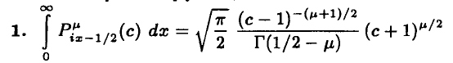

which I can translate for μ = 0 to say

$^{\int_{0}^{∞}{}}$ dp Pip-1/2(chξ) = $\sqrt{π/2}$ (chξ-1)-1/2 /Γ(1/2) = (1/$\sqrt{2}$) 1 / $\sqrt{chξ - 1}$

and then we get

u(ξ,u) = V0$\sqrt{2}$$\sqrt{chξ - 1}$ * (1/$\sqrt{2}$) 1 / $\sqrt{chξ - 1}$ = V0

So his result is going to V0 when u = 2π and u0 = 0.

Notes Added 1.20.11. While doing a web search, I found an obscure paper from which I quote:

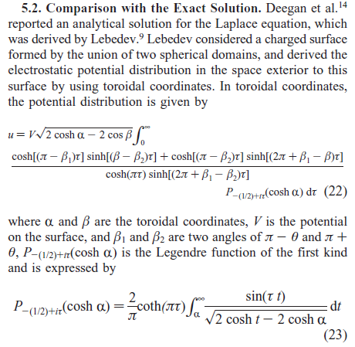

I think it is actually ref (14) that gets this formula. I am now trying Marriott on line PROLA and I get at least this far

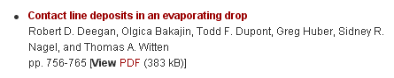
But I can't get in of course, too bad. But then I found it on line and I have it, a preprint. But the preprint has a different result, and does not contain any figures, ouch! I will have to go there in person. Found while browsing:

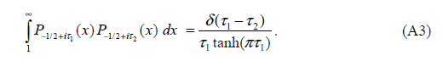

This is exactly the book I have! For comparison, here is Leb's problem 503 solution

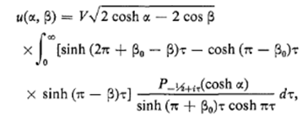

I don't see (22) appearing in the book, but the above makes me think that this Problem 503 is really not about a spherical bowl, but a spherical bowl with a flat metal lid on it! This must be what Lebedev means by a spherical zone!!! I suspect that (22) above is a generalization of Lebedev's result which applies to the surface defined by two bowls of β1 and β2. If in (22) I were to set β2 = π to apply the flat lid, then the two results agree exactly with β1 = β0. Mystery is now explained!!!
The paper in which (22) appears concerns itself with the physics of the evaporation of a drop of liquid which exists on some surface, like a drop of water on the top of your car. It seems that such a "sessile drop" assumes the shape of a spherical cap (certainly not obvious to me), and somehow the evaporation theory is analogous to potential theory (perhaps evaporation is diffusion) and the electrostatic potential of the analogous problem tells you something about evaporation.

(1) So the reason that my spherical bowl result does not agree with Lebedev's result is that we have done different problems! So now I am motivated to find a web verification of my simple answer for the bowl which is this:

V(ξ,u,φ) = V0 [ sh(u - 2π)/ sh(u0 - 2π)]

Again, this is strikingly similar to the result for the charged ellipsoid. I think I could derive the above afresh in a similar manner, perhaps apart from the R-separation factor issue.
What about taking a limit of (22) as β1 = β2. This would describe the potential outside a bowl I think.

Here is the big factor (22) written out by me where I set β1 = β2 = β0:

{ ch[(π-β0)τ] sh[(β-β0)τ] + ch[(π-β0)τ]sh[(2π+β0-β)τ] }/ { ch(πτ)sh(2πτ) }

which I now try to simplify

= ch[(π-β0)τ]{ sh[(β-β0)τ]+ sh[(2π+β0-β)τ]/ { ch(πτ)sh(2πτ) }

I can try the Schaum sh + sh formula which says

shx + shy = 2 sh(x+y)/2 * ch(x-y)/2

Set x = (β-β0)τ and y = (2π+β0-β)τ so

(x+y)/2 = [(β-β0)τ + (2π+β0-β)τ]/2 = πτ
(x- y)/2 = [(β-β0)τ - (2π+β0-β)τ]/2 = (β-β0)τ - πτ

=> sh[(β-β0)τ]+ sh[(2π+β0-β)τ] = 2 sh(πτ) ch[(β-β0)τ - πτ]

Then our big factor has become

= ch[(π-β0)τ]{ sh[(β-β0)τ]+ sh[(2π+β0-β)τ]/ { ch(πτ)sh(2πτ) }

= 2 ch[(π-β0)τ]{ sh(πτ) ch[(β-β0)τ - πτ] / { ch(πτ)sh(2πτ) }

Now write sh(2πτ) = 2 sh(πτ)ch(πτ) and we have

= ch[(π-β0)τ] ch[(β-β0)τ - πτ] / ch2(πτ)

which is not very pleasant. I was hoping for better. I was hoping for a result of this form

V(ξ,β,φ) = V0$\sqrt{2}$ [ $\sqrt{chξ - cosβ}$ sh(β - 2π)/ sh(β0-2π) ] $^{\int_{0}^{∞}{}}$ dτ Piτ-1/2(chξ) ch[τ(β0-π)]/(ch(πτ))

and in order to get this, I have to show that

ch[(π-β0)τ] ch[(β-β0)τ - πτ] / ch2(πτ) = [sh(β - 2π)/ sh(β0-2π)] ch[τ(β0-π)]/(ch(πτ))
or
ch[(β-β0)τ - πτ] / ch(πτ) = [sh(β - 2π)/ sh(β0-2π)]
or
sh(β0-2π) ch[(β-β0)τ - πτ] = ch(πτ)sh(β - 2π)

This is clearly not true since if β = 2π the RHS = 0 but LHS is not 0. So the limit of the general formula does not give my result, too bad.

