Charged Donut PhL 2.10.11

Comments: This was my first "outing" with the donut stuff. The first two sections I think are OK, but after that I make so many errors and wrong statements that this doc is pretty worthless. However, it was here that I hacked the path which later got cleaned up, so I keep this file for a while.

Nothing new on 12.31.15. I think some things below are now in bowl doc.

1.The donut in toroidals 1
(a) obtaining the potential 1
(b) The large r limit and the capacitance formula and its web verification 3
2. Plotting the donut potential in Maple 7
3. Capacitance in the fat donut limit (R = ρ_{c}) 8
(a) the PBM formula 9
(b) Can Maple demonstrate this PBM infinite sum? 10
Changing the gammas makes no improvement. 12
Resume. 13
(c) Trying to take the z → 1+ limit of the capacitance sum 13
4. Back to the original Capacitance sum, best plot so far 17
5. A look at the thin-ring limit 18
(a) Keeping only the n=1 term 18
(b) What is the large z limit of P_{-1/2}(z) ? 21
(c) Repair the thin wire capacitance approximation 22

1.The donut in toroidals

It seems useful to include a solution to this problem in this report.

(a) obtaining the potential

Looking back at the two toroidal atomic forms, we can see that for problems involving a donut as boundary, ξ = ξ0, we must be oscillatory in the other two coordinates u and φ. Thus we select

expo osc osc
(1) $\sqrt{chξ - cosu}$ [Pn-1/2m(chξ), Qn-1/2m(chξ) ] [ sin(nu),cos(nu)] [ sin(mφ),cos(mφ)]

It is convenient for this problem to put bowl label u in the range (-π,π) as suggested by this picture

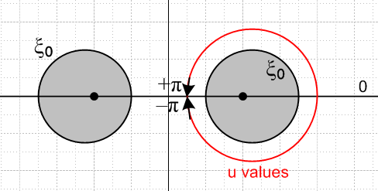

Unlike the situation with the bowl problem, the red path of u values around the grey donut core is unobstructed so the potential must be periodic in u with period 2π, and this fact causes quantization of the parameter n appearing in the atomic form to be an integer. Furthermore, we can see that with this range of u, the potential must be symmetric V(ξ,u) = V(ξ,-u), so only the cos(nu) term survives. Thus we arrive at the following Smythian form for the potential of a charged donut

V(ξ,u) = $\sqrt{chξ - cosu}$ Σn=0∞ Pn-1/2(chξ) Ancos(nu)

where An are coefficients to be determined. As in the bowl case, the Q function is ruled out since it diverges at ξ = 0, whereas ξ = 0 is part of the condition for being "far away" where the potential must vanish . The other part of that condition is u=0.

The boundary condition is constant potential V0 on the charged donut surface

V0 = $\sqrt{chξ0 - cosu}$Σn=0∞ Pn-1/2(chξ0) An cos(nu)
or
V0/$\sqrt{chξ0 - cosu}$ = Σn=0∞ Pn-1/2(chξ0) An cos(nu)

We can invert this to find the An using the normal Fourier Series Cosine Transform whose orthogonality relation is

$^{\int_{0}^{π}{}}$du cos(nu)cos(n'u) = (π/εn) δnn' where εn = 2-δn,0

Applying $^{\int_{0}^{π}{}}$du cos(n'u) to both sides and then replacing n' by n we find

V0$^{\int_{0}^{π}{}}$du cos(nu)/ $\sqrt{chξ0 - cosu}$ = Pn-1/2(chξ0) An (π/εn)

Now it happens that the Fourier expansion of 1/$\sqrt{a - b cos(x)}$ is given by

1/$\sqrt{a - b cos(x)}$ = (1/π) $\sqrt{2/b}$ Σn=0∞ εn Qn-1/2(a/b) cos(nx) // expansion

$^{\int_{0}^{π}{}}$dx cos(nx)/ $\sqrt{a - b cos(x)}$ = $\sqrt{2/b}$ Qn-1/2(a/b) // projection

so
$^{\int_{0}^{π}{}}$du cos(nu)/ $\sqrt{chξ0 - cosu}$ = $\sqrt{2}$ Qn-1/2(chξ0)

and therefore our coefficient is

An = V0 ($\sqrt{2}$εn/π) Qn-1/2(chξ0)/ Pn-1/2(chξ0)

and then the potential of our charged donut is given by

V(ξ,u) = V0 ($\sqrt{2}$/π)$\sqrt{chξ - cosu}$ Σn=0∞ εn Pn-1/2(chξ) [Qn-1/2(chξ0)/ Pn-1/2(chξ0)]cos(nu)

The factor εn = 2-δn,0 is sometimes called the Neumann's factor and is of course 2 except for n=0 when it is 1 and is related to reflection of the negative part of an integer series over to the positive side where everything gets doubled except the n=0 term. We think this name and notation for εn came from Watson's Bessel function treatise, to wit

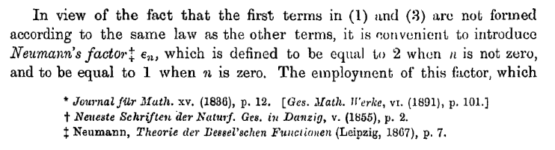

In any event, Morse and Feshbach give the above solution to the charged donut problem, but they inadvertently omit the Neumann's factor :

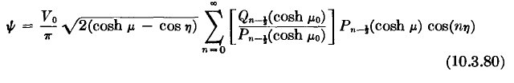
I asked son Mark Feshbach if he knew of an errata collection for the massive 2000 page masterwork coauthored by his father, but he knew of none, which is regrettable.

Meanwhile, we can verify our boundary condition by setting ξ = ξ0 in our solution to get

V(ξ0,u) = V0 ($\sqrt{2}$/π)$\sqrt{chξ - cosu}$ Σn=0∞ εn Qn-1/2(chξ0) cos(nu)

But from our expansion above we know that

1/$\sqrt{chξ - cosu}$ = ($\sqrt{2}$/π) Σn=0∞ εn Qn-1/2(chξ) cos(nu)

so we then get V(ξ0,u) = V0.

(b) The large r limit and the capacitance formula and its web verification

We start with our donut potential

V(ξ,u) = V0 ($\sqrt{2}$/π)$\sqrt{chξ - cosu}$ Σn=0∞ εn Pn-1/2(chξ) [Qn-1/2(chξ0)/ Pn-1/2(chξ0)]cos(nu)

Since large r means ξ→0 and u→0 we can set Pn-1/2(chξ) = 1 and cos(nu) = 1 to get

V(ξ,u) ≈ V0 ($\sqrt{2}$/π)$\sqrt{chξ - cosu}$ Σn=0∞ εn [Qn-1/2(chξ0)/ Pn-1/2(chξ0)]

As in the bowl problem, we know that $\sqrt{chξ - cosu}$ ≈ $\sqrt{2}$a / r in the "far limit" so we get

V(ξ,u) ≈ V0 ($\sqrt{2}$/π) $\sqrt{2}$a / r * Σn=0∞ εn [Qn-1/2(chξ0)/ Pn-1/2(chξ0)]

If we think of this as V = Q/r and using Q = CV0 we find

Q = ( 2V0a/π ) [Σn=0∞ εn [Qn-1/2(chξ0)/ Pn-1/2(chξ0)] ]

C = ( 2a/π ) [Σn=0∞ εn [Qn-1/2(chξ0)/ Pn-1/2(chξ0)] ]

Here is a web verification from a pdf file, MS means Moon and Spencer
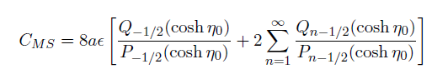

and we agree! This is from page 375 of this book (which Marriott does not have)

Another source of this formula is my Canonical doc page Section 5.5 page 217 in pdf,

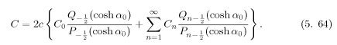

where here the Cn are some Smythian coefficients. Nothing more said, ref [24] is off in the Russian world of reports that are hard to get. I just did a 30 minute web search on

toroid capacitance "toroidal coordinates" -springerlink -elsevier

and of the 110 hits, could find nothing useful. If this is some "well known" special function, it is not very well known!

As our toroidal equation collection shows, R = a/shξ0 is the radius of the donut cross section (about 1/2" for an edible donut), so we get

C = ( 2Rshξ0/π ) Σn=0∞ εn [Qn-1/2(chξ0)/ Pn-1/2(chξ0)]

Sometimes the distances shown in this picture are useful

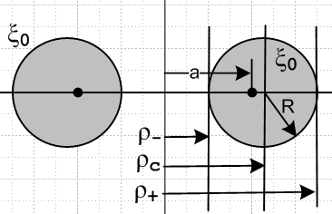

ρ- = a(chξ0-1)/shξ0 = a 2 sh2(ξ0/2) / 2 sh(ξ0/2)ch(ξ0/2) = a tanh(ξ0/2)
ρ+ = a(chξ0+1)/shξ0 = a 2 ch2(ξ0/2) / 2 sh(ξ0/2)ch(ξ0/2) = a coth(ξ0/2)
ρc = a cthξ0
ρc/R = chξ0
R = a/shξ0 => $\sqrt{ρc2 - R2}$ = a $\sqrt{coth2ξ0 - csch2ξ0}$ = a

from which we find that

C = ( 2$\sqrt{ρc2 - R2}$/π ) [Σn=0∞ εn [Qn-1/2(ρc/R)/ Pn-1/2(ρc/R)] ]

In SI units we multiply by 4πε0 to get

CSI(ρc, R) = ( 8ε0$\sqrt{ρc2 - R2}$ ) [Σn=0∞ εn [Qn-1/2(ρc/R)/ Pn-1/2(ρc/R)] ]

which we can compare with Carlos Q's paper, who has σn = (1/2)εn ,

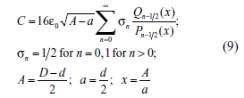

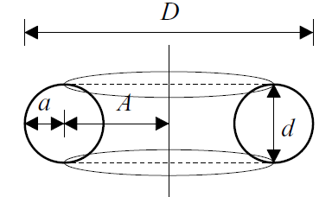

So Carlos should really have $\sqrt{A2-a2}$ . I just sent him an email, wonder if he will reply. // He did, and he has since fixed the error on his site!

http://www.coe.ufrj.br/~acmq/papers/papers.html

Dr. Antonio Carlos Moreirão de Queiroz is Associate Professor at COPPE, Electrical Engineering Program, and at the Electronic and Computer Engineering Department of the Polytechnic School, Federal University of Rio de Janeiro (UFRJ).

He obtained the B. Sc in electronic engineering (1979) from UFRJ, and the M. Sc. (1984) and D. Sc. (1990), in electrical engineering, from COPPE/UFRJ.

His current interests are in circuit theory, switched-current filter structures and analysis methods, techniques for the design of high-frequency continuous-time filters, approximation techniques for general-purpose filters, analysis and simulation techniques for electronic circuits, radiofrequency circuits, and history of science.

So I think I have at least verified my results:

C = (2shξ0R/π ) Σn=0∞ εn [Qn-1/2(chξ0)/ Pn-1/2(chξ0)]

This is much uglier than the capacitance of a bowl, I wonder why that is so? Is there some way to do this sum? Neither paper I looked at suggested anything.

[7]: W. M. Hicks, ``On toroidal functions,'' Philos. Trans. Roy. Soc., v. 171, 1881, p. 609-652. [8]: G. M. Minchin, ``The magnetic field of a circular ...
w

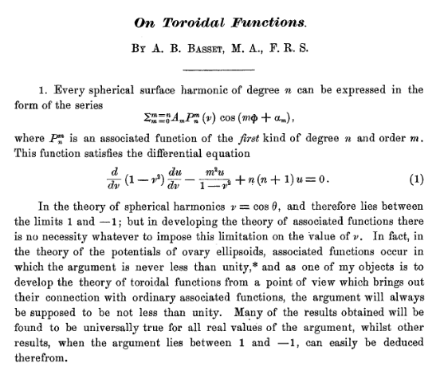

I found this entire article in google books, but no mention of capacitance, so it must be Chester Snow who really did that formula. Carlos says it appears in Hicks but I don't see it.

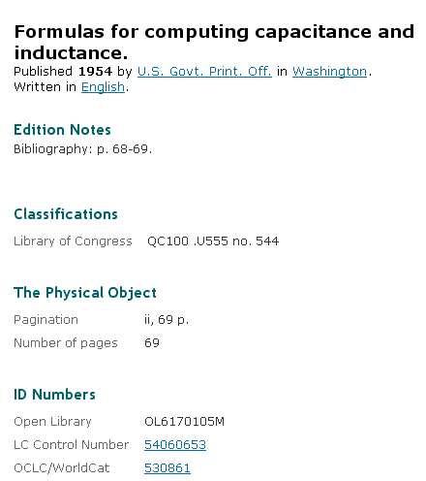

Marriott does not have this book.

Well, I know my formula is right, so I will let Carlos worry about where he got his formula from!

2. Plotting the donut potential in Maple

I have this going pretty well, but I see that it is using the V expression inside the donut which is wrong since we want a constant inside the donut . We have from above

V(ξ,u) = V0 ($\sqrt{2}$/π)$\sqrt{chξ - cosu}$ Σn=0∞ εn Pn-1/2(chξ) [Qn-1/2(chξ0)/ Pn-1/2(chξ0)]cos(nu)

Maybe we just plot ξ = 0..ξ0 to stay on the outside!

OK, I have this plot looking fine.

The capacitance now has a strange result . I know that

Qν(z) / Pν(z) = π (2z)-2ν-1 [Γ(ν+1)]2 /[Γ(ν+3/2)Γ(ν+1/2)] as z→ ∞

So in our capacitance series, in this limit only the first term will survive, the one having ν = -1/2

Q-1/2(z) / P-1/2(z) = π [Γ(1/2)]2 /[Γ(1)Γ(ν+1/2)] = π2 / Γ(ν+1/2) = π2/Γ(0) = 0

so I guess this is what I always expect, the wire just "goes away" in the limit.

3. Capacitance in the fat donut limit (R = ρc)

Here is our capacitance formula

C = ( 2$\sqrt{ρc2 - R2}$/π ) [Σn=0∞ εn [Qn-1/2(ρc/R)/ Pn-1/2(ρc/R)] ]

Things are pretty exciting as we let R→ρc. This seems physically to be a non-dramatic limit. The hole in the donut is squeezed out at the last instant of this limit. We see that $\sqrt{ρc2 - R2}$ has a zero at this point, but what happens to the series? I think we can say Pn-1/2(ρc/R) → Pn-1/2(1) = 1, so it is only the Q function which is at issue here. So we have in this limit [ it turns out that you cannot just set P = 1 ! ]

C ≈ ( 2$\sqrt{ρc2 - R2}$/π ) Σn=0∞ εn Qn-1/2(ρc/R)

Perhaps let z = ρc/R to get

C ≈ ( 2R $\sqrt{z2 - 1}$/π ) Σn=0∞ εn Qn-1/2(z) as z→ 1

In order to study this limit, we need a form for Q that converges at z = 1. This is a very difficult limit. None of the Bateman standard forms converges at z = 1 as best I can tell. This seems reasonable since I know Q diverges there.
But here is an interesting limit from page 163 Bateman

Qν(z) = -(1/2)ln[(z-1)/2] – γ - ψ(ν+1)

where ψ(z) = = ∂z[ ln(Γ(z))] =Γ'(z)/Γ(z) , Bateman page 15, called the digamma function. Maple knows about both lnGAMMA(z) = ln(Γ(z)) and Psi(z) = ψ(z) for the digamma. As for γ ,

-ψ(1) = γ = .577 = Euler's constant, page 1.

ψ(ν+1) is finite at all our n-1/2 points of interest, but it does grow in some log sense

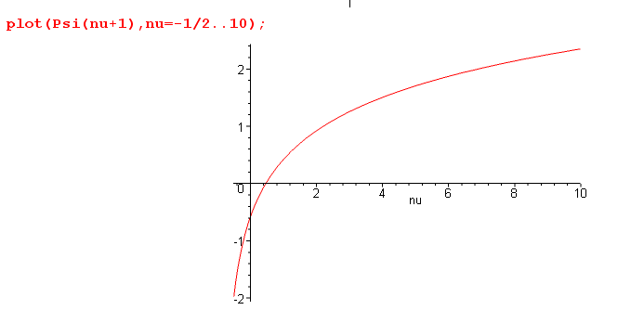

so it can get "large" at large n-1/2. But I think the point is that Qν(z) is at z = 1 is dominated by the log term shown which is the same for all ν. But if we put this into our C formula, then the series diverges and we multiply by the 0, and things are just not clear. [ You cannot run the z→1 limit through the infinite sum limit in this case! ]

(a) the PBM formula

I just found this in PBM (the Q definition matches Bateman (41). )

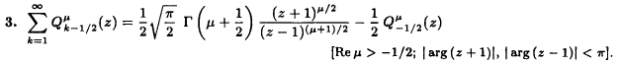

I can write this as

Σn=1 2 Qμn-1/2(z) = $\sqrt{π/2}$Γ(μ+1/2) (z+1)μ/2 (z-1)-(μ+1)/2 – Qμ-1/2(z)

or

Qμ-1/2(z) + Σn=1 2 Qμn-1/2(z) = $\sqrt{π/2}$Γ(μ+1/2) (z+1)μ/2 (z-1)-(μ+1)/2

or

Σn=0 εn Qμn-1/2(z) = $\sqrt{π/2}$Γ(μ+1/2) (z+1)μ/2 (z-1)-(μ+1)/2

and then setting μ = 0 this gives

Σn=0 εn Qn-1/2(z) = $\sqrt{π/2}$Γ(1/2) (z-1)-(1/2) = (π/$\sqrt{2}$) / $\sqrt{z-1}$
or
$\sqrt{z-1}$ Σn=0 εn Qn-1/2(z) = (π/$\sqrt{2}$) // valid for and z on the principle sheet I think

which is JUST the kind of thing I have been looking for!

The C formula above says [ this is wrong since you cannot set P = 1 ]

C ≈ ( 2R$\sqrt{z2 - 1}$/π ) Σn=0∞ εn Qn-1/2(z) as z→ 1

≈ ( 2R $\sqrt{2}$$\sqrt{z-1}$/π ) Σn=0∞ εn Qn-1/2(z)

= (R2 $\sqrt{2}$/π) { $\sqrt{z-1}$ Σn=0 εn Qn-1/2(z)}

= (2R $\sqrt{2}$/π) (π/$\sqrt{2}$) = 2R // wrong

So the big answer is in: The toroid in the limit shown below has twice the capacitance of a sphere the which has radius R..

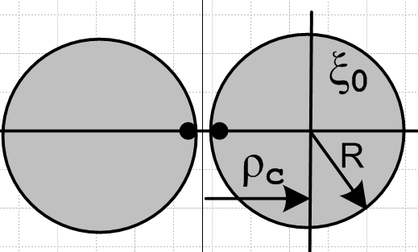

But numerically, I have trouble getting to 2, I get to about 1.74. Why is that?

(b) Can Maple demonstrate this PBM infinite sum?

I am quite happy setting all the denominator P's to 1. I suppose that could cause some subtle problem, but let's for the moment assume that is OK to do. Then I would like to see what Maple says about our PBM sum rule

$\sqrt{z-1}$ Σn=0 εn Qn-1/2(z) = (π/$\sqrt{2}$) = 2.22144

$\sqrt{chξ-1}$ Σn=0 εn Qn-1/2(chξ) = (π/$\sqrt{2}$) = 2.22144

Σn=0 εn Qn-1/2(chξ) = (π/$\sqrt{2}$)(1/$\sqrt{chξ-1}$)

Here is a case study. I set [ this work is (was!) in PandQ v2.mws ]

NOTE: The code below should have eps(n-1) so it giving wrong results. See "toroidal cap function.doc" for a correct numerical study of this PBM sum rule. Also, file PandQ v2.mws has been deleted, and the work is done in TCF1.mws. But the unstable nature of the sum is still true.

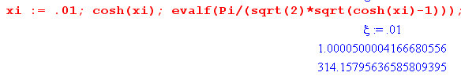

so we are talking z = 1.00005, which is fairly close to 1. Then we do this:

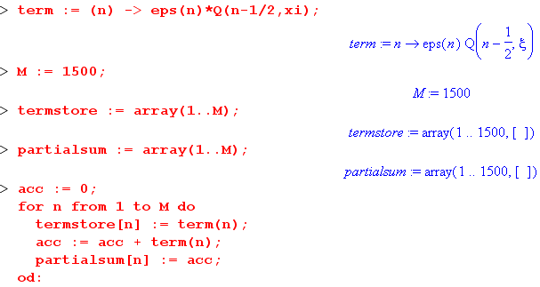

So I compute each term only once to save CPU time, and I store both the terms in termstore, and the partial sums in partialsum. Here are the results:

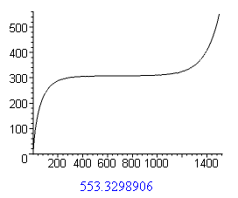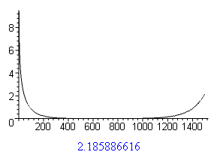

This is a classic situation in numerical work, nice to see it happening in fact. On the right we have the terms getting smaller and smaller, but after a while, they start getting larger again due to some kind of numerical error in our F function

We are close to the branch point at Z = 1 of this thing, and I guess Maple has a tough time when ν = 1500. For example, we have



and then this thing gets squared!

Changing the gammas makes no improvement. It might help to use this formula

22x-1 Γ(x)Γ(x+1/2) = $\sqrt{π}$ Γ(2x)

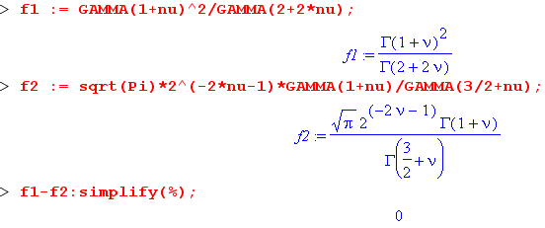

First, here are the original formulas

Qν(z) = 2ν [Γ(1+ν)]2 (z+1)-ν-1/Γ(2+2ν) * F(1+ν,1+ν,2+2ν, 2/(1+z)
Q(ν,ξ) = Qν(chξ) = 2ν [Γ(1+ν)]2 (chξ+1)-ν-1/Γ(2+2ν) * F(1+ν,1+ν,2+2ν, 2/(1+chξ)

Then we can replace

[Γ(1+ν)]2/Γ(2+2ν) = $\sqrt{π}$ 2-2ν-1 Γ(1+ν)/ Γ(3/2+ν)

to get

Qν(z) = 2ν [Γ(1+ν)]2 (z+1)-ν-1/Γ(2+2ν) * F(1+ν,1+ν,2+2ν, 2/(1+z)

= $\sqrt{π}$ 2-2ν-12ν (Γ(1+ν)/ Γ(3/2+ν)) (z+1)-ν-1 F(1+ν,1+ν,2+2ν, 2/(1+z)

= $\sqrt{π}$ 2-ν-1 [Γ(1+ν)/ Γ(3/2+ν)] (z+1)-ν-1 F(1+ν,1+ν,2+2ν, 2/(1+z)

Q(ν,ξ) = Qν(chξ) = $\sqrt{π}$ 2-ν-1 [Γ(1+ν)/ Γ(3/2+ν)] (chξ+1)-ν-1 F(1+ν,1+ν,2+2ν, 2/(1+chξ)

I doubt this will make any difference, but I will give it a spin. The check confirms Q is still matching LegendreQ.

Results are exactly the same, no surprise. Maple knows how to do things. Here is another fact.

In theory Maple should not care how large numbers are. This could somehow be an example of an "asymptotic series". I have only a few notes on that in Scheid, but I think the PBM quoted series is a convergent series.

Resume. OK, let's forget this tail problem and look in the good region and replot the above data.

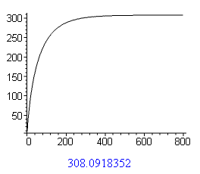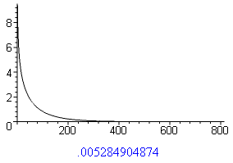

Above we showed that our goal is about 314, and we are getting to 308 which is pretty convincing. But to get most of the way, we see that you really need to do about 400 terms!!! Here again is our case

I was doing my capacitor plot earlier with perhaps 100 terms and kept coming out low, and this is why.

(c) Trying to take the z → 1+ limit of the capacitance sum

Discovery: It is the P term that causes the discrepancy! If you set it to 1, you get the PBM series limit very well, you get 1.99 instead of 1.74. So let's go back to our problem:

C = ( 2$\sqrt{ρc2 - R2}$/π ) [Σn=0∞ εn [Qn-1/2(ρc/R)/ Pn-1/2(ρc/R)] ]

Set z = ρc/R > 1 to get

C(z) = ( 2R$\sqrt{z2 - 1}$/π ) Σn=0∞ εn [Qn-1/2(z)/ Pn-1/2(z)]

This is the thing we want the limit of as z → 1+. We need behaviors near this, not just at it.

How about (14) for P

Pν(z) = F(-ν,1+ν;1;(1-z)/2) ≈ 1 + (-ν)(ν+1)(1-z)/2 ν = n-1/2 ν+1 = n+1/2

Pn-1/2(z) ≈ 1 + (n-1/2)(n+1/2)(z-1)/2 = 1 + (n2-1/4) (z-1)/2

Then we write our sum as:

Σn=0∞ εn [Qn-1/2(z)/ Pn-1/2(z)] ≈ Σn=0∞ εn Qn-1/2(z)/ {1 + (n2-1/4) (z-1)/2}

But I don't know what to do next.

New idea

f(z) = Σn=0∞ εn [Qn-1/2(z)/ Pn-1/2(z)]

f'(z) = Σn=0∞ εn { Pn-1/2(z) Qn-1/2'(z) - Qn-1/2(z) Pn-1/2'(z) }/Pn-1/2(z)2

= Σn=0∞ εn { W[Pn-1/2(z), Qn-1/2(z) ]}/Pn-1/2(z)2

But Leg prop doc says

W[Pn-1/2(z), Qn-1/2(z) ] = (1-z2)-1

f'(z) = Σn=0∞ εn (1-z2)-1 /[Pn-1/2(z)]2 = (1-z2)-1 Σn=0∞ εn /[Pn-1/2(z)]2

But what good does it to even to know f'(1) if we don't know f(1) ?

Smythe page 144 says

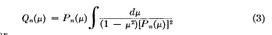

which at least gives an idea for handling the ratio.

Note added 2.22.11. Here is a trivial derivation of the above formula:

PQ'-QP' = W = (1-z2)-1

(Q/P)' = (PQ'-QP')/P2 = 1/[(1-z2)P2] => Q(z)/P(z) = $^{\int_{}^{z}{}}$dz /[(1-z2)P2]

This is the M&F "usual" method of finding a second kind function from a first kind one, I never realized until just this minute that this is just a restatement of the Wronskian! If we want to have two endpoints, we cannot use z=1 because Q blows up there, but we might try this

Q(z)/P(z) - Q(∞)/P(∞) = $^{\int_{∞}^{z}{}}$dz /[(1-z2)P2]

From section 5a above we found that Qν(z)/ Pν(z) ≈ (2z)-2ν-1 = 0 when z→∞ for our ν. Therefore we seem to have this result

Qν(z)/Pν(z) = – $^{\int_{z}^{∞}{}}$dz' /[(1-z'2)Pν(z')2]

This does not seem to appear in Bateman's Legendre chapter anywhere. Nor in AS 2009. Nor in GR7 which just seems to come from Bateman. PBM talks P Q on pages 162,326,592,661 but nada! Is this result just too simple for them to record, or is it wrong? Maple does not know this integral. Not in WW. Only Smythe has this little formula!! I will just assume it is valid as I have written it. Then

T(z) ≡ $\sqrt{z2 - 1}$Σn=0∞ εn [Qn-1/2(z)/ Pn-1/2(z)]

= - $\sqrt{z2 - 1}$ Σn=0∞ εn $^{\int_{z}^{∞}{}}$dz' /[(1-z'2)Pn-1/2(z')2]

= - $\sqrt{z2 - 1}$$^{\int_{z}^{∞}{}}$dz' (1/(1-z')2) [Σn=0∞ εn / Pn-1/2(z')2]

If I knew this 1/P2 sum maybe this would lead somewhere, but as it is, there is no where to go.

But then you have a sum of inverse P's, and PBM don't show any sums of any inverse P or Q functions, I just paged through it all. This is sort of what I just did above. Let's look at that series

g(z) ≡ Σn=0∞ εn /[Pn-1/2(z)]2 with [Pn-1/2(z)]2 ≈ 1 + (n2-1/4) (z-1) + O(n4 (z-1)2 + ...

If z-1 is very small, we might get away with this first order correction so we have

g(z) ≈ Σn=0∞ εn / [1 + (n2-1/4) (z-1)]

Now

[1 + (n2-1/4) (z-1)] = 1 -(1/4)(z-1) + (z-1)n2 = (z-1) [ n2 + α2 ] α2(z) = [1 -(1/4)(z-1)]/(z-1)

So then

g(z) = (z-1)-1 Σk=0∞ εk /(k2 + α2) α2(z) = [1 -(1/4)(z-1)]/(z-1) ≈ 1/(z-1) = large and > 0

Is this a series that maybe has a sum?

In our case, we will have (k2+α2) = (k+iα)(k-iα) so the integrand is even in k so we can reflect the negative sum to the positive and get this

= Σk=0∞ εk / [(k+a)(k+b)]

So factor (k2+α2) = (k+iα)(k-iα) so set a = iα and b = -iα

Σk=0∞ εk /(k2 + α2) = π/(-2iα)[ cot(πiα) - cot(-πiα) ] = π /(-2iα)[ 2cot(πiα) ]

= π /(-iα)[ cot(πiα) ] = π (i/α) cot(iπα) = π (i/α) [ -icoth(πα)] = π coth(πα)/α **

So if this was all justified, we have shown that

Σn=0∞ εn /[Pn-1/2(z)]2 ≈ (z-1)-1 Σk=0∞ εk /(k2 + α2)

= (z-1)-1 π coth(πα)/α α2(z) = [1 -(1/4)(z-1)]/(z-1) ≈ 1/(z-1) = large and >> 1

≈ (z-1)-1 π coth(π/$\sqrt{z-1}$) $\sqrt{z-1}$ = π coth(π/$\sqrt{z-1}$) / $\sqrt{z-1}$

Then we are left with this integral

Σn=0∞ εn Qn-1/2(z)/Pn-1/2(z) ≈ $^{\int_{}^{z}{}}$dz (1-z2)-1 Σn=0∞ εn /[Pn-1/2(z)]2

= $^{\int_{}^{z}{}}$dz (1-z2)-1 π coth(π/$\sqrt{z-1}$) / $\sqrt{z-1}$

But our integrand here is only valid in the range z = 1+ε. So

coth(π/$\sqrt{z-1}$) ≈ 1 leading term // Schaum picture page 29

f(z) = Σn=0∞ εn Qn-1/2(z)/Pn-1/2(z) ≈ π $^{\int_{}^{z}{}}$dz (1-z2)-1 / $\sqrt{z-1}$ ≈ - (π /2) $^{\int_{}^{z}{}}$dz (z-1)-3/2

≈ -( π /2) (- 2) (z-1)-1/2 + constant = π /$\sqrt{z-1}$ + constant

Well, suppose we try to say

f(z) - f(1) = $^{\int_{1}^{z}{}}$dz (1-z2)-1 Σn=0∞ εn /[Pn-1/2(z)]2 ≈ $^{\int_{1}^{z}{}}$dz (1-z2)-1 π coth(π/$\sqrt{z-1}$) / $\sqrt{z-1}$

= π /$\sqrt{z-1}$ - ∞

This cannot in any way be justified, I am just playing around trying to find some way to estimate my limit. So, suppose the constant does not matter in our limit and we get this strange result

Σn=0∞ εn Qn-1/2(z)/Pn-1/2(z)≈ π /$\sqrt{z-1}$

Amazing that I even got any result whatsoever.

But hold a moment and let's compare:

$\sqrt{z-1}$ Σn=0 εn Qn-1/2(z) = (π/$\sqrt{2}$) = 2.22 PBM sum rule which is exact for all z

$\sqrt{z-1}$ Σn=0∞ εn Qn(z)/Pn(z) = π for z very close to 1 only

But something is wrong. We used

Pn-1/2(z) ≈ 1 + (n-1/2)(n+1/2)(z-1)/2 = 1 + (n2-1/4) (z-1)/2

Well, it is negative for n=0 and positive for all others. But the n=0 term by itself gives nothing for z ≈ 1, it is only the infinity of later terms that can have an effect. So in general, Pn-1/2(z)> 1, so the sum with P in there should be smaller, not larger! That is the result I hope to get as well.

Could the PBM sum be wrong? Here is a page 44 GR7 result

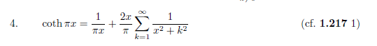

It says this

coth(πx) = (1/π) x Σk=0∞ εk/(x2+k2)

Σk=0∞ εk/(x2+k2) = π coth(πx)/ x

and this agrees with the ** above.

Suppose I made a factor of 2 error. Then I would have

2.22 and π/2 = 1.57

1.57/2.22 = .707 and then .707*2 = 1.41, but I was looking for 1.74

So OK, I think all of the above is malarkey.

(d) What does the sum look like in Maple?

Let's plot this thing: Let z = ρc/R and consider z→1+

C = ( 2$\sqrt{ρc2 - R2}$/π ) [Σn=0∞ εn [Qn-1/2(ρc/R)/ Pn-1/2(ρc/R)] ]

C = ( 2R/π)$\sqrt{z2 - 1}$Σn=0∞ εn [Qn-1/2(z)/ Pn-1/2(z)]

f(z) = $\sqrt{z2 - 1}$Σn=0∞ εn [Qn-1/2(z)/ Pn-1/2(z)]

So I want to plot f(z). I am suddenly getting a completely different result compared with a day ago.

4. Back to the original Capacitance sum, best plot so far

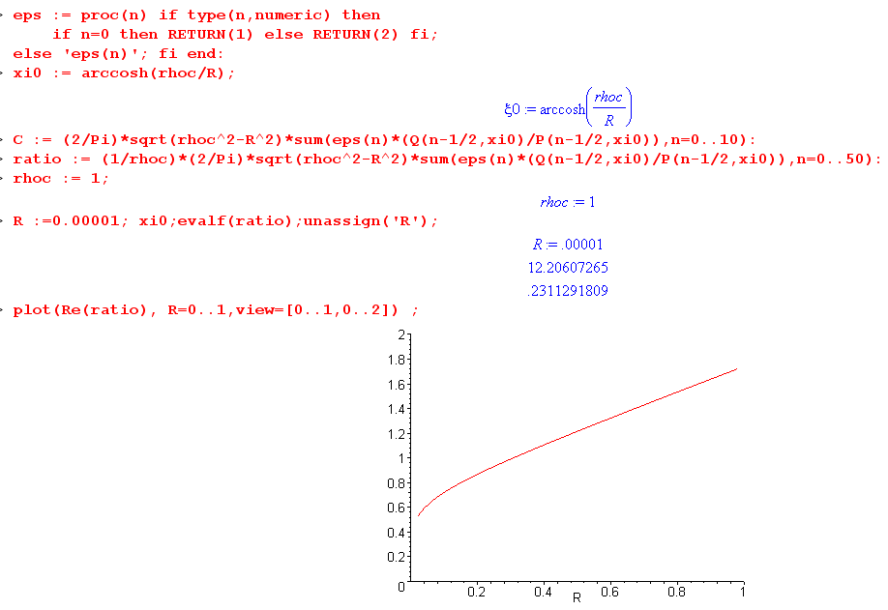

The ratio is to the capacitance of a sphere which passes through the central line of the donut.

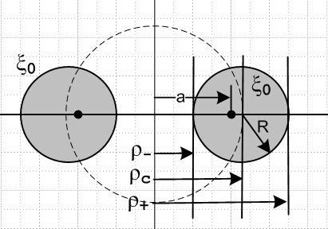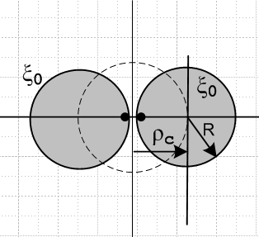

5. A look at the thin-ring limit

Our general formula is this

C = ( 2$\sqrt{ρc2 - R2}$/π ) [Σn=0∞ εn [Qn-1/2(ρc/R)/ Pn-1/2(ρc/R)] ]

If we let z = ρc/R, this can be written

C = ( 2R$\sqrt{z2 - 1}$/π ) [Σn=0∞ εn [Qn-1/2(z)/ Pn-1/2(z)] ]

Here are the large-z limits of the Q and P functions from leg prop doc

Large z limits: ( the two Q limits are the same due to the gamma duplication formula)

e-iπμQνμ(z) ≈ 2ν [Γ(1+ν+μ) Γ(1+ν)/ Γ(2+2ν)] z-ν-1 ν ≠ -1,-2..... // Bateman p 132 (36)

e-iπμQνμ(z) ≈ $\sqrt{π}$ [ Γ(1+ν+μ)/ Γ(ν+3/2)] (2z)-ν-1 ν ≠ -3/2,-5/2..... // Bateman p 134 (41)

Pνμ(z) ≈ (2ν/$\sqrt{π}$) [Γ(ν+1/2)/ Γ(1+ν-μ)] zν Re(ν) > -1/2 // Bateman p 126 (23)

Let's use the second form for Q since it has only two Γ functions, and set μ = 0:

Qν(z) ≈ $\sqrt{π}$ [ Γ(1+ν)/ Γ(ν+3/2)] (2z)-ν-1 ν ≠ -3/2,-5/2..... // Bateman p 134 (41)

Pν(z) ≈ (1/$\sqrt{π}$) [Γ(ν+1/2)/ Γ(1+ν)] (2z)ν Re(ν) > -1/2 // Bateman p 126 (23)

(a) Keeping only the n=1 term

One thing we note is that P-1/2(z) ≈ ∞ due to the Γ(ν+1/2), so this is going to kill off the first Q/P term in this limit [ this is repaired in a later section] . Perhaps this is the cause of a numeric problem in Maple. In any event, what we really want is the ratio

Qν(z)/ Pν(z) ≈ $\sqrt{π}$ [ Γ(1+ν)/ Γ(ν+3/2)] (2z)-ν-1 / {(1/$\sqrt{π}$) [Γ(ν+1/2)/ Γ(1+ν)] (2z)ν }

= π [ Γ(1+ν)/ Γ(ν+3/2)] (2z)-2ν-1 / {[Γ(ν+1/2)/ Γ(1+ν)] }

= π { Γ(1+ν)2/ [Γ(ν+3/2) Γ(ν+1/2)] } (2z)-2ν-1

and for us z = ρc/R → ∞ to get this form. We assume z is finite but "large". One obvious concern is what happens to the gamma functions when ν gets large, so we call upon, from our gamma page,

(7) Stirling: Γ(x+1) = x! = $\sqrt{2πx}$xx e-x { 1 + 1/(12x) + 1/(288x2) + ... }

and we keep only the first term, so write (for large x, large ν )

Γ(x+1) ≈ $\sqrt{2πx}$xx e-x

Γ(ν+1) ≈ $\sqrt{2πν}$xν e-ν x = ν
Γ(ν+3/2) ≈ $\sqrt{2πν}$xν+1/2 e-ν-1/2 x = ν+1/2
Γ(ν+1/2) ≈ $\sqrt{2πν}$xν-1/2 e-ν+1/2 x = ν - 1/2

{} = { Γ(1+ν)2/ [Γ(ν+3/2) Γ(ν+1/2)] }

= (2πν)x2νe-2ν / [ (2πν) xν+1/2 e-ν-1/2 xν-1/2 e-ν+1/2]

= x2νe-2ν / [ x2ν e-2ν] = 1

So we can relax about this coefficient of gammas at least not blowing up. Then of course we see that the factor (2z)-2ν-1 makes the terms drop off very fast for large z. Since the first term vanishes as noted above due to the Γ(ν+1/2)] in the denominator of Qν(z)/ Pν(z), we must keep the next term. Again

Qν(z)/ Pν(z) = π { Γ(1+ν)2/ [Γ(ν+3/2) Γ(ν+1/2)] } (2z)-2ν-1

ν = n-1/2 ν+1= n+1/2 ν+1/2= n ν+3/2 = n+1 2ν+1 = 2[n-1/2]+1 = 2n

Qn-1/2(z)/ Pn-1/2(z) = π { Γ(n+1/2)2/ [Γ(n+1) Γ(n)] } (2z)-2n

Then our desired series is

Σn=0∞ εn [Qn-1/2(z)/ Pn-1/2(z)] = Q-1/2(z)/ P-1/2(z) + 2 Q1/2(z)/ P1/2(z) + ...

= 0 + 2 π { Γ(1+1/2)2/ [Γ(1+1) Γ(1)] } (2z)-2

= 2π { Γ(3/2)2/ [Γ(2) Γ(1)] } (2z)-2 = 2π { Γ(3/2)2} (2z)-2

= 2π {π/4} (2z)-2 = ( π2/2) (2z)-2 = (π2/8) z-2

a pretty simple result. So we then have for our large z limit

C = ( 2R$\sqrt{z2 - 1}$/π ) [Σn=0∞ εn [Qn-1/2(z)/ Pn-1/2(z)] ]

≈ (2Rz/π) (π2/8) z-2 = (π/4) R/z = (π/4) R/( ρc/R) = (π/4) R2/ρc

Therefore, as R→ 0, we have C→0 in a manner quadratic in R. This fact is very much NOT visible in our plot above! Here for example is our Maple work for R in the tiny range (0, .001) meaning z ≥ 1000, and I keep only the first two terms in the series.

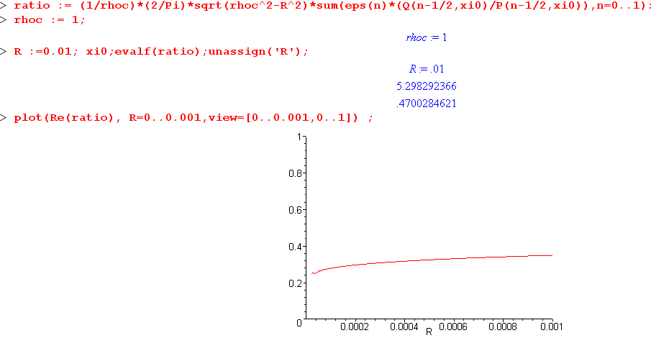

I presume I have done my limit correctly above.
Now go back to this our general form for P:

P(ν,ξ) ≡ Pν(chξ) = (chξ)ν F(-ν/2, 1/2-ν/2; 1; th2ξ)

ν = n-1/2 ν/2 = n/2-1/4 -ν/2 = 1/4-n/2 1/2-ν/2 = 3/4-n/2

P(n-1/2,ξ) ≡ Pn-1/2(chξ) = (chξ)n-1/2 F(1/4-n/2, 3/4-n/2; 1; th2ξ) th2ξ = 1-1/z2

Now set n =0 to get

P(-1/2,ξ) ≡ P-1/2(chξ) = (chξ)-1/2 F(1/4, 3/4; 1; th2ξ) th2ξ = 1-1/z2

= z-1/2 F(1/4, 3/4; 1;1-1/z2)

So out P(n-1/2,ξ) does not have "a pole at n = 0". But as z→∞, this F blows up. Notice that if z = 1000, then th2ξ is only 10-6 away from 1. In my limit above, I have ignored this term pretending it is ∞.
But for z = 1000, we still have P-1/2(1000) = .127 which is NOT infinite!

OK, I guess we have to KEEP the first term after all. I need a different large-z form for P that works when ν = -1/2! So if cannot have Γ(ν+1/2) sitting in it as form (23) does in its second term. Here are the candidates: (18), (19) and that is it. Bateman's table on page 164 has no offerings for ν = -1/2 for P. So this must be "an unusual limit".

(b) What is the large z limit of P-1/2(z) ?

Note that Pν = P-ν-1 buys you nothing. Bateman helps us out on page 172 L

P-1/2(chξ) = (2/π) 1/ch(ξ/2) * K[th(ξ/2)] k = th(ξ/2)

Again, we are looking for the large limit of z = chξ. This means K(s) as s approaches 1 from below. Bateman HT2 talks about K on page 317, but I usually use GR7 for these fellows. And as always we have the ambiguity of argument to worry about. GR and Bateman and I all agree on the convention.

Now power up on the K basics:

k2 + k'2 = 1 k'2 = 1 - k2

So if we are interested in k just less than 1, we are interested in small k' and we have then from GR7

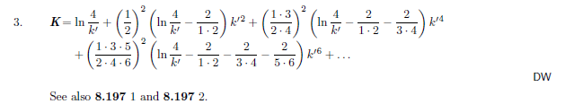

So let's keep only the first term, and we then have that

K(k) ≈ ln(4/$\sqrt{1-k2}$)

In our application we have k = thξ/2 so k' = $\sqrt{1-k2}$ = sech (ξ/2) so then

K(k) ≈ ln[4/ sech(ξ/2)] = ln[4 ch(ξ/2)] = (1/2)ln[16 ch2(ξ/2)] = (1/2)ln[8(chξ+1)]

Then we get

P-1/2(chξ) = (2/π) 1/ch(ξ/2) * K[th(ξ/2)]

= (2/π) ( $\sqrt{2}$/$\sqrt{chξ+1}$) (1/2)ln[8(chξ+1)]

= ($\sqrt{2}$/π) ln[8(chξ+1)] / $\sqrt{chξ+1}$ // large z limit z = chξ

= ($\sqrt{2}$/π) ln[8(z+1)] / $\sqrt{z+1}$

= ($\sqrt{2}$/π) ln[8z] / $\sqrt{z}$ since z >> 1

Let's take it out for a spin, and after two rounds of repairs we have it!

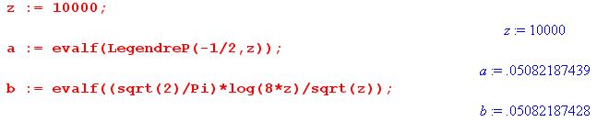

We can express the above limit in terms of ξ for large z using z = eξ/2 and scratch paper gives

P-1/2(chξ) = (2/π)[ ξ + 2ln2]e-ξ/2

and this is in agreement with the Wilson PDF paper which says (see first equation of the three) s

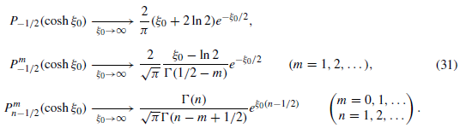

(c) Repair the thin wire capacitance approximation

Last time I just ignored the first term and got this result:

C2nd = ( 2R$\sqrt{z2 - 1}$/π ) [Σn=0∞ εn [Qn-1/2(z)/ Pn-1/2(z)] ]

≈ (2Rz/π) (π2/8) z-2 = (π/4) R/z = (π/4) R/( ρc/R) = (π/4) R2/ρc

I now verify that this is the correct "second term result" by doing this

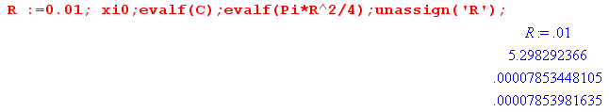
for z = 100. This just shows I have the constant right.
Now we will go "add in" the first term which we formerly left out. That term is

C1st = ( 2R$\sqrt{z2 - 1}$/π ) [Q-1/2(z)/ P-1/2(z)] ]

and we have just shown that for large z,

P-1/2(z) = ($\sqrt{2}$/π) ln[8z] / $\sqrt{z}$

From above regarding Q we had

Qν(z) ≈ $\sqrt{π}$ [ Γ(1+ν)/ Γ(ν+3/2)] (2z)-ν-1 ν ≠ -3/2,-5/2..... // Bateman p 134 (41)

ν = -1/2 1+ν = 1/2 ν+3/2 = 1

Q-1/2(z) ≈ $\sqrt{π}$ [ Γ(1/2)/ Γ(1)] (2z)-1/2 = π (2z)-1/2 = (π/$\sqrt{2}$)( 1/$\sqrt{z}$)

Therefore

Q-1/2(z)/ P-1/2(z) = (π/$\sqrt{2}$)( 1/$\sqrt{z}$) / ($\sqrt{2}$/π) ln[8z] / $\sqrt{z}$ = (π/$\sqrt{2}$) / ($\sqrt{2}$/π) ln[8z]

= (π2/2) (1 / ln[8z] )

C1st = ( 2R$\sqrt{z2 - 1}$/π ) (π2/2) (1 / ln[8z] )

= ( 2R/π ) (π2/2) (z / ln[8z] ) since z is large

= πRz / ln[8z]

So here is our corrected large z (thin wire) limit for capacitance z = ρc/R

C = C1st + C2nd = πRz / ln[8z] + (π/4) R2/ρc

= πRz / ln[8z] + (π/4) R/z

= πRz / ln[8z] + (π/4) Rz/z2

= πRz { 1/ln(8z) + (1/4)/z2 }

Now set z = ρc/R to get

= πρc [1/ln(8z) + (1/4)/z2 ] z = ρc/R

To summarize this long song and dance. For small R where R << ρc we find that

C = πρc [1/ln(8z) + (1/4)/z2 ] z = ρc/R

If ρc= 1 this becomes

C(R) = π [1/ln(8/R) + (1/4)R2]

and here is a numeric test of this formula for z = 10000: both give .278.... so good to 3 places
[ I have corrected formulas above, but the code below does not have those corrections. ]

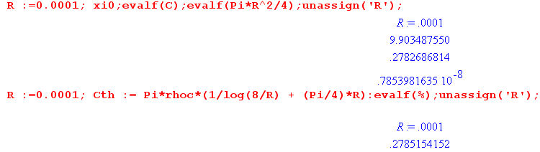

For z = 1000 the above results are .3495 and .3520 so off by 25/3500 = 0.01 or 1%.
For z = 100 the above results are .4700 and .4946 so off by 246/4800 = 0.05 or 5%.
For z = 10 the above results are .7216 and .9636 so off by 2400/8500 = 0.28 or 28%.

OK, here is a plot of C(R) above where I show the two separate terms and the sum

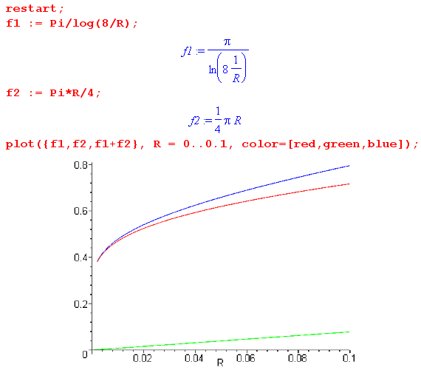

This range is z = (∞, 10), so only the left part is viable. And in this range the f2 term is pretty small. If we restrict to z > 100 we get this plot

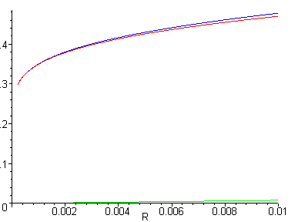

so it is all that first C1st term here. So here is our formula for the capacitance of a thin wire ring:

C(R) = π / ln(8/R) where ρc = 1

and more generally

C(R) = π ρc / ln(8ρc/R)

where ρc is the radius of the toroid, and R the radius of the toroid cross section, for ρc/R > 100 say. Accurate starts at 5% and improves to 1% at > 1000, etc.

The capacitance of a sphere of radius ρc is just Csphere = ρc , so

ratio (wire ring / sphere) = π / ln(8/f) f = cross section radius / ring radius

Maple won't make a semilog plot with log on the x axis, so I had to do this:

F = π / ln(8/f) => f = 8 e-π/F

then I plot f instead on their log plot, and here is the result (Note that 1e-06 means 1 x 10-6 )

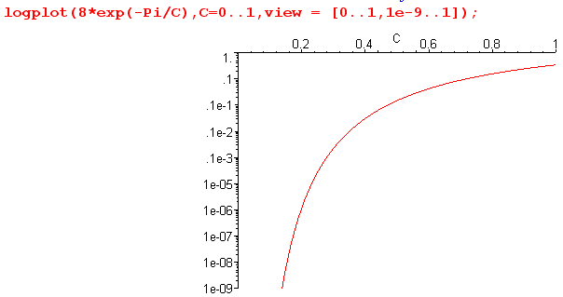

The idea is that C → 0 eventually as the wire thickness goes to zero, but VERY slowly. Even if the wire thickness is a billionth of the wire circle radius, you still have C = 20% of a sphere of the same radius!

So, I am how "happy" with the thin wire limit in this problem!

