The Toroidal Capacitance Function PhL 2.11.11

Early attempts on that T(z) limit business, notice the date! // 12.31.15

Warning: Sometimes saving this file crashes the OS requiring a hard power off and reboot. Therefore, do not save this file if other Word docs are open or they will all have to be "recovered". // I saved this as a docx and then converted back to doc, we shall see.

Note added 12/31/15: I presume this is a problem only with Alta, not Black. I just saved this file and had no problems on Black. Note date upper right above.

Overview (2 pages, written 2.14.11) 1
1. The TCF T(z) as a "special function" 3
2. Can the sum be done to give some simpler answer? 4
3. What T(z) "look like"? 4
4. Maple calculations of the PBM sum rule near z = 1. 5
(a) Convergence of two series 5
(b) Evaluation of the R(z) series in Maple 6
(c) Possible causes of the asymptotic expansion effect 11
4A. Maple calculations of T(z) in the region near z = 1 12
5. What about the charge density? 17
6. The Behavior of P and Q for large ν . 19
Examples of series involving P and Q 21
7. More on the z ≈ 1 behavior of T(z) : an estimate of T'(z) near z = 1 22
8. Still more on the z ≈ 1 behavior of T(z) : trying directly limits of Q and P 25
10. Wolfram Weighs In on the T(z) calculations 28
11. The large z behavior of T(z) 29
12. Full range plot of T(z) 31
(a) comparing the degenerate toroid to the enclosing sphere. 33

___________________________________________________________________________________

Overview (2 pages, written 2.14.11)

In Section 1 I define the T(z) function and show its connection to donut capacitance, and comment that it is in fact a special function which has no name.

In Section 2 I conjecture that there is no simpler way to express this T(z) function. Having P in a denominator is very unusual in terms of external sources' Legendre function data. For example, the PBM book has no series involving Legendre functions in the denominator.

In Section 3 I first comment on how things go for the large z end of the range (thin wire ring). I note that in this limit you have to use a special limit for P in the n=0 term, namely, P-1/2(z) = ($\sqrt{2}$/π) ln[8z] / $\sqrt{z}$. But I don't say more about this limit since I studied it in "charged donut".
I then wonder about the z=1 limit of T(z) and I make an argument that you might just replace P by 1 inside the sum in this limit, and then you would say that T(1) = π from the PBM sum rule. I thought this was true for a while, but now I think you cannot set P = 1, and in fact P is a little larger than 1 in effect, and T(1) is less than π, being roughly T(1) = 2.735353 .

In Section 4 (a) I compare the T(z) and R(z) series in terms of expected convergence rate and give reference for the PBM sum rule R(z) = (π/$\sqrt{2}$). [ I later realized that this PBM sum rule is just a special case of my 1/$\sqrt{a-cosx}$ Fourier expansion.] Then in (b) I do a Maple study of this R(z) sum rule series which I know adds to 2.221441. I find that Maple agrees fine for z = 3, but as you get "close in" accuracy is only 1 unit in 2 places. I give a table summarizing the results. In (c) I make a conjecture at what might cause the "asymptotic series" effect I keep seeing, but then I find a counterexample right away, so I have no theory. Then I show a huge 60 orders of magnitude problem with Q(122,xi) etc which I ignore.

In Section 4a I do a Maple study of the T(z) function near z=1 and again give the results in a table. I find that T(z) approaches the constant 2.735 in a very reasonable fashion, but I have no explanation for the value of the constant, though it might be "e", but I think not. The approach is reasonable when you think of a toroid shrinking so its hole just goes away. In earlier work I was finding something dramatic was happening in this limit, but after fixing all my errors, the limit is quite gentle as you would expect.

In Section 5 I compute an expression for the toroid surface charge density σ

σ = (V0 /4π R) *
{ ($\sqrt{2}$/π)($\sqrt{chξ0 - cosu}$)3 Σn=0∞ εn Pn-1/2'(chξ0) [Qn-1/2(chξ0)/ Pn-1/2(chξ0)]cos(nu) + (1/2)}

When I did this, I had a violent limit for T(z→1) and I wanted to see if σ was doing something wild at z = 1. I obtain the σ formula and then study it in the forward direction (u≈0, outer donut equator) and the backward direction (u≈π, the inside donut equator). At the time, I was looking for trouble since I thought T(z) was diverging, but now I think these are just reasonable values of σ. I then show how to write the P' function in terms of other P's, confirming with Maple. I look at the n = 0 term in particular which dominates the thin-wire limit and find linear density λ = (V0 /2 ) z0 / ln(8z0) as z0 gets large, and I show this is consistent with the former capacitance value I obtained. I then summarize conclusions at that point, and make an Excel plot of σ versus u.

In Section 6 I compute the large n limit of the P and Q function using AS 2009 data.

Pn-1/2(chξ) = $\sqrt{1/shξ}$ $\sqrt{1/2πn}$ e+nξ large n
Qn-1/2(chξ) = $\sqrt{1/shξ}$ $\sqrt{π/(2n)}$e-nξ large n

I note that convergence dissolves as ξ → 0, meaning z → 1. I give a few series examples, but they don't really mean much. Earlier I made a mistake and thought there was an extra Γ strongly converging things, but that was due to the AS "bold" Q function confusion.

In Section 7, while I was confused about the T(1) limit, I tried to compute T'(z) near z = 1. I do get this exact result

T'(z) = { T(1) – $\sqrt{z2 - 1}$ Σn=0∞ εn /[Pn-1/2(z)]2 } / (z2-1)

and this makes me realize that this must be another sum representing T(1). That is to say

$\sqrt{z2 - 1}$ Σn=0∞ εn /[Pn-1/2(z)]2 → T(1)

because that is the only way we can have T'(z) not diverge at z = 1. I get T(1) = 2.735 this way as well. It certainly seems odd that you get the same limiting result with 1/P2 as with Q/P ! This was a very lucky find, a whole second way to compute the T(1) limit that has better numerical properties.

In Section 8 I try moving the z→1 limit through the infinite sum limit, and I get complete garbage.

In Section 9 I learn from some PDF papers that it is very common for a double limit to give different results when you reverse the order, relating to uniform convergence.

In Section 10 I realize that I can make the Wolfram Alpha page compute some of my sums, and it gets basically the same results that I get with Maple.
____________________________________________________________________________________

1. The TCF T(z) as a "special function"

As I show elsewhere, the capacitance of a torus is this

C = (2R/π) $\sqrt{z2 - 1}$ Σn=0∞ εn [Qn-1/2(z)/ Pn-1/2(z)]

where R = cross section radius, ρc = toroid radius to center line, and z = ρc/R. If we dismiss the leading factors, we can consider this function as our "toroidal capacitance function" T(z)

T(z) = $\sqrt{z2 - 1}$ Σn=0∞ εn [Qn-1/2(z)/ Pn-1/2(z)]

The thin-wire limit is z →∞, while the thick-wire limit is z→1. The range of z is this (1,∞).

I realize that one can regard this infinite sum of Legendre functions as "a special function" which has no name. A web scan shows that even the capacitance is stated only a few times in open documents, I have ignored the pay-for-doc world for the time being.

When a Special Function has serious uses, it usually gets a name, like a Legendre Function. Then someone writes up "the properties" of such functions. Our function has no "parameters" and is thus in a class with several other "special functions", such as these

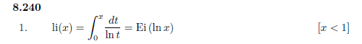
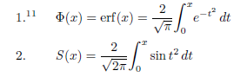
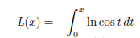
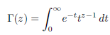

Of course each of these has an official "name", whereas ours does not. Also, these functions are integrals, whereas ours is a sum of other special functions.

2. Can the sum be done to give some simpler answer?

I don't think so. One might construct a contour integral whose pole residues are the sum. One problem with our function is the P in the denominator. I don't know of any published sums or integrals that have P in the denominator! So I think we just have to take it as it is. See "charged donut" for some efforts.

3. What T(z) "look like"?

This question is not quite so simple to answer because we cannot make Maple add up an infinite number of terms. But using some small knowledge, we can estimate how many terms we do need to add.
First of all, as shown in "charged donut" we do know this much regarding z→∞ behavior:

Qν(z) ≈ $\sqrt{π}$ [ Γ(1+ν)/ Γ(ν+3/2)] (2z)-ν-1 ν ≠ -3/2,-5/2..... // Bateman p 134 (41)

Pν(z) ≈ (1/$\sqrt{π}$) [Γ(ν+1/2)/ Γ(1+ν)] (2z)ν Re(ν) > -1/2 // Bateman p 126 (23)

and therefore

Qν(z) / Pν(z) = π (2z)-2ν-1 [Γ(ν+1)]2 /[Γ(ν+3/2)Γ(ν+1/2)] as z→ ∞ ν ≠ -1/2

Qn-1/2(z)/ Pn-1/2(z) = π { Γ(n+1/2)2/ [Γ(n+1) Γ(n)] } (2z)-2n

We have to treat the ν = -1/2 (n=0) case separately due to the bad limit on Pν(z) for this value of ν. I show in said doc the first line below, and then give the corresponding Q function and then the ratio

P-1/2(z) = ($\sqrt{2}$/π) ln[8z] / $\sqrt{z}$ as z → ∞

Q-1/2(z) ≈ $\sqrt{π}$ [ Γ(1/2)/ Γ(1)] (2z)-1/2 = π (2z)-1/2 = (π/$\sqrt{2}$)( 1/$\sqrt{z}$)
so
Q-1/2(z)/ P-1/2(z) = (π2/2) (1 / ln[8z] ) as z→ ∞

The last item here is the first term in the T(z) series for large z. It goes to 0 as z→∞, but at an extremely slow rate which says that a wire ring "hangs on to capacitance" very well as the wire diameter is made smaller and smaller, more on this later.
Now to the question of "how many terms to add?" Since Qn-1/2(z)/ Pn-1/2(z) ~ z-n we see that for some reasonably large z, such as perhaps z > 10, we need add only a few terms of this series. Maple is always happy say to add the first 10 terms of the series. Later we shall make this quantitative.
Even for z > 2, say, we know that some reasonable number of terms will be OK.
But in the range z in (1,2) and especially close to z = 1+ε, things are not so clear!

The first "unclear thing" is that I have no idea whether T(1) has a finite value! That is, what is this limit: ?

T(1) = limz→1 { $\sqrt{z2 - 1}$ Σn=0∞ εn [Qn-1/2(z)/ Pn-1/2(z)] }

= $\sqrt{2}$ limz→1 { $\sqrt{z - 1}$ Σn=0∞ εn [Qn-1/2(z)/ Pn-1/2(z)] }

In "charged donut" I try to make this argument

T(1) = $\sqrt{2}$ limz→1 { $\sqrt{z - 1}$ Σn=0∞ εn [Qn-1/2(z)/ Pn-1/2(z)] }

≤ $\sqrt{2}$ limz→1 { $\sqrt{z - 1}$ Σn=0∞ εn Qn-1/2(z) } = $\sqrt{2}$(π/$\sqrt{2}$) = π

where I use a sum found in PBM. So all I really know is that, if T(1) exists, then T(1) ≤ π. I think this is right, but my proof was not rigorous. the idea is that we know Pn-1/2(z) → 1 but except for the first term this limit is always from above, so each term is then a little less than the Q-only term.
I shall rely on Maple to give T(1) !

4. Maple calculations of the PBM sum rule near z = 1.

(a) Convergence of two series

Our function of interest is this ( εn = Neumann's factor = 2 for n>1, but = 1 for n=0)

T(z) = $\sqrt{z2 - 1}$ Σn=0∞ εn [Qn-1/2(z)/ Pn-1/2(z)]

but we shall first consider a different and slightly simpler function, which is this

R(z) = $\sqrt{z-1}$ Σn=0 εn Qn-1/2(z)

For both functions, our range of interest is z in (1, ∞). We know that for z >>1, these properties of the P and Q function imply fast series convergence in both series

Qν(z) ≈ $\sqrt{π}$ [ Γ(1+ν)/ Γ(ν+3/2)] (2z)-ν-1 ν ≠ -3/2,-5/2..... // Bateman p 134 (41)

Pν(z) ≈ (1/$\sqrt{π}$) [Γ(ν+1/2)/ Γ(1+ν)] (2z)ν Re(ν) > -1/2 // Bateman p 126 (23)

Qν(z)/ Pν(z) ≈ π { Γ(1+ν)2/ [Γ(ν+3/2) Γ(ν+1/2)] } (2z)-2ν-1

and we see that T(z) has faster convergence than R(z) just comparing the (2z)-x factors. It would not be hard to estimate the error resulting from series truncation at some number M of terms, but we shall let Maple do that for us visually. One thing is clear, however: as we bring z down to the neighborhood of z =1, the number of required terms is going to increase.
It happens that the series R(z) adds up to the constant (π/$\sqrt{2}$) = 2.221441469 for all z in (1,∞). We call it "the PBM sum rule" because we found it in the Legendre series section of that special functions handbook (vol 3) where it appears in this more general form:

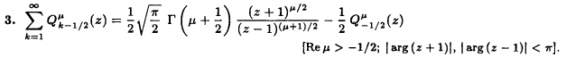

which we translate to say

Σn=0∞ εn Qn-1/2(z) = (π/$\sqrt{2}$)/$\sqrt{z-1}$

Since we know the sum, the R(z) series gives us a good example with which to study the convergence situation. [ I later realized that this PBM sum rule is just a special case of my 1/$\sqrt{a-cosx}$ Fourier expansion. ]

(b) Evaluation of the R(z) series in Maple

First, the LegendreP and LegendreQ functions as implemented internally in Maple have a few quirks because they have to meet so many requirements: different ranges of z, real and complex, functions on and off the cut, integer values of m and n, and so on. For our purposes here, we just want "the basic P and Q functions" defined by Bateman (and PBM) for off-the-cut applications. Since we are in z = (1,∞), both cuts (those with branch points at z = 1 and z = -1) are taken to the left in the usual way so that both P and Q are real in our range of interest. Here then is the Maple code used to implement functions P and Q:

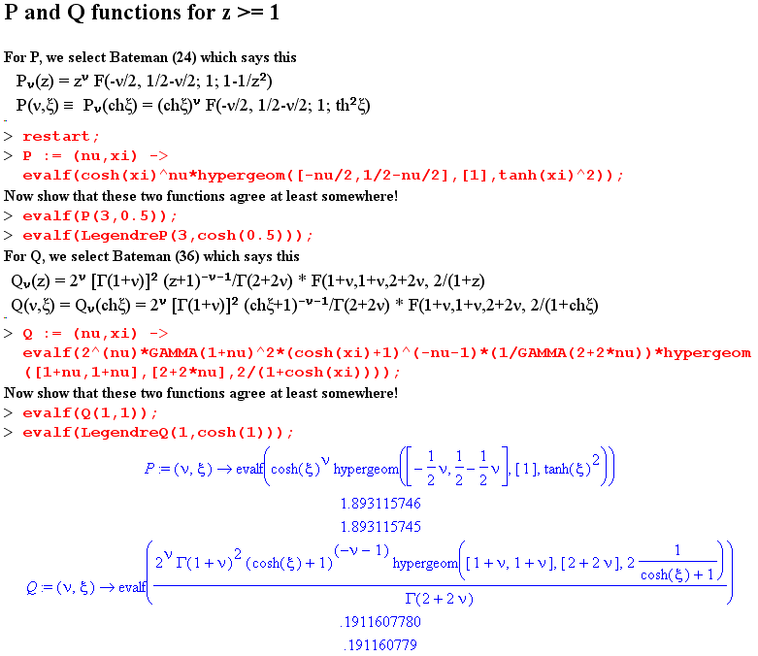

and we have put the code text into Appendix A below so a reader can grab it and use it. Since we were doing work in toroidal coordinates when writing this code, it happens that the second argument of the P and Q functions defined here is ξ = ch-1z. After defining each function, we do one cursory check to make sure we have not made an entry error.
Next, since we like the εn notation, we do this

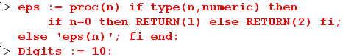

and we also explicitly set Digits to its default value. This means Maple will be doing software floating point with 10 significant places. We imagine there will be rounding error in our series calculations when we start increasing the number of terms added.

Here then is the code for computing the R(z) series (which we know adds up to a constant). We first set in a value for z and compute the corresponding ξ = ch-1(z) for use in the P and Q functions. We then define term[n] as being the (n-1)st term in our series, so that term[1] = the first term with n=0. We do it this way since Maple wants arrays to start with index 1, not index 0. Next we set in the number of terms M we want to compute. We will store the individual terms in termstore[n], and we will store the series partial sums in partialsum[n]. After computation, we can plot both the partial sums and the terms.
We expect that the partial sums should stabilize after a certain number of terms. For the specific case shown here of z = 3, it appears that 6 terms gives a pretty stable answer, at least visually. We are not concerned at this point with high precision, we just want to study convergence. The second plot shows how the terms drop off. Under each plot we show partialsum]M] and term[M], these being the last terms. We note that for 15 terms our series sum is 2.221441470 which is pretty close to (π/$\sqrt{2}$) = 2.221441469.
Notice that we apply the series common factor $\sqrt{z-1}$just before storing off the partial sum.

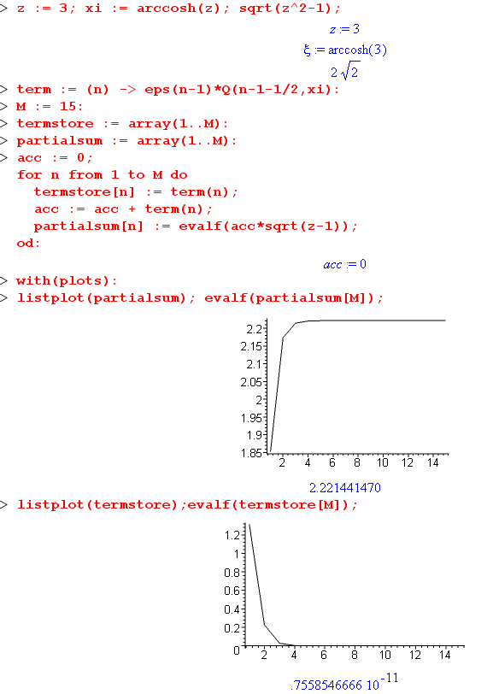
So we can now repeat the program for values of z in the region of z =1 , just to see what happens.

z = 1.1 M = 50 visually we need about 20 terms

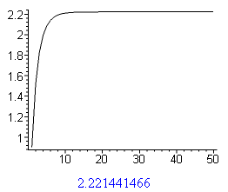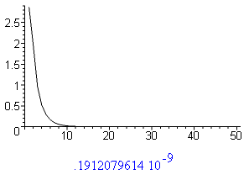

z = 1.01 M = 50

The plots here are a little disturbing:

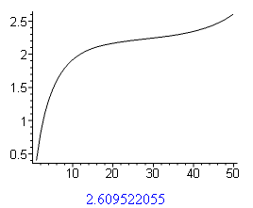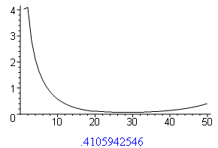

Such plots would be characteristic of "an asymptotic series", but our R(z) series is a fully convergent series. Increasing Digits to 20 makes no difference in the plots really. So we chalk this up to "mystery" for the moment. If we had to pick a partial sum here as our best answer, we might pick sum 26 perhaps, and we find that partialsum[26] = 2.2384587374199691359, so at least our leading two digits are correct (this is the Digita = 20 result).

z = 1.001 M = 200

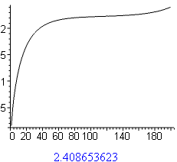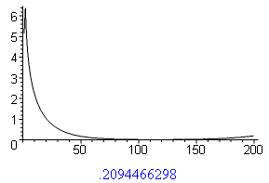

Again we get our asymptotic series effect. This time we might select partialsum[120] as a best value. and we get partialsum[120] = 2.231178965, again only 2 places accurate.

z = 1.0001 M = 1000

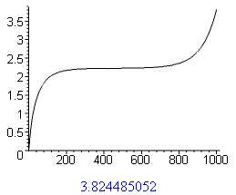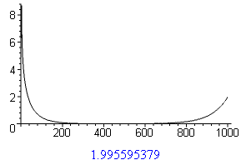

This time we have a better plateau and we might pick partialsum[400] as best value, and we get partialsum[400] = 2.220672149 compared with the exact answer 2.221441469, so we are here accurate to about 3 places.

z = 1.00001 M = 10,000

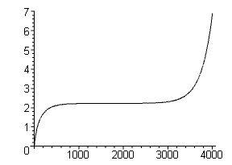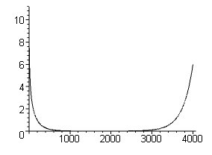

Here we might select R(2000) = 2.223279652 which is again good to about 3 places.

The "asymptotic series" appearance of R(z) is still a mystery. We believe that the series converges and is not just asymptotically convergent for z>0, but for z = 1.01 Maple starts diverging after a mere 40 terms, as the plot above shows.

Summary of results: ( exact answer should be (π/$\sqrt{2}$) = 2.221441469 )

z T(z) terms used
3 2.22144 8
1.1 2.221445 50
1.01 2.23845 26
1.001 2.23118 120
1.0001 2.22067 400
1.00001 2.22328 2000

Maple has trouble doing this sum as you get close in, but it gets it right to 1 unit in 3 places. The curves are a little scary.

(c) Possible causes of the asymptotic expansion effect

Here is a possible explanation of this effect. The large ν limit of Qν is a difficult area for computation because Bateman form (40) is the only classical form for Qν which gives a converging hypergeometric series in terms of ν, In this form, ν is isolated in the c argument of F(a,b,c,z). However, in terms of the z plane, form (40) has an unusually shaped convergence region

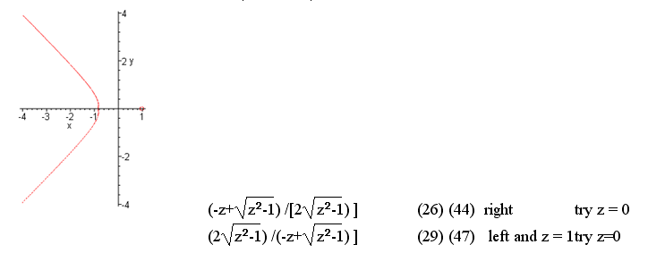

There is a little circle around z = 1 where (44) does NOT converge. On the z axis, this little circle includes all the points between z = 1 and z = 3/$\sqrt{8}$ = 1.060660172. This strange number just arises from the form of the argument of F(a,b,c,Z) where Z = the first z quantity shown above. So my possible explanation is that for z < 1.06, Maple is computing the hypergeom function using a series which does not converge, and is showing this asymptotic convergence behavior.
So, when I try computing 200 terms with z = 1.2, I expect not to get this behavior. However, here is what I see in the termstore (using Digits = 20 and M = 200)

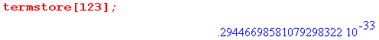
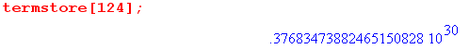

This is a fairly violent behavior. The source of this problem is demonstrated here

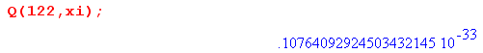
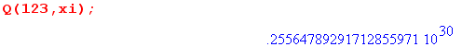

Something very bad is happening in the Maple hypergeom function evaluation code. I could pursue that by examining the code, but for now we just accept this as a Maple problem, and it has nothing to do with the R(z) series really being non-convergent.

4A. Maple calculations of T(z) in the region near z = 1

We now apply the method of the last section to our function of interest T(z)

T(z) = $\sqrt{z2 - 1}$ Σn=0∞ εn [Qn-1/2(z)/ Pn-1/2(z)]

As noted above, this series has better convergence properties than R(z). Our Maple code block is now this:

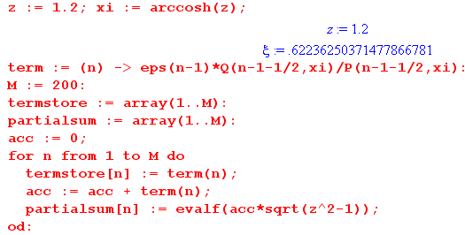

where we add a divide by P, and change to $\sqrt{z2-1}$. With z = 1.2 as shown, we get these results:

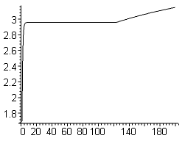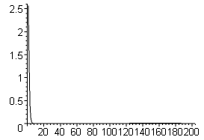

Once again we see trouble brewing out around n = 120 (probably both the Q and P function have the problem), but we see a rock solid plateau before this point, so we select maybe 40 terms and our result is then
T(1.2) = partialsum[40] = 2.9568892956678482159

So now we shall march z in toward 1 and hope to see what T(z) "looks like".

z = 2 M = 50

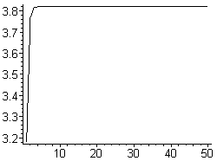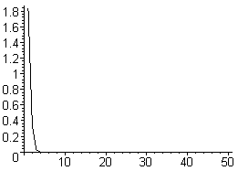

T(2.0) = partialsum[25] = 3.8196589518577332608

z = 1.1 M = 50

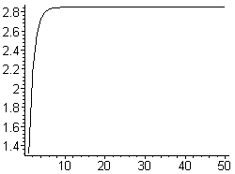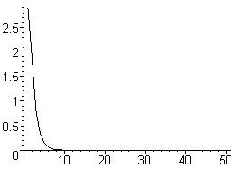

T(1.1) = partialsum[30] = 2.8464666926437287349

z = 1.01 M=200
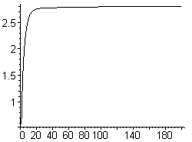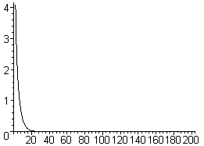

This time we are not so rock solid on the plateau, so we just make a guess

T(1.01) = partialsum[140] = 2.7986557467453447582

z = 1.001 M = 200

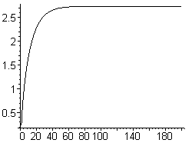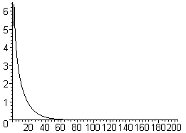

T(1.001) = partialsum[140] = 2.7399330003333922753

z = 1.0001 M = 400

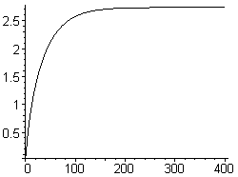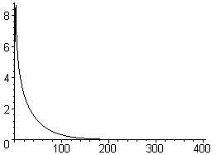

T(1.0001) = partialsum[300] = 2.7351308588392861033

z = 1.0 0001 M = 1000

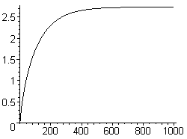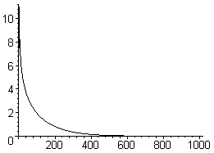

T(1.0 0001) = partialsum[900] = 2.7344425737692892471

Note in passing that "e" = 2.7182818284590452354, and we seem to be approaching this value from above, very slowly. We may compute

[ T(1.0 0001) - e ] / e =
(2.734442573769289247 - 2.7182818284590452354)/ 2.7182818284590452354
0.005945205953647 = 6 x 10-3 so less than 1% away from exact e

z = 1.00 0001 M = 10000 // Maple is taking a long time to do this many terms

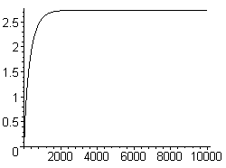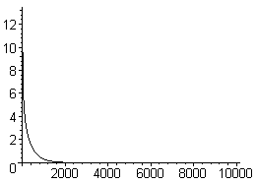

T(1.00 0001) = partialsum[4000] = 2.7353214611940669030

This result is a little larger than the previous result in the 4th place, perhaps it is due to rounding error.

Here is a table showing our results e = 2.7182818284590452354

z T(z) terms used -log10(z-1)
1.1 2.8465 15 1
1.01 2.7987 140 2
1.001 2.7399 140 3
1.0001 2.7351 300 4
1.00001 2.7344 900 5
1.000001 2.7353 4000 6

and here is a little Excel plot showing how we are coming in for a landing and what appears to be "e".

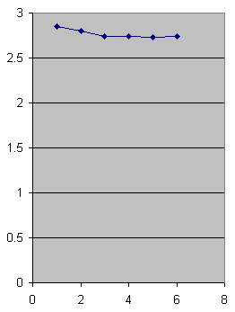

The good news is this in terms of capacitance of a toroid. The first point is with z = 1.1 which means the diameter of the hole in the donut is about 10% of the diameter of the donut cross section. As we gradually close this hole down to nothing, the capacitance drops off only slightly and approaches a limiting value. This is what we physically expect. [ I redid these points with more series terms and got smoother data when writing the toroidal charged bowl doc. It is all a little contrived, but the other series is more solid. ]

5. What about the charge density?

I need to see the charge density on this donut! It must do something special in this last 1%. Here is the charge density, where the + sign is because ξ decreases as you leave the donut surface:

σ = + (1/4π) (1/hξ) ∂ξV(ξ,u)|ξ=ξ0 1/hξ = (chξ0 - cosu)/a

V(ξ,u) = V0 ($\sqrt{2}$/π)$\sqrt{chξ - cosu}$ Σn=0∞ εn Pn-1/2(chξ) [Qn-1/2(chξ0)/ Pn-1/2(chξ0)]cos(nu)

∂ξV(ξ,u) = V0 ($\sqrt{2}$/π)$\sqrt{chξ - cosu}$ Σn=0∞ εnshξ Pn-1/2'(chξ) [Qn-1/2(chξ0)/ Pn-1/2(chξ0)]cos(nu)
+ V0 ($\sqrt{2}$/π)(1/2)[shξ/$\sqrt{chξ - cosu}$] Σn=0∞ εn Pn-1/2(chξ) [Qn-1/2(chξ0)/ Pn-1/2(chξ0)]cos(nu)

(1/hξ) ∂ξV(ξ,u) = (shξ/a) *
{ V0 ($\sqrt{2}$/π)($\sqrt{chξ - cosu}$)3 Σn=0∞ εn Pn-1/2'(chξ) [Qn-1/2(chξ0)/ Pn-1/2(chξ0)]cos(nu)
+ V0 ($\sqrt{2}$/π)(1/2)$\sqrt{chξ - cosu}$] Σn=0∞ εn Pn-1/2(chξ) [Qn-1/2(chξ0)/ Pn-1/2(chξ0)]cos(nu)}

= (shξ /a) *
{V0 ($\sqrt{2}$/π)($\sqrt{chξ - cosu}$)3 Σn=0∞ εn Pn-1/2'(chξ) [Qn-1/2(chξ0)/ Pn-1/2(chξ0)]cos(nu)
+ (1/2)V(ξ,u)}

Evaluate this now at ξ = ξ0 and get

(1/hξ) ∂ξV(ξ,u) = (V0shξ /a) *
{ ($\sqrt{2}$/π)($\sqrt{chξ - cosu}$)3 Σn=0∞ εn Pn-1/2'(chξ) [Qn-1/2(chξ0)/ Pn-1/2(chξ0)]cos(nu) + (1/2)}

And then finally

σ = (V0shξ0 /4π a) *
{ ($\sqrt{2}$/π)($\sqrt{chξ0 - cosu}$)3 Σn=0∞ εn Pn-1/2'(chξ0) [Qn-1/2(chξ0)/ Pn-1/2(chξ0)]cos(nu) + (1/2)}

But recall that a/|shξ| = horizontal circle radius which I have been calling R, so write again as

σ = (V0 /4π R) *
{ ($\sqrt{2}$/π)($\sqrt{chξ0 - cosu}$)3 Σn=0∞ εn Pn-1/2'(chξ0) [Qn-1/2(chξ0)/ Pn-1/2(chξ0)]cos(nu) + (1/2)}

and the leading factor has the right dimensions. Perhaps replace chξ0 = z0 to get

σ(u) = (V0 /4π R) *
{ ($\sqrt{2}$/π)($\sqrt{z0 - cosu}$)3 Σn=0∞ εn Pn-1/2'(z0) [Qn-1/2(z0)/ Pn-1/2(z0)]cos(nu) + (1/2)}

which I suppose we can write as ( recall that z0 > 1 and also that z0 = ρc/R )

σ(u) = ( V0 /4π R) *
{ ($\sqrt{2}$/π)($\sqrt{z0 - cosu}$)3 Σn=0∞εn ∂z[lnPn-1/2(z)]|z=z0 Qn-1/2(z0) cos(nu) + (1/2)}

In the region of u ≈ 0 which is the outer equator of the donut we have cosu ≈ 1 so we have

σ(outer equator) = ( V0 /4π R) *
{ ($\sqrt{2}$/π)($\sqrt{z0 -1}$)3 Σn=0∞εn ∂z[lnPn-1/2(z)]|z=z0 Qn-1/2(z0) + (1/2)}

As we approach our limit z0 =1 it appears that the first term vanishes and only the 1/2 remains.

In the region of u ≈ π which is the inside equator of the donut we have cosu ≈ -1 so we have

σ(inner equator) = ( V0 /4π R) *
{ ($\sqrt{2}$/π)($\sqrt{z0 +1}$)3 Σn=0∞εn ∂z[lnPn-1/2(z)]|z=z0 Qn-1/2(z0)(-1)n + (1/2)}

As we approach our limit z0 =1 we have $\sqrt{z0 +1}$ = $\sqrt{2}$ and the series seems to have term interference which might make it be "small", and again the 1/2 remains. But see below!!

What can we say about the P stuff. Consider this (see "charged donut") series expansion of P about the point z = 1:

Pν(z) = F(-ν,1+ν;1;(1-z)/2) ≈ 1 + (-ν)(ν+1)(1-z)/2 ν = n-1/2 ν+1 = n+1/2

Pn-1/2(z) ≈ 1 + (n-1/2)(n+1/2)(z-1)/2 = 1 + (n2-1/4) (z-1)/2

P'n-1/2(z) ≈ 1 + (n-1/2)(n+1/2)(z-1)/2 = (n2-1/4) (1/2)

P'n-1/2(z) / Pn-1/2(z) ≈ P'n-1/2(z) ≈ (1/2) (n2-1/4)

So we are tempted to use this for ∂z[lnPn-1/2(z)]|z=z0 near z0 = 1 to get

σ(outer equator, z0 ≈ 1) = ( V0 /4π R) *
{ ($\sqrt{2}$/π)($\sqrt{z0 -1}$)3 Σn=0∞εn (1/2) (n2-1/4) Qn-1/2(z0) + (1/2)}

σ(inner equator, z0 ≈ 1) = ( V0 /4π R) *
{ ($\sqrt{2}$/π)($\sqrt{2}$)3 Σn=0∞εn (1/2) (n2-1/4) Qn-1/2(z0)(-1)n + (1/2)}

It is not clear to me whether these series converge!

Revisiting the Charge Density:

From Schaum p 147 ( Bateman p 161 (10)) we have this useful fact

(z2-1)Pν'(z) = [ νzPν(z) - νPν-1(z)] = ν [zPν(z) - Pν-1(z)]

Maple claims however that

(z2-1)Pν'(z) = (ν+1)[ Pν+1(z) - z Pν(z) ]

If we subtract the second line from the first we get

0 = ν [zPν(z) - Pν-1(z)] - (ν+1)[ Pν+1(z) - z Pν(z) ]

= ν zPν(z) - ν Pν-1(z) -ν Pν+1(z) + νz Pν(z) - Pν+1(z) + z Pν(z)

= (2ν+1) zPν(z) - ν Pν-1(z) - (ν+1) Pν+1(z)

But this is exactly what Schaum p 147 25.20 says (all terms negated)

I like Maple's version since it refers us only to larger ν. Then we have with ν = n-1/2

(z2-1)Pν'(z) = (ν+1)[ Pν+1(z) - z Pν(z) ]

(z2-1)Pn-1/2'(z) = (n+1/2)[ Pn+1/2(z) - z Pn-1/2(z) ]

Now, our charge density expression was

σ(u) = (V0 /4π R) *
{ ($\sqrt{2}$/π)($\sqrt{z0 - cosu}$)3 Σn=0∞ εn Pn-1/2'(z0) [Qn-1/2(z0)/ Pn-1/2(z0)]cos(nu) + (1/2)}

and I can use the above item for the P' function and it works for n = 0 as well as n = 1,2,3....

Suppose we pick ξ0 = π/4 so that z0 = ch(π/4) = 1.32

We might imagine in this realm that we could add maybe 50 terms, but I will just let Maple figure it out.

Meanwhile, is there some limit we can take of the above formula? The thin wire limit seems a good one, where we take z0→ ∞ and we then have these large z limits

Qn-1/2(z)/ Pn-1/2(z) = π { Γ(n+1/2)2/ [Γ(n+1) Γ(n)] } (2z)-2n

Pν(z) ≈ (1/$\sqrt{π}$) [Γ(ν+1/2)/ Γ(1+ν)] (2z)ν Re(ν) > -1/2 // Bateman p 126 (23)

Pn+1/2(z) ≈ (1/$\sqrt{π}$) [Γ(n+1)/ Γ(n+3/2)] (2z)n+1/2

Pn-1/2(z) ≈ (1/$\sqrt{π}$) [Γ(n)/ Γ(n+1/2)] (2z)n-1/2

Our quantity of interest is now

(n+1/2)[ Pn+1/2(z) - z Pn-1/2(z) ] [Qn-1/2(z)/ Pn-1/2(z)]

~ [ A(2z)n+1/2 + B(2z)n-1/2] (C (2z)-2n) ~ A' (2z)-n+1/2 + B' (2z)-n-1/2

For the n = 0 term we know we have a special case to worry about, will do that below.
For n = 1 we have A' (2z)-1/2 + B'(2z)-3/2 ~ A' (2z)-1/2 so this term goes as z-1/2.
For n = 2 we get z-3/2 and so on.
So for very large z, only the first term remains.

So, now let's ponder the first term with n=0.

Q-1/2(z)/ P-1/2(z) = (π2/2) (1 / ln[8z] )

P1/2(z) ≈ (1/$\sqrt{π}$) [Γ(1)/ Γ(3/2)] (2z)1/2 = (2/π) (2z)1/2

P-1/2(z) ≈ ($\sqrt{2}$/π) ln[8z] / $\sqrt{z}$

(z2-1) ≈ z2

Then we get

(z2-1)Pn-1/2'(z) = (n+1/2)[ Pn+1/2(z) - z Pn-1/2(z) ]
or
(z2-1)P-1/2'(z) = (1/2)[ P1/2(z) - z P-1/2(z) ]
or
z2P-1/2'(z) = (1/2)[{ (2/π) (2z)1/2}- z { ($\sqrt{2}$/π) ln[8z] z-1/2}]

= (1/2π)[{ 2 (2z)1/2}- { ($\sqrt{2}$) ln[8z] z+1/2}]

= ($\sqrt{2}$/2π)[{ 2 (z)1/2}- { ln[8z] z+1/2}]

= ($\sqrt{2}$/2π) z1/2[2- ln[8z] ]

=> P-1/2'(z) = ($\sqrt{2}$/2π) z-3/2[2- ln[8z] ]

So here is what our n=0 term looks like (set z = z0)

($\sqrt{2}$/π)($\sqrt{z0 - cosu}$)3 Σn=0∞ εn Pn-1/2'(z0) [Qn-1/2(z0)/ Pn-1/2(z0)]cos(nu)

= ($\sqrt{2}$/π) z3/2 ε0 ($\sqrt{2}$/2π) z-3/2[2- ln[8z] ] [(π2/2) (1 / ln[8z] )] cos(0)

= ($\sqrt{2}$/π) ($\sqrt{2}$/2π) (π2/2) [2- ln[8z] ] [(1 / ln[8z] )]

= (2) (1/2) (1/2) [2- ln[8z] ] [(1 / ln[8z] )]

= (1/2) [2- ln[8z] ] [(1 / ln[8z] )]

Then from this first term only, in our thin wire limit, we have

σ(u) = (V0 /4π R) *
{ ($\sqrt{2}$/π)($\sqrt{z0 - cosu}$)3 Σn=0∞ εn Pn-1/2'(z0) [Qn-1/2(z0)/ Pn-1/2(z0)]cos(nu) + (1/2)}

≈ (V0 /4π R) { (1/2) [2- ln[8z0] ] [(1 / ln[8z0] )] + (1/2) } z = ρc/R

≈ (V0 /4πρc) z0 { (1/2) [2- ln[8z0] ] [(1 / ln[8z0] )] + (1/2) } z = ρc/R

≈ (V0 /8πρc) z0 { [2- ln[8z0] ] [(1 / ln[8z0] )] + 1 }

≈ (V0 /8πρc) z0 { 2/ln(8z0) -1 + 1 }

≈ (V0 /4πρc) z0 / ln(8z0)

≈ (V0 /4π R) z0 / ln(8z0)

The linear charge density on the wire is this

λ = 2πRσ = 2πR (V0 /4π R) z0 / ln(8z0)

= (V0 /2 ) z0 / ln(8z0)

The total charge on the wire ring is then

Q = 2πρc λ = 2πρc(V0 /2 ) z0 / ln(8z0) = πρcV0 z0 / ln(8z0) = π ρc2V0 / R ln(8z0)

and with ρc = 1 this becomes

Q = π V0 / R ln(8/R) => C = Q/V0 = π/ ln(8/R)

But earlier we found this result for the capacitance of the thin wire ring

C = C(R; ρc=1) ≈ π / ln(8/R)

so our limit is good!!!

Conclusions to this point:

(1) Our formula for charge density is this:

σ(u) = (V0 /4π R) *
{ ($\sqrt{2}$/π)($\sqrt{z0 - cosu}$)3 Σn=0∞ εn Pn-1/2'(z0) [Qn-1/2(z0)/ Pn-1/2(z0)]cos(nu) + (1/2)}

(2) We can use this replacement for Pn-1/2'(z0) :

Pn-1/2'(z0) = (z02-1)-1(n+1/2)[ Pn+1/2(z0) - z0 Pn-1/2(z0) ]

(3) For large z0, the terms all drop off except the n=0 term. This first term gives

σ(u) = (V0 /4π R) z0 / ln(8z0)

which of course diverges as we jam the charge onto a smaller and smaller tube. If we use this to compute the total charge on the tube we get

Q = π ρc2V0 / R ln(8z0)

and this is in agreement with our previous computation of thin-wire capacitance.

(4) For some reasonable z0 like ξ0 = π/4 so that z0 = ch(π/4) = 1.32, probably 50 terms or less will be enough to map out a reasonable σ(u) and we can get Maple to do that. But be careful to note that u is the angle measured to the focal point a and not to the center of the tube. I did some scratch geometry to conclude that

sinθ = shξ0sinu/(chξ0-cosu)

cosθ = (chξ0cosu-1) /(chξ0-cosu)

where θ is the obvious angle relative to tube center, and u = 0 corresponds to θ = 0:

u = 0 => sinu = 0 and cosu = 1 => sinθ = 0 and cosθ = 1

u = π => sinu = 0 and cosu = -1 => sinθ = 0 and cosθ = -1

I have entered some code in TCF2.mws and will now build a table for ξ0 = π/4.

u σ θ
0 .0400
1π/8 .0380
2π/8 .0270
3π/8 .0160
4π/8 .0080
5π/8 .0035
6π/8 .0014
7π/8 .0005
8π/8 .0003

This at least looks reasonable. The charge is highly peaked on the outside edge. I did each u value one at a time and made sure that the partialsum store stabilized for each value.

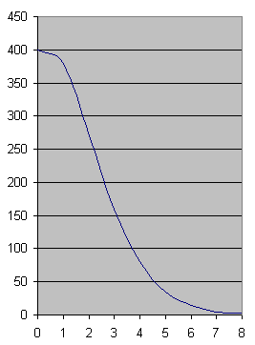

6. The Behavior of P and Q for large ν .

Now the new AS has these interesting large-ν limits (beware: this is a bold Q )

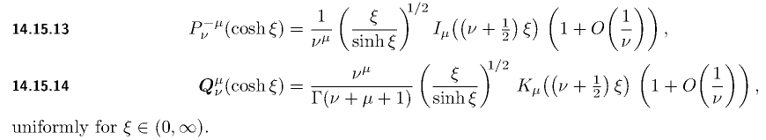

Note carefully that (0,∞) is the open interval (see p xiv of AS) and does not include ξ = 0. So these formulas are simply not valid exactly at ξ = 0 (which is z = 1). So be careful! ALSO, notice that this is the Bold Q function!!!

If we set μ = 0, these say

Pν(chξ) = $\sqrt{ξ/shξ}$ I0[(ν+1/2)ξ] large ν
Qν(chξ) = $\sqrt{ξ/shξ}$ K0[(ν+1/2)ξ] / /Γ(ν+1) large ν

Pn-1/2(chξ) = $\sqrt{ξ/shξ}$ I0[nξ] large n
Qn-1/2(chξ) = $\sqrt{ξ/shξ}$ K0[nξ] / /Γ(n+1/2) large n

Question: how to we reconcile Pν(chξ) = $\sqrt{ξ/shξ}$ I0[(ν+1/2)ξ] with Pν(1) = 1 ? See below.

Meanwhile, we can go see how these two modified Bessel functions behave for large n

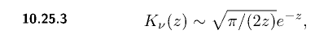
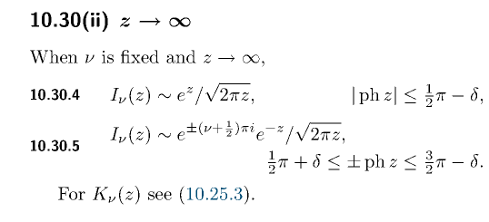
where their δ is my usual ε, an arbitrarily small positive constant. For our z, phase is 0 so the first form above applies. We then have

K0(z) = $\sqrt{π/(2z)}$e-z => K0(nξ) = $\sqrt{π/(2nξ)}$e-nξ
I0(z) = $\sqrt{1/2πz}$ e+z => I0(nξ) = $\sqrt{1/2πnξ}$ e+nξ

Installing these we then get

Pn-1/2(chξ) = $\sqrt{ξ/shξ}$ $\sqrt{1/2πnξ}$ e+nξ large n
Qn-1/2(chξ) = $\sqrt{ξ/shξ}$ $\sqrt{π/(2nξ)}$e-nξ /Γ(n+1/2) large n
or
Pn-1/2(chξ) = $\sqrt{1/shξ}$ $\sqrt{1/2πn}$ e+nξ large n
Qn-1/2(chξ) = $\sqrt{1/shξ}$ $\sqrt{π/(2n)}$e-nξ /Γ(n+1/2) large n

Now Bold Q is not what appears in our formula! We have to correct this way

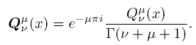

which is to say

Qν = Qν/Γ(ν+1) Qn-1/2 = Qn-1/2/Γ(n+1/2)

So we just remove the Γ factor shown above, and rewrite our final results this way

Pn-1/2(chξ) = $\sqrt{1/shξ}$ $\sqrt{1/2πn}$ e+nξ large n
Qn-1/2(chξ) = $\sqrt{1/shξ}$ $\sqrt{π/(2n)}$e-nξ large n

Question: how to we reconcile Pn-1/2(chξ) = $\sqrt{1/shξ}$ $\sqrt{1/2πn}$ e+nξ with Pν(1) = 1 ? I think when ξ = 0, our main actor e+nξ becomes just "1" and the "lower terms" not shown above come into play. As noted above, the equations do not apply at ξ = 0. So you cannot take this limit I guess. So we always have to think of ξ = ε > 0.

From the last line above we may conclude that: for any fixed ξ > 1, no matter how close, the function
Qn-1/2(chξ) decays exponentially in n due to e-nξ. So as long as we avoid z = 1, we get exponential convergence out at large n.

Examples of series involving P and Q

An example is the PBM sum rule noted above

Σn=0 εn Qn-1/2(z) = (π/$\sqrt{2}$)/ $\sqrt{z-1}$ // valid for all z

The capacitance special function is another example:

T(z) = $\sqrt{z2 - 1}$ Σn=0∞ εn [Qn-1/2(z)/ Pn-1/2(z)]

We have

Qn-1/2(z)/ Pn-1/2(z) = [ $\sqrt{1/shξ}$ $\sqrt{π/(2n)}$e-nξ] / [ $\sqrt{1/shξ}$ $\sqrt{1/2πn}$ e+nξ]

= [ $\sqrt{π/(2n)}$e-nξ] / [$\sqrt{1/2πn}$ e+nξ] = $\sqrt{π/(2n)}$ e-2nξ $\sqrt{2πn}$ = π e-2nξ

so again, excellent convergence away from z = 1.

A third example is our charge density approximation shown above for the outer equator,

σ(outer equator, z0 ≈ 1) = ( V0 /4π R) *
{ ($\sqrt{2}$/π)($\sqrt{z0 -1}$)3 Σn=0∞εn (1/2) (n2-1/4) Qn-1/2(z0) + (1/2)}

and now we consider only the large n "tail" of the series (N is some very large integer)

tail ≈ ( V0 /4π R) *
{ ($\sqrt{2}$/π)($\sqrt{z0 -1}$)3 Σn=N∞εn (1/2) (n2-1/4) [$\sqrt{1/shξ0}$ $\sqrt{π/(2n)}$e-nξ0] + (1/2)}

But $\sqrt{1/shξ}$ = (z2-1)-1/2 ≈ (1/$\sqrt{2}$) (z-1)-1/2 which cancels one outside power so

≈ ( V0 /4π R) *
{ (1/2π) $\sqrt{π/2}$(z0-1) Σn=N∞εn (n2-1/4) e-nξ0] + (1/2)}

As usual, we get sum convergence as long as we avoid ξ = 0. There it clearly diverges.

A fourth example is the charge on the inner equator.

σ(inner equator, z0 ≈ 1) = ( V0 /4π R) *
{ ($\sqrt{2}$/π)($\sqrt{2}$)3 Σn=0∞ εn (1/2) (n2-1/4) Qn-1/2(z0)(-1)n + (1/2)}

tail ≈ ( V0 /4π R) *
{ ($\sqrt{2}$/π)($\sqrt{2}$)3 Σn=0N εn (1/2) (n2-1/4) [$\sqrt{1/shξ0}$ $\sqrt{π/(2n)}$e-nξ0](-1)n + (1/2)}

and we install for $\sqrt{1/shξ0}$ as done above,

tail ≈ ( V0 /4π R) *
{ (1/π)($\sqrt{2}$)3 Σn=0N εn (1/2) (n2-1/4) { (z0-1)-1/2 $\sqrt{π/(2n)}$e-nξ0}+ (1/2)}

≈ ( V0 /4π R) *
{ (1/π)($\sqrt{2}$)3 (1/2) $\sqrt{π/2}$ (z0-1)-1/2 Σn=0N εn (n2-1/4) { e-nξ0}+ (1/2)}

I don't really know what to make of these sums, except they do converge for ξ0> 0.

7. More on the z ≈ 1 behavior of T(z) : an estimate of T'(z) near z = 1

T(z) = $\sqrt{z2 - 1}$ Σn=0∞ εn [Qn-1/2(z)/ Pn-1/2(z)]

We know that if we brute-force set Pn-1/2(z) = 1, we get T(1) = $\sqrt{2}$ * (π/$\sqrt{2}$) = π. But this does not tell us anything about what happens slightly away from z = 1.
Now that we think the limit is finite, we might compute the derivative. I did this partially in "charged donut", so consider

T(z) = $\sqrt{z2 - 1}$ f(z) where f(z) = Σn=0∞ εn [Qn-1/2(z)/ Pn-1/2(z)]

We then compute

T'(z) = $\sqrt{z2 - 1}$ f'(z) + (1/ $\sqrt{z2 - 1}$) f(z)

In "charged donut" ( Section 3 (c), page 15) I used the Wronskian to show that

f'(z) = (1-z2)-1 Σn=0∞ εn /[Pn-1/2(z)]2

Therefore we have

T'(z) = $\sqrt{z2 - 1}$ f'(z) + (1/ $\sqrt{z2 - 1}$) f(z)

= $\sqrt{z2 - 1}$ {1-z2)-1 Σn=0∞ εn /[Pn-1/2(z)]2} + (1/ $\sqrt{z2 - 1}$) f(z)

= – $\sqrt{z2 - 1}$ (1/(z2-1) Σn=0∞ εn /[Pn-1/2(z)]2 + (1/ $\sqrt{z2 - 1}$) f(z)

= – (1/ $\sqrt{z2 - 1}$) Σn=0∞ εn /[Pn-1/2(z)]2 + (1/ $\sqrt{z2 - 1}$) f(z)

= (z2-1)-1 { – $\sqrt{z2 - 1}$ Σn=0∞ εn /[Pn-1/2(z)]2 + $\sqrt{z2 - 1}$) f(z) }

= { – $\sqrt{z2 - 1}$ Σn=0∞ εn /[Pn-1/2(z)]2 + T(z) } / (z2-1)

So, we just showed that

T'(z) = { T(z) – $\sqrt{z2 - 1}$ Σn=0∞ εn /[Pn-1/2(z)]2 } / (z2-1)

Now in the vicinity of z = 1 we can write this as

T'(z) ≈ { "e" – $\sqrt{2}$$\sqrt{z - 1}$ Σn=0∞ εn /[Pn-1/2(z)]2 } / [ 2(z-1) ]

STOP. Now that I know T(z) comes in at a nice zero slope landing to "e" (more or less") , it must be that the following happens

$\sqrt{z2 - 1}$ Σn=0∞ εn /[Pn-1/2(z)]2 → "e" as z → 1

With the same Maple program used above, this seems to be happening.

z = 1.1 above = 2.898517346
z = 1.01 above = 2.751570937
z = 1.001 above = 2.736973437
z = 1.0001 above = 2.735058209
z = 1.00001 above = 2.735362078
z = 1.000001 above = 2.735354499 10,000 terms
z = 1.0000001 above = 2.735353885 40,000 terms (this is done below)

I think this last result is quite accurate for the following reason. First, here are the plots M=10,000 where I have now set Digits = 20 (unlike the above)

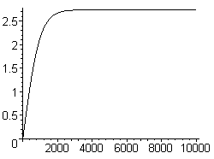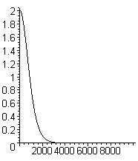

And here are some of the partial sums as we move to the right

1000 2.1436155874401640008 .81678124764208588405
2000 2.6687698498584814443 .11085374403333879449
3000 2.72955585814389028766 .10300677170762051709e-1
4000 2.7349032859403394031 .82806228708563706284e-3
5000 2.7353221859381661403 .61848397768363181630e-4
6000 2.7353530045499066199 .44171613948808663950e-5
7000 2.7353551837851815586 .30605858023903598194e-6
8000 2.7353553337178674615 .20747209703762420506e-7
9000 2.7353553438280382256 .13833048758759337908e-8
10000 2.7353553444993710926 .91040749929023577548e-10

I think I can believe the digits shown in red. This 1/P2 sum is much faster in Maple that the Q/P sum probably because we stay away from the singular point of Q. These digits of course all apply to z = 1.000001 only.
Can we go another step? I set z = 1.000 0001 and M = 40,000. Calc time is 90 seconds

Plots look good

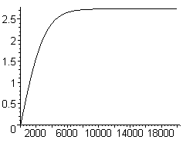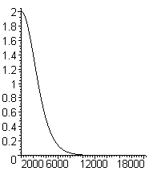

The value at 40,000 is this, but termstore shows things still moving in position 6 or so.

40000 2.7353538859954987758 .64286639725934536264e-13

Red shows now many digits agree with previous z value. Although termsize is low, it is still adding thousands of terms so you cannot imagine this is accurate to 13 places.
Now our best result from doing the painful Q/P sum was this with 4000 terms:

1.000001 2.7353214611940669030 4000 6

and it agrees to the first 5 places. [ Wolfram timed out before it could add all these terms ]

Conclusion: The value of T(1) is NOT e, it is a larger number, and I call it T(1) = 2.735353. I have no idea if this number has some interpretation in terms of π's and 2's. This number rings no bells on the web. Combining π,e,γ a few ways does not help. You cannot help but wonder: is there some way to compute this limit in terms of basic numbers? How would you compute a sum of 1/P2 ? From sum of 1/P perhaps then diff, but first may not converge. I could not find a linear ODE solved by 1/P.
What about

Pn-1/2(z) ≈ 1 + (n-1/2)(n+1/2)(z-1)/2 = 1 + (n2-1/4) (z-1)/2

Well, when put up top for super small z-1 terms blow up, that does not work. I give up. I have NEVER seen any series sum anywhere with a Legendre function "on the bottom". None in PBM. Probably the reason is that there is no way to compute such a sum except numerically as I have done.

8. Still more on the z ≈ 1 behavior of T(z) : trying directly limits of Q and P

I think I have these two facts on solid ground,

T(z) = $\sqrt{z2 - 1}$ Σn=0∞ εn [Qn-1/2(z)/ Pn-1/2(z)]

T'(z) = { T(z) – $\sqrt{z2 - 1}$ Σn=0∞ εn /[Pn-1/2(z)]2 } / (z2-1)

though there could be errors in the second line, the first is just our definition.

What happens if we try to take limits of Q and P directly? Our 2009 AS tells us

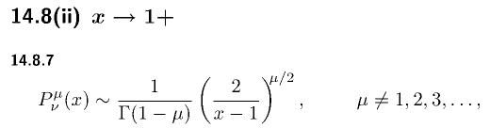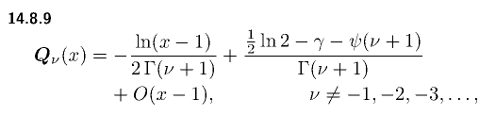
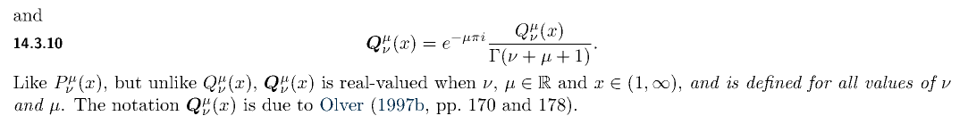

These things can be written for the Bateman Q function

Pν(z) = 1

Qν(z) = [ - ln(z-1) + (1/2)ln2 - γ - ψ(ν+1) ]

Qn-1/2(z) = [ - ln(z-1) + (1/2)ln2 - γ - ψ(n+1/2) ]

If we just jam these forms into our T(z) we get

T(z) = $\sqrt{z2 - 1}$ Σn=0∞ εn [Qn-1/2(z)/ Pn-1/2(z)]

T(z) = $\sqrt{z2 - 1}$ Σn=0∞ εn [ - ln(z-1) + (1/2)ln2 - γ - ψ(n+1/2) ]

= $\sqrt{z2 - 1}$ { - ln(z-1) Σn=0∞ εn

+ [(1/2)ln2 - γ] Σn=0∞ εn

- Σn=0∞ εn ψ(n+1/2)

There is no point in going further here. All three series diverge

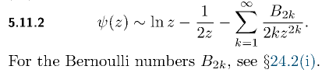

so the limit is meaningless. All done with this pathway.

9. So mathematically, what is the problem here?

I had to go off and do a whole separate writeup on this subject. It has to do with "order interchange of limits". The upshot is that it is very possible even in simple examples for a double limit to be different depending on the order in which you take the limits. This can happen if one of the limits does not exist, or if they both exist, then if both limits separately fail to converge uniformly to their limits. I think the second case applies to the previous section.

We start with

T(z) = limN→∞ $\sqrt{z2 - 1}$ Σn=0N εn [Qn-1/2(z)/ Pn-1/2(z)]

We ask: is this single limit uniformly convergent

for any z > 1 we can certainly write this as

T(z) = Σn=0∞ εn { $\sqrt{z2 - 1}$ [Qn-1/2(z)/ Pn-1/2(z)] }

We then want

T(1) = limz→1+ [Σn=0∞ εn { $\sqrt{z2 - 1}$ [Qn-1/2(z)/ Pn-1/2(z)] } ]

and the question is "can we interchange order of limit and sum" ? Here is another way to think of this

T(1) = limz→1+ limN→∞ [Σn=0N εn { $\sqrt{z2 - 1}$ [Qn-1/2(z)/ Pn-1/2(z)] } ]

Now here is an interesting clip from a paper

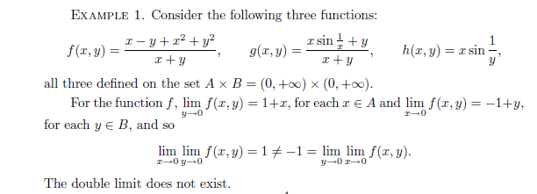

In this example, you get different answers depending on in which order you do the two limits! This relates to the subject of "uniform convergence". Consider the convergence of f above. When we talk about it converging to the function 1+x in our y→0 limit, we talk about this thing being small:

| f(x,y) - (1+x) | < ε

Uniform means you have to be able to find an ε that works for all x in the x set when y < some δ. I have stared at this and don't understand, so off we go to another doc, pushing down another level.

10. Wolfram Weighs In on the T(z) calculations

First run:

sqrt(1.0001^2-1)*(2*sum(LegendreQ(n-1/2,0,3,1.0001)/LegendreP(n-1/2,0,3,1.0001),n=1 to 299) + LegendreQ(-1/2,0,3,1.0001)/LegendreP(-1/2,0,3,1.0001) )

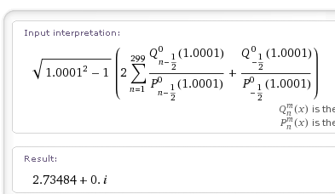

This is adding 300 terms total which is what I did above. My answer is a little different

2.7351308588392861033

but we are off by 1 unit in 4 places, not too bad. Now let's crank down another 0 and add 999 terms to compare to my next result Wolf gets

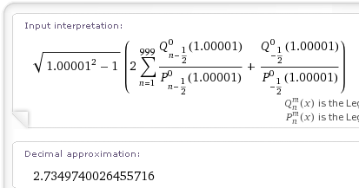

whereas I got T(1.0 0001) = partialsum[900] = 2.7344425737692892471 very close

Now go for the next one, but it times out. But lets now try 2500 terms instead.

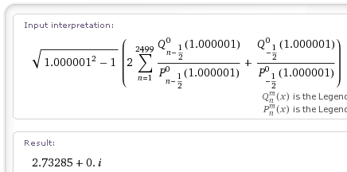
My answer at 4000 terms was 2.7353214611940669030, off by 2 units in 4 places, still very close. Maybe this result is NOT going to "e".
So I get reinforcement from Wolfram, but I cannot do more terms really because of computation time.

What about Wolfram on the P sum>?

sqrt(1.0001^2-1)*(2*sum(LegendreQ(n-1/2,0,3,1.0001)/LegendreP(n-1/2,0,3,1.0001),n=1 to 299) + LegendreQ(-1/2,0,3,1.0001)/LegendreP(-1/2,0,3,1.0001) )

sqrt(1.0000001^2-1)*(2*sum(1/LegendreP(n-1/2,0,3,1.0000001)^2,n=1 to 39999) + 1/LegendreP(-1/2,0,3,1.0000001) ^2)

11. The large z behavior of T(z)

From section 3 above we have these large z limits of our ratio

Qn-1/2(z)/ Pn-1/2(z) = π { Γ(n+1/2)2/ [Γ(n+1) Γ(n)] } (2z)-2n n = 1,2,3...

Q-1/2(z)/ P-1/2(z) = (π2/2) (1 / ln[8z] ) n = 0

For n = 1 we get

Q1/2(z)/ P1/2(z) = π { Γ(1+1/2)2/ [Γ(1+1) Γ(1)] } (2z)-2

= π { ($\sqrt{π}$/2)2 } 2-2 z-2 = π2 z-2/16 = (π2/16) z-2

So keeping only these first two terms we have

T(z) = $\sqrt{z2 - 1}$ Σn=0∞ εn [Qn-1/2(z)/ Pn-1/2(z)]

≈ $\sqrt{z2 - 1}$ [(π2/2) (1 / ln[8z] ) +(π2/8) z-2 + O(z-4)]

≈ z [(π2/2) (1 / ln[8z] ) +(π2/8) z-2 ] z = ρc/R

≈ (ρc/R) [(π2/2) (1 / ln[8(ρc/R)] ) +(π2/8) (R/ρc)2 ] z = ρc/R

≈ (π2/2) (ρc/R) [(1 / ln[8(ρc/R)] ) +(1/4) (R/ρc)2 ] z = ρc/R

The capacitance is (2R/π) T(z) so we then have

C(z) ≈ (2R/π) (π2/2) (ρc/R) [(1 / ln[8(ρc/R)] ) +(1/4) (R/ρc)2 ]

C(R; ρc) ≈ πρc [(1 / ln[8(ρc/R)] ) +(1/4) (R/ρc)2 ]

We can then ask what happens if we hold ρc fixed and decrease R to get into the thin wire limit. It seems reasonable to set ρc = 1 so we can then make a plot versus R where R could range from 1 down to 0.

C(R; ρc=1) ≈ π[(1 / ln[8(1/R)] ) +(1/4) (R)2 ]

≈ π [(1/ ln(8/R) ) + (R/2)2] // agrees with "charged donut" calc

This formula is only valid for z >> 1 which means R << 1. But in this limit, the second term can be neglected, and we get

C(R; ρc=1) ≈ π / ln(8/R) R << 1

As R gradually decreases, the log gets larger and C gets smaller. Maple does not do log plots where only the x axis is log, so we have to invert this equation (result agrees with "donut")

C = π / ln(8/R) => R = 8 e-π/C ρc = 1 z = ρc/R = 1/R

Here is a plot of the thin-wire limit roughly ( for z in range 103 to 1040) ( 1e-06 means 1 x 10-6 )

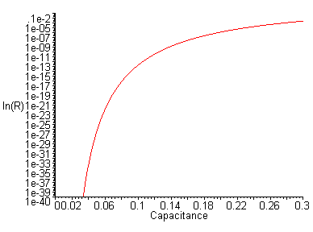

It shows that with ρc = 1 C starts at 0.3 when R ~ 10-3 and drops to 0.03 when R ~ 10-39 . So a thin wire capacitor

12. Full range plot of T(z)

T(z) = $\sqrt{z2 - 1}$ Σn=0∞ εn [Qn-1/2(z)/ Pn-1/2(z)]

We showed above that for z >> 1 this is roughly

T(z) ≈ (π2/2)z / ln[8z] ) z = ρc/R

which is basically a linear plot that drops down a bit due to the slow growth of the denominator. The function is of course unbounded for large z. To get a plot that is perhaps more useful, we can write

C = (2R/π) $\sqrt{z2 - 1}$ Σn=0∞ εn [Qn-1/2(z)/ Pn-1/2(z)]

= (2R/π) $\sqrt{(ρc/R)2 - 1}$ Σn=0∞ εn [Qn-1/2(ρc/R)/ Pn-1/2(ρc/R)]

= (2/π) $\sqrt{ρc2 - R2}$ Σn=0∞ εn [Qn-1/2(ρc/R)/ Pn-1/2(ρc/R)]

Then as before we set the scale setting ρc = 1 to get

C(R) = (2/π) $\sqrt{1 - R2}$ Σn=0∞ εn [Qn-1/2(1/R)/ Pn-1/2(1/R)]

We know from our thin-wire limit that this will very gradually drop off as R becomes very small.

And we know that in the limit R = 1, we have our degenerate toroid for which

T(z=1) = limz→1+{ $\sqrt{z2 - 1}$ Σn=0∞ εn [Qn-1/2(z)/ Pn-1/2(z)] } = 2.7353

This means that

C(R=1) = (2R/π)T(1) = (2/π)T(1) = (2/π) 2.7353 = 1.7413

So basically C will cover this range in our plot: C = (0,1.7413) .

One other data point. At R = 0.5, we have z = 2, so we expect this result

C(R = 1/2) = (2R/π) * T(2) = (1/π)* 3.82 = 1.21

and this computation is just fine at 40 terms, according to "our work above".

Here is my plot

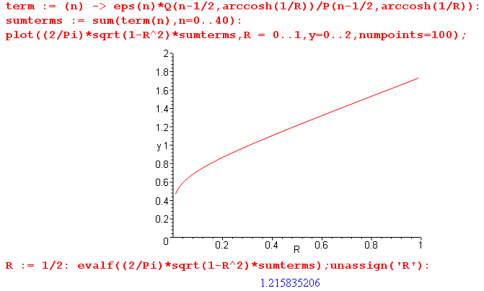

It has the right value at R = 0.5. The right end should reach up to 1.7413 and it is trying to do that, the left end even with our minimal 40 term sums.

So I am now very happy with this curve. I started with it several days ago, and now I understand what is happening at the two ends. That took a ton of work to get right.

(a) comparing the degenerate toroid to the enclosing sphere.

The sphere which just encloses our degenerate torus has radius 2R hence capacitance 2R.

Cdegenenerate torus = 1.7413
Cenclosing sphere = 2.0000 ratio = 2.0000/1.741 = 1.1487651

We can ponder the relative surface areas.

area of toroid = π2( b2-a2) b = outer radius a = inner radius

area of degenerate toroid = π2b2 b = 2R R = radius of the tube

= π2(2R)2 = 4π2R2

A sphere which just encloses our toroid would have radius 2R, so

area of enclosing sphere = 4π(2R)2 = 16πR2

so

enclosing sphere area/ degen toroid area = 16πR2/ 4π2R2 = 4/π = 1.273

The sphere has 27% more area, but only 15% more capacitance.

So our degenerate toroid has 78% of the area of the enclosing sphere, but 74% more capacitance.

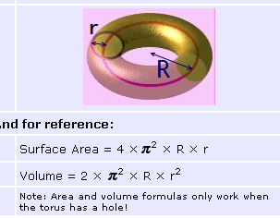

So we could say area = 4π2Rρc.

