or

$\left(\begin{matrix}ch(u0τ) & sh(u0τ) \\ ch(u0'τ) & sh(u0'τ)\end{matrix}\right)$$\left(\begin{matrix}A(τ) \\ B(τ)\end{matrix}\right)$ = $\sqrt{2}$$\sqrt{2}$

= [V0$\sqrt{2}$/(τ ch(πτ))]$\left(\begin{matrix}ch[τ(u0-π)] \\ ch[τ(u'0-π)]\end{matrix}\right)$

M V = W MT = $\left(\begin{matrix}ch(u0τ) & ch(u0'τ) \\ sh(u0τ) & sh(u0'τ)\end{matrix}\right)$ cofMT = $\left(\begin{matrix}sh(u'0τ) & - sh(u0τ) \\ - ch(u0'τ) & ch(u0τ)\end{matrix}\right)$

det(M) = ch(u0τ) sh(u0'τ)- sh(u0τ)ch(u0'τ) = sh(u0'τ) ch(u0τ) - ch(u0'τ)sh(u0τ)ch(u0'τ) = sh[(u'0-u0)τ]

V = M-1W

M-1 = $\frac{1}{sh[(u'0-u0)τ]}$ $\left(\begin{matrix}sh(u'0τ) & - sh(u0τ) \\ - ch(u0'τ) & ch(u0τ)\end{matrix}\right)$

$\left(\begin{matrix}A(τ) \\ B(τ)\end{matrix}\right)$ = $\frac{1}{sh[(u'0-u0)τ]}$$\left(\begin{matrix}sh(u'0τ) & - sh(u0τ) \\ - ch(u0'τ) & ch(u0τ)\end{matrix}\right)$[V0$\sqrt{2}$ch[τ(u0-π)]/(τ ch(πτ))]$\left(\begin{matrix}1 \\ 1\end{matrix}\right)$

= $\sqrt{2}$$\left(\begin{matrix}sh(u'0τ) & - sh(u0τ) \\ - ch(u0'τ) & ch(u0τ)\end{matrix}\right)$$\left(\begin{matrix}1 \\ 1\end{matrix}\right)$

= $\sqrt{2}$$\left(\begin{matrix}sh(u'0τ)- sh(u0τ) \\ - ch(u0'τ) +ch(u0τ)\end{matrix}\right)$

My results seem to be

A(τ) = $\sqrt{2}$[ sh(u'0τ)- sh(u0τ)]

B(τ) = $\sqrt{2}$[ - ch(u0'τ) +ch(u0τ)]

and these results seem different from my original results

A(τ) = V0 $\sqrt{2}$ch[(π–u0)τ] ch[(π+u0)τ] / ch2(πτ)
B(τ) = – V0 $\sqrt{2}$ch[(π–u0)τ] sh[(π+u0)τ] / ch2(πτ) . (2.4.9)

$\left(\begin{matrix}sh(u'0τ) & - sh(u0τ) \\ - ch(u0'τ) & ch(u0τ)\end{matrix}\right)$$\left(\begin{matrix}ch[τ(u0-π)] \\ ch[τ(u'0-π)]\end{matrix}\right)$

A(τ) = $\sqrt{2}$ { sh(u'0τ)ch[τ(u0-π)] - sh(u0τ)ch[τ(u'0-π)] }

This does not agree with my old result.

M-1 = cof MT/detM = $\left(\begin{matrix}sh(u0'τ) & \\ c & d\end{matrix}\right)$

Define,

a = ch(u0τ) b = sh(u0τ) q = V0 $\sqrt{2}$/(τ ch(πτ)) s = $\sqrt{2}$ch[τ(u0-π)]
a' = ch(u'0τ) b' = sh(u'0τ) s' = $\sqrt{2}$ch[τ(u'0-π)]

to rewrite the above equations as

aA + bB = q s
a'A + b'B = q s'

This is a Cramer's Rule problem and we call in Maple to solve for A and B

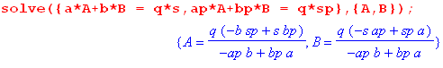
Then

A(τ) = V0 $\sqrt{2}$/(τ ch(πτ)) * [ - sh(u0τ)$\sqrt{2}$ch[τ(u'0-π)] + $\sqrt{2}$ch[τ(u0-π)]sh(u'0τ) ]
/ [ - ch(u'0τ)sh(u0τ) + sh(u'0τ)ch(u0τ)]

=

***************

Before using this transform to invert the two boundary condition equations, we have to first know a little more about the range of the bowl label coordinate u. To that end, here is a picture:

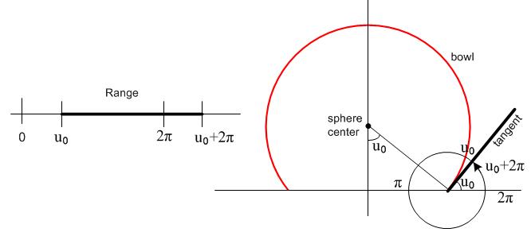 (2.4.4)
This shows in cross section one up-side-down bowl having label u0. Following Lebedev et. al.'s excellent suggestion, instead of running the bowl label in the usual (0,2π) range, we shall have it lie in (u0, u0+2π) so it can be continuous away from the two sides of the bowl. As we start off with u0 as the angle shown, we can imagine a set of mathematical bowl surfaces attached to the two "focal points" on the x axis, whose labels run from u0 up to u0 + 2π. We will explain all this below, but it is perhaps useful to solve the problem first, then see the coordinate details later. The inside surface of the bowl lies at u = u0 while the outside surface is at u = u0+2π.

*****************8

Lastly, but very importantly, we have to figure out how to compute toroidal parameter u from Cartesian coordinates ρ and z ( really cylindrical coordinates). Box (1.3.10) states that

u = tan-1[ 2az/(ρ2+z2- a2)]

but the letters "tan-1" do not indicate which branch of tan-1() we need to be on for a given value of ρ and z. This information is not present in the equation above. For that reason, we compute cosu and sinu separately from these equations shown in box (1.3.10),

ξ = tanh-1[2aρ/(a2+ ρ2+ z2)]
ρ = ashξ/(chξ–cosu) ⇒ cosu = chξ - (a/ρ) shξ
z = asinu/( chξ–cosu) ⇒ sinu = (z/ρ)shξ since z/ρ = sinu/shξ

and then use the (0,2π) arctan2Pi routine shown above to get the proper u. Finally, we have to adjust this value of u so it fits into the adjusted range (u0, u0+2π). And we have to worry about all the special cases that tend to blow things up when ignored. So here then is a routine to compute u:

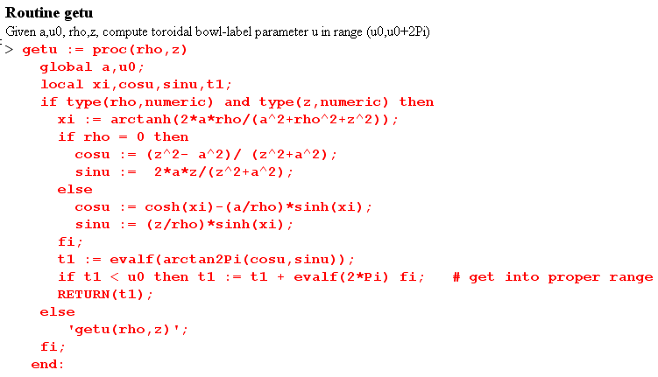

where again one should ignore the "if type" statement.

***********

1. Check that V(ξ,u0) = V0 as u→u0

Start with (8.8),

V(ξ,u) = (V0/π) { π - cot-1[$\sqrt{2}$$\sqrt{chξ-cosu}$] + $\sqrt{chξ - cosu}$$\sqrt{chξ-cos(2u0- u)}$ cot-1[$\sqrt{2}$$\sqrt{chξ-cos(2u0- u)}$] }

Then if u→u0 we find

cos(u0-u/2) = cos(u0/2)
cos(2u0- u) = cosu0
chξ - cos(2u0-u) = chξ - cosu0 .

Inserting these into the above gives

V(ξ,u0) = (V0/π) { π - cot-1[$\sqrt{2}$$\sqrt{chξ-cosu0}$] + $\sqrt{chξ - cosu0}$$\sqrt{chξ - cosu0}$ cot-1[$\sqrt{2}$$\sqrt{chξ-cosu0}$] }

= (V0/π) { π - cot-1[x] + cot-1[x] } = (V0/π) { π } = V0

2. Check The Disk Limit

Start with (8.7),

V(ξ,u) = (V0/π) { cot-1[$\sqrt{2}$$\sqrt{chξ-cosu}$] + $\sqrt{chξ - cosu}$$\sqrt{chξ-cos(2u0- u)}$ cot-1[$\sqrt{2}$$\sqrt{chξ-cos(2u0- u)}$] } (8.7)

Then if u0→π we find

cos(u0-u/2) = cos(π-u/2) = -cos(u/2)
cos(2u0- u) = cos(2π- u) = cosu
chξ - cos(2u0-u) = chξ - cosu.

V(ξ,u) = (V0/π) { cot-1[$\sqrt{2}$$\sqrt{chξ-cosu}$] + $\sqrt{chξ - cosu}$$\sqrt{chξ - cosu}$ cot-1[$\sqrt{2}$$\sqrt{chξ-cosu}$] }

= (2V0/π) cot-1[$\sqrt{2}$$\sqrt{chξ-cosu}$]

We show in Appendix H.3 that, when the above is converted to Cartesian coordinates, the result is

Vdisk(ξ,u) = (2V0/π) $\sqrt{(ρ-a)2+z2}$$\sqrt{(ρ+a)2+z2}$

which agrees with green Jackson p 92 (3.178)

3. Check The Full Bowl Limit

Start with (8.7),

V(ξ,u) = (V0/π) { cot-1[$\sqrt{2}$$\sqrt{chξ-cosu}$] + $\sqrt{chξ - cosu}$$\sqrt{chξ-cos(2u0- u)}$ cot-1[$\sqrt{2}$$\sqrt{chξ-cos(2u0- u)}$] } (8.7)

The limit of interest here is u0→ 0. We then have

cos(u0-u/2) = cos(u/2)
cos(2u0- u) = cosu
chξ - cos(2u0-u) = chξ - cosu

This is the same as the previous limit except for the sign of the second cot-1 ratio, so we get

V(ξ,u) = (V0/π) { cot-1[$\sqrt{2}$$\sqrt{chξ-cosu}$] + cot-1[$\sqrt{2}$$\sqrt{chξ-cosu}$] }

= (V0/π) { cot-1[-x] + cot-1[x] } = (V0/π) { cot-1[-x] + cot-1[x] }

= (V0/π) {π } = V0 = wrong answer! But I know why this is the result.

STOP. Where did I figure out how to do this right with regulation?

****************

Limit for small a (sphere of radius R)

A = B = $\sqrt{z2+ (ρ)2}$ = r Q = 1/(AB) = 1/r2 = 1/(z2+ρ2)

$\sqrt{2}$cos(u/2) = σc $\sqrt{1 + (ρ2+z2- a2)Q}$ = σc $\sqrt{1 + (ρ2+z2)Q}$ = σ2$\sqrt{2}$

cos(u0-u/2) = [cosu0σc$\sqrt{1 + (ρ2+z2)Q}$ + sinu0σs$\sqrt{1 - (ρ2+z2)Q}$]/$\sqrt{2}$

= [cosu0σc$\sqrt{1 + 1}$ + sinu0σs$\sqrt{1 - 1}$]/$\sqrt{2}$

= σccosu0

chξ - cos(2u0 - u) = [ 2a2 - cos(2u0)(ρ2+z2- a2) - sin(2u0) 2az] Q

= - cos(2u0)(ρ2+z2)Q = - cos(2u0)

This seems an odd result, but let's go with it anyway. Then

V(ξ,u) = (V0/π) { cot-1[- $\sqrt{2}$$\sqrt{chξ-cosu}$] + $\sqrt{chξ - cosu}$$\sqrt{chξ-cos(2u0- u)}$ cot-1[$\sqrt{2}$$\sqrt{chξ-cos(2u0- u)}$] }
R1 R2 R3

The problem will be exactly as before. There is no "a" or "R" sitting anywhere

***********88

(a) Verbal description

Here is the basic toroidal picture as a slice in any azimuthal plane, where ρ and z are the usual cylindrical coordinates,

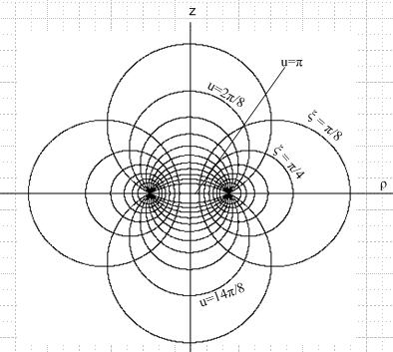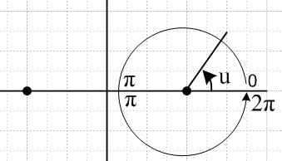

In this picture, the level surfaces of u appear to be vertical set of circles, but each circle is really truncated at the plane z=0 [ since sign(z) = sign(sinu) according to 5.1 below] so we have a set of upper bowls and a set of lower bowls. In this traditional picture, a huge upper bowl has as its limit an iris just above the z=0 plane which is labeled u=0. As these bowls shrink, we pass through the u = 2π/8 bowl shown, and eventually reach very shallow bowls with the limit of a disk of radius a at u = π. Continuing u we cover all the lower bowls and end up with an iris just below the z=0 plane at u = 2π. There is then a discontinuity in u at this iris value, as shown on the right. All these u bowls have a common circular lip in the z=0 plane of radius a, so the distance between the two focal points in the picture above is 2a. One can interpret u as the external bowl lip angle relative to the z=0 plane, but that fact is not very obvious from the above pictures.
Meanwhile the horizontal circles show slices of the toroids labeled by ξ . In the limit ξ → 0 one gets an exceedingly fat toroid with no hole whose inner surface sweeps up against the z axis. Conversely, as ξ→∞, the toroids shrink to a thin circular wire matching the bowl lips. It might be noted that these horizontal circles are the famous ones of Apollonius where |r - a|/|r + a| = constant, and in this case that constant is e-ξ.
Toroidal coordinates start life as 2D bipolar coordinates (see Lucht) with the same picture as above, but the left side circles have ξ < 0. For 3D toroidal coordinates, one takes just the right side of the above picture with ξ > 0 and rotates this around the z axis to get the 3D bowls and toroids.
Lest it be overlooked, the two sets of circles are orthogonal at all intersections, and are both orthogonal to the azimuthal unit vector at any point. The toroidal system is an orthogonal one with a diagonal metric tensor.

(b) Equations

The defining equations are these for toroidal coordinates (toroid,bowl,plane) = (ξ,u,φ) :

x = a cosφ shξ/(chξ - cosu) ρ = a shξ/(chξ - cosu) ρ2 = x2+ y2
y = a sinφ shξ/(chξ - cosu)
z = a sinu/(chξ - cosu) . (5.1)

Here then is a summary of all the basic facts of interest (Lucht)

ρ = ashξ/(chξ–cosu) ρ>0 hξ = hu = a/(chξ–cosu) hφ = shξ hξ
z = asinu/( chξ–cosu) ρ2 = x2+ y2 z/ρ = sinu/shξ (5.2)

ξ = tanh-1[2aρ/(a2+ ρ2+ z2)] metric tensor = diag(hξ2, hu2, hφ2)
tanu = [ -2az/(a2-ρ2-z2)] // use algorithm to find u (see later) (5.3)

r2 = a2 (sh2ξ + sin2u) / (chξ-cosu)2 = ρ2+z2 tanφ ≡ z/ρ = sinu/shξ ??? (5.4)

ρ2 + (z- acotu)2 = a2/sin2u zc = a cot(u) radius = a/|sinu| // vertical circles
(ρ - acothξ)2 + z2 = a2/sh2ξ ρc = acothξ radius = a/|shξ| // horizontal circles (5.5)

ranges: ξ in (0, ∞) u in (0,2π) φ in (0,2π)

Notice that the radius of the sphere on which a bowl u0 lies is R = a/|sinu0|.

(c) More pictures

The following detailed Maple plots of u contours have proved helpful to the author:

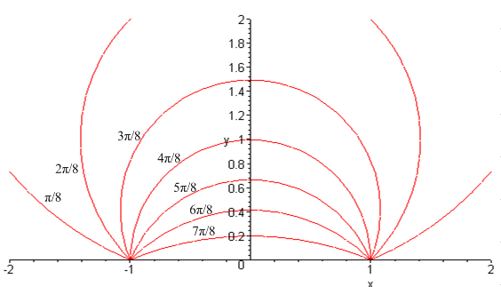
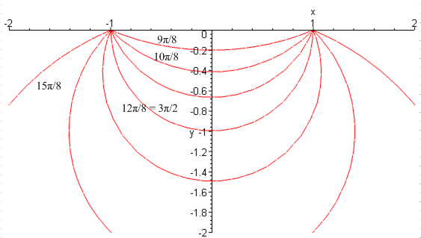

***************

(e) plot of u versus coordinates ρ and z after Lebedev's adjustment

If we adjust things so the u coordinate ranges from u0 to u0 + 2π, the above plot changes. Here is the plot for u0 = π/4 = .78 :

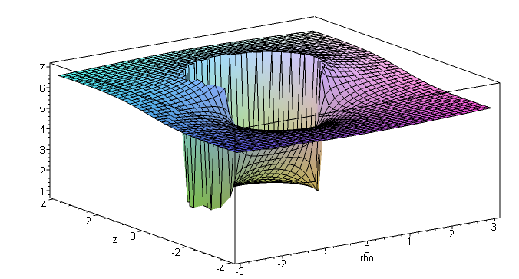

Now the spiral voyage begins inside the bowl at the foot of a vertical curved Niagara Falls which marks the inner boundary of our bowl. We climb up the hill and arrive at the upper plane and walk over to the falls and gaze down from the outer surface of the bowl. Here again is our bowl picture from above
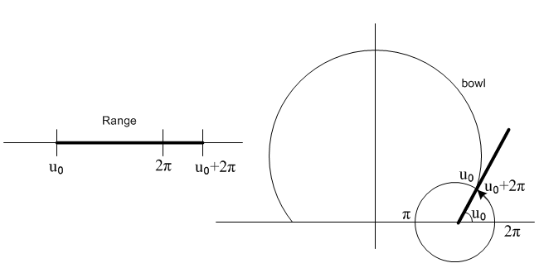

We show all these pictures to make the point that toroidal coordinates are a bit "unfriendly" compared to say spherical coordinates. They have to do violent things to be able to have bowls as level surfaces.

***************8888

The problem as ξ0 → 0 is that we impinge on the branch point of Qn-1/2(z=chξ0) at z = 1. Maple's hypergeometric function used in our Q function (7.4.2) suffers mightily for ξ0 = 0.2 (z = 1.02) for n > 55 (roughly),

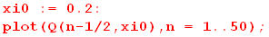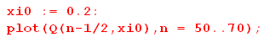
(10.2.8)
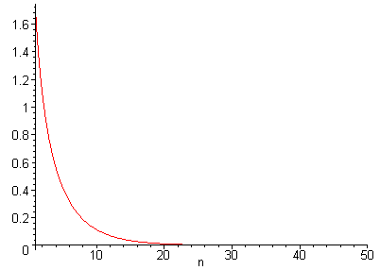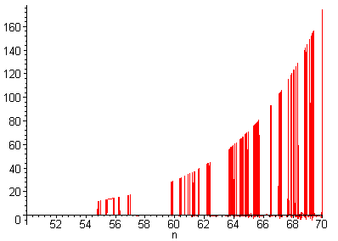

The geographic extent of this problem is illustrated by the following log plot of Q(ν,ξ) ≡ Qν(chξ) where we allow let ν roam in the range (30,90) and ξ in the range (0.01,0.5)

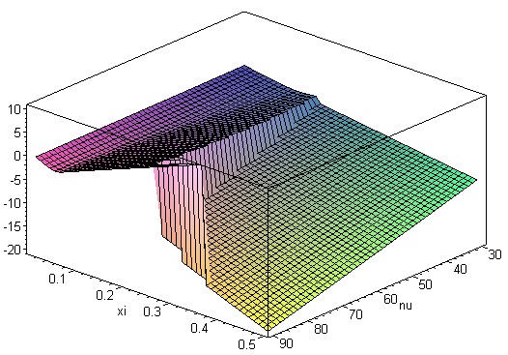 (10.2.9)
Based on the above plot, it does not seem to be an "asymptotic series" problem (nor is it a Digits problem), but rather some bug in evaluation. With due respect to the wonderful Maple, we are using the hypergeometric function of old Maple V.5 (1997) and no doubt this issue has gone away. In any event, we shall steer clear of these treacherous shoals in the following sections.

*******************
In order to study the behavior of sums involving P and Q functions, we first considered this "sum rule" which is expansion (10.1.8) above with x = 0, b = 1 and a = z ,

R(z) ≡ $\sqrt{z-1}$ Σn=0 εn Qn-1/2(z) = (π/$\sqrt{2}$) = 2.221441469 . (B.4)

This sum rule is mentioned in the charged donut.doc and the sum is shown there. I state there that the mws file that did this was deleted and was called PandQ v2.mws before deletion. I have a screen clip of the code there however. So I will try to reconstruct this right now in a new mws file.

Our Maple program was able to obtain the correct sum to three decimal places down to z = 1.00001 where it had to add 2000 terms. Because this series is in a sense only half as convergent as our intended Q/P series, the partial sums (left below) and terms (right below) exhibited characteristics of an asymptotic series, for example [ the horizontal axis shows the number of terms added ]

These curves appear in toroidal cap function.doc page 11

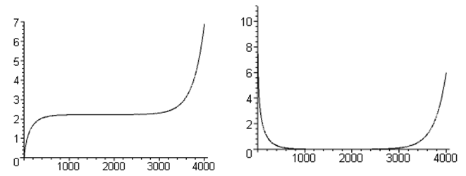

But I had trouble above around n = 55 terms, so how can this be doing 2000 terms??? I need to find the code that made the above plots and check it out.

The series R(z)/$\sqrt{z-1}$really is truly convergent, and this Maple behavior arises (we think) from the way Maple computes the hypergeometric function for very large parameters and z near 1, an area known to be problematic. The Q/P series partial sums (below) did not exhibit this asymptotic series behavior.

*************

Comment: From H.7 I have

fn(x) ≈ εn$\sqrt{x2 - 1}$ [- $\frac{1}{2Γ(n+1/2)}$ ln(x-1) + $\frac{ln4 - γ - ψ(n+1/2)}{Γ(n+1/2)}$] x→1

and it is clear that fn(x) → 0 as x→ 1, so at least we have a chance of convergence ( $\sqrt{ε}$lnε → 0) . But this does not imply convergence.

Question: Can I show that we have pointwise convergence of this series for x in (1,∞) ?

Consider each of the above two terms separately. The second term series is this

an(x) ≈ εn$\sqrt{x2 - 1}$$\frac{ln4 - γ - ψ(n+1/2)}{Γ(n+1/2)}$

Does this implied series converge? Let's try the ratio test. In that ratio the εn$\sqrt{x2 - 1}$ factor cancel and we have

rn ≡ an+1/an = $\frac{ln4 - γ - ψ(n+3/2)}{ln4 - γ - ψ(n+1/2)}$ $\frac{Γ(n+1/2)}{Γ(n+3/2)}$ = $\frac{ln4 - γ - ψ(n+3/2)}{ln4 - γ - ψ(n+1/2)}$ $\frac{1}{n+3/2}$

Maple shows that the limit of the ratio is 1 as n→∞, so basically rn ~ 1/n and this is less than 1, so by the ratio test, the series converges. Then you have

Well, certainly $\sqrt{x2 - 1}$ → 0 so we can ignore the second term. Write first term for n > 0 as

an = $\sqrt{x2 - 1}$$\frac{1}{2Γ(n+1/2)}$ln [$\frac{1}{x-1}$]

rn ≡ an+1/an = $\frac{Γ(n+1/2)}{Γ(n+3/2)}$ = $\frac{1}{n+3/2}$

Since rn → 0, we know the series converges pointwise on (1,∞) !!! See Buck p 161.

Theorem 15 (and precursor p 183)

Sequence fn has Cauchy property ⇔ sequence fn is uniformly convergent.
| fn - fm |E < ε for n,m both > N |....|E = max value on the range!

I could look at my large-n limit and maybe show something. Much of what Buck says applies to my series! Comparison test. Buck talks about order interchange with integral and with derivative, but not with a series.

Comment: Let's do the Cauchy test right here:

| an - am |E = | $\sqrt{x2 - 1}$ln [$\frac{1}{x-1}$] { $\frac{1}{2Γ(n+1/2)}$ - $\frac{1}{2Γ(m+1/2)}$} |E

Now if the range is the interval [1,1.2] I can plot the function of x to get

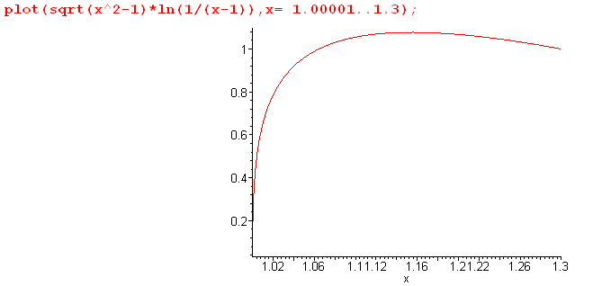

so somewhere around x = 1.16 this function has its max over range value. It goes to 0 at the left. So

| an - am |E = 1.16 { $\frac{1}{2Γ(n+1/2)}$ - $\frac{1}{2Γ(m+1/2)}$}

This looks Cauchy convergent to me! The { } is the difference of two small numbers so cannot exceed the sum of the two small numbers, which is small and gets smaller as n,m increase.

Conclusions:

(1) The series with fn(x) = εn$\sqrt{x2 - 1}$ [Qn-1/2(x) / Pn-1/2(x)] is Cauchy convergent and is therefore uniformly convergent on the range [1, 1,3].

(2) The series with fn(x) = εn [Qn-1/2(x) / Pn-1/2(x)] is not Cauchy convergence because then

| an - am |E = | ln [$\frac{1}{x-1}$] { $\frac{1}{2Γ(n+1/2)}$ - $\frac{1}{2Γ(m+1/2)}$} |E

Contradiction:

Consider

T(z) ≡ Σn=0∞ εn [$\sqrt{z2 - 1}$ Qn-1/2(z) / Pn-1/2(z)]

Since this is uniformly convergent on [1,1.2], I can take my limit inside the sum to get

limz→1 T(z) = Σn=0∞ εn limz→1 [$\sqrt{z2 - 1}$ Qn-1/2(z) / Pn-1/2(z)]

= Σn=0∞ εn 0 = 0

which I know is not true! I am using a theorem Buck never states : that you can do order interchange of a limit and an infinite sum if you have uniform convergence.

and on this interval | ln [$\frac{1}{x-1}$] |E = ∞. No matter how large you let N be, you can find an x in the range where the above is not < ε.

Now consider

f(n,m) = | $\frac{1}{Γ(n+1/2)}$ - $\frac{1}{Γ(m+1/2)}$| < ε

**************

Our motivation of course is that the capacitance of a toroid characterized by

Recall the toroid capacitance expression from (10.2.6) and the drawing (10.2.4)

C = (2/π) $\sqrt{ρc2 - R2}$ Σn=0∞ εn $\frac{Qn-1/2(ρc/R)}{Pn-1/2(ρc/R)}$ , εn = 2-δn,0 . (10.2.6)

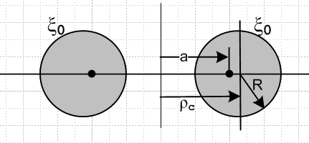 (10.2.4)

We wish to hold ρc constant and increase R to R = ρc when the hole in the toroid just disappears, so the toroid becomes "degenerate", or a "horn torus". Our question of interest is this: what is the capacitance at this point?

We set ρc = 1 and write

C(R) = (2/π) $\sqrt{1 - R2}$ Σn=0∞ εn $\frac{Qn-1/2(1/R)}{Pn-1/2(1/R)}$ , εn = 2-δn,0 . (10.2.6)
T(R) = $\sqrt{1 - R2}$ Σn=0∞ εn $\frac{Qn-1/2(1/R)}{Pn-1/2(1/R)}$ , εn = 2-δn,0 . (10.2.6)

The two functions shown differ by the simple factor shown, and we shall deal with both to be compatible with an earlier version of this appendix.

One cannot simply set R = 1 because Qν(z) has a singularity at z = 1. Rather, we have to carefully approach the limit.

************

C(R) seems to have a value around 1.74 at R = .999, but as we get closer to 1, the sum fades off. The remedy is to include more terms in the sum. If we increase from 100 to 1000 terms, the result is instead this,

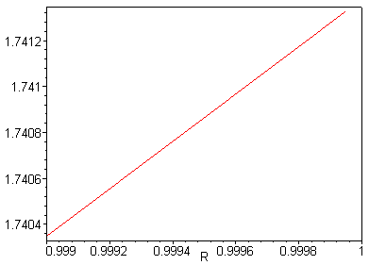

This suggests that the limit is around C = 1.7414 .

To obtain more accuracy, instead of using the Maple plot routine, we make our own curve of only 8 points so we can watch the approach to R = 1, while printing out the values. The code is this,

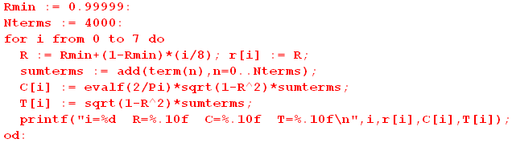
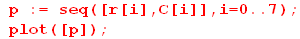
where we start at R = .99999 and approach R→1 using 4000 terms. Here is the output of this code,

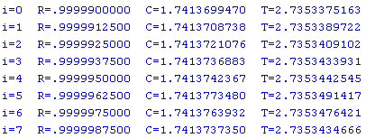

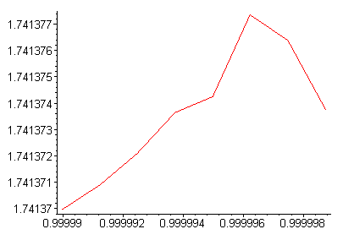

This are a little rocky, but the limit now seems around 1.74137. We have found that a different series is more well-behaved. Using the Wronskian of P and Q, one can show that this slope is given by

T'(z) = { T(z) – $\sqrt{z2 - 1}$ Σn=0∞ εn /[Pn-1/2(z)]2 } / (z2-1) . (B.6)

If we conjecture that T'(1) is not infinite, which the picture certainly suggests, we may conclude that

T(1) = limz→1{ $\sqrt{z2 - 1}$ Σn=0∞ εn /[Pn-1/2(z)]2 } (B.7)

Pause : I would like to get T(z) back into the picture, but I am wearing down from the 3AM start. So let's do that manana.

***********************

= 2 * a-2 * (1/2) * π/$\sqrt{1-α2}$ * [ $\sqrt{1-α2}$ - 1]n /αn * [1 + (-1)n ] α = 1/a

= 2 * a-2 * (1/2) * $\sqrt{1-α2}$* $\frac{a}{a}$ * ( $\sqrt{1-α2}$ $\frac{a}{a}$ )n * [1 + (-1)n ]

= 2 * a-2 * (1/2) $\sqrt{a2-1}$ * ($\sqrt{a2-1}$)n * [1 + (-1)n ]

= π a-1 $\sqrt{a2-1}$ ($\sqrt{a2-1}$ - a)n [1 + (-1)n ]

= π $\frac{1}{chξ}$$\frac{1}{shξ}$( shξ - chξ)n [1+ (-1)n ]

= π $\frac{1}{chξ}$$\frac{1}{shξ}$ (-e-ξ)n [1 + (-1)n ]

= π $\frac{1}{chξ}$$\frac{1}{shξ}$ e-nξ [(-1)n + 1 ]

**********

Let's try for some Maple help here: Maybe start with this, but start with b = +chξ0 and later change the sign. Then

b = chξ
db = shξdξ

∂b = (1/shξ) ∂ξ

$\sqrt{b2-1}$ = shξ

$\sqrt{b2-1}$- b = shξ - chξ = -e-ξ

Then

- { ∂b [$\sqrt{b2-1}$($\sqrt{b2-1}$ - b)n ] }

= - [ (1/shξ) ∂ξ] [$\frac{π}{shξ}$(-e-ξ)n ] }

= (-1)n+1 [ (1/shξ) ∂ξ] [$\frac{π}{shξ}$e-nξ ] }

= (-1)n+1 π[ (1/shξ) ∂ξ] [$\frac{1}{shξ}$e-nξ ] }

= π (-1)n+1(1/shξ){ e-ξn (-cschξ cothξ) - ne-ξncschξ }

= π (-1)n+1{- e-ξn (cothξ) - ne-ξn}

= π (-1)n{e-ξn (cothξ) + ne-ξn}

= π (-1)n e-ξn { cothξ + n } ξ ≥ 0

But now I have to take chξ → -chξ. How do you do that? It is too late now!

So I am then claiming that

J1 = $^{\int_{0}^{π}{}}$du cos(nu)(chξ - cosu)–2 = π (-1)n e-ξn { cothξ + n } ξ ≥ 0

Let's test this in Maple :

= π (1/shξ) { eξn (-cschξ cothξ) + neξncschξ }

= π { eξn (-cothξ) + neξn }

= π enξ { n - cothξ } not bad!

Then here is my claim:

J1 = $^{\int_{0}^{π}{}}$du cos(nu)(chξ0 - cosu)–2 = π enξ0 { n - cothξ0 }

I could check this with Maple numerically. I did so for ξ0 = 1.1 and n = 1 and results do NOT agree!

Question: For n = 0 the LHS is + but RHS is - .

***********************

Insert second method: Now just use the sum rule idea

1/$\sqrt{a - b cos(x)}$ = (1/π) $\sqrt{2/b}$ Σn=0∞ εn Qn-1/2(a/b) cos(nx) // expansion

1/$\sqrt{chξ - cosu}$ = ($\sqrt{2}$/π) Σn=0∞ εn Qn-1/2(chξ) cos(nu)

Σn=0∞ εn Qn-1/2(chξ0) cos(nu) = (π/$\sqrt{2}$) (chξ0 - cosu)-1/2

Then I get

σ2 = $\frac{1}{4π}$ V0 $\sqrt{2}$ (shξ0/a) $\sqrt{chξ - cosu}$ $\frac{1}{2}$(π/$\sqrt{2}$) (chξ0 - cosu)-1/2

= $\frac{1}{4π}$ V0 $\sqrt{2}$ (shξ0/a) $\frac{1}{2}$(π/$\sqrt{2}$) = $\frac{1}{4π}$ $\frac{1}{2}$ V0 (shξ0/a)

*************************

In this limit ξ0 is large so we use large-argument limits of the P', P and Q functions. From (H.6.3) we know for n > 0 that P'n-1/2(x) → (2x)n-3/2 , but the Q/P ratio from (H.6.7) goes as (2x)-2n and wins over the P' factor, causing each element in the sum with n > 0 in (10.5.10) to go as x3/2 (2x)n-3/2(2x)-2n ~ x-n . Our only concern is the n = 0 term in the sum which has P'-1/2(x) → x-3/2 ln(8x) from (H.6.16) while the Q/P ratio goes as 1/ln(8x) from (H..6.15). For n = 0 we then have x3/2 * x-3/2 ln(8x) * 1/ln(8x) ~ x0, so this term does not decay with large x.

σ(u; ξ0) = $\frac{V0}{4πR}$ [ $\frac{1}{2}$ + $\sqrt{2}$ (x)3/2 P'-1/2(x) $\frac{Q-1/2(x)}{P-1/2(x)}$ x = chξ0

From (H.6.14) one has

P'-1/2(x) → - (1/2)$\sqrt{2}$x-3/2 ln(8x) x→∞ (H.6.16)

$\frac{Q-1/2(x)}{P-1/2(x)}$ → (π2/2) 1/ln(8x) x→∞

Therefore

σ(u; ξ0) = $\frac{V0}{4πR}${ $\frac{1}{2}$ + $\sqrt{2}$ (x)3/2 [ - (1/2)$\sqrt{2}$x-3/2 ln(8x)] [ (π2/2) 1/ln(8x)] }

= $\frac{V0}{4πR}${ $\frac{1}{2}$ + $\sqrt{2}$ [ - (1/2)$\sqrt{2}$ ] [ (π2/2)] }

= $\frac{V0}{4πR}${ $\frac{1}{2}$ + [ - (1/2) ] }

= 0/0 since R→ 0

Now that is interesting. It is true as you go to x→∞, the charge goes away. So does that mean I have to worry about the n = 1 term?

Suppose I keep both terms in P' . Then I get

σ(u; ξ0) = $\frac{V0}{4πR}$[ $\sqrt{2}$ (x)3/2 * $\sqrt{2}$x-3/2 * (π2/2) 1/ln(8x) ]

= $\frac{V0}{4πR}$[ 1/ln(8x) ]

This is still uniform, so I get

Q = $\frac{V0}{4πR}$[ 1/ln(8x) ] * 4π2Ra ρc = a in this limit

Q = V0 [ 1/ln(8x) ] πa

and this says

C = πa/ ln(8x)

But how is x related to R? In our limit x = chξ = shξ = eξ .

x = chξ R = a/shξ ≈ a/x x = a/R and 8x = 8a/R so we get

C = πa/ ln(8a/R)

But in my work I always had ρc = 1 and here a = ρc so

C = π / ln(8/R) agrees!!!!

But this has the wrong sign! And it is going to give the wrong capacitance as well. So my limit is screwed up.

********************

10.5 Surface charge density on a toroid

Where do I do this calculation? In toroidal cap function.doc !

Using this cgs units formula ( plus sign because ξ decreases moving outward from the toroid surface )

σ = + (1/4π) (1/hξ) ∂ξV(ξ,u)|ξ=ξ0 1/hξ = (chξ - cosu)/a (10.11)

and the potential stated above

V(ξ,u) = V0 ($\sqrt{2}$/π)$\sqrt{chξ - cosu}$ Σn=0∞ εn Pn-1/2(chξ) [Qn-1/2(chξ0)/ Pn-1/2(chξ0)]cos(nu) (10.5)

we get the following expression for the charge density σ on a charged toroid with label ξ0, (R = a/shξ0)

σ(u) = (V0 /4π R) * (10.12)
{ ($\sqrt{2}$/π)($\sqrt{chξ0 - cosu}$)3 Σn=0∞ εn Pn-1/2'(chξ0) [Qn-1/2(chξ0)/ Pn-1/2(chξ0)]cos(nu) + (1/2) }

where Pn-1/2'(z) means ∂zPn-1/2(z) = (z2-1)-1(n+1/2)[ Pn+1/2(z) - z Pn-1/2(z) ]. In the large z limit, it can be shown that σ = (V0/4π R)z0 / ln(8z0), so for a thin wire the linear charge density is λ = 2πRσ and then the total charge is Q = 2πρc λ = π V0 / R ln(8/R), consistent with the capacitance limit found above when ρc=1. Here is a plot of σ(u) for ξ0 = π/4, a toroid marked in our bipolar coordinates picture above, where the horizontal axis shows u in units of π/8 and the height is relative units (left picture)

Graph on left appears in toroidal cap function.doc page 23

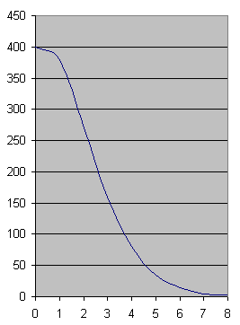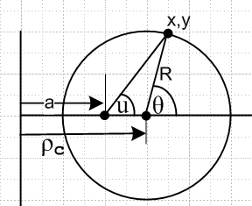

One can convert from angle u to angle θ as shown (Lucht Section 7) using the following equations,

sinθ = shξ0sinu/(chξ0-cosu) cosθ = (chξ0cosu-1) /(chξ0-cosu) . (10.13)

The main idea in the σ(u) sum is that near u = 0 the terms are additive since cos(nu) ~ 1, whereas in the "backward direction" especially near u = π there is term interference from cos(nu) ~ (-1)n, causing the charge to concentrate on the outer toroidal surface just as one would expect. This situation is akin to the forward peak in a scattering amplitude in partial wave analysis. The plot was made from data computed in Maple using 20 terms and confirming term stability as discussed in Appendix B.

**************************88

Appendix B late update 12/11/15 (obs?)

Below old (B.4) plots vs number of terms: not in bowl in toroidals mws files
not in toroidals mws files
not in Legendre mws files

I cannot find this anywhere. It looks like it is a screen flip from Word doc, by the way, since both graphs are together. Where would I study P and Q function series convergence? bowl area! Here is the doc!

the toroidal cap function.doc

shows code for doing the P/Q type sum
doing this sum for various z values like
z = 1.1, 1.01, 1.001, 1.0001, etc
getting the 2.73 magic number here for the capacitance formula
has my little table of z values and the Excel plot clip

the charged donut.doc

*************************

The double bowl coefficients

The boundary conditions stated in (3.4) are

[ A(τ)ch(u1τ) + B(τ)sh(u1τ) ] = V1 $\sqrt{2}$ch[τ(u1-π)] / ch(πτ)
[ A(τ)ch(u0'τ) + B(τ)sh(u0'τ) ] = V0 $\sqrt{2}$ch[τ(u0-π)] / ch(πτ) . (3.4) (H.1.14)

Divide the second equation by the first,

$\frac{A(τ)ch(u0'τ) + B(τ)sh(u0'τ)}{A(τ)ch(u1τ) + B(τ)sh(u1τ)}$ = $\frac{V0 ch[τ(π-u0)]}{V1 ch[τ(π-u1)]}$ (H.1.15)

Multiply out and isolate factors A(τ) and B(τ) to find that

A(τ) P = B(τ) Q (H.1.16)
where
P ≡ { V1 ch(u0'τ) ch[τ(π-u1)] – V0ch(u1τ) ch[τ(π-u0)] }
Q ≡ { V0sh(u1τ) ch[τ(π-u0)] – V1sh(u0'τ) ch[τ(π-u1)] }

Multiply the second equation in (3.4) by Q

[ A(τ)Qch(u0'τ) + B(τ)Qsh(u0'τ) ] ch(πτ) = V0 $\sqrt{2}$Q ch[τ(u0-π)] (H.1.17)

Replace B(τ)Q by A(τ)P in ** and solve for A(τ) to get

ch(πτ)A(τ) = V0 $\sqrt{2}$Qch[τ(π-u0)] / [Qch(u0'τ) + P sh(u0'τ) ] (H.1.18)

Replace A(τ)P by B(τ)Q by in ** and solve for B(τ) to get

ch(πτ) B(τ) = V0 $\sqrt{2}$Pch[τ(π-u0)] / [Qch(u0'τ) + P sh(u0'τ) ] (H.1.19)

The coefficients are then

ch(πτ) A(τ) = V0 $\sqrt{2}$Qch[τ(π-u0)] / [Qch(u0'τ) + P sh(u0'τ) ]
ch(πτ) B(τ) = V0 $\sqrt{2}$Pch[τ(π-u0)] / [Qch(u0'τ) + P sh(u0'τ) ]

P = { V1 ch(u0'τ) ch[τ(π-u1)] – V0ch(u1τ) ch[τ(π-u0)] }
Q = { V0 sh(u1τ) ch[τ(π-u0)] – V1sh(u0'τ) ch[τ(π-u1)] } (H.1.20)

We then use Maple to verify this solution :

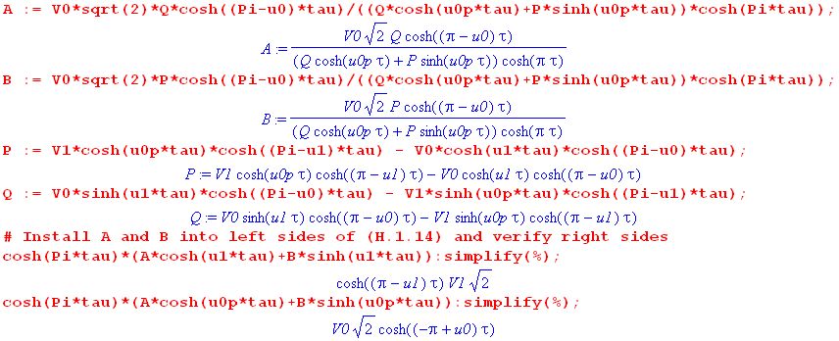
(H.1.21)

************

In the degenerate torus limit ξ0 = 0 (hole just vanishes) the curve seems to approach one which goes to zero around θ = 2.7 radians and then has a small rebounding tail near π. As we lower ξ0, the term count M must be increased, and computation time increases. Here is about the limit of our patience, with M = 450 terms,
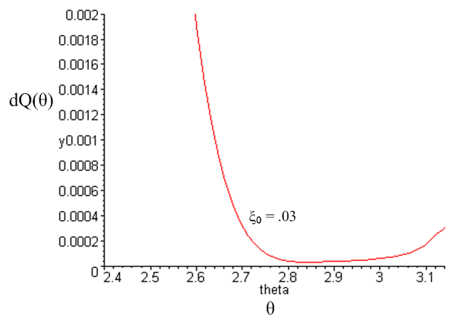 (10.6.13)

***********

For smaller ξ0 values (fatter tori) σ appears to hit a minimum before θ = π, which seems odd. One would think that σ would always be minimum at θ = π. Here we zoom in on the right side tails of the above plots for some small values of ξ0 to show these minima,

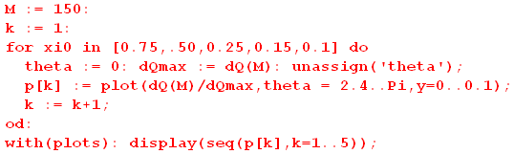

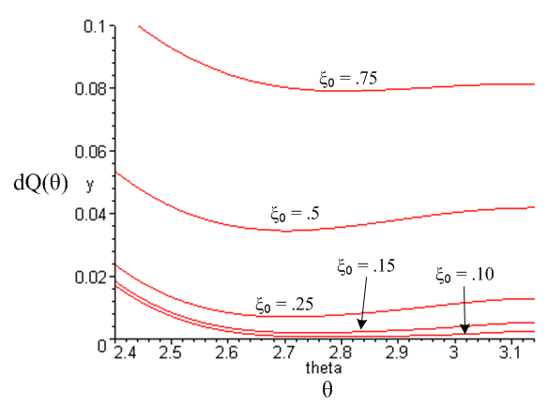 (10.6.12)

***********

This effect of a minimum in σ before θ = π results from the relation between θ and u. We can plot σ directly against the toroidal coordinate u by replacing dQ above with the following,

dQu = σdA = σ (hudu)(hφdφ) = σ huhφdudφ = σ shξ hu2dudφ

= σ R2 sh3ξ (chξ-cosu)-2 dudφ
so
"dQu" ≡ dQ/(dudφ) = σ(u; ξ0) R2 sh3ξ0 (chξ0-cosu)-2 . (10.6.13)

Then for the same set of ξ0 values we plot dQ versus u:

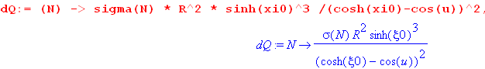
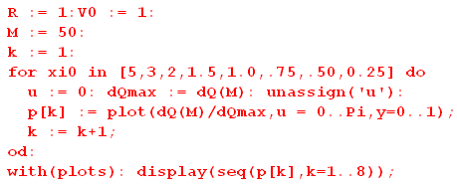

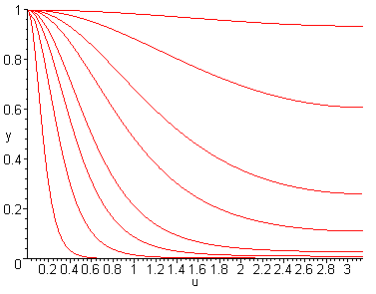 (10.6.14)

Now the plots of σ versus u decrease monotonically toward their values at u = π.

The minima seen in Fig (10.6.12) arise from this fact,

"dQθ" = "dQu" * $\frac{du}{dθ}$ where $\frac{du}{dθ}$ = $\frac{shξ0}{chξ0 + cosθ}$ , (10.6.15)

so "dQθ" is the product of a monotonic falling function "dQu" and a rising function $\frac{du}{dθ}$. Here is a plot of $\frac{du}{dθ}$ for ξ0 = 0.5 ,

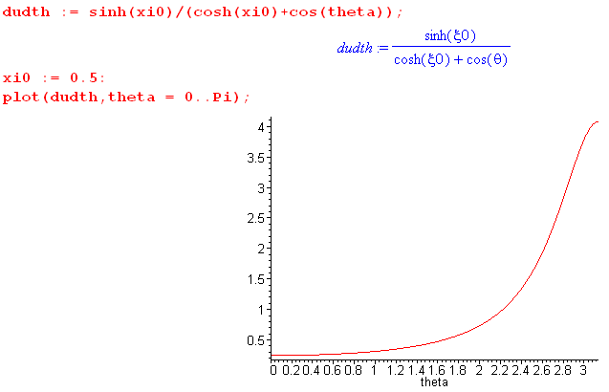 (10.6.16)

***************

Here is some Maple code to illustrate the function f(x). First, consider

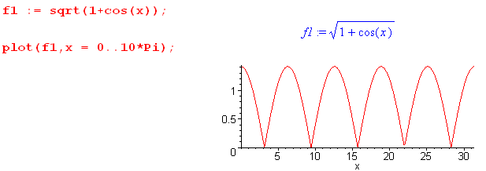 (I.12)

Thus, Maple thinks of $\sqrt{1 + cos(x)}$as being | $\sqrt{1 + cos(x)}$| . This is not the smooth "analytic" result we want. In other words. f1(x) = $\sqrt{1 + cos(x)}$from a Maple viewpoint is a rectified sinusoid with sharp non-analytic discontinuities in slope.

On the other hand, now consider f(x) = (-1)η | $\sqrt{1 + cos(x)}$| which in Maple is f(x) = (-1)η $\sqrt{1 + cos(x)}$:

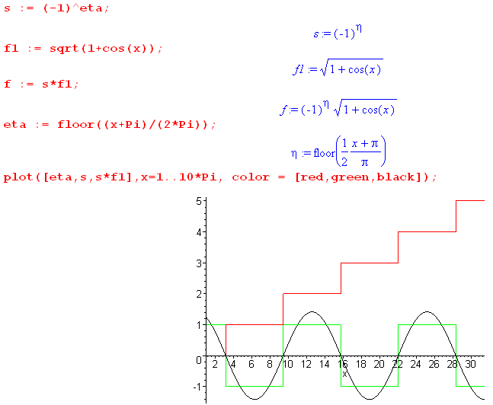 (I.13)

The smooth black sinusoid is the "analytic meaning" of the function f(x) = $\sqrt{1 + cos(x)}$taken as the limit of an analytic function.

****************

