Various kinds of Legendre Functions PhL 12.30.15

AS2010 have a huge array of P and Q functions. I will try to describe them all.

0. The Legendre functions are

Pν(x) Qν(x) Pν(z) Qν(z)

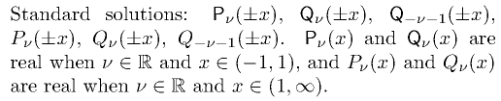

1. Ferrers Functions (Legendre functions on the cut)

The term "on the cut" is ambiguous, what it means is on the interval (-1,1).

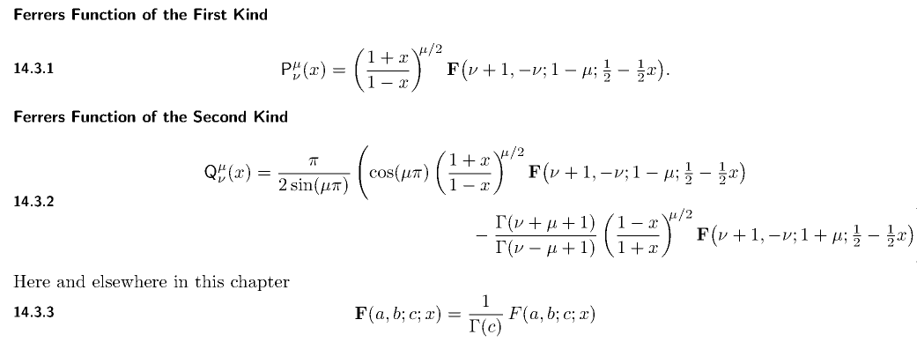

These P and Q are non-italic and the A has a straight bar and beware the bold F ! The first of these agrees with Bateman p 124 (14), where Bateman uses the non-bold F function. In other words, both use this

Ferr Bate
Pμν(x) = Pμν(x) = ( $\frac{1+x}{1-x}$)μ/2 F(ν+1,-ν; 1-μ; 1/2- x/2)

In the Q equation, we can use

Γ(1+μ)Γ(-μ) = - π/sin(μπ).

Neither term agrees with Bateman! They are close, but not the same due to cos(μπ) and e-iμπ issues.
So the Q differs from Bateman. See below for more detail.

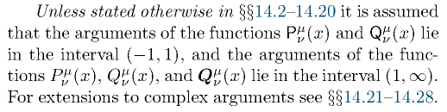

So the Ferrers functions are geared to (-1,1) while the Assoc Legendre to (1,∞).

2. Associated Legendre Functions

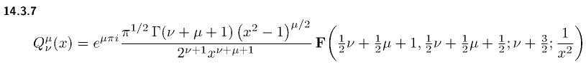

Notice the italic font and the curly Q bar. As before, bold F functions.

Fact: The P here is identical to the Ferrers P and is identical to Bateman (14).

Fact: The Q function here is identical to Bateman (41). So these are the functions I want to deal with!

3. Bold Q function

To confuse things more, AS2010 also defines

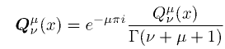

so this is a bolded italic Q. Notice phase and gamma. Thing on right is assoc Leg fnctn.

4.

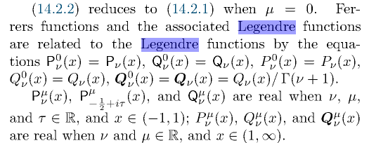

OK, in all cases we have Xν0 = Xν so there are no hidden surprises when you set μ = 0 on the upper index position.

3. Back up to Ferrers Q and Compare to Bateman Q

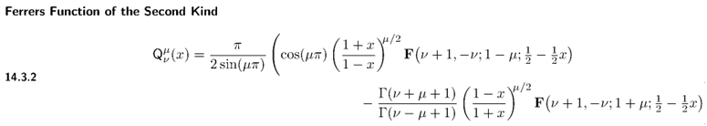
First use

- Γ(1+μ)Γ(-μ) = $\frac{π}{sin(μπ)}$

Then Ferrer says

Qμν(x) = - (1/2)Γ(1+μ)Γ(-μ) cos(μπ) ( $\frac{1+x}{1-x}$)μ/2 F(ν+1,-ν;1-μ;1/2-x/2)/Γ(1-μ)
+ (1/2)Γ(1+μ)Γ(-μ) $\frac{Γ(ν+μ+1)}{Γ(ν-μ+1)}$( $\frac{1-x}{1+x}$)μ/2 F(ν+1,-ν; 1+μ; 1/2-x/2)/Γ(1+μ)

= - (1/2)[Γ(1+μ)Γ(-μ)/Γ(1-μ)] cos(μπ) ( $\frac{1+x}{1-x}$)μ/2 F(ν+1,-ν;1-μ;1/2-x/2)
+ (1/2)Γ(-μ) $\frac{Γ(ν+μ+1)}{Γ(ν-μ+1)}$( $\frac{1-x}{1+x}$)μ/2 F(ν+1,-ν; 1+μ; 1/2-x/2)

= (1/2)Γ(μ) cos(μπ) ( $\frac{1+x}{1-x}$)μ/2 F(ν+1,-ν;1-μ;1/2-x/2) // - [Γ(1+μ)Γ(-μ)/Γ(1-μ)] = Γ(μ)
+ (1/2)Γ(-μ) $\frac{Γ(ν+μ+1)}{Γ(ν-μ+1)}$( $\frac{1-x}{1+x}$)μ/2 F(ν+1,-ν; 1+μ; 1/2-x/2)

= F1 + F2

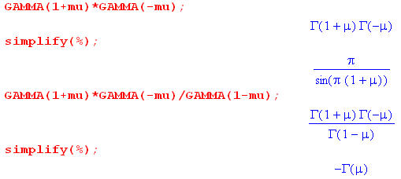

In contrast, here is what Bateman (32) says

Qμν(x) = eiπμ (1/2) Γ(μ) ( $\frac{1+x}{1-x}$)μ/2 F(ν+1,-ν;1-μ;1/2-x/2)

+ (1/2) eiπμ Γ(-μ)$\frac{Γ(ν+μ+1)}{Γ(ν-μ+1)}$( $\frac{1-x}{1+x}$)μ/2F(ν+1,-ν; 1+μ; 1/2-x/2)

= ( eiπμ / cosμπ) F1 + eiπμ F2

and that seems very strange to me. I guess F1 and F2 solve the Legendre equation and here we are just talking about coefficients, so all these equations solve Legendre.

Now what happens when μ = 0?

Qν(x) = Q0ν(x) = F1 + F2 = Q0ν(x) = Qν(x)

So AS failed to state this, but:

Conclusion: Ferrer and Bateman (32) for Q agree with μ = 0.

Examples: According to the above bold thing, we would have

Qν(x) = Qν(x) / Γ(ν+1)

Then

Q0(x) = Q0(x) / Γ(1) = Q0(x) = Q0(x)

Q1(x) = Q1(x) /Γ(2) = Q1(x) = Q1(x)

This is confirmed on page 359

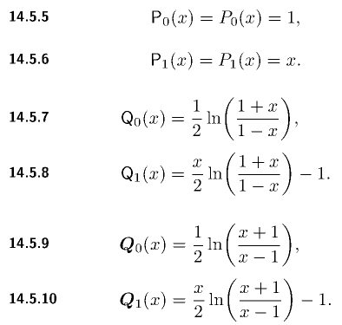

3. How does M&F define the P function?

I will translate this to say (assuming we have the same F)

Pνμ(z) = $\frac{Γ(ν+μ+1)}{Γ(ν-μ+1)}$(1-z2)μ/2 2-μ $\frac{1}{Γ(μ+1)}$ F(μ-ν, μ+ν+1; μ+1; 1/2-z/2)

This is completely different from both Ferrer and Bateman who said

Pμν(x) = Pμν(x) = ( $\frac{1+x}{1-x}$)μ/2 F(ν+1,-ν; 1-μ; 1/2- x/2)

The M&F thing fits NONE of the Bateman forms. Lets try Kummer (1) on page 105

F(a,b;c,z) = (1-z)c-a-b F(c-a,c-b;c;z)

Use this with the Bateman result with

z = (1-x)/2 a = ν+1 b = -ν c = 1-μ

c - a - b = 1-μ - ν-1 +ν = -μ c-a = (1-μ)-(ν+1) = -μ-ν c-b = 1-μ+ν

1-z = 1 - (1-x)/2 = 1 - 1/2 + x/2 = 1/2+x/2 = (1+x) * (1/2)

(1-z)c-a-b = [ (1+x) * (1/2)]-μ = 2μ (1+x)-μ

The Bateman result then becomes

( $\frac{1+x}{1-x}$)μ/2 * 2μ (1+x)-μ * F( -μ-ν, 1-μ+ν; 1-μ; (1-x)/2)

= (1+x)-μ/2 (1-x)-μ/2 2μ F( -μ-ν, 1-μ+ν; 1-μ; (1-x)/2)

= (1-x2)-μ/2 2μ F( -μ-ν, 1-μ+ν; 1-μ; (1-x)/2)

So I have shown that

Pμν(x) = (1-x2)-μ/2 2μ F( -μ-ν, 1-μ+ν; 1-μ; (1-x)/2)

But then

P-μν(x) = (1-x2)μ/2 2-μ F( μ-ν, 1+μ+ν; 1+μ; (1-x)/2)

and here is the M&F function

MFPνμ(z) = $\frac{Γ(ν+μ+1)}{Γ(ν-μ+1)}$2-μ(1-z2)μ/2 $\frac{1}{Γ(μ+1)}$ F(μ-ν, μ+ν+1; μ+1; 1/2-z/2)

= $\frac{Γ(ν+μ+1)}{Γ(ν-μ+1)}$$\frac{1}{Γ(μ+1)}$P-μν(x)

So this is pretty wacko, beware anything that uses these functions. For μ = 0 we get

MFPν(z) = Pν(x)

so at least M&F agree with Bateman on the Pν functions.

4. How does M&F define the Q function?

From page 1327

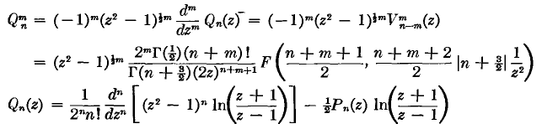

The Qmn agrees exactly with Bateman except Bateman gives the above times eiπm. So

e-iμπ Qνμ(z) = MFQνμ(z)

so these are pretty close.

Now, is there any gimmick in the Qn function? Is it the same as his Qn0 ?? I don't see anything like the rule he quotes above. So maybe he gives some special cases? Not without an upper 0 !

Their toroidals are different still, here is page 1329:

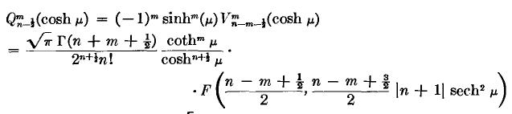

Is this compatible with his earlier Bateman-like claim? I will convert their earlier Q result right here, which earlier result is page 1327

= shmξ 2m $\sqrt{π}$Γ(n-1/2+m+1) 2-(n-1/2)-m-1 z-(n-1/2)-m-1 / Γ(n+1) * F

= shmξ 2m $\sqrt{π}$Γ(n-1/2+m+1) 2-n-m-1/2 z-n-m-1/2 / Γ(n+1) * F

= shmξ 2-n-1/2 $\sqrt{π}$Γ(n +m+1/2) (chξ)-n-m-1/2 / Γ(n+1) * F

= shmξ 2-n-1/2 $\sqrt{π}$Γ(n +m+1/2) (chξ)-n-m-1/2 / Γ(n+1) * F

= (tanhξ)m (chξ)-n-1/2 2-n-1/2 $\sqrt{π}$Γ(n +m+1/2) / Γ(n+1) * F

= $\sqrt{π}$Γ(n +m+1/2) 2-n-1/2 (tanhξ)m (chξ)-n-1/2 / n! * F( $\frac{n+m+1/2}{2}$, $\frac{n+m+3/2}{2}$; n+1; 1/z2)

So once again they are inconsistent. So I have shown that their first Q function gives the thing below. So therefore

MFQn-1/2-m(z)

= $\sqrt{π}$Γ(n -m+1/2) 2-n-1/2 (tanhξ)-m (chξ)-n-1/2 / n! * F( $\frac{n-m+1/2}{2}$, $\frac{n-m+3/2}{2}$; n+1; 1/z2)

= $\frac{Γ(n -m+1/2)}{Γ(n +m+1/2)}$ *

$\sqrt{π}$ Γ(n + m+1/2) 2-n-1/2 (tanhξ)-m (chξ)-n-1/2 / n! * F( $\frac{n-m+1/2}{2}$, $\frac{n-m+3/2}{2}$; n+1; 1/z2)

= $\frac{Γ(n -m+1/2)}{Γ(n +m+1/2)}$ MFtorQn-1/2m(z)

Conclusion: for m = 0 these are all the same

MFtorQn-1/2(z) = MFQn-1/2(z) = Qn-1/2(z) = Bateman

so he has changed from m to - m and added a factor.

My conclusion is that for Qν(z), M&F are the same as Bateman. I would like to see some examples,

Here is another M&F declaration

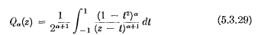

But my main interest today is how M&F define their "toroidal function"/

From page 598 vol 1 M&F say,

These are the two that I wanted. They are in agreement with the quote above. So there is I think no magic difference between Q0 and Q1 , but the issue is really Q-1/2 versus the other Q-1/2+n

