Appendix B. Capacitance of the thin-wire and horn toroid limits. 1
B.1 The toroid thin wire limit R→0 1
B.2 Warm-up Exercises to Prepare for the Degenerate Toroid Limit 4
B.3 The Capacitance of a Degenerate Toroid (horn toroid) 9

This was installed 12/20/15, do not edit here!

Appendix B. Capacitance of the thin-wire and horn toroid limits

B.1 The toroid thin wire limit R→0

Below we shall study the following abstract dimensionless function,

T(z) ≡ $\sqrt{z2 - 1}$ Σn=0∞ εn [Qn-1/2(z) / Pn-1/2(z)] εn = 2-δn,0 . (B.1.1)

Our interest stems from its relation to the toroidal capacitance when z = ρc/R,

T(ρc/R) ≡ $\sqrt{(ρc/R)2 - 1}$ Σn=0∞ εn [Qn-1/2(ρc/R) / Pn-1/2(ρc/R)]

= (1/R)(π/2) { (2/π) $\sqrt{ρc2 - R2}$ Σn=0∞ εn [Qn-1/2(ρc/R) / Pn-1/2(ρc/R)] }

= (π/2R) C . // from (10.2.6) (B.1.2)

It will be convenient to set ρc = 1 and write C in the following two ways,

C(R) = R (2/π) T(1/R)

C(R) = (2/π) $\sqrt{(1-R2)}$ Σn=0∞ εn [Qn-1/2(1/R) / Pn-1/2(1/R)] . (B.1.3)

Our corresponding picture (10.2.4) with ρc = 1 is now this,

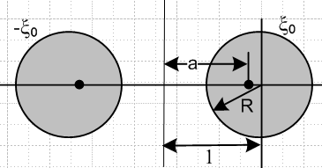 (B.1.4)

We first separate out the n=0 term in (B.1.3) while also setting $\sqrt{(1-R2)}$ → 1 as R→0,

C(R) = (2/π) Q-1/2(1/R) / P-1/2(1/R) + (1/π) Σn=1∞ [Qn-1/2(1/R) / Pn-1/2(1/R)] . (B.1.5)

Note that we really set $\sqrt{(ρc-R2)}$ → ρc so there is an invisible overall ρc = 1 factor in the above equation which gives it the dimension of length. If ρc = 10 cm, one would multiple the above C(R) by 10. As usual for SI units one must add an overall factor of 4πε.

Using the small-R Q/P ratios given in (H.6.7) and (H.6.6) one finds that for very small R,

C(R) = (2/π) { (π2/2) 1/ln(8/R) } + (1/π) Σn=1∞ π $\frac{Γ(n+1/2)/Γ(n+1)}{Γ(n)/Γ(n+1/2)}$(2/R)-2n } . (B.1.6)

As R→0, (2/R)-2n → 0 quickly even for small n, whereas the n = 0 log term lingers, so for very small R one can approximate

C(R) ≈ π / ln(8/R) ≡ C0(R) . (B.1.7)

Here is a plot of C(R) in (B.1.3) for R ranging from 10-16 to ~1, where we use 20 terms in the sum. The plot also shows C0 = π / ln(8/R) (blue) for comparison :

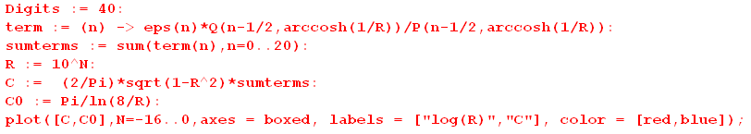

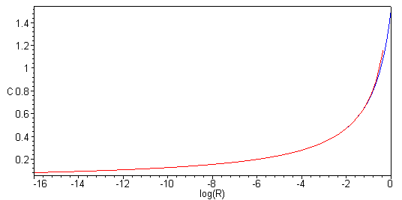 (B.1.8)

The plot shows how gradually capacitance decreases as the wire radius becomes extremely small. It also shows how the n = 0 term completely dominates the result for R < 10-3. Maple has trouble plotting the full C series for very small R beyond that shown above, but we can plot C0 to get a result,

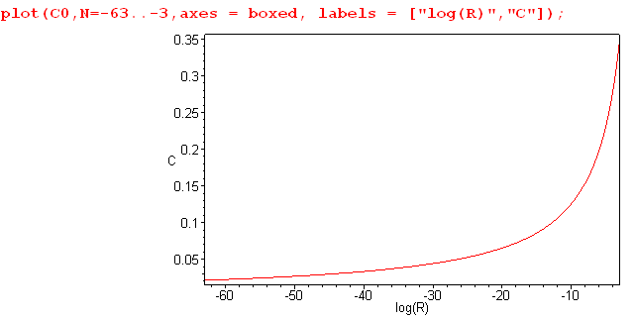 (B.1.9)
Here as the wire radius drops 60 orders of magnitude, the capacitance drops from 0.3 to .03 .

Thin-wire Capacitance from a simple Arm-waving Analysis

In the thin-wire limit of the toroid, where R << ρc, one can make the following simple but somewhat arm-waving model. Very close to the thin wire, the wire looks like an infinitely long straight wire. The solution to that problem is a solution to the 2D Laplace equation for a line charge λ, and one finds outside such a wire that

V(r) = 2λ ln(1/r) + k // very close to the wire (B.1.10)

(Purcell p 43, cgs units) where k is a constant. The "2" in this equation is not arbitrary, just as the "1" in the point charge potential V = 1/r is not arbitrary.

Evaluation at the wire surface gives

V0 = V(R) = 2λ ln(1/R) + k . (B.1.11)

The potential at the toroid center is the same as that of a point charge 2πρcλ located distance ρc from the center, and that potential is then

Vcenter = (2πρcλ)/ρc = 2πλ . (B.1.12)

Now we imagine that (B.1.10) is also valid at the center of the thin-wire toroid, even though that point is not really "close to the wire". One finds,

V(ρc) = 2λ ln(1/ρc) + k = 2πλ . (B.1.13)

Now setting ρc= 1 with R << 1 we find that k = 2πλ. Then from (B.1.11) the potential at the toroid surface is

V0 = V(R) = 2λ ln(1/R) + 2πλ = 2λ [ ln(1/R) + π ] = 2λ [ ln(1/R) + ln(eπ) ]

= 2λ ln(π/R) . (B.1.14)

Now ignoring the potential form (B.1.10) which we applied as far away as the center of the toroid, we claim that very far from the toroid the potential is V = "q/r" = 2πλ/r and so V(∞) = 0. Somehow we are dealing with multiple scales of largeness in this model. Then the toroid is at potential V0 relative to infinity, and we can then compute the capacitance from Q = CV0 using (B.1.14) to get

C = Q/V0 = (2πλ)/[ 2λ ln(π/R)] = π / ln(π/R) . (B.1.15)

We compare this to (B.1.7),

C(R) ≈ π / ln(8/R) . (B.1.7)

If ln(1/R) >> ln(8) and ln(π) then both results say C(R) = π / ln(1/R) and they agree. Again, ρc = 1.

Thin-wire Capacitance from an Even Simpler Arm-waving Analysis

Here we shall compare a sphere and a toroid.

A sphere has area 4πR2 and surface charge σ = Q/(4πR2). The outpointing radial electric field just outside the surface (in cgs units) is E = 4πσ = Q/R2. Further out E(r) = Q/r2. The potential is then

V = -$^{\int_{r}^{∞}{}}$E(r)dr = - Q $^{\int_{r}^{∞}{}}$dr/r2 = +Q/r, and V0 = Q/R

⇒ C = R . (B.1.16)

A toroid has area 4π2ρcR and surface charge σ = Q/(4π2ρcR). The outpointing radial electric field just outside the surface is E = 4πσ = Q/(πρcR). Further out, to some distance Rmax not too large compared with ρc, E(r) = Q/(πρcr). The potential is then

V = -$^{\int_{r}^{∞}{}}$E(r)dr = - (Q/π)$^{\int_{r}^{Rmax}{}}$dr/r = - (Q/π) ln(r/Rmax), and V0 = - (Q/π) ln(R/Rmax)

⇒ C = -π / ln(R/Rmax) = π / ln(Rmax / R) ≈ π/ ln(1/R) . (B.1.17)

We ignore the region beyond r = Rmax because E is small there, stored energy is small, and its contribution to capacitance is small. For very small R the result is then C = π / ln(1/R).

In both cases, as R → 0 the capacitance C → 0. The approach C→ 0 is much faster for the sphere than for the toroid. For the sphere, the charge is all jammed into one point which makes the potential V0 very large and C = Q/V0 is small. For the toroid the charge can spread itself around much better on the thin ring, resulting in a smaller potential and larger C. In the limit R = 0 one can imagine that the charge Q is still present (point charge, line charge), but V = ∞ so C = 0.

B.2 Warm-up Exercises to Prepare for the Degenerate Toroid Limit

An example with elementary functions

Consider the following relatively simple series on the closed interval [0,1] ,

S(x) = Σk=0∞ x e-2kx . (B.2.1)

The series has the following "partial sum" where k stops at n,

Sn(x) = Σk=0n x e-2kx . (B.2.2)

Notice in passing that

Sn(0) = limx→0 Sn(x) = Σk=0n limx→0{ x e-2kx} = Σk=0n {0) = 0 . (B.2.3)

The partial sum (B.2.2) contains a geometric series and can easily be summed. Maple does it :

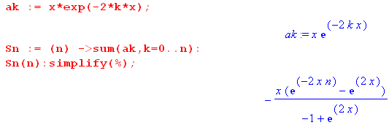 (B.2.4)
Rewrite the result multiplying top and bottom by e-x,

Sn(x) = - x $\frac{e-2xn-x - ex}{-e-x+ ex}$ = - x $\frac{e-(2n+1)x - ex}{2sh(x)}$ . (B.2.5)

One can again verify from this form that Sn(0) = 0.

With this simple closed form expression for the partial sum, one finds that the full sum S(x) is

S(x) = limn→∞ Sn(x) = x $\frac{ex}{2sh(x)}$ . (B.2.6)

Taking the limit x→0 gives

S(0) = 1/2 . (B.2.7)

Here then is The Issue: consider these two limits:

limn→∞ {limx→0 Sn(x)} = limn→∞{0} = 0

limx→0 {limn→∞ Sn(x)} = limx→0{S(x)} = S(0) = 1/2 . (B.2.8)

Interchanging the order of these two limits produces different results. As one learns in calculus courses, the reason for this is that the series S(x) = Σk=0∞ x e-2kx fails to be uniformly convergent on [0,1], having in particular a problem at the x = 0 endpoint.

There are several ways to show a priori that a series is or is not uniformly convergent on an interval [0,1] where 0 is a potential problem point.

If one knows S(0), as is the case in the above example where S(0) = 1/2, then one can check to see if the following is true,

limn→∞ || S(x) - Sn(x)|| → 0 as n→ ∞ for all x in [0,1] ⇔ uniform convergence (B.2.9)

Here the notation ||f(x)|| means the "max norm" of f(x) which is the maximum value of |f(x)| on the interval in question. In our example, we have from (B.2.6) and (B.2.5),

S(x) - Sn(x) = x $\frac{e-(2n+1)x}{2sh(x)}$ . (B.2.10)

By plotting the function for some value of n, or by studying it a bit, one finds that the max of |S(x) - Sn(x)| occurs at the left endpoint x = 0. Thus we have,

|| S(x) - Sn(x)|| = S(0) - Sn(0) = 1/2 - 0 = 1/2.

and so

limn→∞ || S(x) - Sn(x)|| = 1/2 . (B.2.11)

Since limn→∞ || S(x) - Sn(x)|| does not approach 0, we conclude that S(x) is not uniformly continuous on the interval [0,1] and therefore we should expect to have the order interchange problem noted in (B.2.8).

Another way to check for uniform continuity is the check this condition (the Cauchy Property),

limn,m→∞ | Sm(x) - Sn(x)| = 0 for all x in [0,1] (B.2.12)

This has a formal definition that for any ε one can find N such that, for all x in [0,1], | Sm(x) - Sn(x)| < ε as long as both n and m are > N, and N is not allowed to depend on x.

If S(x) is not known, one can use this Cauchy test to check for uniform convergence, but it can take a lot of work since there are three variables at play: x, n, m. In our example one has

Sn(x) = - x $\frac{e-(2n+1)x - ex}{2sh(x)}$ (B.2.5)
so
Sn(x) - Sm(x) = - x $\frac{e-(2n+1)x}{2sh(x)}$ + x $\frac{e-(2m+1)x}{2sh(x)}$ = $\frac{x}{2sh(x)}$ [ e-(2m+1)x - e-(2n+1)x ] . (B.2.13)

In this example, one can take m = ∞ and then run the Cauchy test on

Sn(x) - S∞(x) = Sn(x) - S(x) = $\frac{x}{2sh(x)}$[ e-(2n+1)x ] . (B.2.14)

As long as x > 0 one finds that | Sm(x) - S∞(x)| → 0 as n → ∞. But if x = 0,

Sn(x) - S∞(x) = $\frac{x}{2sh(x)}$[ e-(2n+1)x ] |x=0 = (1/2) (B.2.15)

and thus the Cauchy test fails and the series is not uniformly convergent on [0,1].

Graphically, it is useful to see what happens for this example series near x = 0 for some finite number of terms in the sum. We enter the series and define the partial sum Sn(x) as shown in (B.2.4). Here then are plots of Sn(x) for various small x ranges for n = 10, 100, 10000, and 1,000,000 :

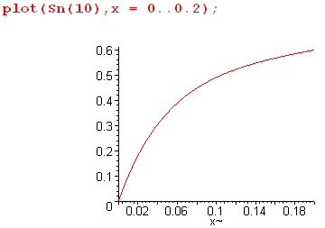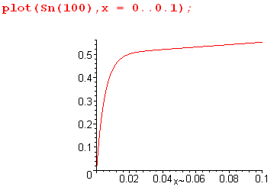

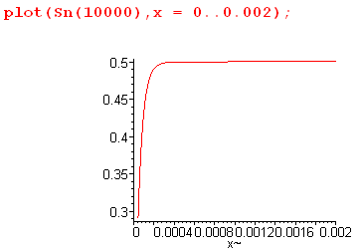 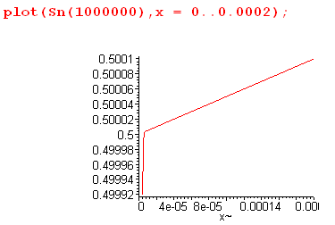 (B.2.16)

The lower right plot is particularly interesting. If we had no idea that S(0) = 1/2 from doing the above analysis, that graph alone would be very convincing evidence that S(0) is extremely close to 0.5. The last three plots are "aiming at 1/2" with increasing targeting precision.

In the degenerate toroid limit studied in the next section, the series is more complicated and we don't know how to add up the full series to get the limit, so we are going to use this "aiming method" to determine the limit numerically.

The Q Sum Rule Example

As a second warm-up exercise, recall the first line of (10.1.18),

(1/π) $\sqrt{2/b}$ Σk=0∞ εk Qk-1/2(a/b) cos(kx) = 1/$\sqrt{a - b cos(x)}$ . // expansion (10.1.18)

Setting a = z, b = 1 and x = 0 we find that

(1/π) $\sqrt{2}$ Σk=0∞ εk Qk-1/2(z) = 1/$\sqrt{z -1}$ εk = 2-δk,0

which we rewrite as the following "sum rule" which is valid for all z ≥ 1 :

S(z) ≡ Σk=0∞ εk $\sqrt{z -1}$Qk-1/2(z) = (π/$\sqrt{2}$) = 2.221441469 . (B.2.17)

This series has the following partial sum

Sn(z) = Σk=0n εk $\sqrt{z -1}$Qk-1/2(z) . (B.2.18)

Near z = 1 we know from (H.7.3) that

Qk-1/2(z) ≈ c1 ln(z-1) + c2

where c1 and c2 are constants depending on k. Letting

δ ≡ z-1

then

Sn(1+δ) ≈ Σk=0n εk $\sqrt{δ}$[ c1 ln(δ) + c2 ] (B.2.19)

and then

Sn(1) = 0 // since $\sqrt{δ}$ln(δ) → 0 . (B.2.20)

If the series (B.2.17) were uniformly convergent at z = 1, one would conclude that

S(1) = limn→∞ Sn(1) = limn→∞ {0} = 0 .

But (B.2.17) says S(1) = 2.22, so one must conclude that the series is not uniformly convergent at z = 1.

Suppose one were unaware of the nature of the sum of this series. At first glance, it is certainly not obvious that S(z) is constant in z, but consider a simple plot,

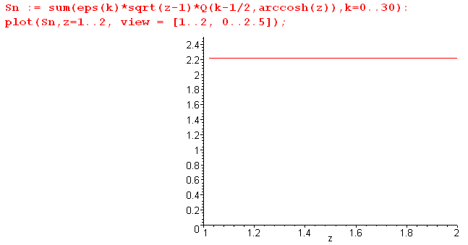 (B.2.21)

So adding only 31 terms, it certainly appears that S(z) is a constant, and that constant is near 2.21.
If we zoom in on the left edge of the above plot, since we are adding a finite number of terms, and since Sn(1) = 0, the plot has to dive down to the origin at some point,

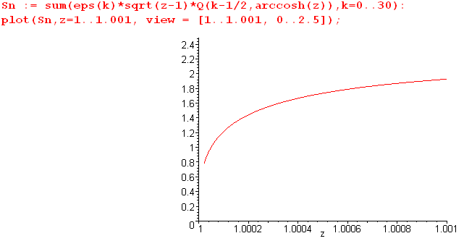 (B.2.22)

One can prop it back up a bit by increasing the number of terms in the sum, but still being a finite sum it will take the dive at some point just above z = 1. If one is looking for the limit S(1) one wants to ignore this diving part of the curve and see where one thinks the curve is "aiming", as in the unzoomed previous plot.

The second example is in fact quite close to the situation below for the degenerate toroid limit, but in that case we don't know the limit S(z=1) and we try to find it by the "aiming method".

B.3 The Capacitance of a Degenerate Toroid (horn toroid)

With ρc = 1, the capacitance of a toroid was given in (B.1.3) as

C(R) = R (2/π) T(1/R) (B.1.3) (B.3.1)
where 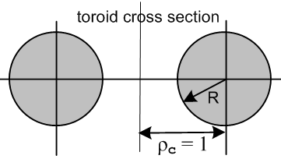 (B.3.2)

T(z) = $\sqrt{z2 - 1}$ Σn=0∞ εn [Qn-1/2(z) / Pn-1/2(z)] εn = 2-δn,0 . (B.1.1) (B.3.3)

When R = 1, the hole in the toroid just goes away. This situation represents a "degenerate" toroid, sometimes called a "horn" toroid,

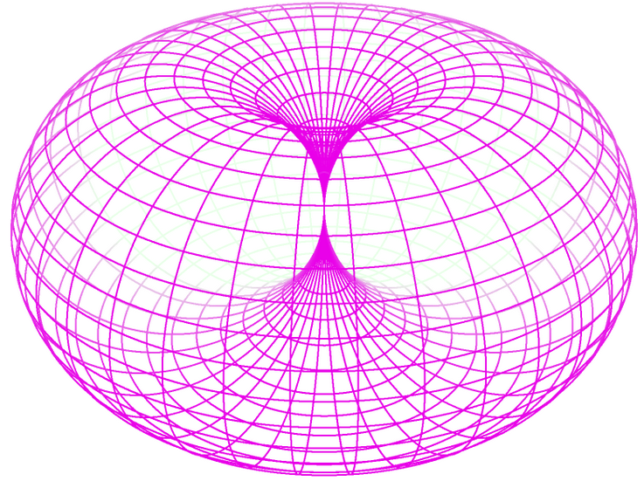 (B.3.4)

The capacitance of such a toroid with ρc = 1 and R = 1 is, from (B.3.1) and (B.3.3),

C(1) = (2/π) T(1)

where

T(1) = limz→1 {$\sqrt{z2 - 1}$ Σn=0∞ εn [Qn-1/2(z) / Pn-1/2(z)] } . (B.3.5)

The series T(z) shown in (B.3.3) is not uniformly convergent (see Section B.2 above) on the range z ≥ 1 due to the left endpoint z = 1. Thus, to compute C(R=1) = (2/π) T(1), we cannot take limz→1 through the summation symbol. If we could do so, we would find that, setting δ = z-1,

T(1) = Σn=0∞ εn limz→1 { $\sqrt{z2 - 1}$[Qn-1/2(z) / Pn-1/2(z)] }

= Σn=0∞ εn limδ→0 { 2$\sqrt{δ}$ [ (c1 ln(δ) + c2) / 1 ] = 0 . (B.3.6)

Here we use the fact (H.7.2) that Pn-1/2(z) → 1 and (H.7.3) that Qn-1/2(z) → c1 ln(δ) + c2 . We know the degenerate toroid does not have 0 capacitance, and from this fact alone we may conclude that the series is not uniformly convergent on z ≥ 1.

If we could evaluate the T(z) sum shown in (B.3.3) in terms of known elementary and special functions, we could take the limit of that result to get T(1), as was possible in both our examples (B.2.6) and (B.2.17). But we don't know how to do such an evaluation. For example, we don't know of any integral representations for the function 1/ Pn-1/2(z). If one exists, it could be used with an integral representation of Qn-1/2(z) to possibly allow computation of the infinite sum in (B.3.3), and then maybe the resulting double integration could be reduced to known special functions. We leave this as a problem for the interested reader.

As discussed in the examples of Section B.2, one approach to obtaining a value for T(1) is the "aiming method", and this does give reasonable results.

But first, we can obtain a simple upper bound for T(1). As shown in (H.7.9), 1/ Pn-1/2(z) ≤ 1 for z just above 1, and therefore, setting $\sqrt{z2 - 1}$ ≈ $\sqrt{2}$(z-1),

T(1) ≤ $\sqrt{2}$ limz→1 {$\sqrt{z - 1}$ Σn=0∞ εn [Qn-1/2(z)] } . (B.3.7)

But (B.2.17) says the sum in {...} is π/$\sqrt{2}$ for any z ≥ 1 so we conclude that

T(1) ≤ π ≈ 3.14 (B.3.8)

Now, taking z = chξ in (B.3.3), we plot T(chξ) as ξ→0 with 600 terms in search of a value for T(1) :

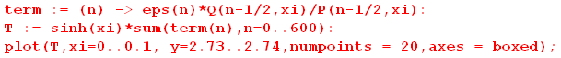

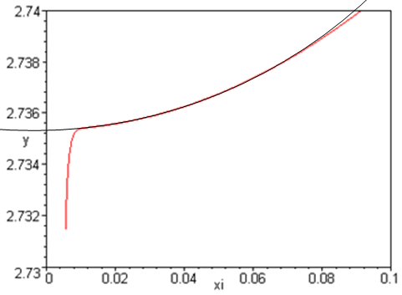 (B.3.9)

With a crude superposed visual fit (black circular segment) the red curve seems to be aiming at this point:

2.734 + (3.25/5)(.002) = 2.734 + 0.0013 = 2.7353 (B.3.10)

As shown in the example of (B.2.16), for a finite number of terms in the sum, the plot must dive down to 0 at the very end, and we must ignore that dive in our "aiming method".

It is difficult to get a more accurate value because adding more terms greatly slows down the calculation due to the Q function being near a singularity. In Appendix H.8 we derive an alternate series for T(z) which is valid only for z very close to 1,

T(z) = $\sqrt{z2 - 1}$Σn=0∞ εn $\frac{1}{[Pn-1/2(z)]2}$ z → 1 (B.3.11)

Using this series, we zoom in on the T(1) limit with the following code,

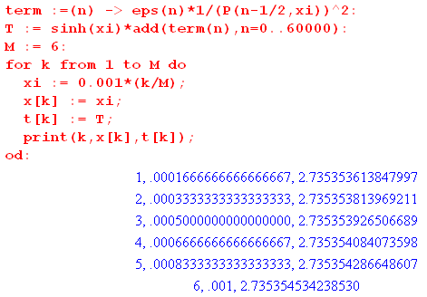 (B.3.12)

The code divides the interval ξ = 0 to ξ = .001 into 6 points and computes T(chξ) for each point using 60,000 terms of the 1/P2 series (B.3.11). The following is a plot of the six (ξ, T(chξ)) points,

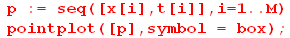

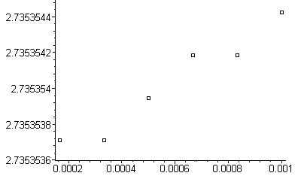 (B.3.13)

The leftmost point is probably the most correct, giving the following estimated value for T(1),

T(1) = 2.7353537±1 . (B.3.14)

Therefore, the capacitance of a degenerate toroid of radius R = 1 cm is

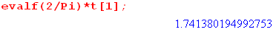

C(1) = (2/π) T(1) = 1.7413802±1 cm (B.3.15)

