do not edit, has been installed on 12/18/15

Appendix J : Converting Expressions from Toroidal to Polar Coordinates 1
J.1 The Conversions 1
J.2 Application: The Disk Potential 5

Appendix J : Converting Expressions from Toroidal to Polar Coordinates

J.1 The Conversions

At first this sounds like a task that requires no effort. After all, we know from (1.3.5) that

x = a cosφ shξ/(chξ - cosu) ρ = a shξ/(chξ - cosu) = $\sqrt{x2+y2}$
y = a sinφ shξ/(chξ - cosu) z/ρ = sinu/shξ
z = a sinu/(chξ - cosu) 0 ≤ ξ ≤ ∞ , 0 ≤ u ≤ 4π (1.3.2) (J.1.1)

The issue is how to convert expressions like chξ - cosu to Cartesian coordinates, and there are a few subtleties involved. The following three positive quantities will be useful:

A ≡ $\sqrt{z2+ (ρ+a)2}$ = s1 B ≡ $\sqrt{z2+ (ρ-a)2}$ = s2 Q ≡ 1/(AB) (J.1.2)

The distances A and B are the distances s1 and s2 to the focal points as shown in Bipolar from which we quote Fig (6.1) (replace axes x,y by ρ,z),

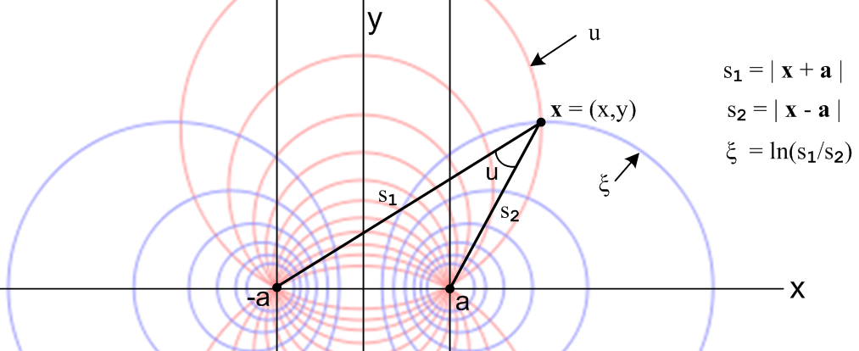 (J.1.3)

For the ξ coordinate, we invoke Maple, then translate below what it says:

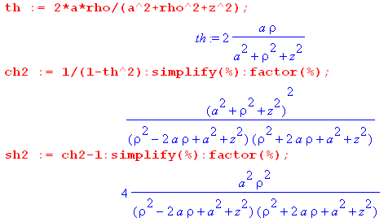 (J.1.4)

The equations above are

thξ = 2aρ/(a2+ρ2+z2) // as appears in (J.1)
ch2ξ = (a2+ρ2+z2)2/(A2B2) = [ (a2+ρ2+z2)Q]2
sh2ξ = 4a2ρ2/ (A2B2) = [2aρQ]2 . (J.1.5)

Since chξ and shξ are always positive (range of ξ is (0,∞)) one has,

chξ = (a2+ρ2+z2)Q
shξ = 2aρQ . (J.1.6)

Notice that

eξ = chξ + shξ = (a2+ρ2+z2)Q + 2aρQ = [(a+ρ)2 + z2]Q = [A2]/(AB) = A/B

and therefore

ξ = ln(A/B) = ln(s1/s2) = ln [ $\sqrt{z2+ (ρ+a)2}$$\sqrt{z2+ (ρ-a)2}$] . (J.1.7)

as shown in Fig (J.3).

We now repeat the above for coordinate u :

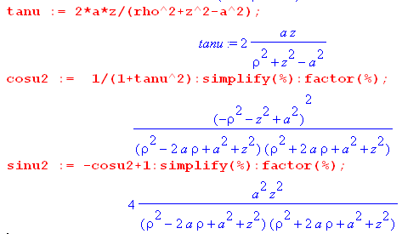 (J.1.8)

The equations above are

tanu = 2az/(ρ2+z2- a2)

cos2u = [ (ρ2+z2- a2)/AB ]2 = [ (ρ2+z2- a2)Q ]2

sin2u = [ 2az/AB ]2 = [ 2azQ ]2 . (J.1.9)

Since u has full range, we don't immediately know the signs to use, so we just write

cosu = ± (ρ2+z2- a2)Q
sinu = ± 2azQ .

It turns out that both signs are determined and are not free. As discussed below (9.1) and as shown in (9.4) the meaning of the tan-1u operation is really this

u = arctan2Pi(X,Y) = arctan2Pi(run,rise) = arctan2Pi(ρ2+z2-a2,2az) (J.1.10)

where the arctan2Pi function returns an angle u in the full range (0,2π) with full knowledge of the quadrant of the argument pair. In particular, we can make this table showing the signs of cosu and sinu that arise in the four regions (quadrants) of the arguments X=ρ2+z2-a2and Y=2az :

cosu sinu
ρ2+z2-a2 > 0 2az > 0 1Q + +
ρ2+z2-a2 < 0 2az > 0 2Q - +
ρ2+z2-a2 < 0 2az < 0 3Q - -
ρ2+z2-a2 > 0 2az < 0 4Q + - (J.1.11)

The arctan2Pi function is calibrated so that a point at z = +ε and large ρ will have u = 0, consistent with Fig (1.2.2) (a). Notice from the table that

sign(cosu) = sign(ρ2+z2-a2)
sign(sinu) = sign(z) . (J.1.12)

This last result is consistent with z/ρ = sinu/shξ in (J.1). Therefore, the ± signs shown above are both + and we have

cosu = (ρ2+z2- a2)Q
sinu = 2azQ . (J.1.13)

The ever-popular factor chξ - cosu is then given by

chξ - cosu = (a2+ρ2+z2)Q - (ρ2+z2- a2)Q = 2a2Q . (J.1.14)

Half-Angle Expressions

Here are some half-"angle" results for ξ

2ch2(ξ/2) = chξ + 1 = (a2+ρ2+z2)Q + 1
2sh2(ξ/2) = chξ - 1 = (a2+ρ2+z2)Q - 1

$\sqrt{2}$ch(ξ/2) = $\sqrt{(a2+ρ2+z2)Q + 1}$
$\sqrt{2}$sh(ξ/2) = $\sqrt{(a2+ρ2+z2)Q - 1}$ (J.1.15)

and here are the corresponding results for u,

2cos2(u/2) = 1+cosu = 1 + (ρ2+z2- a2)Q
2sin2(u/2) = 1-cosu = 1 - (ρ2+z2- a2)Q .

Taking square roots,

$\sqrt{2}$cos(u/2) = σc $\sqrt{1 + (ρ2+z2- a2)Q}$
$\sqrt{2}$sin(u/2) = σs $\sqrt{1 - (ρ2+z2- a2)Q}$ (J.1.16)

The signs σc and σs are determined from these plots of the two functions (or the table) :

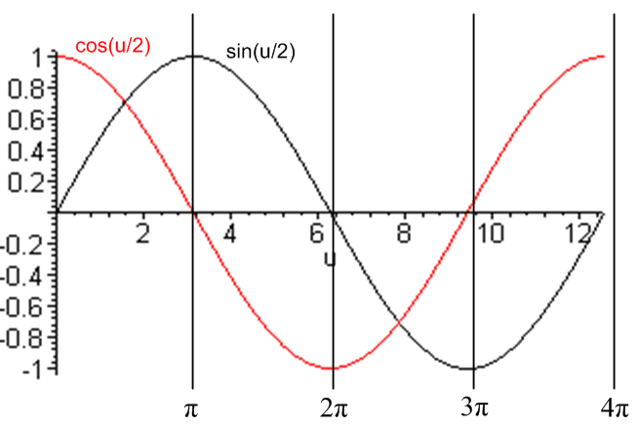 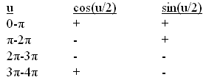 (J.1.17)

We may now summarize the above expression conversions:

thξ = 2aρ/(a2+ρ2+z2) A ≡ $\sqrt{z2+ (ρ+a)2}$ B ≡ $\sqrt{z2+ (ρ-a)2}$ (J.1.18)
chξ = (a2+ρ2+z2)Q Q ≡ $\frac{1}{AB}$ = $\sqrt{z2+ (ρ+a)2}$$\sqrt{z2+ (ρ-a)2}$
shξ = 2aρQ

tanu = 2az/(ρ2+z2- a2) // principle branch; u = arctan2Pi(ρ2+z2-a2,2az) gives u in (0,2π)
cosu = (ρ2+z2- a2)Q
sinu = 2azQ

chξ - cosu = 2a2Q ξ = ln(A/B)

$\sqrt{2}$ch(ξ/2) = $\sqrt{(a2+ρ2+z2)Q + 1}$ Converting expressions from
$\sqrt{2}$sh(ξ/2) = $\sqrt{(a2+ρ2+z2)Q - 1}$ toroidal to Cartesian coordinates.

$\sqrt{2}$cos(u/2) = σc $\sqrt{1 + (ρ2+z2- a2)Q}$
$\sqrt{2}$sin(u/2) = σs $\sqrt{1 - (ρ2+z2- a2)Q}$

J.2 Application: The Disk Potential

The flat disk potential was found in (2.5.4) to be

Vdisk(ξ,u) = (2V0/π) cot-1[$\sqrt{2}$$\sqrt{chξ-cosu}$] // ξ > 0, u0= π, π ≤ u ≤3π . (J.2.1)

Based on the angle range, we set σc = -1 using table (J.17).

To convert this to Cartesian coordinates, we look up the pieces in box (J.18) above,

$\sqrt{2}$$\sqrt{chξ-cosu}$ = $\sqrt{1 + (ρ2+z2- a2)Q}$$\sqrt{2a2Q}$ = $\frac{1 + (ρ2+z2- a2)Q}{2a2Q}$

= $\frac{2Q-1 + 2(ρ2+z2-a2)}{4a2}$ = $\sqrt{2AB + 2(ρ2+z2-a2)}$ . (J.2.2)

Now compute,

A2+B2 = z2+(ρ+a)2 + z2+(ρ-a)2 = 2(ρ2+z2+a2) = 2(ρ2+z2-a2) + 4a2

⇒ 2(ρ2+z2-a2) = A2+B2 - 4a2 (J.2.3)

Then
θ ≡ cot-1[$\sqrt{2}$$\sqrt{chξ-cosu}$] = cot-1 ( $\sqrt{2AB + A2+B2 - 4a2}$) = cot-1 ( $\sqrt{(A+B)2 - 4a2}$) . (J.2.4)

Now we conjure up a right triangle whose angle θ has the cotangent shown,

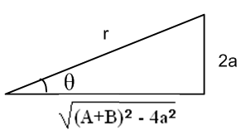 (J.2.5)

Therefore

r2 = [(A+B)2 - 4a2] + [4a2] = (A+B)2 ⇒ r = A+B (J.2.6)

and so

sinθ = $\frac{2a}{r}$ = $\frac{2a}{A+B}$

θ = cot-1[$\sqrt{2}$$\sqrt{chξ-cosu}$] = sin-1( $\frac{2a}{A+B}$) . (J.2.7)

The disk potential has then been converted to Cartesian coordinates :

Vdisk(ξ,u) = (2V0/π) cot-1[$\sqrt{2}$$\sqrt{chξ-cosu}$]

= (2V0/π) sin-1( $\frac{2a}{A+B}$)

= (2V0/π) sin-1( $\sqrt{z2+ (ρ+a)2}$$\sqrt{z2+ (ρ-a)2}$) . (J.2.8)

This result appears in green Jackson p 92. The Jackson equation should have q/a in place of q, and then q/a = (2V/π) by an earlier equation on that page.

General Case

It would be possible to convert the full bowl potential to Cartesian coordinates. Recall (2.4.14) ,

V(ξ,u) = (V0/π) { cot-1[- $\sqrt{2}$$\sqrt{chξ-cosu}$] + $\sqrt{chξ - cosu}$$\sqrt{chξ-cos(2u0- u)}$cot-1[$\sqrt{2}$$\sqrt{chξ-cos(2u0- u)}$] } (J.2.9)

ξ > 0 u0 ≤ u ≤ u0 + 2π
We have already evaluated the first term above

cot-1[- $\sqrt{2}$$\sqrt{chξ-cosu}$] = - σc sin-1( $\frac{2a}{A+B}$) . (J.2.10)

One would then need various unpleasant computed quantities:

cos(u0-u/2) = cosu0cos(u/2) + sinu0sin(u/2)

= [cosu0σc$\sqrt{1 + (ρ2+z2- a2)Q}$ + sinu0σs$\sqrt{1 - (ρ2+z2- a2)Q}$]/$\sqrt{2}$

cos(2u0 - u) = cos(2u0) cosu +sin(2u0) sinu

= cos(2u0)(ρ2+z2- a2)Q +sin(2u0) 2azQ

= [cos(2u0)(ρ2+z2- a2) +sin(2u0) 2az]Q

chξ - cos(2u0 - u) = 2a2Q - [cos(2u0)(ρ2+z2- a2) + sin(2u0) 2az]Q

= [ 2a2 - cos(2u0)(ρ2+z2- a2) - sin(2u0) 2az] Q (J.2.11)

It does not seem useful to pursue this path, although one could perhaps arrive at a reasonably stated result.
In any event, the reader will appreciate that, although the bowl potential looks complicated in toroidal coordinates ξ,u, it is very much more complicated in Cartesian coordinates ρ,z .

