this was installed on 12/20/15 do not edit here!

This is now called Appendix K.

Appendix L: Integration of toroid surface charge density

L.1 Warmup Exercises: Circumference and Area of a Toroid

Circumference

Consider a toroid of label ξ0. A cross section of the solid toroidal tube is a round disc. Let ds be a differential distance ds along the perimeter of this disc. Then using the scale factor hu one has from (1.3.3),

ds = (hudu) = a/(chξ0 - cosu) * du . (L.1.1)

Integrating around the tube means running u from 0 to 2π as shown in Fig (10.1.2). Thus,

circumference = a$^{\int_{0}^{2π}{}}$du (chξ0 - cosu)–1 = - a $^{\int_{0}^{2π}{}}$du (-chξ0 + cosu)–1 . (L.1.2)

We invoke integral (H.4.1),

$^{\int_{0}^{π}{}}$dx cos(nx) $\frac{1}{b+cosx}$ = (sign b)n+1 $\sqrt{b2-1}$($\sqrt{b2-1}$- |b| )n b > 1 or b < - 1 (H.4.1)

and apply it to the case n = 0 and b = -chξ0 to find

circumference = -a * 2 * [ (-1)1 $\frac{π}{shξ0}$] = 2π a/shξ0 = 2πR // (1.3.7) (L.1.3)

which is the expected result.

Area

Next, let dA be a differential patch of area on the toroid of label ξ0. Then from (1.3.3),

dA = (hudu)(hφdφ) = a/(chξ0 - cosu) * a shξ0/(chξ0 - cosu) * dudφ

= a2 shξ0 (chξ0 - cosu)–2dudφ . (L.1.4)

The area of the toroid is then

A = $^{\int_{0}^{2π}{}}$dφ $^{\int_{0}^{2π}{}}$du [ a2 shξ0 (chξ0 - cosu)–2 ]

= 2π * a2 shξ0 * $^{\int_{0}^{2π}{}}$du (-chξ0 + cosu)–2 . (L.1.5)

We invoke integral (H.4.8),

$^{\int_{0}^{π}{}}$dx cos(nx) $\frac{1}{(b+cosx)2}$ = (sign b)n π (|b| + n$\sqrt{b2-1}$)($\sqrt{b2-1}$-|b|)n $\frac{1}{(b2-1)3/2}$ b > 1 or b < - 1
(H.4.8)
and apply it to the case n = 0 and b = -chξ0 to find

$^{\int_{0}^{2π}{}}$du (-chξ0 + cosu)–2 = 2 * π * chξ0/ sh3ξ0 (L.1.6)
so
A = (2πa2sinξ0 ) * ( 2π chξ0/ sh3ξ0) = 4π2a2 (chξ0) / (shξ0)2

= 4π2 [ a/shξ0] [ a/thξ0] = 4π2 R ρc . // (1.3.17) (L.1.7)

which is the correct area of a toroid of tube radius R and centerline radius ρc.

Pappus Digression

If the toroid were a cylinder of length 2πρc and circumference 2πR, the cylinder area would be 4π2 R ρc . The fact that this is still correct if the cylinder is bent into a toroid follows from Pappus's centroid theorem. When the cylinder is bent into a toroid, the inside part has less area than half the cylinder, while the outside part has more, but the deficit and excess exactly cancel. Since we happen to have the tools handy, we can compute the inside and outside areas numerically as follows (see Fig 10.1.2)

Aoutside = 2π * a2 shξ0 * 2 * $^{\int_{0}^{π/2}{}}$du (-chξ0 + cosu)–2 = 4πa2shξ0$^{\int_{0}^{π/2}{}}$du (-chξ0 + cosu)–2
Ainside = 2π * a2 shξ0 * 2 * $^{\int_{π/2}^{π}{}}$du (-chξ0 + cosu)–2 = 4πa2shξ0$^{\int_{π/2}^{π}{}}$du (-chξ0 + cosu)–2
(L.1.8)

Setting ξ0 = 1 and a = 1 to have an example (see Fig (1.2.3) for the toroid fatness for ξ0 = 1 ),

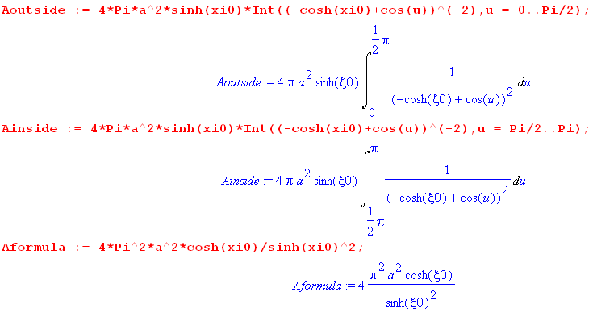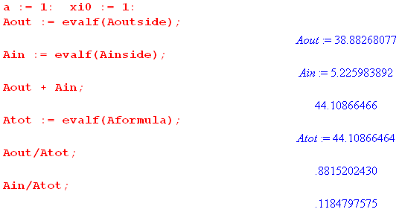 (L.1.9)

So for this example, the outside area accounts for 88% of the total while the inside is 12%.

L.2 Integration of the toroidal surface charge density

Recall the surface charge density on a toroid of label ξ0 from (10.5.10),

σ(u; ξ0) = $\frac{V0}{4πR}$ [ $\frac{1}{2}$ + $\sqrt{2}$(chξ0 - cosu)3/2 Σn=0∞ εn P'n-1/2(chξ0) $\frac{Qn-1/2(chξ0)}{Pn-1/2(chξ0)}$ cos(nu) ] .
(L.2.1)

Our task is to analytically integrate this quantity over the surface of the toroid and then to show that the integral is the expected result. The differential area dA is the same as (L.1.4),

dA = (hudu)(hφdφ) = a2 shξ0 (chξ0 - cosu)–2dudφ . (L.2.2)

Then the total charge Q on the toroid is given by (there is of course no φ dependence in σ)

Q = ∫∫ σ dA = $^{\int_{0}^{2π}{}}$dφ $^{\int_{0}^{2π}{}}$du σ(u; ξ0) [ a2 shξ0 (chξ0 - cosu)–2]

= 2π a2 shξ0 $^{\int_{0}^{2π}{}}$du σ(u; ξ0) (chξ0 - cosu)–2 . (L.2.3)

In (L.2.1) we have highlighted in red the two places where σ(u; ξ0) depends on u. We shall therefore need the following two integrals:

$^{\int_{0}^{2π}{}}$du (chξ0 - cosu)–2

$^{\int_{0}^{2π}{}}$du(chξ0 - cosu)3/2(chξ0 - cosu)–2 cos(nu) = $^{\int_{0}^{2π}{}}$du cos(nu)( chξ0 - cosu)-1/2 . (L.2.4)

The first integral has already been evaluated in (L.1.6) to be 2π chξ0/ sh3ξ0. The second integral is evaluate in (K.3.4) to be 2$\sqrt{2}$Qn-1/2(chξ0). Thus,

$^{\int_{0}^{2π}{}}$du 1 (chξ0 - cosu)–2 = 2π chξ0/ sh3ξ0 // (L.1.6)

$^{\int_{0}^{2π}{}}$du(chξ0 - cosu)3/2(chξ0 - cosu)–2 cos(nu) = 2$\sqrt{2}$Qn-1/2(chξ0) . // (K.3.4) (L.2.5)

Inserting (L.2.1) for σ(u; ξ0) into (L.2.3) for Q, and then supplying the two integrals (L.2.5), we get

Q = 2πa2shξ0 $^{\int_{0}^{2π}{}}$du σ(u; ξ0) (chξ0 - cosu)–2

= [ 2πa2shξ0 * $\frac{V0}{4πR}$]* $\frac{1}{2}$* 2π chξ0/ sh3ξ0
+ [ 2πa2shξ0 $\frac{V0}{4πR}$ ] * $\sqrt{2}$Σn=0∞ εn P'n-1/2(chξ0) $\frac{Qn-1/2(chξ0)}{Pn-1/2(chξ0)}$* 2$\sqrt{2}$Qn-1/2(chξ0)

= $\frac{V0}{2R}$ a2 shξ0 { π (chξ0)(1/sh3ξ0) + $\frac{4}{π}$ Σn=0∞ εn P'n-1/2(chξ0) $\frac{[Qn-1/2(chξ0)]2}{Pn-1/2(chξ0)}$ } . (L.2.6)

The reader is hopefully wondering how on earth one can do the sum on n with P' Q2/P sitting there.

Consider then the sum,

Σn=0∞ εn P'n-1/2(chξ0) $\frac{[Qn-1/2(chξ0)]2}{Pn-1/2(chξ0)}$. (L.2.7)

Recall the Wronskian of P and Q from (H.8.2),

W{Pν(z),Qν(z)} = 1/(1-z2) = Pν(z) Qν'(z) - Pν'(z) Qν(z) . (H.8.2)

With z = chξ0 and ν = n-1/2 this says

P'n-1/2(chξ0) Qn-1/2(chξ0) = + (1/sh2ξ0) + Pn-1/2(chξ0) Q'n-1/2(chξ0) . (L.2.8)

Installing this into the sum (L.2.7) gives two sums. The first sum is,

(1/shξ0)2 Σn=0∞ εn $\frac{Qn-1/2(chξ0)}{Pn-1/2(chξ0)}$ // first sum (L.2.9)

while the second sum is

Σn=0∞ εn Pn-1/2(chξ0) $\frac{Qn-1/2(chξ0)Q'n-1/2(chξ0)}{Pn-1/2(chξ0)}$

= Σn=0∞ εn Qn-1/2(chξ0) Q'n-1/2(chξ0)

= -(π2/4) chξ0 / sh3ξ0 // second sum (L.2.10)

where we use the result (K.4.8) for the QQ' sum.

We now install these two sums into (L.2.6) to get

Q = $\frac{V0}{2R}$ a2 shξ0 { π (chξ0)(1/sh3ξ0) + $\frac{4}{π}$ [ second sum + first sum] }

= $\frac{V0}{2R}$ a2 shξ0 { π (chξ0)(1/sh3ξ0) + $\frac{4}{π}$ [ -(π2/4) chξ0 / sh3ξ0 + (1/shξ0)2 Σn=0∞ εn $\frac{Qn-1/2(chξ0)}{Pn-1/2(chξ0)}$] }

= $\frac{V0}{2R}$ a2 shξ0 {$\frac{4}{π}$ (1/shξ0)2 Σn=0∞ εn $\frac{Qn-1/2(chξ0)}{Pn-1/2(chξ0)}$} // two terms cancel

= $\frac{V0}{2R}$ $\frac{4}{π}$ a (a/shξ0) Σn=0∞ εn $\frac{Qn-1/2(chξ0)}{Pn-1/2(chξ0)}$

= V0 $\frac{2a}{π}$ Σn=0∞ εn $\frac{Qn-1/2(chξ0)}{Pn-1/2(chξ0)}$ (L.2.11)

The implied capacitance of the toroid is then

C = $\frac{2a}{π}$ Σn=0∞ εn $\frac{Qn-1/2(chξ0)}{Pn-1/2(chξ0)}$ (L.2.12)

which agrees with the result (10.2.3) which was found completely independently by taking the far-away limit of the potential (10.1.11). We regard this as a strong validity check on (L.2.1) for σ.

***************************************************************8

This has been installed

H.4 Computation of integrals *****

(a) Derive the following integral:

$^{\int_{0}^{π}{}}$dx cos(nx) $\frac{1}{b+cosx}$ = (sign b)n+1 $\sqrt{b2-1}$($\sqrt{b2-1}$- |b| )n b > 1 or b < - 1 (H.4.1)

That is, compute the Fourier Cosine Series Transform of the function 1/(b+cosx).

Start with this integral from GR7,

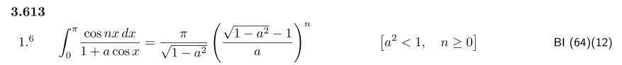
(H.4.2)
Call the above integral J(a) and let b = 1/a. Then

J(a) = $^{\int_{0}^{π}{}}$dx cos(nx) $\frac{1}{1+acosx}$ $\frac{b}{b}$ = b $^{\int_{0}^{π}{}}$dx cos(nx) $\frac{1}{b+cosx}$

$\sqrt{1-a2}$$\frac{b}{b}$ = b $\sqrt{b2-1}$

$\sqrt{1-a2}$ $\frac{b}{b}$ = ($\sqrt{b2-1}$ - b) . (H.4.3)
Then
b $^{\int_{0}^{π}{}}$dx cos(nx) $\frac{1}{b+cosx}$ = b $\sqrt{b2-1}$($\sqrt{b2-1}$ - b)n
so we find

I(b) ≡ $^{\int_{0}^{π}{}}$dx cos(nx) $\frac{1}{b+cosx}$ = b $\sqrt{b2-1}$($\sqrt{b2-1}$ - b)n b > 1, -b = -|b| (H.4.4)

For b < - 1, the correct analytic continuation is to take $\sqrt{b2-1}$ → - $\sqrt{b2-1}$(as verified below) so in this case one finds

I(b) ≡ $^{\int_{0}^{π}{}}$dx cos(nx) $\frac{1}{b+cosx}$ = - $\sqrt{b2-1}$(- $\sqrt{b2-1}$ - b)n b < -1, b = - |b|
= (-1)n+1 $\sqrt{b2-1}$($\sqrt{b2-1}$+ b)n b < -1 (H.4.5)

Combining these results,

I(b) = $^{\int_{0}^{π}{}}$dx cos(nx) $\frac{1}{b+cosx}$ = (sign b)n+1 $\sqrt{b2-1}$($\sqrt{b2-1}$- |b| )n (H.4.6)

and so (H.4.1) has been derived.

Maple numerical integration verification for several cases:

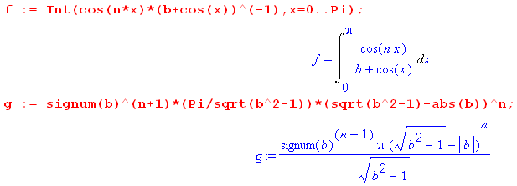
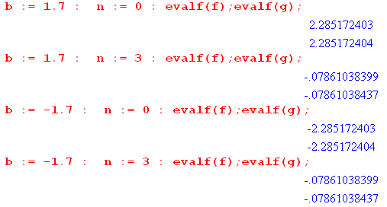 (H.4.7)

(b) Derive the following integral:

$^{\int_{0}^{π}{}}$dx cos(nx) $\frac{1}{(b+cos)2}$ = (sign b)n π (|b| + n$\sqrt{b2-1}$)($\sqrt{b2-1}$-|b|)n $\frac{1}{(b2-1)3/2}$ b > 1 or b < - 1
(H.4.8)

That is, compute the Fourier Cosine Series Transform of the function 1/(b+cosx)2.

Start with (H.4.4) for b > 1

I(b) = $^{\int_{0}^{π}{}}$dx cos(nx) $\frac{1}{b+cosx}$ = b $\sqrt{b2-1}$($\sqrt{b2-1}$ - b)n (H.4.4)

Apply ∂b = d/db to get

∂bI(b) = -$^{\int_{0}^{π}{}}$dx cos(nx)(b+cosx)-2 = ∂b [$\sqrt{b2-1}$($\sqrt{b2-1}$ - b)n ] (H.4.9)

Maple does the derivative,

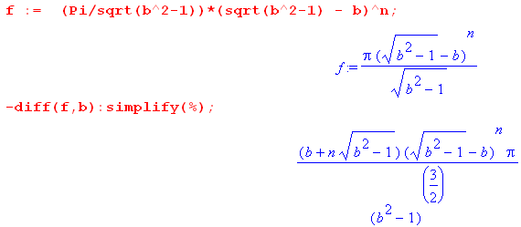 (H.4.10)
Thus,

$^{\int_{0}^{π}{}}$dx cos(nx) $\frac{1}{(b+cos)2}$ = π (b + n$\sqrt{b2-1}$)($\sqrt{b2-1}$- b)n $\frac{1}{(b2-1)3/2}$ b > 1 , |b| = b (H.4.11)

For b < - 1, the correct analytic continuation is to take $\sqrt{b2-1}$ → - $\sqrt{b2-1}$(as verified below) so in this case one finds,

$^{\int_{0}^{π}{}}$dx cos(nx) $\frac{1}{(b+cos)2}$ = π (b - n$\sqrt{b2-1}$)(- $\sqrt{b2-1}$- b)n [- $\frac{1}{(b2-1)3/2}$]

= π (-b + n$\sqrt{b2-1}$)(- $\sqrt{b2-1}$- b)n $\frac{1}{(b2-1)3/2}$

= (-1)n π (-b + n$\sqrt{b2-1}$)( $\sqrt{b2-1}$+ b)n $\frac{1}{(b2-1)3/2}$ b < -1, -b = |b| .
(H.4.12)
Combining these results one gets,

$^{\int_{0}^{π}{}}$dx cos(nx) $\frac{1}{(b+cos)2}$ = (sign b)n π (|b| + n$\sqrt{b2-1}$)($\sqrt{b2-1}$-|b|)n (b2-1)-3/2 (H.4.13)

and so (H.4.8) has been derived.

Maple numerical integration verification for several cases:

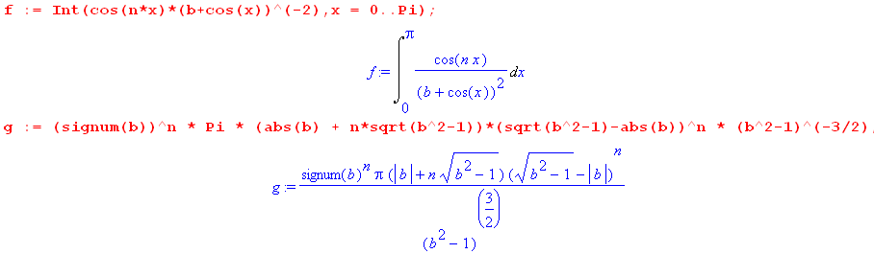

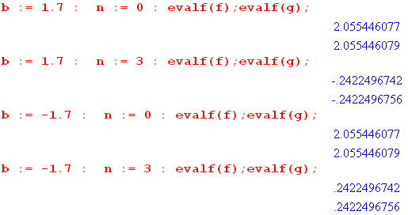 (H.4.14)

