Appendix K. The Fourier Cosine Series Transform and its Application 1
K.1 Regular Boundary Value Problems and Associated Transforms 1
K.2. The Fourier Cosine Series Transform 3
K.3. Application to f(θ) = (a-bcosθ)^{1/2} 6

do not edit, has been installed on 12/18/15

Appendix K. The Fourier Cosine Series Transform and its Application

Since Morse and Feshbach seem to have an error on this topic (as noted below), and since they have so few errors, we treat this subject very carefully and systematically.

K.1 Regular Boundary Value Problems and Associated Transforms

In the general theory of a "regular boundary value problem" (see Stakgold Section 4.2), one has second order differential operators L and Lλ of the form

L = -∂x[p(x)∂x] + q(x)

Lλ = L - λs(x) (K.1.1)

where p,q,s and ∂xp are real continuous functions on some interval (a,b) and p and s are positive on that interval. The function s(x) is a "weight function" which is 1 in many cases. The boundary conditions at the endpoints a and b must be "unmixed" with real coefficients.

There are three differential equations of interest,

Lλφ = 0 or Lφ = λs(x)φ // the eigenvalue problem

Lλg(x|ξ;λ) = δ(x-ξ) // the Green's Function problem

Lλu = f // equation one wants to solve for u (K.1.2)

The unmixed boundary conditions can be written.

α1h(a) + α2h'(a) = 0
β1h(b) + β2h'(b) = 0 (K.1.3)

where αi and βi are real, and where h is any of the functions φ, g or u.

The theory shows that the eigenvalues must be real, must have a discrete spectrum, and that the eigenfunctions must be orthogonal with weight s(x). The eigenvalue problem is then written

Lφn(x) = λns(x)φn(x) . (K.1.4)

The scale of φn(x) is of course not set by this equation, so one can adjust the scale of each φn(x) so that the φn(x) are orthonormal on (a,b), where a and b are finite.

$^{\int_{a}^{b}{}}$dx s(x) n(x) φm(x) = δn,m . (K.1.5)

where the overbar indicates complex conjugation.
As Stakgold shows in (4.43), the completeness of the eigenfunctions is given by

δ(x-ξ) = s(x) Σn φn(x) n(ξ) . (K.1.6)

Defining the inner product of two functions as (physics convention)

<f,g> ≡ $^{\int_{a}^{b}{}}$dx (x)g(x) (K.1.7)

one can write the orthonormality of the eigenfunctions as

<$\sqrt{s}$φn, $\sqrt{s}$φm> = δn,m . (K.1.8)

It turns out that the Green's Function g(x|ξ;λ) can be written as an expansion on the eigenfunctions (4.42),

g(x|ξ;λ) = Σn φn(x) n(ξ)/(λn- λ) (K.1.9)

and that the solution of Lλu = f is given by,

u(x) =$^{\int_{a}^{b}{}}$dx g(x|ξ;λ) f(ξ)dξ

= Σn <f,φn> / (λn-λ) . (K.1.10)

An obvious simplification is to define new functions

ψn ≡ $\sqrt{s}$φn (K.1.11)

and then one has

$^{\int_{a}^{b}{}}$dx n(x) ψm(x) = δn,m // orthogonality

Σn ψn(x) n(ξ) = δ(x-ξ) . // completeness (K.1.12)

Now expand a function u(x) on this complete set of basis functions,

f(x) = Σm fm ψm(x)

Apply $^{\int_{a}^{b}{}}$dx n(x) to "project out" the coefficients fn.

$^{\int_{a}^{b}{}}$dx n(x) f(x) = Σm fm $^{\int_{a}^{b}{}}$dx n(x)ψm(x) = Σm fm δn,m = fn

Thus our transform may be summarized as

f(x) = Σm fm ψm(x) // expansion

fn = $^{\int_{a}^{b}{}}$dx n(x) f(x) // projection (K.1.13)

Stakgold goes on to discuss the singular boundary value problem where a and/or b might be infinite, or where p(x) might vanish in (a,b), or where some other condition of the regular problem is violated. Our main concern however are these results for the regular problem, as derived above :

f(x) = Σm fmψm(x) // expansion
fn = $^{\int_{a}^{b}{}}$dx n(x) f(x) // projection

$^{\int_{a}^{b}{}}$dx n(x) ψm(x) = δn,m // orthogonality
Σn ψn(x) n(ξ) = δ(x-ξ) // completeness (K.1.14)

K.2. The Fourier Cosine Series Transform

This should not be confused with the Fourier Cosine Transform which has interval (0,∞).

For the Fourier Cosine Series Transform we apply the above theory where

variable x = θ

interval = (a,b) = (0,π)

boundary conditions: h'(0) = 0 and h'(π) = 0

weight function s(θ) = 1

differential operator L = - ∂θ2 so p(θ) = 1 and q(θ) = 0

spectrum: n = 0,1,2....

orthonormal eigenfunctions = ψn(θ) = $\sqrt{εn/π}$cos(nθ) where εn = 2 - δn,0 (K.2.1)

Notice the in the last line above the appearance of factor εn which equals 1 when n = 0, but equals 2 otherwise. This factor appears in the eigenfunctions because it is necessary to make them be orthonormal. The n = 0 case is different from all the other cases due to this fact,

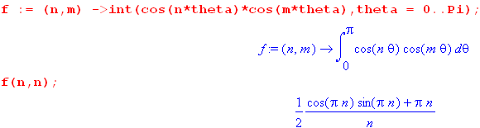

For n = 1,2,.... the integral is clearly π/2, but for n = 0 the integrand is just 1 so the integral is π. For example,

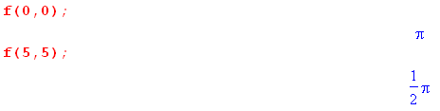
One then writes

$^{\int_{0}^{π}{}}$dθ cos(nθ)cos(mθ) = (π/εn)δn,m (K.2.2)

and then the eigenfunctions ψn(θ) = $\sqrt{εn/π}$cos(nθ) are orthonormal,

$^{\int_{0}^{π}{}}$dθ ψn(θ)ψm(θ) = δn,m (K.2.3)

Expanding a function f(θ) on the ψn(θ) we get

f(θ) = Σn fn ψn(θ) // expansion
fn = $^{\int_{a}^{b}{}}$dx ψn(θ) f(x) // projection (K.2.4)

or
f(θ) = $\sqrt{εn/π}$ Σn fncos(nθ)
fn = $\sqrt{εn/π}$$^{\int_{a}^{b}{}}$dx cos(nθ) f(θ) (K.2.5)

Defining an by

$\sqrt{εn/π}$fn = (1/2)εn an an = 2/$\sqrt{πεn}$ fn fn = (1/2) $\sqrt{πεn}$ an (K.2.6)

the equations *** are written in a more traditional manner

f(θ) = (1/2) Σn εnancos(nθ) = a0/2 + Σn=1∞ ancos(nθ)

an = (2/π)$^{\int_{a}^{b}{}}$dx cos(nθ) f(θ) (K.2.7)

The simple factor εn = 2 - δn,0 is usually called "the Neumann factor" (see etymology below).

After the above very long-winded introduction, we finally arrive at a full statement of the Fourier Cosine Series Transform,

f(θ) = a0/2 + Σn=1∞ an cos(nθ) = (1/2) Σn=0∞ εn an cos(nθ) // expansion
an = (2/π) $^{\int_{0}^{π}{}}$dθ f(θ) cos(nθ) // projection

$^{\int_{0}^{π}{}}$ dθ cos(nθ)cos(n'θ) = (π/εn) δnn' // orthogonality
Σn=0∞ (εn/π) cos(nθ)cos(nθ) = δ(θ-θ') . // completeness (K.2.9)

As a verification of these results , consider

f(θ) = (1/2) Σn=0∞ εn an cos(nθ) =

= (1/2) Σn=0∞ εn [(2/π) $^{\int_{0}^{π}{}}$dθ' f(θ') cos(nθ')]cos(nθ)

= $^{\int_{0}^{π}{}}$dθ' f(θ') [ Σn=0∞ (εn/π) cos(nθ')cos(nθ) ] // now use completeness

= $^{\int_{0}^{π}{}}$dθ' f(θ') δ(θ-θ') = f(θ) (K.2.10)

Going the other direction

an = (2/π) $^{\int_{0}^{π}{}}$dθ f(θ) cos(nθ)

= (2/π) $^{\int_{0}^{π}{}}$dθ [ (1/2) Σm=0∞ εm am cos(mθ)]cos(nθ)

= Σm=0∞ (εm/π) am [$^{\int_{0}^{π}{}}$dθ cos(mθ)cos(nθ) ] // now use orthogonality

= Σm=0∞ (εm/π) am (π/εm) δnm = an (K.2.11)

K.3. Application to f(θ) = (a-bcosθ)1/2

Consider the function

f(θ) = 1/$\sqrt{a - b cosθ}$ . (K.3.1)

The projection coefficients an are then given by

an = (2/π) $^{\int_{0}^{π}{}}$dθ f(θ) cos(nθ)

= (2/π) $^{\int_{0}^{π}{}}$dθ cos(nθ) / $\sqrt{a - b cosθ}$ . (K.3.2)

This seemingly simple integral, the Fourier Cosine Series Transform of 1/$\sqrt{a - b cosθ}$, does not appear in the expected places. Armed with a premonition of the result, we start with the following integral representation of the Qνμ(z) function appearing on GR7 p 961 (also Bateman HTF I p 156 (10) ) ,

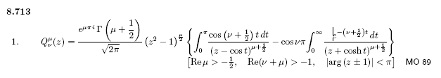
(K.3.3)

We simultaneously set μ = 0 and ν = n-1/2. Since cos(νπ) = cos(nπ-π/2) = cos(π/2-nπ) = sin(nπ) = 0, the entire second term conveniently vanishes, leaving us with

Qn-1/2(z) = (1/$\sqrt{2}$) $^{\int_{0}^{π}{}}$dt cos(nt)/$\sqrt{z -cost}$ . (K.3.4)

Therefore
Qn-1/2(a/b) = (1/$\sqrt{2}$) $^{\int_{0}^{π}{}}$dt cos(nt) $\sqrt{(a/b) -cost}$ * $\sqrt{b}$$\sqrt{b}$

= $\sqrt{b/2}$$^{\int_{0}^{π}{}}$dt cos(nt) $\sqrt{a -bcost}$
and so

$^{\int_{0}^{π}{}}$dθ cos(nθ) / $\sqrt{a - b cosθ}$ = $\sqrt{2/b}$Qn-1/2(a/b) . (K.3.5)

The projection coefficients ** are therefore

an = (2/π) $\sqrt{2/b}$Qn-1/2(a/b) . (K.3.6)

The corresponding expansion is then

1/$\sqrt{a - b cosθ}$ = (1/2) Σn=0∞ εn an cos(nθ)

= (1/2) (2/π) $\sqrt{2/b}$ Σn=0∞ εn Qn-1/2(a/b) cos(nθ)

= (1/π)$\sqrt{2/b}$ Σn=0∞ εn Qn-1/2(a/b) cos(nθ) (K.3.7)

We thus arrive at the transform pair

1/$\sqrt{a - b cos(x)}$ = (1/π) $\sqrt{2/b}$ Σn=0∞ εn Qn-1/2(a/b) cos(nx) // expansion

$^{\int_{0}^{π}{}}$dx cos(nx)/ $\sqrt{a - b cos(x)}$ = $\sqrt{2/b}$ Qn-1/2(a/b) // projection (K.3.8)

which we quote as (10.1.8) in Section 10.

If in the expansion we set b = 1, a =cosh μ and x = η we get,

$\sqrt{cosh μ - cos η}$ = $\sqrt{2}$ Σn=0∞ εn Qn-1/2(cosh μ) cos(nη) . (K.3.9)

It is in the expansion that Morse and Feshbach omit the Neumann factor on page 1304

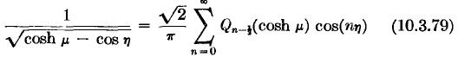 // wrong

and this then leads to the omission of the same εn factor in the potential for the torus which we quote below (10.1.11).
The Morse and Feshbach function Qmn(z) is defined on their page 1327 and agrees with the Bateman form (41) in HTF I page 135, so we can rule out a discrepancy of the definition of this function.

A simple application of the expansion (K.3.8) is a representation of the potential 1/R of a unit point charge in cylindrical coordinates ρ,z,φ. It is easy to show that

1/R ≡ 1/|r-r'| = 1/$\sqrt{ρ2 + ρ'2 - 2ρρ' cos(φ-φ') + (z-z')2}$. (K.3.10)

Now define

a = ρ2 + ρ'2 + (z-z')2 a/b = (ρ2 + ρ'2 + (z-z')2)/(2ρρ')
b = 2ρρ' $\sqrt{2/b}$= 1/$\sqrt{ρρ'}$ (K.3.11)
x = φ-φ'

and use (K.3.8) so that

$\frac{1}{R}$ = $\sqrt{a - b cos(x)}$ = $\frac{1}{π}$$\frac{2}{b}$ Σn=0∞ εn Qn-1/2( $\frac{a}{b}$) cos(nx)

= $\frac{1}{π}$$\frac{1}{ρρ'}$ Σn=0∞ εn Qn-1/2( $\frac{ρ2 + ρ'2 + (z-z')2}{2ρρ'}$) cos[n(φ-φ')] . (K.3.12)

This result appears in Snow's 1953 "bulletin", where his εm is half our Neumann factor,

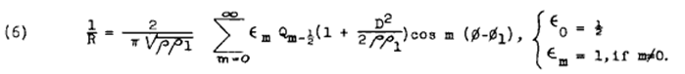
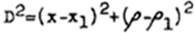
(K.3.13)
Comment on the Neumann Factor.

Morse and Feshbach (1953) refer to εn by that name on page 1274,

In his Treatise "The Theory of Bessel Functions" (1944), Watson uses the term on page 22,

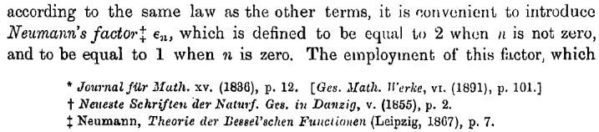

and there we see a reference back to Neumann's 1867 Theory of the Bessel Functions, page 9,

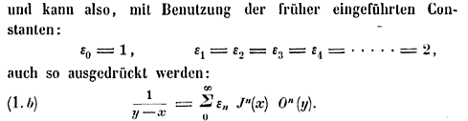

so presumably this is the source of the usage. Incidentally, the latter equation involves "Neumann's polynomials" On(z) and appears in AS2010 as

