Do not edit, this has been installed on 12.28.15

Appendix L: Some Mehler Integrals PhL

Since the six Mehler integrals stated in (7.1.3) through (7.1.8) do not generally appear in standard references, and since there are sometimes typos where they do appear, we derive all of them here in full detail, hopefully providing the reader with a traceable source for these integrals. For each integral we provide at least one external verification.

L.1 (7.1.1)
L.2 (7.1.2)
L.3 (7.1.3)
L.4 (7.1.4)
L.5 (7.1.5)
L.6 (7.1.6)

L.1 Compute $^{\int_{0}^{∞}{}}$dτ Piτ-1/2(y)

Show that :

I ≡$^{\int_{0}^{∞}{}}$dτ Piτ-1/2(y) = $\sqrt{2}$$\sqrt{y-1}$ . y > 1 (L.1.1)

Start with this P function integral representation from GR7 8.715 (1) page 962,


Set μ = 0, ν = -1/2+iτ to get

P-1/2+iτ(chα) = ($\sqrt{2}$/π) $^{\int_{0}^{α}{}}$dx cos(τx) / $\sqrt{chα - chx}$ y > 1 . (L.1.2)

Insert (L.1.2) into (L.1.1) with y = chα to get,

I = $^{\int_{0}^{∞}{}}$dτ Piτ-1/2(chα) =$^{\int_{0}^{∞}{}}$dτ [ ($\sqrt{2}$/π) $^{\int_{0}^{α}{}}$dx cos(τx) / $\sqrt{chα - chx}$ ]

= ($\sqrt{2}$/π) $^{\int_{0}^{α}{}}$dx (1/$\sqrt{chα - chx}$) $^{\int_{0}^{∞}{}}$dτ cos(τx) . (L.1.3)
But

$^{\int_{-∞}^{∞}{}}$dτ eiτx = 2πδ(x) = $^{\int_{-∞}^{∞}{}}$dτ cos(τx) = 2$^{\int_{0}^{∞}{}}$dτ cos(τx)

=> $^{\int_{0}^{∞}{}}$dτ cos(τx) = πδ(x) . (L.1.4)

Using (L.1.4) in (L.1.3),

I = ($\sqrt{2}$/π)$^{\int_{0}^{α}{}}$dx (1/$\sqrt{chα - chx}$) πδ(x) = ($\sqrt{2}$/π) (π) (1/2) 1/$\sqrt{chα - chx}$

= (1/$\sqrt{2}$) 1/$\sqrt{chα - 1}$ α > 0

= (1/$\sqrt{2}$) 1/$\sqrt{y - 1}$ y > 1 (L.1.5)

which verifies (L.1.1). Note that the integration picks up exactly 1/2 of δ(x) since the integration starts at x = 0. This is a mathematically rigorous fact demonstrable using limits of delta functions sequences.

Verification: The following integral appears in Bateman IT 2 page 330 18.3 (21),

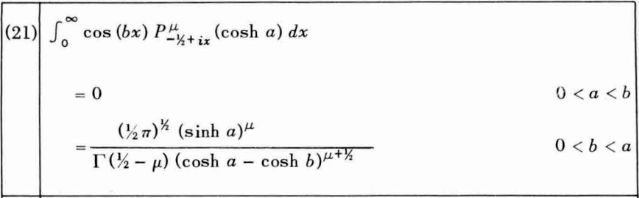 (L.1.6)

Setting b = 0, μ = 0 and chα = y the integral states

$^{\int_{0}^{∞}{}}$dτ Piτ-1/2(y) = $\sqrt{π/2}$/ [$\sqrt{π}$(y-1)1/2 ] = (1/$\sqrt{2}$) (1/$\sqrt{y-1}$) y > 1 (L.1.7)

verifying (L.1.1). Integral (L.1.1) also appears in Oberhettinger and Higgins Table C page 28, the first entry with a = 1 and k = 0. The above Bateman integral appears as the 2nd integral in that Table.

L.2 Compute $^{\int_{0}^{∞}{}}$dτ Piτ-1/2(y) cos(aτ)

Show that [ θ is the Heaviside function ]

I ≡ $^{\int_{0}^{∞}{}}$dτ Piτ-1/2(y) cos(aτ) = $\sqrt{2}$ $\sqrt{y-cha}$ θ(y-cha) . (L.2.1)

This result is the content of Bateman (L.1.6) noted above if we set μ = 0 and b = a, and we have (L.1.6) verified in two reference locations. Nevertheless, we compute the integral directly.
Insert the P integral representation (L.1.2) into (L.2.1) to get

I = $^{\int_{0}^{∞}{}}$dτ Piτ-1/2(chα) cos(aτ) = $^{\int_{0}^{∞}{}}$dτ [ ($\sqrt{2}$/π) $^{\int_{0}^{α}{}}$dx cos(τx) / $\sqrt{chα - chx}$] cos(aτ)

= ($\sqrt{2}$/π)$^{\int_{0}^{α}{}}$dx (1/$\sqrt{chα - chx}$) $^{\int_{0}^{∞}{}}$dτ cos(xτ)cos(aτ) . (L.2.2)

The τ integral is recognized as the completeness relation (or the orthogonality relation) for the Fourier Integral Cosine Transform where 0 ≤ z ≤ ∞ and 0 ≤ k ≤ ∞ :

f(z) = $\sqrt{2/π}$$^{\int_{0}^{∞}{}}$dk cos(kz) fk // expansion
fk = $\sqrt{2/π}$$^{\int_{0}^{∞}{}}$dz cos(kz) f(z) // projection
$^{\int_{0}^{∞}{}}$dz cos(kz) cos(k'z) = (π/2)δ(k-k') // orthogonality
$^{\int_{0}^{∞}{}}$dk cos(kz) cos(kz') = (π/2)δ(z-z') // completeness . (L.2.3)

Thus $^{\int_{0}^{∞}{}}$dτ cos(xτ)cos(aτ) = (π/2)δ(x-a) for a > 0 and then from (L.2.2),

I = ($\sqrt{2}$/π)$^{\int_{0}^{α}{}}$dx (1/$\sqrt{chα - chx}$) (π/2) δ(x-a) = (1/$\sqrt{2}$) (1/$\sqrt{chα - cha}$) θ(α - a)

= (1/$\sqrt{2}$) (1/$\sqrt{y - cha}$)θ(y - cha) (L.2.4)

which verifies (L.2.1), where θ is the Heaviside function.

Verification:
Oberhettinger and Higgins Table C page 28, second entry.
Bateman (L.1.6) above with μ = 0, chα = y and b = a.

L.3 Compute $^{\int_{0}^{∞}{}}$dτ Piτ-1/2(y) cos(aτ) / ch(πτ)

Show that :

I ≡ $^{\int_{0}^{∞}{}}$dτ Piτ-1/2(y) cos(aτ) / ch(πτ) = $\sqrt{2}$ $\sqrt{y+cha}$. (L.3.1)

Start with this P function integral representation from GR7 8.713 (3) page 961 (also Bateman HTF 1 3.7 (11), page 156),

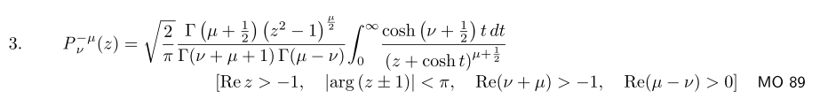

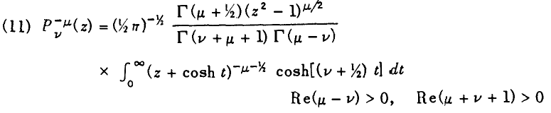
Set μ = 0 to get

Pν(y) = $\sqrt{2/π}$$\sqrt{π}$ [ Γ(ν+1)Γ(-ν)]-1 $^{\int_{0}^{∞}{}}$dt (y +cht)-1/2 ch[(ν+1/2)t],
Re(-ν)>0 and Re(ν+1)>0 . (L.3.2)

We note from Maple that

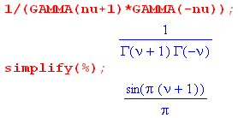 . (L.3.3)
Setting ν = iτ - 1/2 one finds,

sin[π(ν+1)] = sin[π(iτ+1/2)] = sin(π/2 + iπτ) = cos(iπτ) = ch(πτ)

ch[(ν+1/2)t] = ch[iτt] = cos(τt) . (L.3.4)

Note also that Re(-ν) = 1/2 and Re(ν+1) = 1/2, so both conditions in (L.3.2) are met. Thus,

Piτ-1/2(y) = $\sqrt{2}$ [ch(πτ)/π] $^{\int_{0}^{∞}{}}$dt (y +cht)-1/2 cos(τt) . (L.3.5)

Now insert (L.3.5) into the integral I of (L.3.1) to get

I ≡ $^{\int_{0}^{∞}{}}$dτ Piτ-1/2(y) cos(aτ) / ch(πτ)

= $^{\int_{0}^{∞}{}}$dτ [ $\sqrt{2}$(1/π) ch(πτ) $^{\int_{0}^{∞}{}}$dt (y +cht)-1/2 cos(τt) ] cos(aτ) / ch(πτ)

= ($\sqrt{2}$/π)$^{\int_{0}^{∞}{}}$dτ $^{\int_{0}^{∞}{}}$dt (y +cht)-1/2 cos(τt) cos(aτ) // note how ch(πτ)'s canceled

= ($\sqrt{2}$/π) $^{\int_{0}^{∞}{}}$dt (y +cht)-1/2 $^{\int_{0}^{∞}{}}$dτ cos(τt) cos(aτ)

= ($\sqrt{2}$/π) $^{\int_{0}^{∞}{}}$dt (y +cht)-1/2 (π/2)δ(t-a) // see (L.2.3)

= (1/$\sqrt{2}$) (y + cha)-1/2 (L.3.6)

which then is the claim of (L.3.1).

Verification: Oberhettinger and Higgins Table C page 28, the 4th integral with k = 0 and Pkk(z) = 1.

L.4 Compute $^{\int_{0}^{∞}{}}$dτ Piτ-1/2(y) cos(aτ) / ch2(πτ)

Show that :

I ≡$^{\int_{0}^{∞}{}}$dτ Piτ-1/2(y) cos(aτ) / ch2(πτ) = $\sqrt{2}$ $\sqrt{y-cha}$tan-1[ $\sqrt{y-cha}$$\sqrt{1+cha}$] . (L.4.1)

There is surely some simple way to compute this integral, but we don't know what it is so we resort to very ugly brute force with many steps. Start with the integral representation (L.3.5) for P,

Piτ-1/2(z) = ($\sqrt{2}$/π) ch(πτ)$^{\int_{0}^{∞}{}}$dt (z +cht)-1/2 cos(τt) . (L.3.5)

Install this into (L.4.1) to get,

I = $^{\int_{0}^{∞}{}}$dτ Piτ-1/2(y) cos(aτ) / ch2(πτ)

= $^{\int_{0}^{∞}{}}$dτ [ ($\sqrt{2}$/π) ch(πτ)$^{\int_{0}^{∞}{}}$dt (y +cht)-1/2 cos(τt)] cos(aτ) / ch2(πτ)

= ($\sqrt{2}$/π)$^{\int_{0}^{∞}{}}$dt (y +cht)-1/2 $^{\int_{0}^{∞}{}}$dτ cos(τt) cos(aτ) / ch(πτ) (L.4.2)

and we now have to evaluate

J ≡ $^{\int_{0}^{∞}{}}$dτ cos(τt) cos(aτ) / ch(πτ) . (L.4.3)

Replace the cosine product as follows,

cos(tτ) cos(aτ) = ch(ixτ) ch(iaτ) = (1/2){ ch[i(t+a)τ] + ch[i(t-a)τ] } (L.4.4)

so that

J = (1/2) $^{\int_{0}^{∞}{}}$dτ $\frac{ch[i(t+a)τ]}{ch(πτ)}$ + (1/2) $^{\int_{0}^{∞}{}}$dτ $\frac{ch[i(t-a)τ]}{ch(πτ)}$ . (L.4.5)

We then make use of GR7 3.5.11 (4), page 371,

Set b = π and a = i(t+a) to get

J = (1/2) (1/2) sec [ i(t+a)/2] + (1/2) (1/2) sec [ i(t-a)/2]

= (1/4) { sech[(t+a)/2] + sech[(t-a)/2] }

= $\frac{ch(t/2)ch(a/2)}{ch(t) + ch(a)}$. (L.4.6)

The last line follows from standard identities and we use Maple to verify the result,

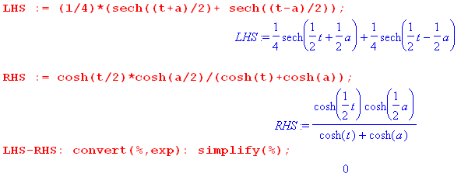 (L.4.7)
The integral I is now

I = ($\sqrt{2}$/π)$^{\int_{0}^{∞}{}}$dt (y +cht)-1/2 J

= ($\sqrt{2}$/π)$^{\int_{0}^{∞}{}}$dt (y +cht)-1/2 $\frac{ch(t/2)ch(a/2)}{ch(t) + ch(a)}$

= ($\sqrt{2}$/π) ch(a/2) $^{\int_{0}^{∞}{}}$dt (y +cht)-1/2 ch(t/2) (cht + cha)-1

= (1/π) ch(a/2) $^{\int_{0}^{∞}{}}$dt (y +cht)-1/2 (cht +1)1/2 (cht + cha)-1 . (L.4.8)

Now define

α ≡ cha ⇒ ch(a/2) = $\sqrt{1+cha}$/$\sqrt{2}$ = $\sqrt{1+α}$/$\sqrt{2}$ (L.4.9)

so that

I = $\sqrt{2}$ $\sqrt{1+α}$ $^{\int_{0}^{∞}{}}$dt (y +cht)-1/2 (cht +1)1/2 (cht + α)-1 . (L.4.10)

Next, change variables to s = cht with ds = shtdt = $\sqrt{s2-1}$dt to get

I = $\sqrt{2}$ $\sqrt{1+α}$ $^{\int_{1}^{∞}{}}$ [ds (s2-1)-1/2] (y+s)-1/2 (s+1)1/2 (s+α)-1

= $\sqrt{2}$ $\sqrt{1+α}$ $^{\int_{1}^{∞}{}}$ ds (s-1)-1/2 (y+s)-1/2 (s+α)-1 . (L.4.11)

Now change variables again to x = s + α. Then,

$^{\int_{1}^{∞}{}}$ ds =$^{\int_{1+α}^{∞}{}}$ dx s-1 = x - (1+α) y+s = x + (y-α) s+α = x (L.4.12)

so now

I = $\sqrt{2}$ $\sqrt{1+α}$ $^{\int_{1+α}^{∞}{}}$ dx [ x - (1+α)]-1/2 [x + (y-α)]-1/2 [x]-1

= $\sqrt{2}$ $\sqrt{1+α}$ $^{\int_{1+α}^{∞}{}}$ x-1 [x + (y-α)]-1/2 [ x - (1+α)]-1/2 . (L.4.13)

Finally we have a form which can be connected with a hypergeometric function. Consider this integral representation of F from GR8

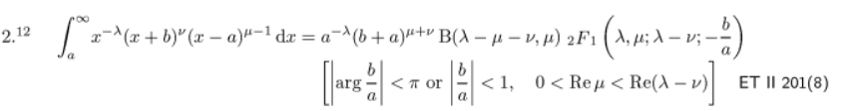

[ The corresponding GR7 equation had a typo which got fixed in GR8.] Set

a = 1+α λ = 1 b = y-α ν = -1/2 μ = 1/2 μ+ν = 0 . (L.4.14)

Then the above GR8 integral says

$^{\int_{1+α}^{∞}{}}$ x-1 [x + (y-α)]-1/2 [ x - (1+α)]-1/2 = (1+α)-1* 1 * B(1,1/2)* F(1,1/2; 3/2; -[y-α]/[1+α]) .
(L.4.15)
Now

B(1,1/2) = Γ(1)Γ(1/2)/Γ(3/2) = 1 * $\sqrt{π}$ / ($\sqrt{π}$/2) = 2 (L.4.16)

so then

I = $\sqrt{2}$ $\sqrt{1+α}$ (1+α)-1 2 F(1,1/2; 3/2; -[y-α]/[1+α])

= $\sqrt{2}$(1+α)-1/2 F(1,1/2; 3/2; -[y-α]/[1+α])

= $\sqrt{2}$(1+cha)-1/2 F(1/2,1; 3/2; -[y-cha]/[1+cha]) . // recall α = cha (L.4.17)

We now make use of GR7 9.121 (27) on page 1007,

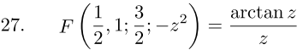
(L.4.18)
where we set z = $\frac{y-cha}{1+cha}$ . Then

I = $\sqrt{2}$(1+cha)-1/2 tan-1 $\frac{y-cha}{1+cha}$ / $\frac{y-cha}{1+cha}$

= $\sqrt{2}$$\sqrt{y-cha}$ tan-1 $\frac{y-cha}{1+cha}$ (L.4.19)

which is the desired result (L.4.1).

Verification: Oberhettinger and Higgins Table B page 20, the 5th entry. In this entry, the first form agrees with the above. The second form has a typo: the leading 2-1/2 should be 2-1.

L.5 Compute $^{\int_{0}^{∞}{}}$dτ Piτ-1/2(y) ch(bτ) / ch2(πτ)

Show that :

I ≡ $^{\int_{0}^{∞}{}}$dτ Piτ-1/2(y) ch(bτ) / ch2(πτ) = $\sqrt{2}$ $\sqrt{y-cosb}$ cot-1[$\sqrt{1+cosb}$$\sqrt{y-cosb}$] . (L.5.1)

Start with the previous result (L.4.1),

$^{\int_{0}^{∞}{}}$dτ Piτ-1/2(y) cos(aτ) / ch2(πτ) = $\sqrt{2}$ $\sqrt{y-cha}$tan-1[ $\sqrt{y-cha}$$\sqrt{1+cha}$] . (L.4.1)

Set a = ib so that

cos(aτ) = cos(ibτ) = ch(bτ) and ch(a) = ch(ib) = cos(b). (L.5.2)

Then (L.4.1) becomes

$^{\int_{0}^{∞}{}}$dτ Piτ-1/2(y) ch(bτ) / ch2(πτ) = $\sqrt{2}$ $\sqrt{y-cosb}$tan-1[ $\sqrt{y-cosb}$$\sqrt{1+cosb}$]

= $\sqrt{2}$ $\sqrt{y-cosb}$ cot-1 [ $\sqrt{1+cosb}$$\sqrt{y-cosb}$] (L.5.3)

which is the claimed result (L.5.1). One could replace $\sqrt{1+cosb}$ = $\sqrt{2}$cos(b/2).

Verification: Oberhettinger and Higgins Table B page 20, the 6th entry, but they have a typo. Their result should be this:

(1/$\sqrt{2}$) (1/ - $\sqrt{2}$ (1/tan-1 [$\sqrt{1+cosb}$$\sqrt{y-cosb}$]

= $\sqrt{2}$ (1/ ( $\frac{π}{2}$ - tan-1 [$\sqrt{1+cosb}$$\sqrt{y-cosb}$ ) = $\sqrt{2}$ (1/cot-1($\sqrt{1+cosb}$$\sqrt{y-cosb}$) (L.5.4)

which agrees with our result (L.5.3). But their result is presented instead as

2-1/2 (y-cosb)-1/2 - 21/2π-1 (y-cosb)1/2 tan-1 [$\sqrt{1+cosb}$$\sqrt{y-cosb}$] // wrong (L.5.5)

where the red 1/2 should be -1/2. This same erroneous exponent also appears in PBM volume 3 on Special Functions (2003), Russian page 181, integral 2.17.24.6,

// wrong (L.5.6)

To make sure our form (L.5.1) is the correct form, we do a sample numerical integration. RHS is the right hand side of (L.5.1) while RHS_OB is the right hand side of the "wrong" result (L.5.5) stated above. First, we enter the three items of interest, using our (7.4.1) P(ν,ξ) = Pν(chξ) so P(ν,y) = Pν(arccosh(y)),

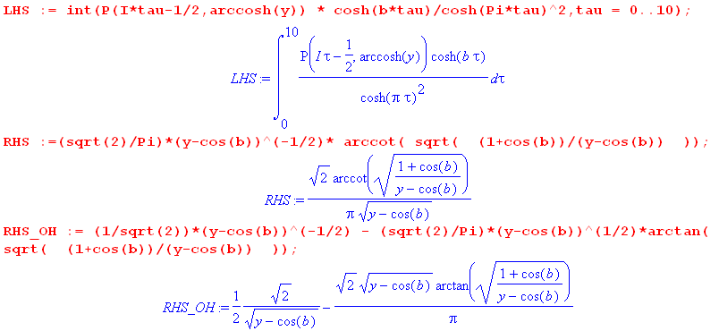

Next we enter the P function as in (7.4.1), along with some random values for parameters b and y, then we compare the numeric integral to the two candidate expressions,

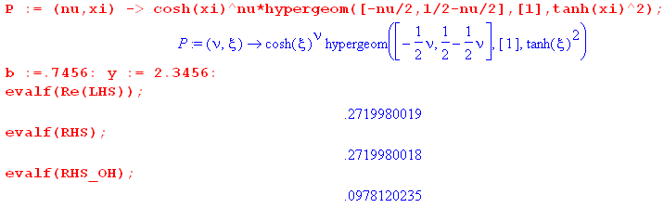(L.5.7)

Notice that integration to τ = 10 gets the result accurate to 10 decimal places.

Go back now to (L.5.3),

$^{\int_{0}^{∞}{}}$dτ Piτ-1/2(y) ch(bτ) / ch2(πτ) = $\sqrt{2}$ $\sqrt{y-cosb}$tan-1[ $\sqrt{y-cosb}$$\sqrt{1+cosb}$]

= $\sqrt{2}$ $\sqrt{y-cosb}$ cot-1 [ $\sqrt{1+cosb}$$\sqrt{y-cosb}$] . (L.5.3)

To make the proper analytic continuation in b more obvious, we replace

$\sqrt{1+cosb}$ = $\sqrt{2}$cos(b/2)

This shows that as b runs along the real axis, the function called " $\sqrt{1+cosb}$" in fact changes sign at odd multiples of π. Then (L.5.3) can be written as

$^{\int_{0}^{∞}{}}$dτ Piτ-1/2(y) ch(bτ) / ch2(πτ) = $\sqrt{2}$ $\sqrt{y-cosb}$tan-1[ $\sqrt{y-cosb}$$\sqrt{2}$]

= $\sqrt{2}$ $\sqrt{y-cosb}$ cot-1 [ $\sqrt{2}$$\sqrt{y-cosb}$] (L.5.8)

L.6 Compute $^{\int_{0}^{∞}{}}$dτ Piτ-1/2(y) sh(bτ) sh(πτ)/ch2(πτ)

Show that :

I ≡$^{\int_{0}^{∞}{}}$dτ Piτ-1/2(y) sh(bτ) sh(πτ)/ch2(πτ) = $\sqrt{2}$ $\sqrt{y+cosb}$tan-1 ($\sqrt{1-cosb}$$\sqrt{y+cosb}$) . (L.6.1)

Start by expanding

2 sh(bτ) sh(πτ) = ch[(b+π)τ] - ch[(b-π)τ] (L.6.2)

so then

I ≡ $^{\int_{0}^{∞}{}}$dτ Piτ-1/2(y) sh(bτ) sh(πτ)/ch2(πτ)

= (1/2) $^{\int_{0}^{∞}{}}$dτ Piτ-1/2(y) ch[(b+π)τ] - (1/2) $^{\int_{0}^{∞}{}}$dτ Piτ-1/2(y) ch[(b-π)τ] . (L.6.3)

But (L.5.8) says, replacing b by β,

$^{\int_{0}^{∞}{}}$dτ Piτ-1/2(y) ch(βτ) / ch2(πτ) = $\sqrt{2}$ $\sqrt{y-cosβ}$ cot-1 [ $\sqrt{2}$$\sqrt{y-cosβ}$] . (L.6.4)

For the first term in (L.6.3) we set

β = b+π
cosβ = cos(b+π) = -cos(b)
cos(β/2) = cos(b/2+π/2) = - sin(b/2) (L.6.5)
so
$^{\int_{0}^{∞}{}}$dτ Piτ-1/2(y) ch[(b+π)τ] / ch2(πτ) = $\sqrt{2}$ $\sqrt{y+cosb}$ cot-1 [ $\sqrt{2}$$\sqrt{y+cosb}$] . (L.6.6)

For the second term in (L.6.3) we set

β = b-π
cosβ = cos(b-π) = -cos(b)
cos(β/2) = cos(b/2-π/2) = cos(π/2-b/2) = sin(b/2) (L.6.7)

so
$^{\int_{0}^{∞}{}}$dτ Piτ-1/2(y) ch[(b-π)τ] / ch2(πτ) = $\sqrt{2}$ $\sqrt{y+cosb}$ cot-1 [ $\sqrt{2}$$\sqrt{y+cosb}$] . (L.6.8)

Then,

I = (1/2) $^{\int_{0}^{∞}{}}$dτ Piτ-1/2(y) ch[(b+π)τ] - (1/2) $^{\int_{0}^{∞}{}}$dτ Piτ-1/2(y) ch[(b-π)τ]

= (1/2) $\sqrt{2}$ $\sqrt{y+cosb}$cot-1 [ $\sqrt{2}$$\sqrt{y+cosb}$] - (1/2) $\sqrt{2}$ $\sqrt{y+cosb}$cot-1 [ $\sqrt{2}$$\sqrt{y+cosb}$]

= (1/2) $\sqrt{2}$ $\sqrt{y+cosb}$ { cot-1 [ $\sqrt{2}$$\sqrt{y+cosb}$] – cot-1 [ $\sqrt{2}$$\sqrt{y+cosb}$] } . (L.6.9)

We now twice use the fact that cot-1(x) = π/2 - tan-1(x) to rewrite the above as

I = (1/2) $\sqrt{2}$ $\sqrt{y+cosb}$ { tan-1 [ $\sqrt{2}$$\sqrt{y+cosb}$] - tan-1 [ $\sqrt{2}$$\sqrt{y+cosb}$]

= (1/2) $\sqrt{2}$ $\sqrt{y+cosb}$ { 2 tan-1 [ $\sqrt{2}$$\sqrt{y+cosb}$] }

= $\sqrt{2}$$\sqrt{y+cosb}$ tan-1 ( $\sqrt{2}$$\sqrt{y+cosb}$)

= $\sqrt{2}$$\sqrt{y+cosb}$ tan-1 ( $\sqrt{1-cosb}$$\sqrt{y+cosb}$) (L.6.10)

and this is the result claimed in (L.6.1).

Verification: The evaluation shown in (L.6.1) appears in Oberhettinger and Higgins Table B page 20 entry 3.

